

  - Operating Hotel Facilities
  - BMIH4006

Presentation

Student name: Mihaita Ionut Manda

Student ID number: 2232074

Lecturer: Scott James

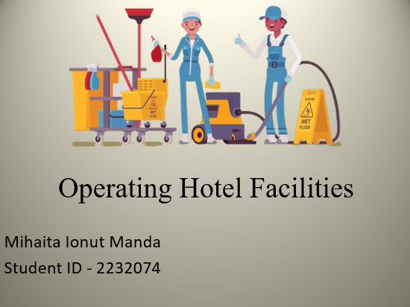

Table of content

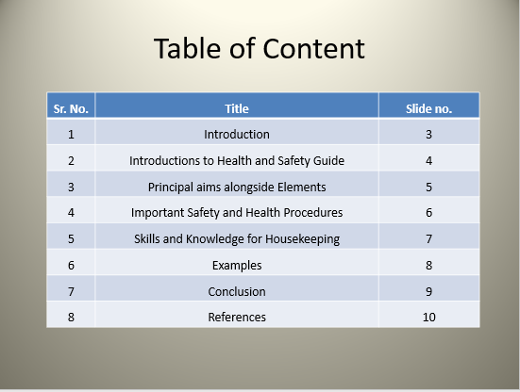

Introduction

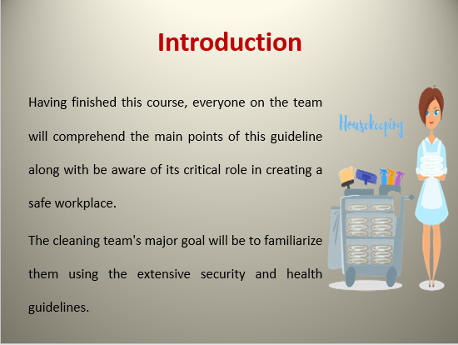

Introduction
When it comes to avoiding accidents and harm throughout cleaning space procedures, this information serves as an invaluable resource. Salutations and a warm welcome for the course on " Improving Safety and Health in Room Cleansing" (Shapoval et al., 2022). Having finished this course, everyone on the team will comprehend the main points of this guideline along with be aware of its critical role in creating a safe workplace. The cleaning team's major goal will be to familiarise them using the extensive security and health guidelines. This will strengthen our dedication to security, guaranteeing the health and security of the staff alongside raising the general bar for cleaning services.

Introductions to Health and Safety Guide

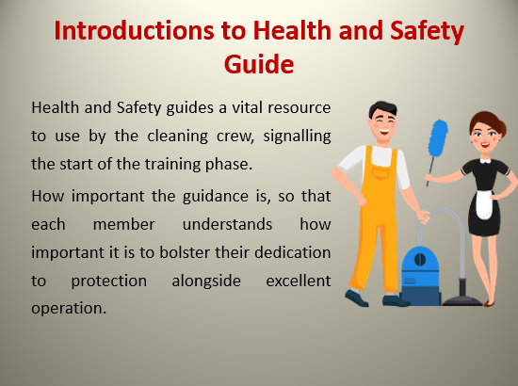

This guide is created to serves as an all-inclusive document that describes within great depth the essential procedures needed to keep a space intact and secure when washing it. This introduces the health and Safety guides as a vital resource to use by the cleaning crew, signalling the start of the training phase. Establish the mood throughout the remaining slides by highlighting how important the guidance is, so that each member understands how important it is to bolster their dedication to protection alongside excellent operation. Emphasise the importance of guidance by going over the main training goals alongside stressing how important it is to align procedures with the demands of the industry.

Principal aims alongside Elements

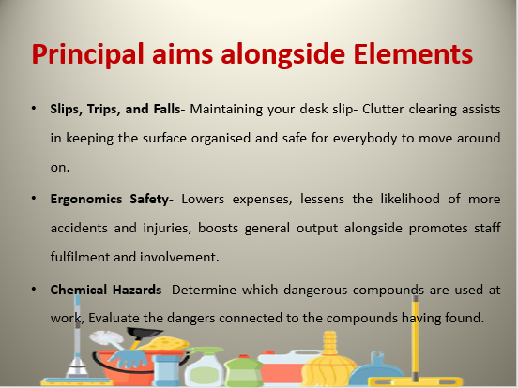
Principal aims alongside Elements
Slips, Trips, and Falls
Maintaining your desk slip-free involves regular cleaning. Clutter clearing assists in keeping the surface organised and safe for everybody to move around on. Individuals may potentially fall and trip on poorly lighted paths (NOR, 2021). They may trip across items along with tumble to the ground when they are unable to see their way well. It is important to have precautionary signs along with markings to deter falls, trips, and slides. To maintain the safety of visitors, post warning signs about roaming in dangerous areas.
Ergonomics Safety
The workplace environment security initiative's use of ergonomic security assists ensure that workers' physical constraints and abilities are matched by providing appropriate workspaces along with equipment to provide secure and pleasant environments for work (Tiwari and Trivedi, 2020). Lowers expenses, lessens the likelihood of more accidents and injuries, boosts general output alongside promotes staff fulfilment and involvement.
Chemical Hazards
Determine which dangerous compounds are used at work, Evaluate the dangers connected to the compounds having found. Use warning symbols and signs, put in place effective control systems, and conduct periodic checks (Kuzmina et al., 2022). Personal protective equipment (PPE) Employ PPE to decrease exposures and hazards when organisations cannot prevent the use of dangerous substances as well as minimise staff contact with chemicals.

Important Safety and Health Procedures
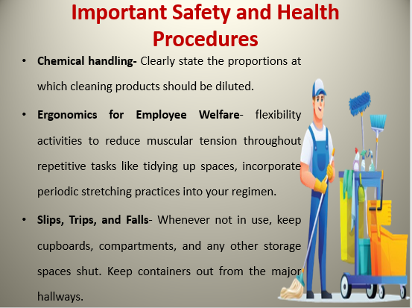

Chemical handling
Best Practices for Chemical Handling
Clearly state the proportions at which cleaning products should be diluted. Provide guidelines to employees that how crucial it is to use personal safety gear (PPE).
Situation - Effects of Inadequate Chemicals Management:
A member of the maintenance crew of an establishment in the United Kingdom combined cleaning supplies with no using the required personal protective equipment (PPE) (Kuzmina et al., 2022). A biological response followed, resulting in cutaneous discomfort and difficulty breathing. In addition to endangering the worker's wellness, the event forced a short-term shutdown of the impacted areas to thoroughly decontaminate them, which affected hospitality services.
Achievement Narrative: The Implementation of Strict Chemical Management Education by Yet another British Hotel Shows the Beneficial Effect of Proper Processes. Employee adherence to procedures resulted in increased operating safety and efficiency (Lloyd, 2023).
The Importance of Ergonomics for Employee Welfare
Flexibility Activities: To reduce muscular tension throughout repetitive tasks like tidying up spaces, incorporate periodic stretching practices into your regimen.
Support for keeping appropriate position alongside utilising ergonomics movements of the body in order to reduce strain on the body (Tiwari and Trivedi, 2020).
Actual For instance: the British establishment's implementation of ergonomics methods Highlight the ways in which staff happiness, job fulfilment, and level of weariness were all enhanced. Stress the beneficial effects on employee happiness and productivity.
For instance, front-desk staff may utilise flexible-height workstations to increase relaxation along lower their likelihood of spinal injury, while housekeeping staff may employ lighter vacuum cleaners along with flexible cleansing trolleys to lessen the impact on their backs.
Slips, Trips, and Falls
Maintain housekeeping
Whenever not in use, keep cupboards, compartments, and any other storage spaces shut. Place rubbish inside the appropriate receptacle. Keep containers out from the major hallways. wires, extensions, including wires should all be covered for protection (NOR, 2021).
Make sure spots for walking have enough illumination.
If the space has adequate lighting, employees may move about the area more easily. Given light of that, it would be advisable to install sufficient illumination at both entering and leaving locations, including hallways, stairs, ramps, and outlets.
Put up warning symbols
For instance, businesses post signs warning patrons of slippery floors, such as "Warning: Wet Ground." Concurrently, the construction industry designates zones that are limited or navigable using control areas, cautionary lines of code, and designated spaces.

Skills and Knowledge for Housekeeping

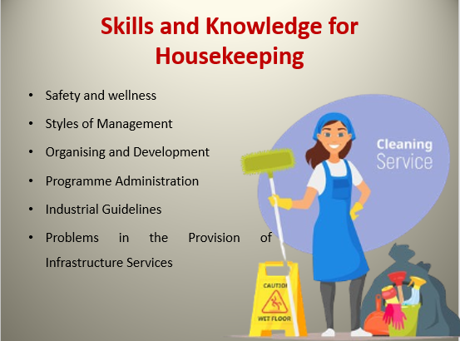

Skills and knowledge for housekeeping
Safety and wellness- Continuous Enhancement Apply a methodology that integrates input and changing requirements to continually enhance safety and health processes. Conformity Make sure that all operational components strictly adhere to safety and health requirements (Cottrell, 2019).
Styles of Management- leadership development to improve administrators' efficacy in various operating situations, offering them with leadership opportunities. Flexibility Promote flexible methods of leadership which are tailored to the particular requirements of every division (Cottrell, 2019).
Organising and Development- collaboration plan promote departmental cooperation for coordinated execution and preparation. Effective processes Provide seamless delivery of services by streamlining processes via effective organisation and planning (Cottrell, 2019).
Programme Administration- programme assessment continually assesses and modify programmes to make certain that support organisational objectives. Strategy Development Create targets for the future along with resource optimisation into your strategy strategies for providing infrastructure services (Cottrell, 2019).
Industrial Guidelines- credentials to reach or surpass benchmarks in the industry, assist and motivate employees to earn the necessary credentials. Comparison to find opportunities for advancement, compare facility services regularly to current standards.
Problems in the Provision of Infrastructure Services- technological understanding encourage on-going education to maintain employees up to date on the newest developments alongside developments in the sector (Cottrell, 2019). Allocating resources use funds wisely in accordance with departmental objectives alongside requirements.

Examples

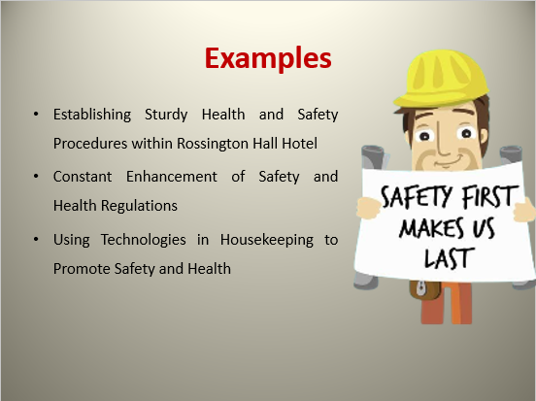

Establishing Sturdy Health and Safety Procedures within Rossington Hall Hotel
Decreased Injuries: Following extensive instruction on safe use of machinery including chemicals dealing with, the hotel's staff saw a notable decline in housekeeping-related mishaps.
Improved Worker Morale: A focus on employee welfare led to a rise in worker satisfaction with their work. Workers were appreciated and knew that their health came first (Quick, 2020).
Administrative The continuity: By averting incidents and harm, the hotel's operations were able to continue providing housekeeping solutions, which enhanced its general efficiency.
Constant Enhancement of Safety and Health Regulations
Flexibility to Shifting rules the hotel successfully avoided compliance problems by taking a proactive stance that guaranteed quick adaption to changing safety and health rules.
Loyalty to customers alongside excellent evaluations resulted from travellers' recognition of the hotel's dedication to security and sanitation (Phalane and Gupta, 2023).
Worker Development Workers took an active part in making suggestions for enhancements, which encouraged a sense of responsibility for upholding rigorous safety and health standards.
Using Technologies in Housekeeping to Promote Safety and Health
Immediate view interaction smartphones allow cleaning personnel to communicate instantly, allowing for a prompt reaction to security issues or crises (Sharma et al., 2019).
Effective assignment administration As a result of better collaboration and organisation brought about by the emergence of technological advances, the management of tasks has gotten better and the probability of mishaps has decreased (Howell, 2023).
Computer-Driven information the lodging facility used information analysis to spot trends and possible threats to public safety, which made preventative action and on-going enhancement possible.

Conclusion

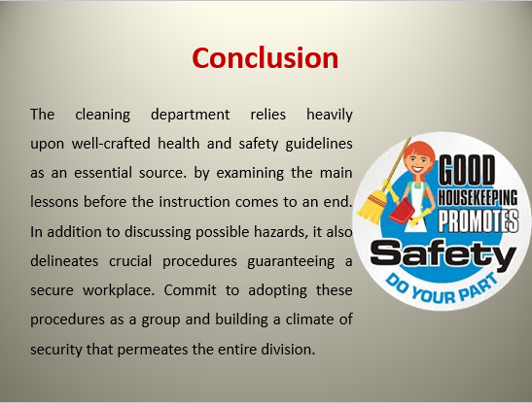

The cleaning department relies heavily upon well-crafted health and safety guidelines as an essential source. By examining the main lessons before the instruction comes to an end. In addition to discussing possible hazards, it also delineates crucial procedures guaranteeing a secure workplace. Commit to adopting these procedures as a group and building a climate of security that permeates the entire division. Enable team members to execute their tasks alongside conviction by putting the guide's suggestions into practice and letting them understand that what matters most is their happiness.

References



