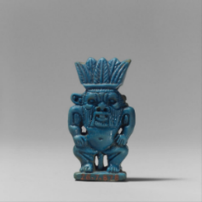
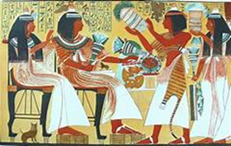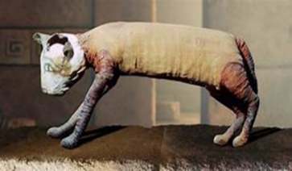

Cats & their relationship with the ancient Egyptians in Life, Religion, Mummification & Death. By Julia Jones 2007994

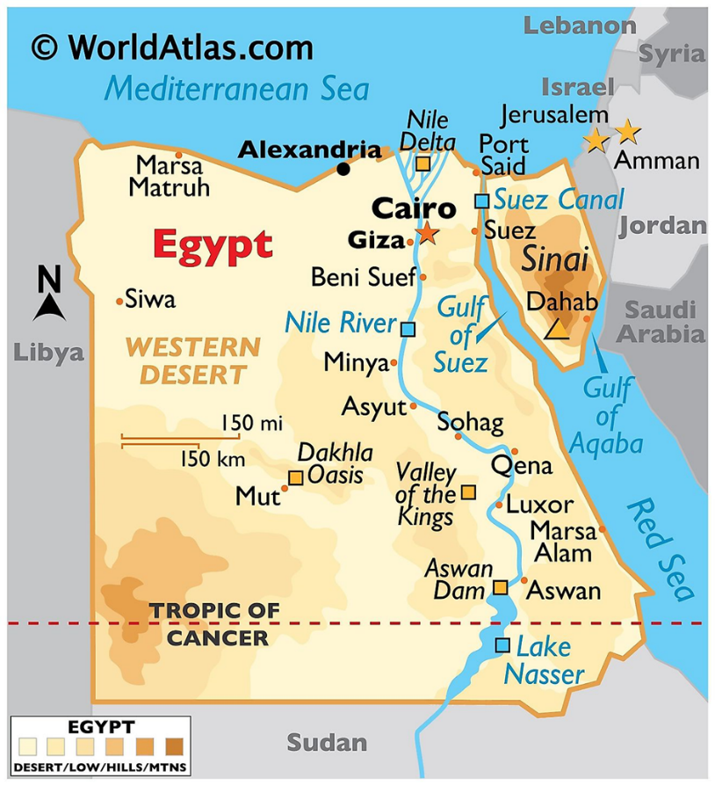
Egyptian people and animals have been attracted to the generosities of the Nile, Egypt’s primary source of water for centuries shown in (map1) with flooding planes leaving fertile soil behind for plants, animals, and farming to flourish. Egypt is situated in the North-eastern corner of Africa. Its dry hot weather conditions have enabled exceptional preservation of artefacts, manuscripts and artwork that now help us to work out the life stories of the ancient Egyptians and the animals that surrounded them on a day-to-day basis. In the 26th century, writing was developed in Egypt which in turn began the record of history that we can interpret today. This essay will look at cats and their relationship with the ancient Egyptians in life, exploring their transition from wild to domesticated, then sacred, with a brief explanation of Bes a male cat god who was favoured in the Greco-Roman period, two female goddesses Sekhmet of the middle kingdom, and Bastet with early evidence being found under the famous step pyramid of Djoser at Saqqara. Finally, in death with the mummification of cats as gifts or offerings to the gods, the ancient Egyptians took cats into the afterlife by depicting them on their tombs. Using articles and books to gain a better understanding and demonstrate an unbreakable bond that can still be seen in much the same way to this day.
Map 1: Showing the Nile running through the heart of Egypt (WorldAtlas.com, 2021)

Cats and ancient Egyptian people’s relationships in life

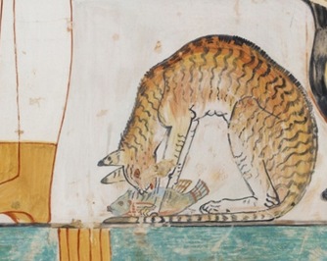
Initially, wild cats would have been attracted to ancient Egyptian settlements by small rodents that were eating the food supplies of the farmers (Ikram, 2015) (Linseele et al., 2007:11) and snakes that would have threatened their lives (Mills, 2018). Farmers would have quickly realised the cat to be an asset and would have welcomed and even encouraged them into their dwellings, increasing contact, eventually leading to domestication over time and developing an unbreakable bond. (Baldwin, 1975) (Linseele et al., 2007:11)
Image 1 Copy of a Cat eating a fish under the chair where a woman sits. Ashmolean Museum/Heritage Images/Getty Images/ (Davies, 2021) (Yuko, 2021)

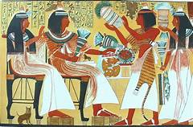
With the ‘Egyptians fond of writing and their religion informing them their gods would recreate the scenes on their tomb in the afterlife,’ the walls of the tombs were decorated with what the ancient Egyptians wanted to take with them which included cats (Brier & Hobbs, 2008). The first Tomb paintings depicting cats interacting with the ancient Egyptians, still close to their wild form Felis Silvestri’s, were from the Middle kingdom (Lange-Athinodorou, 2021) and a cat with a collar was found in a tomb from the fifth dynasty, further demonstrating their bond and domestication.
Cats shown sitting underneath a chair as in images 1 & 2 were common in Egyptian art and was a good way to fill a space. With the painting in image 1 only partially complete (Burzacott, 2015), it has created the need to find and preserve artefacts before it is too late with moisture now being the main enemy due to intensive farming (Brier & Hobbs, 2008). Cats seen underneath a noble lady represented her prosperity and fertility as displayed in image 1 of a playful kitten sitting on Ipuy’s knee, his wife Duammeres with an older cat beneath her chair with a silver earring and collar. (Burzacott, 2015) Big cats such as lions and cheetahs served as symbols of power and royalty, often kept as pets, hunted and their skin highly prized depicted in image 2 with Ipuy’s son wearing one (Nag, 2018).
Image 2 Tomb scene including 2 cats, from funerary chapel of Royal sculptor Ipuy who served Ramesses II approximately 1250 BCE (Burzacott, 2015) (Mills, 2018)
As with the ancient Egyptian people, cats had a class system of their own, with wild or feral cats as the lowest, living on the fringes of society, being hunted, or raised for food and possibly bread for the production of mummies. Secondly, there were domestic cats, which were kept as pets and to catch mice, they were generally respected as members of a species and honoured by the gods (Grimal, 1969:26). Thirdly, sacred cat statues which were shown by specific markings or temple lineage were not worshipped but represented embodiments of the god/goddesses, with cats themselves being given status and protection in day-to-day life (Grimal, 1969:26) (Ikram, 2015) (Yuko, 2021).

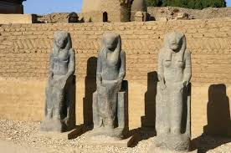
Myths and Religion
Ancient Egypt is famous for its cults of gods with mythological concepts being varied, inter-connecting with local religion and the Pharaoh being responsible for the standard practice of a cult. Egyptians made cats into “divine totems” (Ikram, 2015) and in many cases, the gods took the shape of them. They were regarded as the soul of the god and believed to be gifted with specific powers (Grimal, 1969:26). The ritual and ceremonial offerings were performed by priests and offerings such as the cat mummies were then given at the many yearly festivals dedicated to those gods (Grimal, 1969:28).
Sekhmet meaning powerful one was one of the oldest feline deities (Hill, 2008). Originally from the triad of Memphis, daughter of Ra, she was shown mainly with the head of a lioness as in image 3 (Grimal, 1969:26) she was the goddess of war, battle, fire, and healing, also associated with wind and natural disasters depending on her mood. Egyptians held festivals, using alcohol to appease her. Sekhmet is mentioned several times in the book of the dead as both a creative and destructive force (Hill, 2008).
Image 3 Goddess-Sekhmet-Statues-Egypt (Evans, 2021)
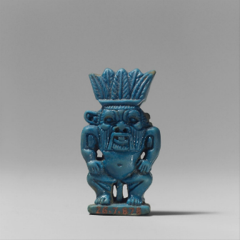

Bes shown in image 4 of an Amulet belonging to the Metropolitan Museum of Art collection was an ugly male household god, a fierce protector of the people. He often wore leopard skin and was the smallest of the cat gods known as a “Dwarf God”. He was said to protect children from lions and snakes. Bes had no temples attributed to him, just shrines placed in many homes, especially those with pregnant women or children (Brier & Hobbs, 2008) (Metmuseum.org, 2021) (Otherworldlyoracle.com, 2018).
Image 4 Third Intermediate period Bes Amulet (ca. 1070-712 BCE) (metmuseum.org, 2021)

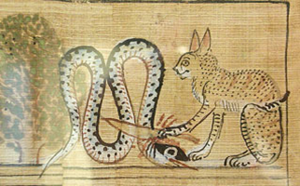
Image 5 is of Bastet subduing Apep an Egyptian demon of chaos who had the form of a serpent in one of the ancient Egyptian myths (Egyptianmuseum.org, 2021) (Hill, 2010). The earliest evidence of Bastet came from galleries under the famous step pyramid of Djoser at Saqqara near Memphis. Bastet was normally shown as a black cat or woman with the head of a cat, initially, she was a warrior goddess, later representing the patroness of love, beauty, self-indulgence, light-hearted rivalry, and motherhood. (Ikram, 2015) The New Kingdom onwards had temples of Bastet in Sakkara, Alexandria and a Festival of Bastet at Bubastis, the Cult centre (Lange-Athinodorou, 2021) with Bastet reliefs and statues carefully being preserved in museums all around the world (Grimal, 1969:25) giving us a valuable glimpse of what it was like to be an ancient Egyptian and the importance of cats in their religion.
Image 5 The Great cat subdues Apep (Hill, 2010) Original image by Charles K. Wilkinson

Mummies

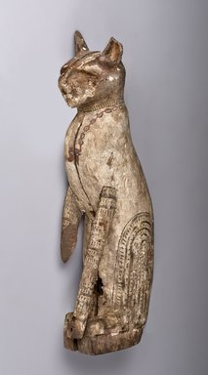
Cats were one of the most commonly mummified pet animals, as they were linked in every aspect of the ancient Egyptians day to day life and death. The cat would be ‘embalmed using natron, oils & resins, wrapping or linen bandages’, some of which was not local or easily sourced, for sacred cat’s ‘amulets may have been included, which then could be placed inside a burial container such as a stone sarcophagus, wooden or cartonnage coffin such as in Image 6, or pots’ which varied in cost and materials to suit the buyers budget (Ikram, 2015).
Cats used for mummification were well looked after and then killed by priests, they were then purchased by pilgrims and given as offerings (Anastasia & Shotz, 2019). People believed that if they bought a mummified cat and presented it to the temple of a goddess-like Bastet or Pakhet, the cat’s spirit would join the goddess in the afterlife, where it would continually urge her to bless and answer the prayers of the giver (Ikram, 2015). A cat cemetery at Beni Hasan was discovered in 1888 dedicated to Pakhet a feline goddess, with thousands of layered mummified cats being found (Francisco, 2014).
Image 6 Cat coffin with mummy (Ashworth, 1947)

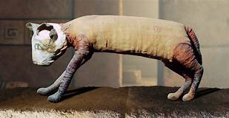
The popularity of cat mummification increased after 1000 BCE as temples relaxed their practices and common people began to express their devotion, some animals being bred solely for the mummy trade with cats able to have up to three litters a year (Ikram, 2015). Children often dug up the cat mummies and sold them to tourists, some were stripped of their wrappings to be recycled into paper and many were sold and taken on mass from Egypt in the nineteenth century to be turned into fertiliser. The demand for cat mummies can be shown in image 7 with modern technology revealing an ancient mummy containing the remains of many cats with a ball of fabric in place of the head, this may have been due to the sheer amount of Cat mummies needed and the supply not being able to meet demand or just an ancient deception. (Harvey, 2019)
Image 7 Bizarre Ancient Egyptian Cat mummy, with 5 legs and 3 tails (Harvey, 2019)

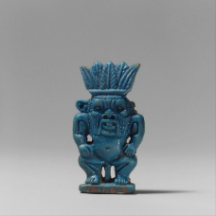
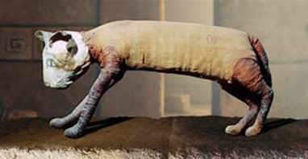

Ancient Egyptian people of all capabilities since records began have lived side by side and benefited from a day-to-day relationship with cats, brought forth by the Niles generosity. First protecting their homes and so well thought of in life by proving their usefulness were painted on the tomb walls to be taken into the afterlife, to continue protecting food stores and homes. Secondly starting as real-life characters with catlike traits than in myth becoming embodiments such as Sekhmet, Bes, and Bastet. The mummification of cats shows people cared for and respected them as much as themselves. Cats in ancient Egypt were interlinked with everything from health, the economy, religion, education, and laws reinforcing the inter-connective bonds between cats and humans through stories, paintings, and statues. The Nile initially supported life, now threatening the archaeological remains due to moisture caused by the intensive farming of modern-day Egyptians, creating the need to find, record and preserve any remains before any more important information is lost thus gaining a better understanding of the ancient Egyptians relationship in life, religion, mummification, and death.

Reference list

Amin, O.S.M., 2016 [online] Available at: The Gayer-Anderson cat (Illustration) World History Encyclopaedia (Accessed 03-11-2021).
Anastasia, L. & Shotz, J.L. 2019. Cats Under Wraps: Why did the ancient Egyptians turn cats into mummies? Scholastic News 81(13), 4 (Explorer ed.) Accessed 21-10-2021).
Brier, B.M. and Hobbs, H., 2008. Daily life of the ancient Egyptians. ABC-CLIO. Accessed 27-10-2021. Collins English Dictionary, 2021. Animal definition and meaning [online] Available at: https://www.collinsdictionary.com/dictionary/english/animal Accessed 20-10-2021.
Cotterell, A. & Storm, R., 1999. The Ultimate Encyclopaedia of Mythology. An A-Z Guide to the Myths and Legends of the Ancient World. Hermes House.
Francisco, C.L., 2014. Cat mummies of Ancient Egypt [online] Available at: Cat mummies of ancient Egypt \ C L Francisco Accessed 25-10-2021.
Grimal, P., 1969. Larousse world mythology. Hamlyn. 1973 ed. Eighth impression – 1984. P25-28. Ikram, S., 2015. Speculations on the role of animal cults in the economy of ancient Egypt. Apprivoiser le sauvage/taming the wild (CENiM 11), 3, pp.211-228 (Accessed 28-10-2021).
Kozma, C., 2006 Dwarfs in Ancient Egypt American Journal of Medical Genetics Part A [online] Available at: https://onlinelibrary.wiley.com/doi/abs/10.1002/ajmg.a.31068 historical review (abstract) (Accessed 01-11-2021).
Lange-Athinodorou, E. 2021. The goddess Bastet and the cult of feline deities in the Nile delta. American research centre in Egypt [online] Available at: https://www.arce.org/resource/goddess-bastet-and-cult-feline-deities-nile-delta (Accessed 01 -11-2021).
Linseele, V., Van Neer, W. & Hendrickx, S., 2007. Evidence for early cat taming in Egypt. Journal of Archaeological Science, 34(12), pp.2081-2090. [online] Availableat:https://www.sciencedirect.com.ezproxy.uwtsd.ac.uk/science/article/p11 Accessed 21-10-2021.
Otherworldlyoricle.com, 2018 ‘Gods and Goddesses’ Explanation of Bast-female, Bes-male (Accessed 26 & 28-10-2021).

Images
Ashworth, G., 1947. Brooklyn Museum Cat mummy [online] Available at: https://www.brooklynmuseum.org/opencollection/objects/118451https://d1lfxha3ugu3d4.cloudfront.net/images/opencollection/objects/size2/37.1947E_Gavin_Ashworth_photograph.jpg
(Accessed 03-11-2021)
Burzacott, J., 2015. Tomb painting of Ipuy and cats [online] Available at: https://www.nilemagazine.com.au/march-2015-archive/2015/3/22/ancient-egypts-best-dressed-cats) (Accessed 03-11-2021).
Davies, N., 2021 [online] Available at: https://www.ashmoleanprints.com/image/453762/davies-nina-copy-of-wall-painting-from-private-tomb-52-of-nakht-thebes-i-1-99-102-cat-eating-fish (copyright-free)(Accessed 07 11 2021).
Evans, M., 2021. Goddess Sekhmet statues Egypt [online] Goddess Sekhmet statues. Egypt (Print #14321432) Thaliastock (prints-online.com) (Accessed 03-11-2021).
Harvey, I., 2019 Egyptian cat mummy [online] Available at: https://www.thevintagenews.com/2019/11/18/ancient-egyptian-cat-mummy/
Article from Vintage News Held in Museum of fine arts in Rennes. Picture from Getty Images (copy-right free image) (Accessed 03-11-2021).
Hill, J. 2010 Cats in Ancient Egypt ‘The great cat subdues Apep’ [online] Available at: Ancientegyptonline.co.uk/cat/ Accessed 07-11-2021.
Mark, J.J, 2016 Bastet [online] Available at: www.worldhistory.org/Bastet/ (copy-right free image) (Accessed 03-11-2021).
Met. Museum, 2021 Bes-Image Amulet | Third Intermediate Period | The Metropolitan Museum of Art (metmuseum.org) [online] Available at:
https://www.metmuseum.org/art/collection/search/548301 (picture in the public domain) (Accessed 03-11-2021).
Mills, J., 2018 Why did Ancient Egyptians Love cats? [online] Available at: https://blogs.ucl.ac.uk/researchers-in-museums/2018/04/17/why-did-ancient-egyptians-love-cats/ Accessed 03-11-2021.
Nag, O.S., 2018 Ancient Egyptian Animals – World Atlas [online] Available at:
https://www.worldatlas.com/articles/animals-of-ancient-egypt.html
Accessed 03-11-2021.
Rosicrucian Egyptian Museum.org, Bastet (Bast) Explore Deities of Ancient Egypt [online] Available at: Egyptian Museum.org/deities-Bastet Accessed 28-10-2021.
World Atlas, 2021 Map of Egypt [online] Available at: www.worldatlas.com/maps/egypt
(Accessed 03-11-2021).
Yuko, E., 2021. How cats became divine symbols in Ancient Egypt. [online] Available at: https://www.history.com/news/cats-ancient-egypt
Picture of Cat eating fish under the chair from Ashmolean Museum/Heritage Images/Getty Images
(Accessed 28-10-2021).

