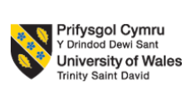
Programme Name: Master of Business Administration
Module Code: LCMB7023
Module Title: Human Capital Management

Assignment Title: Assessment Component 1: Individual Report

Lecturer’s Name: Dr. Hoang Nguyen (London)

Student Name: Harsh Deep Singh
Student ID: 2436567
Word Count: 2550
Date of Submission: 14 NOV
Table of Contents
1. The Impact of Technological Advancements on Labour Markets and Strategic Responses in HRM and IHRM 2
1.1 Technological Advancements and Their Impact on Contemporary Labour Markets 3
1.2 Strategic Implications for HRM and IHRM in the Digital Era 4
2. Demographic and geopolitical influences on employment markets 6
2.1 Contemporary Demographic and Geopolitical Forces Shaping Employment Markets 6
2.2 Implications and Challenges for Human Resource Professionals 7
3. Different ways of addressing Skills Gaps and Talent Shortages through Strategic HRM 8
4. Reflective Report 9
References 15

List of Figures
Figure 1: “Global Generative AI in Jobs Market size” 4
Figure 2: Stages of Digital Transformation in HR 5
Figure 3: “Annual growth rates for employee jobs and payrolled employees” 7
Figure 4: Gibbs Reflective Model 10
List of Tables
Table 1: Action Plan 14

1. The Impact of Technological Advancements on Labour Markets and Strategic Responses in HRM and IHRM

1.1 Technological Advancements and Their Impact on Contemporary Labour Markets
Artificial intelligence (AI), automation, and digital platforms are some of the technological changes that are transforming work in the UK. These technologies are transforming workplace activities, workplace organization and modes of employment. It is estimated that the percentage of current jobs that are at risk of automation is approximately 7% in five years. This amount may increase up to 18% in a decade and close to 30% in a decade (House of Commons, 2023). Generative AI is already exposed to 11% of the existing work in the UK economy (IPPR, 2024). This exposure may be 59% in a second wave of adoption. Another alarming fact that the think tank has issued is that, without taking preventive measures, the number of jobs that can be disrupted due to the continued deep adoption of AI in the UK can reach as many as 8 million (Bloomberg, 2024). Automation is most threatened by low-skilled and routine jobs, particularly administrative and clerical tasks. Meanwhile, new opportunities exist in technology-based sectors that need innovativeness, problem-solving, and online literacy. Remote work options and the expansion of the gig economy have also been increased by the increasing use of AI tools and digital platforms.
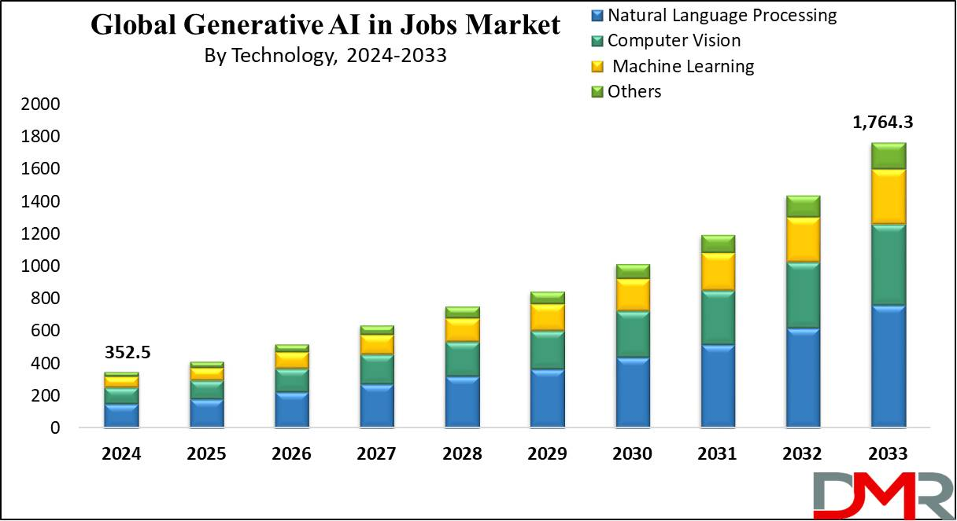

Figure 1: “Global Generative AI in Jobs Market size”
(Source: Dimension Market Research, 2024)
As the IPPR (2024) observes, jobs most prone to displacement are those in the back-office, part-time, and entry-level jobs. The number of jobs based on technology and AI support is growing rapidly. Digital competence and flexibility have become increasingly important to employers, not conventional qualifications. A lot of individuals are currently employed under short-term and flexible contracts, as opposed to full-time employment. This change reflects a consistent trend of moving to platform-based work and self-employment although statistics in relation to the UK are not so detailed.

1.2 Strategic Implications for HRM and IHRM in the Digital Era
Digitalisation of the UK labour market is something that requires significant shifts in HRM and IHRM practices. Organisations have become required to be agile, be guided by data, and incessantly reshape their workforce. AI-based HR analytics is becoming more popular in domestic HRM. These tools assist in enhancing the process of recruitment, forecasting performance, and enhancing employee engagement. In the UK, digital systems are now being adopted by many HR departments to hire and plan their workforce (EU Business News, 2025). This change has a pronounced trend towards evidence-based HR practice. The new forms of competitiveness now require reskilling and lifelong learning. The White Paper by the UK Government on Skills for Jobs (2023) encourages employer-led training to alleviate the problem of digital skills shortage. It is also aligned with the national agenda of equipping the labor force with AI-related industry (Government of the UK, 2023). HR executives should pay attention to building internal educational platforms and online learning. These strategies make the employees remain flexible and innovative in the changing technology. Concisely, HRM policies in the UK need to strike a balance between technology and human ability.
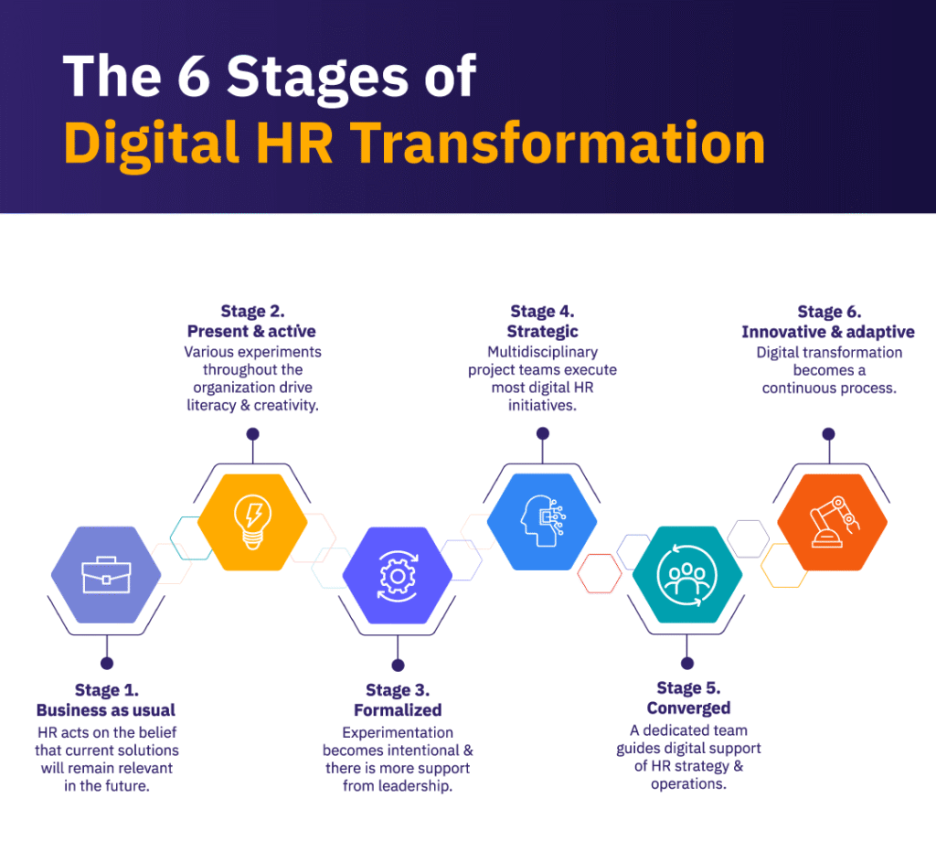

Figure 2: Stages of Digital Transformation in HR
(Source: von Moltke and Verlinden, 2024)
In terms of IHRM, with the advent of digitalisation, global teams can be more integrated, and virtual collaboration is possible (Caligiuri et al. 2022). It also promotes the hiring of talent without any limit to countries, and therefore, companies are able to acquire talent in other countries. Nevertheless, there are new challenges to this development. Privacy of data and its security have become a concern in cross-border operations. Culture, language, and access to digital facilities may also be barriers to effective teamwork. IHRM professionals are thus called to ensure that they come up with policies that safeguard the data and enhance equity (Pareekh, 2025). They should also make sure that digital tools and training are equally available in all regions.

2. Demographic and geopolitical influences on employment markets

2.1 Contemporary Demographic and Geopolitical Forces Shaping Employment Markets
The UK faces a lot of pressure in terms of the employment markets due to demographic changes. In November 2024 to January 2025, the labour market rate of those aged 16 to 64 was 75.0, and the unemployment rate was 4.4% (ONS, 2025). The level of economic inactivity of the same age group was 21.5% and this means that a significant segment of the potential workforce is not employed (ONS, 2025). In the meantime, net migration will even out at 245,000 individuals from 2026 to 2027. It supports the labour force as the working population will shrink. The UK labour market is influenced on the geopolitical front by global factors, including the post-Brexit migration environment, disruptions, and changes in global trade patterns and supply chains (UK Parliament, 2023). The fact that the UK is under a free movement regime no longer implies that labour supply in EU countries is limited, which strains some sectors.
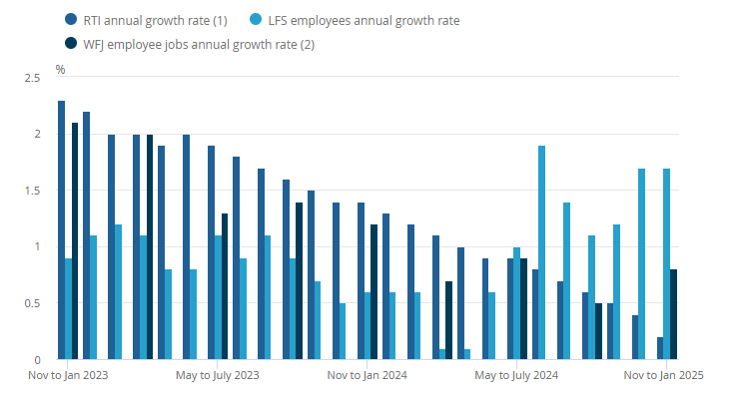

Figure 3: “Annual growth rates for employee jobs and payrolled employees”
(Source: ONS, 2025)
Both demographic and geopolitical forces face challenges to retain a large and skilled labour force to satisfy demand and adjust the employment markets to the global changes, including migration, trade policy, and geopolitical risk. To the HR professionals and organisations in the UK, these forces need to be understood in order to plan the workforce, acquire and develop resilience in the workforce in the face of both ageing populations and world uncertainty.

2.2 Implications and Challenges for Human Resource Professionals
HR professionals are faced with tough challenges through demographic and geopolitical changes. The senior workforce is putting the succession planning and knowledge transfer bar higher. The older experienced employees may require some flexible work schedules or retraining to align with technological changes (George, 2023). In the meantime, younger workers demand career development, the balance between the work and the life, and the important work. The HR managers must create a balance between all these demands to bring about motivation and retention. The other reason is the post-Brexit migration change that has limited access to foreign talent. The HR departments are forced to compete internationally to hire qualified personnel, and in most cases, in an industry with a permanent shortage of employees (Pucik et al. 2024). In this kind of situation, improved employer branding and improved talent pipelines are needed.
Another influence of geopolitical instability is on workforce stability. It might be unstable due to the intervention of trade tensions or conflicts, which affect employee confidence and productivity (LeNoble et al. 2023). HR professionals should be able to address these risks by using effective communication, engagement, and change management solutions. Moreover, there are new leadership and performance management requirements in hybrid and remote work models. In dispersed teams, HR should guarantee equal treatment, online inclusion, and employee welfare. There are also increasing ethical issues because global HR activities need to adhere to diverse labour regulations and data security requirements (Valecha, 2022). In general, HR professionals must be highly adaptable, culturally conscious, and futuristic.

3. Different ways of addressing Skills Gaps and Talent Shortages through Strategic HRM
Strategic Workforce Planning
Organisations are required to strategise their workforce requirements. Strategic workforce planning assists in determining future positions and skills, and determining them before they become short (Sparkman, 2025). Healthcare, technology, and hospitality are also growing areas in the UK that are experiencing gaps with automation and demographic change. The NHS Long Term Workforce Plan (2023) will focus on broadening domestic training to lessen the dependency on overseas workers (NHS England, 2023). The application of analytics and AI tools in technology allows for predicting future skills requirements at the company level.
Continuous Learning and Reskilling
Continuous learning is critical to overcome the actual skill gaps. About the skill programmes, employers can collaborate with colleges, universities and training bodies to come up with joint skill programmes (Thornhill-Miller et al. 2023). The digitised and technical fields of learning offered by the UK Government through Skills Bootcamp and apprenticeships are targeted and flexible. Short customer experience and digital systems reskilling courses in the hospitality sector enhance service quality and minimise turnover.
Employer Branding and Employee Value
Good employer branding is necessary to attract talented employees. Professionals demand significant work, sufficient salary, and promotion. HR teams have to make work environments inclusive and engaging so that they attract different talent groups (Coleman, Dossett and Dimick, 2021). Retention is promoted through flexible work arrangements as well as accommodating cultures. This decreases burnout and enhances motivation in areas like healthcare.
Technology and Collaboration in HRM
The recruitment and learning systems based on AI facilitate HR operations and improve their speed and accuracy. Online tools may distinguish the transferable skills and monitor the growth of the employee (Mikołajczyk, 2022). Partnership with government and industry councils assists organisations in distributing the training resources and matching the skills with the labour requirements of the region.
Inclusive and Sustainable HR Strategies
The sustainable HRM is concerned with workforce expansion in the long term. Diversity increases the talent pool and spurs innovation. Inclusive recruitment is also associated with enhanced innovation and social responsibility in teams (Coleman, Dossett and Dimick, 2021). A moderate balance between technology and human development is what can keep organisations afloat in a competitive market.

4. Reflective Report
The reflective report employs the Reflective Cycle proposed by Gibbs (1988) to comment on the capabilities that I have when working in an international environment. It discusses technology, communication, teamwork, leadership and self-directed learning and assesses my current strengths and weaknesses, and gives me strategies, which are aimed at enhancing my work in a global technology-based environment.
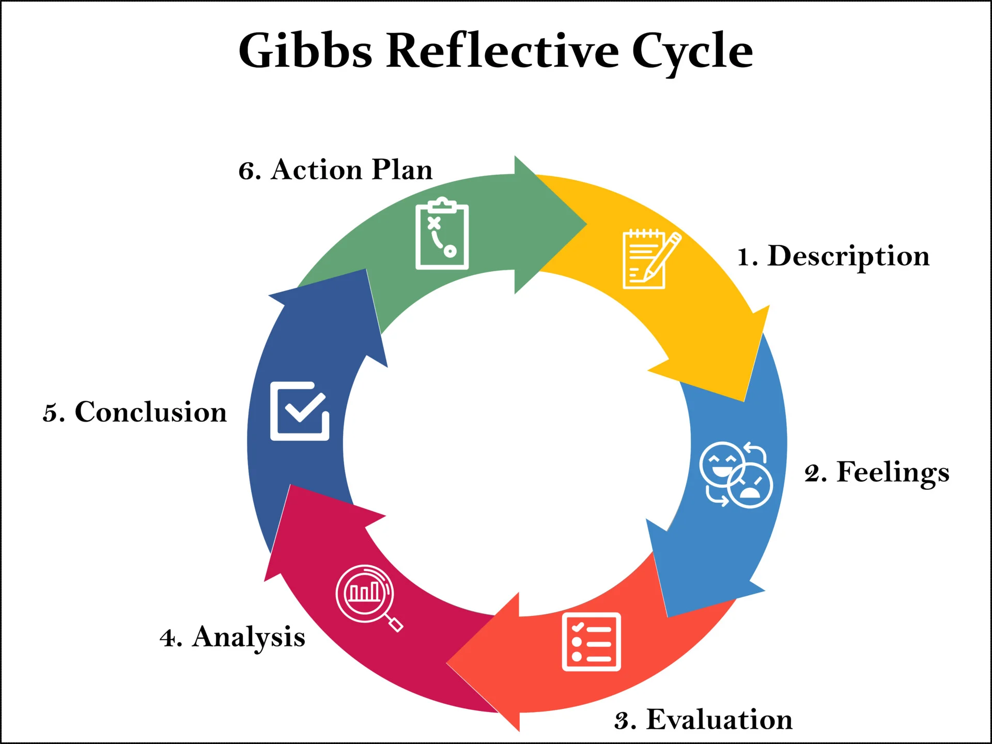

Figure 4: Gibbs Reflective Model
(Source: McLeod, 2025)
Description
A group project is an international student project that I was conducting during this semester. In this assignment, I had to make a business proposal using the assistance of digital collaboration tools. I had to organize the meetings, dissemination of research, and make the final presentation meet the submission criteria. The work with the international colleagues exposed me to other communication styles and work habits. I experienced the existence of cultural imbalance in decision-making and feedback. In some cases, it was hard to organise meetings in different time zones. But collaboration was facilitated by the use of digital platforms. We were also asked to report our findings using online presentation software as part of the project, and this enhanced my confidence in using technological aspects.
Feelings
I was excited and nervous at the onset of the project. I was glad to work with people from other countries, and I was worried about the communication issues. I also was not comfortable with using certain of the new digital tools. My confidence was gradually increasing as the project went on. I started to like listening to the opinions of others and being adjusted to the different working styles. On other occasions, I was frustrated because team members did not understand the instructions given or their slowness in responding due to time differences. Nevertheless, I realised that these obstacles were involved in global collaboration. I was proud when I managed to organise the work and help others with the help of technology.
Evaluation
When I reflect on my experience, I may conclude that there were both opportunities and challenges in working in an international team. Teamwork in a multicultural team made me realise that there are other cultural orientations and communication norms (Bahrami et al. 2023). Another thing it taught me is the need to be patient, flexible and respectful to the ideas of others when collaborating in a team.
Strengths
In my view, there are some areas where my performance worked effectively during the project. I kept in touch with my team members and made them aware of their duties. I coordinated and employed computer aids well to monitor the advancement. I was encouraging open communication, and it assisted in establishing trust in the group. My perception of new ideas improved the team collaboration.
Weakness
Time zone differences and the ability to arrange the meetings in an efficient way were certain issues. I was not that good when it came to making decisive leadership decisions. I even dared not to provide feedback to the higher or assertive individuals in the team. I also understood that my issues are that I am not assertive, manage time, and I am familiar with cross-cultural communication.
Analysis
In the reflective cycle created by Gibbs (1988), I realised that the key to successful teamwork within an international context is cultural awareness and flexibility. Cultural diversity enhances creativity and can lead to misunderstandings (Agbai, Agbai, and Oko-Jaja, 2024). Trust is necessary and is achieved by open communication and empathy. I also learned how to collaborate digitally with such tools as Microsoft Teams or Slack, but it is possible to remember that over-reliance may lead to time losses. Flexibility in leadership was also instrumental since transformational leaders inspire others (Deng et al. 2023). I found out that my participative style encourages inclusion and restricts decisiveness during conflict. Intercultural communication was also about clarity and tone sensitivity (Balakrishnan, 2022). I understood that it is essential to be to the point and pay attention to non-verbal communication. Lastly, online skill improvement enhanced my flexibility because of self-directed learning. Generally, this experience taught me that emotional intelligence, cultural competence, and lifelong learning are the key to achieving international competence in terms of balancing technology, leadership, and interpersonal cooperation in global professional practice.
Conclusion
This reflection enabled me to understand my skills in collaborating and communicating in the world. I have identified my strengths and they are teamwork, flexibility, and effective online communication. The areas which I need to work on are my leadership confidence, time management and cross-cultural sensitivity. It was an experience that working in the global environment requires emotional intelligence, patience, and lifelong learning. The model of Gibbs (1988) prompted me to critically evaluate what I am doing and the impact that it has on other people. Now I realize that to become successful in international settings, technical skills are not the only measure needed but also interpersonal skills and understanding of one, to enable an individual to evolve professionally.
Action Plan
Area for Improvement | Specific Actions | Resources | Timeline | Expected Outcome
Leadership Confidence | Participate in leadership training courses and lead in small group activities. | Leadership programs (University, LinkedIn Learning, Coursera). | 3-6 months | Developed decision-making and the ability to lead different teams.
Time Management | Planning and monitoring tasks with the help of project management tools (Trello, Asana). Set clear weekly goals. | The digital tools and mentors. | 2-3 months | Improved prioritisation of tasks and completion of projects in time.
Cross-Cultural Communication | Participate in training on intercultural communication and interact with colleagues with different backgrounds. | University intercultural training, web-based. | 4-6 months | Improved cultural awareness and communicative efficacy within the international teams.
Feedback and Assertiveness | The aspects of providing and receiving feedback in academic or work-related situations. Participate in discussions in groups. | Peer feedback, communication, or HR courses. | Continuous | More assertiveness and confidence when voicing an opinion respectfully.
Continuous Learning | Achieve self-learning objectives and take one new professional course per term. | Internet-based instruction, instructor support. | Ongoing | Better self-directed learning and current professional knowledge.

Table 1: Action Plan
(Source: Self-Developed)

References
Agbai, E., Agbai, E. and Oko-Jaja, E.S. (2024, March) ‘Bridging culture, nurturing diversity: Cultural exchange and its impact on global understanding.’ In International Dialogue Of Civilization And Tolerance Conference-Abu Dhabi 2024. https://www.academia.edu/download/112831532/Bridging_Culture_Article.pdf
Bahrami, P., Kim, Y., Jaiswal, A., Patel, D., Aggrawal, S. and Magana, A.J. (2023) ‘Information technology undergraduate students’ intercultural value orientations and their beliefs about the influence of such orientations on teamwork interactions.’ Trends in Higher Education, 2(2), pp.270-282. https://doi.org/10.3390/higheredu2020014
Balakrishnan, K. (2022) ‘Influence of cultural dimensions on intercultural communication styles: Ethnicity in a moderating role.’ Journal of Communication, Language and Culture, 2(1), pp.46-62. https://www.researchgate.net/profile/Kavitha-Balakrishnan-3/publication/358751751_Influence_of_Cultural_Dimensions_on_Intercultural_Communication_Styles_Ethnicity_in_a_Moderating_Role/links/63d84bfd62d2a24f92decbf8/Influence-of-Cultural-Dimensions-on-Intercultural-Communication-Styles-Ethnicity-in-a-Moderating-Role.pdf
Bloomberg (2024) UK Stands to Lose 8 Million Jobs From AI, Analysis Warns. Available at: https://www.livemint.com/news/uk-stands-to-lose-8-million-jobs-from-ai-analysis-warns-11711499430923.html. (Accessed 1 November 2025)
Caligiuri, P., De Cieri, H., Minbaeva, D., Verbeke, A. and Zimmermann, A. (2022) ‘International HRM insights for navigating the COVID-19 pandemic: Implications for future research and practice.’ In Crises and disruptions in international business: How multinational enterprises respond to crises (pp. 417-454). Cham: Springer International Publishing. https://link.springer.com/chapter/10.1007/978-3-030-80383-4_17
CIPD (2024) Resourcing and talent planning report 2024. Available at: https://www.cipd.org/globalassets/media/knowledge/knowledge-hub/reports/2024-pdfs/8662-resource-and-talent-planning-2024-report-web.pdf. (Accessed 1 November 2025)
Coleman, D.M., Dossett, L.A. and Dimick, J.B. (2021) ‘Building high performing teams: opportunities and challenges of inclusive recruitment practices.’ Journal of Vascular Surgery, 74(2), pp.86S-92S. https://doi.org/10.1016/j.jvs.2021.03.054
Deng, C., Gulseren, D., Isola, C., Grocutt, K. and Turner, N. (2023) ‘Transformational leadership effectiveness: an evidence-based primer.’ Human Resource Development International, 26(5), pp.627-641. https://doi.org/10.1080/13678868.2022.2135938
Dimension Market Research (2024) Generative AI in Job Market Size, Share, Trends and Forecast 2033. Available at: https://dimensionmarketresearch.com/report/generative-ai-in-job-market/. (Accessed 1 November 2025)
EU Business News (2025) How Digital HR Tools Are Revolutionising Workplaces - EU Business News. Available at: https://www.eubusinessnews.com/how-digital-hr-tools-are-revolutionising-workplaces/. (Accessed 1 November 2025)
George, A.S. (2023) ‘The ephemeral career: How technological change necessitates flexible employment.’ Partners Universal International Innovation Journal, 1(5), pp.47-62. http://www.puiij.com/index.php/research/article/view/100
Government of the UK (2023) Skills for jobs: implementing a new further education funding and accountability system Government consultation response. Available at: https://assets.publishing.service.gov.uk/media/64ad5092b3377f000f2c23bb/Skills_for_jobs_implementing_a_new_further_education_funding_and_accountability_system.pdf. (Accessed 1 November 2025)
House of Commons (2023). Potential impact of artificial intelligence on the labour market. Available at: https://researchbriefings.files.parliament.uk/documents/CDP-2023-0090/CDP-2023-0090.pdf. (Accessed 1 November 2025)
IPPR (2024) Up to 8 million UK jobs at risk from AI unless government acts, finds IPPR. Available at: https://www.ippr.org/media-office/up-to-8-million-uk-jobs-at-risk-from-ai-unless-government-acts-finds-ippr. (Accessed 1 November 2025)
LeNoble, C., Naranjo, A., Shoss, M. and Horan, K. (2023) ‘Navigating a context of severe uncertainty: The effect of industry unsafety signals on employee well-being during the COVID-19 crisis.’ Occupational Health Science, 7(4), pp.707-743. https://link.springer.com/article/10.1007/s41542-023-00155-x
McLeod, S. (2025) Gibbs Reflective Cycle. Available at: https://www.simplypsychology.org/gibbs-reflective-cycle.html. (Accessed 1 November 2025)
Mikołajczyk, K. (2022) ‘Changes in the approach to employee development in organisations as a result of the COVID-19 pandemic.’ European Journal of Training and Development, 46(5-6), pp.544-562. https://doi.org/10.1108/EJTD-12-2020-0171
NHS England (2023) NHS Long Term Workforce Plan. [online] www.england.nhs.uk. Available at: https://www.england.nhs.uk/publication/nhs-long-term-workforce-plan/. (Accessed 1 November 2025)
ONS (2025) Labour market overview, UK. Available at: https://www.ons.gov.uk/employmentandlabourmarket/peopleinwork/employmentandemployeetypes/bulletins/uklabourmarket/march2025. (Accessed 1 November 2025)
Pareekh, S. (2025) Human Resource management in the global era. Academic Guru Publishing House.
Pucik, V., Evans, P., Bjorkman, I. and Morris, S. (2024) The global challenge: International human resource management. Sage Publications.
Sparkman, R. (2025) Strategic workforce planning: Developing optimized talent strategies for future growth. Kogan Page Publishers.
Thornhill-Miller, B., Camarda, A., Mercier, M., Burkhardt, J.M., Morisseau, T., Bourgeois-Bougrine, S., Vinchon, F., El Hayek, S., Augereau-Landais, M., Mourey, F. and Feybesse, C. (2023) ‘Creativity, critical thinking, communication, and collaboration: Assessment, certification, and promotion of 21st century skills for the future of work and education.’ Journal of Intelligence, 11(3), p.54. https://doi.org/10.3390/jintelligence11030054
UK Parliament (2023) Post-pandemic economic growth: UK labour markets - Business, Energy and Industrial Strategy Committee. Available at: https://publications.parliament.uk/pa/cm5803/cmselect/cmbeis/306/report.html (Accessed 1 November 2025)
Valecha, N. (2022) ‘A study on importance of ethical responsibilities in HR management.’ International Journal for Global Academic & Scientific Research, 1(1), pp.13-22. https://pdfs.semanticscholar.org/af71/7d384f47559402190896fdf2e0ecbf42d2c4.pdf
von Moltke, N. and Verlinden, N. (2024) HR Digital Transformation: An HR Leader’s Guide. Available at: https://www.aihr.com/blog/hr-digital-transformation/. (Accessed 1 November 2025)

