I began my project by researching into the meaning of the word sublime, which I learnt was the feeling of beauty and excellence. I considered what kind of work would make me experience these feelings and the connective theme that could related them all. I knew I had to find Five pieces of work that were either from film and television, video games, photography or any type of art. I finally began researching into thematic part of my project, which was going be the feelings that these pieces of work conveyed and would connect these artworks together. The examples of art that I looked at to begin with conveyed feelings of loneliness and isolation, which became my original inspiration for project. Out of curiosity, I decided to research the antonyms of these feelings, this was the initial step that led me to deciding on what would become my final idea, society. I personally feel this topic and theme is important to discuss in today’s climate because of the negativity in world news and the media in general. Another reason I think that society is important to discuss is because of the impact and effect that isolation has on people today like loneliness, depression and sometimes even self-harm or worse, all of which seem to be happening more often today. “We don’t function well as human beings when we’re in isolation” Robert Zemeckis. The work that I have decided to showcase in my exhibit is pulled from different parts of media, I’ve included a video game, concept art or a lithograph, a film and a TV show and a photograph from an album cover, I believe that the theme connects all five pieces of work.

At first, I struggled to decide on the title of my exhibit because my theme was so broad, I can only describe the theme and not name it. As I mentioned earlier my initial theme and connective idea was the feeling of isolation and loneliness, but I had decided to flip that on its head and look at the opposite of isolation instead, for a while that was the only way of thinking about the thing that I had. Even after choosing the five pieces of artwork I couldn’t think of a title for my exhibit, I considered naming it the opposite of isolation, yet it sounded too broad again. I finally decided on the theme and title of society, as it encapsulates for me the feeling of being part of something bigger, which is the feeling I was trying to put across with my five pieces of work. A society is usually thought to be a group of people who live or work in the same area or society is thought to be a large community of people, this is a perfect description of what I want my theme to be, and it connects all my artworks perfectly. As Immanuel Kant said in his book Critique of Pure Reason “Whereas the beautiful is limited, the sublime is limitless, so that the mind in the presence of the sublime, attempting to imagine what it cannot, has pain in the failure but pleasure in contemplating the immensity of the attempt”

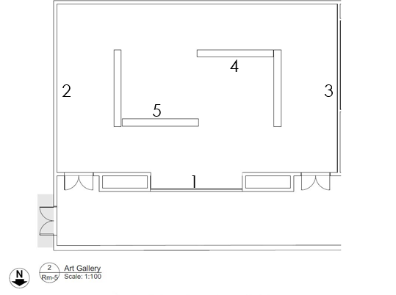
Before deciding on the title of my theme but after I decided on my idea, I began looking into the five pieces of artwork that I need to choose for my exhibit. To begin with I found this difficult because I couldn’t find pieces of work that connected to my theme and that I found interesting, but after looking at some different forms of art, I decided on the type of work that I would like to have in my exhibit. The forms of work that I decided in the end were a lithograph, a shot from a video game, a shot from a film, a shot from a television series and cover art from an album. All the pieces of art are from different media and the artists or directors behind the work are from different backgrounds as well. Although all these pieces of work were created for different media, I find it interesting that they all connect to the theme and were created at roughly the same time being 2015-2018. As I mentioned earlier I believe that the feelings of isolation and loneliness are becoming more common today, this seems to work while the world is shown to be getting bigger whether that be in the media or in real life.

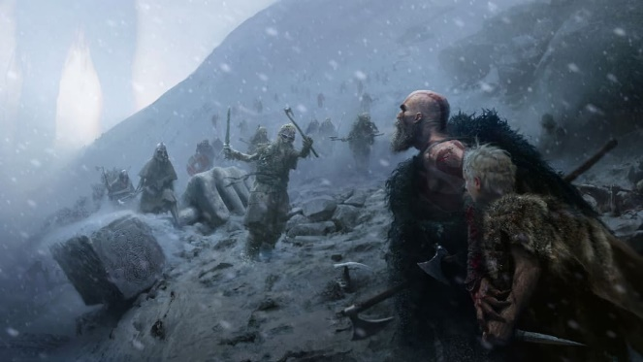
The lithograph I chose to show in my exhibit is concept art for God of War (2018), which is a video game that follows the story of God and his son travelling through Norse mythology on a deeply personal mission. The game is extremely cinematic and expansive and was all inspired by this original concept art. The lithograph was created by Jose Cabrera and Cory Barlog as an initial concept or vision for what game would eventually look like. Cory Barlog who is the creative director of the game, has said that this lithograph was the first image created early in development in 2015 for the game and that it encapsulates the core of what the game should be.

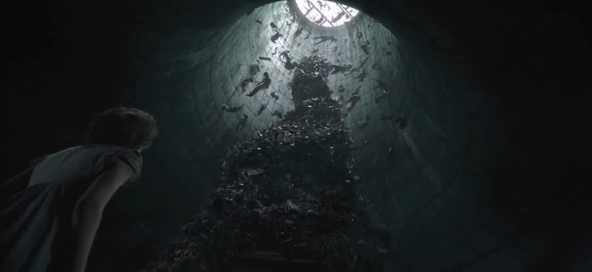
I’ve chosen a shot from it (2017) which is a film directed by Andrés Muschietti that follows a group of children that are trying to rid their town of a shape shifting killer clown. The shot I have chosen is one from near end of the film, where one of the children is captured and taken to the clown’s lair. Although we see a few children fall victim to the clown throughout the film, this is the shot that shows the audience and the characters how many more children the clown had taken.
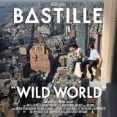
The third piece of artwork that I have chosen for my exhibit, is the album cover art for Bastille’s ‘Wild World’ (2016). The picture used for the cover art shows two boys sitting on the side of a skyscraper in New York City and has been said not to be photoshopped, it is in fact a picture taken by one of the members of the band. Most of the songs on the album are connected to the title of the album and the picture used as the cover art, and I feel that these link to my theme as they discuss population and community.
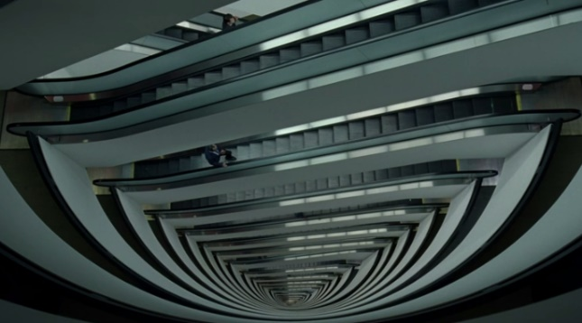
I have also chosen a shot from the Television series Westworld (2016) which is directed and created by Jonathan Nolan and is based on the 1973 film of the same name and follows the creation of a theme park based around the Wild West. The shot I’ve chosen is one that is reused throughout the series and is normally very quick, but I find it very effective as it shows the amount of people that work at the park unconventionally, by doing this without showing the people themselves.

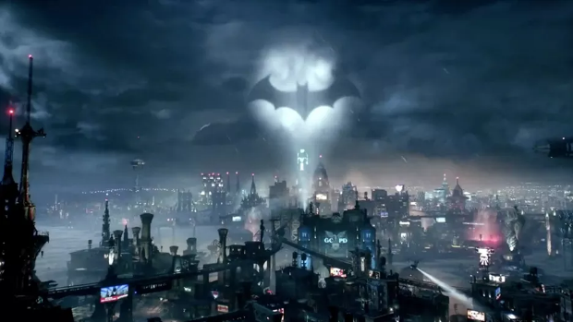
The final piece of work that I’ve chosen for the exhibit is from another video game being Batman Arkham knight (2015) that follows Batman trying to protect his city from a group of his enemies in one night. I’ve chosen a shot from the beginning of the game which pans across the city, the reason I chose this shot is because it shows Batman standing on top of a building in the background, but he is so small that you don’t realise that he is there until the shot fully zooms in on him. The shot was created by Ian Ball and David Hego to show the audience that Batman is just like everyone else in the city.

Bibliography
Zemeckis, R. (2014) Accessed at:
https://www.brainyquote.com/quotes/robert_zemeckis_441648?src=t_isolation

Kant, I. (1781) Accessed at:
https://www.goodreads.com/quotes/tag/sublime

