Student name: | Sharif Fathi | Student ID number: | 1701105
Programme: | Games / Software Engineering
Module: | Advanced Software Development
Module code: | ACCA5011 | Contribution to Overall Module Assessment (%): | 50%
Lecturer: | Andrew Baker | Internal Verifier:
Assignment Title: | File loader | Word count (or equivalent): | 2000 equiv
Submission deadline: | 13th January 2020 | Return date of provisional marks & written feedback: | 10th February 2020

‘Introduction’ section:
Is required to build my own graphics file loader to load 3D object file into a computer graphics application. The variables for the object file should be dynamically allocated, in order to store each object during reading file, and then deallocate the memory before the software stops running.

The software should load objects into mesh class that stores the data from the file and the mesh class should contains functions that hold the following 3D object data.

- vertices
- faces
- texture coordinates
- edges

The mesh class should have child class(cTransform) that inherits from parent class (cMesh) using the following:

- Position
- Scale
- Rotation

Breakdown of the memory
Reading ahead and scanning the entire file, allowed the software to count the data that is in the file and used that count variables to dynamically allocate to store all memory needed.

here is code that counts how many lines of vertices that is in the obj file and that (numOflinesV) it keeps add 1 each time it finds new line of data.
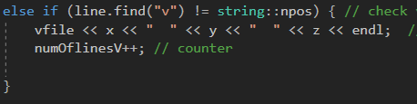

here is the function that takes the counter and the (numOflinesV) it depends on how many vertices that is in the obj file which can increase and decrease the array size.
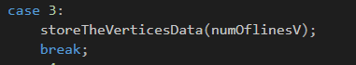

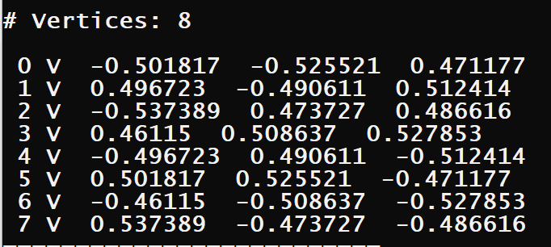

The software creates txt files to send a specific data to files so that software can open those files and dynamically store them into arrays.
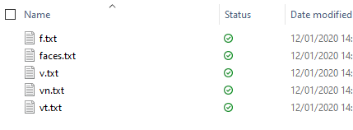

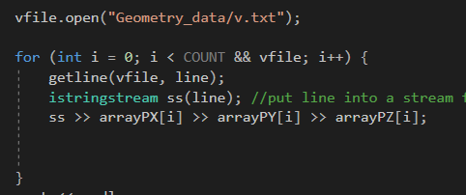

Menu design:

The software has simple menu that allows the user to see the 3D geometric data and is easy to use because the user must input their choice and it will run show the data.

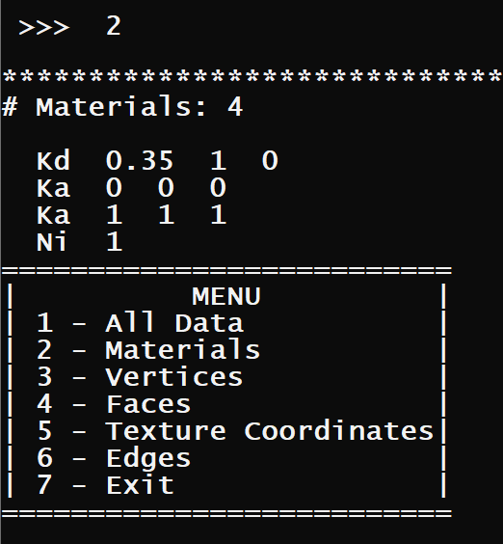

USER INPUT IS 2

DATA USER REQUESTED

Software User Guide:
1: Must downlead visual studio 2017.
2: Open the project folder on visual studio.
3: If you want to run different obj file, you need to change the input of this variables. bellow there is a screen shot.
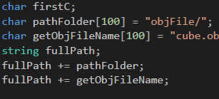
your file name goes here.

4: You need to run the software by clicking (local windows debugger).


