Cavallaro Germano Martino

Student ID : 2111129

Effective team working and communication

University of Trinity Wales Saint David

Module code: BMSW4002

Lecturer : Soban Sadiq

Word count: 2200 words
Table of Contents
Word count: 2200 words 1
Section 1: Introduction 3
Section 3: Three models of communication 4
Section 4: Schramm’s model 6
Section 5: Berlo’s model 7
Section 6: The advantages and disadvantages of communication theory 8
Section 7: Conclusion 9

Section 1: Introduction
The Communication is essential in human life. It facilitates the interchange of information and knowledge, as well as the development of relationships with others. As a result, the value of communication skills in our daily lives cannot be overstated, therefore the importance of the communication is fondamental in order to maintain our life and work well balanced and organised, but most of the times we face barriers that can lead the receiver to a wrong understanding, a simple example of barriers could be a different language, noise or sender using a wrong channel. The consequences of the receiver receiving a wrong information could create many problems on the individuals or in a team, it can affect productivity, create tensions, frustration or if not taking wrong decisions.
The communication is the conveyance of information from a sender to a recipient with the goal of reaching a common understanding. Information must be transferred from one sender to one or more receivers. The procedure can be completed through speaking, reading, listening, or writing. So, communication skills are critical since they allow people to convey information while also understanding one another.

What are the different types of communication and skills?
Communication can be breakdown into 4 different categories:
- Verbal communication, this belongs to the speaking to a group of people or an individual
- Non-verbal communication, body language for example
- Written communications such as email’s, text message or now adays very common to everyone like what’s app.
- Visual communication, this comes down to pictures, photo, maps or graphics.
Communication falls into four different types. These are: verbal communication as in speaking to a person a group of people; non-verbal communication such as body language and proxemics; written communication like emails, letters and postcards and visual communication that includes maps, reports, graphics etc..
Verbal communication
Verbal communication is the use of words and language to convey a message. Verbal communication includes discussions, speeches, and phone calls. Verbal communication is an alternative to nonverbal communication, which uses text, symbols, or body language to convey messages.
Verbal communication is a soft skill that distinguishes leaders. This is one of the reasons why effective verbal communication is valued so highly in business and the workplace.
In the case of study of “A day with the Chief” we can observe the initial tension of Mark prior the arrival at the California’s office, still after been meet Mrs. Brown he was quite nervous and feeling awkward, once the Chief made himself feeling comfortable but Mike has taken this as an opportunity to be heard from the Boss saying how potentially the office in London should be run, we can still see here a verbal communication and also active listening from the Chief really keen on hearing all what he has to say but then letting him leave immediately breaking the conversation up, that’s when the verbal communication has stopped.

Non-Verbal communication
Nonverbal communication is the practise of conveying message without using words. To put it simply, nonverbal communication is any form of communication between two or more people that uses facial expressions, hand movements and other nonverbal signals.
In the case study we can observe many parts where non-verbal communication has taken, in the first part we can see Mark arriving at the California’s office very nervous and scared, his mouth was dry and still after he shacked the hand. In the second part of the story, we can identify non-verbal communication during Mike’s talking and start to relax loosing his tie, corssing his legs and feeling very comfortable, but in the conclusive part of the story in the other side we have the CEO having a very rude reaction making him leave instantly.
Written communication
The most prevalent and effective way to communicate especially in a team or business related is the written communication, it is defined as any sort of message conveyed via the use of written words. As mentioned above this communication involves emails, text massages, reports, manuals, letters, telegrams etc...
Visual Communication
Visual communication is a fundamental notion in which two or more people can successfully convey their thoughts, messages, and ideas. Through the use of visual components, the emphasis is on delivering valuable information and material with the viewer. A few examples of visual communication could be organization chart, flow diagrams, maps, animation etc...

Section 3: Three models of communication
Shannon Weaver model
The Shannon Weaver Model of communication, widely known as the "mother of all models," was developed in 1949 by Claude E. Shannon and Warren Weaver. It is a transmission model made up of five components: an information source that generates a message; a transmitter that encodes the message into signals; a channel over which the signals are sent; a receiver that decodes (reconstructs) the message from the signal; and a destination where the message arrives. Noise, the sixth element, is a dysfunctional factor: any interruption with the message travelling down the channel.
- The individual who develops the messages (Sender) and determines which channel to broadcast them from is known as the information source.
- Transmitter (Encoder) the sender use a system to convert massages into binary data or signals.
- Receiver (Decoder) this role has played by the person or system that translate the signals or binary data to messages
- The message's destination (Receiver) can be either an individual or a location. Depending on the message, the recipient provides feedback.
- Noise is the natural disruption caused by individuals and circumstances that prevents the message from reaching the intended recipient precisely.
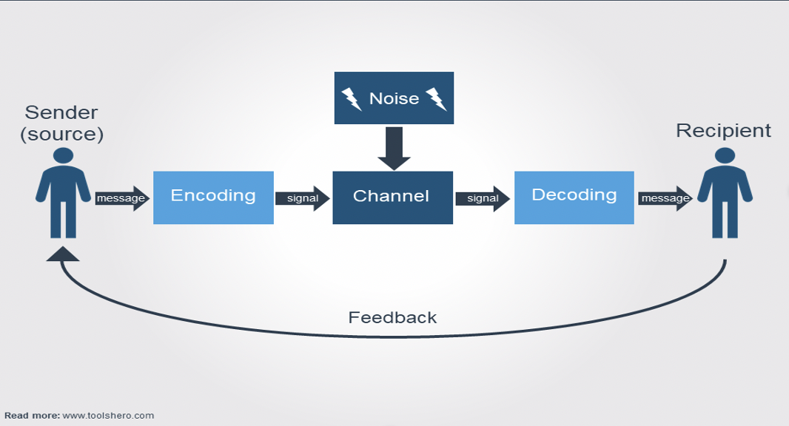
In the example of Maria and Pedro story, it’s very clear that the messages have not been delivered correctly because of the noise at the building site, also the receiver has not pay too much attention to the message as he was working at the building site.
The noise at the building site didn’t let the message comes through perfectly and the receiver didn’t give any feedback to the sender, one thing that could have avoided the confusion would have been the feedback, if the receiver was confirming what has been understood the issue would have been avoided.
For this reason, I don’t think the Shannon Weaver model applies to this story, as there are no feedback from the receiver which would have solved the problem.
Experience in the workplace
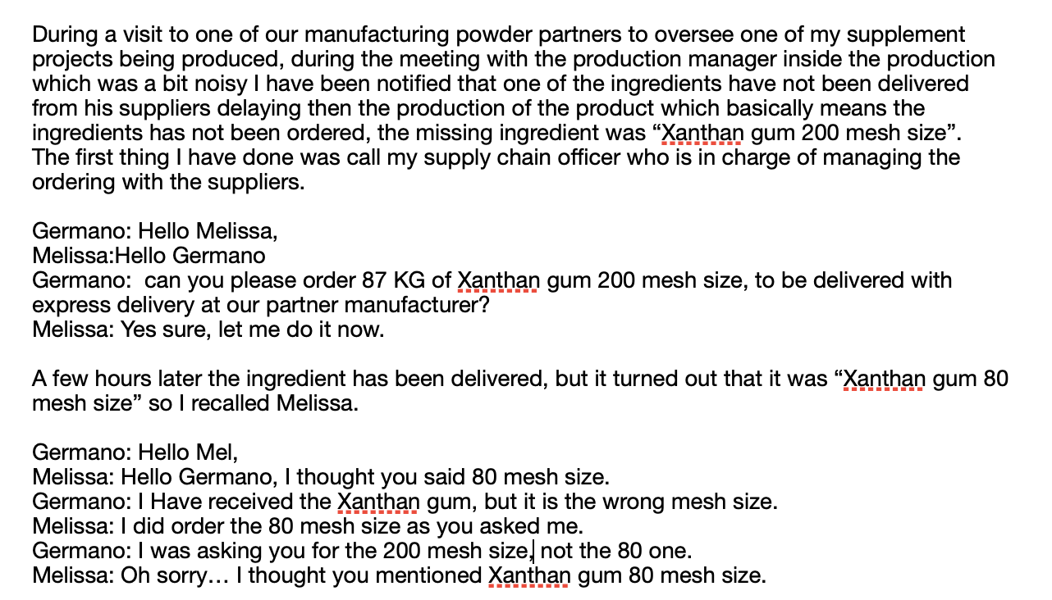
This example reflects exactly the same scenario as Pedro and Maria, the manufacturing site is especially in production with the noise of machinery it didn’t let the message send by me to Melissa correctly, the noise has interfered upon arrival of the message to Melissa, Melissa has also not giving feedback to me to confirm the message passed was acknowledged correctly.

Section 4: Schramm’s model

Wilber Schramm introduced his communication model, Schramm's Model, in 1954, with the influence of Shannon and weaver itself. Encoding is important because it starts the communication cycle by converting thoughts into messages. When a message arrives, the recipient instantly tries to decipher it. Thus, encoding and decoding are crucial for good communication because information cannot be shared without them. According to Schramm, a two-way system requires feedback from the receiver to be complete.
Schramm's model says that in order to have a good conversation, you need to think about your knowledge, experience, and cultural background. People from different religions and backgrounds are more likely to understand things in different ways, so this it is important.
The difference between Schramm and Shannon Waever model is :
- No noise in the channel
- Feedback are shared from both sides
With the addition of these 2 the Schramm’s model makes the communication much easier and efficient between the sender and receiver, the receiver acknowledge the message and then provide feedback’s each other which in the Shannon model is not happening.

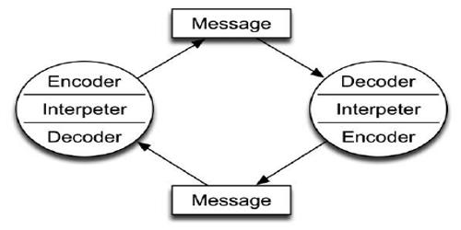

In the case study of Maria and Pedro this communication model does not apply as we don’t have a noise or disruption and both sender and receiver once decode and encode the message they provide feedback to the other, which absolutely can avoid the confusion between Maria and Pedro.

Section 5: Berlo’s model

David Berlo developed a new communication model known as the Berlo's SMCR Model of Communication. This model was influenced by Shannon and Weaver's 1949 model once more. Berlo identified characteristics in communication that positively enhance people's ability to communicate more successfully, to highlight on this model the encodes and decodes play an important role.

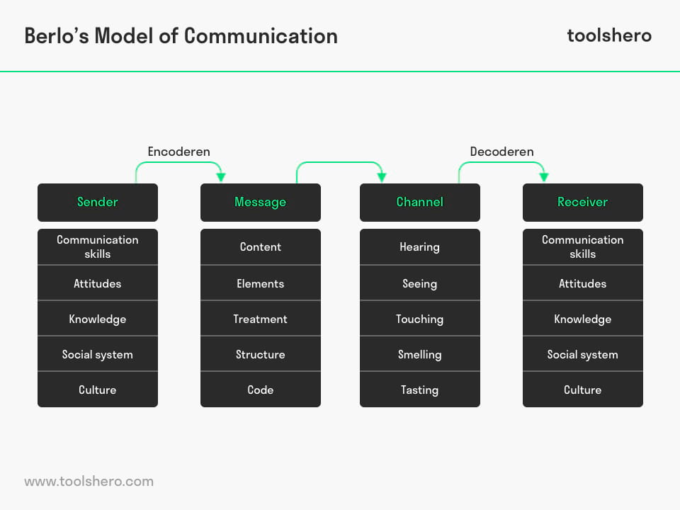

- The sender is responsible for sending the message to the recipient. The sender's communication skill may be altered by their communication skill. Sender attitude influences message, as well as social systems and culture. Their views, religion, values, and cultural background can impact the message.
- The message is the information sent to the receiver by the sender. Speech, image, text, etc. The message is influenced by its content, non-verbal signals, treatment, how it is presented, structure, how it is structured, and coding, how it is sent, such as video or email.
- The Channel is the message delivery technique. Telephones, mail, internet, etc. However, human senses influence the efficiency of communication channels. Hearing, seeing, smelling, tasting, and touching.
- The receiver is the person or place receiving the message. According to Berlo's concept, mutual understanding requires that the receiver's thinking process match the sender's. Otherwise, the message may not have the intended meaning. Communication skills, attitudes, information, social systems, and cultures should all be on the same level as the sender.

In conclusion Berlo’s Model of communication developed by David Berlo is a linear model of communication; as a result, feedback is absent from the model. It is one of the most important communication models because it describes the communication process through a number of different aspects, including the Sender, the Message, the Channel, and the Receiver.

In the Case study of “The professor and the village people” I can identify right away the attitude of the professor feeling superior to the village people because of his instruction level as he is an English professor of a renowned University, creating also the barrier with the village and the people as he never visited before.
The social class of the professor being, and the education doesn’t help the relation or connection with the village people which are with much lower education and do just manual works.
When the house went on fire, the professor (Sender) asked for help to the village people (Receiver), the content and the structure of the message due to the use of terminology high skilled has not been decoded by the village people which in this case the social system and the culture are showing their propriety in this part of the story, without helping the professor and letting the flames take over the house for just a misunderstanding.
The sender should have used simpler vocabulary and the receiver would have get the message and come for help surely. The channel was perfectly working but the message has failed after the 3rd stage not being uncoded correctly from the receiver. This explain how Berlo’s model has applied to this story.

Workplace experience

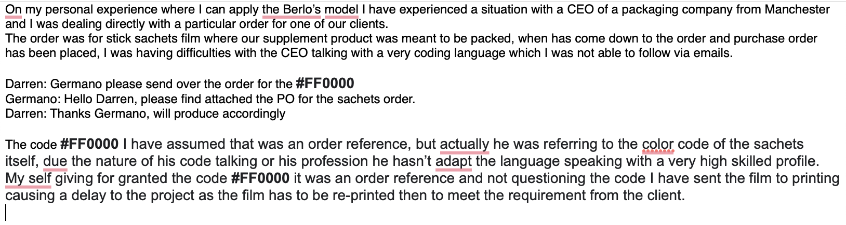

Section 6: The advantages and disadvantages of communication theory

Advantage of communication

There are advantages to communicating. One advantage of communication is that it makes it easier to comprehend what is being said. When one person transfers an idea to another, the second person has an understanding of what was going on in the first person's head. A large number of processes in society are made possible by the exchange of ideas. An additional advantage of effective communication is that it improves efficiency. When someone communicates an idea to another, they are assisting that other in the achievement of a desired result. If employees had to make educated guesses about what their coworkers were thinking, the organisation would not be very successful.

Disadvantage of communication

When there is miscommunication, it is difficult to communicate effectively. It is possible for one individual to wish to communicate an idea to another. However, if the other person does not grasp what you are trying to say, there will be a misunderstanding between you. Many of society's problems are the result of misunderstandings between people. When communication is clear and concise, the likelihood of misunderstandings is minimised to a minimum. Misunderstandings can occur when there are a number of factors at play, such as cultural and socioeconomic influences, which can lead to a misinterpretation of the goal.

Section 7: Conclusion

Effective communication in business and its importance, as well as the function of culture in communication, were the focus of this portfolio, which covered all four categories of communication. Shannon Weaver's theory of communication, Schramm and Berlo's model were also covered in the course.
In overall conclusion we can understand also how the 4 different types of communication and skills we should be approaching based on the situations and circumstances we face in the daily bases at work and in the daily life, the different 4 types of communication should be used appropriately in order to deliver the desired and correct message to a group of people or individual.
The 3 different theory of communication explain quite well how the message can be delivered or miss received based on many different aspects such as sender, message, channel and receiver.

References

- Editors, B., 2022. Verbal Communication - Definition, Development, Types | Business Terms. [online] Business Terms. Available at: <https://businessterms.org/verbal-communication/> [Accessed 3 May 2022].
- Oxford Reference. 2022. Shannon and Weaver's model. [online] Available at: <https://www.oxfordreference.com/view/10.1093/oi/authority.20110803100459436> [Accessed 3 May 2022].
- Qsstudy.com. 2022. Schramm's Model of communication - QS Study. [online] Available at: <https://qsstudy.com/schramms-model-communication/> [Accessed 4 May 2022].
- toolshero. 2022. Berlo's SMCR Model of Communication. [online] Available at: <https://www.toolshero.com/communication-skills/berlos-smcr-model-of-communication/> [Accessed 4 May 2022].

