Lorena M. Mihalcea
2019847

Employability skills in the workplace today
Report

Cover Page

Date: 19.03.2021

Table of Content
Table of Contents
Cover Page 0
Table of Content 1
1.0 Introduction 2
2.0 Main Findings 3
2.1 Workforce Trends and Change Within Employability Skills Requirements 3
2.3 Employability Skills 5
2.3.1 Time Management 5
2.3.2 Digital Competency 6
2.3.3 Resiliency 8
2.3.4 Emotional Intelligence 9
3.0 Conclusion 11
4.0 Recommendations 12
5.0 Reference List 13

1.0 Introduction

This report aims to identify employability skills development within the workplace today.
The researcher main topics are workforce trends at present, employers’ requirements from graduates/employees, how employability skills have developed during the time and, skills adaptations during a global pandemic (Covid-19) – In March 2020 home- based work was a new concept for many individuals. Home being the “new office” was not viewed as a positive movement because employers believed that the work productivity will decrease. (Prodoscore, 2020)
Moreover, the report discusses the negative and positive impact on individuals personal and professional aspects of life during COVID-19.
The report subtopics are reflecting on time management, digital competency, resiliency and emotional intelligence and why are they essential skills today.
“Many of the most highly sought-after skills today are soft skills pertaining to your ability to communicate and work with a team or hard skills focused on technology.” (DOYLE, 2020).
The purpose of this report is to investigate how employability skills have changed and what are the most required skills for a successful career development.

2.0 Main Findings

2.1 Workforce Trends and Change Within Employability Skills Requirements

With the Generation Z (Gen Z) being the newest candidate to the modern workforce there are also changes regarding skills requirements at the workplace from both employees and employers. Generation Z is represented by individuals born from 1997 to early 2010 and they are known to be “digitally native” (Regan, 2020).
Marshall (2016) claims that the rapid technology development during the last 25 years had a massive impact on the way we complete tasks and work now. He claims that while there are positive effects such as agile working, flexible time hours, not having to travel physically for meetings resulting in saving finances, there are also negative aspects such for example: significant decrease in employability due to machines taking over individuals tasks leading to an increased number of tasks and pressure for the employers. (Marshall, 2016)
The covid-19 global pandemic speed up an existing trend in remote work and the usage of e-commerce platforms . (Lund, et al., 2021) Furthermore, has negatively impacted many sectors. Unfortunately, some sectors will still remain affected until everything return back to normal - aviation, tourism, real estate, hospitality, fashion etc. (The New Indian Express, 2021)
Yet, just before COVID-19 crisis, employers were looking into changing the traditional approach with an agile approach. (Smarter With Gartner, 2020) The reason behind this is that remote work is cost effective. (Smarter With Gartner, 2020) An analysis conducted by Granter indicates that even after pandemic organisations will still continue to use remote work to maintain flexibility in labour force management.
(Lewis, 2020) argues that artificial intelligence, driverless cars, robotics, 3D printings, and other technologies are changing the way humans behave and affects relationships making it hard for human to have real social life. Machines such as: self-checkout on markets, mobile banking apps, self-watering systems for plants and others are taking over humans’ jobs .
The govern expressed concern about young people unemployability rate going high because most of the jobs that has been affected by COVID-19 were jobs held by young people. (Kirby, 2020)

2.3 Employability Skills

2.3.1 Time Management

Time management it is a crucial skill that individuals must master to be able to organise/plan events and prioritise tasks efficiently. The COVID-19 pandemic has forced people to work from home therefore, there is an increased excessive number of tasks leading people to avoiding difficult tasks. (Cabral, n.d.)
The most pressured group of people by poor time management are parents as they are obliged to spend more time with their children without having possibility to take a break. During the National Lockdown caused by COVID-19 , a large number of parents have expressed concern about the high level of stress they are experiencing due to home schooling approach – the method consists in online classes and virtual homework that require digital skills. Thw homework must be completed by a deadline and many parents found difficult finding a balance between work and children virtual education. Parents have experienced difficulties making children to focus on their homework’s resulting in a high number of frustrated and upset parents telling their stories on social media. Also, unpaid carers have voiced about how difficult is to access additional care services for the person they care for or even for themselves – resulting in a very difficult and lonely time for both carer and the person in need.
(Department for Education, 2020) argues that the pandemic has been a tough phase and that many individuals are still not comfortable with remote education.
Having so much time at home individuals often choose delaying tasks which is a disruptive behaviour caused by lack of motivation or low self-control (Alblwi, et al., 2019)
During a global pandemic, excellent time management is needed to reduce the stress and procrastination as people are tempted to be less active or interested considering the fact that they spend most of the time home. (Cabral, n.d.)
“The correct use of time is intimately related to the setting of short-term priorities” - Using memory only is not enough to make individuals memorize all the task needed therefore, the usage of tools such as digital calendars, agendas, to-do lists, planners and so, are necessary. (Alvarez , et al., 2019)
(The Skills You Need, n.d.) claims that individuals that are able to make a clear distinction between high importance tasks and low urgency tasks are better at managing time. 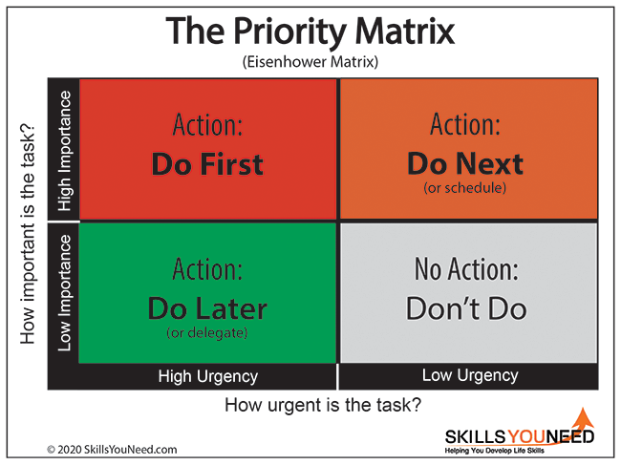
(Eisenhower, (1890-1969))

2.3.2 Digital Competency

According to the UK Department for Education, digitals skills are separated in two categories: basic and advanced. Basic skills are referring to: Digital foundation skills; communicating efficiently; handling information and content safely; transacting; problem-solving and being safe and legal online. Advanced Skills are referring to: digital marketing, social media, user experience (UX), web analytics and artificial intelligence (AI). (Future Learn, 2020)
Due to Covid-19 pandemic there is an increased demand for digital communication skills. Sending e-mails and virtual communication it is essential today. The employees and employers must have a visual and audio connection be able to efficiently communicate (Parikh, 2021).
Individuals that own digital skills are less likely to feel socially isolated as online communication platforms give individuals” a sense of belonging “ and support. (Kapetaniou, 2020) . Social platforms for example: TikTok, Facebook, WhatsApp, Twitter, Instagram and even YouTube, are often use for entertainment or interaction with members of families from a different household as the physical meetings and gathering in large groups presents a high risk of spreading and getting infected with the virus Covid-19.
Individuals from Gen Z are known to be highly effective in using modern technology and digital competency (Finances Online, n.d.)
The use of a software such as: Microsoft Teams, Zoom meetings, sending e-mails as communication instruments or any similar tool it is a “must” to be able to communicate and share documents freely from distance.
In a study conducted by (Sprout Social, 2020) on 2000 customer reviews to see how they are using social media , they discovered that from mid- April 2020 there was an increased activity on social platforms- On Facebook they find that people were more active in weekends. Instagram used to have more activity on middle of the week, specifically Wednesdays and Fridays, recently an increased activity is noticed on Monday, Tuesdays and Fridays
In the study they also identified how brand behaviour has been impacted – the results show little to insignificant change in all industries and networks in terms of their posting activity.
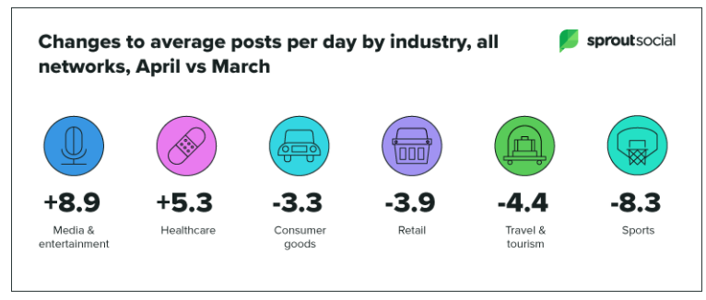
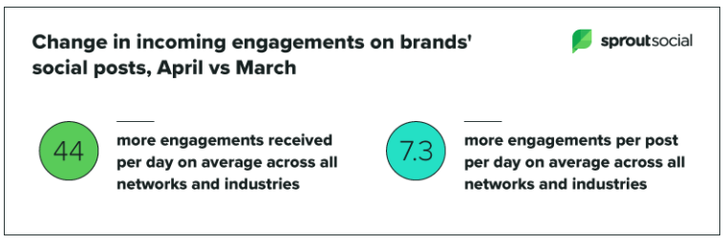

2.3.3 Resiliency

Resiliency describes the ability to overcome challenging situation/ event/ phase. Reflecting on and learning from the experience are highly recommended because it helps us overcome difficult moments faster. Additionally, lacking resiliency skills could lead to an increased amount of stress which has further effects such as: anxiety, depression, and others. (Rees, et al., 2015)
(Cassidy, 2016) considers resilience a benefit for both employers and employees . With the COVID-19 impact on many sectors, parents are obliged to support their children with education from home, work from home, shop online at home as most of the business are closed apart from the businesses that provides essentials items/ services (food market, pharmacy, emergency dentist services, etc), parents experience a high level of stress. ( Mountsinai Health, 2020)
Resiliency skills includes optimism and selflessness. ( Mountsinai Health, 2020) Optimism is the ability to see the positive aspects of an experience- this is important because people need to be optimistic, so they could avoid disappointment keeping individuals motivated. Selflessness refers to the capability share with others, to share, give help, voluntary work and things that we do for other people without expectations – being selfless in such difficult times gives people hope for better.
The lack of leisure and access to entertainment is also playing a huge role in how parents/ individuals manage their wellbeing. Recently, only online entertainment it is accessible which urges individuals to take time to reflect and investigate alternatives options. Online movies and exercising at home has replaced the old activities such as cinema or gym.
Resiliency is a key skill that must be learnt to be effortlessly cope with the stress management and pressure caused by these above factors.

2.3.4 Emotional Intelligence

Emotional intelligence describes the ability to be aware of own and other individuals’ emotions and feelings. Additionally, the ability of an individual to aware of its feeling, identify the emotions/feelings then practice empathy learning from the experience. Furthermore, planning and finding solutions to efficiently manage emotions (Psychology Today, n.d.)

Reflect/ Practice Empathy
Identify emotion/feeling
Awareness
Feel/ Emotion

Emotional Intelligence Skills
Learn
Plan/ Find Solutions

Emotional intelligence also refers to practicing empathy – the ability to understand how other people feel, showing concern and being sensitive towards other persons - to imagine that themselves the place of the other. (MURRAY, 2020)
Dr. Timothy R. Clark claims that COVID-19 was one of the biggest challenges of emotional intelligence within many generations because the demand in emotional skills had increased significantly quite rapid. (Clark, 2020)
Emotional intelligence it is a skill that can be learnt by any individual. However, Dr Clark (2020) claims that learning this skill it is more effective then possessing it naturally because it provides a structured frame which individuals with this skill naturally gifted are not always aware of.
(BBC, 2021) has published a graphic that highlights that only 16% of grownups are showing signs of mild or severe of depressions but for children, depression is getting worse with the number of kids with behavioural issue increasing. (See Graphics below)
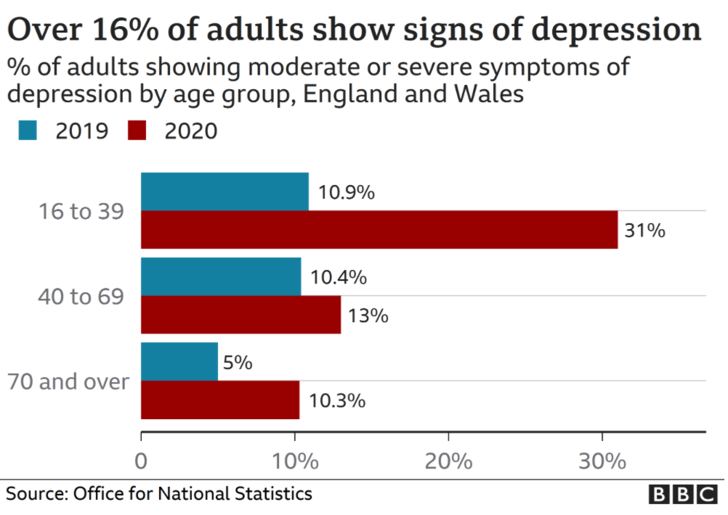

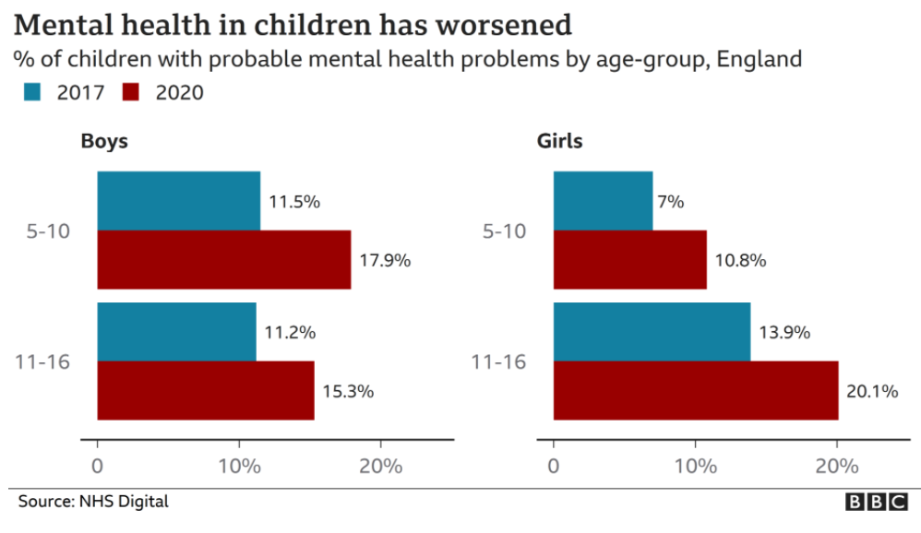
(Heftiba, et al., 2020) argues that many managers have failed to understand the importance of emotional intelligence (EI) - leading them to failure caused by lack of empathy and lack of leadership skills – the arising issue it is a concern for parents and medical professionals.

3.0 Conclusion

The Covid-19 Pandemic had a significant role on how fast society and technology developed and progressed.
A significant number of individuals, corporations, organisations and businesses has been affected by COVID-19 with many individuals considering that COVID-19 had a massive negative impact on their personal and professional aspect of their lives.
The individuals which master skills such as: time management, digital competency, resiliency and emotional intelligence are more likely to overcome the difficulties and challenges encountered during or after pandemic.
Mastering this set of skills will not only help individuals to adapt to the change rapidly but will also give employees/ employers a boost of confidence and a sense of control over their personal and professional lives.
Individuals that refuse to adapt to the change and avoid learning new skills are more likely to be stressed, anxious, and are risking to feel excluded from social groups leading to an unbalanced and unhealthy lifestyle.
Having studied and considered all key areas and the evolution of employability skills above, the researcher assesses that employability skills has drastically changed during the time, especially in the last two years. It would be wisely that individuals are continuously working to develop their employability, focusing on skills with a high demand from the employers.

4.0 Recommendations

Based on the finding and the conclusion presented, the researcher suggests the following recommendations
To efficiently practicing managing time, I suggest (The Study Skills Handbook by Stella Cottrell) which contains diverse activities that helps individuals to identify how are they spending their time and what could be improved. (Cottrell & Macmillan, 2003). The researcher also suggests a digital calendar on the mobile phone so that there would be easy access at any time. Usage of notification and mobile applications such as: Reminder, Microsoft To-Do List, Task’s Manager and others should be used as tools to prioritise manage time efficiently.
To enchase digital competency individuals should identify the gap areas that must be improved. One of the many tools that can be used for this purpose it is a self-assessment tool . For example: The Digital Skills Accelerator Method (DIGITAL SKILLS ACCELERATOR, n.d.) published by
To develop resiliency skills individuals should reflect frequently on their personal and professional life - Gibbs (1988) and Kolb Reflecting Cycle are commonly used to allow individuals to reflect on different experiences they might have – also using these tools helps us determine what are our feeling about the experience and. To remain positive in difficult time I suggest setting up rewards after the completion of each task so that individuals can maintain sense of achievement.
To understand the skill of emotional intelligence I suggest that individuals should use a reflective journal, meditation, taking time to listen others (family/ friends/ peers/ co-workers) and learn from their feedback. A useful tool to use for increasing self-awareness is The Johari Window by is Luft J. and Ingham H (1955)

5.0 Reference List

Mountsinai Health, 2020. COVID-19: Coping and Resiliency Skills. [Online]
Available at: https://health.mountsinai.org/blog/covid-19-coping-and-resiliency-skills/
[Accessed 18 03 2021].
Alblwi, A., Stefanidis, A., Phalp, K. & Ali, R., 2019. Procrastination on Social Networking Sites: Combating by Design , United Kingdom: Raian Ali.
Alvarez , M. S. et al., 2019. Time management: skills to learn and put into practice. 61(5).
BBC, 2021. How has mental health changed?. [Online]
Available at: https://www.bbc.co.uk/news/explainers-55957105
[Accessed 19 03 2021].
Cabral, D., n.d. Simplify Your Life: Time management skills during COVID-19.
Cassidy, S., 2016. The Academic Resilience Scale (ARS-30): A new multidimensional construct measure. Volume Vol. 7.
CIPD. & Crowley, L., 2020. COVID-19 and the youth labour market.
Clark, T. R., 2020. Emotional intelligence during the pandemic: 5 tips for leaders, 29 04.
Cottrell, S. & Macmillan, P., 2003. The Study Skills Handbook. second, sevent ed. New York : Palgrave Macmillan.
Department for Education, 2020. Supporting your children's remote education during coronavirus (COVID-19). [Online]
Available at: https://www.gov.uk/guidance/supporting-your-childrens-education-during-coronavirus-covid-19
[Accessed 18 03 2021].
DIGITAL SKILLS ACCELERATOR, n.d. Self Assesment. [Online]
Available at: https://www.digitalskillsaccelerator.eu/radar/
[Accessed 18 03 2021].
DOYLE, A., 2020. What Are Employability Skills?. Definition & Examples of Employability Skills.
Eisenhower, G. D. D., (1890-1969). The Priority Matrix. s.l.
Finances Online, n.d. financesonline. [Online]
Available at: https://financesonline.com/workplace-trends/
[Accessed 17 March 2021].
Future Learn, 2020. The complete guide to digital skills. [Online]
Available at: https://www.futurelearn.com/info/blog/the-complete-guide-to-digital-skills#:~:text=Digital%20skills%20are%20broadly%20defined%20as%20those%20needed,course.%20There%20are%20different%20tiers%20of%20digital%20skills.
[Accessed 19 03 2021].
Gibbs G. (1988). Learning by Doing: A guide to teaching and learning methods. Further Education Unit. Oxford Polytechnic: Oxford
Heftiba, T., Nevins, M., Adam, M. & Forbes, 2020. Why A Post-Covid World Demands Greater Emotional Intelligence.
Kapetaniou, C., 2020. Learning in a Pandemic: Closing the digital skills gap during COVID-19.
Kirby, S., 2020. 5 ways COVID-19 has changed workforce management. [Online]
Available at: https://www.weforum.org/agenda/2020/06/covid-homeworking-symptom-of-changing-face-of-workforce-management/
[Accessed 19 03 2021].
Kolb, D. A. (1984) Experiential learning: experience as the source of learning and development. Englewood Cliffs: Prentice-Hall
Lewis, K., 2020. Technology in the Workplace: Redeﬁning Skills for the 21St Century, 61(3), pp. 348-355.
Luft J. and Ingham H (1955) The Johari window, a graphic model of interpersonal awareness, University of California, Los Angeles.
Lund, S. et al., 2021. The future of work after COVID-19, s.l.: McKinsey Global Institute.
Marshall, J., 2016. Taking it back to ’91 – How the workplace has changed. [Online]
Available at: https://www.dpgplc.co.uk/traditional-workplace-changed/?gclid=70f488897d0c1057c908e8db75312610&gclsrc=3p.ds&msclkid=70f488897d0c1057c908e8db75312610
[Accessed 2021].
MURRAY, L. K., 2020. How to Lead With Emotional Intelligence in the Time of COVID-19.
Parikh, K. S., 2021. Key Trends Shaping The Workforce Of The Future.
Prodoscore, 2020. Prodoscore. [Online]
Available at: https://www.prodoscore.com/blog/productivity-has-increased-during-the-pandemic-due-to-remote-work/?_sp=5751adce-855a-48bb-8e6c-71fd2bce2a30.1613137042333
[Accessed 17 03 2021].
Psychology Today, n.d. Emotional Intelligence. [Online]
Available at: https://www.psychologytoday.com/us/basics/emotional-intelligence
[Accessed 18 03 2021].
Rees, et al., 2015. Understanding Individual Resilience in the Workplace: The International Collaboration of Workforce Resilience (ICWR) Model, Volume 6.
Regan, R., 2020. Everything You Need To Know About Generation Z In The Workplace in 2021. [Online]
Available at: https://connecteam.com/generation-z-in-the-workplace/#:~:text=If%20you%20were%20born%20between,the%20working%20and%20consumer%20population.
[Accessed 2021].
Smarter With Gartner, 2020. 9 Future of Work Trends Post-COVID-19. 8 June.
Sprout Social, 2020. How COVID-19 has changed social media engagement, online: Elizabeth Arens.
The New Indian Express, 2021. Coronavirus impact: Here's a look at the most affected sectors. [Online]
Available at: https://www.newindianexpress.com/business/2021/jan/01/coronavirus-impact-heres-a-look-at-the-most-affected-sectors-2243210.html
[Accessed 19 03 2021].
The Skills You Need, n.d. Time Management Skills. [Online]
Available at: https://www.skillsyouneed.com/ps/time-management.html
[Accessed 18 03 2021].

Words Count: 2279
Report Requested by: Laura James, Lecturer and Level 4 Course Manager
Organisation: University of Wales Trinity Saint David

