Understanding and Engaging in the Customer Experience
Module Lecturer: Tanja Nathan
Module Code: BMSK5003
Student Name: Eva Afia Begum
Student ID: 1605387

Table of Contents
Introduction 3
The definition of customer experience and engagement 4
The case on ‘’Vodafone UK’’ 4
1. Factors that influence the Vodafone’s ability to maximise customer value 7
1.1 Customer Journey 7
1.2 TouchPoints 8
1.3 Customer Satisfaction and Loyalty 9
1.4 Service Quality 10
1.5 Customer Centricity and Customer Focus 11
1.6 Information technology: 12
1.8 Market Competition 14
2. Critical understanding of Vodafone’s quality processes and its effectiveness in meeting customer requirements 15
2.1 Six Sigma Model 18
2.2 Customer Engagement processes and models of Vodafone UK 21
Conclusion 22
References 23

Introduction
Customer experience is the most widely used word in today’s business world. However, customer experience has a very complex definition to explain(Addis, 2016). Briefly, customer experience is the customers’ responses directly or indirectly to the company(Addis, 2016). Customer engagement refers to the ways how the company connects and engages with its customers to create brand value, customers’ loyalty, and satisfaction(Anderson and Kerr, 2013). For every company, customers’ engagement is a strategic tool and theory that contributes to the maximization of customers’ value and meeting the customers’ requirement(Armstrong, 2010). This report includes the broad understanding and engaging in the customer's experience using a case study. For a case study, the customers experience a case of Vodafone UK has been chosen and analysed in this assignment. Vodafone UK is the UK based company that provides telecommunications services in the telecommunication industry. As of 2018, Vodafone UK has the 17.5 million subscribers and third largest telecommunication company. However, this report outlines the critical analysis of factors that contribute to the Vodafone’s ability to maximize the customers’ value and critical understating of Vodafone’s quality processes to meet the customers’ requirement.

The definition of customer experience and engagement
Customer experience is the most widely used word in today’s business world(Addis, 2016). However, customer experience has a very complex definition to explain. Briefly, customer experience is the customers’ responses directly or indirectly to the company(Addis, 2016). Direct experience is initiated by the purchase, use, and services and the indirect experience is the representation of the company’s product and services by word of mouth and communications with others(Armstrong, 2010). For every company to be successful in the long run, customer experience is to be seen from all the perspectives. Customer experience is the sumof how the customers engage with the company and represent its brand to others(Head, 2012). However, customer engagement refers to the ways how the company connects and engages with its customers to create brand value, customers’ loyalty, and satisfaction(Anderson and Kerr, 2013). For every company, customers’ engagement is a strategic tool and theory that contributes to the maximization of customers’ value and meeting the customers’ requirement(Armstrong, 2010).

The case on ‘’Vodafone UK’’
Vodafone UK is the UK based company that provides telecommunications services in the telecommunication industry(Vodafone.co.uk, 2018). As of 2018, Vodafone UK has the 17.5 million subscribers and third largest telecommunication company(Vodafone.co.uk, 2018).
Vodafone UK improved the networks’ performance by developing interactive and graphical representative network performances(Vodafone.co.uk, 2018). This was developed to simplify the customers’ experience which is the first in the UK telecom markets. The main objective of improving the network performance is to reduce the network related queries into the call centre by creating a system that helps to communicate the affected customers to the company(Harvard Business Review, 2018). The new system was easy to maintain and got updated in real time that offers service seven days a week and 24 hours a day. The new system also improved specific T-NPS scores of the company(Vodafone.co.uk, 2018).
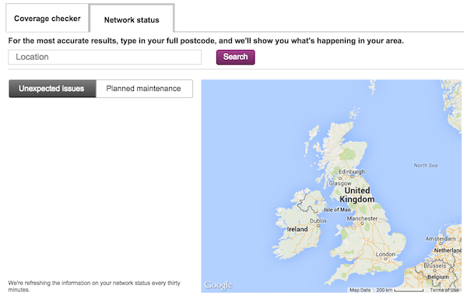
Figure: The improved network system for Vodafone UK(Vodafone.co.uk, 2018).
Vodafone Company eliminated cross-channel working group and focus on the important and sensible areas such as public relations, network operations, online, technology, third-party supplier, and security(Harvard Business Review, 2018).
The project was initiated by the technology team. The duty of the technology team was to translate the network information into messages(Vodafone.co.uk, 2018). Later, the designers of UX joined the project to ensure the importance of the customer’sexperiencevalue in attaining the company’s long-term success. Before implementing the graphic design, the Vodafone Company carried out the extensive research with the public to validate their experiences(Vodafone.co.uk, 2018). The field engineers were responsible to update the information in the system. The engineers update the information via the network operation centre that was linked to email notification centre. The idea of the system was that the affected users register their email account in the system that would send the email to the affected users or customers when the issues are reported to the central network system(Schmitt, 2013).

The outcomes
- There was a 40% increase in visitors’ experience after the launch of the system (Vodafone.co.uk, 2018).
- Reduction in network related forum topics.
- Reduction of manual intervention from the social operations team.
- Decommissioning the forum for communicating the network issues.
- Almost a 10% reduction in network related complaints
- 60% reduction in queries regarding customer call back(Vodafone.co.uk, 2018).
- Improving the T-NPS.
- Improvement in loading the faults for customers’ view(Vodafone.co.uk, 2018).

1. Factors that influence the Vodafone’s ability to maximise customer value
Customers’ value is a critical factor for organisational success(Addis, 2016). Increasing the customer’s value is a key concept of Vodafone’s customer’s relationship management(Armstrong, 2010). However, there are several layers to consider analysing the factors that contribute to the maximization of customers’ value.
1.1 Customer Journey:
Customers’ journey refers to the journey every customer of Vodafone takes in purchasing, using, and giving feedback to the used products(Head, 2012). In the case of Vodafone, the customers’ journey starts with the purchasing of products with multiple stages to follow up. There are several stages in a customer journey.
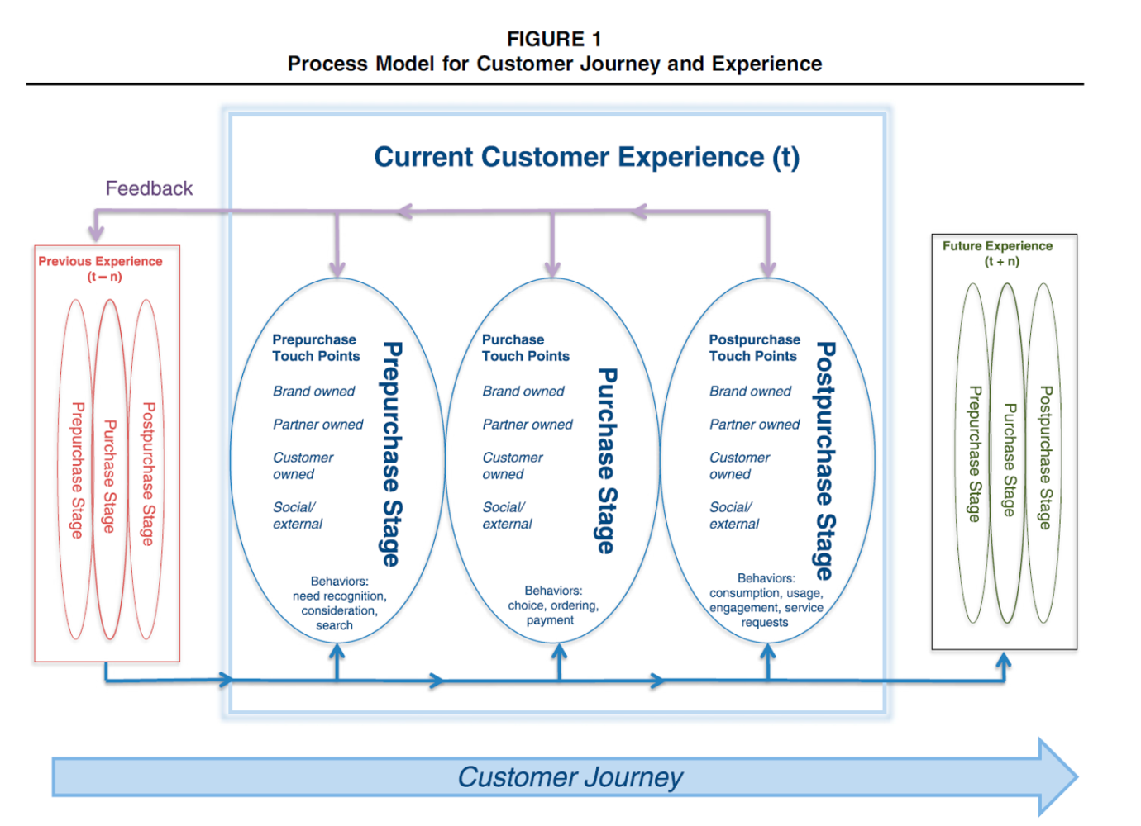
Figure: a Process model for customer journey and experience (Head, 2012).
The Pre-purchase phases: The pre-purchase involves the customers’ interaction with the brand environment, and category before the customers goes for the final purchase(Head, 2012). In this pre-purchase stage, the Vodafone UK tries to convince the customers by telling the benefits of its products and services(Lemon and Verhoef, 2016). The customer value is created when the customers are convinced by the pre-selling effort of the company and the customers decide to buy the product(Lemon and Verhoef, 2016).
The Purchase stage: The customers involve and interact with the brand analysing the business environment of Vodafone UK. The purchase stage involves the choice, ordering, and the payment for the product and services(Lemon and Verhoef, 2016). In the purchase stage, the marketing activities of Vodafone are responsible for making the customers’ value(Head, 2012). If the marketing strategies are effective enough to allure the customers, then the customers’ retention and loyalty rate increase thus the customers’ value(Anderson and Kerr, 2013).
The post-purchase stage:In the post-purchase stage, the customers actually use and consume the products and services(Lemon and Verhoef, 2016). For example, the customers of Vodafone consumers the telecommunication and internet services offered by the company(Head, 2012). In this stage, the Vodafone tends to create the customers’ value by providing the after sales services such as higher internet services, answers to the queries, and repairment or replacement(Armstrong, 2010).

1.2 TouchPoints
Touchpoints are the crucial factors that influence the customers’ value through the customers’ journey and experience with the Vodafone UK(Anderson and Kerr, 2013). The Touchpoints of Vodafone UK are the websites that provide information to the customers about the product and services and their usages, advertising of the products, and the call centre services(Addis, 2016). Being clever with the Touchpoints can create higher customers value in the long run. The four types of customer experience Touchpoints are discussed below.
Brand owned touchpoint: Brand owned Touchpoints are under the control of the firm(Lemon and Verhoef, 2016). These include the brand controlled elements of marketing strategies and mix,advertising, websites, and loyalty programs. These Touchpoints have the extensive effects on the firm’s ability to increase the market share, sales amount, and customers’ value(Maslowska, Malthouse and Collinger, 2015). The advertising and promotion strategies influence the firm’s ability to attract the customers to buy the Vodafone’s products and internet services. Every year Vodafone Company spends a huge amount of money in its marketing, and advertising, and promotional campaign(Vodafone.co.uk, 2018). In addition, the loyalty programs by the Vodafone also contribute to the increasing the customers’ value in the market(Maslowska, Malthouse and Collinger, 2015).
Partner-ownedTouchpoints: These Touchpoints are jointly designed by the Vodafone’s partners such as marketing agencies, multichannel distribution, communication channel partners, multivendor loyalty programs partners, etc(Vodafone.co.uk, 2018). The distribution channels are largely responsible for how the customers value the Vodafone’s products(Head, 2012). Customers’ demands are fulfilled in different locations by the company’s distribution channels. The stronger the distribution channels the higher the firms’ ability to increase the customers’ value(Maslowska, Malthouse and Collinger, 2015).
Social/externalTouchpoints: The social or external Touchpoints affect the firms’ ability to maximize the customer’s value(Mehta, 2017). The social or external Touchpoints are peer influences, other customers, different independent information sources, and the environment that influence the overall process of how Vodafone creates the customers’ value(Schmitt, 2013). Peer companies can exert influence by offering the extensive competition. AMC networks, Altice, Etisalat Group are the main competitors of Vodafone UK can reduce the firms’ ability to maximize the customers’ value(Schmitt, 2013). The third party information sources are social media such as Facebook, Instagram, and review sites(Mehta, 2017).

1.3 Customer Satisfaction and Loyalty
One key element that influencesthe firms’ ability to maximize the customer’s value is the measurement and management of customers’ satisfaction and loyalty(Lemon and Verhoef, 2016). Customers’ attitudes and loyalty are the attitudes and behaviours the customers show to the company’s products and services(Mehta, 2017). In the above case of Vodafone, the company designed the new system to reduce the customers’ hassle in finding the information and having their queries on the products(Vodafone.co.uk, 2018). The main objective of the new network system is the ultimate customers’ satisfaction and loyalty. The firm takes the new strategies and ways to identify the loyal customers and service to the highest extends(Mehta, 2017). The measurement of customer’ssatisfaction and loyalty also helps the company to identify the rate of customers’ value and rectify where necessary. The measurement creates a block to include the customers in a specific range and service them(Head, 2012).

1.4 Service Quality
The influence of service quality to maximize the customers’ value can be best described with the service quality model or SERVQUAL Model(Desjardins and Fossett, 2014). Service quality model is a marketing tool or marketing theory that is used to increase the firm’s value by increasing the customers’ value in turn. The service quality emphasises the improving the quality of Vodafone’s products to satisfy the target customers(De Sousa, 2017). The improved service quality of Vodafone gives the competitive advantages to the company in the market(Davies, 2011). The five dimensions of the service quality model are as follow.
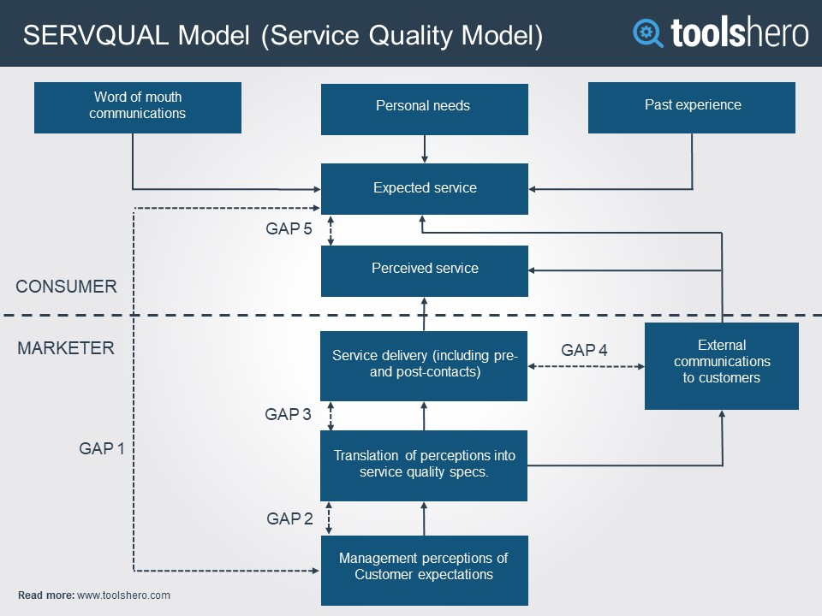
Figure: The service quality model(Desjardins and Fossett, 2014)
- Reliability:The reliability dimension measures the degree of product’s honesty and accuracy to the customers(De Sousa, 2017). The higher the customers get the honest and accurate services from the Vodafone, the higher will be customers’ value and perception towards’ the Vodafone’s services(Mehta, 2017). Vodafone is the largest company in the telecommunication industry due to its higher service quality compared to the other companies in the industry(Harvard Business Review, 2018).
- Responsiveness: The above case is the example of Vodafone’s responsiveness to the customers’ queries and complaints. Vodafone UK improved the networks’ performance by developing interactive and graphical representative network performances(Vodafone.co.uk, 2018). This was developed to simplify the customers’ experience which is the first in the UK telecom markets. The main objective of improving the network performance is to reduce the network related queries into the call centre by creating a system that helps to communicate the affected customers to the company. The customers can fill the complaints and queries in the system and get the feedback in no time(Vodafone.co.uk, 2018).
- Tangibles: The tangible services are the staffs, office equipment, and other facilities that serve the customers in their journey through the customers’ experience(Lemon and Verhoef, 2016). The physical existence of office and branches are tangible services of Vodafone UK(Mehta, 2017).
- Assurance: The assurance refers to the skills and knowledge of salesperson of Vodafone Company(Desjardins and Fossett, 2014). The skills and knowledge of Vodafone’s personnel contribute to the maximization of customers’ value(Schmitt, 2013).
- Empathy/Courtesy: The empathy refers to the politeness and clear communication between the customers and Vodafone’s clients(De Sousa, 2017).The company needs to provide credible, clear, honest, and prompt to the customers so that customers can use and consume the Vodafone’s services promptly and quickly after getting the required information(Desjardins and Fossett, 2014).

1.5 Customer Centricity and Customer Focus
Customer centricity and customer focus are the strategic factors that determine whether customers are serviced and prioritized as per the strategy of valuation creation(Davies, 2011). Customer’s centricity marketing is responsible for analysing the needs of the customers and serve them to their choices(Armstrong, 2010). Vodafone UK has implemented the new network system to serve the cust6omers in their queries and complaints. The main objectives of customer focus and customer centricity factors are to ensure that the customers are the main target and the company has to maximize the customers’ value by offering the services of customers’ choices(Head, 2012). The pillars of customers’ centricity are experience, loyalty, communication, assortment, promotions, price, and feedback. These pillars start with buying the Vodafone’s services and end in giving feedback about their concern(Mehta, 2017).

1.6 Information technology:
The telecommunication industry is all about the exchanging the information between the firm, partners, and the customers(De Sousa, 2017). Information technology of Vodafone determines the degree of customers’ value throughout the customers’ journey with the firm(Davies, 2011). Recently, Vodafone UK has deployed a Voyager to transform optical networks. This Voyager is a part of company’s telecom infra project that aims to create the customer’s value by investing largely in the technological sectors. Moreover, Vodafone is the pioneer of flexible Ethernet in the UK market(Vodafone.co.uk, 2018). In the above case study, Vodafone aims to improve specific T-NPS scores of the company by introducing the new system as its technological projects(Vodafone.co.uk, 2018).
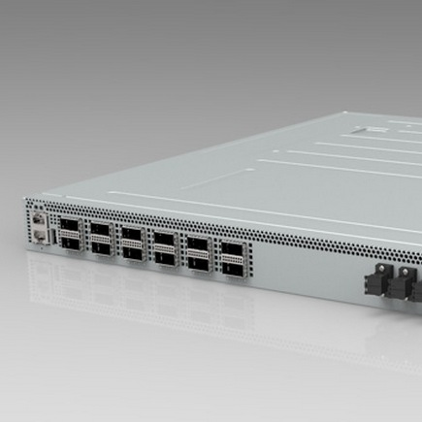
Figure: The Vodafone’s Voyager technology to transform optical networks(Vodafone.co.uk, 2018)

Vodafone has been able to hold the third highest market share due to its investment in technology that aims to provide the relevant information to the company’s customers and clients performing smooth business operations(Davies, 2011). As a telecommunication company, the Vodafone's ability to maximize the firm’s value and customers’ value largely depends on the development and invention of new technologies in customers’ preferences(Davies, 2011).
1.7 Customer relationship management:
The customer relationship management is the main factor that largely influences the target customers and the firm’s profitability(Desjardins and Fossett, 2014).Customer relationship management refers to the strategies, technologies, and practices that aim to manage and improve the customers’ services(Lemon and Verhoef, 2016). The core objective of customer relationship management is to maximize the customers’ value by making a relationship with the customers(Maslowska, Malthouse and Collinger, 2015). The customer relationship model will discuss how the CRM influences the firm’s ability to increase the customer value.
- IDIC Model:The IDIC model suggests that Vodafone has to take four broad actions to build and create the strong customers’ value(Schmitt, 2013). These actions are identifying, differentiating, interaction, and customization. In the identification stage, the Vodafone has identified the customers to whom the company wants to serve(Head, 2012). Identification of customers’ choices and preferences are also the part of the identification stage(Lemon and Verhoef, 2016).
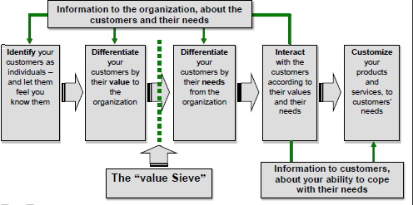
Figure: The IDIC model of customer relationship management (Lemon and Verhoef, 2016)
The differentiation stage involves the differentiating the customers that will add more value in the future(Lemon and Verhoef, 2016). In this stage, Vodafone makes strategies to fulfil the individual needs and requirements. In the interaction stage, the company interacts with the customers to fulfil the individual needs and requirements(Maslowska, Malthouse and Collinger, 2015). The marketing and advertising strategies are the parts of the interaction stage. The last stage is the customization stage where the company customize the products and services to the customers’ choices(Mehta, 2017). The above case study is the customization strategy where the Vodafone customizes the network to answer the customers’ queries and complaints more promptly and inan accurate manner(Head, 2012).

1.8 Market Competition
The intense of market competition determines whether Vodafone can effectively maximize the firm’s value or not(Desjardins and Fossett, 2014). The intensive market competition reduces the firm’s ability to maximize the customer’s value and low market competition increases the Vodafone’s ability to maximize the customers’ value(Addis, 2016). Vodafone is the largest and leading company in the UK telecommunication industry with the third highest market share(Vodafone.co.uk, 2018). AMC networks, Altice, Etisalat Group are the main competitors of Vodafone UK can reduce the firms’ ability to maximize the customers’ value. Vodafone’s investment in information technology, competent human resources, and competitive strategies lead the company to reduce the competition to great extent(Anderson and Kerr, 2013)(Anderson and Kerr, 2013). However, with the changing nature of the industry, economy, trends, environment, customers’ preferences can exert huge competition in the future that may reduce the firm’s ability to maximize the customers’ value(Armstrong, 2010). Hence, the prospective strategies of Vodafone must involve how the company can hold the constant growth and higher customer satisfaction in the future.

2. Critical understanding of Vodafone’s quality processes and its effectiveness in meeting customer requirements
The quality processes of Vodafone UK combine the providing of standardized and customised products and services(Cook and O'Hearn, 2014). In the above case, the Vodafone UK designed and customised the new system to provide quality network system to its users that reduce the complaints and queries time and getting feedback in no time(Vodafone.co.uk, 2018). The quality processes of Vodafone UK involve quality assurance, quality control, and quality improvement(Cook and O'Hearn, 2014).
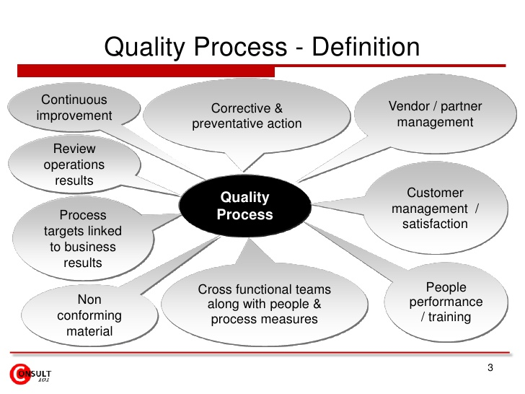
Figure: The quality processes of Vodafone Company (Cook and O'Hearn, 2014)
- Quality Assurance: The quality assurance of Vodafone involves that the services of Vodafone UK meet the users’ demand and requirements(Desjardins and Fossett, 2014). The H Band specialist core network management team is responsible to provide the improved and standardised network services to the company’s users(Vodafone.co.uk, 2018).To ensure the quality assurance, the Vodafone has the competent staffs and managerial team with improved knowledge and skills in technology and network system(Davies, 2011). In the case, the project was initiated by the technology team. The duty of the technology team was to translate the network information into messages. Later, the designers of UX joined the project to ensure the importance of the customer’s experience value in attaining the company’s long-term success(Vodafone.co.uk, 2018).
- Quality Control: Quality control team involves analysing the outcomes of existing quality processes or network system of Vodafone UK(Mehta, 2017). This quality control team ensures that the users’ requirements are fulfilled and provide a recommendation to the management if any rectification is necessary to carry out(Cook and O'Hearn, 2014).
- Quality improvement: Depending on the industry and market condition, Vodafone has to develop a new system and improve the existing network systems to meet the customers’ requirements(Harvard Business Review, 2018). In the case study, the Vodafone UK has improved the existing system of customers’ queries and complaints that reduce the time giving and taking feedback(Vodafone.co.uk, 2018). This has much satisfied the company’s users to exchange the information of feedback for improving the existing services(Schmitt, 2013).
However, to deal with the technology of Vodafone UK, a specialist team has been assigned to meet the users’ requirements and ensure the highest quality processes for the company(Vodafone.co.uk, 2018). The responsibilities of The H Band Specialist Core Network Management team are as follows.
- Ensuring the delivery of optimal NOC service delivery to the network switching subsystem(Vodafone.co.uk, 2018).
- Investigating and detecting the core network failures and problems.
- Analysing the trends of network failures (Vodafone.co.uk, 2018).
- Contributing to research and development team to introduce the new solutions and incidents to the existing system.
- Providing assistance to the regional and internal teams on various issues(Vodafone.co.uk, 2018).

Apart from the network management team, Vodafone UK has the other operations and strategies to ensure the quality processes to meet the customers’ requirements. The several layers of Vodafone’s quality processes are as follow.
Marketing operations/processes
The marketing processes of Vodafone UK are responsible for capturing the standards and tests for every customer in the market segment(Maslowska, Malthouse and Collinger, 2015). The marketing team then circulate the information to the business to improve the existing processes and services(Schmitt, 2013).
Service operations
Service operations of Vodafone are responsible for analysing and improving the existing processes, practices, and skills(Lemon and Verhoef, 2016). The call centre of Vodafone UK tracks the high touch points that maintain the survey on existing quality processes(Cook and O'Hearn, 2014).
Products/Service developments
Service development is the outcome of extensive market research to meet the customers’ requirements(Davies, 2011). The changing nature of industry, market, and customers’ choices force the company to introduce the new services for the new and existing customers in different market segments(Desjardins and Fossett, 2014). The introduction of the new mobile set, internet services, and network service such as 4G are the outcome of product and service development processes(Armstrong, 2010).
Information technology
The information technology of Vodafone UK analyse the information and data regarding the company’s quality processes and provide a recommendation for any improvement that will contribute to the meeting of customers’ requirements(Davies, 2011).
.

2.1 Six Sigma Model
Six Sigma is a quality process and quality management process that was developed to understand the quality processes of Vodafone UK in meeting the customers’ requirement(Zinkgraf, 2014). The core idea of six sigma model is to identify the defects in business processes torectifying them for better quality services and processes(Cook and O'Hearn, 2014)(Cook and O'Hearn, 2014). It is a statistical developed by the Motorola in 1986. The six sigma model helps to prevent the defects of Vodafone in business processes.The six sigma model provides a set of tools to improve the Vodafone’s business processes(De Sousa, 2017). The network management team of Vodafone UK is responsible for ensuring the introduction of six sigma model within the company(Vodafone.co.uk, 2018).
Participants in the Implementation Process
The implementation of Six sigma model requires the participation of several groups within the company.
Top Management:The top management of Vodafone UK is responsible for structuring the company’s long-term goals and objectives and design the required business processes and operations to achieve the long-term goals and meet the customers’ needs and requirements(Maslowska, Malthouse and Collinger, 2015). The top management of the company provides the assistance to the other groups in business processes that are designed to serve the same objectives(Mehta, 2017).
Champion:The champion group in six sigma model is responsible for providing assistance to the black belt group. The champion group supports the logistics and business processes of customers’ choices(Zinkgraf, 2014).
Black Belts:The black belt group measures, analyses, improve, and controls the existing business processes(Mehta, 2017). When the requires improvement in the company’s current network system, the black belt group of Vodafone recommends the new network system that is discussed in the above case scenario.
Green Belts:The green belt groups implement and apply the six sigma tool to the current and new network systems of Vodafone UK(Zinkgraf, 2014).

Project Implementation Phases OF Six Sigma model in Vodafone’s quality processes
The six sigma model introduces several tools that must be used in systematic ways to have the best quality processes within the company(Addis, 2016). These tools or phases of Six sigma model are discussed below.
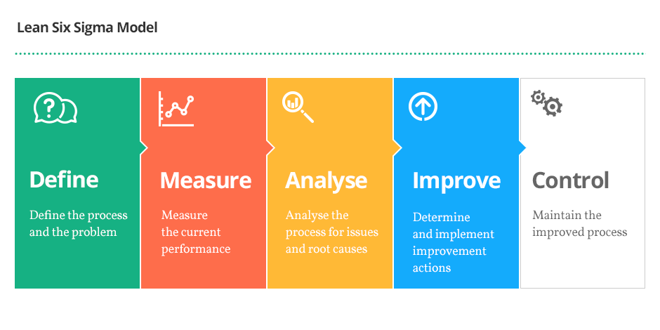
Figure: The Sigma model in Vodafone’s quality processes(Zinkgraf, 2014)
- Define:Define phase involves the identification of existing quality processes or networks system that must be improved or introduced newly to serve the better customer services(Zinkgraf, 2014).
- Measurement:This phase collects the data and information regarding existing or new network systems of Vodafone that will serve the customers most effectively and reduce the costs(Mehta, 2017).
- Analysis:Analysis stage involves the evaluating of data and information that is collected in the measurement phase(Head, 2012). In this stage, the participation groups of quality processes analyse the outcome from the improvement of the new network systems for Vodafone UK(Desjardins and Fossett, 2014).
- Improvement:The improvement stage involves the improving the existing network system to serve the customers in better and effective ways(Zinkgraf, 2014). In the above case scenario, Vodafone UK improved the networks’ performance by developing interactive and graphical representative network performances(Vodafone.co.uk, 2018). This was developed to simplify the customers’ experience which is the first in the UK telecom markets. The main objective of improving the network performance is to reduce the network related queries into the call centre by creating a system that helps to communicate the affected customers to the company(Vodafone.co.uk, 2018).
- Control: This is the maintenance phase where the Vodafone UK will control the effectiveness of the new network system in the company’s future growth(Zinkgraf, 2014).
The effectiveness of Vodafone’s quality processes using six sigma model
- There was a 40% increase in visitors’ experience after the launch of the system(Vodafone.co.uk, 2018)
- Reduction in network related forum topics.
- Reduction of manual intervention from the social operations team.
- Decommissioning the forum for communicating the network issues.
- Almost a 10% reduction in network related complaints
- 60% reduction in queries regarding customer call back(Vodafone.co.uk, 2018).
- Improving the T-NPS.
- Improvement in loading the faults for customers’ view(Vodafone.co.uk, 2018).

2.2 Customer Engagement processes and models of Vodafone UK
The Vodafone UK has the business processes to ensure that customers are actively and duly engaged with the company by buying and using and products and services offered by the Vodafone UK(Vodafone.co.uk, 2018).
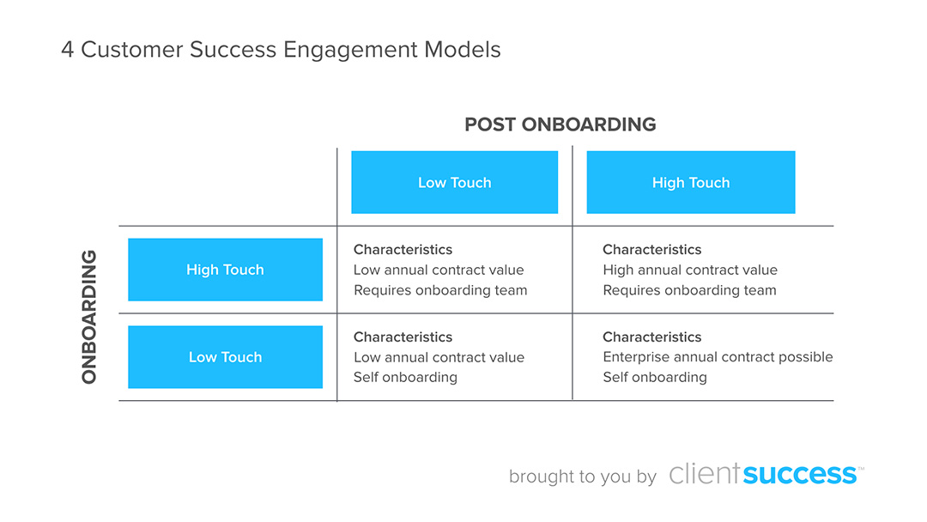
Figure: Customer Engagement processes and models of Vodafone UK(Maslowska, Malthouse and Collinger, 2015)
- High Touch Onboarding: The first engagement process of Vodafone UK is the high touch on-boarding process(Mehta, 2017)(Mehta, 2017). This process is used after the customers buy the products and start to use them. For example, the customers of Vodafone UK have subscribed to the internet services provided by the company. The high touch onboarding is responsible to provide the after sales services to the customers regarding the usages of internet services(Maslowska, Malthouse and Collinger, 2015).
- Low touch onboarding: In low touch onboarding, the Vodafone UK Company teaches the customers about the usage of its services through the training and onboarding tools such as video tutorial posted in the website, designated networks or information system designed in this regard(Mehta, 2017). The Vodafone Company provides the readily available tips to the customers about how to use the telecommunication services provided by the company simply providing updated information on specific blogs and websites(Head, 2012).
- High touch post-on-boarding: In touch post onboarding business process, the Vodafone UK meets the customers’ requirement with dedicated human resources employed by the company and online services(Mehta, 2017). The high touch customer success manager deals with the high touch onboarding business processes on Vodafone Company(Vodafone.co.uk, 2018). This business process mainly focuses on the certain segments such as small business, mid-market and enterprise to engage with the customers and meet their requirement(Head, 2012).
- Low Touch Post On-Boarding: In low touch onboardingprocess, the Vodafone Company communicates with the customers completely through the digital means such as online, email, and digital approaches(Maslowska, Malthouse and Collinger, 2015).

Conclusion
Understanding the customer's experience and engage throughput the journey is the crucial part for the company’s success(Lemon and Verhoef, 2016). The customers of Vodafone UK are the people to whom the company provides telecommunication and internet services to earn profits that will contribute to the achievement of the company’slong-term objectives and goals(Armstrong, 2010). All the business processes and strategies are implemented to attract the valuable customers to buy the company’s products and use the services(De Sousa, 2017). Thus, it is necessary for every company to critically analyse the customers’ needs and experience to understand them and provide even better services the next time(De Sousa, 2017). In addition, the Vodafone needs to have strong network systems and services to engage and communicate with them to meet the customers’ requirement and needs(Addis, 2016).

References
Addis, M. (2016). Understanding the Customer Journey to Create Excellent Customer Experiences. International Journal of Marketing Studies, 8(4), p.20.
Anderson, K. and Kerr, C. (2013). Customer relationship management. New York: McGraw-Hill.
Armstrong, B. (2010). Customer focus: obtaining customer input. The Australian Library Journal, 43(2), pp.108-117.
Cook, R. and O'Hearn, G. (2014). Processes for a quality environment. [Green Bay]: University of Wisconsin--Green Bay.
Davies, P. (2011). Information technology. Oxford [England]: Oxford University Press.
De Sousa, J. (2017). Neuromarketing and Big Data Analytics for Strategic Consumer Engagement. Hershey: IGI Global.
Desjardins, B. and Fossett, B. (2014). Integration of Quality Improvement with Existing Quality Assessment/Quality Management Processes. Journal For Healthcare Quality, 15(5), pp.17-19.
Harvard Business Review. (2018). Understanding Customer Experience. [online] Available at: https://hbr.org/2007/02/understanding-customer-experience [Accessed 3 Aug. 2018].
Head, T. (2012). Customer experience management. Delhi: White Word Publications.
Lemon, K. and Verhoef, P. (2016). Understanding Customer Experience Throughout the Customer Journey. Journal of Marketing, 80(6), pp.69-96.
Maslowska, E., Malthouse, E. and Collinger, T. (2015). The Customer Engagement Ecosystem. SSRN Electronic Journal.
Mehta, A. (2017). Customer Engagement: A Case Study. SSRN Electronic Journal.
Schmitt, B. (2013). Customer experience management. Hoboken, N.J.: Wiley.
Vodafone.co.uk. (2018). Mobile phone deals, SIM only and broadband offers | Vodafone. [online] Available at: https://www.vodafone.co.uk/ [Accessed 3 Aug. 2018].
Zinkgraf, S. (2014). Six sigma. Upper Saddle River, NJ: Prentice Hall.

