

Assessment 1 – Reading Task Template
PART 1: Upload your photo of your A3 in-class notes here:
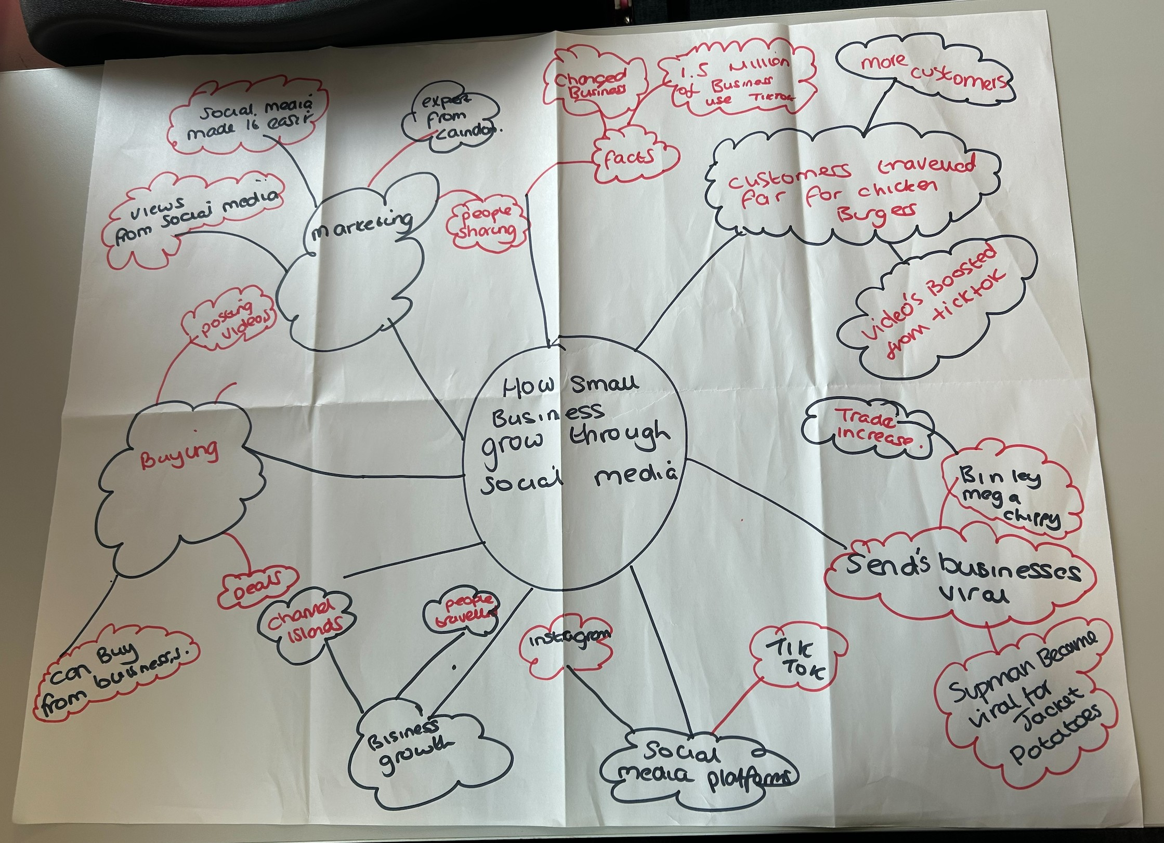

PART 2:
- Answer every question below in 1-3 full sentences.
- Use your own words. Do not use generative AI to answer these questions.
- Include a specific detail from the text when asked.
REMINDER
- The main idea is the overall message of the whole text.
- A key point helps to explain the main idea.
- A specific detail or example from the text shows that the key point is true.

- What is the main idea of the whole text?
It’s how your business grows through social media

- What is one key point that supports the main idea, and which specific example from the text shows this?
I think marketing is one of the most important things to help your business grow through social platforms

- What is a different key point that supports the main idea, and which specific example from the text shows this?
Buying is important because it helps the growth I.e. people have travelled for hours to buy things that have gone viral.

- Which part of the text do you think is most important, and why?
Viral is important as it helps trade increase and gets smalls business’s out
There and noticed.

Reflection:
- What did you find difficult in this task (including in-class components), and why was it difficult?
I did not find anything difficult as my tutor explained everything very clearly and helped me
- What helped you with this difficulty, and how did it help you?
My tutor helped me with everything I needed

