Maze Pathfinding Implementation
  - Submitted by: Kallem Thomas (Student ID: 2304300)
  - Module: Advanced Software Development (ACCB5011)
  - Lecturer: Tim Bashford
Table of Contents
Introduction 2
1. Description of Pathfinding Algorithms 2
Dijkstra's Algorithm 2
A* Algorithm 2
2. Comparison of Dijkstra’s and A* Algorithms 3
3. Implementation Development Process 4
4. Results and Analysis 5
Implementation 8
5. Reflection 8
References 8

Introduction
In computer science, pathfinding is an algorithm for finding a path between a set of points to create a route between the starting node and target node [1]. Pathfinding is used for many applications such as Video Games, logistics, or even a simple form of navigation in a vehicle (satellite navigation). Pathfinding algorithms could be known as an ant searching for food from its nest. Also known as Ant Colony Optimization (ACO)[2].
The significance of the efficiency of these algorithms is highly necessary for example a simple way to navigate is to hold an arm out on the left side and follow a wall, if there’s a roadblock ahead, turn 90⁰ to the right and continue until the wall stops, however by using this method, depending on the amount of obstacles and walls between point A and point B, the more there are, the less efficient the method becomes, but this raises the question which is a common problem within computer science. What is an efficient algorithm for pathfinding?

1. Description of Pathfinding Algorithms

Dijkstra's Algorithm
Dijkstra’s algorithm, created by Edsger W. Dijkstra in 1956, is a pathfinding algorithm commonly known as a shortest-path Algorithm. This algorithm is a BFS (breadth first search) which means that it starts at the source node and has a look at every unvisited node surrounding the source node that has the least tentative distance from the source node. After doing so it views the next surrounding nodes of this new node which then updates the tentative distances if there is a shorter path is found. This continues in a loop until the target has been visited[3].
The relevance of Dijkstra’s algorithm to maze navigation is that it doesn’t only output the fastest route to one destination, it also outputs the ordered list of travel times from the current location to the other point that might want to be visited [4].
Dijkstra’s algorithm is also used in many real-world examples such as navigation systems, logistics or even transportation planning. Google maps for example uses Dijkstra’s algorithm as well as Waze to calculate the shortest path from current location to the destination. However, Dijkstra’s algorithm fails whenever there is a negative edge weight on a node. Some algorithms that do take negative edge weights into consideration are: The Bellman-Ford algorithm, Prim’s algorithm and Kruskal’s algorithm [5][6][7].

A* Algorithm
The A* Algorithm is similar to Dijkstra’s algorithm, however with some improvements. A* is known as a DFS (depth first search), this means that it would search all the way down to the end node instead of searching through all nodes. This means that with having a target or goal to work towards, A* can implement new things to Dijkstra’s algorithm, such as distance from starting node and distance from target node. As we have distance from target node – distance from starting node, we can calculate which next node will be the best node to visit to get closer and closer to the target node. [8]

2. Comparison of Dijkstra’s and A* Algorithms
- Strengths and weaknesses of both algorithms.
- Applicability to solving a 20x20 grid maze.
- Insights on efficiency, complexity, and heuristic impact.
As Dijkstra’s algorithm is a breadth first search algorithm it will search all nodes from the starting point until it finds the target node, Dijkstra’s algorithm favors the node closest to the start node, however A* is a combination of Dijkstra's algorithm and the Greedy algorithm where A* finds the next best node depending on from where the start point is and from how far it is from the target [9]. When Dijkstra’s algorithm comes across a map to navigate through, even if the target node has not been made visible or any obstacles made visible until we visit a node, it would always find the target. Whereas A* would require the target’s location to be able to navigate through to the target. If you consider a map of 20x20 with obstacles and target made visible, then A* would be the best algorithm to use compared to the greedy algorithm or Dijkstra’s algorithm. However, in a clear 20x20 map, meaning no obstacles, then the greedy algorithm would be best to use. When there is a map with no target made visible with a fog in front of each unvisited node, then Dijkstra’s algorithm would become the better algorithm to use.
A* Strengths:
- Always finds the most optimal path if target is made visible.
- Can handle large maps by pruning unpromising paths.
- Efficient to use.

A* weaknesses:
- Requires the target to be made visible for the algorithm to calculate distances.
- Space required to store nodes visited.
- Time complexity to calculate and visit each node.

Dijkstra’s strengths
- Will always work for non-negative edge weighted graphs.
- Low complexity which is almost linear.

Dijkstra’s weaknesses
- Dijkstra performs a blind search which can become time consuming
- Cannot handle negative edge weights

3. Implementation Development Process
As implementing, the biggest challenge was time, and as time was my biggest challenge there had to be some sacrifices, and the sacrifice made was that the decision to implement an algorithm to search through the 20x20 map was not Dijkstra’s or A* algorithm. The algorithm decided on was the wall following algorithm. This algorithm hugs a wall and follows it until the target is visited. The wall that the algorithm follows is the right-hand side wall because the target is always in the top right-hand side of the map. Because this is the case, it would be more efficient to follow the right hand side wall because of the idea that when you follow the left wall, you would have to get to the very top and when this is done it would always go to the top left of the 20x20 map, however with the right hand side, it will always reach for the top right hand side of the map first.

Another challenge during development was understanding on the method of turning and which direction the player is facing, as the player is created, he is started facing north as the default setting, knowing this, all would be necessary would be to have a switch case for turning right and turning left. However, as the algorithm does work, a problem of this algorithm is that there is no implementation of understanding if the node has already been visited, this means that while turning, it does not consider that the node travelling to has already been visited and is using moves in a wasteful manner. This was made known when debugging, because when debugging, there is an annotated an implementation of a counter, each time the implementation has been run, the counter goes up by 1, every 30 runs, another printed version of the map is outputted to the console. When viewing the console, the player had sometimes gone forward 5 steps, turns and goes backwards a couple of steps and turns again. There has been no implementation to fix this bug within the algorithm yet.

4. Results and Analysis
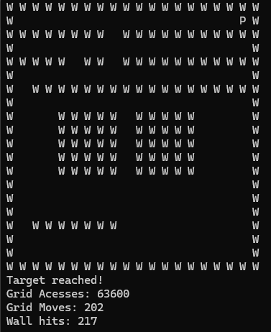
Figure 1, Title: Summary of results (debugging), Author: Kallem G Thomas 2304300
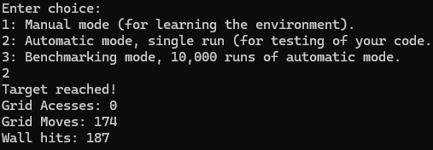
Figure 2, Title: Summary of results (No Debugging), Author: Kallem G Thomas 2304300
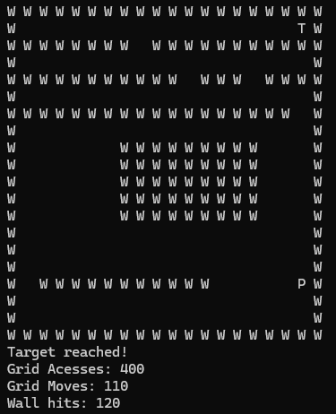
Figure 3, Title: Summary of results (efficient), Author: Kallem G Thomas 2304300
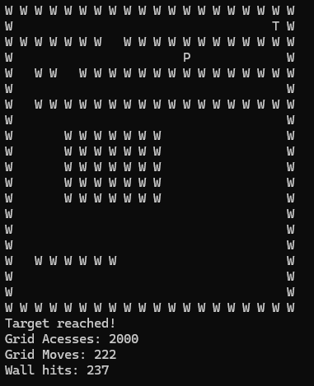
Figure 4, Title: Summary of results (inefficiency), Author: Kallem G Thomas 2304300
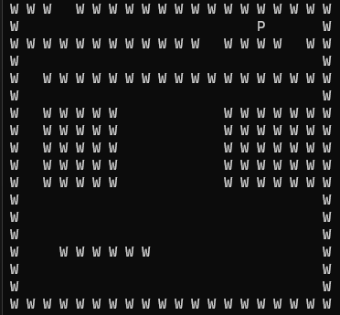
Figure 5, Title: Glitched Loop, Author: Kallem G Thomas 2304300

As seen in figure 1, the amount of grid accesses is because of the Counter mentioned before in the implementation process, the algorithm would still work just as fine without any grid accesses as seen in Figure 2.
An interesting portion of the results are that the results vary from efficient to inefficient, as seen in Figure 3, the results took one print of the grid and managed to get through the map no problem, However in Figure 4 the grid was accessed 2000 times. Another interesting result was that if the player has found a small loop in the lines of walls then as there is no way to check if that node has been accessed then it would continue to think "This is an okay move” and continue to loop itself around 2 gaps in the wall. This is able to be seen in Figure 5.

Implementation

Ctrl+Click here for the implementation:
https://drive.google.com/file/d/158FDpY6h6TdHTn7DSRmDWmPJLvIWKwPp/view?usp=sharing

5. Reflection
Future improvements of my algorithm is to implement an “Already been here” method so that the Figure 5 glitch and inefficiency problem is fixed.

References
[1] "Pathfinding algorithms in A Level computer science." https://teachcomputing.org (accessed Dec 29).
[2] "untitled," Accessed: Jan 9, 2025, [Online]. Available: https://iopscience.iop.org/article/10.1088/1757-899X/769/1/012021/pdf
[3] "What is Dijkstra’s Algorithm? | Introduction to Dijkstra's Shortest Path Algorithm." https://www.geeksforgeeks.org/introduction-to-dijkstras-shortest-path-algorithm/ (accessed Dec 30).
[4] "Bellman–Ford Algorithm." https://www.geeksforgeeks.org/bellman-ford-algorithm-dp-23/ (accessed Dec 30).
[5] "Prim's Algorithm," Accessed: Dec 30, 2024, [Online]. Available: https://www.programiz.com/dsa/prim-algorithm
[6] "Kruskal’s Minimal Spanning Tree Algorithm." https://www.tutorialspoint.com/data_structures_algorithms/kruskals_spanning_tree_algorithm.htm (accessed Dec 30).
[7] "Introduction to A*," Accessed: Jan 9, 2025, [Online]. Available: https://theory.stanford.edu/~amitp/GameProgramming/AStarComparison.html
[8] "What is Greedy Algorithm: Example, Applications and More | Simplilearn." https://www.simplilearn.com/tutorials/data-structure-tutorial/greedy-algorithm (accessed Jan 9).

