

Title: Strategic Management Analysis of Volkswagen Group: Building Sustainable Competitive Advantage Through Electrification, Software Transformation, and Strategic Governance

Programme: Master of Business Administration
Module: Strategic Management (LCMB7003)
Lecturer: Dr Zulfiqar Khan
Student name: Syed Ajharul Amin
Student ID: 2436655
Word count: 5434
Submission deadline: Wednesday 01/04/2026 by 2pm

Executive Summary
The report critically analyses the strategic management practises of Volkswagen Group focusing on how the firm aligns the capabilities of the firm with a business environment that is vulnerable to change in order to build a sustainable competitive advantage. The analysis shows that the strategic environment of Volkswagen is characterised by stricter regulations on CO2 standards in Europe, growing competition between Chinese EV producers, and a very high rate of technological change to software-defined cars. The response of Volkswagen lies in platform modularity and portfolio breadth and transformation agenda that is a combination of electrification, digitalisation and sustainability commitments.
External analysis based on PESTEL and competitive dynamics indicating compliance flexibility till 2027 without alleviating the overall strategic control of enhancing speed in product and cost and software capabilities (European Parliament and Council, 2025). Internal perspective VRIO analysis shows that the modular platform system and worldwide manufacturing scale can establish an advantage in Volkswagen provided that the alignment and execution discipline stay high according to the resource-based logic (Chatzoglou et al., 2018; Paz and Ruiz Gálvez, 2021).
Nevertheless, the report also mentions the presence of the execution risks of the matter, which is associated with the organisational complexity, software delivery, and competitive pressure in China (Reuters, 2025). Balanced Scorecard is a transformation of the strategic priorities into quantifiable goals and initiatives (Kaplan and Norton, 1996). The report proposes a more focused portfolio and platform governance approach, a more integrated software and partnership capabilities, and a China strategy anchored on customer value differentiation and local innovation, and controlled by KPI-based assessment and risk management systems.

Table of Contents
Executive Summary 2
1. Introduction 5
2. Current Situation 6
2.1 Description of the Business 6
2.2 Industry, competitors, and market position 7
3. External Audit 8
3.1 External environment and its importance 8
3.2 PESTEL Analysis for Volkswagen and key issues emerging 8
3.3 Industrial Organization (I/O) Model of Above-Average Returns 9
3.4 Competitive dynamics using Porter’s Five Forces Framework 10
4. Internal Audit 12
4.1 Internal environment and its importance 12
4.2 Key resources, capabilities, and core competencies 12
4.3 VRIO evaluation of Volkswagen’s strategic capabilities 12
4.4 Resource-Based Model (RBV) of Above-Average Returns 13
4.5 Relationship between internal and external environments 14
5. CSR and Sustainability Objectives 16
5.1 Conceptual framing: CSR, sustainability and strategic CSR 16
5.2 Volkswagen’s CSR strategy: legitimacy rebuilding and system integration 17
5.3 Alignment with business objectives: value creation and risk management 18
6. Strategy Formulation 19
6.1 Framing strategic choice under turbulence 19
6.2 Business-level and corporate-level strategic choices and recommended direction 19
7. Strategy Implementation 21
7.1 Implementation as change management and capability building 21
7.2 Implementation priorities, governance risks, and control mechanisms 21
8. Evaluation and Control 23
8.1 Importance of evaluation and control 23
8.2 Balanced Scorecard for Volkswagen 23
9. Financial Plan 25
10. Recommendation and Conclusion 26
10.1 Strategic evaluation using SWOT and Ansoff 26
10.2 Recommendations (evidence-led and implementation-oriented) 27
11. Conclusion 28
12. Reflective Account (Gibbs’ Reflective Cycle) 29
12.1 Description 29
12.2 Feelings 29
12.3 Evaluation 29
12.4 Analysis 30
12.5 Conclusion 30
12.6 Action Plan 31
13. Reference List 32

Introduction
Strategic management entails a keen synthesis of the way organisations fit the internal resources and capabilities to the external circumstances in order to develop and sustain competitive advantage in the face of uncertainty (Hitt et al., 2019). This report analyses the case of Volkswagen Group, a multinational automotive corporation that is experiencing structural disruption in regulation, technology, and competition. The method adheres to a logical strategy process that links the diagnosis of situation to formulation, implementation and evaluation and acknowledges that strategy is also emergent and may be subject to learning and change over time (Mintzberg et al., 2008). The analysis uses the explicit models of the module; PESTEL, VRIO, competitive positioning logic, CSR and sustainability viewpoints, Balanced Scorecard, and strategy assessment tools such as, SWOT and Ansoff to formulate recommendations on theory and evidence basis (David et al., 2017).

Current Situation

Description of the Business
Volkswagen Group is a multi-brand motor group that is in the business of passenger car, premium brands, and commercial cars coupled with its industrial business, research and development, and services (Volkswagen Group, 2025). The post-emissions scandal governance of the firm and the legitimacy rebuilding efforts that led to compliance, sustainability and stakeholder trust centralization of the strategy discussions have a significant impact on the strategic trajectory of the firm (Poier, 2020). The business model of Volkswagen is a blend of the scale production, application of the modular platforms, differentiation of the brand portfolio, and coverage of the global market; it has some leverage and complexity. The 2024 annual report of the Group explains its transformation as focused on electrification, digital products and sustainability with corporate reporting according to the current expectations of ESG disclosure (Volkswagen AG, 2024).
Table 1. Volkswagen strategic context snapshot (Volkswagen AG, 2024; Poier, 2020)
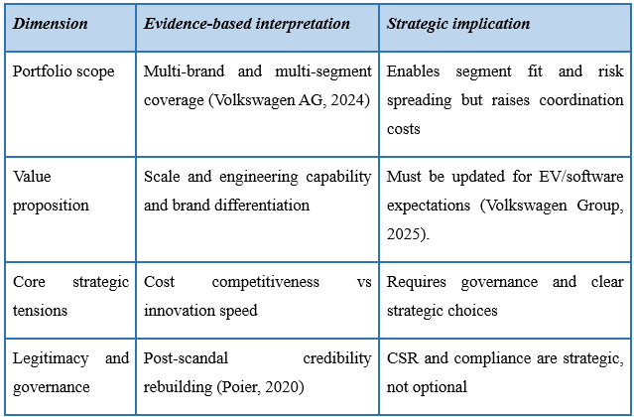

Industry, competitors, and market position
Electrification, digitalisation, and intervention by policies are leading to a structural change in the automotive industry (Chen, 2024). In Europe, CO2 compliance schemes remain at an eye of the competitive viability, but short-term flexibility in compliance calculations towards 2025-2027 change the direction of travel but not the direction (European Parliament and Council, 2025). All over the world, competition has been elevated with the aim of Chinese EV manufacturers scaling up and putting pressure on the price/performance of the incumbent, this influences the strategic space of Volkswagen more in China (Reuters, 2025). Simultaneously, the diffusion of EVs in diverse markets is increasing but not evenly distributed, and thus, strategic choices should consider the variations in the aspect of regulations, infrastructure and consumer preparedness (IEA, 2025).
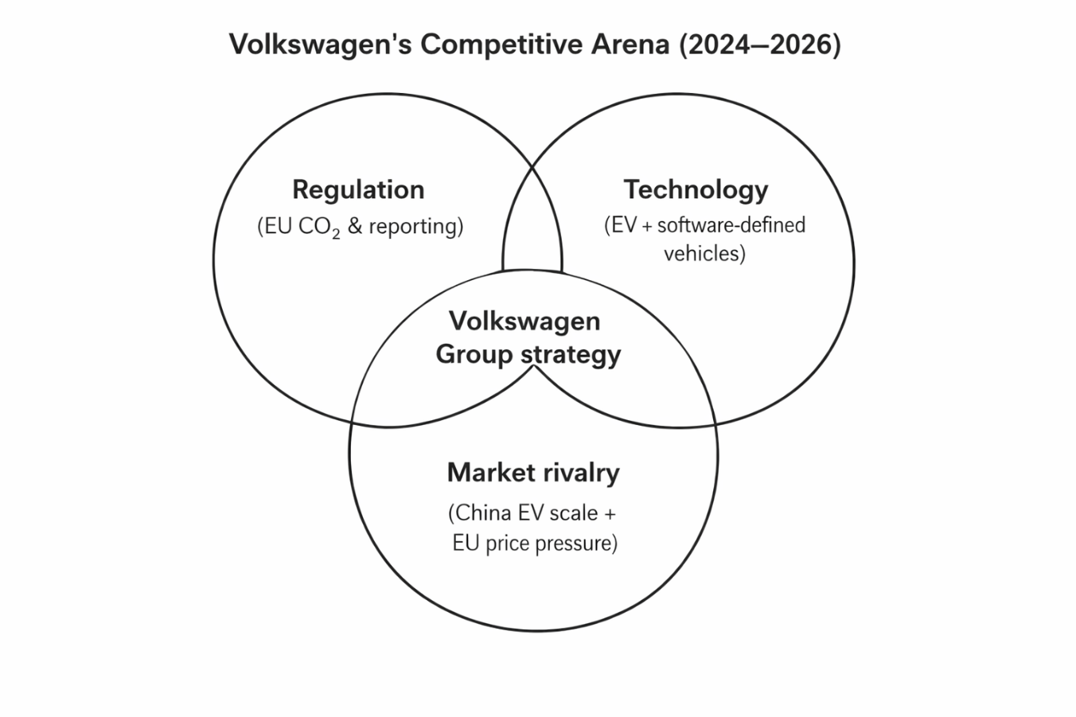
Figure 1. Volkswagen’s Competitive Arena (2024–2026) (Self-Designed based on European Parliament and Council, 2025; Reuters, 2025; IEA, 2025)

External Audit

External environment and its importance
External analysis refers to the fact that the performance of organisations cannot be accounted by the internal decisions alone since the strategy has limited ability and capacity to be constrained and facilitated by the forces and dynamics of macro environmental and industries (Collins et al., 2024). PESTEL can be applied to scan the pressure that influences the strategic decision-making process, but it is essential to note that the tool needs to be used as a dependent category because categorising the pressure as changing and interdependent is an oversimplified approach to urgent decisions (Buye, 2021). Critically applied, PESTEL makes us conscious of the reality that Volkswagen is being faced by what can be considered as regulatory, technological and geo-political pressures that can compound one another and can expedite the strategic urgency (Bou Hatoum et al., 2023).

PESTEL Analysis for Volkswagen and key issues emerging
Critical interpretation of it shows that regulation is not a binding tool but a market-forming influence that redistributes benefit to those companies that can perform compliance-compliant innovation at scale (Ulubeyli et al., 2019). The flexibility adaptation in 2025-27 aims to minimise the immediate compliance risk, but may also lead to more competition as firms may opt to postpone transformation through this, and may result in a steeper capability gap in the future (European Parliament and Council, 2025). The size of the Chinese EV market that has already transformed the competitive landscape and challenged the cost and speed leadership of established players increases competition in the market (Reuters, 2025; Chen, 2024).
Table 2. PESTEL factors shaping Volkswagen’s strategic decisions (McKinsey and Company, 2025; Reuters, 2025; Chen, 2024)
PESTEL factor | Volkswagen-relevant evidence | Strategic implication
Political | EU policy and regulatory interventions shape compliance requirements (European Parliament and Council, 2025) | Product and pricing strategy must align with compliance pathways (Collins et al., 2024)
Economic | Industry cost pressure and affordability concerns in Europe (McKinsey and Company, 2025) | Platform efficiencies and procurement leverage become decisive
Social | Sustainability expectations and trust recovery post-scandal (Poier, 2020) | CSR credibility affects brand value and stakeholder support
Technological | EV diffusion + software-defined vehicles shift basis of competition (IEA, 2025; Volkswagen Group, 2026) | Competitive advantage depends on software delivery and digital customer value
Environmental | Climate transition increases lifecycle scrutiny and disclosure intensity (Sheehy and Farneti, 2021) | Operations and supply chain decarbonisation must be measurable and reportable
Legal | CO₂ compliance standards with 2025–2027 flexibility adjustment (European Parliament and Council, 2025) | Short-term compliance relief but no long-term reduction in transition pressure

Industrial Organization (I/O) Model of Above-Average Returns
The Industrial Organisation (I/O) model states that the capabilities of a firm to generate returns above average are largely influenced by the external environment, particularly industry structure and competition (Berry et al., 2019). This model presumes that companies operating in the industry are likely to be similar in terms of resources and resources required can be easily acquired, as the market conditions are responsible to create performance disparities rather than specific internal strengths (Hitt et al., 2019; David et al., 2017). The I/O perspective can be applied to the Volkswagen case since the company is in an industry where stiff competition exists, pressure on suppliers in battery and chip industries, evolving customer preferences, government intervention, and the proliferation of Chinese EVs. Therefore, the profitability of Volkswagen relies heavily on its response to the industry appeal, market dynamics, and the positioning (Hitt et al., 2019).
Table 3. Industrial Organization (I/O) model applied to Volkswagen (Berry et al., 2019; Hitt et al. (2019) and David et al. (2017)
I/O model element | Explanation | Application to Volkswagen
External environment | Industry structure shapes profitability (Berry et al., 2019). | EV transition, regulation, and market turbulence strongly affect Volkswagen
Industry attractiveness | Firms seek industries/segments with strong profit potential | Volkswagen must compete in attractive EV and digital mobility segments (Reuters, 2025).
Competitive forces | Rivalry, buyer power, supplier power, substitutes, and entrants influence returns | Chinese EV brands, battery suppliers, and changing customer expectations increase pressure
Strategic implication | Firms must position themselves effectively within industry constraints Hitt et al. (2019). | Volkswagen needs cost efficiency, differentiation, and faster response to market change

Competitive dynamics using Porter’s Five Forces Framework
In order to supplement PESTEL, the industry pressure can be presented in terms of industry pressure logic, where the bargaining power, rivalry, substitute and entry threats dictate the strategic profitability (Dobbs, 2014). Although the nature of the five forces will be different in each region and segment, the macrotrend is that competition is growing, switching costs are going down through platform convergence and the suppliers of inputs like batteries and chips, which are very essential, influence margins and schedules. This corresponds to the perception that sustainable advantage consists of the differentiation of capability, rather than mere market presence (Hitt et al., 2019).
Table 4. Competitive pressure summary (industry pressure logic applied to Volkswagen)
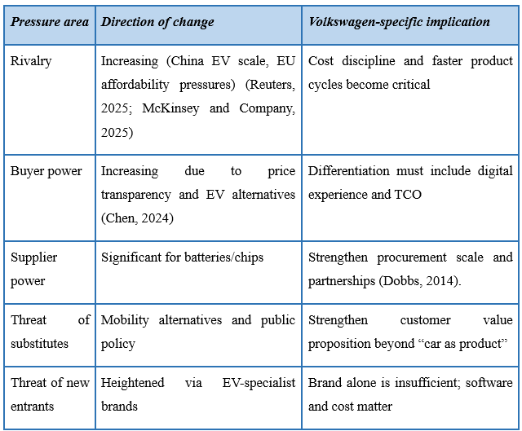

Internal Audit

Internal environment and its importance
Internal analysis determines how resources and capabilities are involved in the strategic choice and performance. Another goal at the postgraduate level is to determine the value of assets, their rarity, imitation, and organisational systems to support them, which is different, in line with the resource-based view and the VRIO logic (Chatzoglou et al., 2018). More recent research also points out that VRIO needs to be utilised in a systematic manner so as to transform resources into quantifiable capability constructs and prevent any superficial assessment (Larbi et al., 2024).

Key resources, capabilities, and core competencies
The tangible resources of Volkswagen are global manufacturing capacity, access to capital and extensive product portfolio, and the intangible resources are brand equity and engineering reputation that has had to be restored after the emissions crisis revealed the governance flaws (Poier, 2020). One of the strengths is the strategy of modular platform. Supplier-impact evidences in the Polo production by Volkswagen in Navarra show that the modular platforms re-organise supplier relations and the potential to improve coordination and performance by means of the use of standardisation and interface management (Paz and Ruiz Gálvez, 2021). This is a capacity of importance in the EV transistion since it is supportive to scale, cost control and speed in the event of coherent governance and execution.

VRIO evaluation of Volkswagen’s strategic capabilities
This VRIO rationale would imply that organisational systems of scale and modularity are the most credible characteristics of sustainability advantage at Volkswagen (Miethlich and Oldenburg, 2019). In the case of capabilities that are developing, e.g. software integration, benefits are contingent on learning and organisational redesign, and not merely on investment (Chatzoglou et al., 2018; Larbi et al., 2024). It can be concluded that integrating capability should be considered by Volkswagen as a strategic competence instead of a technical project according to modern strategic management emphasis on dynamic capability in an uncertain environment (Hitt et al., 2019).
Table 5. VRIO assessment of selected Volkswagen capabilities (Paz and Ruiz Gálvez, 2021; Ainvest, 2025; Volkswagen Group, 2026)
Capability/  resource | Value | Rarity | Imitability | Organisation | Strategic implication
Modular platform capability | High (cost and variety leverage) | Medium | Medium | High if governance strong | Potential sustained advantage if execution remains disciplined
Global manufacturing scale | High (Paz and Ruiz Gálvez, 2021) | Medium | Medium | High | Competitive parity to advantage depending on cost position
Multi-brand portfolio management | High | Medium | Medium | Medium | Advantage if complexity is controlled; otherwise, strategic drag
Post-scandal compliance and reporting systems | High | Medium | Medium | Medium–High | Supports legitimacy and risk reduction (Poier, 2020)
Software and digital integration capability | High | Low–Medium | Medium | Developing | Advantage depends on organisational learning and integration execution (Ainvest, 2025; Volkswagen Group, 2026)

Resource-Based Model (RBV) of Above-Average Returns
Resource-Based View (RBV) is a theory that proposes above-average returns as a result of factors that are internal to a firm and do not solely rely on the industry structure (Lubis, 2022). It presupposes the difference in the resources that organisations possess and that the difference may be permanent since useful capabilities are not mobile or easily copied (Hitt et al., 2019; Chatzoglou et al., 2018). Within this reasoning, the competitive capability of Volkswagen is pegged on its ability to integrate physical resources, human expertise, and organisation systems into meaningful capabilities. They include modular platform architecture, massive production, knowledge in engineering, and coordination of global brand portfolio. When such resources are of value, hard to imitate, and well-organised, they may sustain competitive advantage and greater strategic performance throughout the EV and software transformation (Hitt et al., 2019; Paz and Ruiz Gálvez, 2021).
Table 6. Resource-Based Model (RBV) applied to Volkswagen (Hitt et al. (2019), Chatzoglou et al. (2018), and Paz and Ruiz Gálvez (2021)
RBV element | Explanation | Application to Volkswagen
Resources | Firms possess different tangible and intangible assets (Paz and Ruiz Gálvez, 2021). | Volkswagen has manufacturing scale, brands, capital, and engineering expertise
Capabilities | Resources are integrated to perform activities effectively | Modular platforms and cross-brand production systems support efficiency (Volkswagen Group, 2026).
Core competencies | Certain capabilities become sources of competitive advantage (Hitt et al., 2019; Paz and Ruiz Gálvez, 2021). | Platform management and global scale can strengthen Volkswagen’s market position
Strategic implication | Superior returns come from unique, hard-to-imitate capabilities | Volkswagen must strengthen software integration and governance to sustain advantage (Volkswagen Group, 2026).

Relationship between internal and external environments
The operational capabilities and size strengths of Volkswagen are a direct response to the external forces of low cost, compliance and increased competition (Volkswagen Group, 2026). However, the same external factors disclose internal weaknesses: the complexity of organisations slows down their responsiveness, and the discrepancies in software capabilities are found when customers use different brands and different ecosystems to call on digital experiences (IEA, 2025; Ainvest, 2025). Thus, internal-external fit is not just a question of strategic positioning, but also the implementation architecture, in line with the opinion that strategic advantage is based on both the strategy selection and implementation capability (David et al., 2017).
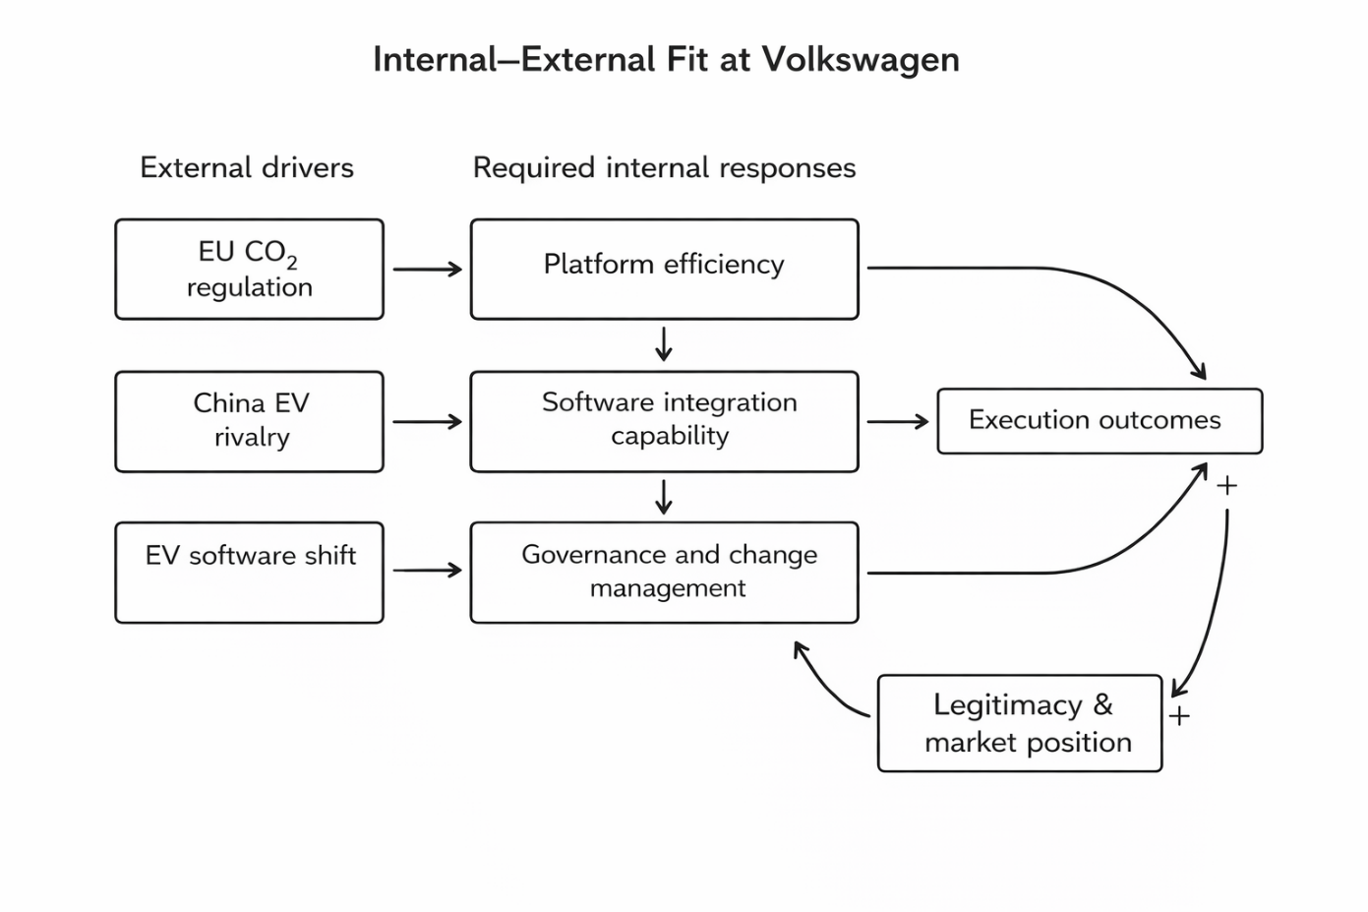
Figure 2. Internal–External Fit at Volkswagen (Self-Designed based on European Parliament and Council, 2025; Reuters, 2025; Paz and Ruiz Gálvez, 2021; Hayes, 2010)

CSR and Sustainability Objectives

Conceptual framing: CSR, sustainability and strategic CSR
CSR and sustainability can be used interchangeably, although there are differences between the two that cannot be described as absolute (Sheehy and Farneti, 2021). CSR belongs to an organisation to its stakeholders and the society, and, in the case of sustainability, the focus is placed on environmental and social sustainability over the long term and corporate sustainability is bringing these responsibilities into the strategy and governance and performance systems (Sheehy and Farneti, 2021). In the case of Volkswagen, this difference is significant since CSR should not be regarded as a reputational add-on, it must be operationalised as a strategic management capability that helps avoid risk and sustain long term competitiveness (Volkswagen Group, 2026). Strategic CSR hence demands systematic policies, management norms and quantifiable results that are directly connected with the generation of value, risk containment and validity in the stakeholder markets (Fonseca et al., 2023).
Table 7. Comparison of CSR, sustainability, and strategic CSR in Volkswagen’s context (Sheehy and Farneti (2021), Fonseca et al. (2023), Ismail (2021), and Volkswagen AG (2024)
Concept | Main focus | Strategic meaning | Relevance to Volkswagen
CSR | Responsibility to stakeholders and society (Sheehy and Farneti, 2021). | Ethical conduct, accountability, and legitimacy | Important because Volkswagen must rebuild stakeholder trust after the emissions scandal (Poier, 2020)
Sustainability | Long-term environmental, social, and economic balance | Focuses on continuity, resilience, and responsible value creation | Relevant due to decarbonisation, ESG reporting, and supply-chain scrutiny (Volkswagen AG, 2024)
Strategic CSR | Integration of CSR into strategy, governance, and performance systems | Turns responsibility into measurable value creation and risk management | Helps Volkswagen align legitimacy rebuilding with business performance and compliance capability (Fonseca et al., 2023; Volkswagen AG, 2024)

Volkswagen’s CSR strategy: legitimacy rebuilding and system integration
The CSR agenda of Volkswagen can also be closely connected with its post-emissions scandal (Aslaksen et al., 2021). The governance exposure of the emissions scandal increased the questioning of regulators, investors and consumers, and the strategic significance of the compliance, transparency and ethical leadership (Poier, 2020). The Annual Report 2024 of Volkswagen can be viewed as an indication of the introduction of sustainability objectives as the part of the corporate reporting and governance, where the institutional commitment to the implementation of ESG commitments as the component of the planning and reporting practises can be seen (Volkswagen AG, 2024).
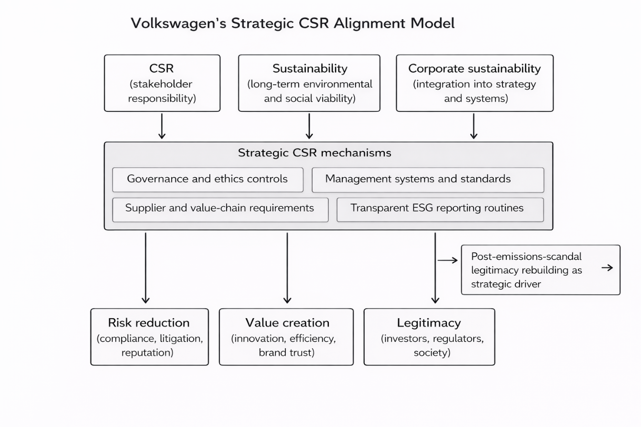
Figure 3. Post-emissions-scandal legitimacy rebuilding as strategic driver (Self-designed based on Sheehy and Farneti, 2021; Poier, 2020; Ismail, 2021; Volkswagen AG, 2024)

Alignment with business objectives: value creation and risk management
Volkswagen CSR strategy is congruent with business goals in the cases when it is applied to enhance regulatory compliance capacity, stabilise stakeholder trust and competitive advantage based on operational enhancement (Aslaksen et al., 2021). As explained by Fonseca, Carvalho and Santos (2023), when strategic CSR is implemented in management systems and reported in measurable outcomes, it leads to better sustainability. In this respect, the alignment of Volkswagen should be assessed based on the presence of CSR commitments that become standards in the supply chain, operational initiatives, governance controls and transparent reporting (Volkswagen AG, 2024; Sheehy and Farneti, 2021).

Strategy Formulation

Framing strategic choice under turbulence
Strategy formulation refers to the way Volkswagen will select and invest in a path of competing in the environment of environmental turbulence and internal limitations (Tawse and Tabesh, 2021). Although deliberate planning emphasises on an orientation in choice that is driven by analysis, Volkswagen operates in an environment where strategic learning and adaptation is unavoidable because of the dynamic nature of EV diffusion, regulation and software-defined vehicles as compared to traditional automotive planning cycles (Mintzberg et al., 2008; IEA, 2025). The key implication is that the process of formulation, used by Volkswagen, should be balanced in terms of long horizon platform bets and shorter cycle experimentation in software and customer experience (Volkswagen AG, 2024).

Business-level and corporate-level strategic choices and recommended direction
Structurally, the mass market brands by Volkswagen at the business level experience the issue of structural affordability in Europe where price pressure is growing and transition cost and compliance pressures are squeezing the margins (McKinsey and Company, 2025). Cost leadership is essential and perilous in the event that it is accomplished in a simplistic way by reducing expenses that lead to the loss of quality or perceived value and research has indicated that there are various performance and risk implications to cost leadership and differentiation strategies and incoherent mixing can harm performance (Dadashi and Amiri Lolaki, 2019).
Table 8. Comparison of business-level and corporate-level strategy in Volkswagen (Dadashi and Amiri Lolaki (2019), Bai (2021), Reuters (2025), McKinsey and Company (2025), and Volkswagen AG (2024)
Strategy level | Main focus | Key strategic issue for Volkswagen | Recommended direction
Business-level strategy | How individual brands compete in specific markets | Mass-market brands face affordability pressure, EV rivalry, and digital-experience expectations | Combine cost efficiency with selective differentiation in EV features, quality, and user experience (Dadashi and Amiri Lolaki, 2019; McKinsey and Company, 2025)
Corporate-level strategy | How the group allocates resources across brands, markets, and capabilities | Portfolio complexity, capital allocation, platform leverage, and China competitiveness | Prioritise cross-brand platforms, software integration, disciplined investment, and selective localisation in China (Reuters, 2025; Bai, 2021; Volkswagen AG, 2024)

At corporate level, the diversified portfolio of Volkswagen makes it resilient, but needs a discipline of resource allocation: capital must be biassed towards platforms and integration capabilities that bring cross-brand leverage (Volkswagen AG, 2024).
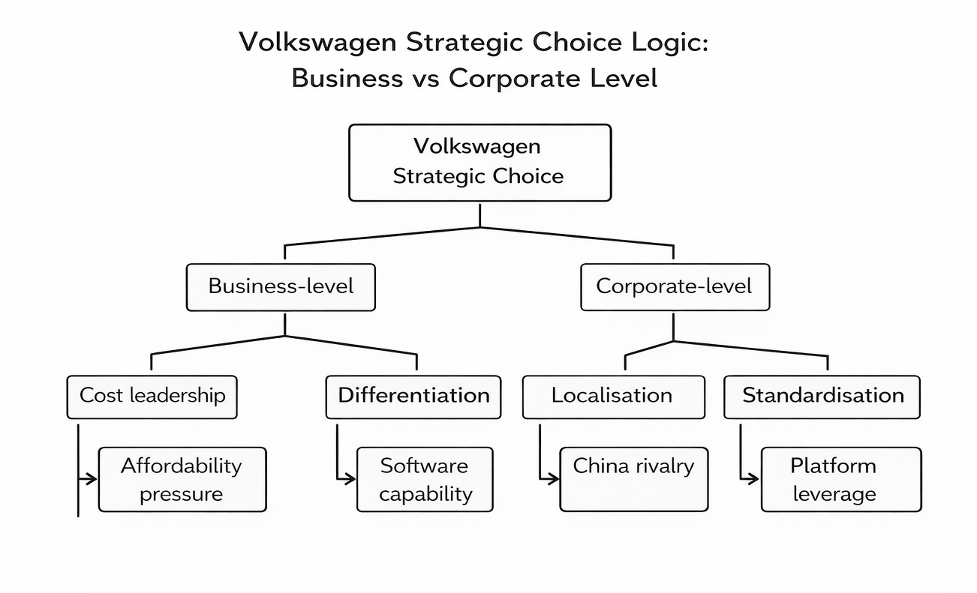
Figure 4. Volkswagen Strategic Choice Logic: Business vs Corporate Level (Self-designed based on Dadashi and Amiri Lolaki, 2019; Reuters, 2025; Bai, 2021)
In China, the locally responsiveness of strategy is necessary because the domestic EV competitors have become faster than the incumbents in terms of scale and customer value, therefore, the proposed corporate option is selective localisation in addition to core platform leverage and more stringent governance measures to prevent the risk of fragmentation (Reuters, 2025; Bai, 2021).

Strategy Implementation

Implementation as change management and capability building
Strategy implementation is transforming the intent into outcomes through structures, processes and behaviour (Tawse and Tabesh, 2021). According to change management theory, change will not succeed when leaders do not consider resistance, align structure and culture, or a strong feedback system, which is likely to be the situation in Volkswagen due to its size and multi-brand business complexity (Hayes, 2010). The EV and software transition of Volkswagen is not only a technical programme, but it is an organisational redesign task which comes with all the decision rights and cross-unit co-ordination and capability building it involves (Volkswagen Group, 2026).
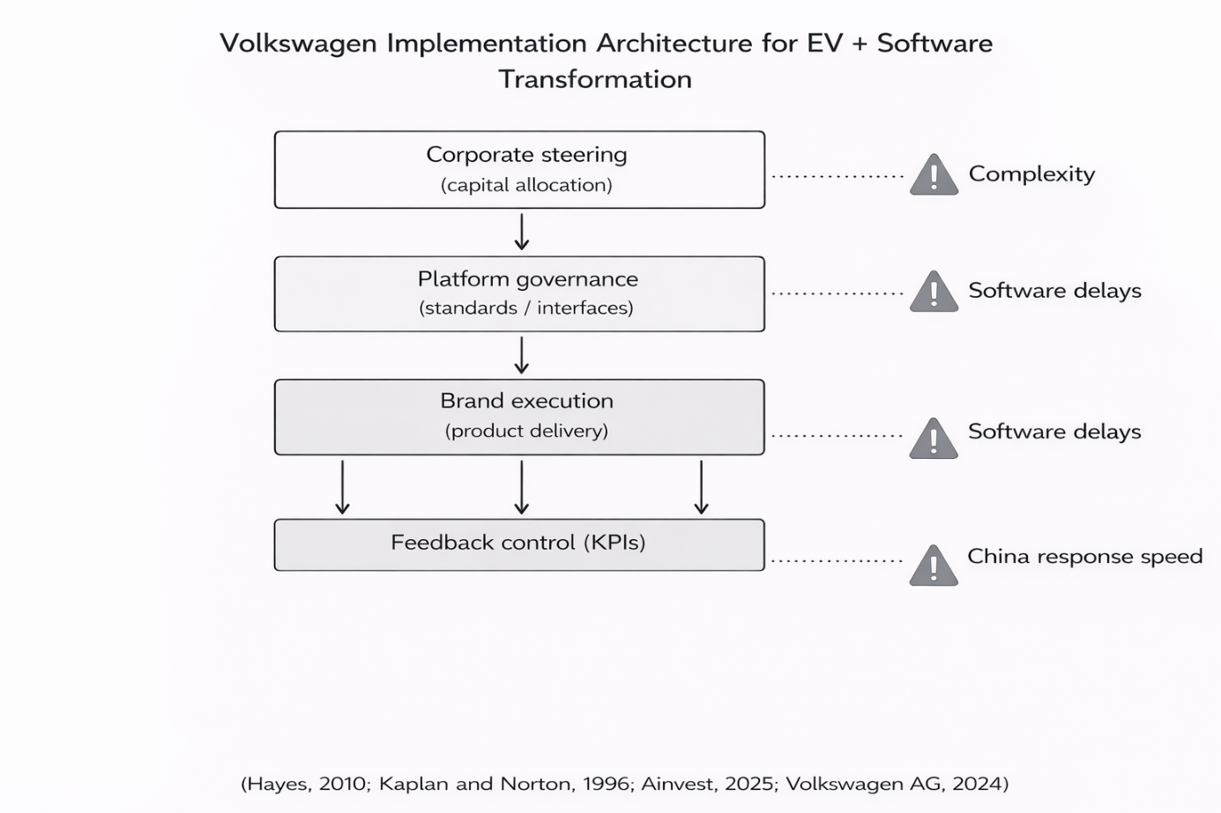
Figure 5. Volkswagen Implementation Architecture for EV and Software Transformation (Self-designed based on Ainvest, 2025; Volkswagen Group, 2026)

Implementation priorities, governance risks, and control mechanisms
The implementation priorities must be then emphasised on the clarity of governance and by measurement delivery (Tawse and Tabesh, 2021). Platform governance demands the given right to make decisions explicitly to eliminate duplication and avoid strategic fragmentation across brands (Volkswagen AG, 2024). Software integration requires partnership and internal capability development to be managed in unison as otherwise it risks creating more and more defects and not differentiation as the consequence, which would affect the cost leadership and brand credibility (Dadashi and Amiri Lolaki, 2019). The execution of the strategy in China has to be swift and locally responsive since the competitive shock is not cyclical but structural (Reuters, 2025). The controls should track these priorities of the type utilised in the Balanced Scorecard linking implementation activities to customer and process measures to ensure that early warning indicators are present and an appropriate response can be taken (Kaplan and Norton, 1996).
Table 9. Implementation priorities and change-management linkage Complexity risk across brands (Volkswagen AG, 2024)
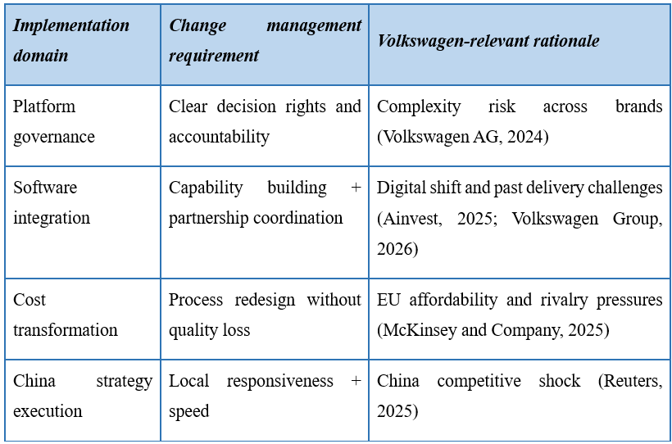

Evaluation and Control

Importance of evaluation and control
Evaluation and control mechanisms reduce strategic drift by integrating the goals, measures and actions to take (Wall, 2021). Balanced Scorecard is particularly applicable because it incorporates both financial and non-financial metrics in controlling the impact of strategy implementation, learning and capability development (Kaplan and Norton, 1996). This can be significant to Volkswagen since EV transformation success depends on the leading indicators like discipline of software releases, quality metrics and capability building, and not on short-term profits alone.

Balanced Scorecard for Volkswagen
Balanced Scorecard logic supports strategic coherence by making trade-offs visible (Kaplan and Norton, 1996; Hitt et al., 2019).
Table 10. Balanced Scorecard aligned to Volkswagen strategy and mission-level priorities
Perspective | Objectives | KPIs | Targets | Initiatives
Financial | Improve transformation efficiency and margin resilience | Operating margin trend; transformation ROI; unit cost reduction (Hitt et al., 2019). | Year-on-year improvement with protected quality | Platform standardisation governance; procurement leverage programmes
Customer | Strengthen EV value and digital experience | EV customer satisfaction; digital feature adoption; warranty claims | Improved satisfaction and reduced defects | Software product management; customer feedback loops; OTA reliability focus (Wall, 2021).
Internal processes | Accelerate development cycles | Time-to-market; compliance readiness rate; defect per vehicle | Shorter cycle time with stable quality | Integrated programme management; quality gate redesign; compliance-by-design
Learning and growth | Build software and change capability | Digital skills index; retention of key talent; change adoption metrics (Wall, 2021). | Capability growth with measurable adoption | Training, agile delivery discipline, leadership communication systems

As an example, aggressive cost reduction must be weighed against customer and process measures to ensure that quality is not thinned in such a manner that would undermine differentiation and trust, which aligns with the thinking of strategic management systems (Kaplan and Norton, 1996; Hitt et al., 2019).
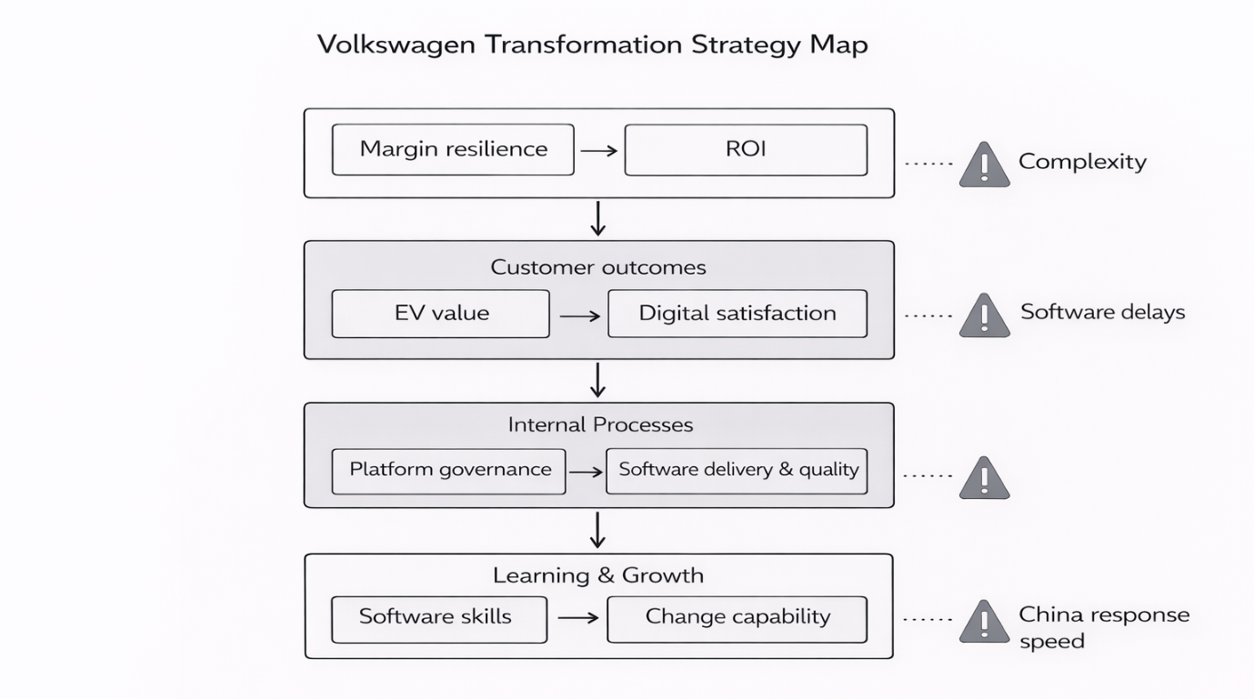
Figure 6. Volkswagen Transformation Strategy Map (Self-designed based on Hayes, 2010; Volkswagen AG, 2024)

Financial Plan
The financial strategy of Volkswagen will have to strike a balance between transformational investment and margin resilience during the period of an increased price competition and regulation (Alekseev et al. 2018). Under the FY2024 communications, Volkswagen highlights high performance and ongoing change agenda, implying that the management is more liquidity disciplined, cost controlled and strategic capital allocation in contrast to unchained growth spending (Volkswagen Group, 2025).
Investment is only financially rational in terms of the VRIO when it improves valuable capabilities that are difficult to imitate and coexist with organisational systems, in other words, modular platform leverage and software integration routines (Chatzoglou et al., 2018; Paz and Ruiz Gálvez, 2021). In the face of competitive shocks in China and affordability pressure in Europe, financial plan must emphasise initiatives with shorter payback due to scale effects, lower unit cost with no loss of quality, and that spending is associated with quantifiable delivery milestones to prevent the so-called ability spending and no ability output phenomenon (Reuters, 2025; McKinsey and Company, 2025).
Table 11. Financial-plan priorities linked to strategic capability and control (Volkswagen Group, 2025)
Financial priority | Strategic logic | Monitoring focus
Capital allocation discipline | Concentrate funding on platform leverage and integration capability (Alekseev et al. 2018). | ROI by platform/programme; delivery milestones (Volkswagen Group, 2025)
Cost transformation with quality protection | Defend margins while sustaining customer value | Unit cost trend; defect/warranty costs (McKinsey and Company, 2025)
Regional risk balancing | Reduce exposure to single-market shocks | China vs EU margin/volume mix (Reuters, 2025)
Investment-to-capability conversion | Ensure spending strengthens VRIO-relevant capabilities | Capability KPIs tied to outcomes (Chatzoglou et al., 2018)

Recommendation and Conclusion

Strategic evaluation using SWOT and Ansoff
SWOT can be applied in case evidence-based, and applied to the development of strategic options, rather than descriptive statements (Benzaghta et al., 2021). The strengths of Volkswagen include modularity and scale on the platform (Paz and Ruiz Gálvez, 2021), and its weaknesses include complexity in the organisation and risk of software delivery (Ainvest, 2025). The opportunities are EV diffusion in the markets, and the demand changes caused by regulations, and the threats are the increase in the intensity of competition with Chinese manufacturers and the affordability pressure (Reuters, 2025; McKinsey and Company, 2025).
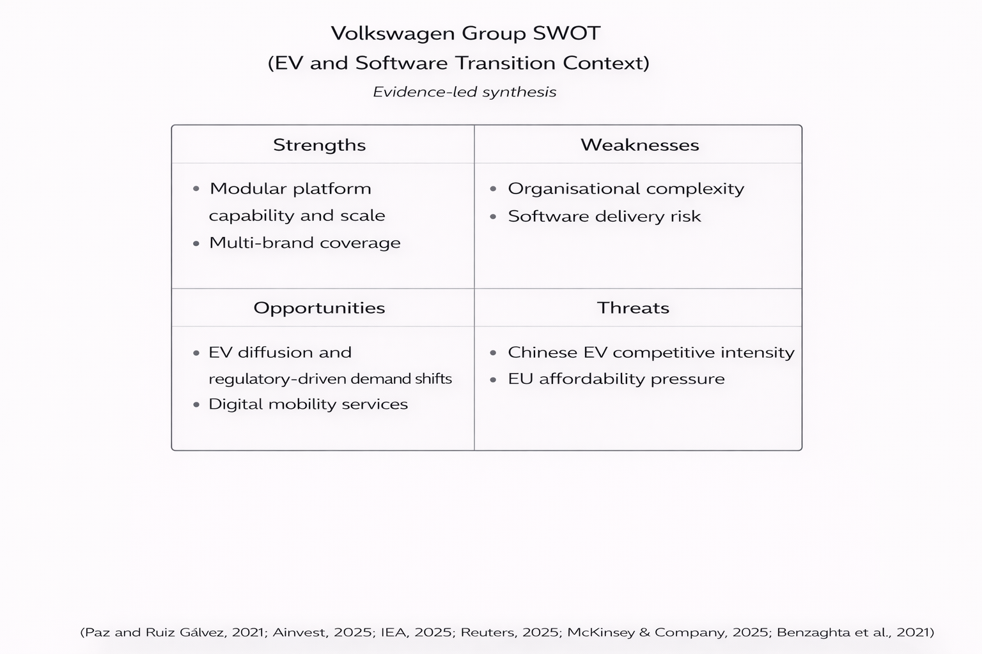
Figure 7. Volkswagen Group SWOT (EV and Software Transition Context) (Self-designed based on Reuters, 2025; McKinsey and Company, 2025)
Ansoff is the complement to SWOT as it assists in organising the potential developmental opportunities and determines the strategic risk exposure (Benzaghta et al., 2021). The matrix continues to be used to make market penetration, product development, market development and diversification decisions in information and service adjacent expansion like digital mobility services (Ferreira and de Sá, 2024). In the case of Volkswagen, the product development and market penetration in Europe will entail low-cost provision of EVs as per compliance and expectation of the customers, and market development is to be used in selected regions in a disciplined manner without excessive stretching. It is not generic expansion in China but a local relevance product and digital differentiation strategy in regaining its competitiveness amidst stiff domestic competition (Reuters, 2025; Bai, 2021).
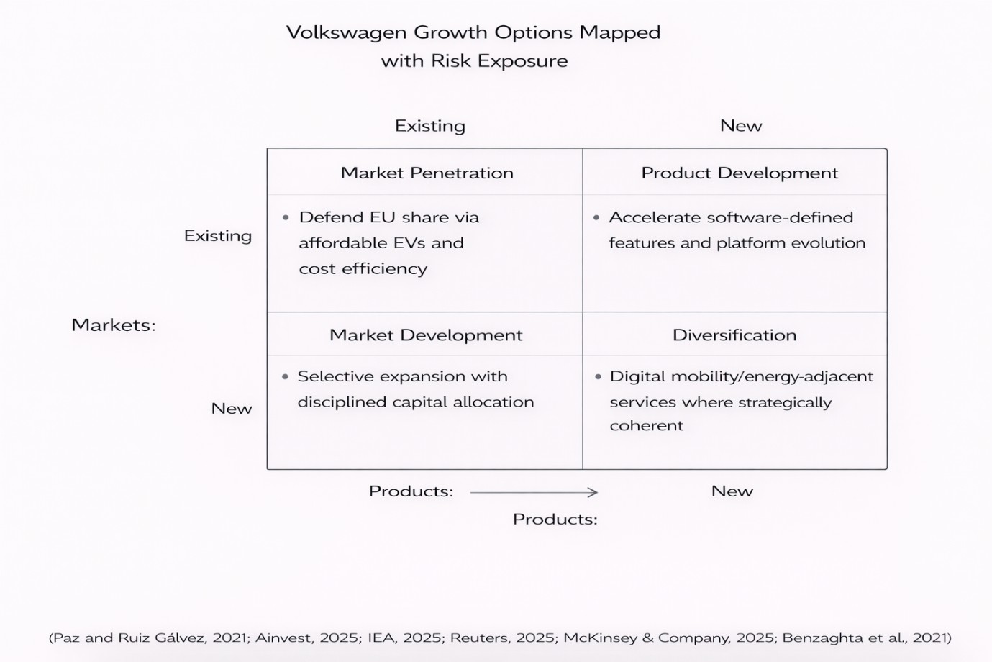
Figure 8. Volkswagen growth strategy matrix (Self-designed based on Reuters, 2025; Bai, 2021)

Recommendations (evidence-led and implementation-oriented)
First, Volkswagen needs to strengthen a firm-wide integration capability as a core strategic competence, where elements of software delivery, partner integration and governance are regarded as VRIO relevant organisational capabilities and not discrete projects; this is a direct response to strategic importance of software-defined vehicles, and an answer to well-publicised challenges with tech-unit performance (Ainvest, 2025; Volkswagen Group, 2026).
Secondly, platform and portfolio governance in Volkswagen ought to be instituted to reduce the cost of complexity, protect speed and offer affordability without sacrificing quality. Modular platform effects supplier evidence suggests that modularity can help to achieve coordination and performance when interfaces and standards are handled in a similar fashion (Paz and Ruiz Gálvez, 2021). This will enable the cost leadership on the mass market brands and concurrent differentiation on the premium brands based on the competitive strategy trade-offs offerings in the literature (Jyoti et al., 2017).
Third, Volkswagen ought to come up with a strategy of China which is local responsiveness and digital features competitiveness, and performance accountability. According to investigative reporting, new auto giants in China have moved ahead of incumbents and therefore position is unlikely to be reclaimed by using business as usual (Reuters, 2025). The relevance of localisation of overseas management strategies to the host market dynamics, as opposed to global standardisation, is also expressed in international strategy research relating to Volkswagen (Bai, 2021).

Conclusion
The strategic management issue that Volkswagen is facing is to convert strong scale and modular platform assets into long-term competitive advantage under increased regulatory constraints, hastening EV adoption, and major competitive pressure. The externality analysis shows that fast regulatory flexibility in the short term does not nullify the long-term pressure of transformation as the demand aspect of the competitive pressure and in particular, the competitive pressure of the EV ecosystem in China compel the urgency to deliver the cost and capability (European Parliament and Council, 2025; Reuters, 2025). The internal analysis indicates that platform capability is a believable competitive advantage in cases where organisational alignment is strong, however software integration and complexity control are overwhelming limitations.

Reflective Account (Gibbs’ Reflective Cycle)

Description
The process began by mapping the assignment requirements onto the leader of the module proposals on how to structure assignments with the meaning that the individual components of the brief were mapped to the PESTEL, VRIO, CSR, Balanced Scorecard, strategic choice, implementation, and evaluation: them. The second step was to select the sources out of the list of references given in order to form an evidence-based story. The organisational context and strategic intent were taken as main sources of company reporting (Volkswagen Group, 2025), and the priority was given to the regulatory and competitive environment information as external sources (European Parliament and Council, 2025; Reuters, 2025; IEA, 2025). Then the support of the model application was also supported by scholarly sources and the reinforcement of the critique instead of the description (Buye, 2021, Chatzoglou et al., 1996).

Feelings
Initially, there was the danger of publishing a model-laden report which explained structures without building an argument. This was enhanced by the fact that the need to cut the normal length of a report to a shorter one could encourage the superficiality of the report. The regained confidence would be in the form of a clear thread: the argument in the report would be that competitive advantage of Volkswagen lies in internal -external fit with the platform modularity as an asset and software integration as a liability. Structured method also helped to make the anxiety less intimidating because each part comprised the final recommendations in line with the advantages of reflective practise reported in literature of the field (Adeani et al., 2020).

Evaluation
The most prominent aspect of the process was the capability to tie evidence to analysis in a disciplined fashion, in particular with the help of regulation as a tangible external constraint and modular platform evidence as a tangible inner ability (Paz and Ruiz Gálvez, 2021). This improved the credibility of recommendations because they were based on logical sense of problems diagnosed. It had a weakness in the fact that time and word count limit made it impossible to conduct financial analysis in greater detail and gave a lesser chance to examine other strategic scenarios in detail. A small universe of high impact sources of external information was also used to determine the current competitive dynamics, but triangulation was also made by integrating context of the industry with evidence of IEA and European competitiveness commentary (IEA, 2025).

Analysis
The application of Gibbs cycle enabled an iterative cycle of evidence selection, model application and synthesis until sections were coherent. The PESTEL phase had to be approached with a critical eye to avoid perceiving categories as being independent; scholarly research cautions that PESTEL approaches the strategist side of strategic planning to become mechanistic without the analyst consciously forming the connection between the categories and strategic decisions and taking into account the limitations of the tools (Buye, 2021). Similarly focused discipline was also required by VRIO analysis since the value and the rarity is a statement that can be made and not proved and the process so was oriented towards capabilities that have a much more empirically grounded base such as modular platforms and organisational systems, which aligns with the RBV research that highlights the importance of firm-specific factors in the formation of strategy - performance outcomes (Chatzoglou et al., 2018).
Balanced scorecard was subsequently used as an interface between strategy and implementation to seal the gap between abstract priorities and measurable initiatives and this aligns with the argument by Kaplan and Norton that the scorecards were strategic management systems and not performance dashboards (Kaplan and Norton, 1996). This is a reflective discussion that greatly aligns with the idea that critical strategy work is based on the requirement to move beyond description to justified judgement under incomplete data

Conclusion
This process revealed that writing a good strategic report needs consistency compared to quantity: The case needs to connect context, external forces, internal capabilities, and suggestions with rationalised logic and affirmations. We learned the best, that models are not convincing as such, but rather as analytical instruments to organise evidence and create action implications. The second lesson was that implementation capability is a strategic variable; concepts of change management are needed in order to prevent recommendations that presuppose a frictionless implementation of the recommendations (Hayes, 2010).

Action Plan
To enhance future tasks, the initial step will be to enhance the quality of the evidence by sourcing more quantified measures of performance directly out of Volkswagen annual reporting and incorporating them into the argument, especially in the case of profitability drivers, investment priorities, and regional performance comparisons. That would enable the analysis to shift to closer examinations on whether strategic initiatives are enhancing outcomes. The second will be to develop other strategic situations prior to writing the final recommendations where at least two possible strategic routes are compared and how they would work under varying market and regulatory environments. It will be reinforced by clear risk and sensitivity analysis as part of the evaluation and control section so that the recommendations will not reflect the norms but this uncertainty.

Reference List
Adeani, I. S., Febriani, R. B. and Syafryadin, S. (2020) Using GIBBS’ reflective cycle in making reflections of literary analysis. Indonesian EFL Journal, 6(2), 139–148.
Ainvest (2025) Volkswagen revives troubled tech unit key to its future – FT. Ainvest, 2 October. Available at: https://www.ainvest.com/news/volkswagen-revives-troubled-tech-unit-key-future-ft-2510/ (Accessed: 2 March 2026).
Alekseev, A. N., Evdokimov, S. Y., Tarasova, A. Y., Khachaturyan, K. S., and Khachaturyan, A. A. (2018) Financial strategy of development of industry 4.0 in the countries with developing economy. Revista Espacios, 39(12).
Aslaksen, H. M., Hildebrandt, C., and Johnsen, H. C. G. (2021) The long-term transformation of the concept of CSR: Towards a more comprehensive emphasis on sustainability. International Journal of Corporate Social Responsibility, 6(1), 11.
Bai, Y. (2021, March) Analysis of Overseas Management Strategy of the Volkswagen Group. In 6th International Conference on Financial Innovation and Economic Development (ICFIED 2021) (pp. 229–234). Atlantis Press.
Benzaghta, M. A., Elwalda, A., Mousa, M. M., Erkan, I. and Rahman, M. (2021) SWOT analysis applications: An integrative literature review. Journal of Global Business Insights, 6(1), 55–73.
Berry, S., Gaynor, M., and Morton, F. S. (2019) Do increasing markups matter? Lessons from empirical industrial organization. Journal of Economic Perspectives, 33(3), 44-68.
Bou Hatoum, M., Nassereddine, H., Musick, S. and El-Jazzar, M. (2023) Investigation of PESTEL factors driving change in capital project organizations. Frontiers in Built Environment, 9, 1207564.
Buye, R. (2021) Critical examination of the PESTEL analysis model. Project: Action Research for Development, pp. 1–12.
Chatzoglou, P., Chatzoudes, D., Sarigiannidis, L. and Theriou, G. (2018) The role of firm-specific factors in the strategy-performance relationship: Revisiting the resource-based view of the firm and the VRIO framework. Management Research Review, 41(1), 46–73.
Chen, R. (2024) Shaking things up? Chinese EVs impact on the global auto industry. Third Bridge Perspectives, 1 November. Available at: https://www.thirdbridge.com/en-us/about-us/media/perspectives/how-chinese-evs-are-shaking-up-the-global-auto-industry (Accessed: 2 March 2026).
Collins, G. S., Dhiman, P., Ma, J., Schlussel, M. M., Archer, L., Van Calster, B., ... and Riley, R. D. (2024) Evaluation of clinical prediction models (part 1): from development to external validation. bmj, 384.
Dadashi, I. and Amiri Lolaki, Z. (2019) Corporate diversity and bankruptcy risk; with emphasis on differentiation strategies and cost leadership. Financial Accounting Knowledge, 6(2), 185–213.
David, F. R., David, F. R. and David, M. E. (2017) Strategic Management: Concepts and Cases: A Competitive Advantage Approach. Pearson.
E. Dobbs, M. (2014) Guidelines for applying Porter's five forces framework: a set of industry analysis templates. Competitiveness review, 24(1), 32-45.
European Parliament and Council (2025) Regulation (EU) 2025/1214 of 17 June 2025 amending Regulation (EU) 2019/631 to include an additional flexibility as regards the calculation of manufacturers’ compliance with CO2 emission performance standards for new passenger cars and new light commercial vehicles for the calendar years 2025 to 2027. Available at: https://eur-lex.europa.eu/eli/reg/2025/1214/oj/eng (Accessed: 2 March 2026).
Ferreira, A. P. P. F. S. and de Sá, M. M. B. P. (2024) The importance of the Ansoff matrix for the study of the information services market. The Canadian Journal of Information and Library Science, 47(2), 78–84.
Fonseca, L., Carvalho, F. and Santos, G. (2023) Strategic CSR: Framework for sustainability through management systems standards—Implementing and disclosing sustainable development goals and results. Sustainability, 15(15), 11904.
Hayes, J. (2010) The Theory and Practice of Change Management. Palgrave Macmillan.
Hitt, M. A., Ireland, R. D. and Hoskisson, R. E. (2019) Strategic Management: Competitiveness and Globalization: Concepts and Cases, Ch. 2. Cengage Learning.
International Energy Agency. (2025) Global EV outlook 2025: Expanding sales in diverse markets (Revised version, July 2025) [Report]. Available at: https://iea.blob.core.windows.net/assets/7ea38b60-3033-42a6-9589-71134f4229f4/GlobalEVOutlook2025.pdf (Accessed: 2 March 2026).
Ismail, Y. (2021, March) Reach sustainability through Corporate Social Responsibility (CSR). In IOP Conference Series: Earth and Environmental Science, 716(1), 012056. IOP Publishing.
Jyoti, J., Arora, H. and Kour, S. (2017) Outsourcing and organizational performance: Role of cost leadership, differentiation and innovation strategies. In Sustainable Competitive Advantage: A Road to Success, p. 171.
Kaplan, R. S. and Norton, D. P. (1996) Using the balanced scorecard as a strategic management system. Harvard Business Review.
Larbi, A. O., Asare-Danquah, G. A. and Ackah, A. A. F. (2024) Utilization of internal analysis with the VRIO framework and development of scale for resource and capabilities of fashion and design organization. International Journal of Research and Scientific Innovation, 11(6), 63–70.
Lubis, N. W. (2022) Resource based view (RBV) in improving company strategic capacity. Research Horizon, 2(6), 587-596.
McKinsey and Company (2025) A new ‘ERA’: An action plan for the European automotive industry. McKinsey, 8 September. Available at: https://www.mckinsey.com/features/mckinsey-center-for-future-mobility/our-insights/a-new-era-an-action-plan-for-the-european-automotive-industry (Accessed: 2 March 2026).
Miethlich, B. and Oldenburg, A. G. (2019) The employment of persons with disabilities as a strategic asset: A resource-based-view using the value-rarity-imitability-organization (VRIO) framework. Journal of Eastern Europe Research in Business and Economics, 1, 1–13.
Mintzberg, H., Ahlstrand, B. and Lampel, J. (2008) Strategy Safari: The Complete Guide Through the Wilds of Strategic Management. Harlow: FT Prentice Hall.
Paz, M. J. and Ruiz Gálvez, M. E. (2021) Effects of modular platforms on suppliers companies: Evidence from Volkswagen Polo manufacturing in Navarra (Spain). Journal of Manufacturing Technology Management, 32(2), 337–355.
Poier, S. (2020) Clean and green–the Volkswagen emissions scandal: Failure of corporate governance? Problemy Ekorozwoju, 15(2), 33–39.
Reuters (2025) How China’s new auto giants left GM, VW and Tesla in the dust. Reuters Investigations, 3 July. Available at: https://www.reuters.com/investigations/how-chinas-new-auto-giants-left-gm-vw-tesla-dust-2025-07-03/ (Accessed: 2 March 2026).
Sheehy, B. and Farneti, F. (2021) Corporate social responsibility, sustainability, sustainable development and corporate sustainability: what is the difference, and does it matter? Sustainability, 13(11), 5965.
Sheehy, B., and Farneti, F. (2021) Corporate social responsibility, sustainability, sustainable development and corporate sustainability: what is the difference, and does it matter?. Sustainability, 13(11), 5965.
Tawse, A., and Tabesh, P. (2021) Strategy implementation: A review and an introductory framework. European management journal, 39(1), 22-33.
Ulubeyli, S., Kazancı, O., Kazaz, A. and Arslan, V. (2019) Strategic factors affecting green building industry: A macro-environmental analysis using PESTEL framework. Sakarya University Journal of Science, 23(6), 1042–1055.
Volkswagen AG (2024) Volkswagen Group Annual Report 2024. Available at: https://annualreport2024.volkswagen-group.com/_assets/downloads/entire-vw-ar24.pdf?h=5AteXYgL (Accessed: 2 March 2026).
Volkswagen Group (2025) Volkswagen Group with solid FY 2024 results and a robust outlook (Media Information, No. 18/2025, 11 March 2025). Available at: https://uploads.vw-mms.de/system/production/documents/cws/002/941/file_en/90c2f89b8eaadfa5941d47a52265de7437f2b17b/PM_Volkswagen_Group_with_solid_FY_2024_results_and_a_robust_outlook.pdf (Accessed: 2 March 2026).
Volkswagen Group (2026) The Car of the Future. Available at: https://www.volkswagen-group.com/en/the-car-of-the-future-19027 (Accessed: 2 March 2026).
Wall, W. P. (2021) Strategic management and evaluation of the performance of family firms using management control system. Transnational Corporations Review, 1-16.

