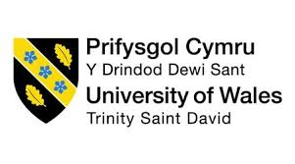

MANAGEMENT AND ORGANISATIONAL BEHAVIOUR
BMIH5004

STUDENT NAME: KALLE CLEMENT DITOU
STUDENT ID: 2029083

LECTURER: DANIEL PAYNE WORDCOUNT: 2052

AI Acknowledgement
I confirm that I have not used any AI tools in the research and creation of this assignment and have not presented any AI-generated materials as my own work. I confirm that I have copies of my drafts, notes, and other resources I used, which I may be asked to provide in evidence.

Executive Summary
The following assignment on management and organisational behaviour is focused on the business environment of Hyatt Hotel Corporation. The management of the organisation involved assessing organisational structure and managing a positive workplace culture. The report explored recent changes in the organisation, which included sustainable practices and digital transformation. In addition to this, the strategic direction of the organisation was also explored, which included offering an improved experience for customers and guests. The strategic approach was supported by technological integration and effective employee management.

Table of Contents
Introduction 5
Organisational Structure, Culture and Goals 6
Recent Change Initiatives 7
Strategic Direction 9
Conclusions 11
Recommendations 11
References 12

Introduction
Hyatt Hotels Corporation is an American multinational hospitality company with its headquarters in California, United States. The company was founded by Jay Pritzker in 1957, and he worked with his brother to deliver improved care to customers within the hospitality industry. At present, it is one of the leading world hotel groups with 1300 hotels and other properties in 76 countries (Hyatt About, 2023). Its services include resort management, brand management, tour operator, travel agency, destination management, accommodations and so on. In 2023, the company generated a revenue of GBP 5.13 billion, which shows its popularity and recognition among consumers (Statista, 2023). The company’s diverse and distinct portfolio of brands is effective in the market.
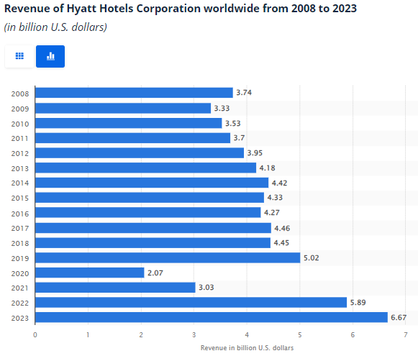
Figure 1: Revenue generated by Hyatt Hotel Corporation
(Source: Statista, 2023)
In the following report, the organisational structure, culture and goal of the company will be assessed and evaluated. It will also focus on recent change initiatives taken by the company to adapt to the market needs. The report will also focus on strategic direction along with strategies applied to accomplish long-term objectives. These areas will be explored to achieve a clear insight into management and organisational behaviour. Based on this analysis, recommendations will be provided to Hyatt Hotel Corporation.

Organisational Structure, Culture and Goals
Organisational structure refers to the framework that defines activities, responsibilities and direction for the organisation to achieve set objectives. It also includes the allocation of tasks along with coordination and supervision towards the objective (Wood et al., 2024). The business operation of Hyatt Hotel Corporation is managed through a hierarchical business structure. The company’s management is led by the President and CEO, Mark Hoplamazian (Hyatt, 2024a). The hierarchical structure of the hotel has an impact on both corporate and individual levels. The hierarchical structure of the hotel has an impact on both corporate and individual levels. This structure presents a clear role and guidelines among employees that improve their efficiency and engagement (Leino et al., 2022). Other advantages of this structure include specialisation, well-organised operations and opportunity for career growth. The company gives tasks to employees based on their specialisation and interests, which results in higher productivity. The well-organised operation of Hyatt Hotel Corporation can be understood from its clear chain of command. Career growth opportunities and specialisation promote higher employee engagement as these deliver higher satisfaction in the workplace (Mullins, 2019). The growth opportunity for employees enhances job satisfaction and employee engagement in the workplace. At the individual level, a hierarchical structure offers opportunities for career growth and development. However, there are certain disadvantages to the structure, such as reduced autonomy, lack of flexibility, departmental rivalry, and higher costs for management.
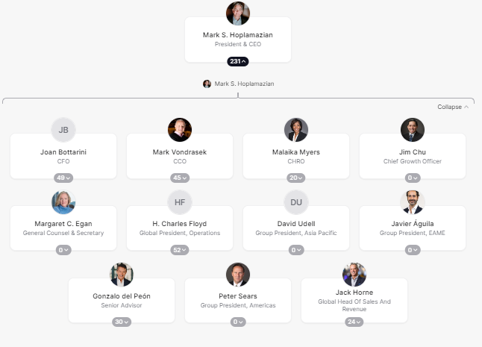
Figure 2: Organisational Structure of Hyatt Hotel Corporation
(Source: Hyatt, 2024b)
Corporate culture describes a set of values, principles and behaviours influencing the activities of employees (Mullins and Dosser, 2013). Hyatt’s corporate culture has had a significant influence on its business operations. The culture of a firm is categorised into clan, market, adhocracy and hierarchy cultures. The corporate culture of Hyatt Hotel Corporation can be described as the clan culture, which fosters family-like relationships with employees. This culture offers several advantages to the company, including higher employee retention and engagement, open communication, effective collaboration and adaptability. As per Handy’s Cultural types, corporate culture can be distinguished as task culture, power culture, person culture and role culture (Mullins, 2023). The task culture enables Hyatt Hotel Corporation to focus on completing business tasks, while the power culture represents quick decision-making as the power is held by higher authorities only. The personal culture of the company effectively focuses on individuals, offering individual autonomy in the workplace. On the other hand, role culture focuses on delegating responsibilities and roles based on individuals’ specialisation, interests and educational qualifications. Apart from this, the visionary leadership style implemented in the company focuses on delivering better care for both guests and employees (Armstong, 2021).
The structure, culture and leadership of Hyatt Hotel Corporation helps to accomplish goals at both corporate and individual unit levels. The goal of the company is to provide better care for people alongside an inclusive experience (Hyatt, 2024). It also focuses on delivering distinctive experiences for guests and creating a world of better care and understanding. At the individual level, the company’s goal is to support the development of employees and provide them with opportunities for career growth. Offering excellent customer service to each guest is also a part of the goal and contributes to the organisation’s ultimate objective. At an individual level, the goals of Hyatt Hotel Corporation include innovation, effective employee engagement, and employee development. The company provided opportunities and training for employees to improve their professional skills and knowledge. Career advancement is also an important goal in this case, where employee development and contributions offer better positions in the organisation.

Recent Change Initiatives
In Hyatt Hotel Corporation, recent change initiatives were primarily focused on developing the organisation and its operations. The company has been taking a scientific approach to address the issue of climate change and water resources. The company has set the target of cutting greenhouse gas emissions through a scientific approach (Hyatt About, 2021). Digital transformation can be highlighted as another meaningful recent change adopted by Hyatt Hotel in its business operation (Hyatt About, 2024). In terms of digital hospitality, the company is leading other competitors by optimising the digital experience for guests. For example, the Hyatt iOS app helps digitally manage the guest experience. The shift to cloud management systems highlights the recent change or development of the company toward digital transformation. It enhances the firm's ability to manage many hotels, improving the reservation system (Armstrong, 2012).
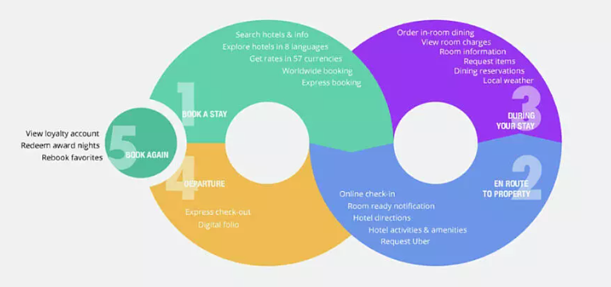
Figure 3: Digital approach in Hyatt Hotel Corporation
(Source: Kyatt, 2024)
These changes in Hyatt Hotel Corporation significantly impact its business operations and management. On the other hand, digital transformation in the company has directly impacted operational efficiency and effectiveness. The change has supported the company in delivering an integrated approach to managing hotel and guest preferences. Innovation is one of the potential impacts of digital transformation, and it helps the company address issues effectively. Digital technologies also improve teamwork and collaboration by making it possible to interact and access information easily. Another important impact of the change is to improve customer services as data collected helps to understand customers' needs.
Sustainability has empowered the organisation to deal with environmental or social issues (‌Shakeel et al., 2020). The impact of sustainable change in the company is that it has enhanced the image and reputation of the company.
The company has managed these changes successfully and it can be seen from the improvement in services delivered in the market. Managing change is a difficult process for an organisation as it faces several challenges and barriers (Buchanan and Huczynski, 2007). The company identified and analysed sustainability and digital transformation challenges to implement a change management system successfully. These changes were managed well by involving different stakeholders, including employees and investors. Employees were encouraged and motivated to be involved and support these new changes. The management of change was supported by clear communication and transparency, which delivered the desired output. The company achieved successful digital transformation and implementation of sustainable practices.

Strategic Direction
The company's strategic direction is the roadmap created to reach its goals and objectives. It includes both decisions and actions necessary to accomplish the targeted objectives (Huczynski and Buchanan, 2019). This ultimately helps the company achieve its vision using fundamental ideas that enhance organisational strategy. Strategic direction is important as it provides a direction and guides decision-making towards a particular goal. In the case of Hyatt Hotel Corporation, the goal is to expand the business while offering the best care to guests. Its goals of improving guest experience and bringing a change in their life are supported by its strategic direction. Sustainability can be taken as one of the strategic directions of the organisation which is focused on fulfilling the sustainable demand of consumers. The success of an organisation can be measured by its ability to meet and satisfy consumers' needs and requirements (Arslan, 2020). In 2022, it was found that 78% of travellers worldwide want to stay at least once in sustainable or eco-friendly accommodation (Statista, 2022). Investing in this area helps Hyatt Hotel to satisfy the existing demand of consumers in the hospitality industry. It contributes to the goal of the company to deliver better care and well-being of guests.
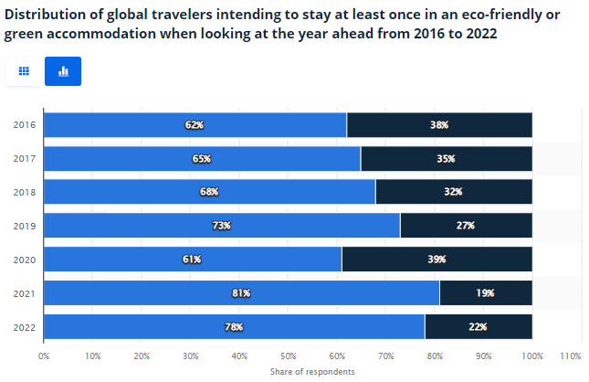
Figure 4: Sustainable demand among travellers
(Source: Statista, 2022)
The luxury and lifestyle focus of Hyatt Hotel can be regarded as an effective strategic direction to support its business objectives. One of the major objectives of the business is to ensure customer satisfaction and build loyalty. The hospitality and tourism industry has witnessed a significant demand for premier and luxury experiences (Sousa et al., 2021). In this case, fulfilling the demand for a premier travelling experience for customers empowers the organisation’s performance. These strategic directions provide a sense of purpose and guide actions as well as decisions of the organisation (Adair, 2009).
Hyatt Hotel Corporation has implemented a range of strategies to achieve its long-term objectives. Technological integration is one of them, and it proves to be extremely important. Technologies like AI, data analytics, and cloud computing increase efficiency in business operations (Jayawardena et al., 2023). It also helps the company to make more precise decisions by analysing a large amount of data. Sustainability is another important step taken by the company to ensure its long-term success within the market. In the hospitality and tourism industry, people have become more aware of environmental safety and prefer sustainable services. Implementing a sustainable model in the business helps the company to align with customers’ interests. Employee management is an important approach taken by an organisation to support its future success. The successful accomplishment of long-term business goals depends on the involvement and engagement of employees (Boddy, 2017). In this case, Hyatt Hotel selects potential employees and offers effective training and development opportunities. In addition to this, the performance management system and employee motivation strategies are aligned throughout the process. Apart from this, the company ensures continuous monitoring and control of the strategies. It ensures that the company's progress towards future goals is on track and that the desired result is delivered.

Conclusion
In the above report, the organisational structure, culture, and goals of Hyatt Hotel Corporation were assessed and evaluated. It focused on recent change initiatives taken by the company to adapt to the market needs. The report also focused on strategic direction along with strategies applied to accomplish long-term objectives. These areas were explored to achieve a clear insight into management and organisational behaviour. From the above analysis, it was found that the management of an organisation considers a range of areas influencing its future objectives. The company was found to apply different strategies that supported long-term objectives and success in the industry.

Recommendation
The above report analysed the management and organisational behaviour through the lens of Hyatt Hotel Corporation. The most important area for the company to focus on is addressing issues regarding its business structure. To be specific, the company should improve alignment between individual goals like growth and development and corporate goals. It can be achieved by communicating clear goals and incorporating inputs from employees. For the change initiatives, the company can apply a range of change management models that make the process much easier and faster. Lewin's change management model is one of the most effective, as it states clear steps and strategies to plan and manage change. The company’s change should align more with the existing and changing demands of consumers. At present, the customers’ demands include technological integration, improved customer service and convenience in booking processes. Employees should be offered training and development programs to make them capable of adapting to change, supporting strategic directions and using modern technologies and tools like AI, data analytics and IoT. The management team needs to consider and study these recommended practices. Improvement in these areas is important for the company to maintain its competitive position and support long-term business goals. For this, the company should ensure the involvement of employees in decision-making.

References
Adair, J. (2009) The Inspirational Leader (2nd Ed), London: Kogan Page
Armstrong, M. (2012) Armstrong’s Handbook of Management and Leadership (3rd Ed), London: Kogan Page.
Arslan, I.K. (2020) The importance of creating customer loyalty in achieving sustainable competitive advantage. Eurasian Journal of Business and Management, 8(1), pp.11-20.
Boddy, D. (2017) Management: An Introduction (7th Ed), Harlow, Pearson
Buchanan, D. and Huczynski, A. (2007) Organisational Behaviour: An Introductory Text (6th edition), Harlow: Prentice Hall.
Huczynski, A. and Buchanan, D. (2019) Organisational Behaviour (10th Ed), Harlow: Pearson
‌Hyatt (2024a) Hyatt | The Org. [online] THE ORG. Available at: https://theorg.com/org/hyatt [Accessed 23 Oct. 2024].
‌Hyatt (2024b) Hyatt Mission, Vision & Values. [online] Comparably. Available at: https://www.comparably.com/companies/hyatt/mission [Accessed 23 Oct. 2024].
‌Hyatt About. (2021) Climate Change and Water Conservation | Hyatt World of Care. [online] Available at: https://world.hyatt.com/content/hyatt-about/en/world-of-care/caring-for-the-planet/climate-change-and-water-conservation.html#:~:text=We%20strive%20to%20accelerate%20climate,which%20we%20achieved%20in%202018. [Accessed 23 Oct. 2024].
Hyatt About. (2023) About Hyatt. [online] Available at: https://about.hyatt.com/en.html [Accessed 23 Oct. 2024].
Hyatt About. (2024) Digital Technology. [online] Available at: https://about.hyatt.com/en/risehy/digital-technology.html [Accessed 23 Oct. 2024].
Jayawardena, C., Ahmad, A., Valeri, M. and Jaharadak, A.A., (2023) Technology acceptance antecedents in digital transformation in the hospitality industry. International Journal of Hospitality Management, 108, p.103350.
Kyatt. (2024) Hyatt: Leading the industry in digital hospitality | Slalom Build. [online] Available at: https://www.slalombuild.com/en-gb/case-studies/hyatt [Accessed 5 Nov. 2024].
Leino, T. et al. (2022) August. Challenging hierarchical structure to boost technical outcomes. In European Conference on Software Process Improvement (pp. 707-714). Cham: Springer International Publishing.
Mullins, L and Dosser, P. (2013) Hospitality Management and Organisational Behaviour (5th Ed) Harlow, Pearson.
Mullins, L. (2019) Organisational Behaviour in the Workplace (12th edition) Harlow:Pearson
Mullins, L. (2023) Management and Organisational Behaviour (13th edition) Harlow: Pearson
‌Shakeel, J. et al. (2020) Anatomy of sustainable business model innovation. Journal of cleaner production, 261, p.121201.
Sousa, B.B., Magalhães, F.C. and Soares, D.B., (2021) The role of relational marketing in specific contexts of tourism: A luxury hotel management perspective. In Building consumer-brand relationship in luxury brand management (pp. 223-243). IGI Global.
‌Statista. (2022) Global travelers that want to use green lodging in the next year 2022 | Statista. [online] Available at: https://www.statista.com/statistics/1055777/sustainable-travel-travelers-staying-in-green-lodging-in-the-next-year/#:~:text=According%20to%20the%20source%2C%20as,looking%20at%20the%20year%20ahead. [Accessed 23 Oct. 2024].
‌Statista. (2023) Hyatt Hotels revenue worldwide 2023 | Statista. [online] Available at: https://www.statista.com/statistics/257362/revenue-of-the-hyatt-hotels-corporation/#:~:text=The%20Hyatt%20brand&text=In%202023%2C%20the%20number%20of,the%20industry%20average%20of%2075. [Accessed 23 Oct. 2024].
Wood, J.M., Wiesner, R., Morrison, R.R., Factor, A. and McKeown, T., (2024). Organisational behaviour: Core concepts and applications. John Wiley & Sons.
‌

