LITERARY ACCOUNTS OF VICTORIAN LIVERPOOL

Emily Brontë, Wuthering Heights (Oxford: Oxford University, 1995 [1847]), pp. 30–32, 44

Emily Brontë (1818–1848) was one of three sisters – herself, Anne and Charlotte – who became celebrated authors during the Victorian period. Wuthering Heights is Emily’s only novel. It centres on the life of the Earnshaws, a family in Yorkshire. The plot revolves around the relationship between Cathy and Heathcliff, who is adopted into the family as a boy. The below extracts give an account of Heathcliff’s arrival at the family home.

[p. 30] … Before I came to live here, she [Mrs Dean] commenced – waiting no farther invitation to her story – I was almost always at Wuthering Heights; because my mother had nursed Mr. Hindley Earnshaw, that was Hareton’s father, and I got used to playing with the children: I ran errands too, and helped to make hay, and hung about the farm ready for anything that anybody would set me to.
One fine summer morning – it was the beginning of harvest, I remember – Mr. Earnshaw, the old master, came down-stairs, dressed for a journey; and, after he had told Joseph what was to be done during the day, he turned to Hindley, and Cathy, and me – for I sat eating my porridge with them – and he said, speaking to his son,
‘Now, my bonny man, I’m going to Liverpool to-day, what shall I bring you? You may choose what you like: only let it be little, for I shall walk there and back: sixty miles each way, that is a long spell!’
… [p. 31] It seemed a long while to us all – the three days of his absence – and often did little Cathy ask when he would be home. Mrs. Earnshaw expected him by supper-time on the third evening, and she put the meal off hour after hour; there were no signs of his coming, however, and at last the children got tired of running down to the gate to look. Then it grew dark; she would have had them to bed, but they begged sadly to be allowed to stay up; and, just about eleven o’clock, the door-latch was raised quietly, and in stepped the master. He threw himself into a chair, laughing and groaning, and bid them all stand off, for he was nearly killed – he would not have such another walk for the three kingdoms.
‘And at the end of it to be flighted to death!’ he said, opening his great-coat, which he held bundled up in his arms. ‘See here, wife! I was never so beaten with anything in my life: but you must e’en take it as a gift of God; though it’s as dark almost as if it came from the devil.’
We crowded round, and over Miss Cathy’s head I had a peep at a dirty, ragged, black-haired child; big enough both to walk and talk: indeed, its face looked older than Catherine’s; yet when it was set on its feet, it only stared round, and repeated over and over again some gibberish that nobody could understand. I was frightened, and Mrs. Earnshaw was ready to fling it out of doors: she did fly up, asking how he could fashion to bring that gipsy brat into the house, when they had their own bairns to feed and fend for? What he meant to do with it, and whether he were mad?
The master tried to explain the matter; but he was really half dead with fatigue, and all that I could make out, amongst her scolding, was a tale of his seeing it starving, and houseless, and as good as dumb, in the streets of Liverpool, where he picked it up and inquired for its owner. Not a soul knew to whom it belonged, he said; and his money and time being both limited, he thought it better to take it home with him at once, than run into vain expenses there: because he was determined he would not leave it as he found it. Well, the conclusion was, that my mistress grumbled herself calm; and Mr. Earnshaw told me to wash it, and give it clean things, and let it sleep with the children.
[p. 32] Hindley and Cathy contented themselves with looking and listening till peace was restored: then, both began searching their father’s pockets for the presents he had promised them. The former was a boy of fourteen, but when he drew out what had been a fiddle, crushed to morsels in the great-coat, he blubbered aloud; and Cathy, when she learned the master had lost her whip in attending on the stranger, showed her humour by grinning and spitting at the stupid little thing; earning for her pains a sound blow from her father, to teach her cleaner manners.
…. This was Heathcliff’s first introduction to the family. On coming back a few days afterwards (for I did not consider my banishment perpetual), I found they had christened him ‘Heathcliff’: it was the name of a son who died in childhood, and it has served him ever since, both for Christian and surname.

… [p. 44] [Mr Linton] ‘But who is this? Where did she pick up this companion? Oho! I declare he is that strange acquisition my late neighbour made, in his journey to Liverpool – a little Lascar, or an American or Spanish castaway.’

Charles Dickens, ‘Poor Mercantile Jack,’ The Uncommercial Traveller (Chapman & Hall: London, 1861), pp. 57–75 (extracts)

Author of any number of classic works, Charles Dickens (1812–1870) was the most celebrated English writer of the Victorian period. The Uncommercial Traveller contains a series of essays and sketches based on Dickens’ travels around London and other British cities. ‘Poor Mercantile Jack’ gives an account of a visit to Liverpool, and its title refers to a generic nickname Dickens gave to dock and ship workers.

[p. 57] Is the sweet little cherub who sits smiling aloft and keeps watch on life of poor Jack, commissioned to take charge of Mercantile Jack, as well as Jack of the national navy? If not, who is? What is the cherub about, and what are we all about, when poor Mercantile Jack is having his brains slowly knocked out by penny-weights, aboard the brig Beelzebub, or the baroque Bowie-knife – when he looks his last at that infernal craft, with the first officer’s iron boot-heel in his remaining eye, or with his dying body towed overboard in the ship’s wake, while the cruel wounds in it do ‘the multitudinous seas incarnadine’?
… This was my thought as I walked the dock-quays at Liverpool, keeping watch on poor Mercantile Jack. … there I was, and there Mercantile Jack was, and very busy he was, and very cold he was: the snow yet lying in the frozen furrows of the land, and the north-east winds snipping off the tops of the little waves in the Mersey, and rolling them into hailstones to pelt him with. Mercantile Jack was hard at it, in the hard weather: as he mostly is in all weathers, poor Jack. He was girded to ships’ masts and funnels of steamers, like a forester to a great oak, scraping and painting; he was lying out on yards, furling sails that tried to beat him off; he was dimly discernible up in a world of giant cobwebs, reefing and splicing; he was faintly audible down in holds, stowing and unshipping cargo; he was winding round and round at capstans melodious, monotonous, and drunk; he was of a diabolical aspect, with coaling for the Antipodes; he was washing decks barefoot, with the breast of his red shirt open to the blast, though it was sharper than the knife in his leathern girdle; he was looking over bulwarks, all eyes and hair; he was standing by at the shoot of the Cunard steamer, off to-morrow, as the stocks in trade of several butchers, poulterers, and fishmongers, poured down into the ice-house; he was coming aboard of other [p. 58] vessels, with his kit in a tarpaulin bag, attended by plunderers to the very last moment of his shore-going existence. As though his senses, when released from the uproar of the elements, were under obligation to be confused by other turmoil, there was a rattling of wheels, a clattering of hoofs, a clashing of iron, a jolting of cotton and hides and casks and timber, an incessant deafening disturbance on the quays that was the very madness of sound. And as, in the midst of it, he stood swaying about, with his hair blown all manner of wild ways, rather crazedly taking leave of his plunderers, all the rigging in the docks was shrill in the wind, and every little steamer coming and going across the Mersey was sharp in its blowing off, and every buoy in the river bobbed spitefully up and down, as if there were a general taunting chorus of ‘Come along, Mercantile Jack! Ill-lodged, ill-fed, ill-used, hocussed, entrapped, anticipated, cleaned out. Come along, Poor Mercantile Jack, and be tempest-tossed till you are drowned!’
The uncommercial transaction which had brought me and Jack together, was this: I had entered the Liverpool police force that I might have a look at the various unlawful traps which are every night set for Jack. As my term of service in that distinguished corps was short, and as my personal bias in the capacity of one of its members has ceased, no suspicion will attach to my evidence that it is an admirable force. Besides that it is composed, without favour, of the best men that can be picked, it is directed by an unusual intelligence. Its organisation [p. 60] against Fires, I take to be much better than the metropolitan system, and in all respects it tempers its remarkable vigilance with a still more remarkable discretion.
Jack had knocked off work in the docks some hours, and I had taken, for purposes of identification, a photograph-likeness of a thief, in the portrait-room at our head police office (on the whole, he seemed rather complimented by the proceeding), and I had been on police parade, and the small hand of the clock was moving on to ten, when I took up my lantern to follow Mr. Superintendent to the traps that were set for Jack. In Mr. Superintendent I saw, as anybody might, a tall, well-looking, well-set-up man of a soldierly bearing, with a cavalry air, a good chest, and a resolute but not by any means ungentle face. He carried in his hand a plain black walking-stick of hard wood; and whenever and wherever, at any after-time of the night, he struck it on the pavement with a ringing sound, it instantly produced a whistle out of the darkness, and a policeman. T
We began by diving into the obscurest streets and lanes of the port. Suddenly pausing in a flow of cheerful discourse, before a dead wall, apparently some ten miles long, Mr. Superintendent struck upon the ground, and the wall opened and shot out, with military salute of hand to temple, two policemen – not in the least surprised [p. 61] themselves, not in the least surprising Mr. Superintendent.
‘All right, Sharpeye?’
‘All right, sir.’
‘All right, Trampfoot?’
‘All right, sir.’
‘Is Quickear there?’
‘Here am I, sir.’
‘Come with us.’
‘Yes, sir.’
So, Sharpeye went before, and Mr. Superintendent and I went next, and Trampfoot and Quickear marched as rear-guard.

… [p. 64] It was a Friday night, and Friday night was considered not a good night for Jack. At any rate, Jack did not show in very great force even here, though the house was one to which he much resorts, and where a good deal of money is taken. There was British Jack, a little maudlin and sleepy, lolling over his empty glass, as if he were trying to read his fortune at the bottom; there was Loafing Jack of the Stars and Stripes, rather an unpromising customer, with his long nose, lank cheek, high cheek-bones, and nothing soft about him but his cabbage-leaf hat; there was Spanish Jack, with curls of black hair, rings in his ears, and a knife not far from his hand, if you got into trouble with him; there were Maltese Jack, and Jack of Sweden, and Jack the Finn, looming through the smoke of their pipes, and turning faces that looked as if they were carved out of dark wood, towards the young lady dancing the hornpipe: who found the platform so exceedingly small for it, that I had a nervous expectation of seeing her, in the backward steps, disappear through the window.

… [p. 66] But we had not yet looked, Mr. Superintendent – said Trampfoot, receiving us in the street again with military salute – for Dark Jack. True, Trampfoot. Ring the wonderful stick, rub the wonderful lantern, and cause the spirits of the stick and lantern to convey us to the Darkies.
There was no disappointment in the matter of Dark Jack; he was producible. The Genii set us down in the little first floor of a little public-house, and there, in a stiflingly close atmosphere, were Dark Jack, and Dark Jack’s delight, his white unlovely Nan, sitting against the wall all round the room. More than that: Dark Jack’s delight was the least unlovely Nan, both morally and physically, that I saw that night.
As a fiddle and tambourine band were sitting among the company, Quickear suggested why not strike up? ‘Ah, la’ads!’ said a negro sitting by the door, ‘gib the jebblem a darnse. Tak’ yah pardlers, jebblem, for ‘um QUAD-rill.’
This was the landlord, in a Greek cap, and a dress half Greek and half English. As master of the ceremonies, he called all the figures, and occasionally addressed himself parenthetically – after this manner. When he was very loud, I use capitals.
‘Now den! Hoy! ONE. Right and left. (Put a steam [. 67] on, gib ‘um powder.) LA-dies’ chail. BAL-loon say. Lemonade! TWO. AD-warnse and go back (gib ‘ell a breakdown, shake it out o’ yerselbs, keep a movil). SWING-corners, BAL-loon say, and Lemonade! (Hoy!) THREE. GENT come for’ard with a lady and go back, hoppersite come for’ard and do what yer can. (Aeiohoy!) BAL-loon say, and leetle lemonade. (Dat hair nigger by ‘um fireplace ‘hind a’ time, shake it out o’ yerselbs, gib ‘ell a breakdown.) Now den! Hoy! FOUR! Lemonade. BAL-loon say, and swing. FOUR ladies meet in ‘um middle, FOUR gents goes round ‘um ladies, FOUR gents passes out under ‘um ladies’ arms, SWING – and Lemonade till ‘a moosic can’t play no more! (Hoy, Hoy!)’
The male dancers were all blacks, and one was an unusually powerful man of six feet three or four. The sound of their flat feet on the floor was as unlike the sound of white feet as their faces were unlike white faces. They toed and heeled, shuffled, double-shuffled, double-double-shuffled, covered the buckle, and beat the time out, rarely, dancing with a great show of teeth, and with a childish good-humoured enjoyment that was very prepossessing. They generally kept together, these poor fellows, said Mr. Superintendent, because they were at a disadvantage singly, and liable to slights in the neighbouring streets. But, if I were Light Jack, I should be very slow to interfere oppressively with Dark Jack, for, whenever I have had to do with him I have found him a simple and a gentle fellow. Bearing this in mind, I asked his friendly permission to leave him restoration of beer, in wishing him good night, and thus it [p. 68] fell out that the last words I heard him say as I blundered down the worn stairs, were, ‘Jebblem’s elth! Ladies drinks fust!’
The night was now well on into the morning, but, for miles and hours we explored a strange world, where nobody ever goes to bed, but everybody is eternally sitting up, waiting for Jack. This exploration was among a labyrinth of dismal courts and blind alleys, called Entries, kept in wonderful order by the police, and in much better order than by the corporation: the want of gaslight in the most dangerous and infamous of these places being quite unworthy of so spirited a town. I need describe but two or three of the houses in which Jack was waited for as specimens of the rest. Many we attained by noisome passages so profoundly dark that we felt our way with our hands. Not one of the whole number we visited was without its show of prints and ornamental crockery; the quantity of the latter set forth on little shelves and in little cases, in otherwise wretched rooms, indicating that Mercantile Jack must have an extraordinary fondness for crockery, to necessitate so much of that bait in his traps.

… [p. 75] When I at last ended this night of travel and got to bed, I failed to keep my mind on comfortable thoughts of Seaman’s Homes (not overdone with strictness), and improved dock regulations giving Jack greater benefit of fire and candle aboard ship, through my mind’s wandering among the vermin I had seen. Afterwards the same vermin ran all over my sleep. Evermore, when on a breezy day I see Poor Mercantile Jack running into port with a fair wind under all sail, I shall think of the unsleeping host of devourers who never go to bed, and are always in their set traps waiting for him.

Herman Melville, Redburn: His First Voyage (London: Penguin, 1986 [1849]), pp. 275–278

Herman Melville (1819–1891) was one of the outstanding literary figures to emerge during the mid-19th century ‘American Renaissance.’ Many of Melville’s books chronicle his experiences of having worked aboard American merchant ships as a young man. Redburn – published the year before Melville’s opus Moby Dick – is a semi-autobiographical account of Melville’s first overseas trip, from New York to Liverpool, in the 1830s. It is told from the perspective of Wellingborough Redburn, a naïve youngster who is something of an alter-ego of Melville himself. The assigned extracts contain descriptions of the different sights, sounds, smells and people Redburn encounters in Liverpool.

‘Redburn Roves about Hither and Thither’
[p. 275] … Wherever I have been in the world, I have always taken a vast deal of lonely satisfaction in wandering about, up and down, among out-of-the-way streets and alleys, and speculating upon the strangers I have met. Thus, in Liverpool I used to pace along endless streets of dwelling-houses, looking at the names on the doors, admiring the pretty faces in the windows, and invoking a passing blessing upon the chubby children on the door-steps.
…. [p. 277] And here, I must not omit one thing that struck me at the time. It was the absence of negroes; who in the large towns in the “free states” of America, almost always form a considerable portion of the destitute. But in these streets, not a negro was to be seen. All were whites; and with the exception of the Irish, were natives of the soil: even Englishmen; as much Englishmen, as the dukes in the House of Lords. This conveyed a strange feeling: and more than anything else, reminded me that I was not in my own land. For there, such a being as a native beggar is almost unknown; and to be a born American citizen seems a guarantee against pauperism; and this, perhaps, springs from the virtue of a vote.
Speaking of negroes, recalls the looks of interest with which negro-sailors are regarded when they walk the Liverpool streets. In Liverpool indeed the negro steps with a prouder pace, and lifts his head like a man; for here, no such exaggerated feeling exists in respect to him, as in America. Three or four times, I encountered our black steward, dressed very handsomely, and walking arm in arm with a good-looking English woman. In New York, such a couple would have been mobbed in three minutes; and the steward would have been lucky to escape with whole limbs. Owing to the friendly reception extended to them, and the unwonted immunities they enjoy in Liverpool, the black cooks and stewards of American ships are very much attached to the place and like to make voyages to it.
Being so young and inexperienced then, and unconsciously swayed in some degree by those local and social prejudices, that are the marring of most men, and from which, for the mass, there seems no possible escape; at first I was surprised that a coloured man should be treated as he is in this town; but a little reflection showed that, after all, it was but recognizing his claims to humanity and normal [p. 278] equality; so that, in some things, we Americans leave to other countries the carrying out of the principle that stands at the head of our Declaration of Independence.
During my evening strolls in the wealthier quarters, I was subject to a continual mortification. It was the humiliating fact, wholly unforeseen by me, that upon the whole, and barring the poverty and beggary, Liverpool, away from the docks, was very much such a place as New York.

William Wells Brown, Three Years in Europe,: or, Places I Have Seen and People I Have Met (London: Charles Gilpin, 1852), pp. 1–(]
^{[p.1]}
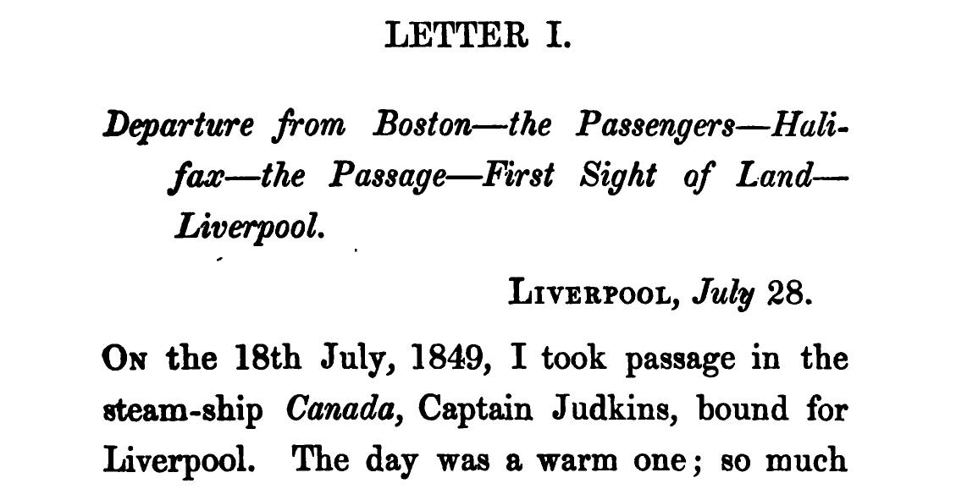

[p. 3]

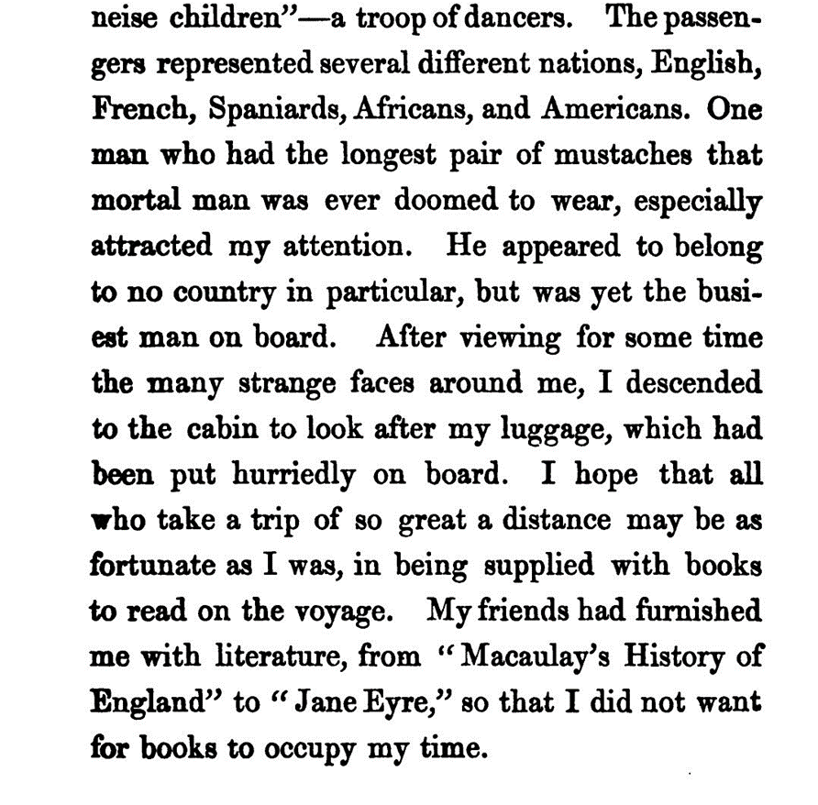
[p. 5]



