  REVIEW OF prıor LEARNING | University of wales trınıty saınt davıd  1811279  Merve Can  BMPF 7105 march 2021

Content

- Review of Prior Learning p.3-23
  - Introduction p.3
  - Learning Theories to be Considered while Giving an Account on the Prior Learning p.4
  - Four Learning Outcomes: 1. Difference between Coaching Individuals and Teams p.5
  - Four Learning Outcomes: 2. Designing Individual and Team Coaching /Training Programs p.9
  - Four Learning Outcomes: 3. Delivering Individual and Team Coaching /Training Programmes p.10
  - Four Learning Outcomes: 4. Coaching /Training Multi-cultures and Multinationals p.11
  - Conclusion p.12
  - References p.13
  - Appendix p.14-23

- Annotated Curriculum Vitae p.24-29
- Job Description p.30-31

BMPF 7105 Review of Prior Learning Assignment
Merve Can - March 2021

Introduction

This Review of Prior Learning paper will explore a specific learning area, its relevance to my professional role and to my Doctorate in Profession (DProf) research field. The readers will find 4 learning outcomes associated with the learning area and their details in terms of what and how. While explaining how part of what I learned, some references to learning theories will be made in order to let the reader understand fully which mechanisms were in place helping me to learn those outcomes.

Learning Area to be Explored: Coaching & Training

It is very straightforward, in my case, to look at a specific learning area since it would be very appropriate both in terms of its link to my professional role and my research field: It is coaching and training.
It may sound and make the reader curious about why 2 things or words instead of one. Essentially, it is simple, as these two concepts are quite intermingled and requires each other in many cases. They are the main components of a professional development programme. In other words, they are like a twin who are inseparable and needs to be thought together.
The link to my professional role can be easily explained with my title and job description which is shared on separate documentation. I have been working as an executive and team coach and as a global facilitator and trainer for prestigious multinational companies for 10 years. I’m also a psychologist and a former management consultant who is running her own consulting and coaching firm since 2011.
The choice of the learning area and its relevance to my D.Prof research field coincided with my potential aim: In my D.Prof Part 2 research, I wish to investigate the best approaches to training and coaching individuals undertaking space missions. Following this investigation, I would like to transfer best practices and some concepts to business trainings and coaching modules. Then, I want to develop a new training model or programme which has elements of coaching, space psychology and strategic management consulting. As an outcome, I would like to increase the effectiveness of cross-functional business teams using this coaching and training programme. From a personal perspective, my career goal is to become a developer and democratizer of space teams training for the rest of the world for sustainable living and commerce.
Four learning outcomes picked up for this assignment are also relevant for D.Prof Part 2 research as they will all be utilized with full exploitation. These 4 learning outcomes are:
- Difference between Coaching Individuals and Teams
- Designing Individual and Team Coaching /Training Programmes
- Delivering Individual and Team Coaching /Training Programmes
- Coaching /Training Multi-cultures and Multinationals

Here I want to also clarify why I have not chosen the learning area of Space Psychology Trainings. If I picked it up, then I was going to repeat myself in terms of what I said and researched back in BMPF 7100 course. Instead of looking at where I am currently which would have been an easier topic, I rather chose to use this assignment as a preparation for DProf Part 2 Research. It made more sense to look at the “desired path” and what I need to consider in order to serve for the purpose of designing a new coaching/training programme which aspires to act as a means for sustainability, effectiveness and survival, literally and metaphorically for the business world.

Before starting to give an account on the 4 sub-learning areas, it might be relevant to mention the learning theories that were available in these last 100 years and later in the detail of the learning outcomes, how they are related with my learning.

Learning Theories to be Considered while Giving an Account on the Prior Learning

Being a psychology graduate, one needs to understand and talk about learning theories, cognition and memory in a rich way. Although I have a tendency to do that also in this assignment, I choose to exemplify almost all relevant theories in one neatly packaged change model designed for employees. I encountered Ben Hur & Kinley (2015)’s book called “Changing Employee Behavior” in 2017. It was very relevant for my coaching business and for my coachees who were struggling with non-functional behaviours of their direct reports. Ben-Hur&Kinley developed their own behavioural change model called MAPS (Motivation-Ability-Psychological Capital-Support) looking into 4 areas: 1. Behaviourism 2. Cognitive Psychology 3. Systemic Psychotherapy and 4. Behavioural Economics (p.17).
These 4 titles actually represent in a neat way what happened in the theoretical and experimental psychology in the last 100 years in terms of learning knowledge built-up. Leahey & Harris (2001) mentions 1940’s Clark Hull with his axiomatic formula for behaviour in the era of logical behaviourism. Hull believed in _{s}E_{R}=_{s}H_{R} x D mathematical formulation. In other words, reaction potential (_{s}E_{R)} was a result of habit strength (_{s}H_{R}) multiplied by motivation or drive (D) (p.100). By 1950’s he even made this formula more complex taking into account incentive motivation and stimulus intensity. His theory was a continuity theory rather than being a contingency theory (p.101). By the end of 1950’s, challenging Hull, a Harvard-graduate, Erward C. Tolman came up with the idea of “purposive behaviourism” where one started to speak about purpose and cognition (p.103). In contrary to Hull, Tolman was saying that nonreinforcement was not necessary for unlearning. Therefore he was rejecting the law of effect for animals and human beings when it comes to learning. He was also adding that there are affective and cognitive dimensions to learning and human beings can disregard affective when it comes to learning an information. In other words, although it might be painful to learn something, human beings would choose getting the information, which is the cognitive dimension, although he might be punished with a physical pain generator. He also talked about cognitive maps which proves that in the nonexistence of reinforcement, animals including human beings can show latent learning. For instance, learning a route that your chauffeur takes you everyday is happening not because you intended to memorize but as a by-product of the journey. Despite Hall’s contingency theory, Tolman was coming from a contiguity theory. Though, the most known psychologist for behaviourism is B.F. Skinner who came up with radical behaviourism: “His theory of operant conditioning describes the acquisition of behaviours through reinforcement and their elimination through extinction and punishment.”(Cloninger, 2004, p.319). Various schedules of reinforcement produce different effects.
While all these happening in the field of Behaviourism in terms of how learning happens, in 1940 and 1950’s, another view started to be adopted which says actually what matters can be how people think and process as normal. Social norms started to play a role in this understanding as well. This is the era of Cognitive Psychology. In other words, unlike behaviourism, cognitive psychology sees the behaviours as a result of what people think about them. In order to change a behaviour from this perspective, one needs to change how they think about it. Therefore showing them that their thinking is “negative of unhelpful for them” is the key (Ben-Hur & Kinley, p.24). Albert Bandura, in 1986, in his book called “Social Foundation of Though & Action: A Social Cognitive Theory” talks about 4 important processes in his concept of “observational learning”: there need to be a model and an active observer, functional retention process which is basically remembering it, motor reproduction processes which is being able to do it and motivational processes which is deciding if it is worth doing (Cloninger, 2004, p.371). After Bandura, there’s George Kelly who emphasized the importance of “constructs” and “man-the-scientist” concept which suggests we learn as we extract meaning out of things. Kelly’s stance is influenced by Alfred Adler’s “individual psychology” which sees human being as unique and as a whole that needs to grow setting goals. This information is important as it is the reason, I chose the Adler Centre Europe for my coaching formation. Adler who can be considered as an early feminist, says “I believe that by changing our opinion of ourselves we can also change ourselves” (Bottome, 1947, p.83).
Although Behaviourism and Social Cognitive Learning theories seemed to cover everything, in 1980’s, external factors including environments and relationships started to be considered for change psychology and learning. According to BenHur & Kinley’s reference to Fliegenschnee, M. and Schelakovsky, A. (1998), “at least 80 percent of the factors influencing behavior come from these external elements” (p.25). In other words, we might learn from our relationships with others and even the physical environment. This is called Systemic Theory. All the systems around us, for instance family, work, clubs, social media can all affect what and how we learn.
Finally in these last 3 decades, Behavioral Economics emerged as a merge between economics and psychology happened. As the world got more populated, to make it more habitable, governments in UK, US, Australia, Singapore started to engineer their citizen’s behaviours either teaching or letting them learn new behaviours or by influencing their frequencies. It is by the use of nudges that one learns a habit. It goes back to the work of 2 psychologists, Amos Tversky and Daniel Kahneman who as a psychologist earned a Nobel prize in economics in 2002. Basically, our decisions can be nudged with 5 ways, when: 1. provided information, 2. Primed or cued for a specific way of acting 3. there is social influence like peer pressure 4. Costs and benefits are shown or decision economics is made available in thought 5. Given a scenario around loss avoidance therefore we do not want to lose what’s at hand.
David Kolb’s Experiential Learning Cycle can be another learning theory that should be taken into account. As the Figure 1 shows it is a loop. It is also used in a qualitative research method called “Action Research”. The learner here becomes the “man-the-scientist” as Kelly used and looks deeper into experiences, reflect on them, conceptualize the learning and go for active experimentation. Me, being the leaner and me, being the coach is all intermingled. The role of the action researcher is not unfamiliar to coaches and facilitators of the new world. The researcher is trying to help participants to tell their own stories and come up with their own solutions in a loop that is turned again and again. The action research model has a large amount of resemblance to Kolb’s experiential learning cycle.

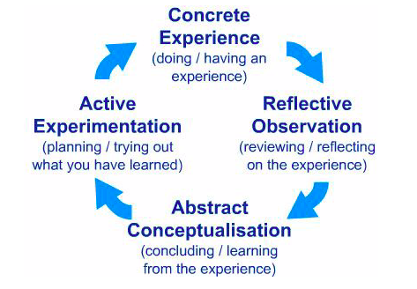
KOLB’s Experiential Learning Cycle

Source: www.simplypsychology.com

Having laid the “how” part of the foundations for giving details of the learning outcomes, now the “what” part can be explored.

Four Learning Outcomes: 1. Difference between Coaching Individuals and Teams

My first encounter with the profession and the word of Coaching was 7 years after I learned about Training in Fall of 2003 (please go to App.1). I took Psychology 306 – Industrial Organizational Psychology course of which had a textbook called Psychology Applied to Work and all my classmates learned about the details of Training (please go to App.2). What I learnt about Training could be summarized under 4 headings which can be found under Figure 2-5.
Innovation Strategy
Speed Strategy

Strategic Value of Training & Development

Cost-Reduction Strategy
Quality Enhancement Strategy

Figure 2: Strategic Value of Training & Development, Muchinsky, 2003

Training & Development

Methods & Techniques of Training
- On-Site Training
- Off-Site Training

Evaluation of Training Criteria
- 4 Types of Criteria
- Internal vs External Criteria
- 4 Dimensions of Training Validity
Assessing Training Needs

- Organisational Analysis
- Task analysis
- Person analysis

Figure 3: Training & Development, Muchinsky, 2003

Off-Site Training Methods
- Lectures
- Audiovisual Material
- Computer-Based Training
- Simulation
- Role playing
Behavioral Role Modeling

Methods & Techniques of Training
On-Site Training Methods
- On-the-Job Training
- Job rotation
- Apprentice training

Figure 4: Methods & Techniques of Training, Muchinsky, 2003

Reaction criteria

Learning criteria
Evaluation Criteria for Training

Behavioral criteria

Results criteria

Internal vs. External criteria

4 Dimensions of Training Validity

Figure 5: Evaluation Criteria for Training, Muchinsky, 2003

Back in 2003, I did not know that I was going to own a Coaching & Training firm in 2011. I always thought I was going to be a Human Resources Professional within a firm. I believe not only for this reason but also for others reasons such as changing my career path to Marketing in 2005, I did not learn enough about training back at that time. However in 2010, having experienced Marketing and Strategic Management consulting as professional role, I understood that my passion was about helping people to unleash their potential. In 2011, I started my own business in training and coaching areas. Everybody was telling me back at that time, the new trend was coaching instead of mentoring and training. I only knew sports coaches but did not exactly know what a business and/or executive coach would do for their clients. For that reason, I enrolled to a coaching training programme in 2011 from Adler Centre Europe. This was an intense course of 15 days spread out for 4 months. There were 3 parts of the course: 1. Foundations of Coaching 2. Coaching Conversation in the Context of Work 3. Moving towards Artful Coaching (please see App.3). What I immediately learned in the very first part was that in terms of the skill set required, coaching individuals and teams is different. Fast forward to 2020, International Coaching Federation (ICF) announced two different sets of skills with the same 8 core competencies as shared in Appendix 4. In Figure 6, other team development modalities are compared by ICF as they define team coaching:
“Team coaching is an experience that allows a team to work towards sustainable results and ongoing development. It is becoming an increasingly important intervention in corporate environments as high team performance requires aligning toward goals, remaining innovative, and adapting quickly to internal and external changes. Team coaching exists under this umbrella of team development, along with the following modalities: team building, team training, team consulting, team mentoring, team facilitation, and team coaching. These modalities are further compared in Figure”.

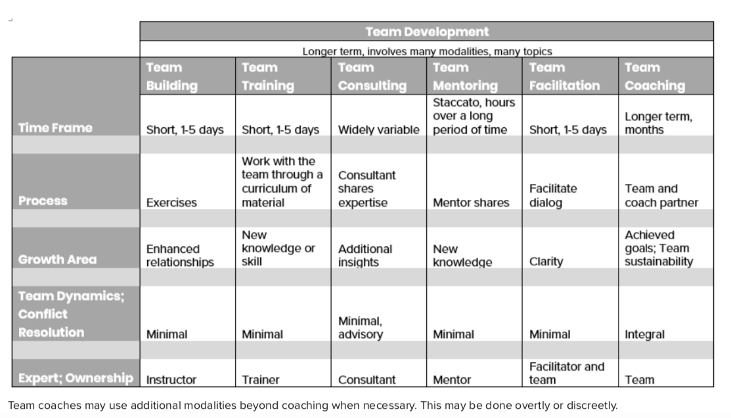
Figure 6: Comparison of Team Development Modalities, https://coachingfederation.org

In 2011, ICF was not as active as a regulating mechanism and people who are interested in coaching were figuring out themselves that the skill set was different. I learned from Adler’s course that individual coaching requires perfect active listening, reflection or play back of the words that the client is using, acknowledgment or championing of what the client is doing correctly and the artful use of metaphors if the client is not understanding what does not work for them. Acknowledgment or championing was very relevant if we remember Skinner’s behavioural conditioning. It worked as a motivator. Till 2013, I coached for 100 hours and by experience I learned that the use of metaphors was extremely important as well. I used Kolb’s learning cycle and reflected about my coaching experience as lot. In coaching profession, one needs to have a supervisor and that is the role of the supervisor using Kolb’s learning cycle to help the coach reflect about their experiences and actively experiment. I had 3 different supervisors till today and learned different things from each one. The first one was Turkish and a former HR Director and she taught me how to sell coaching projects to HR people. The second one was a Canadian seasoned coach and she taught me that I can trust my level of English while coaching English mother-tongued individuals. The last one was a British group coach and she taught me how to efficiently and effectively “surf” in group coaching. Thus, my own supervisors were also divided into the 2 categories as well: teaching me the differences between individual and group coaching, giving me self-confidence in coaching and selling.
In 2013, I decided to take a course on Team Coaching and started a journey of 14 months with CRR Global’s “Organizations and Relationships and Systems Coaching”, shortly ORSC course (please see Appendix 5). This course had 5 parts: 1. Fundamentals 2. Vision and Potential 3. Roles and Structure 4. Roadmap for change 5. Systems Integration Mastery.
With these formal learning experiences, I learned that the main differences between individual and team coaching are the number of people involved, the increased complexity in team systems, managing the different levels of education and knowledge in teams.
What I still need to learn is the functioning of cross-functional teams of Multi-team systems as the world goes through that direction with the needs for innovation and speed increasing. The fundamentals of multi-team systems, I believe, lie under the concept of “systems thinking” and that is why I recently enrolled to a new course called “Systems Thinking” from Massachusetts Institute of Technology Open Learning (Please see Appendix 6). I learned about this program with the help of a digital nudge through Google, an advertisement popped up while I was surfing internet. It will be very important to learn the application of Systems Thinking as I want to develop a new coaching/training program for increasing the effectiveness of multi-team systems with my DProf research.

Four Learning Outcomes: 2. Designing Individual and Team Coaching /Training Programmes

Despite the formal way I learned the differences in individual and team coaching, I, very informally, learned how to design individual and team coaching and/or training programmes.
In Adler’s Coaching course or ORSC’s team coaching course, one learns the fundamentals although they claim there is a mastery section in the end. Designing programmes that the companies would buy and do investment in requires a whole different mindset. In my strategic management consulting experience (please see my CV, years between 2010-2011), I had the chance to observe how partners were selling projects to big, prestigious companies. The learning mechanism that was in play here was Bandura’s observational learning when there needs to be a model. Partners were models for me.
As I did not have a Master’s degree in industrial organisational psychology, I did not have the chance to be formally educated on “need analysis” for trainings. However it was actually very straightforward to ask for needs to the Human Resources (HR) representatives, categorize them, go look into the literature and find what needs to be taught to the employees. This is what partners were doing as well when selling a management consulting project. Because of having a formal coaching formation, I always integrated a critical thinking and reflection method in my coaching or training programmes. In other words, they were not composed of pure lecturing, but very small amount of lecturing, if applicable a prework for the client(s), and then either role-playing and/or assignments.
What might be potentially missing in my repertoire of training programmes are physical and digital simulations. For that reason, I have been researching about “gamification” method. As Ben-Hur & Kinley(p.155) explains:
“The term gamification was first used in 2002, as games developers started looking at how to apply what they had learned about engaging players in games to engaging people in other activities, such as buying particular products… Gamification is such a big hit because it offers a set of techniques that are affordable, relatively easy to implement, and that promise to significantly increase customer and employee engagement. It has also been accompanied by some high-profile early successes with big name firms, including Nike and Ford.”
The use of simulations and/or gamification is also important for my D.Prof research as Space Agencies are known to use many simulations training their astronauts for the unearthly environment of space which can only be trained with the use of simulations. For the purpose of learning more, I scheduled a meeting with a company called Paradiso which for about 1 year has been nudging me over LinkedIn to schedule a meeting with. Again, this is the way I learned about the company: nudging. The meeting will take place in 3rd week of March 2021 and I hope to learn more about the simulation and gamification methods.

Four Learning Outcomes: 3. Delivering Individual and Team Coaching /Training Programmes

Delivering coaching/training programmes are very different than designing those. There is the human factor and one can never know what might exactly happen in a coaching or a training programme. My way of learning was self-learning where experiences and anecdotes played a role here.
I learned all by myself, not with the help of any formal or mentor-led relationship that I need to prepare the programmes minute by minute (To see an example please go to Appendix 7). This detailed preparation was at first to make myself in control of the time and the promised learning material is delivered. Back to Hull’s reaction potential formula, my habit got stronger as I could have more control over the programme.
Then I also learned by experience, a coach/trainer needs to be very flexible as the need of the audience might differ compared to what was known before. I’d like to share an anecdote about this: In 2017, I went to Dubai to deliver a leadership training to a multi-cultural and multi-national audience. The client company has defined their leadership behaviours as “Inspire-Connect-Achieve” and it seemed like it covers all areas a leader should demonstrate. However, when we came to the “Connect” part the audience started to ask questions about how to come over negativities. They were using this specific word but what they are trying to say was the “toxic behaviours” as team psychologists call them: blaming, defensiveness, contempt and stonewalling. I knew they needed this extra information and I started to educate them about these toxic and their antidotes as a leader can exhibit. The audience thanked me and it was one of the peak experiences of the whole training.
I continue to do minute by minute calculations but I rather being flexible and nimble in case I find out the attendees want something else from me. At the end of any programme, the attendees are asked to rate the success of the programme and I learned that they are to be satisfied rather than the HR representatives. Remembering Hull’s axiomatic formula, my drive or motivation increases as I have been rated with higher scores for being flexible.
Although as shown in Figure 6, ICF thinks that there is little team dynamics or conflict resolution in team training, I have also experienced some in my previous exposure. As per Team Coaching, it is an integral part of the process and one needs to solve conflicts and quite often this is why you are hired as a team coach. As in designing, I learned by myself how to solve conflicts and teach people to do agreements. In theory, ORSC course taught me how important to set agreements in coaching with more than one people. However how I do this is all a result of trial-and-error process. In summary, I ask people their expectations out of the training, write them on a flipchart. Even at that time, sometimes conflict can arise. I remind them the main purpose of the training in one sentence and write it all above the expectations. Then, I ask them to “calibrate” their expectations with the purpose of the training and say it loud linking them together. This resolves the conflict as this adds another layer to their thinking out of their own expectations.
Delivering individual coaching is different from team coaching and team training. It’s very personal and every single individual is different in terms of their learning method and capacity for being coached. I learnt this having read Howard Gardner’s “Frames of Mind” book which talks about multiple intelligences and in his 2003 dated evaluation of his 20-year old theory back then, he says “Educational goals need to reflect one’s own values, and these can never come simply or directly from a scientific theory.”(p.9). In my view, as in line with Gardner’s, one values are actually their strengths. As people know they are good at something, for instance language, they choose to speak and as they choose to speak they may say that “before writing to you I wanted to speak as I value human connection”. Therefore, in order to go to the strengths, at the very beginning of individual coaching, I started to ask about their values. Not everybody is clear minded about this question, so I facilitate it by asking more, such as “what makes you sad when you don’t see people show it you?”. In summary, delivering individual coaching, as I learned by experience, is just-in-time, personal, customized, and should not be delivered in a way that satisfies the coach, on the contrary it is for the coachee. As defined by ICF’s 3rd competency, (Appendix 4) establishing and maintaining an agreement at the beginning of each session has great importance. In learning this, David Kolb’s experiential learning theory was relevant not only for me as the coach but also for the coachee as in the process they pick up a topic, make a plan, experiment their plan, get a preliminary learning and come to the new session with the results for another loop of reflection.
Another recent anecdote about one-to-one coaching clients having different learning methods is a Finnish coachee of mine who told me that he is “visual”. This coaching assignment started during Covid-affected period and we were having the sessions over the virtual platform Zoom. This coachee’s visualization need had to be met so I could be helpful as a coach. That’s how I started to use the “share screen” feature of Zoom and create diagrams on powerpoint together with the coachee. He was very happy to have his own “slides” at the end of each session. I learned with my coachees that there are other people who require kinesthetics or auditory triggers to learn. For kinesthetic learners, I ask people to stand up and move while we are doing coaching or for auditory learners, I send auditory books.
In the case of delivering these programmes, what still needs to be learned will be figured out by the MIT’s system thinking course and Paradiso meeting for simulations.

Four Learning Outcomes: 4. Coaching /Training Multi-cultures and Multinationals

The fourth learning I want to explore is something not taught formally anywhere but for global facilitators like me is a “must” to be learned: coaching and training multicultural multinational people
Since 2014, I have been working with a UK-based coaching firm as an invoicing associate and the clients are multinational companies such as Unilever, Abbott, BP, etc. On an ordinary day, I may have coaching sessions with 4 different countries such as France, UK, USA and UAE. Although both UK and USA are Anglo-Saxon cultures, French culture and Arab Emirates cultures are totally different. Not only for coaching sessions, but also for training I have exposure to Turkish, British, Arabian employees. This means one needs to be aware of cultural sensitivities and differences.
Because of being a psychology and a sociology graduate, I studied on an undergraduate level what sociocultural differences there are. This gave me an understanding of individualism of Western cultures and collectivism of Eastern cultures. Apart from that and its sub-results, to my experience, there is not much difference among human beings. There are universal needs of being seen, heard and spoken to in a respectful way. Coaching, by nature, champions all these 3 behaviours for the coach to demonstrate. As this was the case, I have always tried my best to show these behaviors in both contexts of coaching and training. It does not matter if individuals or teams are the audience as they are composed of human beings.
See-hear-speak is also a model that we teach to coaching clients in the UK-based coaching company mentioned. As we always say, we, as coaches, first need to a role model for letting others to take people with them.
In order to exemplify, how I coach in multicultural, multinational people, I will give some written accounts. Here I’d like to share here a British coachee’s January 12, 2021 feedback about me which given to the UK-based coaching company and we have no control over:
“Outstanding coach, she was very easy to connect with, I instantly felt like I could trust her. She listened & adapted to what she was hearing, I never felt like she was giving me the answers or leading me to a conclusion, but really letting me think and express my thoughts/feelings. I felt like she really understood everything I was saying, and she offered really practical advice, none of which felt text book, but actually something I could go away and make happen. I can't speak highly enough of Merve.”
Below is a Canadian coachee’s January 28,2021 feedback:
“Merve is an excellent coach - she helped synthesize KF 360 feedback & draw out key themes extremely effectively. She asked provocative questions and provided thoughtful perspective in real-time. I appreciated her warm style & strong listening skills. I felt she really understood my strengths and opportunities as a leader despite our short time working together.”
Below is an Egyptian coachees’s August 31, 2020 feedback:
“Simply the most valuable coaching sessions I've had to date.”
This last one is a Swiss coachee’s May 2019 feedback:
“ Merve is very agile and cuts through in a relatively short time. I also felt she strongly remembered the 360 each time as well as conclusions from previous sessions”
All the bold words are actually confirming what people appreciate and there is a common appreciation for real listening. In summary, what I learned as important while coaching and training multi-cultures and multinationals are see them, hear them, speak to them with respect and genuine understanding.
This learning is also important for my DProf thesis as I am going to be developing a new training programme and I aim to present it to a multinational, multicultural audiences. In writing its manuscript in terms of how to deliver it, I plan to write this important detail as hopefully there will be other trainers that I will educate.
Coaching and training multicultural, multinational individuals and teams is a never-ending learning process as one encounters new people. For this reason, there is still to be learned and I genuinely believe if I am asked the same question 5 years later, my answer would be different.

Conclusion

Using Kolb’s reflection cycle, I believe the main purpose of this course is to let us reflect and understand how we learn and by intentionally keeping those learning ways at hand, boost our learning till we get to the DProf Part 2 period and write something exceptional that the World will benefit from.
While writing this account, I reflected about my own ways and remembered seeing role models, going to courses, reflecting itself are my keys for learning. At the time of writing, I took 2 important steps like enrolling into a course and scheduling a meeting with a potential partner company. These two steps and the reminder of my way of learning is also going to be important for my DProf thesis.

References

Ben-Hur, S. & Kinley, N (2015) Changing employee behavior. Plagrave MacMillan.

Bottome, P. (1947) Alfred Adler: apostle of freedom. London: Faber & Faber.

Cloninger, S. (2004) Theories of personality. Pearson Prentice Hall. 4th edition.

Gardner, H. (2003) Multiple intelligences after twenty years. Paper presented at the American Educational Research Association, Chicago, Illinois, April 21, 2003.

Harris, R.J. & Leahey, T.H. (2001) Learning and Cognition. Prentice Hall. 5th edition.

International Coaching Federation (2021) Available at
https://coachingfederation.org/app/uploads/2020/11/Team-Coaching-Competencies-2.pdf

Muchinsky, P. (2003) Psychology applied to work. Thomson Wadsworth. 7th edition.

Simply Psychology (2020) Available at
https://www.simplypsychology.org/learning-kolb.html (Accessed: 19th June 2020)

Appendix 1: Official Transcript for Undergraduate studies

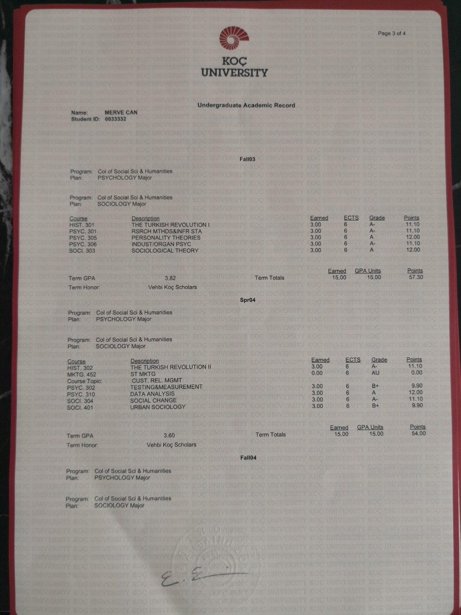

Appendix 2: Industrial Organizational Psychology Book Index

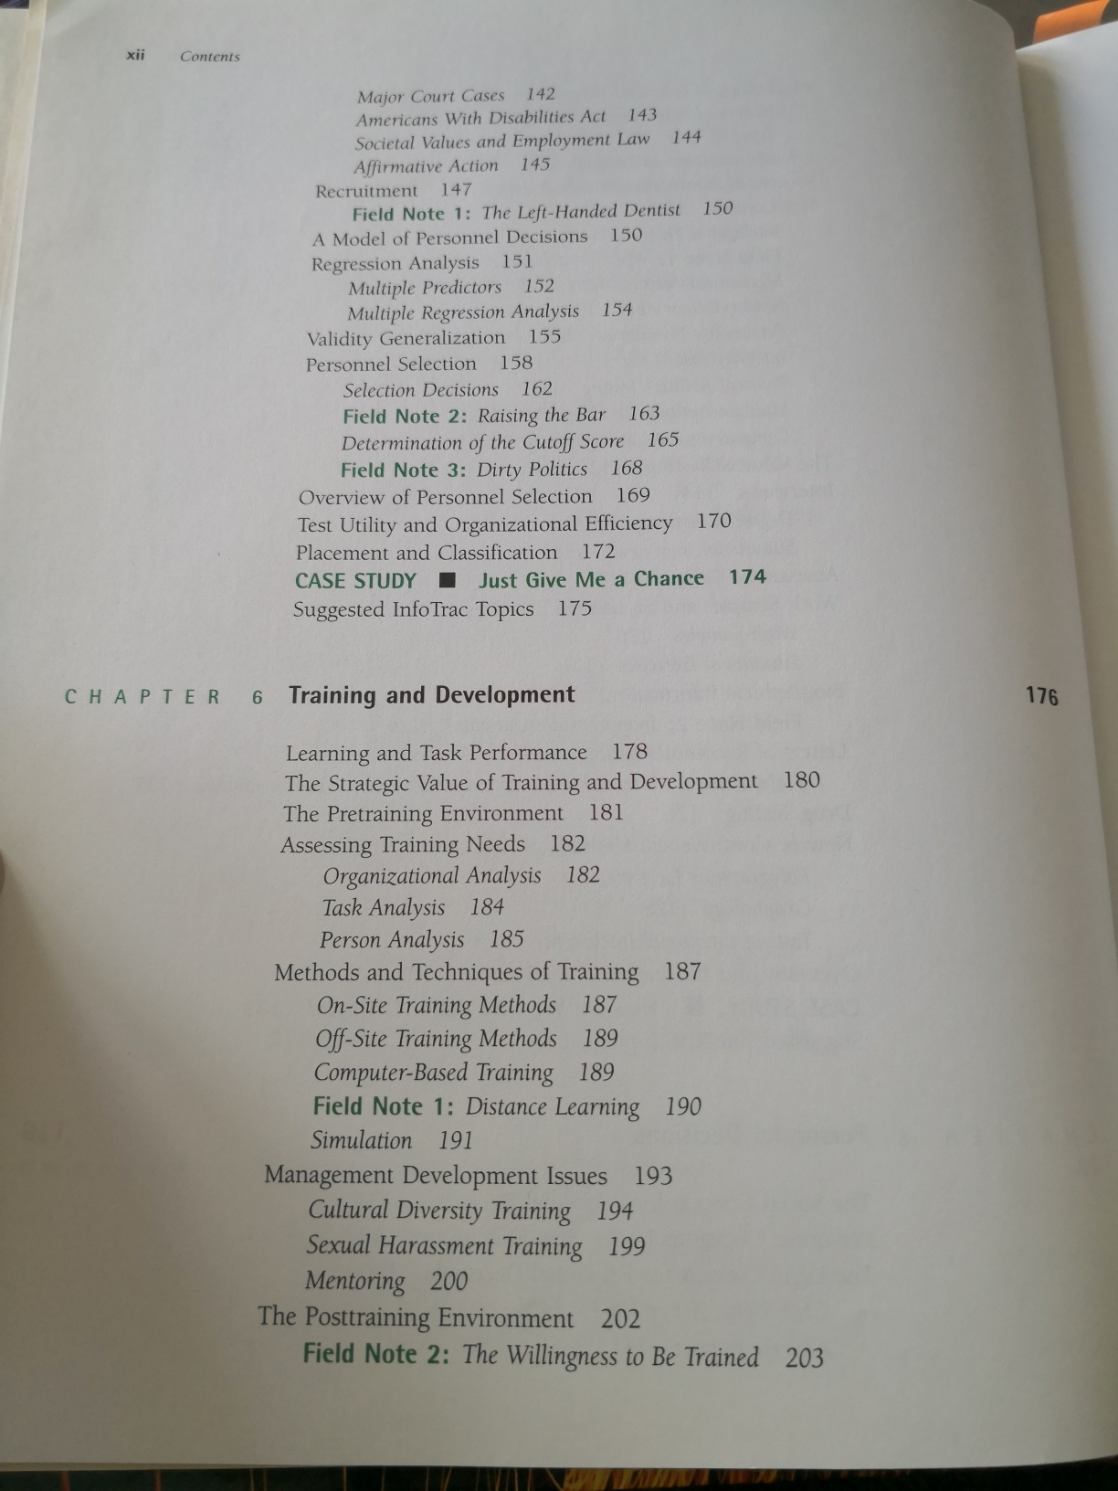

Appendix 3: Adler Center Europe Coaching Couse Certifications, 2011
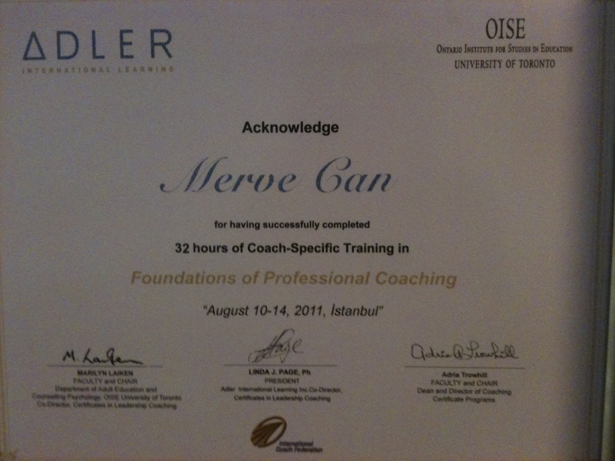
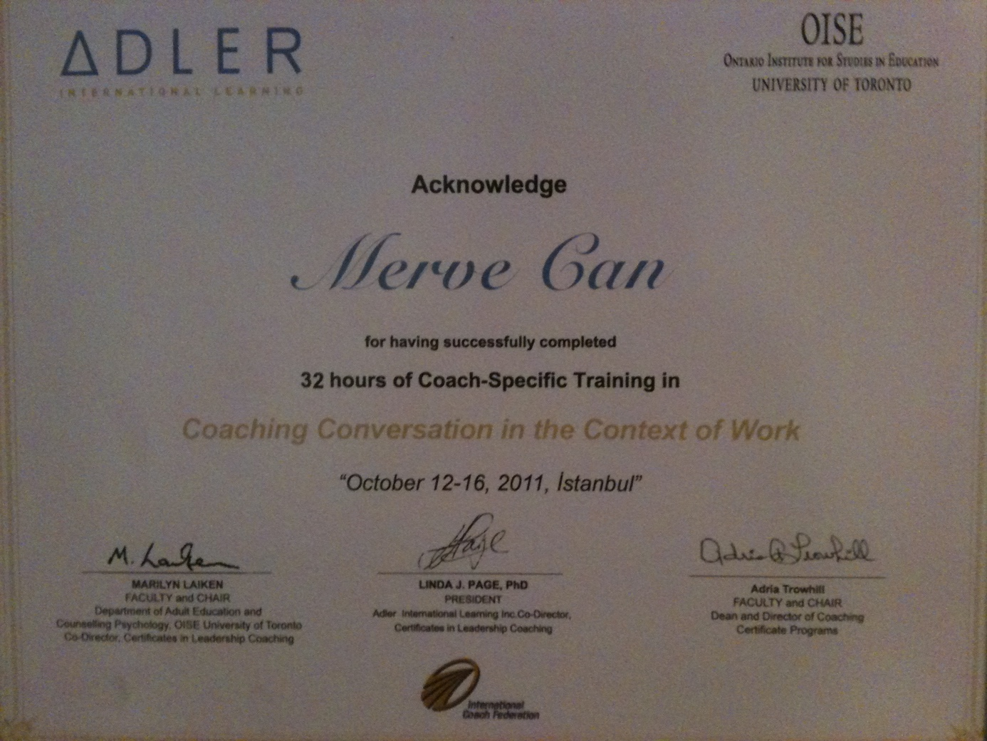

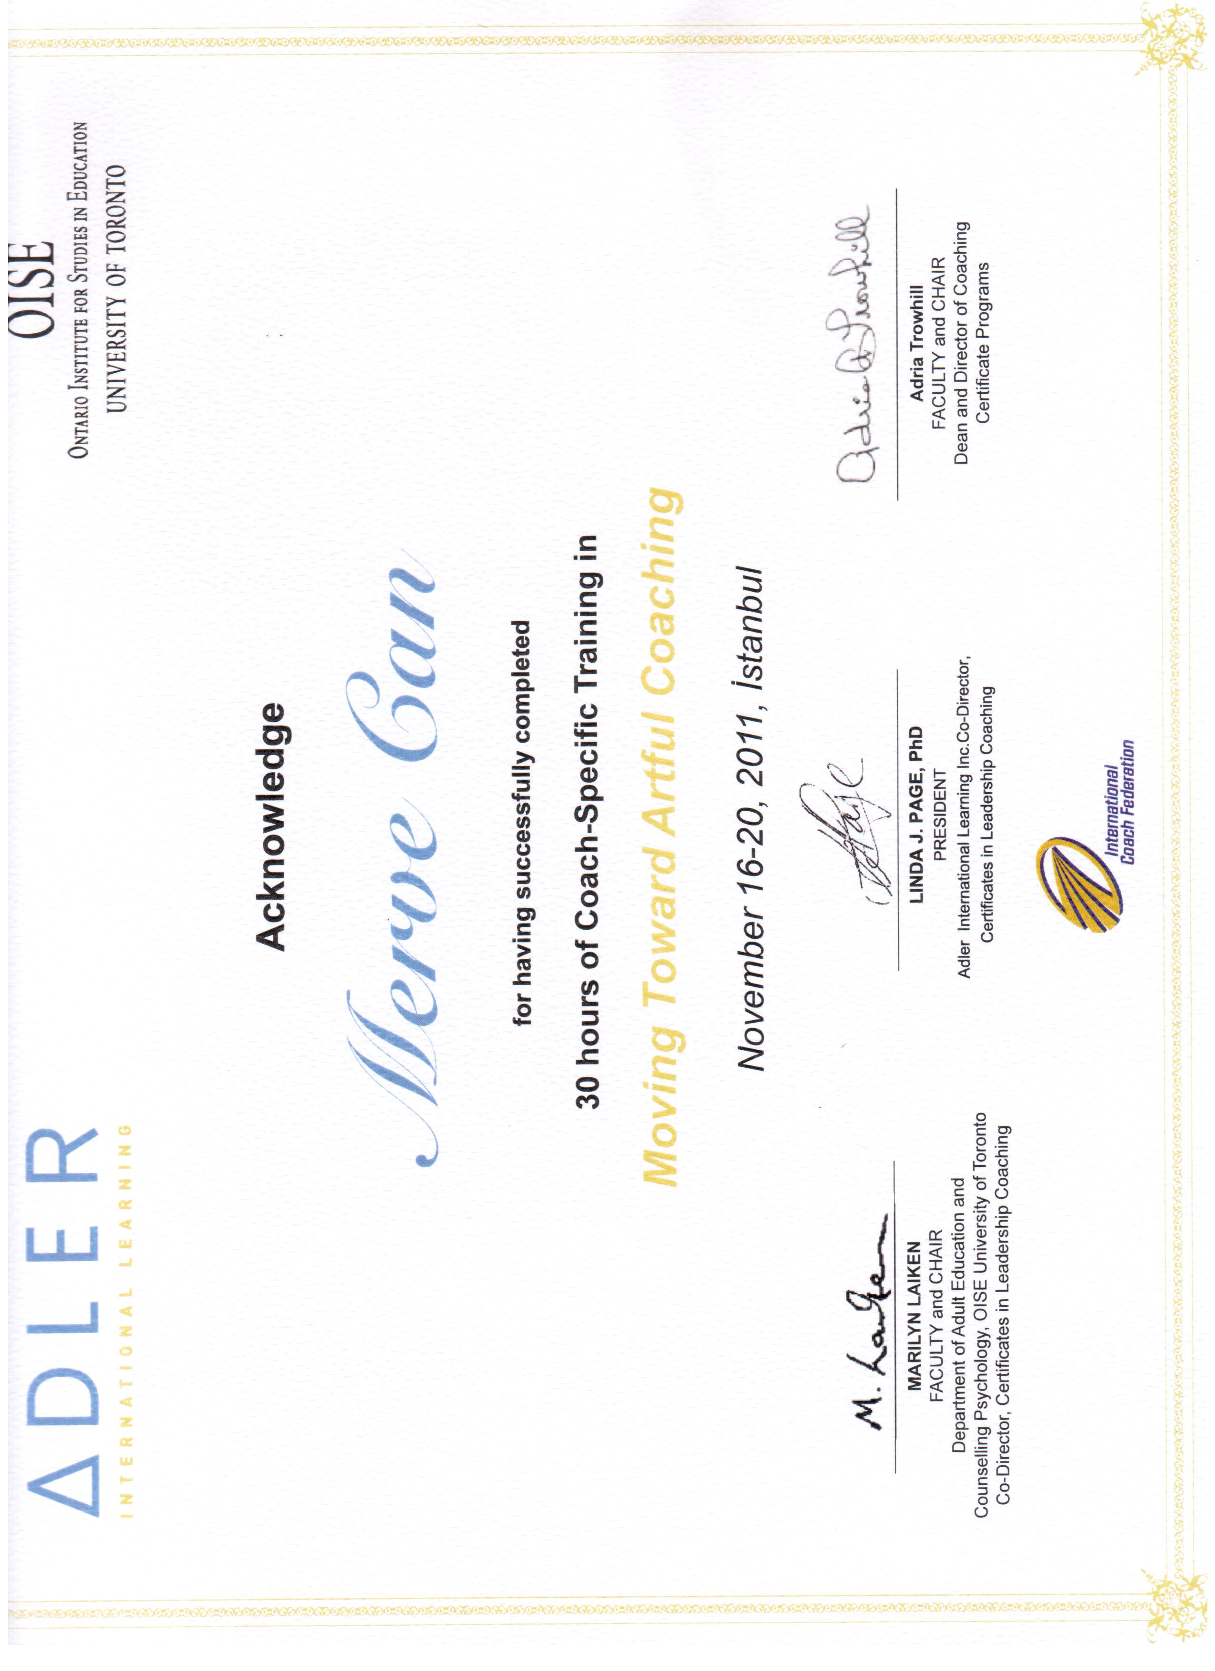

Appendix 4: International Coaching Federation Individual and Team Coaching competencies

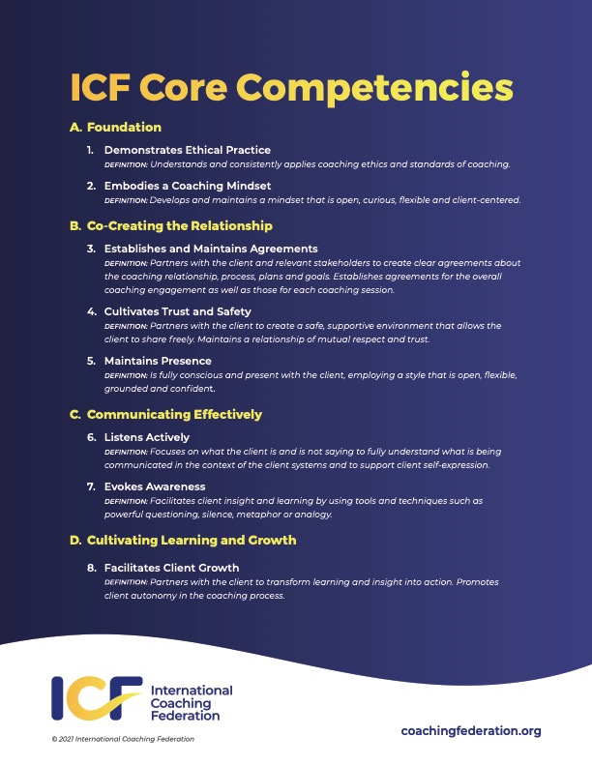

Appendix 5: ORSC course completion certificates
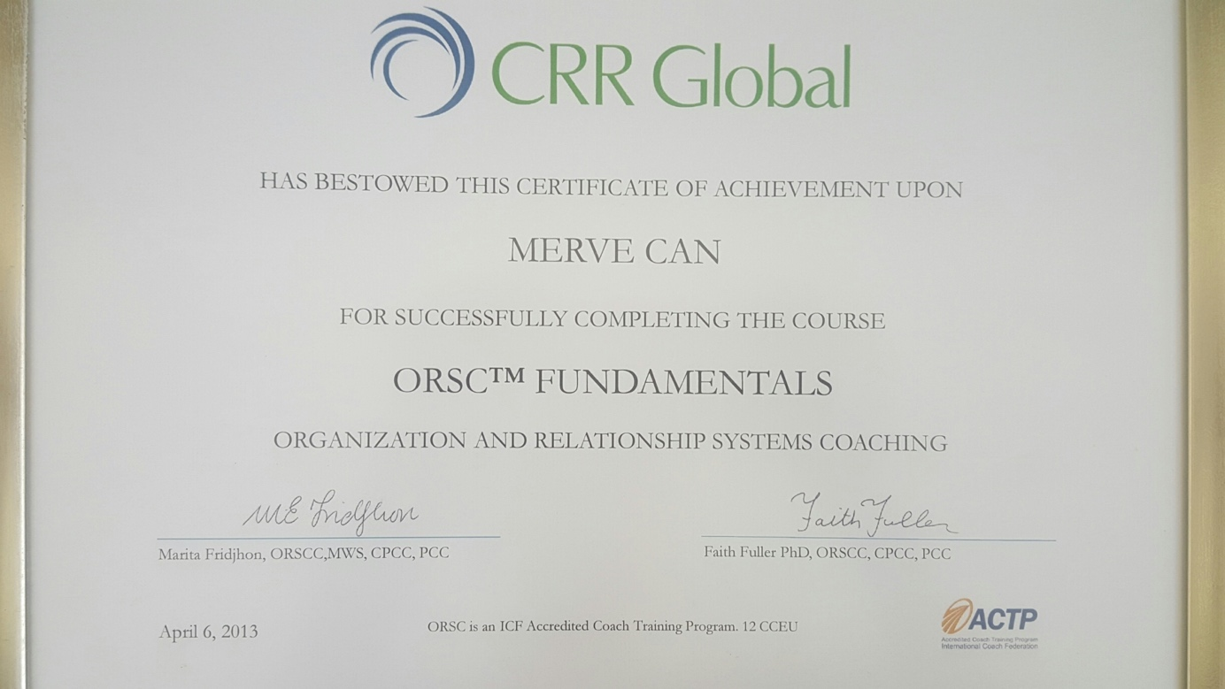
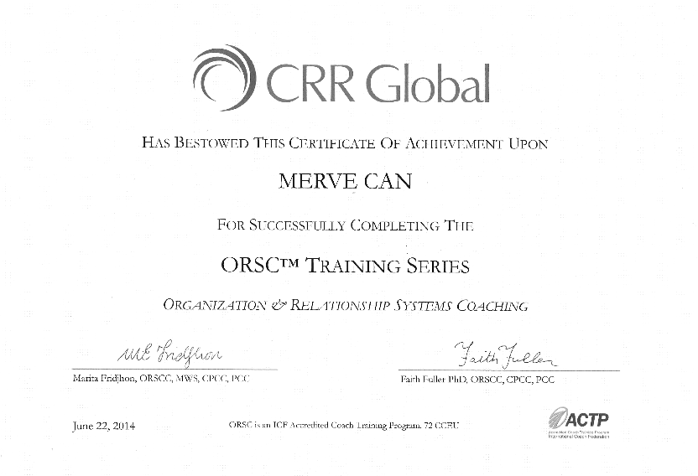

Appendix 6: Massachusetts Institute of Technology Open Learning, Systems Thinking, April 2021, Payment Receipt

Appendix 7: One day of a training programme (dk stands for min. Referring to the minute bu minute design)

Ön Çalışma | Psikolojik Sermaye ile ilgili Self-assesment bir gece önce yapılır
Gün 2 | Amaç | Araçlar / Teknikler | Uygulama
Check in (30 dk) | Her katılımcıyı görüp duymak, gerekliliklerle ilgili ilk hissiyatı almak için | Check in  Yerde LC-ME Matı | . Dinleme, Tanımak için Çaba Gösterme  . “İlk 2 günden sonra nasıl hissederek geldiniz?” ve “Psikolojik Sermaye”nin ne olduğunu düşünüyorsunuz?”
İç Kaynaklar (30 dk) | Yöneticilerin, çalışanlarının Psikolojik Sermayelerini artırmakla ilgili kilit açıcı olduğunu mesajını vermek | LC-ME, Being, Protecting ve Controlling boyutlarıyla ilişkilendirme | . İç grup tartışması (3kişiX4) . Mini Sunum
Özgüven (45 dk.) | Psikolojik sermayenin yararlarını ortaya koyma ve Davranış Mühendisi olmak için yapılması gerekenlerin anlaşılmasını sağlama | “Ustalık” ve “Kontrol Odağı” modelleri | . 2’li uygulama  . Workbook – Worksheet – Çalışan/Danışan İsim Listesi-İndikatörler- Kontrol Odağı Teşhisi- Yapılması Gerekenler  . Grup tartışması
Özgüven (20 dk.) | Psikolojik sermayeyi artırabilmek için tekniklerin paylaşılması | . Video . Modelleme | . Grup tartışması: “Modelleme nasıl günlük ritme sokulur?”
Özgüven (40 dk.) | Psikolojik sermayeyi artırabilmek için tekniklerin paylaşılması | . İkna . Pygmalion effect . Golem effect . Video | . 2’li uygulama  . Workbook – Worksheet – İç içe 2 halka
Özgüven (15 dk.) | Psikolojik sermayeyi artırabilmek için tekniklerin paylaşılması | . Fizyolojik durum | . Perakende Bankacılık Vakası . Grup tartışması (106)
Olumluluk ( 45 dk.) | Olumluluğun öneminin ve bilinçaltı yapılanların tanınmasını sağlama | . Yerde Kognitif Bozunma örnekleri | . Takım Koçluğu – Constellation (30 dk.)
Olumluluk ( 20 dk.) | Öz Varlık kavramını güçlendirmenin önemi vurgulanır | . Öz Varlık Kavramı | . Oyun ( Grup 3’e bölünür. 5 saniye Hatırlama testi yapılır. 1. Grup Öz varlık için verilen kağıtlara sıfatlarını yazar. 2. Grup yazmaz. 3. Grup içeride kalır ve puan verir.)
Olumluluk (30 dk.) | LC-ME Caring boyutunun İrade ve Dayanıklılıkla ilişkisi vurgulanır | . İrade . Zihin konuşmaları (Mindfulness) | . Kognitif Psikoloji – ABCDE tekniği – 2’li uygulama- Worksheet
Olumluluk (10 dk.) | LC-ME Being-Composure alt boyutu ile ilişkilendirilir | . Dayanıklılık | . “Beni Öldürmeyen, Güçlendirir” zihin yapısı (growth mindset) . Anlatım (124)
Psikolojik Sermaye Vaka Çalışmaları (1 saat) | Psikolojik Sermaye bileşenleri ile ilgili yol planı yapmaya başlamaları sağlanır | . Tembel, iyi eğitimli, varlıklı, işsiz (yo)  . Çalışkan, ups&downs, geç kaldı yöneticiliğe, insan yönetmekte katı ve kırıcı (gt-e)  . Çalışkan, başarılı, yıllarca aynı tecrübe, kötü takım, yeni şirket, batmakta olan şirket, öfke | . Grup çalışması  . 10 dk düşünme  20 dk sunum hazırlama  30 dk sunumlar ve değerlendirme

2. Annotated Curriculum Vitae

MERVE CAN

Executive Coach and Psychologist

Bağdat Street No:399/1 Suadiye merve@mervecancoaching.com

+90(542) 671 76 39

Kadıköy LinkedIn link

ISTANBUL, TURKEY

PROFILE

Executive and team coach, global facilitator, psychologist and company owner with former experience in strategic management consulting, marketing and human resources with respected industry leaders. Strengths and career highlights include the following:

KEY ABILITIES AND ACHIEVEMENTS

- Executive and Team Coaching: Executive coach for top and mid-level management representatives.
Annotation:
After experiencing Strategic Consulting work experience in 2010’s and Marketing experience in 2005’s and Human Resources experience in 2003’s, I started to see a lacking corporate intervention area: Coaching. The employees of the companies which are receiving strategic consulting services were struggling to implement what was proposed. With my psychology background, I had always found myself in client management roles and I decided to start my own company in coaching to support employees to unleash their potentials.
I have been running my own coaching firm, “Minerve Coaching and Consulting Ltd.” since 2011. Besides, I work as an associate of an UK-based coaching company “BTSCoach” taking on significant global coaching projects and the coaching work of top and mid-management level executives. For example, I have been coaching The Coca-Cola Company mid-level managers in Europe, Deutsche Bank mid-level managers for an internal development programme, BP top and mid-level managers in many continents, Kellogg’s top-level managers in Europe, Abbott top and mid-level managers in Turkey and Middle East and many other global prestigious firms.
As of March 2021, I have 3150 hours of individual and team coaching experience and in June 2019, I have been awarded and credentialed as a “Master Certified Coach, MCC” by International Coach Federation (ICF) after thorough evaluations of performance at the two recorded coaching sessions in English, the total hours of practice, having more than 200 hours of trainings and receiving legitimate mentor coaching. ICF calls MCC title as the “gold standard in coaching”. Of approximately 10,000 credential holders in 89 countries, only 6% are Master Certified Coaches according to Cathy Shaugnessy, another MCC herself.

- Strategic Management Consulting: 1.5-year consulting experience at Bain & Company (consultant level) in Milan office assigned for projects in Turkey, Italy, France and Switzerland with exceptional client management skills. Expertise includes the following:
- Strategic analysis and business planning
- Market entry strategy, emerging market growth, proposition development in due diligences
- Customer segmentation strategy
- Sales Execution, Route-to-Market Strategy and customer engagement
- Supply chain optimization
- Organizational re-structuring and re-organization
Annotation:
Bain & Co.is an American global consulting company which has branches all over the world. Milan Office hired me for projects in Turkey and Italy in 2010. I started the role as a senior “Consultant” after finishing my Master of Science studies at Bocconi University. I had contributed to the role with my previous knowledge of Fast-Moving Consumer Goods (FMCG) industry, my language skills in English, Italian and Turkish and my organizational skills. I served as a member of a “Consultant” team contributing to the overall work with some assigned parts relevant with my skills. Most of the time I have been chosen for projects in FMCG and had the opportunity to work for different functions such as Supply Chain and Sales in Turkey and Italy. I also had the chance to make a due-diligence project for a European insurance company in France. I learned Strategic Management Consulting skill package involved systematic thinking, planning, organizing, client management and analytical skills in the European context. I could improve these skills to some extent but I would try to stay longer and even learn more.

- Marketing Management: Managed wine and liquor product portfolio as a Junior. Product Manager at Mey Alcoholic Beverages (Diageo). Expertise includes the following:
- Strategic marketing planning
- Competitive industry analysis
- Pricing
- Product and marketing innovation, product development and launch
- Consumer behaviour research planning, pre and post analysis, surveyor trainings
- Trade marketing and key account management
Annotation:
In 2005, I started Junior Product Manager role right after finishing my undergraduate studies in Psychology and Sociology. I learned everything hands-on as I did not have any formal education regarding business administration or marketing management. “Coloured-beverages” were given under my supervision and together with my line manager, we won a branding award for relaunching and renovating a liquor brand in 2006. I learned doing strategic marketing and event planning, pricing, conducting competition mapping and analysis, the process of product development and innovation. I learned to collaborate with different stakeholders and third parties such as advertising, event, public relations agencies, consumer behaviour research companies, etc. Approaching to the end of my time in the role, wine product portfolio was also given under my supervision and after I left within 5 years wine umbrella brand became #1 in sales in the whole country. The success of the wine product portfolio together with raki brands convinced Diageo, a British multinational alcoholic beverages company, to acquire the Mey company. Due to my lack of academic knowledge of marketing and one after another acquisitions, I decided to leave the company and study Marketing abroad. I earned a Master of Science degree in Marketing Management in 2009 from Bocconi University, Milano, Italy. This M.Sc. degree enabled me to learn e-marketing, industrial analysis, competitive strategy, strategic marketing, legal issues in marketing, advanced consumer behaviour, channel strategies, research and statistics for marketing, etc. I had the chance to apply those skills for my own company Minerve since 2011.

PROFESSIONAL EXPERIENCE

MINERVE MERVE CAN COACHING, Istanbul, Turkey 2011 - Present
A sole proprietorship of coaching and consulting firm with a network of coaching partners

Owner, Executive and Team Coach (MCC), Psychologist

- Awarded with the MCC title by International Coach Federation in 2019, “the gold standard in coaching”
- Executive and team coach for mid-level management at GarantiBBVA Technology, Haribo, Abbott, Adel-Faber Castell
  - Since 2013, executive coaching in Garanti-BBVA bank and GarantiBBVA Technology (GarantiBBVA Bank’s - Turkey’s second largest private bank with consolidated assets exceeding US$ 106 billion as of September 30, 2013 - technology branch with 1.100 employees)
  - Between 2014 and 2021, executive coaching in Adel-Faber Castell (Turkey’s Anadolu Holding’s stationery company. Anadolu group recorded a turnover of 5 billions of dollars as of the end of 2009 and which is quoted at Istanbul Stock Exchange with its 5 companies, is forging ahead to become a global company)
  - On and off, executive and team coaching for Abbott Turkey, Haribo Turkey, Volkswagen Doğuş Finance Turkey, Arkas Holding Turkey.
- Trainings & Facilitations held in and for:
  - 2017-2018-2019 Abbott Turkey
  - 2019 Space Psychology with Commander Cosmonaut Sergey Ryazansky
  - 2018-2020 Garanti BBVA and Technology
  - 2018 Haribo Turkey
  - 2014-2015-2016-2017-2018-2020-2021 Adel-Faber Castell
  - 2013 Intel Turkey
  - 2012 Anadolu Holding
  - 2011-2012 Koç Holding Internal Coaches Training of Adler
  - 2011 Reckitt Benckiser Turkey
Annotation:
I am helping companies maintain growth and constructive change working with the top and mid-level managers. It also involves provoking and teaching learning agility, emotional intelligence, team management skills and global mindset development. In Minerve, I combine strategic management consulting with corporate psychology and turn it into coaching projects for prestigious companies. After I started my own company, for 6 consecutive years it grew by 100% in revenue and since 2018 it grows by 20% each year. Running my own company and collaborating with the UK-based coaching company BTSCoach, I actively coach in Istanbul and Dubai, virtually in London, Geneva, Milan, Moscow, Baku and many other European and American metropolitan cities for Fortune 500 companies. As of March 2021, I have 3150 hours of individual and team coaching experience and have been awarded and credentialed as a “Master Certified Coach, MCC” by ICF to which it’s the “gold standard in coaching”. I came to a point where an American multinational FMCG giant is asking for my name specifically for their executive coaching. It was exceptional to be granted MCC title within 8,5 years since I started coaching as the average year for achieving MCC credential is 12 years. Although I achieved many things in 10 years, I am still to develop my own theory in coaching or training. Till March 202, I have been reading and consolidating literature for different training content and methodologies and applying those refurbished materials for coaching and training assignments I conduct. As it is time to go for the extra mile, I have chosen to pursue a Doctorate in Profession degree for the purpose of creating my own methodology, writing my own book and applying my own coaching framework and training theory for my customers.

BTSCoach, London, United Kingdom 2014 - Present

- Leadership Coach and Facilitator for
- eBay Europe

- Unilever Turkey, Iran and UAE
- Coca-Cola Company (Global)
- Kellogg's (Global)
- ABB (Global)
- Abbott (Turkey and United Arab Emirates)

- Ball Corporation (Turkey and UAE)

- British Petroleum (Global)
- Deutsche Bank (Global)
- Lloyds Banking Group (London)

- Qinetiq (London)
- British Aerospace Systems (London)
- SAB Miller (Prague)
- Leadership Trainings held in and for:

- 2017-2018-2019 Abbott Turkey & Dubai
- 2017-2018-2019 Ball Corporation Turkey & Dubai
- 2014- 2015 Unilever Turkey

Annotation:
I joined the associate coach team of Europe in 2014, have been assigned many pilot and reputable projects. It is important to be appointed a pilot program since it is to convince the potential client for a bigger and established project. I have been coaching in two languages, both in English and Turkey for the above mentioned multinational giant companies. I learned to fluently coach in English due to doing lots of projects like this. I also had the opportunity to coach cross-culturally in 4 different culture zones, America, Europe, Middle East and Asia. I gained significant knowledge about cross-cultural differences and what works and what does not work for coaching and unleashing potential. I would like to do more “executive coaching” and “global facilitation” projects but there is time-wise trade-off between delivering these projects and “thinking and creating” your own methodology.

ISTEYASAM.COM, Istanbul, Turkey 2013 - 2019
Co-founder

- IsteYasam.com was Turkey's first employer branding communication platform. IsteYasam.com was
a service to increase the employer brand value of the companies
- providing the best environment for career advice and experience sharing on the web portal
- directing the job seekers to vacant positions

Annotation:
Started this internet-based dot-com company with a partner. We designed and established a very nice website but failed in delivering revenue targets. Although I had theoretical e-marketing knowledge, that was not enough for running an IT-based company. Due to both my partner and I were lacking coding and user experience knowledge and skills, we had to close down the company. This experience taught me to think about the core skills required for launching a new business thoroughly. A successful software developer and computer engineer background individual might have contributed as a third partner. At the beginning of 2020’s, in the era of Tik Tok, Instagram and Snapchat, the idea of the company and website could be very popular since we were shooting videos of different companies and their employees to talk about their experiences.

BAIN & COMPANY, Milan, Italy 2010 - 2011
Consultant
Assigned to projects in FMCG, Banking & Insurance and Sports industries projects in Turkey, Italy, France and Switzerland

- Appointed for strategic projects which require expertise for the Turkish market
- Acted as a Project Coordinator for a very important client with a TL 1 billion annual turnover, which is a division of a market leader company with USD 9 Billion revenue as of 2007
- Demonstrated exceptional performance by establishing excellent client management skills

Annotation: Please see above under “Strategic Management Consulting” skill

MEY ALCOHOLIC BEVERAGES (DIAGEO), Istanbul, Turkey 2005 - 2007
Turkey’s leading spirits company with increasing existence in wines, acquired by Diageo in 2011

Jr. Product Manager
Focused on the Marketing Management of the Wine product portfolio

- Acted as an analyst to identify the market trends and potential opportunities, evaluate and analyze competitor sales & marketing information
- Determined brand & pricing strategies
- Managed advertising, PR and event agencies for the execution of communication strategies
- Planned promotion campaigns, executed and monitored the effectiveness
- Planned and evaluated media plans
- Coordinated technical applications for innovations and renovation (R&D, Packaging)
- Coordinated trade marketing practices
- Acted as a liaison with the sales team, planning and executing the organizations at Ho.Re.Ca points, and monitoring competitor activities

Annotation: Please see above under “Marketing Management” skill

L’OREAL, Istanbul, Turkey 2005
Part-timer in Marketing Communications

COCA-COLA COMPANY, Istanbul, Turkey 2004
Part-timer in HR Talent Acquisition and Development

PHILIP MORRIS SA, Istanbul, Turkey 2003
Part-timer in HR Personnel Administration and HR Systems

EDUCATION

D.Prof. (Doctorate in Profession) in Business & Management 2018-Present
University of Wales Trinity Saint David, Wales, United Kingdom
- In progress

M.Sc. in Marketing Management 2007-2009
Bocconi University, Milan, Italy
- Graduation grade: 105/110
- Thesis Subject: “The Influence of Psychological Factors on Usage Behavior in Online Social Networking”

B.A. in Psychology 2000-2005
Koç University, Istanbul, Turkey
- Graduation grade: 3,59/4
- 2003, 2004 Vehbi Koç Scholar Award

B.A. in Sociology 2000-2005
Koç University, Istanbul, Turkey
- Double Major – Honor Student

English High School, Istanbul, Turkey 1993-2000
A high school established by British in 1905. Ministry of National Education took over in 1979.

CERTIFICATES

Korn Ferry 360 Tool, 14 hours 2019
Jane Coppenrath, Online from Canada

Resource Development, 6,5 hours 2019
Coach in a Box, London, United Kingdom

Ethics in Coaching, 3 hours 2017
ICF, Online

Resource Development, 9 hours 2017
Coach in a Box, London, United Kingdom

Learning Pathway Level 1 ,12 hours 2017
Deep Democracy, Istanbul, Turkey

Leadership Circle 360 Developmental Tool, 20,25 hours 2016
Full Circle Group, Oslo, Norway

Personal Presence and Coaching Awareness, 9 hours 2016
Coach in a Box, London, United Kingdom

Organizations and Relationship Systems Coaching, 72 hours 2014
CRR Global, Istanbul, Turkey

Fundamentals of Organizations and Relationship Systems Coaching, 12 hours 2013
CRR Global, Istanbul, Turkey

Moving Towards Artful Coaching, 30 hours 2011
Adler Europe, Istanbul, Turkey

Coaching Conversation in the Context of Work, 32 hours 2011
Adler Europe, Istanbul, Turkey

Foundations of Professional Coaching, 32 hours 2011
Adler Europe, Istanbul, Turkey

OTHER SKILLS
Communications
- Negotiation skills, Developing and conducting trainings, Community outreach

Operations
- Project management, Teambuilding, Conflict and problem resolution
Language
- English (Fluent), Italian (Intermediate), Turkish (Native)

Computer
- Microsoft Office Programs: Word, Excel, PowerPoint

SEMINARS HELD

Agile Working, Scrum, and Its Relationship with How to Work Effectively, 1 hour 03 May 2020
For Bocconi Alumni, Online from Istanbul

Sustainable Career, 2 hours 13 April 2019
For Bocconi Alumni, Istanbul

PUBLICATIONS

- "Space Psychology Has Something To Offer: What Can We Transfer From Astronaut Trainings to Business Trainings?", 71st International Astronautical Congress (IAC) – The CyberSpace Edition, 12-14 October 2020.

- "The Influence of Psychological Factors on Usage Behaviour in Online Social Networking", Bocconi University Milano, Italy, 2009

REFERENCES - Available upon request

- Job Description

General Information
Job Title | : | Founder, Owner, Executive & Team Coach, Global Facilitator
Name / Surname | : | Merve CAN
Location | : | Istanbul, Turkey

Key Purpose Statement
As the owner of my own company and also serving as an Executive & Team Coach, I am responsible of conducting all the administrative work of own company and serve my clients to the best of my skills and competencies in an ethical way. I am focused for full support of managers and employees of all levels coming from my clients for their leadership, team building & development skills in alliance with the business strategy and Client company’s plans.

Competency Requirements

- At least 2,500 hours (2,250 paid) of coaching experience with at least 35 clients following the start of coach-specific training.
- Excellent understanding and application of International Coach Federation’s 11 Core Competencies for Coaching:
A. Setting the Foundation
  - 1. Meeting Ethical Guidelines and Professional Standards
  - 2. Establishing the Coaching Agreement

B. Co-creating the Relationship
  - 3. Establishing Trust and Intimacy with the Client
  - 4. Coaching Presence

C. Communicating Effectively
  - 5. Active Listening
  - 6. Powerful Questioning
  - 7. Direct Communication

D. Facilitating Learning and Results
  - 8. Creating Awareness
  - 9. Designing Actions
  - 10. Planning and Goal Setting
  - 11. Managing Progress and Accountability
- Minimum of Masters degree in Psychology, Sociology and/or Business and Management.
- More than 5 years of experience in corporations
- Very good computer skills (MS Office, Zoom platform).
- An accreditation in Coaching (International Coach Federation, EMCC, etc.)
- Excellent verbal and written language skills in English and Turkish
- Excellent communication and interpersonal skills.
- Strong interpersonal skills necessary to communicate with diverse groups and range of people.
- Exposure to challenging and multicultural environments.
- Ability to work on own initiative.
- Demonstrate responsibility and follow through for "owned" work.
- Leadership ability
- Strong attention to detail with the ability to multitask
- Ability to work in a fast-paced environment
- Ability to work extended hours in order to meet strict deadlines

Duties and Responsibilities
- To coordinate external reporting process in order to comply with all appropriate rules and standards for both Minerve Ltd. Turkey and BTSCoach London.
- To provide the necessary financial data for the inquiries of Tax Office or other offical institution related with the consolidated financial statements of Minerve
- To coordinate financial studies to reach the financial and non-financial targets.
- To control and measure the key performance indicators of Minerve which enables to reach the targets.
- To conduct sales visits to potential and actual clients
- Understand the client need and ensure the project is designed and presented in a timely manner to the client
- To coordinate legal requirements with the clients and finalize agreement phase
- Deliver all the agreed coaching, training and facilitation projects
- To follow up the effects of the intervention with the client and ensure perfect delivery
- To do annual analysis of competition and strategy
- To attend important conferences and seminars to represent the company

