
Skills for the Workplace
Module Assignment Submission
Student Name: | Andrea Williams
Student Number: | 1815415
Module No: | BMSK4006
Module Title: | Managing Enterprise in the 21st Century –  Part II Reflective Submission

Statement of Confirmation of Authenticity
By the act of making this submission, the student declares that this is the work of the student named above. The work has not, in whole or in part, been knowingly presented elsewhere for assessment, or where assessment has been built on a previous assessment, this has been identified. Where materials have been used from other sources it has been properly acknowledged. If this statement is untrue, the student acknowledges that an assessment offence has been committed.
Attention is drawn to the plagiarism and unfair practice policies of both the University and of ILM.
Permission for ILM to use this script
ILM uses learners’ submissions – on an anonymous basis – for assessment standardisation. By submitting, both the centre and the learner agree that ILM may use this script on condition that identifying information is removed. However, if you are unwilling to allow ILM use this script, please refuse by ticking the box: □

Table of Contents
Introduction 3
Section 1 4
Section 2 4
Section 3 5
Section 4 6
Section 5 7
Section 6 8
References 10

Introduction

For the reflective submission I am using Gibbs model of Reflection as the template for this part of the assignment.

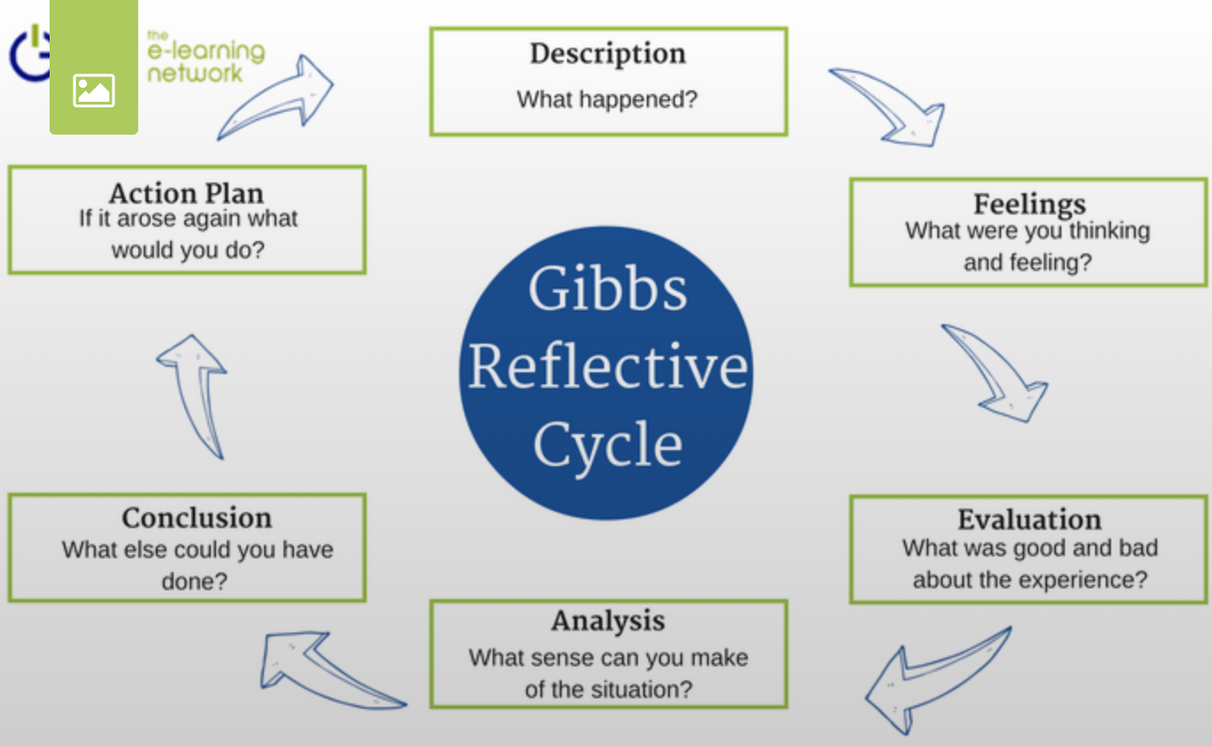

Section 1

Description
The Residential Weekend

Starting with the residential weekend at University of Wales, Trinity St David, we all met our groups and other students from different colleges and universities to start our new module Managing Enterprise in the 21st Century.

During the weekend we were put into our respective groups to discuss our topic. After much discussion amongst our group (Delyth Carter, Dawn Lincoln and myself) we decided to opt for a dog grooming business.

Working on the Assignment

We decided to meet each other twice a week to work on the assignment we would go through different sections and the assignment checklist. We each had different tasks to complete for the business plan by the time we would next meet. Eg. Research agility equipment for dogs and price lists. Etc.

Presenting the Business Plan

On completion of the business plan, we had to email a copy to Julia our lecturer and print a copy then meet in University to present it. We were filmed and were asked different questions on the business.

Section 2

Feelings
The Residential Weekend

During my time at the residential weekend, I remember feeling anxious, overwhelmed but excited as I thought this would be a good fun weekend. I recall meeting Delyth on Friday night, and we sat in the hall and listened to the lecture on the financial planning aspect of our new module. I enjoyed the talk, but felt the last section, calculating the cost of one teaspoon of sugar was really overwhelming and I felt quite worried, and thought that this business plan is going to take forever. The rest of the weekend was enjoyable, the food was really lovely too. I did feel like a small fish in a rather huge pond, there wasn’t many of the Carmarthen group that attended the weekend so I did feel a little out of my depth.

Working on the Assignment

On the first few meetings of our group we discussed the business plan and what we each needed to complete by the time we next met. I felt very rushed, as I have a really busy schedule and work full-time. I never thought we had enough time to complete the business plan. My time management skills are not the greatest but as the days and weeks working on the project progressed, my time management skills improved. I actually enjoyed working on the project, felt really positive, about 3 weeks into the project, I could see the plan taking shape and started to feel more positive. I felt I was contributing equally with my colleagues, which I was quite relieved.

Presenting the Business Plan

I felt rather nervous and anxious, on the thought of presenting the business plan, I know we had all equally given the project 100%, but when answering questions, I found it intimidating in front of the camera. After a few minutes I started to relax a little, I knew a lot about our business, we all researched it thoroughly, so we knew the answers to any questions that were going to be asked. Felt a huge sigh of relief when we had finished.

Section 3

Evaluation
The Residential Weekend
To evaluate the residential weekend, I found it very beneficial. The lecturers were very helpful and it was nice to meet other lecturers and students. The talk on the financial aspect of the business plan could have been longer and more in depth. That was probably what we needed help with the most. Going over the checklist was just what we needed to help layout the business plan, and talking us through each section was not to be missed.

Working on the Assignment

Evaluating the business plan assignment. We each input sections and topics equally which was good and I didn’t find any member not pulling their weight. I did feel that we should have been given the assignment a lot earlier or at least we should have chosen our respective businesses prior to the residential weekend.

I was responsible for the marketing aspect of the business. I have a history in marketing and research so I took charge of this area. I designed and set up the facebook page, and researched dog adventure play rooms, products, wholesalers etc, and chose products and ideas that I thought would fit our needs. Having previously worked in marketing, this was quite easy for me.

Presenting the Business Plan

The presentation was nicely broken down into questions divided between the group which I thought was good. As we all worked on it, we each knew a little bit about everything. Dawn researched and worked on our legal status, where I worked on marketing, and we were asked questions where we could answer respectively. We all worked on the finances and cashflow. I think it showed that we worked hard on the project as we knew all aspects of our business and could answer all the questions.

Section 4

Analysis
The Residential Weekend

Analysing the weekend. Firstly I think we should have been given the business plan checklist and then discussed each topic at the beginning of the weekend. We should have gone through marketing and research and I believe a whole day should have been spent on the financial aspect of the business plan. This should have been longer and more in depth. I felt it needed a lot more time. The weekend could have been condensed into 2 full days, maybe too much time was spent discussing amongst ourselves in our respective groups.

Working on the Assignment

Although we all worked on all aspects of the business plan together, we all found preferences on which areas to work. My own skills set being marketing and research. I designed and set up the facebook page, found various dog play rooms and equipment, and products. We all did research on our own little tasks we had.

I enjoyed this and learned a lot about my own personal skills, I am self motivated and found that when I started work on the assignment, I would get stuck in and time would fly, I am dependable, I know my team can count on me, I will always pull my weight and get try my best not to let anyone down.

My time management skills have improved dramatically throughout the course of the business plan. I have scheduled time to work on the assignment. I feel we worked well together but we all worked on everything. Analysing this, we should have separated the business plan into different sections and maybe all been responsible for a different section each. This perhaps would have been quicker than it actually took us.

Presenting the Business Plan

The presentation of the business plan was made easier for us by being questioned by Julia, rather than a powerpoint presentation. It wasn’t too lengthy and didn’t feel like we were being interrogated. Julia made us feel relaxed and at ease. Each question covered different topics on the business plan e.g. legal status, marketing, cashflow and we were all asked in turn respectively.

Section 5

Conclusion

To sum up the entire module of Modern Enterprise in the 21st Century, I have found it to be excellent. For anyone who dreams of starting their own business, it proves to be a real eye opener, and will make anyone aware of actually how much work you actually need to do before you even contemplate setting up a business.
Creating a business plan, is an ideal way to see how step by step each little detail is needed and how much it will cost. You will calculate and discover your running costs, how much starting capital is needed. Wages, outgoings, everything down to the last penny.

After working on the business plan personally, I have concluded that I would not want to set up my own business. The dog grooming business would actually be a little gold mine and will be extremely profitable, but I do not think I could give it 100% dedication. In the first few years, there will not be enough of a work life balance, Its going to be hard working for 6 days a week, and some of those working late nights. There is definitely money to be made for the right person, but I do not think that I would be the right person for this business.

I think I could come up with another business plan and the prospect of setting up my own business and working for myself is really appealing but at the moment I am enjoying my job and career and have no plans to change in the immediate future.

On a personal level I have learned a lot about myself and my own characteristics, my own employability skills that I possess and skills that I could take to any future employment. I am dependable and reliable, and I don’t like to let any of my team down. I am hard working and give 100%.

My time management skills have improved as well as my organisational skills, Although they have greatly improved they are still not at the level I wish them to be and there is always room for improvement. I have found that my maths and financial planning is a lot better that I thought, which is good to know, once I started working everything out It proved to be a lot easier than I initially thought.

Section 6
Action Plan

There is always room for improvement and although I have improved greatly, its still not perfect yet. Time management has always been an issue for me. I need to diarise time, not only on the day, I should use calendar more and book time for tasks.

I am more organised than I used to be, I have now got a file with all my bits of paper in, and my email has folders where other mail sits. All my emails did use to sit in the inbox. Now it is much more organised with different folders.

My organisational skills have dramatically improved but there is still more room where I can improve.

Gap Analysis

Objective | Current Position | Deficiency | Action
What do I want to do? | What can I already do? | What am I lacking? | How do I fix this?
Manage my time effectively | I can prioritise my workload, diarise time | Currently lacking structure. | Schedule allotted time for certain tasks. Diarise this.
Improve my organisational skills | Prioritise my workload.  Be more tidy with files and folders | Lacking control, less important tasks are being left incomplete | Delegate to other staff members
Solve problems and Analyse situations | Identify the problem and break it down | Research skills | Adopt a teamwork approach. Research.

My action plan lists areas for improvement and what I can do to improve them.

Objectives | Tasks | Success Criteria | Time Frame | Resources
List your Goals | What do you need to do to achieve these goals? | How will you identify your success? | When do they need to be done by? | Who or what do you need to help you?
Become efficient and organised | Research methods online, try them out and see which work best | By being organised and efficient | asap | Research best practices, and other methods, action plan
To be able to solve/analyse problems easily and quickly | Research methods online, try them out and see which work best | Being able to solve any problems easily | asap | Look for research methods online, adopt these, action plan
To complete tasks competently and within timescales | Be more organised, avoid unnecessary interruptions, diarise time for tasks | By managing my time more effectively | asap | Action plan

During the business plan, I have looked closely at my own personal strengths and weaknesses, seen room for improvement in all aspects of myself. My employability skills, working in a team etc. Working alone, how I can motivate myself. I have progressed so much in a year and hope to continue to do so in the future.

References

Bing.com. (2019). gibbs reflective cycle - Bing. [online] Available at: https://www.bing.com/images/search?view=detailV2&id=2CAAEBE9708CB93A25CA528C2C9D08D51B191017&thid=OIP.KooO-hVmZXqBwUvYslPZFAHaEj&mediaurl=https%3A%2F%2Fwww.eln.io%2Fblog%2Ffilemanager%2Fphotos%2F4%2F5ce62d9f7a727.png&exph=842&expw=1368&q=gibbs+reflective+cycle&selectedindex=2&ajaxhist=0&vt=0&eim=1,2,6 [Accessed 16 Sep. 2019].

