How the Bettelbühl mound shows status in females

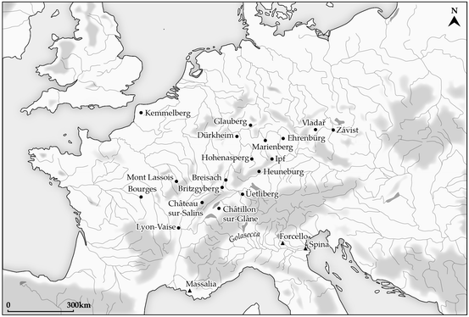
The aim of this essay is to analyse who the interred individuals from Bettelbühl were, where they came from and what their role in society could have been. To do this, the role of women in Celtic times will be analysed as well as the particularly high amount of female burials in Hallstatt Heuneburg. The origin and importance of the timber used in the burial will be looked at in regards to how it shows status. Inherited status is also of particular significance as children cannot be wealthy of their own making. Comparing the wealth of the two women shows an indicator of status difference. The chamfron in the burial raises questions of the origin of those in the tomb, so the possibility of trade and migration needs to be analysed. It will also be argued that terming these types of burials as ‘princely’ and those within as ‘princesses’ is erroneous and should be changed within the scholarly community.
Fig. 1
Map of Iron Age Settlements north of the Alps

Ellis assumes that women ‘enjoyed considerable rights and freedom and, indeed, political power’ (Ellis, 2003, p. 81). Much of Ellis’ ideas of women’s influence on societal matters is based on the extravagance of the contents of burial sites (Aitchtey, 1995, p. 330). However, analysing female burials in a way such as this indicates that gender was a major factor in social status within Hallstatt societies, something which may not be true (Arnold, 2016, p. 832). Female burials in the Heuneburg mortuary outnumber male burials, with 39 percent female, and 21 percent male (Arnold, 2012, p. 97). The higher amount of female burials in Heuneburg indicate to the importance of women in their society. Because burials were a time and recourse consuming venture, it would have only been practiced by those wealthy or important enough to do so.

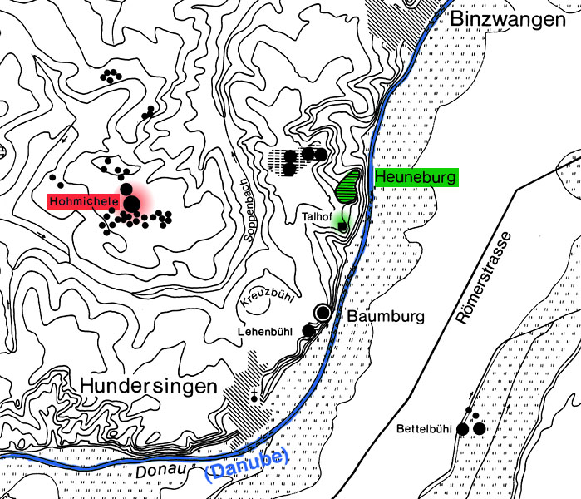
Dendrochronological studies have shown that the timber used in the Heuneburg burial sites, mainly silver fir and oak were extensively lumbered and were locally sourced (Million, et al., 2018, p. 373). It is interesting to note that at Bettelbühl, construction was more oak than silver fir timbers. Oak trees had some importance in religious terms, this can be seen in the etymology of the word druid which comes from the words oak and knowledge (Ellis, 2003, p. 48) as well as the presence of oak in a burial chamber where it was thought the journey to the otherworld began. The use of silver fir timber in a time when it was in high demand probably meant more expense, indicating that those within Bettelbühl were of a high status. Dendrochronological analysis dates the site to 583 BC (Krausse, et al., 2017, p. 108). The burial chamber itself was aligned north to south and rectangular, fitting with other finds from the Hallstatt period (Krausse, et al., 2017, p. 110).
Fig. 2
Mortuary Landscape of Heuneburg

Bettelbühl has the bodies of a 2-4 year old (probably) girl and a (approximately 30-40 year old) 1.6-1.62m tall woman who was lavishly adorned as well as the bones of another (probable) female who was approximately 1.57m tall and adorned more simply than the others (Krausse, et al., 2017, p. 113/117).
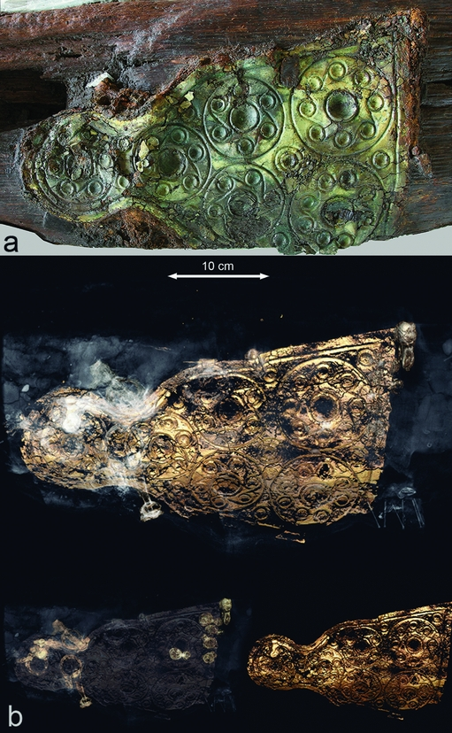
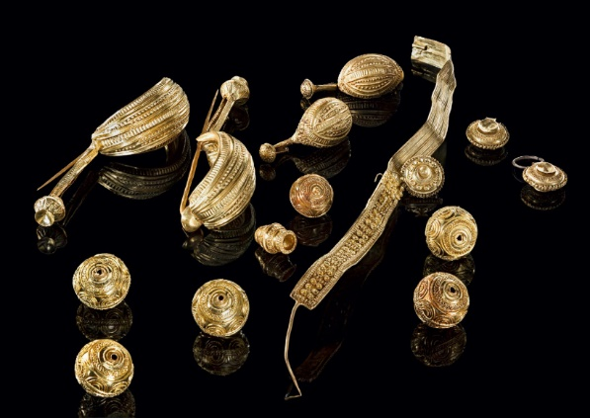
Fernández-Götz argues that the elaborate jewellery and effects granted for the child’s burial indicates ‘that at this time the concept of inherited status was becoming established at the Heuneburg’ (Fernández-Götz & Krausse, 2013, p. 480). The idea of wealth as a hereditary concept seems to be entirely viable in regards to the child, but we cannot assume that the richer woman in the chamber had not accumulated the wealth through her own means, and therefore cannot assume that inherited status was becoming popular. Through similarities between the items placed in the mounds, it seems as though the deceased were somehow socially connected (Fernández-Götz & Krausse, 2013, p. 481). The second woman in the grave had another woman with less effects on her person. The lack of riches on her compared to the other two within the burial point to her being a companion of the deceased who was probably not as wealthy (Krausse, et al., 2017, p. 118).
Fig. 4
Chamfron from Bettelbühl
Fig. 3 Jewellery from Bettelbühl

Among finds at the site were jewellery of gold and amber as well as a chamfron. This is particularly as it is an abnormality. The artefact indicates towards an exchange in Heuneburg or a possibility of the deceased being migrants. The chamfron may have been a gift of good will to the woman in Bettelbühl. This tradition was ‘especially designed for the purpose of creating and maintaining friendly relations through the creation of debt’ (Babic, 2002, p. 78). If this was the case in regards to Bettelbühl, then it would stipulate that the deceased were of high social importance.


The chamfron is made up entirely of iron, and therefore probably came from the Neuenbürg mining district based in the Black Forest (Gassmann & Wieland, 2015). Many Hallstatt finds were produced locally though they put their own twist on art forms often considered to be primarily Etruscan or Greek (Morris, et al., 1994, pp. 123-124). We do know from other finds around Heuneburg that there were many imported goods, mainly Greek and Etruscan (Wells, 1980, p. 16), consequently, the proposition of imported goods seems feasible. Ergo, the chamfron itself was probably imported or made in Heuneburg. The circular motifs embossed on the chamfron are rarely found in Hallstatt culture, though Slovenia possesses some (Krausse, et al., 2017, p. 118). Southern Italy and the Northern Pontic steppes were known for using chamfrons in the 6th century and could be associated to this find (Krausse, et al., 2017). Consequently, we could link this find to the prospect of them being migrants who had settled in Heuneburg from another area. Beyond our knowledge of where the mines were, it is difficult to definitively trace origins and no attempt has yet been made on this artefact. Regardless of where the chamfron itself comes from, it tells us a lot about the status of those within the grave, showing that they were wealthy enough to own a unique object not otherwise found within Hallstatt culture (Krausse, et al., 2017, p. 118).
Fig. 5
Reconstruction of Bettelbühl chamfron

The term ‘princely grave’ is used for richly furnished mounds, such as Vix and Bettelbühl and ‘princely seat’ for fortified hilltop ‘Celtic’ settlements considered more ‘urban’ (Knipper, et al., 2014, p. 818). These conjure up images of royalty and a social hierarchy similar to that of a Medieval Society, something we cannot simply assume through our own bias. Aside from the fact that there might not have been a rigidly hierarchical society, by terming those in these tombs as ‘princesses,’ we do not acknowledge that they may have been higher up in this supposed hierarchical structure. Seemingly, women were indeed capable of obtaining power and chieftainship in their own right, such as is apparent in annals which record a Queen of Ireland who reigned for 7 years (Ellis, 1995, p. 79). As well as through leaders such as Queen Cartimandua (Howarth, 2008), Boudica (Webster, 1993) and Onomaris (Gera, 1997). However, it is unknown how accurate these stories are and they are based in the La Tene period in Celtic Britain, in an era and geographical area different to Heuneburg.

The burial at Bettelbühl indicates to a high status woman, and through the amount of women buried at Heuneburg we know females were immolated in the area. The timber used is a local resource that had religious significance and the use of silver fir trees would have been a novelty since there was high demand for the timber, indicating that they were wealthy enough to acquire it. The grave was very opulent, yet the items give us no indication of their societal roles, nor of their identity. It does seem possible through the chamfron that they could have been migrants to the oppida, but this is only a speculation, and it could just as well have been imported or created from iron from Neuenbürg. However, what is entirely certain is that the use of the term ‘princess’ and ‘princely’ in regards to these types of burials should be used with caution until we have more conclusive evidence on the hierarchical structure of the Celts. Alternatively, a word such as ‘affluent’ could be used in its place.

Bibliography
Aitchtey, R., 1995. Celtic Women. Contemporary Review, Volume 297, p. 330.
Arnold, B., 2012. Gender, Temporalities, and Periodization in Early Iron Age West-Central Europe. Social Science History, Volume 36.1, pp. 85-112.
Arnold, B., 2016. Belts vs. Blades: the Binary Bind in Iron Age Mortuary Contexts in Southwest Germany. Journal of Archaeological Method and Theory, pp. 832-853.
Babic, S., 2002. Princely graves' of the central Balkans – a critical history of research. European Journal of Archaeology, pp. 70-88.
Ellis, P. B., 1995. Celtic Women. London: Constable & Company Ltd..
Ellis, P. B., 2003. The Celts. London: Constable and Robinson Ltd..
Fernández-Götz, M. & Krausse, D., 2013. Rethinking Early Iron Age urbanisation. Antiquity Publications Ltd., Volume 87, pp. 473-487.
Gassmann, G. & Wieland, G., 2015. Early Celtic iron production at Neuenbürg in the northern Black Forest (southern Germany). Persistent Economic Ways of Living: Production, Distribution, and Consumption in Late Prehistory and Early Histor, pp. 91-99.
Gera, D. L., 1997. Warrior Women: The Anonymous Tractatus De Mulieribus. In: s.l.:E.J. Brill, p. 223.
Howarth, N., 2008. The Queen, the Woman, the Invention. In: Cartimandua Queen of the Brigantes. Stroud: The History Press Ltd., pp. 121-143.
Knipper, C. et al., 2014. Social differentiation and land use at an Early Iron Age “princely seat”: bioarchaeological investigations at the Glauberg (Germany). Journal of Archaeological Science, Volume 41, pp. 818-835.
Koch, J. T., 2006. Celtic Culture: A Historical Encyclopedia. California: ABC. Clio.
Krausse, D. et al., 2017. The ‘Keltenblock’ project: discovery and excavation of a rich Hallstatt grave at the Heuneburg, Germany. Antiquity, Volume 91, p. 108–123.
M. Fernández-Götz, I. R., 2017. The Complexity and Fragility of Early Iron Age Urbanism in West-Central Temperate Europe. Journal of World Prehistory, Volume 30.3, pp. 259-279.
Million, S. et al., 2018. Iron Age utilization of silver fir (Abies alba) wood around the Heuneburg e Local origin or timber import?. Quaternary International, Volume 463, pp. 363-375.
Morris, I., Francoise, A. & Broodbank, C., 1994. Classical Greece: Ancient Histories and Modern Archaeologies. Cambridge: Cambridge University Press.
Webster, G., 1993. Boudica: the British Revolt against Rome AD 60. London: The Bath Press.
Wells, P. S., 1980. Culture contact and culture change. Cambridge: Cambridge University Press.

Images
Fig. 1
https://link.springer.com/article/10.1007/s10814-017-9107-1
Fig. 2
http://www2.iath.virginia.edu/Barbarians/Sites/Heuneburg/
Fig 3
https://balkancelts.wordpress.com/2018/10/21/the-glory-of-celtic-europe-the-case-of-the-rich-burial-of-a-celtic-princess-with-horse-armour-at-bettelbuhl-baden-wurttemberg-germany/
Fig. 4
https://www.cambridge.org/core/journals/antiquity/article/keltenblock-project-discovery-and-excavation-of-a-rich-hallstatt-grave-at-the-heuneburg-germany/06DA174F38A2CD1D2EB737222AAFCEBA/core-reader
Fig. 5
https://balkancelts.wordpress.com/2018/10/21/the-glory-of-celtic-europe-the-case-of-the-rich-burial-of-a-celtic-princess-with-horse-armour-at-bettelbuhl-baden-wurttemberg-germany/

