Mudbox & Zbrush Creation Pipeline Analysis

BA: Creative Computer Game Design
M6X02045

Nathan Anthony Scott Small
P143486

Word Count: 4,533

Contents:

Declaration 3
Abstract 4
Introduction 5
Methodology 7
Results 16
Analysis 22
Conclusion 24
Further Work 25
Bibliography 26
References 27

Declaration

I declare that this assignment is my own work and that I have correctly acknowledged the work of others. This assignment is in accordance with University guidance on good academic conduct (and how to avoid plagiarism and other assessment irregularities).

Abstract

There has been speculation in the 3D creation pipeline as to which 3D sculpting program is better, ZBrush or Mudbox, both pieces of software are industry standard and so come at a large price. There are beginner artists who struggle to conclude as to which one to purchase because buying both is normally out of the question. This anatomical sculpt of a human male torso should hope to provide an insight to those interested in which is easier to learn and which will end with the best result.

Introduction

There are many forms of 3D modelling, from traditional clay sculpting to more modern digital alternatives; this investigation will be focus on the digital arts. Currently, 3D modelling plays a role in a large number of industries, being used to create prosthetics for film and medical practices and in the designing of moulds, schematics for 3D printing, sculptures, and statues. This is in addition to its staple employment in creating computer game assets and characters. Traditional methods, however, are still used, and rather than perceived as an alternative to a digital approach, it has been suggested that they should be utilised as a way to bolster one’s abilities;
“‘When comparing the two approaches, neither is better or worse any more than the trumpet is better or worse than the guitar. It comes down to the preference of the artist,’ says Kent. The good news is, you may not have to choose, as Lisa knows: ‘Nobody says you should restrict yourself to digital or traditional only’ says Lisa. ‘As an artist, you should be open to every way to express yourself. You can embrace both worlds.’” (Karon, 2016).
Depending on the intention of the modeller and what they are setting out to achieve, there are multiple approaches that can be taken when 3D modelling. For film, this can include VFX (Visual Effects) in conjunction with makeup and prosthetics. In medicine, however, the capability of ZBrushes’ ability to create personalised prosthetics which will fit the wearer better than one made traditionally from clay moulds is beginning to be recognized. Computer games require the use of digital sculpting software in order to reach an end asset, be it organic or hard surface material which can be integrated into a game engine.


In current times, sculpting 3D characters today has become a staple requirement in the industry, as players buy game titles expecting to have a seamless connection to a character. This will usually be the protagonist, who serves as an anchor for the player’s immersion within the game-world. Software such as Zbrush helps to create unique characters of all shapes and styles for games. 3D sculpting by these means gives the user the benefits of free hand sculpting to get detail where software such as Autodesk’s Maya or 3DS Max struggles to achieve.
For there to be an industry end product there must be a creation pipeline and in the case of game art it is a collaboration between multiple artists. The pipeline starts with concept art, which is then used as the basis for orthographic drawings. Following this, a digital model is made from the orthographic drawing. Although many home based artists free hand sculpt without orthographic drawings, this is usually because they are working on solo projects as the approach saves time. Additionally, this approach calls on the artists ability to sculpt and recognise form, and can be seen as good practice.
“ZBrush is the 3D industry's standard digital sculpting application. Use customizable brushes to shape, texture, and paint virtual clay, while getting instant feedback. Work with the same tools used by film studios, game developers and artists the world over.” (Pixologic, 2017).
There is no real competition between Zbrush and Mudbox in the professional industry; the choice between the two being a matter of preference above all else. Game developers usually prefer their artists using whatever software they prefer to work in. This is liberating for employees as it allows them to work in a familiar program.
This analysis is focused on whether these two pieces of software can achieve certain bench marks in a timed one-hour speed sculpt. The data recorded during this process will provide evidence on which program is easiest to use, which is the fastest and which provides the best results.
“A pixel is a coloured square that appears on the screen at a specified position – Pretty simple, at least to begin with. A raster graphic is an image made up of thousands of pixels. A pixel is imbued with a certain amount of colour and position information that is stored in memory. If you load a rasterized graphic into a digital viewing program and then scale the image up (or zoom in), you can actually see how the image is composed of these pixels.” (Keller, 2011)
The main difference between the programs is that Zbrush deforms and stretches polygons on models and Mudbox creates new geometry (polygons) as you sculpt. Zbrush gives an illusion that it is creating new polygons, but it spreads around the existing geometry like a smudge rather than adding anything substantial. New geometry is only implemented when the ‘dyna-mesh’ button is used, which updates the model’s geometry. This is where Mudbox excels over Zbrush; by being able to apply polygons on top of already existing model’s polygon structure, the need for a dyna-mesh function is rendered obsolete in the sculpting pipeline.
“Essentially, Dynamesh tries to replicate the feel of sculpting in practical clay by allowing you to continually pull new forms from the base shape, interactively combining new meshes into the existing volume, and even carve away negative spaces, all the while maintaining an easily workable even quad mesh layout. This frees you from really having to think about the underlaying topology as you work. It also allows you to create any kind of volume for sculpting without having to be tied to the limits of a base mesh.” (Spencer, 2012)

Methodology

These two programs are both industry standard, artists either stick to one program although combining both programs together can be beneficial. By saving the model as an OBJ file format, files can be opened in either programme.

A modelling test will be conducting by using each of the programs to create a human torso model, with a time limit of one hour for each model. Tools from the standard tool pallet of each programme will be utilised when completing the task. Each model will aim to be of a anatomically accurate human torso, followed from Anatomy for 3D Artists, the essential guide for CG professionals.
It will be paramount to remain unbiased to one program. Although Zbrush has been used more than Mudbox and is therefore more familiar, this should not affect the relative difficulty of each programme, due to the similarities of their standard tool sets. Programs similar to Mudbox have been previously used, including ‘SculptGL’ and ‘Sculptfab’, which also use an active dyna-mesh.
In this experiment limited tools will be needed to create the base mesh of a torso. Dyna-mesh & subdivide will be available to use. Using tools such as ‘light box’ or importing an already sculpted model will be prohibited. These tool restrictions will make for a closer comparison of the standard tools which are frequently used on both programs. When setting the scene there will be a choice of using a singular cube or sphere.
There will not be any discrimination; each experiment will have the same time spent on each model, an alarm will be set for one hour and will commence count down upon starting the sculpture. The same reference material will be used. Notes on the tools used will be documented to find which were most beneficial.

Task:
A study of basic human anatomy, male torso.
One hour.
Limited tool pallet.
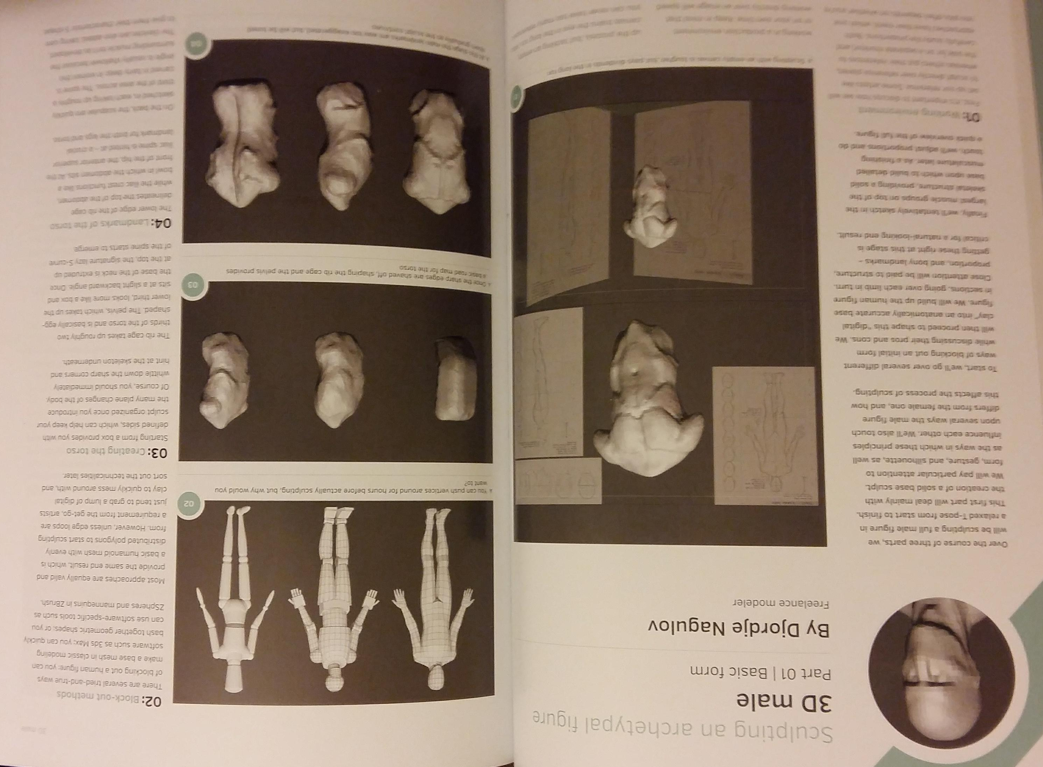
Step 1 of 5
“01: Working environment.
First, it is important to discuss how we will set up our reference. Some artists like to sculpt directly over reference planes, whereas others put their references to the side (or on a separate monitor) and carefully study the proportions. Both approaches have their merit; which one you pick often depends on whether you're working in a production environment or on your own time. Keep in mind that working directly over an image will speed up the process, but tackling an empty canvas trains the eye in the long run.” (Legaspi, 2015)
“02: Block- out methods. There are several tried-and-true ways of blocking out a human figure: you can make a base mesh in classic modeling software such as 3DS Max; you can quickly bash together geometric shapes; or you can use software-specific tools such as ZSpheres and mannequins in ZBrush. Most approaches are equally valid and provide the same end result, which is a basic humanoid mesh with evenly distributed polygons to start sculpting from. However, unless edge loops are a requirement from the get-go, artists just tend to grab a lump of digital clay to quickly mess around with, and sort out the technicalities later.” (Legaspi, 2015)

“03: Creating the torso.
Starting from a box provides you with defined sides, which can help keep your sculpt organised once you introduce the many plane changes of the body. Of course, you should immediately whittle down the sharp corners and hint at the skeleton underneath. The rib cage takes up roughly two thirds of the torso and is basically egg-shaped. The pelvis, which takes up the lower third, looks more like a box and sits at a slight backward angle. Once the base of the neck is extruded up at the top, the signature lazy S-curve of the spine starts to emerge. (Legaspi, 2015)
“04: Landmarks of the torso.
The lower edge of the rib cage delineates the top of the abdomen, while the iliac crest functions like a bowl in which the abdomen sits. At the front of the hip, the anterior superior iliac spine is hinted at – a crucial landmark for both the legs and torso. On the back, the scapulae are quickly sketched in, each taking up roughly a third of the area across. The spine is carved in fairly deep; in women's this angle is usually shallower because the surrounding muscle isn’t as developed. The clavicles are also added, taking care to give them their characteristic S-shape.” (Legaspi, 2015)
05: Adding some muscle.
It’s important not to go overboard with muscles at this early stage, which is a classic beginners mistake. Only add bulk where it describes the form; don’t get bogged down in the details. The pectorals hang from the clavicles and drape over the rib cage, tucking under the deltoids. Sitting on top of the iliac crest are the obliques, while on the back the huge latissimus dorsi give the male torso its triangular shape. The mass of the trapezius extends above the scapulae, sitting on the shoulders and tapering into the neck. (Legaspi, 2015)

Interface

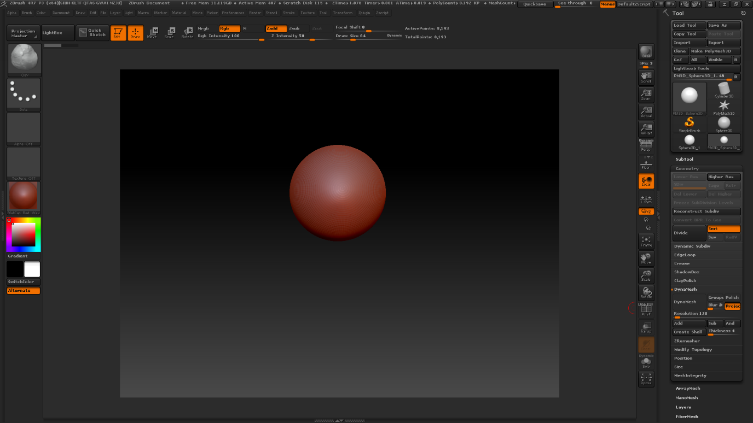
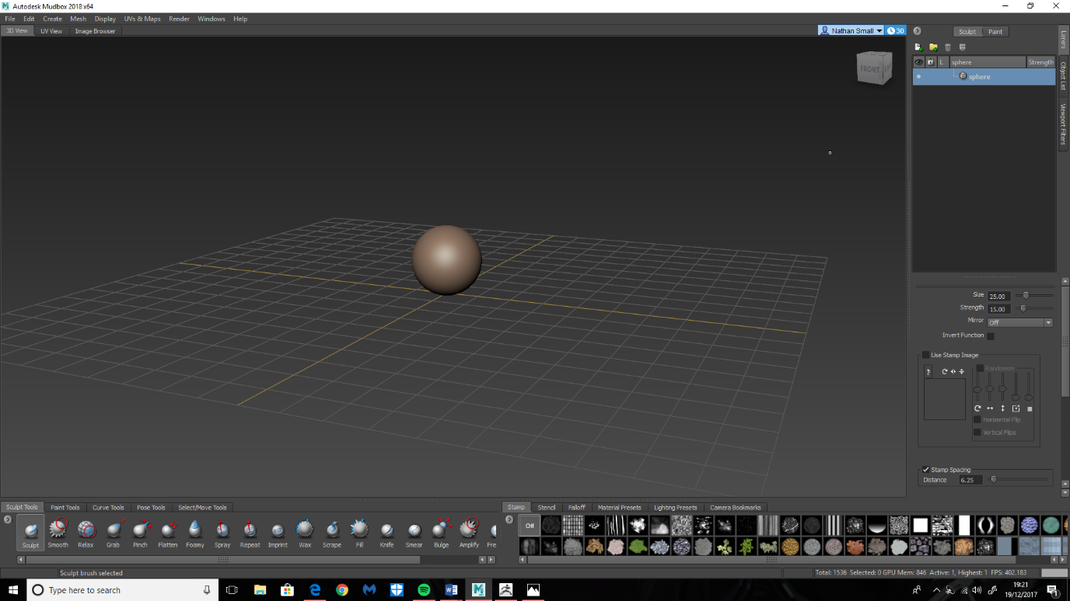
ZBrush

Mudbox

Both program interfaces are sleek in style and well designed. The creators of each program clearly had the idea of making the image plane look spacious, with tool boxes making up a boarder around it. ZBrush’s tool boxes are less crowded than Mudbox, instead having sub-tools hidden away in drop down tool menus on the right-hand side. This, however, can lead to spending an unnecessary amount of time looking for a specific tool.
Mudbox has incorporated interface aspects from other programs Autodesk, the creators of the software, have released, including Maya and 3DS Max. This has led to both positive and negative outcomes. The object transpose tool set, which was derived from Maya, is simple to use and easy to learn. The tool boxes in Mudbox are spread out well, although it is perhaps not necessary for some less used tools to be displayed constantly. The positive is that the most frequently used tools needed are displayed clearly.
“you face two core issues when you create realistic game characters, technology and artistic ability. Five years ago, the biggest problem was technology. We simply couldn't put enough polygons on the screen to get true realism. Today, artistic ability is the biggest factor limiting a 3D modeler's growth in the game industry. The demand for realism increases with technological advances. Today, it is your ability to sculpt a face, but in two years' time realism may depend on understanding what happens to the palpebral ligament when your character is frightened. Your artistic ability is the one constant in the equation of creating realistic characters, whether you are painting in Photoshop or sculpting in ZBrush.” (Kingslien, 2011)
Ryan Kingslien is the founder of www.zbrushworkshops.com, he attended Academy of Fine Arts and Visual effects and was the first product manager for ZBrush at Pixologic.

Tool List & Function

ZBrush ‘Clay / Clay Build Up’ – Mudbox ‘Sculpt’
These are the standard clay brushes which will be used to paint volume on the model.
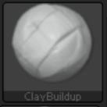
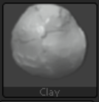

(ZBrush)

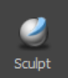
(Mudbox)

ZBrush ‘Move Topological’ – Mudbox ‘Grab’
This tool will be vital as it helps move the clay to the desired shape. These tools function the same; by grabbing a chunk of the model and pulling it.
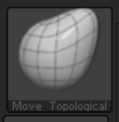

(ZBrush)
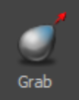

(Mudbox)

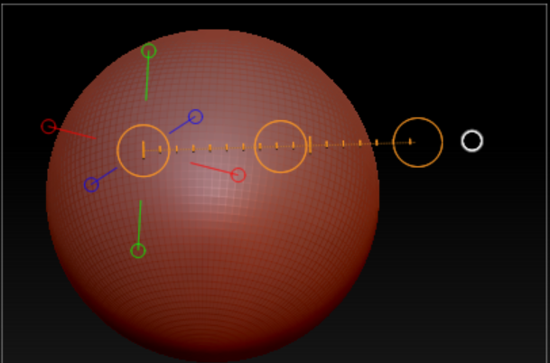
Both programs use a ‘smooth’ tool, this is activated when holding down shift on the keyboard, smoothing is needed when polygons become too stretched, it will flatten the geometry to fix this problem. Smooth is extremely useful as it also helps remove unwanted marks made by sculpting tools.

ZBrush ‘Transpose’ - Mudbox ‘Translate’
In ZBrush, the Transpose tool can be difficult to understand because the display doesn’t provide any tool tips.
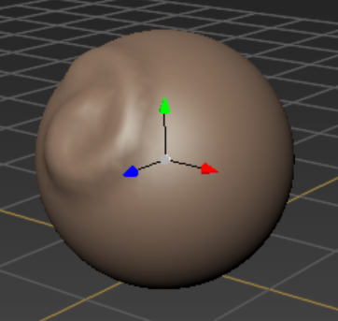

For Mudbox this tool provides three pulling grips each representing the X, Y and Z axis which is far easier to understand.

ZBrush Transpose and Mudbox Translate are both accompanied by partner tools such as Move/Translate, Scale, and Rotate.
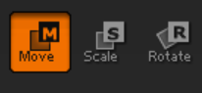

(ZBrush)
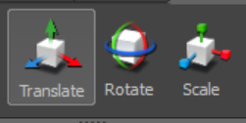

(Mudbox)

Each Program has a tool bar for the mouse cursor/brush, the main sliders that will be used are intensity/strength, draw size of the brush.
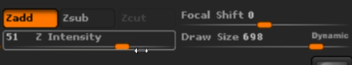

(ZBrush)

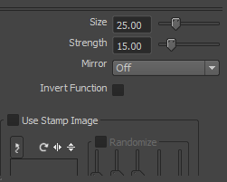

Mudbox

Ultimately, this test would need to be set before a relevant target audience with varying skill sets in the digital arts in order to generate valuable data. Those participating would be categorised into two defining groups; those who have experience in digital sculpting software and those who have never used either of these programs. Solely using the responses of those who have used this software could potentially be problematic, as this data could be biased to the program of their preference.
Using the responses from both parts of the audience, it would be possible to work out the average program ratings and compare the experiences. The study will need to be recorded to provide evidence that no cheating has taken place. This will also provide the average speed of each sculpt and will mean that the problem solving used will be visible to evaluate in the questionnaire. This will be provided after completion in order find out more about the experience.
There is a known starting issue with Zbrush that is often overlooked by those not familiar with the program; once a sphere is created, it is necessary to click on ‘edit’ or the canvas will not become a 3D plane. People who do not use this program will not realise this until told. This would need to be made clear from the onset, as this is needed for the creation of the model to progress correctly.
This test will only be conducted by Nathan Small of UWTSD Swansea, a third-year student in Creative Computer Games Design who undertakes a modelers role.
This investigation could be valuable in finding out exactly why some modellers prefer to use one of these programs over the other, when each can potentially provide the same results. Is preference the only issue here, or is there one program categorically superior when compared to the other?

Results

Overall there were few problems or issues faced during the two sculpts, however there were two hinderances that were documented. ZBrush’s ZRemesher progress which is new geometry being loading into the scene this used up valuable time.
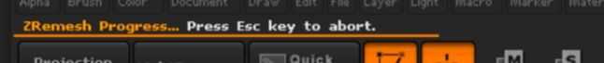

A problem occurred in Mudbox at the time of 0:52:37, the mesh turned yellow, it was not a material pre-set but a random bug, to fix this issue progress needed to be saved, the countdown stopped, and the program restarted.

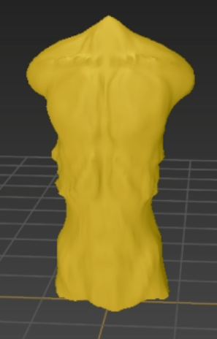

0:20:00 minute comparison
Both sculpts were at a similar point at the twentieth minute, both sculpts had been blocked out with the move topological/ grab brush and muscle mass was being marked for later in the sculpt.
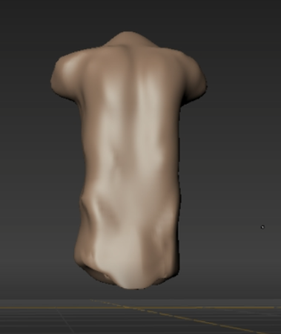
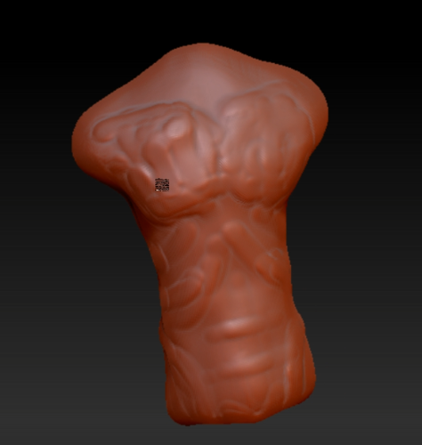

Mudbox ZBrush

It was found that applying the clay was more rustic and flowed better in Mudbox, whereas marking out the proportions in ZBrush was more precise.

0:40:00 minute comparison
Reaching the fortieth minute both sculpts were close in comparison, although Mudbox’s muscle definition is softer to the eye, the width of the model was to a higher standard when aiming for human-likeness. ZBrush had muscle definition but was out of proportion when referring to a human.
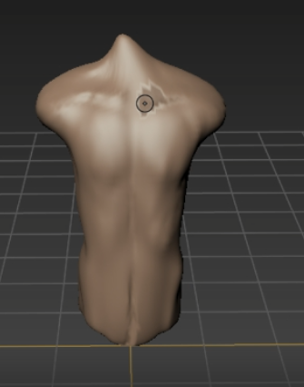

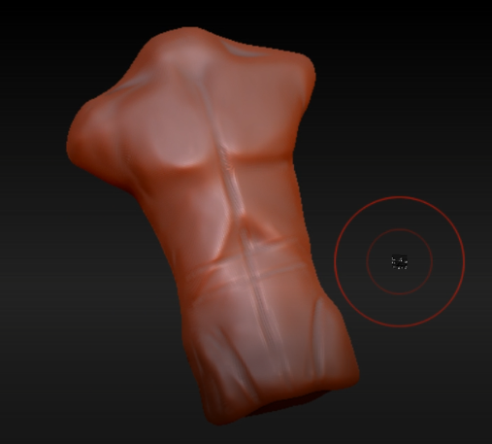

Mudbox ZBrush

0:60:00 minute – Final Image
With both investigations at a closing point, when comparing together it is clear that Mudbox ability to free hand sculpt from a singular shape has come to better results. The proportions on the Mudbox sculpt are more alike to that of a human male, the muscle mass in the pectorals and abdomen is neat but that of a male who is very physically fit with chiselled definition.
The ZBrush sculpt was at a better, more aesthetically pleasing state in the fortieth minute rather than the final product shown here. It was found that the simple brushes in ZBrush were having less influence on the mesh, with ZBrush the smooth capability was destroying more polygons than fixing which can be seen around the abdomen area. Thus, lowered the quality of the muscle definition and thinned the width of the waist to an unhealthy size.

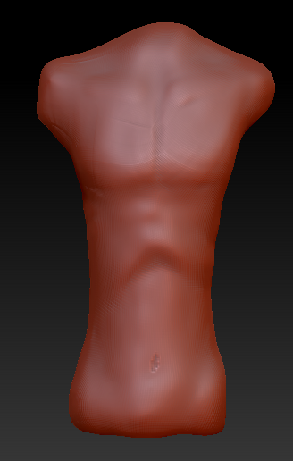
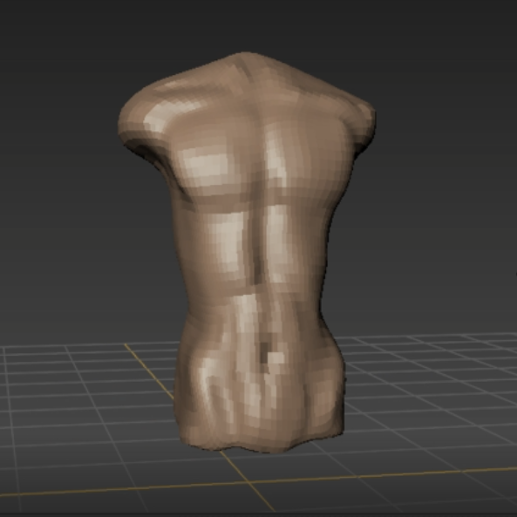

Mudbox ZBrush

End of Sculpt: Mudbox

The overall experience in Mudbox was enjoyable, having never used it before the result is aesthetically pleasing and it looks human. The overall proportions of limb size to muscle are to a high standard when reflecting to the reference material used.

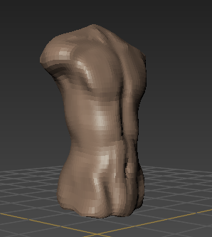

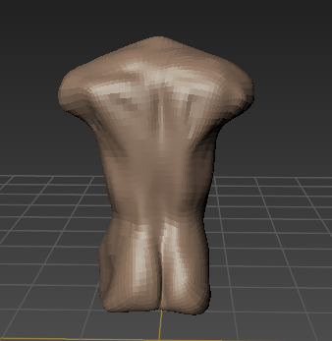
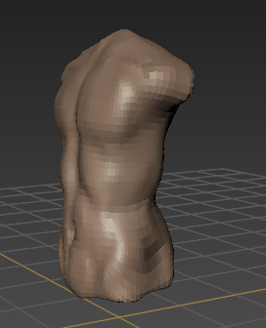

End of Sculpt: ZBrush

The Experience in ZBrush was disappointing, once advanced tools had been removed from use it began to show signs of being the weaker program for the set task. The clay was less responsive to paint and tougher to move due to the elasticity of the polygons as they grouped together for a more detailed sculpt. The proportions are less anatomically correct with the waist being far too slim in comparison to the width of the chest and pectorals.

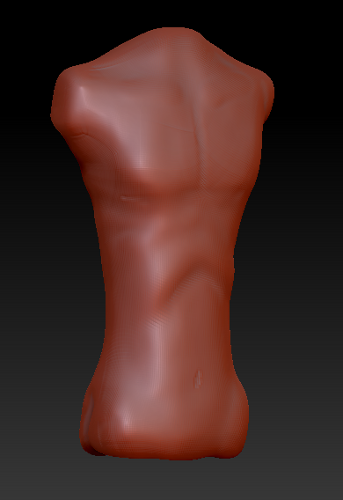

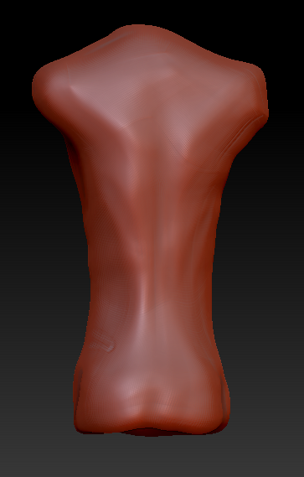
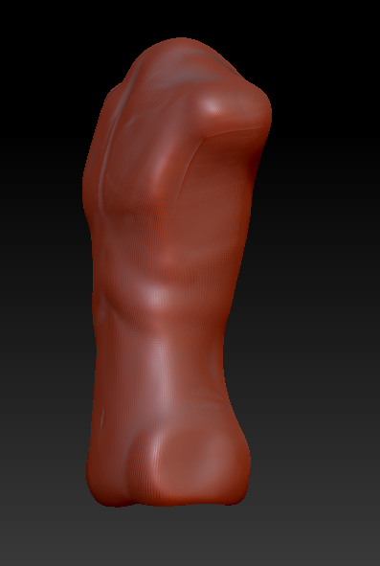

Analysis

The result from Mudbox's one hour sculpt is the most anatomically correct and the model is closer to a completed state when compared to the ZBrush variant of the hour sculpt. There are multiple reasons for why this might be.
Ease of navigation – tools and drop down menus.
Loading screens.
Difference in clay manoeuvrability.
Manually adjusting the resolution and poly count.

Mudbox's interface is simpler and tools are easier to find, although this is not necessarily better than Zbrush’, as this has more tools and functions which may speed up the process when it comes to tackling more complex tasks. In this experiment however, it was clear the less was more, and that simplicity sped up the creation process.
Adding clay in Mudbox has more of an effect on the mesh than in ZBrush. This seems to be because Zbrush's layers of clay are thinner and require a greater amount of building up a base shape.
Both ZBrush and Mudbox are industry standard 3D sculpting packages and both can reach the same bench mark in quality of work, although once there are certain features removed for a fair analysis there is only one program which stands out.
It was found that the ZBrush’s drop down menus were a hindrance, hiding needed functions. This ate into time which could have been spent on the torso sculpt. Mudbox's interface is easier to understand because the tools which are frequently used are more easily accessible. (refer to the times in the video)

ZBrush's clay sculpting tools did not have as much of an impact in the early stages of the sculpt, feeling weaker in comparison to Mudbox's singular clay sculpt tool. This is likely because ZBrush modelling requires building up layers of clay and using dyna-mesh once mass has been added; this cleans the topology of the model, regenerating the topology into a more workable surface for sculpting. Dyna-mesh and adjusting the object resolution are functions that can cause loading screens and no other action is allowed until the program has finished constructing the new topology. The loading time can vary; factors such as how good the computer components are and how large or detailed the model is can effect this. ZBrush uses Random Access Memory (RAM) where as Mudbox tends to use more of the Graphics Processing Unit (GPU) than ZBrush. The GPU is also known as the

graphics card and the more powerful it is, the better the computer and its software will run. This could be a reason for slower responses of adding clay to the model in ZBrush.
“imagine walking into a fully stocked artist’s studio. Inside you find cabinets and draws full of paints and brushes, a large canvas, a closet full of every type of sculpting medium imaginable, a lighting rig, a camera, a large box, a projector, a kiln, armatures for Marquette’s, and a seemingly infinite array of carving and cutting tools. On top of this everything has been neatly arranged for optimal use while working. This is ZBrush, a self-contained studio where you can digitally create paintings and sculptures – and even combinations of the two. Furthermore, you are not limited to what you find in ZBrush. Digital 3D models and 2D textures can easily be imported from other applications and used as tools within ZBrush. ZBrush can function as a self-contained digital art workspace or as an integral part of an animation production pipeline.” (Keller, 2011)
Keller has a valid point, when working in ZBrush there is a digital studio mind frame and when working in an art studio, it is best to spend more than one hour working on a project, the same applies to ZBrush.

“The central problem of sculpting, in my view, revolves around understanding the hierarchy of planes. In a life model, we are confronted with thousands of planes all calling for attention. How do we know which planes to focus on and which to ignore, at least for the moment? The key to working with planes is to move from the largest to the smallest. You, the artist, must create inside of your own brain a 3D model that has multiple levels of resolution. On level 1, it should have the most basic and simplistic planes. On level 5, it might have planes small enough to describe the carbuncular of the eye.” (Kingslien, 2011)
When manoeuvring the clay in Mudbox there is a feeling that it is more malleable than Zbrush, with clay being added onto a mesh and smoothed into position as though it was traditional fine art sculpting and because of this Mudbox was easy to build up planes of muscle and skin tissue. Resultingly, the Mudbox sculpts progression was faster. ZBrush was slower in achieving the desired end product but this does not say it is incapable of reaching such standards. As working in ZBrush it is possible to sculpt finer details with greater ease from being equipped with a large quantity of brushes. ZBrush would need more time dedicated to the 'blocking out' stage if starting from a singular sphere or cube. There are ways of speeding this process, for example by combining multiple shapes together or using the tool brush 'Zspheres'. These actions were taken into consideration although were not used to keep the analysis consistent with using a singular starting shape. Without being able to take advantage of the unique tool Zsphere, ZBrush’s progress fell behind on time when compared to Mudbox's position at 40 minutes in.

Conclusion

Mudbox sculpt was better overall, knowledge gained from this result can conclude that once ZBrush has been stripped of its specialist tool set the program is not as good as Mudbox in a timed sculpt. Although it would be beneficial to understand that both ZBrush and Mudbox are better suited for where the other lacks in. The creators of both pieces of software intentionally made this to help market the product. It would be wise to give ZBrush credit in preforming the task without using its advanced Zsphere tool brush.
If ZBrush was used with all tools being eligible for use it could have hit the same quality, if not better than Mudbox. There is a feeling when working within ZBrush that is almost cosy for the artist, it allows for longer duration of time being spent within the program.
As a ZBrush user it would be beneficial as a learning artist to use and understand more about Mudbox and its benefits it can have on sculptural projects in the future.

Further Work

To validate this analysis further it would be beneficial to set this task out for a class or to a wider audience. This would make it possible to understand a wide variety of performances and a questionnaire at the end would provide opinions on the programs core performances. This would also help deduce how much subjectivity came into play, as results would probably indicate that some participants had a better performance with Zbrush, whilst other preferred Mudbox.
Conducting a third comparison which would allow the use of all tools and brushes in Zbrush like Zspheres could be beneficial in showing Zbrush can reach the quality of a higher standard, which would normally be expected of it.
Conducting a fourth comparison which could consist of using both Mudbox and Zbrush to create a singular asset of higher detail would also be beneficial. The time limit would naturally need to be extended to two hours, an hour spent in each program. This would work by starting the sculpt in Mudbox and blocking out the initial shape of the torso and setting the anatomy of the bodies muscles into their correct position. Once the first hour ends the base mesh would need to be exported as an OBJ file, allowing it to be imported into Zbrush for finer detail sculpting. The method of working with both programs is not unheard of, as each piece of software is clearly beneficial in specific instances or for certain purposes. It would be good practise for future employment purposes to know the fundamentals of both programs.

Bibliography

Karon, P. (2016). Digital vs. Traditional Sculpting. [online] CGCOOKIE. Available at: https://cgcookie.com/articles/digital-vs-traditional-sculpting [Accessed 11 Dec. 2017].
Pixologic. (2017). Zbrush Features. [online] Available at: http://pixologic.com/features/ [Accessed 12 Dec. 2017].

References
Legaspi, C. (2015). Anatomy for 3D Artists: The Essential Guide for CG Professionals. 1st ed. United Kingdom: 3DTotal Publishing, pp.94 - 96.
Keller, E. (2011). INTRODUCING ZBRUSH 4. Indianapolis: Wiley Publishing, pp.2-3.
Kingslien, R. (2011). ZBrush Studio Projects: Realistic Game Characters. 1st ed. Indianapolis: Wiley Publishing, pp.1 - 2.
Spencer, S. (2012). ZBrush Creature Design: Creating Dynamic Concept Imagery for Film and Games. 1st ed. Indianapolis: John Wiley & Sons, p.178.

