Gareth James
2217522
Chemical Compatibility and Decomposition Pathways in Energetic Materials
ACDA6020 – Advanced Chemistry of OME

Abstract
Chemical compatibility and decomposition pathways vary according to the properties of each energetic material. To ensure that a system remains safe throughout the manufacture, transport and storage, compatibility testing is conducted. The following report outlines the Vacuum Stability Test, Thermogravimetric Analysis, Differential Scanning Calorimetry and the use of High Flow Calorimetry (at various stages of compatibility testing), from these tests key information is identified relating to activation energy, heat of reaction, and environmental considerations that can instigate decomposition. Data is identified during the compatibility testing process that confirms the compatibility of energetic materials and stabilisers, and how suitable they are for use with each other. It is identified that a minimum of two compatibility tests are required to provide an understanding of suitability, and that several material properties need to be considered before confirming compatibility.

Table of Contents
1. Introduction 2
2. Compatibility Testing 3
2.1. Vacuum Stability Test 3
2.2. Thermogravimetric Analysis: 4
2.3. Differential Scanning Calorimetry Test 4
3. Long Term Safety and Life Cycle Management 6
4. Conclusion 7
5. References 8

Figure 1 - Vacuum Stability Test - Results example - Showing the compatibility testing of nitrocellulose and other materials as stabilisers - to examine the effect on thermal stability and decomposition. [4] 3
Figure 2 - Thermogravimetric Test - Example of results from TGA and stabiliser testing. these results illustrate the mass lost during test procedure for Nitrocellulose, and NC and stabiliser mixtures. [4] 4
Figure 3 – Differential Scanning Calorimetry test - NC compatibility testing results demonstrate how Onset and Peak Temperature are affected in the presence of different stabilisers [4]. 5
Figure 4 - Tabulated Results of Differential Scanning Calorimetry Test - Following analysis of results in Figure 3 [4]. 6
Figure 5 - Heat Flow Calorimetry Test results - Nitrocellulose based propellant surveillance. Heat flow is shown on the (y) axis, with time (days) along the (x) axis. 7

Introduction
Compatibility testing is an essential part of the weapons design process, especially with the increasing complexity of modern weapons and development in energetic materials. The process involves the assessment of chemical and thermal stability of the energetic material (EM) and all other components that it will come into contact with during its lifecycle. These components include casings, binders, and stabilisers, as well as liner materials [1] [2].
There are currently a wide range of energetic materials (EM) of different types with a broad range of sensitivities unique to each. To deliver a desired effect on target, whether that is to screen/mask military assets, or to deliver an airborne countermeasure, the system has to be reliable and safe, throughout all stages of its lifecycle. This is achieved through Compatibility testing. Standardized testing allows allied forces and NATO members to share and use munitions safely, effectively enhancing and supporting interoperability.
The process of classification and compatibility of energetic materials is governed by the United Nations, with advice being found in the Manual of Tests and Criteria. Essential (and overarching) guidance has been identified within the Standardisation Agreement of NATO (STANAG) 4170, and Allied Ordnance Publication (AOP) 7. STANAG 4170 does not contain specific test procedures but refers to further STANAGS that provide details on them [3]. A list of STANAGS relevant to compatibility testing can be found in Appendix 1.

Compatibility Testing
The compatibility of energetic materials plays an important part of the Ordnance, Munitions and Explosives lifecycle, and the data gathered from these tests informs safe handling at all stages of the lifecycle, including manufacture, handling, use, transport, storage and disposal.
Several test methods exist within the compatibility testing framework. Information about the decomposition process of EM can be identified using a variety of tests. This included specific test procedures relating to Vacuum Stability Testing (VST), Thermogravimetry (TGA) Testing, and Differential Scanning Calorimetry (DSC) Testing. During the test process, information relating to thermal stability, melting point, decomposition onset and peak temperatures can be identified.

Vacuum Stability Test
The test procedure is conducted using small sample quantities (2-4g) and is conducted in a sealed and contained environment. The sample is then heated to a set temperature and then held at that temperature for a set time. The volume of gas generated (and the associated pressures) during the decomposition process are measured, which allows direct comparison between a pure sample and others run concurrently. This is used
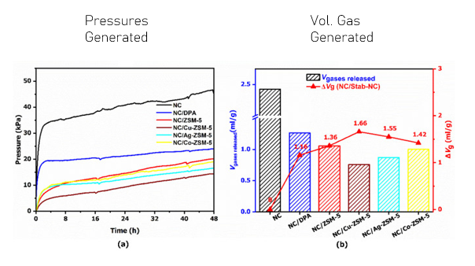
VST has been used to examine the volume and pressure of gasses generated during decomposition in evaluating chemical compatibility of nitrocellulose and stabilisers. This research demonstrated that both the volume and pressures generated are decreased by the presence of other materials that were being tested. The decrease demonstrates that the other substances are compatible with NC as a result of this reduction [4]. Should the test results show an increase in pressure and volumes of gas produced, this would indicate an adverse effect, indicating that the materials are incompatible. Examples are shown in Figure 2.
Figure 1 - Vacuum Stability Test - Results example - Showing the compatibility testing of nitrocellulose and other materials as stabilisers - to examine the effect on thermal stability and decomposition. [4]

Thermogravimetric Analysis:
Thermogravimetric Analysis (TGA) examines the physical mass of a sample that is lost during the test procedure. This is conducted by exposing a sample to a set temperature for a fixed duration of time in an inert atmosphere [5] [6]. For testing NC this is conducted at 150°C for 80 minutes.
From examining mass loss during this test procedure information can be identified about consumption of stabilisers in storage. As NC decomposes, it breaks down into ROO, NO, RONO₂, and NO₂, and the mass decreases as these products are generated [7]. By weighing the initial sample and what remains at the end of the test procedure, it is possible to identify the total mass lost as a result. The TGA test indicates whether a material is compatible with a sample as it will reduce the total weight lost, and example of results from this are shown in Figure 3.
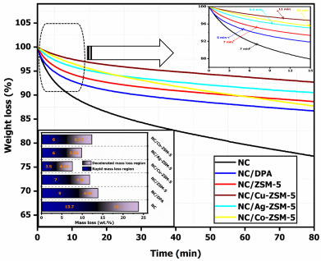
Figure 2 - Thermogravimetric Test - Example of results from TGA and stabiliser testing. these results illustrate the mass lost during test procedure for Nitrocellulose, and NC and stabiliser mixtures. [4]

Differential Scanning Calorimetry Test
Differential Scanning Calorimetry (DSC) testing is used to examine thermal decomposition kinetics of a material sample. It has been used to identify the change in enthalpy and establish the heat of reaction (Δ_{r}H) of a material sample. It is conducted by exposing the sample to a variety of heating rates over a range of temperatures. DSC Identifies Onset temperature (T_{onset}) & Peak temperature (T_{peak}) of decomposition reactions to determine the Activation energy (E_{a}) of the material being tested. Where the E_{a} is reduced (or increased) by the presence of another material or stabiliser its compatibility is identified, according to the baseline results of the material itself.
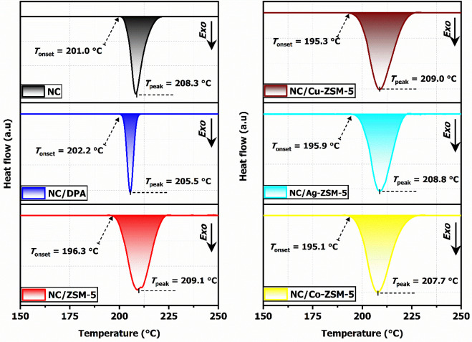
Analysis provides information on how a material reacts during compatibility testing, with examples shown in Figure 4.
Figure 3 – Differential Scanning Calorimetry test - NC compatibility testing results demonstrate how Onset and Peak Temperature are affected in the presence of different stabilisers [4].
Figure 4 shows a number of examples related to how NC T_{onset} is affected by different materials. Pure NC has a T_{onset} of 201.0°C, which increases to 202.2°C when compatibility testing with DPA is conducted. From testing alongside other materials (ZSM-5 and other ZSM-5 compounds) a decrease in temperature indicated that there was a decrease in Δ_{r}H, which would initially suggest that the presence of these materials had an adverse effect on the T_{onset}. Further analysis E_{a} required to initiate the decomposition of NC can be seen in Figure 5. This showed that the presence of the other materials considerably increased the E_{a} required to initiate a reaction, thus indicating chemical compatibility of the materials tested.
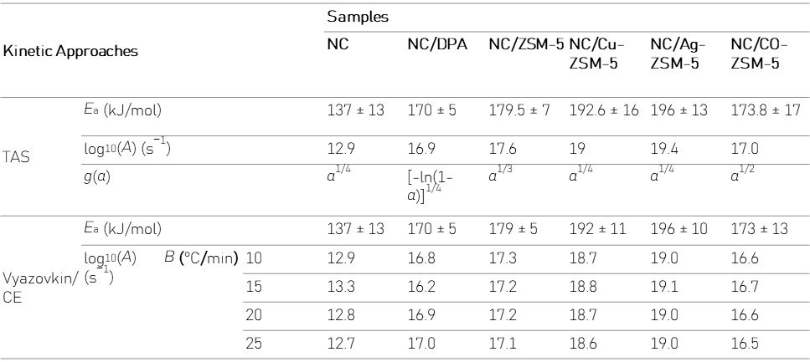
Figure 4 - Tabulated Results of Differential Scanning Calorimetry Test - Following analysis of results in Figure 4 [4].

Long Term Safety and Life Cycle Management
Nitrocellulose has been identified as a common ingredient in civilian and military propellants (and commonly found in single and double base propellants) [8]. Thus when used in propellants of this nature it is required to perform to a satisfactory standard wherever military assets are deployed, which has included a broad range of temperatures and environments. During storage, NC is prone to decomposition even when stabilisers are present (albeit at a much slower rate than pure NC). This is as a result of low bond energies of the nitro-ester functional group. In storage stabilisers (such as DPA, Centralite 1 and Akardite 2) are consumed as part of the decomposition process, however, reduce the onset of autocatalytic decomposition [9] [10]. As part of this, regular testing for stabiliser depletion needs to be conducted to ensure that articles containing NC will perform as and when required. In-Service surveillance ensures that performance and safety requirements are met throughout the lifecycle of any given munition.
In-Service Surveillance has been conducted using Het Flow Calorimetry (HFC) and DSC [4] [11]. This test procedure measures the thermal absorption of materials over time and utilises Gas Chromatography-Mass Spectrometry (GCMS) to identify the quantity of stabiliser remaining. HFC testing standards are identified within STANAG 4582 and STANAG 4620 (AOP 48 - Explosives, Nitrocellulose-Based Propellants, Stability Test Procedures and Requirements using stabiliser Depletion). An example of HFC data is shown in Figure 5.
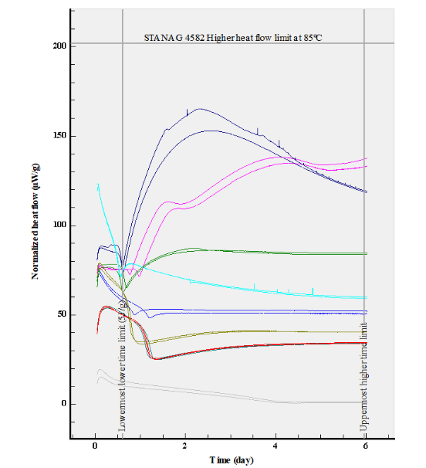
Figure 5 - Heat Flow Calorimetry Test results - Nitrocellulose based propellant surveillance. Heat flow is shown on the (y) axis, with time (days) along the (x) axis.

Conclusion
Compatibility testing plays an important role in identifying the chemical compatibility of materials, with the aim of reducing the hazards associated with all stages of the lifecycle of energetic materials. The test methods of VST, TGA, DSC and HFC are essential in evaluating the safety and compatibility of energetic materials throughout the manufacture, storage, and transportation processes associated with them [12]. Understanding how the interactions between EM, stabilisers and the effects these have on material sensitivity need to be considered, as these share an intimate relationship based on the materials and environments they are exposed to throughout their lifecycle.
The thermal stability, kinetics, and activation energy of isothermal decomposition vary between EMs and play an important role when considering the practicalities of safe handling throughout their respective lifecycles [13].
The selection and use of stabilisers can enhance safe handling but should be established based on empirical evidence gathered through the different test procedures, with a minimum of two compatibility tests being conducted to ensure compatibility. E_{a} and Δ_{r}H vary throughout the lifecycle and should be monitored at key stages to ensure longevity, with appropriate disposal pathways in place for materials that do not meet required safety standards [10] [14]. Compatibility testing should therefore be considered an essential step factored into all stages of the energetic lifecycle of any OME article following the guidance laid out in the relevant STANAGs and AOPs according to the EM used.

References

[1] | N. J. Blay and I. Dunstan, “Compatibility Testing of Priwary Explosives and Pyrotechnics,” Ministry of Defence Explosives Research and Development Establishment, Waltham Abbey, 1973.
[2] | E. L. M. Krabbendam-La Haye, W. P. de Klerk, M. Miszczak and J. Szymanowski, “Compatibility testing of energetic materials at TNO-PML and MIAT,” Journal of Thermal Analysis and Calorimetry, vol. 72, no. 3, pp. 931-942, 2003.
[3] | B. Vogelsanger, “Chemical Stability, Compatibility and Shelf Life of Explosives,” CHIMIA International Journal for Chemistry, vol. 58, no. 6, pp. 401-408, 2004.
[4] | M. Chebbah, A. F. Tarchoun, F. Benaliouche, A. Abdelaziz and D. Trache, “Advancing nitrocellulose thermal stability through the incorporation of ion-exchanged ZSM-5 zeolite for enhanced performance,” FirePhysChem, vol. 5, no. 3, pp. 209-222, 2025.
[5] | L. F. Garcia-Herrera and H. Price, “Thermogravimetric analysis (TGA),” LibreTexts, 2020. [Online]. Available: https://chem.libretexts.org/Courses/Franklin_and_Marshall_College/Introduction_to_Materials_Characterization__CHM_412_Collaborative_Text/Thermal_Analysis/Thermogravimetric_analysis_(TGA). [Accessed 09 01 2026].
[6] | R. B. Prime, H. E. Bair, S. Vyazovkin, P. K. Gallagher and A. Riga, “Chapter 3: Thermogravimetric Analysis,” in Thermal Analysis of Polymers: Fundamentals and Applications, Hoboken, NJ, John Wiley & Sons, Inc., 2009, pp. 241-318.
[7] | R. Wei, S. Huang, Z. Wang, X. Wang, C. Ding, R. Yuen and J. Wang, “Thermal behavior of nitrocellulose with different aging periods,” Journal of Thermal Analysis and Calorimetry, vol. 136, no. August, p. 651–660, 2019.
[8] | W. P. C. de Klerk, “Assessment of Stability of Propellants and Safe Lifetimes,” Propellants, Explosives, Pyrotechnics, vol. 40, p. 388 – 393, 2015.
[9] | K. Cieślak, K. Gańczyk-Specjalska, K. Drożdżewska-Szymańska and M. Uszyński , “Effect of stabilizers and nitrogen content on thermal properties of nitrocellulose granules,” Journal of Thermal Analysis and Calorimetry, vol. 143, no. January, p. 3459–3470, 2021.
[10] | D. Trache and A. F. Tarchoun, “Stabilizers for nitrate ester-based energetic materials and their mechanism of action: a state-of-the-art review,” UER Procédés Energétiques, Ecole Militaire Polytechnique, Algiers, 2017.
[11] | J. Rychlý, A. Lattuati-Derieux, L. Matisová-Rychlá, K. Csomorová, I. Janigová and B. Lavédrine, “Degradation of aged nitrocellulose investigated by thermal analysis and chemiluminescence,” Journal of Thermal Analysis and Calorimetry, vol. 107, no. June, p. 1267–1276, 2012.
[12] | Y. Tang, Z.-P. Li, H.-L. Zhou, C.-F. Miao, J.-C. Jiang and A.-C. Huang, “Thermal stability assessment of nitrocellulose by using multiple calorimetric techniques and advanced thermokinetics,” Journal of Thermal Analysis and Calorimetry, vol. 148, no. November, p. 5029–5038, 2023.
[13] | L. Luo, B. Jin, Y. Xiao, Q. Zhang, Z. Chai, Q. Huang, S. Chu and R. Peng, “Study on the isothermal decomposition kinetics and mechanism of nitrocellulose,” Polymer Testing, vol. 75, no. May, pp. 337-343, 2019.
[14] | S. N. A. Rusly, S. H. Jamal, A. Samsuri, S. A. M. Noor, N. Shazwani, A. Latif and K. S. A. Rahim , “Stabilizers for Nitrocellulose-Based Propellants: Insights from Compatibility and Thermal Stability,” Journal of Thermal Analysis and Calorimetry, Vols. -, no. November, p. (Online), 2025.
[15] | G. Xu, M. Li, R. A. Mensah and O. Das, “A strategic approach to thermal stability enhancement of nitrocellulose,” Journal of Thermal Analysis and Calorimetry, vol. 150, no. October, p. 11875–11891, 2025.
[16] | T. Lindblom, “Reactions in Stabilizer and Between Stabilizer and Nitrocellulose in Propellants,” Propellants, Explosives, Pyrotechnics, vol. 27, pp. 197-208, 2002.
[17] | P. Guillaume, M. Rat, G. Pantel and S. Wilker, “Heat Flow Calorimetry of Propellants - Effects of Sample Preparation and Measuring Conditions,” Propellants, Explosives, Pyrotechnics, vol. 26, pp. 51-57, 2001.

Appendix 1:
The following STANAGs and AOPs were identified through conducting a literature search into compatibility testing. This should not be considered an exhaustive list; the majority of STANAGs are not available for free as open-source copies. This list should be considered an example of the breadth and depth of subject areas relevant to compatibility testing that are referenced in research articles and/or identified through research.
STANAG | AOP | Description
2953 | AOP-02 | Identification of Ammunition shows marking and colour coding which will serve to identify the use, effect produced, and hazard potential of ammunition used by NATO Forces.
4147 | AOP-4147 | Common procedures for testing the chemical compatibility of explosives and propellants with other ammunition components, ensuring safety and reliability during manufacturing, storage, and use.
4170 | AOP-07 | Manual of Data Requirements for the Qualification of Explosive Materials for Military Use provides the principles and methodology to assess new explosives materials for military use.
4297 | AOP-15 | Guidance on the Assessment of the Safety and Suitability for Service of Non-Nuclear Munitions for NATO Armed Forces establishes and maintains the munition development and assessment policies.
 | AOP-38 | Specialist Glossary of Terms and Definitions on Ammunition Safety (No Covering STANAG). This is in the process of being updates, and with NATO definitions being moved to the NATO term database incrementally.
4315 | AOP-46 | The Scientific Basis for the Whole Life Assessment of Munitions enables nations to collaborate in effectively implementing and conducting Munitions Whole Life Assessment to optimise munition life and achieve improved safety, reduced cost and sustained capability.
4556 |  | Explosives: Vacuum Stability Test: Stability testing procedures for energetic materials using vacuum stability are described/contained within this standard.
4620 | AOP-48 | Explosives, Nitrocellulose-Based Propellants, Stability Test Procedures and Requirements using Stabilizer Depletion provides the general methodology, test procedures, limits of acceptance and data sheets for stability testing of nitrocellulose-based propellants using stabilizer depletion.
4675 | AOP-62 | In-Service Surveillance of Munitions General Guidance provides basic guidance on ISS including, why it is necessary, when it should be implemented, and the key personnel and documentation required.
4675 | AOP-63 | In-Service Surveillance of Munitions Sampling and Test Procedures enables nations to conduct joint in-service surveillance programmes of munitions provides guidance for selecting test items that adequately represent the whole population to be assessed.
4675 | AOP-64 | In-Service Surveillance of Munitions Condition Monitoring of Energetic Materials provides standards for the procedures required to assess continued or extended service use of an item.
4844 | AOP-4844 | NATO Handbook for Munitions Health Management provides an agreed best-practice guide for the implementation of munitions health management which when applied, supports, and enhances national policy for In-Service Surveillance.

It should be noted that there are three variations of TGA: Dynamic TGA (DGTA), Static TGA (STGA) and Quasistatic TGA (QTGA). The key differences between these are that when conducting DTGA temperature and weight are recorded; during STGA temperature is held at a constant, to measure the temperature resistance of a sample; and QTGA where the sample is heated at different rates and held at those temperatures until the sample stabilises (i.e. no further mass is lost). The majority of TGA conducted is Isometric, focussing on only one variable at a time.
Note: Where the temperatures of the alternative stabilisers adversely affected the T_{onset}, this paper also noted that the Zeolite mixtures also improved the temperature of output NC demonstrating a higher T_{peak.} (Chebbah et al.).

