

Programme Name: Master of Business Administration
Module Code: LCMB7023
Module Title: Human Capital Management

Assignment Title: Assessment component 1: Individual Report

Lecturer’s Name: Ejike Udeogu (Birmingham)

Student Name: Manikandan Gopalakrishnan
Student ID: 2507423
Word Count: 2610
Date of Submission: 17-10-2025

Table of Contents
1.0 Impact of Technological advancements on reshaping labour markets and their implication on HRM and IHRM 4
1.1 Technological Transformation in Labour Markets 4
1.2 Analysis of implications on HRM and IHRM strategies 5
2.0 Influence of Demographic and Geopolitical Factors on Employment Markets 6
2.1 Key demographic and geopolitical factors influencing employment markets 6
2.2 Challenges faced by HR Professionals 7
3.0 Analysis of tactics for addressing skill gaps and shortages of talent 8
4.0 Reflective Report 9
References 15

List of Figures
Figure 1: Impact of AI on the labour market 4
Figure 2: Impact of Technological Advancement on HRM 6
Figure 3: Ageing demographics in the workplace 7
Figure 4: Resource-Based View Model 9
Figure 5: Gibbs model 10
Figure 6: Communication Skills 11
Figure 7: Process of Self-Directed Learning 12

List of Tables
Table 1: Strengths and Weaknesses 13
Table 2: Action Plan 14

1.0 Impact of Technological advancements on reshaping labour markets and their implication on HRM and IHRM

1.1 Technological Transformation in Labour Markets
​​The UK labour market is changing considerably due to technological progress, such as AI, automation, and online platforms, with some dramatic consequences being witnessed in recent years. ​The digitisation of work and the use of AI are changing the nature of work in 2025, increasing the demand for big data and cybersecurity (World Economic Forum, 2025). ​In a study of job vacancies and LinkedIn profiles in 2021 to 2025 in the UK, high-income firms and professional roles were found to be experiencing the biggest falls in job and waged employment attributable to AI, whereas less-paid work areas were mostly immune (Ford, 2025).
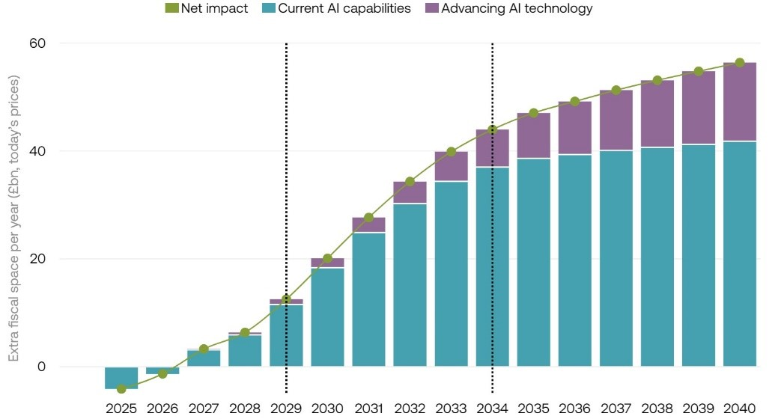

Figure 1: Impact of AI on the labour market
(Source: Sharps, 2024)
The companies that had highly skilled workforces in terms of AI abilities decreased their overall workforce by 4.5% on average, and a reduction of 5.8% in lower-level jobs. ​This increase has raised average wages in such firms by more than 1,300 pounds in spite of the fact that some of the high-skilled jobs have gone down in demand (Partridge, 2025). ​sThe most significant reductions in job offerings were in technical positions of software engineers and data analysts, whereas positions involving direct interaction with customers, not based on big language models, saw slight increases, indicating that they are less vulnerable to big language models' disruption (Pradhan, 2025). This raises the necessity of employees to develop new forms of skills, which include data analysis, critical thinking, and advanced problem-solving, because routine tasks are automated (Furaijl et al., 2025). ​To facilitate such changes and create a culture of flexibility, the UK government and businesses are investing in training initiatives to prepare the workforce to meet these changes.

1.2 Analysis of implications on HRM and IHRM strategies
​The most relevant trends in the context of HRM are the emergence of new hybrid work arrangements, the focus on the well-being and mental health of the employees, and the increase in technological progress, such as AI and automation in recruitment (Jha, 2024). Since 2024, hybrid work arrangements have been transforming the conventional office environment in the UK, and employers have been developing more complex structures to accommodate remote and in-person employees. ​The use of AI and automation is transforming the recruitment process by simplifying the process of hiring, scanning resumes fast, and finding suitable hires, accelerating the speed of recruitment and increasing its precision by cutting human bias (CIPD, 2024). ​Moreover, data analytics are utilised to learn about employee behaviour, productivity, and satisfaction and enable the HR professionals to predict the needs and plan the program to achieve increased satisfaction and retention (Jha, 2024).
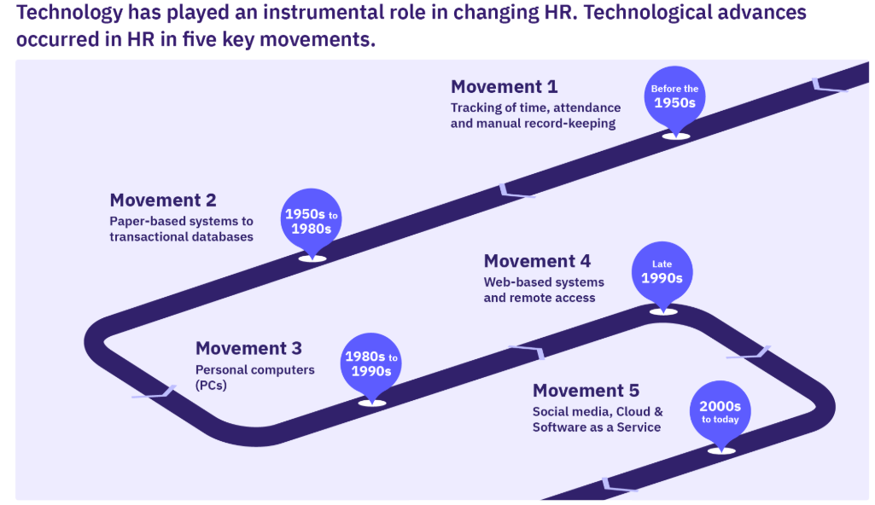

Figure 2: Impact of Technological Advancement on HRM
(Source: Veldsman, 2025)
​In the case of IHRM, globalisation of the workforce in different cultural settings and, in this instance, the UK multinational enterprises (MNEs), has complex challenges and opportunities. ​Multinational firms are in urgent need to be competitive in the global arena (Rodriguez, Johnstone and Procter, 2017). ​Foreign assignments are one of the most important aspects of IHRM strategy, and corporations are exploring options to the customary expatriation in order to cope with complexity and expenses. ​In 2025, the 17th Conference on “International Human Resource Management (IHRM)” will be covering innovative work on IHRM, AI, global talent mobility, and inclusive growth, which will be an important step in ensuring the efficient usage of AI and making the IHRM strategies more efficient (BAM, 2025).

2.0 Influence of Demographic and Geopolitical Factors on Employment Markets

2.1 Key demographic and geopolitical factors influencing employment markets
​Several demographic changes are causing complex scenarios in the labour market of the UK. ​The global economies and labour markets are increasingly changing due to population ageing and the reduction in the working-age population. ​The UK has the challenges linked to the ageing population and globalisation, which is the case in many of the developed economies (Lewissilkin, 2025). ​The labour force in the UK is ageing at different rates in different places and poses a challenge to workforce development for all age groups, and specifically the elderly, who face difficulties in securing jobs (Centre for Ageing Better, 2025). ​This is a demographic change, or the proportion of working hours will be lower, and the mean number of hours will decline rather mildly over the medium term (Lewissilkin, 2025). ​According to the latest statistics published by the ONS in May to July 2025, 34.24 million people aged 16 and above are in employment, and the employment rate of people aged 16 to 64 is 75.2% (Office for National Statistics, 2025). ​However, there was a decline in the number of payrolled employees in the UK to 142,000, approximately 0.5% between July 2024 and July 2025, and another reduction of 6,000 between June and July 2025 (Office for National Statistics, 2025).
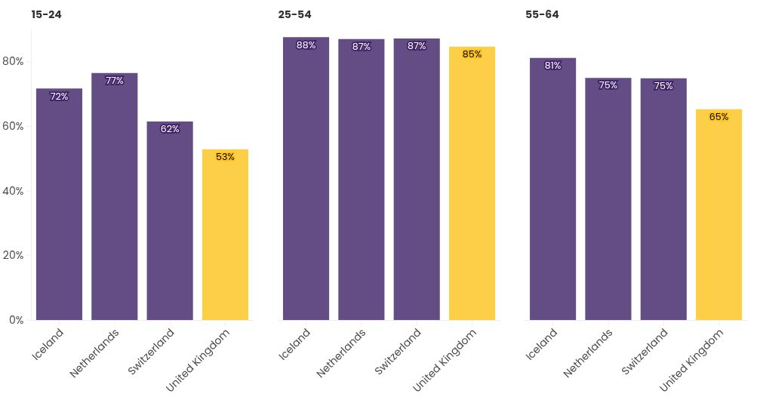

Figure 3: Ageing demographics in the workplace
(Source: Centre for Ageing Better, 2025)
​Another key factor that is influencing the job market in the UK in 2025 is the geopolitical factors. ​Multinational businesses are being destabilised by global tensions, trade disagreements, tariffs, as well as changing international alliances (Indeed, 2025a). ​The UK and other G7 economies are at risk of significant growth owing to geopolitical uncertainties and global pressure on the economy, in general. ​Foreign trade in 2024 and 2025 is likely to have an effect on the war in Ukraine and other geopolitical influences, hence the need to further stabilise global markets (S&P Global, 2025). ​

2.2 Challenges faced by HR Professionals
​The UK is facing a lot of challenges in modern times, and the dynamic labour market environment is pushing HR professionals to overcome them. ​One of the main issues is the existence of skill gaps, as well as the acute necessity to upskill and reskill the workforce, which has become the most important HR challenge among employers in the UK (Hunter Adams, 2025). ​The acquisition of talent is also fast becoming complicated by the decreased number of vacancies, increased competition, and increased expectations of the HR departments. ​The duty of identifying talent in a challenging market and employee engagement is regarded as one of the biggest challenges of HR in 2025 (Pearson, 2025). ​Organisations also need to deal with the effect of mental health issues on workers, which necessitates the identification and assistance of HR professionals, managers, and even employees (Parry and Battista, 2023).
​The changing dynamics of work, which have been caused by both technology and globalisation, also imply that the traditional HR practices need to be reassessed. ​HR workers have the role of dealing with hybrid workforces and the future regulatory changes, including the Employment Rights Bill 2024 and other employment laws that are expected in 2025 (Hunter Adams, 2025). ​Moreover, the demand to have a high level of digital capabilities among HR professionals increases to keep pace with new technological progress, such as artificial intelligence (Skýpalová et al., 2024). ​The effect of the increased employment costs in the form of increasing employer National Insurance and increasing minimum wage floors is specifically encountered by the low-pay sectors and employers of youth and part-time workers.

3.0 Analysis of tactics for addressing skill gaps and shortages of talent
Regular skills deficiencies and lack of talents in key areas of the UK economy, like technology, hospitality, and healthcare, are major threats to organisational competitiveness and output. Strategic Human Resource Management helps organisations to fill these gaps by being proactive in workforce planning, talent development and responsive when recruiting (Adias and Raimi, 2025).
A major practice is reskilling and upskilling of the workforce, which fits employees to the new market demands. For example, in the UK technology industry, where AI, cybersecurity, and data analytics skills are needed more than they are provided, organisations are turning to educational institutions and government programs, including Skills Bootcamps, to develop future talent (Singh Dubey, Paul, and Tewari, 2022). Healthcare NHS Trusts are employing the apprenticeship system and the continuous professional development to retain and promote employees (Kalejaiye, 2023). Similarly, the hospitality sector manages the problem of deficiencies by providing vocational education, non-linear career opportunities, and recruiting foreigners within the UK Skilled Worker visa initiative.
This strategic direction is supported by the Resource-Based View (RBV) theory that highlights the fact that human capital of a firm, when it is of value, is difficult to imitate, and can serve as a source of long-lasting competitive advantage (Pickles, Duffy, and Stewart, 2025). Through training and internal talent pipelines, organisations can acquire exclusive skill sets that would boost performance in the long run as well as minimise reliance on external labour markets.
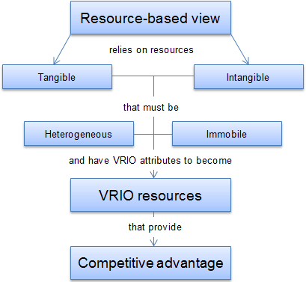

Figure 4: Resource-Based View Model
(Source: Jurevicius, 2024)
Furthermore, employer branding and comprehensive recruitment are significant. UK employers are also providing job benefits such as hybrid working structures, wellbeing and diversity-focused recruitment, as strategies to attract underrepresented populations (Braun et al., 2024). HR analytics based on data will also enable companies to map their future skill requirements and modify the development program to match those requirements.
Thus, to resolve the issue of skills deficit with the help of strategic HRM, the balance of talent prediction, investment in life-long learning, and the creation of a culture of adaptability should be achieved.

4.0 Reflective Report
In the current fast-changing environment, knowing about technology, communication, teamwork, leadership, and self-directed learning is important to achieve success. The study uses the Gibbs model to reflect on the experience as well as identify strengths and weaknesses. It is a reflective cycle developed by Graham Gibbs in 1988 to learning from experiences (Reflection, 2024).
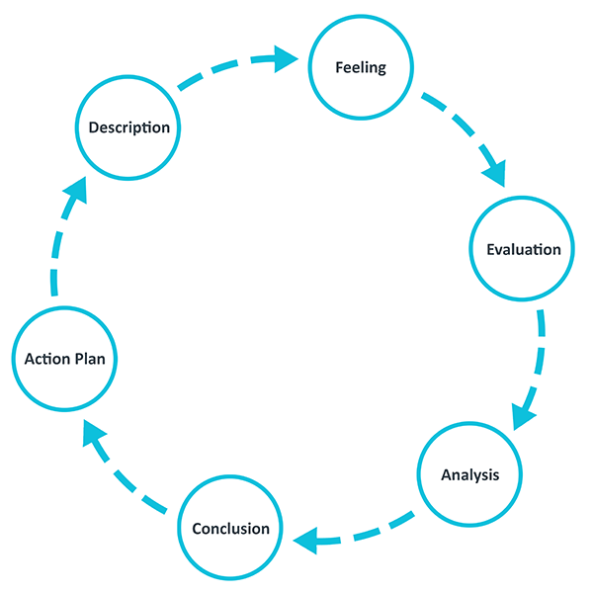

Figure 5: Gibbs model
(Source: Reflection, 2024)
Gibbs model
Description: In today’s digital environment, technology is crucial for communication, collaboration and problem-solving. I also use digital tools in my university work, like submission of assignments and finding resources from databases. Good communication is the key to success. Open communication between team members is characteristic of a team (Class Slides). Effective communication skills are also helpful to know the differences in how to communicate through phone conversations or face-to-face interactions, or digital communications (Indeed, 2025b). Also, I understand that leadership includes guiding others and making decisions for teams. Learning on own is a key success area for students in this rapidly changing world. Self-Directed Learning means planning one's own learning path through self-learning and keeping task-specific objectives in mind (Charokar and Dulloo, 2022).
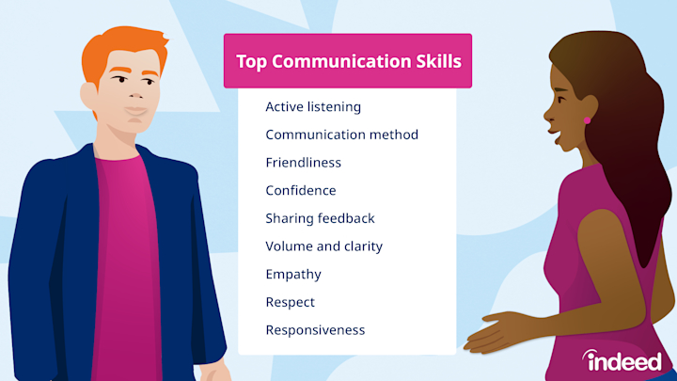

Figure 6: Communication Skills
(Source: Indeed, 2025b)
Feelings: At first, I feel excited as well as nervous about the assessment. I also struggled and did not feel confident while I was talking with my group or sharing my perspectives. I also understand that while I know how to pan or problem-solving, I still choose small parts like editing or note-taking. This shows that I do not challenge myself in problem-solving tasks. To improve the situation, I will try new responsibilities in group projects and use time management tools as well as communication tools for virtual teamwork.
Evaluation: I understand that between verbal and written communication, I am strong in written communication. I can explain my ideas properly through writing, but when it comes to speaking, I struggle. I understand that I have good teamwork ability, which I show in group projects. In the group project I was a part of, planning and problem-solving. Leadership Potential is a skill that helps to set goals and involve other members while completing a shared goal and value, like a group project (Uaikhanova et al. 2022). Teamwork skills are important for academic, personal and professional settings, so the education sector makes it a vital component of learning (Prada, Mareque and Pino-Juste, 2022). It is also a key in job settings, especially international jobs. I have understood my leadership ability in organising group tasks. I am good at managing my time and setting goals. I also make study plans, stick them, or create events on Google Calendar for a reminder.
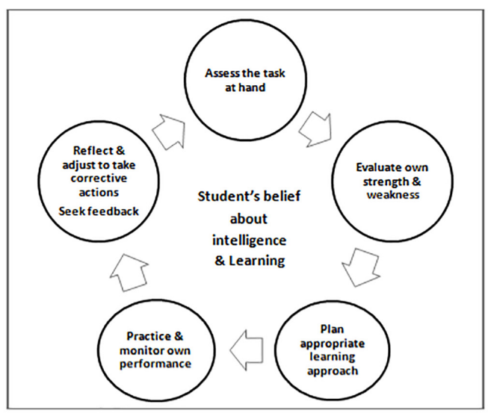

Figure 7: Process of Self-Directed Learning
(Source: Charokar and Dulloo, 2022)
Analysis: I understand that ineffective technology is a problem that the HR department faces. Also, according to Huda and Ardi (2021), Human Resource management stores employee data and uses it for predictive modelling as a preventive action, but I do not know how it works or why people use it. In leadership, I found it challenging while I am assigning work to another person. I feel worried about whether they can do it properly or not. Sometimes I rely on only lecture notes and do not explore databases for resources. In order to improve this, I need to explore more sources like journals, articles and reports to find relevant and current research.
Conclusion: In conclusion, I want to improve my technological competence by enrolling in online classes and joining a digital workshop at my university. In future, I need to speak more in group discussions or join a speaking club to get more confident while communicating. Also, to mitigate leadership issues, I will join the university leadership workshop and ask for advice from lecturers or seniors.
Action Plan:
Strengths and Weaknesses
Strengths | Weaknesses
I feel confident in writing, and I can express my ideas well in assignments. | I feel low confidence in the time of speaking.
I manage my time with time management skills to meet deadlines and avoid stress at the last minute of submission. | I have limited experience in advanced technologies.
I contribute positively in group tasks, helping others in creating a plan or problem-solving. | When complex situations and uncertainty come, I hesitate to take leadership roles because of low confidence.
I reflect on myself to improve my self-learning. | I have not worked yet in a virtual team which lacks experience.

Table 1: Strengths and Weaknesses
(Source: Self-Created)
Leveraging Strengths
To use my strengths, I will take more group work and continue practising my writing skills. To support and make effective teamwork, I will share my study plan with other students and also learn from them. I will also ask feedback from my peers and professors to know my areas for improvement.
Addressing Areas for Improvement: Action Plan
Action | Steps | Resources | Responsible person | Time
Improve Communication | Practice speaking | Peer feedback, class sessions | Myself | Weekly
Learn advanced technology | Take online courses | LinkedIn learning and other online course platforms. | Myself | 2 Months
Improve leadership skills | Lead group tasks and join workshops | Group projects and University Workshops | Myself | 4 Months
Explore virtual teams | Use online video or a meeting tool | Trello, Google Meet | Myself | 3 Months

Table 2: Action Plan
(Source: Self-Created)
This reflection helps me to understand my current strengths and areas for improvement. By enhancing my strengths and improving my weaknesses, I will become a better student as well as a better professional in this global workplace.

References
Adias, L.T. and Raimi, A.A.G. (2025) ‘Addressing Skills Gaps and Talent Shortages in Nigeria: HRM Strategies for the Future’, JMIR Preprints, 11(04), p.2025. Available at: https://www.researchgate.net/profile/Raimi-Gift/publication/390722022_Addressing_Skills_Gaps_and_Talent_Shortages_in_Nigeria_HRM_Strategies_for_the_Future_Preprint/links/67fada19df0e3f544f40ff77/Addressing-Skills-Gaps-and-Talent-Shortages-in-Nigeria-HRM-Strategies-for-the-Future-Preprint.pdf
BAM (2025) The 17th Conference on International Human Resource Management (IHRM 2025). Available at: https://www.bam.ac.uk/resource/the-17th-conference-on-international-human-resource-management-ihrm-2025.html (Accessed: 2nd October 2025)
Braun, G., Rikala, P., Järvinen, M., Hämäläinen, R. and Stahre, J. (2024) ‘Bridging Skill Gaps: A Systematic Literature Review of Strategies for Industry’, Advances in transdisciplinary engineering. Available at: https://jyx.jyu.fi/jyx/Record/jyx_123456789_94425
Centre for Ageing Better (2025) Work | The State of Ageing 2025. Available at: https://ageing-better.org.uk/work-state-ageing-2025. (Accessed: 1st October 2025)
Charokar, K. and Dulloo, P. (2022) ‘Self-directed learning theory to practice: a footstep towards the path of being a life-long learne’, Journal of Advances in Medical Education & Professionalism, 10(3), p.135. Available at: DOI: 10.30476/ JAMP.2022.94833.1609
CIPD (2024) CIPD | Flexible and hybrid working practices in 2023. Available at: https://www.cipd.org/en/knowledge/reports/flexible-hybrid-working/. (Accessed: 2nd October 2025)
Ford, N. (2025) AI could impact a million jobs in London, research suggests. BBC. Available at: https://www.bbc.com/news/articles/c07vmllz38jo. (Accessed: 1st October 2025)
Furaijl, H.B., Khader, O.M., Mohammed, R.J., Dawie, W.M., Salih, A.S. and Alwan, A.M. (2025) ‘The digital economy and labor markets: how automation and AI are reshaping employment trends’, Procedia of Environmental Science, Engineering and Management, 12, pp.251-260. Available at: https://procedia-esem.eu/pdf/issues/2025/no1/29_Furaijl_25.pdf
Huda, A. and Ardi, N. (2021) ‘Predictive Analytic on Human Resource Department Data Based on Uncertain Numeric Features Classification’, Int. J. Interact. Mob. Technol., 15(8), pp.172-181. Available at: https://doi.org/10.3991/ijim.v15i08.20907
Hunter Adams (2025) HR in Transition: The UK Job Market Outlook 2025 - Hunter Adams. Available at: https://hunteradams.co.uk/blog/navigating-the-shift-what-the-changing-uk-job-market-means-for-hr-in-2025/ (Accessed: 1st October 2025)
Indeed (2025a) UK job market outlook 2025: trends and predictions for employers | Indeed Flex UK. Available at: https://indeedflex.co.uk/blog/for-employers/uk-job-market-outlook-2025-trends-and-predictions-for-employers/. (Accessed: 1st October 2025)
Indeed (2025b) Mastering Essential Communication Skills. Available at: https://in.indeed.com/career-advice/resumes-cover-letters/communication-skills (Accessed: 6th October 2025)
Jha, N. (2024) Top HR Trends for 2024 in the UK | Avado Learning. Available at: https://www.avadolearning.com/blog/hr-trends-in-uk/. (Accessed: 1st October 2025)
Jurevicius, O. (2024) Resource-Based View. Available at: https://strategicmanagementinsight.com/tools/resource-based-view/. (Accessed: 1st October 2025)
Kalejaiye, P.O. (2023) ‘Addressing shortage of skilled technical workers in the USA: A glimpse for training service providers’, Future Business Journal, 9(1), p.50. Available at: https://doi.org/10.1186/s43093-023-00228-x
Lewissilkin (2025) Changing demographics and ageing workforces. Available at: https://www.lewissilkin.com/our-thinking/future-of-work-hub/insights/2025/05/19/changing-demographics-and-ageing-workforces. (Accessed: 1st October 2025)
Office for National Statistics (2025) Labour market overview, UK. [online] Ons.gov.uk. Available at: https://www.ons.gov.uk/employmentandlabourmarket/peopleinwork/employmentandemployeetypes/bulletins/uklabourmarket/september2025. (Accessed: 1st October 2025)
Parry, E. and Battista, V. (2023) ‘The impact of emerging technologies on work: a review of the evidence and implications for the human resource function’, Emerald Open Research, 1(4). Available at: https://doi.org/10.1108/EOR-04-2023-0001
Partridge, J. (2025) Gen Z faces ‘job-pocalypse’ as global firms prioritise AI over new hires, report says. Available at: https://www.theguardian.com/money/2025/oct/09/gen-z-face-job-pocalypse-as-global-firms-prioritise-ai-over-new-hires-report-says. (Accessed: 1st October 2025)
Pearson, J. (2025) The UK HR job market in 2025 is more complex than ever. Available at: https://www.linkedin.com/posts/jon-pearson-37889532_hrrecruitment-activity-7368200646203817985-PSCr (Accessed: 2nd October 2025)
Pickles, M., Duffy, P.O.R. and Stewart, J. (2025) ‘Addressing global labour challenges: An integrative model for sustainable hospitality workplaces, informed by resource-based view theory and the kaleidoscope career model’, International Journal of Hospitality Management, 131, p.104258. Available at: https://doi.org/10.1016/j.ijhm.2025.104258
Prada, E.D., Mareque, M. and Pino-Juste, M. (2022) ‘Teamwork skills in higher education: is university training contributing to their mastery?’, Psicologia: Reflexao e critica, 35, p.5. Available at: https://doi.org/10.1186/s41155-022-00207-1
Pradhan, B. (2025) UK firms cut hiring for AI-exposed roles, tech and finance jobs fall 38%. Available at: https://www.business-standard.com/world-news/uk-firms-cut-hiring-for-ai-exposed-roles-tech-and-finance-jobs-fall-38-125071400209_1.html. (Accessed: 1st October 2025)
Reflection (2024) Gibbs' Reflective Cycle. Available at: https://reflection.ed.ac.uk/reflectors-toolkit/reflecting-on-experience/gibbs-reflective-cycle (Accessed: 6th October 2025)
Rodriguez, J.K., Johnstone, S. and Procter, S. (2017) ‘Regulation of work and employment: advances, tensions and future directions in research in international and comparative HRM’, The International Journal of Human Resource Management, 28(21), pp.2957-2982. Available at: https://doi.org/10.1080/09585192.2017.1416555
S&P Global (2025) Economic Research: U.K. Economic Outlook Q4 2025: | S&P Global Ratings. Available at: https://www.spglobal.com/ratings/en/regulatory/article/economic-research-uk-economic-outlook-q4-2025-inflation-and-labor-costs-are-a-persistent-challenge-s101646672. (Accessed: 2nd October 2025)
Sharps, S. (2024) The Impact of AI on the Labour Market. Available at: https://institute.global/insights/economic-prosperity/the-impact-of-ai-on-the-labour-market. (Accessed: 2nd October 2025)
Singh Dubey, R., Paul, J. and Tewari, V. (2022) ‘The soft skills gap: a bottleneck in the talent supply in emerging economies’, The International Journal of Human Resource Management, 33(13), pp.2630-2661. Available at: https://doi.org/10.1080/09585192.2020.1871399
Skýpalová, R., Šikýř, M. and Vávrová, J. (2024) ‘What HR issues and challenges are addressed by contemporary hr professionals and line managers? A survey evidence from the Czech Republic’, Economics and Culture, 21(1), pp.114-131. Available at: https://doi.org/10.2478/jec-2024-0009?urlappend=%3Futm_source%3Dresearchgate
Uaikhanova, M., Zeinulina, A., Pshembayev, M. and Anesova, A. (2022) ‘Developing leadership skills in university students’, Cogent Education, 9(1), p.2143035. Available at: https://doi.org/10.1080/2331186X.2022.2143035
Veldsman, D. (2025) Technology in HR: Advances That Will Shape HR in 2030. Available at: https://www.aihr.com/blog/technology-in-hr/. (Accessed: 2nd October 2025)
World Economic Forum (2025) What’s happening across global labour markets in 2025? Available at: https://www.weforum.org/stories/2025/09/global-labour-market-unemployment-wages/. (Accessed: 1st October 2025)

