
De vere
Developing a new landscape of customer care

Charlotte Joyner (1650411)
Strategic Management (BMMB7013)
MBA International Hotel Management

Executive Summary
This report will critically evaluate De Vere’s strategic position at present and also consider their strategic options for developing a new landscape of customer care. The new strategic direction will be analysed alongside some strategic theories to support the requirements for a new strategy. The aim of the revised strategy will be to make sure De Vere can sustain a competitive advantage and encourage future resilience
The theories and analysis tools used in this report will be Porter’s Five Forces and SWOT as this will lead to an internal and external analysis of De Vere’s strategic focus and will warrant the necessity of the new strategic direction when it comes to delivering customer care.
The emegercy project team will be proposing strategies that incorporate the need for omnichannel communication, a revised recruitment strategy and the potential to focus on ‘localising’ the hotel estates within De Vere. These strategies will be presented with their benefits to the company but also clearly outlining any implications that James and other senior management within De Vere will need to consider before implementing.
Finally, the conclusion will involve providing some recommendations to the senior management team, with an action plan , as to how the new strategic proposal could be successful implemented now and sustained in the long term.

Table of Contents
Executive Summary 1
Introduction 3
Critical evaluation of De Vere to establish strategic possibilities 4
Porter’s Five Forces 4
Threat of new entrants 5
Bargaining power of suppliers 5
Bargaining power of buyers 5
Threat of substitutes 6
Degree of competitive rivalry 6
SWOT Analysis 7
Strengths: 7
Weaknesses: 8
Opportunities 8
Threats 9
De Vere – current strategic direction 9
De Vere- Newly proposed strategic direction 11
Omnichannel communication – Hyperpersonalised customer care 11
Recruitment for the future 13
Conclusion 15
Reference List 17
Appendices 21
Appendix 1: De Vere background and story 21
Appendix 2 : Sustainability strategy 22

Introduction

In early 2022, the then CEO of De Vere , Tony Troy, announced he would be stepping down from his role and the opportunity would be given to James Burrell (Hospitalitynet, 2022). James had already been working within the company as Chief Financial Officer and so has a good understanding of the company and overall strategic development. However, James has only been appointed in this new role very recently, at a time when the industry is slowly recovering after the Covid 19 pandemic. This recovery could be regarding the known labour shortages, strategies to recover missed revenues or even changes in customer expectations (Patalay, 2021). Nevertheless, James and other members of senior management have suggested they will need support with adapting to an industry which has experienced a lot of turmoil.
Therefore, De Vere have decided to put together an emergency project team in order to determine a new strategic direction, in particular considering the new landscape for customer care. This will be achieved by the team critically evaluating the current strategic direction, analysing industry trends and considering any impact changes will have on other departments in the organisations. There will be internal and external analysis conducted, such as a SWOT analysis and an analysis using the Porter’s Five Forces model. This will enable the team to outline a new strategic direction for De Vere and provide recommendations to James and other senior managers that will ensure future resilience and a competitive advantage is attainable for the hotel group.
The emergency project team will be imposing a variety of new long term strategies for De Vere to implement to enhance their customer care initiative. Customer care should be a long term strategy and not a temporary fixed, so providing strategy that will allow for longevity is essential (Bailey, 1996). Additionally, it is essential to consider the whole organisation when it comes to strategy and so the emergency team will consist of the Director of Finance, Chief Trustee and Susan Cook , who is the Director of People and Well-being.

Critical evaluation of De Vere to establish strategic possibilities

Porter’s Five Forces
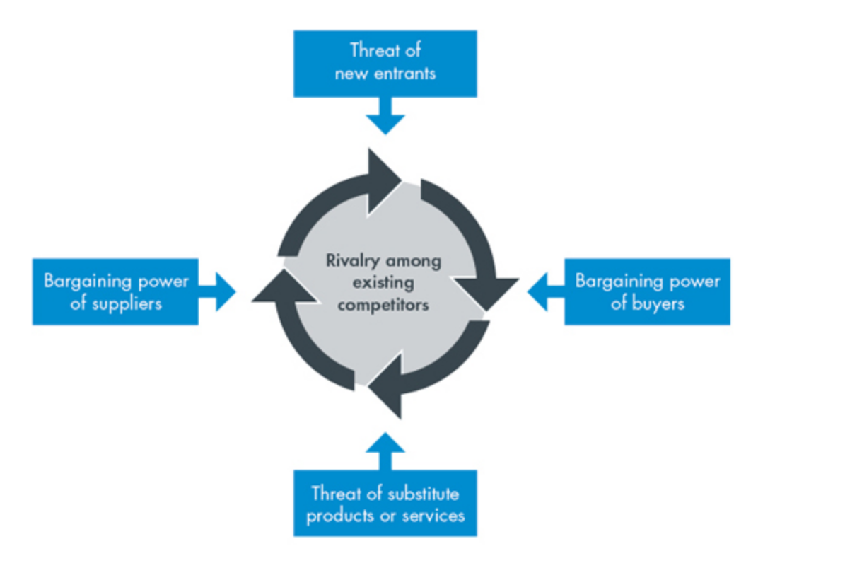
Porter’s Five Forces is a framework that can be used to understand the strategic implications for a company within an industry by analysing the nature of competition (Dobbs, 2014). The framework in broken down into five forces with consist of the threat of new entrants, bargaining power of suppliers, bargaining power of buyers, threat of substitutes products and the degree of competitive rivalry (Tutor2u, 2021). Therefore, this tool of analysis can be used by the project team at De Vere to assess the level of competition in the industry.
(CGMA, 2013)

Threat of new entrants
The threat of new entrants refers to how easy it is for a new firm to move into the industry (Tutor2u, 2021). It is suggested the profitable markets or those with less barriers to entry will see competitors make more attempts to enter, potentially weakening the current companies position (CGMA, 2013). In terms of De Vere, they operate in a niche segment of the hotel market, due to operating from historic properties/estates, rather than the ‘conventional’ hotel brands. Therefore, it could be suggested there are higher barriers to entry that could reduce direct competitors from frequently entering the market. Although, this is still a possibility and a something for De Vere to be wary of and prepared for. Nevertheless, De Vere should continue to focus on their branding around the historic properties as this provides a USP within the wider industry.

Bargaining power of suppliers
This force refers to the ease in which suppliers can increase the cost of goods. It can be affected by the availability of the goods or how easy it is to switch to another supplier (Investopedia, 2022). Currently, the rising cost of living is putting a strain on many stakeholders and so suppliers have responded by equally raising the cost of goods (Economist, 2022). This will have impacted De Vere as many price rises from suppliers will have been unavoidable and therefore would have increased De Vere’s overheads.
Additionally, these unpredictable changes and price rises would have impacted not only De Vere’s current suppliers but also any other potential suppliers De Vere might decide to switch to if costs increased too significantly. Therefore, if potentially looking to change food, housekeeping or utility suppliers it would be important to analyse each suppliers unit cost or see if there is any room for negotiations due to possible bulk buying in order to achieve economies of scale (RBS, 2022).

Bargaining power of buyers
The bargaining power of buyers looks at the ability of customers to drive down prices and could be determined by the number of customers or the potential cost of switching to alternative business (Tutor2u, 2022). This could be evident in the hotel industry when large group bookings or business customers look to purchase rooms in bulk as the hotel might offer a lower overall price to secure the deal. On the other hand, many events and weddings were lost due to the Covid 19 pandemic and therefore De Vere might be able to capitalise on this knowing the consumer is eager for the event to take place, other venues are potentially booked and resulting in bargaining power of the supplier being low.

Threat of substitutes
Porter suggests that a substitute is a product or service which meets the same basic need as the industry’s product in a different way (Magretta and Porter, 2011). Customers are more likely to switch to alternatives when close substitutes exist in the same market (CGMA, 2013). De Vere will be impacted by this as the hotel industry poses lots of options for consumers which can result in potential customers ‘shopping around’ for the hotel that most closely meets their expectations. Additionally, the increase in technology will add to this threat. For example, the progression of video conferencing technology has resulted in many organisations using this as a tool to conduct meetings, rather than the previously preferred meeting room which could have taken place in a hotel. Although this may not be considered a direct competitor, it will indirectly be impacting the De Vere hotel as one of their key revenue streams is from business customers. This further highlights the importance for De Vere to focus on its unique qualities as a way of reducing the direct substitutes and could be new strategic focus that the newly appointed project team take into consideration.

Degree of competitive rivalry
Martin (2023) states that this factor examines how intense the competition is within the market. It looks at the existing competition and what ability they have to cause challenges to the company. De Vere do experience close rivalry with the Q hotel collection as they also promote their properties being full of ‘character and charm’ (QHotels, 2023). This could result in increased costs for De Vere as they are likely to need to spend more money on promotions and ensure they are consistently offering a competitive price.

SWOT Analysis
Strengths | Weaknesses
- Clear tag line “unforgettable experience, thoughtfully crafted” (De Vere, 2023)  - Locations are all known for being historic estates.  - Had consistent leadership from Tony Troy for many years (De, Vere 2022)  - Diversification – hotels, spa, conferences, weddings, events  - Luxury/prestigious image | - Has rebranded as a hotel group on more than one occasion  - Sold a number of properties when repositioning themselves as country house hotels (Price, 2019).  - Labour shortages after Covid 19  - Cost of recruitment and training after staff loss due to Covid 19
Opportunities | Threats
- New CEO , James Burnell presents the chance to revise strategy (De Vere, 2022)  - Only having a small portfolio of properties can allow for more individualised attention  - Make each location “its own” and look at ‘localising’ each property  - Focus on sustainability and changes to reduce environmental footprint  - Launch a cross platform communication app or tool  - Maximise the events strand of the business after the pandemic | - Financially still recouping costs lost during the Covid 19 pandemic  - Continuous labour shortages affecting the whole industry  - Cost of living crisis – affecting consumer spending (BigHospitality, 2022)

Strengths:
The first point identified for De Vere in the SWOT analysis is their clear tag line and clear company brand image. It is evident as soon as you look at De Vere they focus on historic properties and grand estates , with a tag line “unforgettable experience, thoughtfully crafted” (De Vere, 2023).
Additionally, the group have diversified their offering to also focus on weddings, spa breaks, corporate and social events. This is a logical step to take for the organisation because they are already situated in properties and locations that can support these offerings. According to Chandler (2018), the wedding market is worth around £10 billion a year and so having the facility to accommodate this in your venue is a vital source of revenue and imperative to sustaining a competitive advantage in a somewhat saturated market. Therefore, the strong focus De Vere already has on events and other external offerings, paired with their prestigious image, is paramount to their continued success and will contribute to the opportunity to stand out from competition.

Weaknesses:
De Vere has rebranded itself on numerous occasions since it has been in operation (See appendix 1). Whilst, repositioning themselves in the hotel market, De Vere sold a number of properties to allow for their sole focus to be on owning country house hotel estates (Price, 2019). This could present itself as a weakness for the organisation because employees might question the security of their jobs or not fully understand the new direction of the business. In turn, this could affect the brand image of the hotel if all employees are not informed of the new strategic focus of the hotel. Although, Todor (2014) argues rebranding is necessary when a company wants to enter a new market or there is a down turn in the companies performance. Todor (2014) also states rebranding can cause stakeholders to view the company as unstable if not implemented successfully. Therefore, De Vere need to ensure any change is communicate effectively to prevent a negative connotations from being associated with the image of the company.
Arguably, society is moving on from the Covid 19 pandemic as restrictions and precautions have lifted (Shmerling, 2022). However, the hotel industry is still recovering from the disruption of the pandemic in term of trying to recoup revenue due to lack of trading and also trying to combat labour shortages that are being seen throughout the industry (Vinter, 2022). Although, this is a weakness that the whole industry is facing, it is certainly something for De Vere to consider when focusing on a new customer care strategy and planning for the future to combat these shortfalls.

Opportunities
According to McKinsey (2020), customers are demanding a more personalised experience which has resulted in a greater demand for companies to think about a hyperpersonalised customer care strategy. This is an opportunity the emergency project team at De Vere have acknowledged and are considering the prospect of introducing an omnichannel approach to communicating with customers. This omnichannel approach to communication should result in the customer feeling recognised , connected with the company and allow for seamless communication (Amar et al, 2020).
Additionally, building upon the trend of customers wanting a personalised experience, De Vere could focus on trying to ‘individualise’ each of their properties. This opportunities now presents itself due to now having a smaller number of locations. The individualised approach supports the concept of ‘localisation’ which involves really trying to connect with the consumer and is something the emergency project team can discuss (Liu et al, 2014).

Threats
The cost of living crisis is an external factor that the hotel industry is going to have to take into consideration for the foreseeable future. BigHospitality (2022) has statistics to support the decline in spending within hospitality as consumer become more concerned with higher household bills. This is also coupled with the industry still recovering from the money lost during the pandemic and so it makes it vitally important for the team at De Vere to review current strategies and proposed new strategies that endeavour to support resilience in an unpredictable future.

De Vere – current strategic direction

James Burrell was appointed the new CEO of De Vere in January 2022 and this change of leadership inevitably resulted in some strategic changes for the organisation (De Vere, 2022). Appendix 2 shows the clear focus on sustainability. James understands the importance of sustainability from a customer perspective as many consumers now have an appetite for personal responsibility but also he highlights the importance from an industry perspective in wanting to ensure the De Vere is having a positive impact within the industry. The aim in 2022 was for one final hotel in the group to be awarded a green tourism sustainability certificate which will result in the De Vere being a fully green tourism accredited group (see appendix 2).
UK Hospitality have released an initiative that states they aim and are committed to supporting businesses across the hospitality sector to reach the goal of being net-zero by 2040 (Sapte, 2022). There is also evidence of sustainability strategies across the hotel industry in the UK as many hotels announce the plan they have in support of this. For example, the Village hotel have formed a relationship with Carbon Intelligence in the steps to support the net zero goal (Village Hotels, 2022). Additionally, The Greenhouse Hotel in Bournemouth is known for being the greenest hotel in the UK and utilises this as their USP (The Green House, 2019). Therefore, it is important for James and the rest of De Vere to continue this strategic focus on sustainability in order to remain competitive within the industry and continually meet customer expectation now and in the future.
According to Amar et al (2020), personalisation is an important part of the customer experience and one that can be achieved by investments in technology. New technology can allow for a seamless experience throughout the customer journey with the organisation. On one hand, De Vere have already realised the importance of this as they have turned to Appurity (a cross platform mobility consultant) to help revamp their current mobile handsets (Hospitality and Catering, 2022). In this current strategy, De Vere aim to invest in new mobile strategy to speed up the communication between different departments and allows for a more seamless experience for each customer during their stay in a De Vere hotel. The new software will allow for faster communication in terms of room maintenance, guest check in/out and then rooms that require cleaning (Hospitality and Catering, 2022). This investment will benefit many departments in the hotel and assist in more efficient practices. As a result, customers should experience a more efficient service as check in could be offered earlier and rooms should be of consistent quality. On the other hand, the emergency project team have highlighted that this investment in technology is only aiming to improve the customer experience during their stay with De Vere. Therefore, in order to capitalise on the current trend of ‘hyperpersonalisation,’ De Vere need to consider investing in technology to supporting a seamless customers experience throughout their whole journey with the company.

De Vere- Newly proposed strategic direction

As previously stated, the emergency project team have been appointed to discover a new way to deliver customer care that is viable for the future and supports a sustainable competitive advantage. The team have conducted external and internal analysis of the organisation , as well as reviewing their current strategy direction , in order to make an informed decision about the next strategic direction De Vere should pursue. Additionally, the project team have also conducted research into current trends of customer care to ensure proposed strategies are relevant. For example, research shows that customer care strategies should focus on the 4C’s. These include customer experience, conversation, content and collaboration (Barot, 2016). According to Pratt (2022), reflecting on the proposed 4C’s will provide the business with the opportunity to consider the product (or in other words the customer) from another perspective. The 4C’s will be incorporated into the newly proposed strategies but also the team will be suggesting these new strategies should begin to be implemented by the last quarter of 2023 to ensure they correlate with current trends.
The team has also taken into consideration the impact these newly proposed strategies could have on different departments within the hotel. It is important to consider the scope of the strategy in order to forecast the influence it might have within the organisation (Gluck et al , 1980). James will want to know the potential implications of each strategy so he can make a sound judgement on which of the proposals are worth short term disruption to department for potential longer term gain.

Omnichannel communication – Hyperpersonalised customer care

According to Amar et al (2020), companies should make hyperpersonalisation in customer care a top goal for 2025. This view is supported by Agarwal et al (2020) who also agrees that personalisation is the future of customer experience and that organisations should be putting a strong focus on customer awareness. One approach taken to achieve this is investment in technology that supports contact across all channels (Amar et al, 2020). An omnichannel approach to communication looks at a way of combining the different platforms of communication and should lead to a more seamless experience for the customer (Akter et al, 2021). Furthermore, Patel (2022) reinforces the importance of omni-channel communication to ensure companies are giving consistent experience to the customer with every interaction. However, although Freeze (2019) supports the benefits suggested with introducing omni-channel communication, he also emphasises the importance for organisations to take into considerations the large cost implications of maximising the use of this new technology.
Nevertheless, a new strategy proposed by the emergency project team for De Vere will be for a continued investment in technology to find a way of combining the channel of communication used by the consumers. De Vere has already paired with Appurity to improve the current mobile strategy as a way of streamlining provisions (Hospitality and Catering, 2022). This project could be extended to look at the possibility of improving communication with customers on multiple platforms. It will be important for De Vere to focus on communication with customers at all stages of their journey with the company. For example, after a stay with De Vere a customer could receive communication about other offers available to them or other facilities they could use with the hotel estates. It could present an opportunity for De Vere to exploit other potential revenue streams and increase wedding or spa bookings, rather than just hotel stays. Yoong (2023) agrees with the idea of hotel diversifying ‘beyond the hotel bed’ as it will reduce their risk of exposure. Therefore, it could be suggested that omnichannel communication will not only lead to a seamless customer experience but also allow for De Vere to maximise their potential revenue from facilities they already possess within the estates.
However, Saghiri et al (2017) argues there is little research to support the benefits of adopting an omnichannel approach to communication. This is due to there currently being a lack of evidence that shows a correlation between the multi-channel communication and the transaction or purchase taking place (Saghiri et al, 2017). Furthermore, it is vitally important to identify which channels of communication the potential audience visit most which requires the right technology and in turn the business will need to consider the time and cost implications of carrying out this task (eHotelier, 2021). For De Vere, this could put a huge strain on the IT department if given the responsibility of carrying out this research. Additionally, if this task is sub contracted out to Appurity then James will need to analyse the financial implications of fulfilling this new future of communication.
Nevertheless, Guillet (2020) states that omni channel communication can be the new approach to upselling for the hotel industry as communication with a customer could be sent after a booking has taken place. This links back to Yoong (2023) need for hotels to diversify as communication could be sent in regards to other facilities within the hotel available during the dates of their stay to further increase revenue. OYO Rooms has already implemented omnichannel communication throughout its 43’000 properties and has already experienced improvements within the user experience and customer engagement (MoEngage, n.d.). The company believe it was important to create a seamless user experience across the vast amount of properties they own and the results have been immensely positive. The successful implementation of omni-channel communication for OYO rooms will be discussed amongst the emergency project team and shared with James. As a result, James will be encouraged to have talks with Appurity about the potential cost implications of this strategy because the long term outcome could lead to more demand for the other facilities that De Vere have available and a improve customer experience.

Recruitment for the future
It is no secret that the hotel and hospitality industry have experienced high labour shortages since the Covid-19 pandemic. The Economist (2022) state that the industry is around 1.3 millions workers short in comparisons to the 16.9 million employed before the pandemic. UK Hospitality (2022) further this discussion in support of the industry experiencing significant labour shortages and put it down to not only the pandemic but also a knock on effect from Brexit. This is resulting in those still working within the industry to be exposed to a more stressful environment and longer working hours (The Caterer, 2022). Therefore, as a consequence even more workers are leaving the industry which is negatively contributing towards the rising number of vacancies.
De Vere has inevitably found themselves experiencing labour shortages across many departments within their hotels and therefore resulted in the need to revise their recruitment strategy. James has previously stated that just raising wages to attract new candidates is not a sustainable option for any business. This is supported by McAllister (2021) who agrees that money is not everything and it will not lead to increased retention. There needs to be more of a focus on providing other incentives and looking at aligning these incentive with current employee expectations (The Caterer, 2022).
The emergency project team are prosing a new strategy called ‘recruiting for the future.’ This strategy plans to look at the current job profiles and hiring procedures within the organisation to ensure recruiters are offering jobs to employees that align with the visons and objectives of De Vere. According to Breaugh (2009), a poorly designed recruitment process can result in the organisation missing the opportunity to attract the right candidates and instead leave the organisation with unqualified candidates. Buesing et al (2020) agrees that the recruitment process needs to be effective in order to get the right people through the door and this can only be achieved if first the company know what skills and attributes they are looking for from the employees. Therefore, the initial step in implementing this strategy is for James and other senior management to discuss what the long term vision is for De Vere and who they want to represent the company. This should encourage a congruent workforce who align with the company visions and hopefully reduce employee turnover.
However, in order to find talent capable of stepping up and supporting the long term vision of De Vere it will require a large input from the HR team and department leads. This is due to the need to review job specification, recruitment adverts and the hiring process. Breaugh (2009) highlights the importance of involving input from other departments aside from HR as they will have additional information specific to the role. As a consequence, if James decides to adopt this approach then changing the recruitment strategy will increase the workload for managers across many departments in the hotel.
The project team suggest highlighting the department most affected by labour shortages and start there with reviewing the recruitment process. This should result in a more manageable role out of the strategy and not overwhelm managers. Additionally, it will allow time for James to sit with the HR team to establish a clear and coherent strategy which according to Breaugh (2009) is essential to ensure strategic success. Seo (2022) proposes the labour shortages in the hospitality industry is going to continue to be evident for the foreseeable future. Therefore, this further emphasises the importance for James to seriously consider revaluating the recruitment process to make to sustainable for the future and enable De Vere to be ahead of competition.

Conclusion

In conclusion, the emergency project team have conducted a thorough analysis of the internal and external factors affecting De Vere. In order to offer strategies to improve customer care, the report firstly considered the current strategic direction for De Vere. This involves James currently putting a large focus on sustainability. Additionally, De Vere are currently working alongside Appurity to revamp their mobile handset and as a result improve communication within each department. This knowledge then allowed for recommendations to be offered to James at De Vere as to the new strategic direction the company could take in order to enhance their customer care initiatives.
The report proposes that De Vere should focus on omni channel communication. This is involves combining all channels of communication for a more seamless customer experience (Akter et al, 2021). The advice on offer was for James to correspond with Appurity to see if they can support De Vere with ways of introducing omni channel communication. This could be an important factor towards increase customer engagement and could also result in and increased revenue for De Vere as they can exploit all the facilities they have available at their estate hotels.
Additionally, the emergency project team proposed that De Vere should attempt to review their recruitment strategy as the hotel industry as a whole has experienced large labour shortages. The proposal involves the tagline ‘recruitment for the future’ and suggests that De Vere need to ensure their recruitment process in up to date with modern expectations, whilst also making sure the process aligns with finding talent that will support the visions and values that De Vere aim to achieve. This revised strategy was not proposed without taking into consideration the impact it could have on other departments, such as the HR team who would be involved in rewriting the new recruitment process. However, the increase workload is a small setback when the long term gain should be a more sustainable workforce.
Overall, the strategies proposed to James and other senior managers within De Vere both looks to improve the level of customer care within the organisation. Both strategies take into consideration that customer care should be more personalised which is in line with Amar et al (2020) who highlights the vision for 2025 should be hyperpersonalised customer care. Therefore, the over arching aim for James at De Vere is look at the two newly proposed strategies and find an attainable way of implementing them successfully.

Reference List
Agarwal, R., Jacobson, R., Kline, P. and Obeid, M. (2022) The Future of Customer Experience: Personalized, White-glove Service For All. McKinsey & Company. Available from: The future of customer experience: Personalized, white-glove service for all | McKinsey [Accessed 24 February 2023]
Akter, S., Hossain, T.M. and Strong, C. (2021) What Omnichannel Really Means?. Journal of Strategic Marketing. 29 (7), pp. 567-573.
Amar, J., Berg, J., Buesing, E., Obeid, M. and Raabe, J. (2020) The Vision For 2025: Hyperpersonalized Care and 'Care of One'. McKinsey & Company. Available from: https://www.mckinsey.com/capabilities/operations/our-insights/the-vision-for-2025-hyperpersonalized-care-and-care-of-one [Accessed 24 February 2023]
Amar, J., Jacobson, R., Kleinstein, B. and Shi, A. (2020) Redefine the omnichannel approach: Focus on what truly matters. Available from: https://www.mckinsey.com/businessfunctions/operations/our-insights/redefine-the-omnichannel-approach-focus-on-what-trulymatters [Accessed 27 February 2023)
Appurity (2022) De Vere hotels revamps its current mobile strategy. Available from: De Vere Hotels revamps its current mobile strategy - Appurity [Accessed 24 February 2023]
Bailey, G. (1996) Customer Care - Making It Work. Managing Service Quality: An International Journal. 6 (3), pp. 36-38.
Barot, D. (2016) Transforming customer care with four C’s. Available from: Transforming Customer Care with Four C’s (etechgs.com) [Accessed 24 February 2023]
Big Hospitality (2022) Rising cost of living starts to hit hospitality sector. Available from: Rising cost of living starts to hit hospitality sector (bighospitality.co.uk) [Accessed 25 February 2023]
Breaugh, J.A. (2009) Recruiting and Attracting Talent. United States of America: SHRM Foundation.
Buckingham, L. (1999) Greenalls close to £1bn sale. The Guardian [online]. Available from: Greenalls close to £1bn sale | Business | The Guardian [Accessed 24 February 2023]
Buesing, E., Gupta, V., Higgins, S. and Jacobson, R. (2020) Customer Care: The Future Talent Factory. McKinsey & Company. Available from: Customer-care-The-future-talent-factory.pdf (uwtsd.ac.uk) [Accessed 27 February 2023]
CGMA (2013) Porter’s Five Forces of Competitive Position Analysis. Available from: Porter’s Five Forces of Competitive Position Analysis (cgma.org) [Accessed 25 February 2023]
De Vere (2023) Modern Country Estates. Available fro: De Vere Hotels - Modern Country Estates [Accessed 23 February 2023]
De Vere (2023) Staying Sustainable. Available from: de_vere_sustainability_brochure_2022.pdf (devere.co.uk) [Accessed 24 February 2023]
Dobbs, M.E. (2014) Guidelines For Applying Porter's Five Forces Framework: A Set of Industry Analysis Templates. Competitiveness Review. 24 (1), pp. 32-45.
eHotelier (2021). How hotels can leverage omnichannel marketing to improve footfall. Available from: How hotels can leverage omnichannel marketing to improve footfall - Insights (ehotelier.com) [Accessed 27 February 2023]
Eversham, E. (2021) Starwood Capital Group acquires hotel and conference operator Principle Hayley. Available from: Starwood Capital Group acquires hotel and conference operator Principal Hayley (bighospitality.co.uk) [Accessed 25 February 2023]
Freeze, J. (2019) Addressing the roadblocks to omnichannel communication. Available from : https://www.forbes.com/sites/forbescommunicationscouncil/2019/04/15/addressing-the-roadblocks-to-omnichannel-communication/?sh=7c10a0606d96 [Accessed 25 March 2023]
Gluck, F.W., Kaufman, S.P. and Walleck, A.S. (1980) Strategic Management For Competitive Advantage. Harvard Business Review [online]. Available from: Strategic Management for Competitive Advantage (hbr.org) [Accessed 26 February 2023]
Guillet, B.D. (2020) Online Upselling: Moving Beyond Offline Upselling in the Hotel Industry. International Journal of Hospitality Management. 84, pp. 1-13.
Harmer, J. (2017) How the Principle Hotel Company has reimagined the De Vere brand. Available from: How the Principal Hotel Company has reimagined the De Vere brand - The Caterer [Accessed 25 February 2023]
Hospitality and Catering News (2018) Why hotels need to up their game to claim a slice of the wedding cake event market cake. Available from: Why hotels need to up their game to claim a slice of the wedding event market cake - Hospitality & Catering News (hospitalityandcateringnews.com) [Accessed 26 February]
Hospitality Net (2022) Change in Leadership at De Vere Hotels- Tony Troy stepping down as CEO. Available from: Change in Leadership at De Vere Hotels – Tony Troy stepping down as CEO (hospitalitynet.org) [Accessed 24 February 2023]
Investopedia (2022) Porter’s 5 Forces Explained and How to Use the Model. Available from: Porter's 5 Forces Explained and How to Use the Model (investopedia.com) [Accessed 25 February 2023]
Kurter, H.L. (2019) How Hilton reduced their time to hire from 43 Days down to 5. Available from: How Hilton Reduced Their Time To Hire From 43 Days Down To 5 (forbes.com) [ Accessed 25 March 2023]
Magretta, J. (2012) Understanding Michael Porter. Boston: Harvard Business Review Press.
Martin, M. (2023) How Porter’s Five Forces can help small businesses analyze the competition. Available from: Analyzing the Competition with Porter's Five Forces - businessnewsdaily.com [Accessed 25 February 2023]
MoEngage (n.d). MoEngage helps OYO deliver seamless omnichannel user engagement. Availabe from: OYO_CS copy (moengage.com) [Accessed 25 March 2023]
OYO (2022) The World’s Fastest Growing Hotel Chain. Available from: OYO Hotels in UK - Book Sanitised Hotels Online in London | OYO UK (oyorooms.com) [Accessed 25 March 2023]
Patalay, A. (2021) How Covid changed the hospitality industry. The Financial Times [online]. Available from: How Covid changed the hospitality industry | Financial Times (ft.com) [Accessed 26 February 2023]
Pratt , M. (2022) 4Cs Marketing Model & Why it’s good for business https://www.business.org/marketing/sales/4cs-marketing-model-good-business/ [Accessed 25 March 2023]
Price, K. (2019) Three De Vere hotels on the market for £60m. The Caterer [online]. Available from: Three De Vere hotels on the market for 60m - The Caterer [Accessed 25 February 2023]
Q Hotels (2023) The Q Hotels Collection. Available from: Unique Four-Star Hotels In The UK | The QHotels Collection [Accessed 26 February 2023]
Royal Bank of Scotland (2022) Cost of living crisis: negotiating with suppliers. Available from: Cost of living crisis: negotiating with suppliers | Royal Bank of Scotland (rbs.co.uk) [Accessed 25 February 2023]
Saghiri, S., Wilding, R., Mena, C. and Bourlakis, M. (2017) Toward a Three-dimensional Framework For Omni-channel. Journal of Business Research. 77, pp. 53-67.
Sapte, S (2022) UK Hospitality unveils sustainability strategy. Big Hospitality [online]. Available from: UKHospitality unveils sustainability strategy (bighospitality.co.uk) [Accessed 24 February 2023]
Shmerling, R.H. (2022) Is the Covid-19 pandemic over, or not? Harvard Health [online]. Available from: Is the COVID-19 pandemic over, or not? - Harvard Health [Accessed 25 February 2023]
Staffaroni , S. (2021) What is the difference between customer care and customer service? Available from: What is the difference between customer care and customer service? - GetFeedback [Accessed 25 February 2023]
The Caterer (2022) How to address the worsening labour shortage in the hospitality industry? Available from: How to address the worsening labour shortage in the hospitality industry - The Caterer [Accessed 27 February 2023]
The Economist (2022) The cost of living crisis in Britain is not just about energy. Available from: The cost-of-living crisis in Britain is not just about energy | The Economist [Accessed 27 February 2023]
The Economist (2022) Why workers are fleeing the hospitality sector. Available from: Why workers are fleeing the hospitality sector | The Economist [Accessed 27 February 2023]
The Green House (2019) Environment . Available from: Eco Hotel Bournemouth | Environmentally Friendly Hotel Bournemouth Green House (thegreenhousehotel.co.uk) [Accessed 25 February 2023]
Todor, R.D. (2014) The Importance of Branding and Rebranding For Strategic Management. Economic Sciences. 7 (56), pp. 59-64.
Tooher, P. (1996) Small beer no longer. The Independent [online]. Available from: Small beer no longer | The Independent | The Independent [Accessed 24 February 2023]
Tutor2u (2021) Porter’s Five Forces Model. Available from: Porter's Five Forces Model | Business | tutor2u [Accessed 25 February 2023]
UK Hospitality (2022) Hospitality sector recovery stymied by labour shortages, rising costs. Available from: Hospitality sector recovery stymied by labour shortages, rising costs - UKHospitality [Accessed 27 February 2023]
Village Hotels (2022) Village Hotels takes first step in net zero strategy. Available from: VILLAGE HOTELS TAKES FIRST STEP IN NET ZERO STRATEGY | News and Articles from Village Hotels Club (village-hotels.co.uk) [Accessed 25 February 2023]
Vinter, R. (2022) Staff shortages see UK restaurants struggle to cope with Christmas season. The Guardian [online]. Available from: Staff shortages see UK restaurants struggle to cope with Christmas season | Restaurants | The Guardian [Accessed 27 February 2023]
Wei, L., Denizci Guillet, B., Xiao, Q. and Law, R. (2014) Globalization Or Localization of Consumer Preferences: The Case of Hotel Room Booking. Tourism Management. 41, pp. 148-157.
Yoony, K. (2023) Virtualization and diversification: looking beyond the hotel bed. Available from: Virtualization and diversification: looking beyond the hotel bed (ehl.edu) [Accessed 27 February 2023]

Appendices

Appendix 1: De Vere background and story
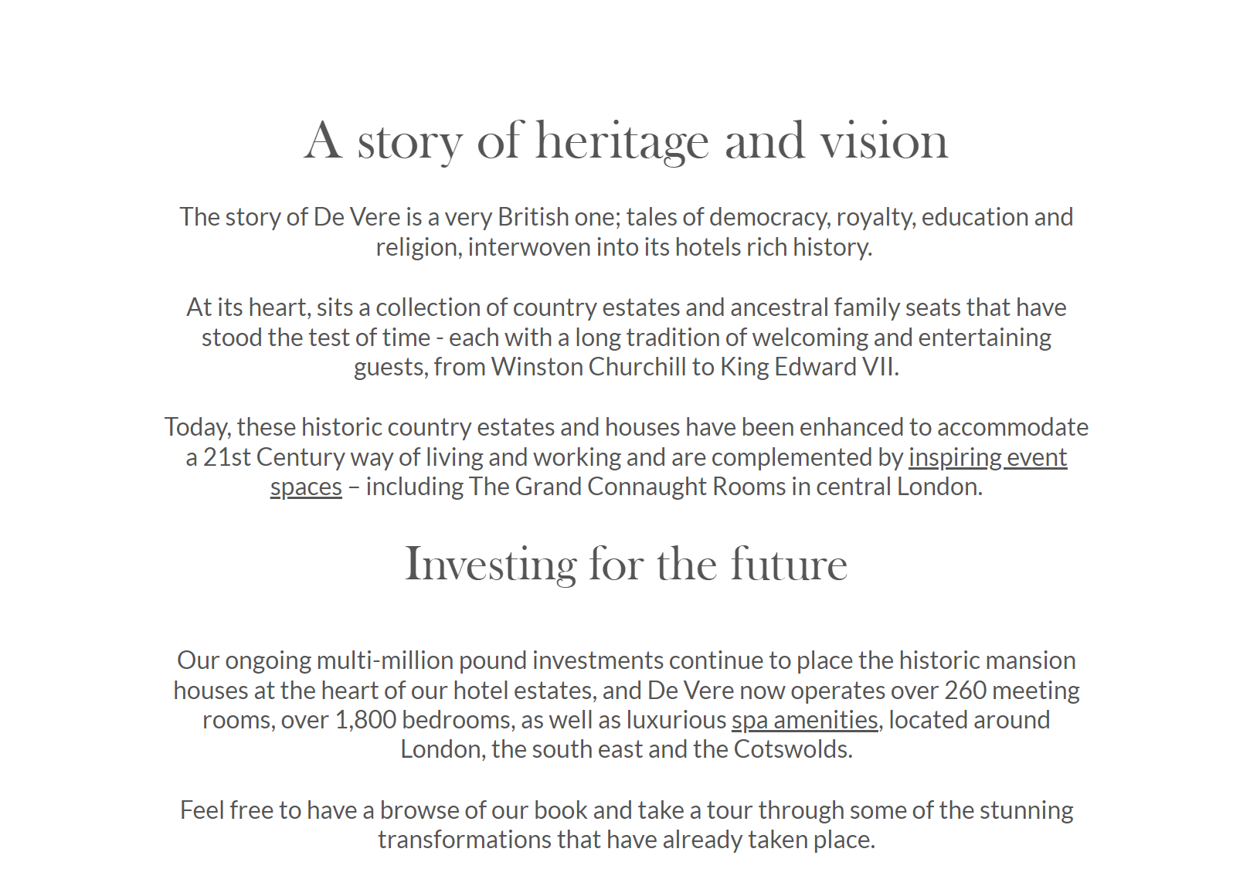
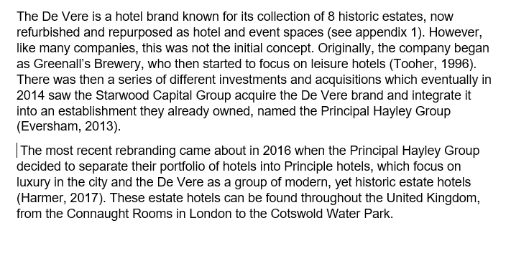

Appendix 2 : Sustainability strategy


