

Is a Neighbourhood Policing Team essential within a Police Force?

Name of student – Bethany Slack
Student number - 1916168
Degree title – BSc (Hons) Professional Police Practice

Acknowledgements

First and foremost, I would like to thank my dissertation tutor, Samantha Mcalister Wilson, for all her help and support throughout this process.

In addition, I would like to thank all of the university staff and Police staff from the time I started training to now, who have helped me throughout the last three years. I would also like to thank my colleagues who have been very supportive and helpful when I needed.

Also to the Police staff, officers and members of the public who have completed the surveys that have been included in this dissertation.

Finally, I would like to give my sincere thanks to my family and friends, who have helped me throughout, been a listening ear and supporting me when needed, which has enabled me to complete this process.

Declaration
This work has not previously been accepted in substance for any degree and is not being concurrently submitted in candidature for any degree.
Signed: B.Slack
Date: 24/09/2023

STATEMENT 1
This dissertation is being submitted in partial fulfilment of the requirements for the degree of BA.
Signed: B.Slack
Date: 24/09/2023

STATEMENT 2
This dissertation is the result of my own independent work/investigation, except where otherwise stated.
Other sources are acknowledged by footnotes giving explicit references. A bibliography is appended.
Signed: B.Slack
Date: 24/09/2023

STATEMENT 3
I hereby give consent for my dissertation, if accepted, to be available for photocopying and for interlibrary loan, and for the title and summary to be made available to outside organisations.
Signed: B.Slack
Date: 24/09/2023

STATEMENT 4
I hereby give consent for my dissertation, if accepted, to be available on the university’s IT system to those who have consent to use the system.
Signed: B.Slack
Date: 24/09/2023

Abstract

This dissertation examines and compares research that has already been conducted around Neighbourhood Policing/Community Policing and the public perceptions of Neighbourhood Policing Teams (NPT).

It looks into the public’s perceptions of Policing and NPT and their trust and confidence within the Police. It also looks into the Police officers/staff thoughts on how they feel the publics trust and confidence is within the Police and if they feel that NPT is essential to have within a Police force. It will discuss some factors that could be affecting the publics perceptions.

This dissertation will provide some recommendations on how the Police and NPT can improve the trust and confidence of the Public. Two surveys were carried out, one of which went to the Police officers/staff within Wales and the other survey went to members of the public within Wales. The result showed that Neighbourhood Policing is very popular within a Police force and that there are improvements that can be made to improve the publics perceptions of the Police.

Contents Table
Acknowledgements……………………………………………………………………………………………………………………….2
Declaration……………………………………………………………………………………………………………………………………3
Abstract………………………………………………………………………………………………………………………………………..4
- Chapter one: Introduction………………………………………………………………………………………………………7
  - Background…………………………………………………………………………………………………………………………….7
- Chapter Two: Literature Review……………………………………………………………………………………………..8
  - Introduction……………………………………………………………………………………………………………………………8
  - Background…………………………………………………………………………………………………………………………….9
  - Aims………………………………………………………………………………………………………………………………………10
2.3A Perceptions of Community/Neighbourhood Policing…………………………………………………………..10
2.3B Factors affecting the publics trust and perceptions of the Police…………………………………………11
  - Gaps in the Literature……………………………………………………………………………………………………………12
  - Conclusion…………………………………………………………………………………………………………………………….12
- Chapter Three: Methodology………………………………………………………………………………………………..13
  - Introduction………………………………………………………………………………………………………………………….13
  - Research Strategy…………………………………………………………………………………………………………………13
  - Data Collection……………………………………………………………………………………………………………………..14
  - Limitations and Problems……………………………………………………………………………………………………..14
3.4A Participants…………………………………………………………………………………………………………………………14
3.4B Ethical Considerations…………………………………………………………………………………………………………15
3.5 Conclusion…………………………………………………………………………………………………………………………….15
4 Chapter Four: Analysis of Results……………………………………………………………………………………………..16
4.1 Introduction………………………………………………………………………………………………………………………….16
4.2 Survey Findings: Members of the Public……………………………………………………………………………….16
4.3 Survey Findings: Police………………………………………………………………………………………………………….19
4.4 Conclusion…………………………………………………………………………………………………………………………….22
5 Chapter Five: Conclusions and Recommendations…………………………………………………………………..23
5.1 Introduction………………………………………………………………………………………………………………………….23
5.2 Completion and Achievement of Aims………………………………………………………………………………….23
5.3 Main Findings and Conclusions…………………………………………………………………………………………….23
5.3A Public…………………………………………………………………………………………………………………………………23
5.3B Police…………………………………………………………………………………………………………………………………24
5.4 Recommendations……………………………………………………………………………………………………………….25
6 Chapter Six: Bibliography………………………………………………………………………………………………………..26
7 Chapter Seven: Appendices…………………………………………………………………………………………………….29
7.1 Research Proposal………………………………………………………………………………………………………………..29
7.2 Ethics Form…………………………………………………………………………………………………………………………..33
7.3A Survey (Public)……………………………………………………………………………………………………………………52
7.3B Survey (Police)……………………………………………………………………………………………………………………54
7.4A Survey Results (Public)……………………………………………………………………………………………………….56
7.4B Survey Results (Police)……………………………………………………………………………………………………….58

Chapter One - Introduction

This dissertation will look at the perceptions of the Police and the Public on Neighbourhood Policing, also known as Community Policing. It will discuss the factors that might be affecting the publics trust and confidence in the Police and the recommendations that could help strengthen this. It will be looking into if it is essential to have Neighbourhood Policing Teams (NPT) in a Police force and why. It will also be taking into consideration members of the publics and officers’ thoughts and opinions on NPT by conducting surveys.

This subject has been chosen by the researcher as they have an interest in it and previously worked within a neighbourhood team, so has first-hand experience within it and the opinions of members of the public and officers. The issues that have arose is that the Public are aware that neighbourhood teams (Police community support officers PCSO) have less powers than a Police officer and do not take NPT seriously which could have an impact on community policing. Another issue is that due to paperwork increasing the public feel they are seeing less of the Police, which decreases their trust and confidence within the Police.

Most people will or would have had at least one dealing with the Police within their lifetime which might or might not have resulted to being involved or dealt with by the Neighbourhood Policing Team. This dissertation will show if people’s personal opinions are different whether they have had previous dealings with Police or not and if this has affected their trust and confidence within the Police as a whole.

Neighbourhood Policing was introduced in 2005. Due to crime rate increasing Neighbourhood Policing was introduced to tackle low level disorder, improve the quality of life within communities and to increase the public’s confidence in the police. Due to Police Constables dealing with more and more crime and having to complete a lot more paperwork it is down to the Neighbourhood teams to engage with the community and to offer the support and reassurance needed.

Research suggests that NPT is an essential element of modern policing and that it is important to build those relationships and trust between the Police and the community as it is essential to maintain public safety and effective Policing.

The publics opinions matter within a Police Force, and it is mostly down to the Neighbourhood teams to build and maintain the public’s trust and confidence.

Chapter Two - Literature Review

2.1 - Introduction

This chapter of the dissertation seeks to provide an analysis of any key and relevant sources of literature regarding the topic of Neighbourhood Policing, also known as Community Policing and if it is essential to have Neighbourhood Teams within Police Forces. This chapter is divided into four sections the first part is the background of Neighbourhood Policing (NPT). The next section is the aims of this dissertation which is the perceptions of community/neighbourhood policing and that factors affecting the public’s trust and confidence within the Police. The fourth section is about gaps in the literature and the last section is the conclusion where all the research conducted will be concluded.

The purpose of this chapter is to critically research and analyse information online which support Neighbourhood Policing and information that is against it regarding Public Perception and Trust in the Neighbourhood Policing within a Police Force. The dissertation will then be discussing and evaluating both sides and comparing this to the information that has been received and collected from conducting the research and surveys with officers, Community support officers, staff and the Public.

This critical analysis will be achieved by examining literature from the University online library as well as other search engines, such as Google Scholar. Additionally, to obtain the information relevant to this dissertation some terms such as “Neighbourhood Policing”, “Community Policing”, “Trust in Community Policing/Neighbourhood Policing”, and “Public Perception of Neighbourhood Policing/Community Policing” will be searched to obtain the information required.

2.2 - Background

Neighbourhood/Community Policing is an essential element of modern Policing (College of Policing, 2023) In 2005 Neighbourhood Policing was introduced into Police forces, this was to show “consistent presence of dedicated neighbourhood teams capable of working in the community to establish and maintain control” (HMIC, 2008). Neighbourhood teams consist of Police officers and community police officers who will then be managed by a sergeant and will then liaise with partner agencies to tackle and reduce crime and anti-social behaviour.

Community Policing is a methodical strategy for policing that focuses on creating and fostering a sense of community within a specific neighbourhood in order to improve quality of life. This is accomplished by organising the police and putting into practise a combination of three essential components: (1) the distribution of traditional police resources; (2) the relationship of the police with everyone in the community to reduce crime and the fear of crime through unique proactive initiatives; and (3) a concerted effort to address the root causes of crime problems rather than just covering up the symptoms. In the UK, an evaluation of National Reassurance Policing Programme, found improvements in crime and antisocial behaviour in some sites and also found overall improvements in fear of crime and public confidence. (Police Foundation, 2015).

As the Peeling Principles state that the Police are policing by consent and that the Police should “maintain at all times a relationship with the public that gives reality to the historic tradition that the police are the public and that the public are the police” (Home Office, 2012). K. Bullock (2014) said that by giving the public a voice in setting out local priorities this will encourage residents to work with the Police to tackle crime and other problems. So, increasing emphasis was placed on how best to capture the needs and expectations of local communities and involve them in decisions (Police Foundation, 2015).

It is important to add that according to Sommerville (2008) Policing is not just a concern for the police and the communities, but it is also a concern for other agencies who have responsibility in helping to reduce the crime and prevent any further issues or concerns. These agencies, who are known as partner agencies, will include organisations such as Social Services, Mental health services, Schools, GPs/NHS, Fire Service to name a few.
Police and community relationships are important because if there are Strong relationships of mutual trust between police agencies and the communities, they serve are critical to maintaining public safety and effective policing. (Community relations service, 2016).

Back in 2014 research shows that over a variety of “places neighbourhood policing has been effective at, reducing public perceptions of disorder, increasing trust and confidence in the police and increasing the perceived legitimacy of the police” (Colover, 2020). By building trust, this “means that local people will have a say in how their area is policed, and can work in partnership with the police, the wider police family and local agencies to address the crime and disorder issues of most concern to them.” (M2 Preswswire, 2005) However, K.Bullock (2014, p.385) stated that this all depends on the willingness and the interest of the public to play their part and engage with the Police.

2.3 - Aims

2.3A - Perceptions of Community/Neighbourhood Policing

Merry.S (2011) stated confidence in policing in Wales and England has declined since the 1980s. There are many reasons for this decrease, including social conflict and the growth of a diverse community. When people have less faith in the police, they are less likely to report crimes to them, which has a significant impact on policing and can make it less effective.

W.Skogan (2006, p.27) stated that the concept of community policing is very popular with politicians and the general public. It is so popular that there are very few Police chiefs that want to be caught without a community Policing program. It is so popular that A.Wakefield (2007) has found out that public opinion surveys have proven to show that there is a high demand for Police foot patrol and that there is a level of dissatisfaction from the community in regards to the level of Police resources who are typically devoted to this.
Members of the community expected officers and PCSOs within the Neighbourhood teams to deal with any problems they may have, which is not the case. Most problems that are reported to the Neighbourhood team are either a council problem or other agencies such has housing or even civil matters, which would not require police attendance. Fielding and Innes (2006) stated that from the research it suggests that community policing benefits from frontline officer commitment and that itself is reliant on managerial support. They also state that discretion is enhanced when officers are required to engage with the community to collect information and respond to their needs as this encourages officers to negotiate interests among the community members.

“Officers who serve in agencies characterized by traditional forms of law enforcement may have difficulties adjusting to the philosophy of community policing” (Glaser and Denhardt, 2010). This is due to the fact that the link between the officers values and their behaviour is a complex and meditated one and caused by factors such as supervisory priorities and also organisational support within their role.
Glaser and Denhardt (2010) stated that an officer will find it easier to follow suit if they see a fellow officer exhibiting behaviour and holding the values that are consistent with the wellbeing of both the community and the neighbourhood. Glaser and Denhardt (2010) also completed a survey which was distributed to officers in regard to officers perceptions and commitments to community policing. There was a combination of officer’s views of themselves and the citizens they serve which is assumed to be an influencing factor, also behaviour of the part of their colleagues and fellow officers.

Somerville.P (2009) has stated that the reviews of literature that are about community policing suggests that the evidence in regard to the impact on communities is mixed and that the interpretation of the evidence is fraught with difficulties. According to Sommerville (2008), Skogan (1994) discovered that community assessment of six community policing programmes across the USA showed decreased fear of crime, and that community evaluations of police service were either unchanged or improved when compared to similar communities that had not received these services.

2.3B - Factors affecting the public’s trust and perception of the Police

There are a few factors that could be affecting the public’s trust and confidence within the Police as a whole, which could be a reason as to why members of the public are less likely to engage with Police and neighbourhood teams.
Merry. S (2011) stated that some of these factors are Gender, Age and Ethnicity. Gender is believed to play an important role with confidence in the police, such as the fact that females express more positive attitudes. “Research suggests that women police differently to their male counterparts and play a considerable part in the improvement of legitimacy, along with public trust and confidence” (College of Policing, 2022).
Although back in 1850, Miller, S (1999) stated that females were excluded from the world of Policing because it was thought that they were too soft for be fighting crime on patrol.

It is generally indicated that that confidence appears to increase with age. The view is that the older the citizen the more favourable towards police and the younger the citizen could potentially be more hostile and have negative attitudes. A summary was conducted which showed that “White people aged 75 and over (82%) had the highest percentage of people with confidence in their local police out of all ethnic and age groups” (GOV.UK, 2021). According to Merry.S (2011), ethnicity has found out to be an inconsistent predictor of confidence, this is from research from the USA and Australia which suggests that racial minorities hold more of a dislike towards the Police. Some research, in the UK, has found that White citizens hold less confidence.

Another factor could be if members of the community have had a bad experience with police before, then they are less likely to report or make contact with the police if they are in a place of need. Also alongside this is social media platforms reporting incidents that Police are involved in. “The necessity to control the police image through the media is central to the maintenance of trust and confidence in the police and in turn police legitimacy” (Ellis.J 2020).
Incidents such as the ones that have recently occurred in the Metropolitan Police whereby officers are involved in crimes and being investigated, this is going to have a negative impact and effect on the trust and confidence within the Police by the public. According to the IOPC, a number of incidents including “the rape and murder of Sarah Everard by a serving police officer, recent cases or police misconduct, and misuse of stop and search have been widely noticed by the public and are highly likely to have impacted how the public feel towards the Police” (UK Parliament, 2023).
The same goes for the George Floyd incident in Minnesota which was all captured-on camera in 2020.

2.4 - Gaps in the literature

From conducting the above research there is a gap in the literature which is that the information and research found are all from overseas and not in a local context. I will bridge this gap by doing my own study on this topic in Wales.

2.5 – Conclusion

To conclude this chapter, since the 1980s the confidence in Policing according to Merry.S (2011) has declined and there are many reasons for this. In the eyes of the politicians and the general public community policing is very popular and that there are very few Police chiefs that want to be caught without this program.
There are a number of factors that affect the publics trust and confidence within the police and some of these are age, gender and ethnicity. It is believed that female officers express more positive attitudes whilst at work which has changed since the 1850s when women were deemed too soft to work in the Police on patrol. Another factor is members of the public having bad experiences with the police, and that previous reports involving Police officers, such as misconduct investigations have also affected the public trust and confidence in the Police.

Chapter Three – Methodology
3.1 - Introduction

The previous chapter of the dissertation completed part of objective three of this study which was analysing the key existing literature that is surrounding the topic of Neighbourhood Policing. The other objectives for this dissertation are to find out what are the Publics and Officers Perceptions of Community/Neighbourhood Policing and the Factors affecting the public’s trust and perceptions of the Police and what improvements can be made to ensure this improves.
This research is undertaken to gain information from the Police officers, community support officers and members of the public in relation to their opinions on the objectives above. Are their opinions positive or negative and what can be done to improve this or maintain the standard of Neighbourhood Policing.
In this chapter it will be talking about quantitative and qualitative data and the methods that are going to be used to analyse the results from the surveys.
Looking back at the literature review although most of the literature was from an international point of view, there appear to be gaps in the literature as there is no recent literature from Wales / UK around perceptions of Neighbourhood Policing. By conducting this research, it will fill in those gaps as it will be based in the UK.

3.2 - Research Strategy

There are many pros and cons to using qualitative and quantitative research. Qualitative is the “measuring of things that can be counted using predetermined categories that can be treated as interval or ordinal data and subjected to statistical analysis” (Skinner, D. 2000). One of the pros of using qualitative research is that it gives a detailed description of the research. It also has a flexible structure and can be constructed to a greater extent.
Although there are pros there are also cons to this type of research. One con is that sometimes it can leave out contextual sensitivities and instead focus more on experiences.

Quantitative findings usually involve a larger sample which is likely to be generalised into a sub-population or a whole one. The cons of this is that there could also be underlying explanations which would not be explained. Once a participant has answered the question you cannot go back and follow-up on any answers in order to gain more information. Some pros of quantitative research is that the collection of data happens quickly compares to other methods. Another pro is that you can generalise findings with this method which makes it possible to identify problem areas before they have a chance to start.

The research method that has been chosen to collect the information and thoughts of the Public and Officers/Staff is Surveys. The surveys will be distributed to officers/staff and the communities. Collecting the information this way would be the best way to get the views and thoughts of members of the public and officers. The reason for this is because it is a reliable way of collecting data, which is cost-effective and can be flexible in the way that it can reach a wider range of people. “No other research approach can offer such a broad range of capabilities, ensuring a more accurate sample from which to draw conclusions and make key decisions.” Balamurugan, V (2023)
The survey results will be kept anonymously also, which hopefully will encourage more people to take part in it. On the survey for members of the public I will place a disclaimer at the start of the survey explaining that the questions asked are not designed to trigger any past or present experiences. In the event whereby any of the questions asked do trigger them then to seek help and support from relevant agencies such as GP or Mental Health services.
The survey link will be sent around on Social media platforms, which will be requested to be shared around various persons on Facebook and Instagram. Regarding the Survey for the Police officers/staff, the survey link will be uploaded onto ‘The Beat’ homepage for anyone to complete.
For sampling the targets, the questions will be asked to Family members and also Officers/staff within the Police. This is a good way of seeing if the questions that have been set out are relevant and if the obtain the information or views that are requires for the dissertation.

3.3 - Data Collection

The data that will be collected from the surveys will be analysed and presented in two different types of formats. The surveys will consist of a few questions with a Yes/No answer or a tick box answer, other questions will be an open box answer and will give the person completing the survey a chance to put their views across which will hopefully gather more information around the subject of trust and their perception of Neighbourhood Policing.
Once the results have been collected, they will be analysed and moved into two different types of data, Quantitative and Qualitative. O’Dwyer (2016, p.20) states that quantitative and qualitative is use a systematic process to make things that are currently unknown, known.
The questions which have the options for answers, such as Yes/No or multiple choice, will be set out in a quantitative form which will be presented in chart and graph formats. This will depend on the answers to the question as to which format it will be. This way it will be easier to see what the answers are and if there is a theme or pattern with the answers.
The open box questions will be qualitative methods, this means that each answer will be read through and separated into themes. I will be looking for themes around trust, confidence and perceptions which will help me answer my research objectives.

3.4 - Limitations and Problems

3.4A – Participants

This survey will consist of 9 questions which will be a variety of tick boxes/multiple choice answers and an open text box where they can write and explain their views and opinions on the subject within the questions asked.

The surveys that will be conducted are two different ones, one for members of the public, which will be placed on social media pages. I will be distributing the member of the publics survey by sharing it around friends and family.
The other is the Police survey, which will be placed on the Gwent Police homepage called “The Beat”. This means that anyone who works for Gwent Police will be able to complete this. I will also be distributing this survey to other Police officers and staff in various forces which will give me a wide range of results from different forces.

With this research there are some limitations which is the fact that the survey for the members of the public is going to be going to a limited variety of people, due to it not reaching certain age groups or people who do not have social media.
Another limitation is going to be the number of people completing the survey. It is unknown as to how many people and officers/staff are going to complete these surveys. This could be a problem when it comes to comparing the results. To avoid this being a problem I will use the same amount of responses from both surveys and compare them.
If the Police survey has more results than the members of the public, then this would mean that the survey has not got around many people or that people are not willing to complete it. Which would not provide me with much information from members of the public in order to compare this with the Police survey.

The pilot for the survey is big enough and will give an idea of if the survey will work or if it needs improving/changing.

3.4B - Ethical Considerations

There are some ethical considerations that have been acknowledged and taken into account when conducting the surveys. One of these is that the survey will be anonymous, this will protect the participants personal data and will hopefully get more people to take part. Another consideration was that if any of the questions asked triggered a past/present experience which might affect the participants mental health to contact their GP or the Mental health team. The questions were not mandatory therefore this gave the participants the option to complete them and to opt-out at any time.

3.5 - Conclusion

In conclusion, the data from these surveys will be collected and analysed and placed into two different types of methods. These are qualitative and quantitative methods. The tick box answers will be placed in a graph or chart format, which will be easier to analyse, and the open text answers will be read and broken down into sections such as perceptions and trust.

There are a few problems and limitations with this research such as, the survey reaching a wide variety of people, for example the older generation who might not be on social media.

The data that will be collected from the primary surveys will then be compared to the secondary data that has already been collected and extracted from various sources to see if there is a pattern and why this is or not.

Chapter Four – Analysis of Results

4.1 - Introduction
The previous chapter described the research methods and methodology. The purpose of this chapter will be to gather, analyse and present findings of the results.
I am going to be analysing the results I had received from the two surveys I conducted. One of which was for members of the public and the other was for Police officers and staff. The surveys were conducted online through Survey Monkey and distributed through family and friends and the Police system. In total there were 47 results, 12 were from members of the public and 35 were from Officers and Staff of various Police forces.
One way I will be presenting my findings is through graphs and the other will be through themes. These themes will be trust and confidence within the Police and Public perceptions.

4.2 - Survey findings – Members of the public

There are 12 results from this survey, but Survey Monkey will only allow me to view 10 of these results.
Question 1 and 2 I have not included in this chapter, but the full set of results can be seen in Appendix 7.3A. These questions were to get some background information about themselves as the participants and is not necessary to include the results in this chapter.

On question 3, participants were asked if they have had any involvement with their local NPT. Out of these 10 answers, 30% have said ‘Yes’ and the other 70% have said ‘No’. These answers alone go to show that the majority of participants have not had any involvement with NPT as of present.

Question 4 is asking if the participants have seen their local NPT around. The answers for this question are the opposite of the previous one, showing 3 out of 10 people said ‘No’ and 7 out of the 10 said ‘Yes’. These answers show that most people taking part in this survey have seen their local NPT around. Not seeing NPT around could affect the public perceptions and confidence on Policing in general. This could be due to not having reassurance and engagement from the Police/NPT.

Question 5

80% stated ‘Yes’ and the other 20% stated ‘Just Police’. This goes to show that 8 out of 10 people would approach both the Police and NPT if needed and the other 2 would only approach the Police. This could be to do with the lack of trust and confidence within the NPT, or the participants could be aware that the NPT are very limited with their powers and what they can do. There were no answers for ‘No’ or ‘Just NPT’.

Question 6

From the chart you can see that for answers 1 and 3 there is a total percentage of 44%. 56% of participance have rated 4 and 5 on the scale. From this you can see that both percentages are nearly equal which shows that just under half of the people completing this survey do not have much trust and confidence in NPT.
Only 9 people out of the 10 have answered this question which has provided me with inaccurate results compared to the other questions. In the next question I have asked the participants to explain their answer for this question to gain a better understanding of why they have provided these answers.

Question 7 – “Please explain your answer for question 6.”
From reading these responses I could see that regarding the theme of trust and confidence 4 out of 7 have stated that they have never seen or met their NPT and that when they have called the Police they have not heard back as promised. There is also a public perception theme as one person mentioned that the trust in the Police force is not like it was years ago. The others have stated that the NPT have acted promptly and are very approachable, and even though they have not had any dealings with the Police they know that they are there if they need help.

Question 8

As you can see from the chart most people have said ‘Yes’ this being 70%.
Question 9 - “If you have answered “Yes” to question 8, please state what factors you believe are affecting the publics trust and confidence in the Police/NPT.”
Answers for this question are shown in the table below. I will be splitting the answers provided into themes.

Trust & Confidence | Public Perception
‘Trust works both ways’ | ‘Terrible incidents involving corrupt officers’
‘Need to be visible to be trusted’ | ‘Police image in the public spotlight’
‘The fact that some, not all, do not seem to be working for the public anymore’ | ‘Mostly, social media and members of the public giving a bad name to the Police due to past experience’
 | ‘Think they have too much paperwork to complete if there’s a serious problem. They seem to want to just fine the public on speeding’

As you can see public perception is affected by past experiences and news that is placed in the media. It appears from the answers provided that they need to be visible and approachable to gain the trust of the public.

4.3 - Survey findings – Police

The first two questions are again questions to gain a bit more of a background on the Officers/staff completing the survey. I can only see 10 participant answers. I have also chosen to not include questions 2 and 3 as these do not offer any additional information that would affect the overall results. All the results will be in Appendix 7.3B.

Question 1

From looking at the results the majority of the Police officers completing this are on response. 2 are in CID/PPU and there is 1 in NPT and 1 in another department.
Question 4 - The participants were asked if they believe it is essential to have NPT within a Police Force. 90% of people have said ‘Yes’ and 10% have said ‘No’. In the next question I have asked them to explain the reason for this answer. I will be splitting the answers provided into themes.

Question 5 – “Please provide a reason for your answer above.”
Community Engagement | Tackling Crimes
‘They have a better understanding of continuing issues within certain areas of the force’ | ‘Neighbourhood policing tackle the local minor problems that other departments wouldn’t have to investigate. They are the voices and faces of the local community’
‘So that they can work closer with the communities’ | ‘NPT should be a proactive team, designed to tackle persistent issues/repeat offenders who affect communities the most, and cause high demand’
‘Allow for visible policing as response are often stretched’ | ‘Its desirable, but ultimately the most important thing is answering calls’
‘Provide a consistent team to the community that can engage with them without having the issue of dealing with ongoing response calls’
‘To engage with communities when response can’t, to assist with demand of prolific offenders’
‘I think it’s vital as they are our primary intelligence gathers who build the trust and connections within the communities’
‘Breaking down barriers with communities who may not have a good view of Police’

Most of the officers and staff that have completed this survey have stated that NPT is essential to have within a Police Force as they are there to build a relationship with the community and deal with repeat offenders and demand drivers.
9 out of 10 participants feel that NPT has helped to gain public trust and confidence within the Police the other 10% stated they did not feel this was the case.

Question 7

From the graph above it shows that the Police officers and staff believe that the public does not have complete trust and confidence within the Police, but on the other hand no one has stated that they feel that there is no trust or confidence in the Police.
Question 8 asked if they think there are factors affecting the publics trust and confidence in the Police and if so, to explain their answers.
From reading through the results the majority of responders have stated that the main factors is the Media and bad press in the News. Another response was misconduct in officers and staff, that the media are producing fake news. Another person has stated that lack of funding can also be a factor that is affecting the trust and confidence. This could be due to the lack of officers and budget cuts that have occurred.

Question 9
I will be splitting the answers provided into themes.
What improvements can be made to increase the public’s trust and confidence within the Police?
Community | Funding/Budgets | Other
‘More visible policing/ encouragement for people to apply’ | ‘Tell victims/witnesses that we do not have the financial budget and lack of officers’ | ‘Police to employ more people of ethnic minorities’
‘Establish better relationships with all types of communities, priorities to keep victims updated’ | ‘Better training and funding’ | ‘Continue to be open and honest and improve recruitment process’
‘More integration in the community to allow the public to voice their concerns’ |  | ‘Less red tape. File building could put more officers out on the beat. Using civilian roles to undertake a majority of tasks to keep officers out on the beat’
‘More engagement’

These results suggest that there are plenty more things that can be improved on within a Police force in order to increase the member of the public’s trust and confidence within the Police.
Most police officers/staff believe that being visible in the community and engaging with all types of communities is the way to improve the publics perception.

4.4 - Conclusion
In conclusion there are differences between both surveys with some of the answers that have been provided. These answers go to show that the public perception of the police is not the best and the fact that the media and past experiences have a big role to play in this. There are some areas which have require improvements which have been stated in question 9 which officers believe will improve the publics trust and confidence within the Police. On a whole it is believed that NPT have played a big role in policing and the community and will be noticed if they were not in the Police forces. I will be explaining the key areas which have come out of my findings in more depth in the next chapter.

Chapter Five – Conclusions and Recommendations

5.1 - Introduction
In the previous chapter the data found and collected by the surveys were analysed. This showed the main findings and helped towards achieving the first and second aim of this research project.
This chapter will meet the third aim which is:

“To compare the public and police perceptions with online research and to outline what improvements can be made to gain public trust and confidence within the Police.”

This chapter will be explaining the key areas which have come out of my findings in more depth. By reviewing various online materials and comparing this with the information that has been collected from the surveys, this will assist in finding out if NPT is essential within a Police force.

5.2 - Completion and Achievement of Aims

- To gather the public’s perceptions, trust, and confidence in Community/Neighbourhood Policing through carrying out a survey.

This aim was achieved in the previous chapter which has closed a gap in the research which was to obtain research in the local area as the other research viewed was from overseas.

- To gather the officers and staff’s perceptions on Community/Neighbourhood Policing through carrying out a survey.

This aim was also achieved in the previous chapter whereby the results were analysed and compared against the first objective.

The final aim will be achieved in this chapter.

5.3 - Main Findings and Conclusions

5.3A - Public
From looking at the data in Chapter four (analysis of results) it shows that there is room for improving the public perception of the Neighbourhood policing and policing in general. It also showed that half of the public taking part in the survey has stated that they have very little trust and confidence in the Police as a whole.
From analysing the research in the previous chapter, it shows what Skogan (2006) stated, which was that the concept of community policing is very popular with the general public is accurate. This is shown by the results for question 5 of the publics survey where 80% of the public state that they feel they can approach the Police/NPT if required. Although the public say that they can trust the Police/NPT, 70% of participants have stated that they believe there are factors which are affecting the publics trust and confidence in the police. Some of these factors being they think the police have too much paperwork to complete and that they need to be visible to be trusted. This matches with that Wakefield (2007) has stated, which is that there is a high demand for police foot patrol and that the community is dissatisfied by the level of Police resources. This goes to show that because the Police/NPT have too much paperwork and staffing levels being low that they are not as visible to the public as they would like. Feilding and Innes (2006) stated that from research they have conducted they have found out that discretion is enhanced when the Police are required to engage with the community to respond to the publics needs. By doing this it helps the public and police negotiate interests within the community. The research conducted in this project shows that there is a lack of trust within the Police and by engaging with the community this could build the relationships between the Police and the public.

According to Preswswire (2005) building trust within the community can be done by giving the local people a say in how their area is policed, this is also shows in the survey in question 9 whereby the public have stated that some police officers/staff do not seem to be working for the public anymore, by taking the publics voice and ideas into consideration. Possible reasons for this could be due to previous past experiences with the Police which is giving the Police as a whole a bad name.

Although Merry (2011) stated that some of the factors that are affecting the publics trust and perception are gender, age and ethnicity, whilst conducting my survey none of these factors were mentioned as to whether these would affect the publics perceptions of the Police.
One factor that was mentioned several times on the survey was the way the Police have been portrayed through the media and previous experiences, such as incidents involving corrupt officers.
Ellis (2020) stated that to maintain the publics trust and confidence in the Police it is necessary to control the police image through social media. Schultz, J (2019) has stated that police departments around the country are undergoing close examination as a result of the media’s clear highlighting of violent crimes against defenceless minorities.

5.3B – Police

From analysing the results from the Police survey in the previous chapter this has shown that 90% the Police officers and staff believe that it is essential to have a neighbourhood policing team within a Police force. This has left 10% saying no.

In the survey the Police were asked to explain their reasons for their answers. Most of these answers have been categorised under the ‘Community engagement’ section. These are things such as to be breaking down barriers with communities, to work closer with the communities and to provide a consistent team to the communities. This supports Colover’s (2020) research which showed that neighbourhood policing has been effective in increasing trust and confidence in the police. Although this has got to work both ways, as Bullock (2014) stated it all depends on the willingness and interest of the public and the community to engage with the Police in order to reduce crime, protect the public and bring offenders to justice.

As seen in the results chapter, the Police feel as though the publics trust and confidence levels are mostly around 2 out of 5 which was low. As Preswswire (2005) stated that by building the trust between the Police and the public this will mean that local people will have more of a say in how their area is policed. By giving the public their voice, this would meant that they are willing to speak to the police and would be more willing to provide information and intelligence in regards to crimes. They will be more likely to report incidents to the Police if they feel they have built a good relationship with them. Brown, R (2023) stated that citizens are less likely to participate with investigations or report crimes to the police if there is lack of trust.

5.4 – Recommendations

The following recommendations are based on the information collected and findings made whilst conducting the research.

From the results collected in the results chapter it shows that NPT is essential to have in a Police force and one recommendation would be for Police Forces to continue to invest in neighbourhood policing departments as they are valued by the Police and the public.

Another recommendation would be to conduct more research in the local areas by sending out the surveys to various Police forces and distributing it around on various social media sights and also to various groups/clubs where this could get the views and opinions of a wider range of people (elderly), in England and Wales in order to obtain a bigger picture of people’s perceptions and other Police forces perceptions.

Chapter Six – Bibliography
Balamurugan, V (2023) ‘7 Reasons why survey is the best data collection method’
URL: https://blocksurvey.io/research/reasons-why-survey-is-the-best-data-collection-methods
(Accessed: 24th July 2023)

Brown, R (2023) ‘Do we trust the Police?’
URL: https://psychologytoday.com/gb/blog/understanding-health-behaviours/202303/do-we-trust-the-police
(Accessed: 6th October 2023)

Bullock.K (2014) ‘Examining the nature and extent of public participation in neighbourhood policing’, Policing and Society, 24(4), pp. 385-404.
DOI: 10.1080/10439463.2013.844130
(Accessed: 14th April 2023)

College of Policing (2022) ‘Perception of gender equality and fairness within the promotion process in a national police force’.
Available: https://www.college.police.uk/research/projects/perception-gender-equality-and-fairness-within-promotion-process-national-police-force
(Accessed: 2nd October 2023)

College of Policing (2023) ‘Modernising Neighbourhood policing’
URL: https://www.college.police.uk/guidance/neighbourhood-policing/foreward
(Accessed: 9th February 2023)

Colover, S.C. (2020) ‘Neighbourhood policing: impact and implementation’.
URL: https://prohic.nl/wp-content/uploads/2020/11/2020-04-14-Neighbourhood_policing_impact_and_implementation.2018.pdf
(Accessed: 26th February 2023)

Community relations service (2016) ‘Importance of Police-Community Relationships and Resources for further reading’
URL: https://www.justice.gov/file/1437336/download
(Accessed: 26th February 2023)

Fielding and Innes (2006) ‘Reassurance Policing, Community policing and measuring Police performance’, An international Journal of Research and Policy, 16(2), pp. 127-145.
DOI: 1080/10439460600662122
(Accessed: 7th May 2023)

GOV.UK (2021) ‘Confidence in the local police’
Available: https://www.ethnicity-facts-figures.service.gov.uk/crime-justice-and-the-law/policing/confidence-in-the-local-police/latest
(Accessed: 2nd October 2023)

HMIC (2008) ‘Metropolitan Police Service, Neighbourhood Policing, Developing Citizen Focus Policing’.
Available at: https://assets-hmicfrs.justiceinspectorates.gov.uk/uploads/metropolitan-police-service-phase2-neighbourhood-policing-citizen-focus-20080830.pdf
(Accessed: 9th February 2023)

Home Office (2012) ‘Definition of policing by consent’
Available: https://www.gov.uk/government/publications/policing-by-consent/definition-of-policing-by-consent
(Accessed: 28th September 2023)

UK Parliament (2023) ‘Police standards and culture: Resorting publics trust’
Available: https://lordslibrary.parliament.uk/police-standards-and-culture-restoring-public-trust/
(Accessed: 2nd October 2023)

M2 Presswire, M.P. (2005) ‘UK Government: Serving communities, building respect: delivering neighbourhood policing.’
Coventry: M2 Communications LTD.

Merry. S (2011) ‘Drivers of public trust and confidence in police in the UK’, International Journal of Police Science & Management, 14(2), pp. 118-135.
URL: https://doi.org/10.1350/ijps.2012.14.2.268
(Accessed: 8th May 2023)

Miller, S (1999) ‘Gender and Community Policing, Walking the Talk’
United States of America: Northeastern University Press.

O’Dwyer (2016 p.20) ‘Understanding the Purpose of Research in the Qualitative and Quantitative Traditions’. SAGE Publications, Inc.,
DOI: https://doi.org/10.4135/9781506335674

Schultz J (2019) ‘Media Coverage of Law Enforcement and Effects of the Image Created’, Senior Theses. 127.
URL: https://doi.org/10.33015/dominican.edu/2019.CMS.ST.01
(Accessed: 6th October 2023)

Skinner, D. (2000) Managers and Research, The Pros and Cons of Qualitative Approaches
Management Learning, 31(2), 163-179.
DOI: https://doi.org/10.1177/1350507600312002
(Accessed: 30th July 2023)

Skogan.W (2006) ‘Police Innovation’. 2nd edn.
Cambridge: Cambridge University Press

Somerville.P (2009) ‘Understanding Community Policing’,
UK: University of Lincoln.

The Police Foundation (2015) Neighbourhood Policing: Past, present and future
URL: https://www.police-foundation.org.uk/publication/neighbourhood-policing-past-present-and-future/
(Accessed: 9th February 2023)

Wakefiled.A (2007) Continuing the discussion on Community Policing, Carry on Constable? Revaluing Foot Patrol, Policing: A Journal of Policy and Practive, 1(3), pp. 342-355.
URL: https://doi.org/10.1093/police/pam038
(Accessed: 2nd May 2023)

Chapter Seven – Appendices
7.1 – Research Proposal


UNDERGRADUATE DISSERTATION
RESEARCH PROPOSAL FORM

Please complete the following research proposal and submit it to Turnitin.

Which project option are you taking? Please tick:

8,000 word project

NAME: Bethany Slack | STUDENT ID No.: 1916168
DRAFT RESEARCH TITLE QUESTION: Is a Neighbourhood Policing Team essential within a Police Force?
INTRODUCTION:
This dissertation will look at Neighbourhood Policing within a Police Force and if it is essential to have Neighbourhood Teams (NPT) and why. It will also be taking into consideration members of the publics and Officers thoughts and opinions on neighbourhood teams. This subject has been chosen by the researcher as they have an interest in it and previously worked within a neighbourhood team, so has first-hand experience within it and the opinions of members of the public and officers. The issues that have arose is that the Public are aware that neighbourhood teams (Police community support officers) have less powers than a Police officer and do not take NPT seriously which could have an impact on community policing.

Most people will or would have had at least one dealing with the Police within their lifetime which might or might not have resulted to being involved or dealt with by the Neighbourhood Police Department. This dissertation will show how peoples personal opinions are different whether they have had previous dealings with Police or not.

Neighbourhood Policing was introduced in 2005. Due to crime rate increasing Neighbourhood Policing was introduced to tackle low level disorder, improve the quality of life within communities and to increase the public’s confidence in the police. Due to Police Constables dealing with more and more crime and having to complete a lot more paperwork it is down to the Neighbourhood teams to engage with the community and to offer support and reassurance needed.

Public opinions matter within a Police Force, and it is mostly down to the Neighbourhood teams to maintain the public’s trust and confidence.

SUMMARY OF RESEARCH OBJECTIVES:

During this assignment the information I want to collect and the objectives I will be working on are:
- Opinions from the community regarding Neighbourhood Policing within the police force and the public perceptions of Neighbourhood policing. I will be conducting a survey for the public to complete which I will be placing on social media platforms.
- Opinions of the officers from various departments and community support officers (CSO) within the Neighbourhood teams and why they think the public may or may not have a good perception of it. I will again be completing a survey which will be placed on the Force internet page.
- What improvements can be made by the Police and the Neighbourhood department in order to build or maintain public relations and trust.

LITERATURE REVIEW:
Neighbourhood Policing is an essential element of modern Policing (College of Policing, 2023) In 2005 Neighbourhood Policing was introduced into Police forces, this was to show consistent presence of dedicated neighbourhood teams capable of working in the community to establish and maintain control (HMIC, 2008). As the Peeling principle states that Police are policing by consent. So, increasing emphasis was placed on how best to capture the needs and expectations of local communities and involve them in decisions (Police Foundation, 2015).

Police and community relationships are important because if there are Strong relationships of mutual trust between police agencies and the communities, they serve are critical to maintaining public safety and effective policing. (Community relations service, 2016).

Back in 2014 research shows that over a variety of “places neighbourhood policing has been effective at, reducing public perceptions of disorder, increasing trust and confidence in the police and increasing the perceived legitimacy of the police” (Colover, 2020). By building trust, this means that local people will have a say in how their area is policed, and can work in partnership with the police, the wider police family and local agencies to address the crime and disorder issues of most concern to them. (M2 Preswswire, 2005)

In the UK, a thorough assessment of the National Reassurance Policing Programme indicated minor reductions in crime and anti-social behaviour in some locations as well as overall increases in public confidence and crime fear, but no rise in collective efficacy (Police Foundation, 2015).

SUMMARY OF RESEARCH –SURVEY METHOD:
- Survey to the police officers/staff – This is best suited to gather information from people within these roles who have either worked within or worked alongside the neighbourhood teams.
- A survey will be placed on Social media platforms for the community to complete – This is the best method to gather information and opinions from members of the public as this will reach a wider range of people.
- I will also be conducting research online by using various websites to find old/new evidence and information in order to compare the information I receive from the other methods.

These are best suited to my research as they will provide me with a variety of answers from a number of different sources, which will enable me to compare and discuss my findings.

SUMMARY OF SAMPLING FRAMEWORK:
I will be asking Police officers within Gwent Police and also Police community support officers to participate in my research as persons who work within or alongside the Neighbourhood Teams. I will also be carrying out a survey to the communities within Gwent Police to get their views on the Neighbourhood teams as a whole.
This sample will be best for me as it will hopefully provide me with different information from different sources. It will also give members of the public the opportunity to get their thoughts across. This will also be anonymous which by doing this will hopefully make more persons participate in the survey. The surveys will be sent out via social media for the public and on the Police Intranet for the police survey. I am aiming to get at least 10 people for each survey to compare the results.

ETHICAL ISSUES:
The ethical problems that might arise is that completing the survey could bring up trauma from past experiences. A disclaimer will be written on the survey prior to members of the public taking part and signposting them to the correct services if required.
Whilst carrying out the survey I will be protecting the individual’s identity by not requesting this information. The survey will consist of the area within they are residing within and I will use this to compare.

TIME SCALE:
This will be a continuous stage throughout my investigation, and this will be completed once my final submission has been completed.
The surveys will be conducted between 24th July 2023 and 31st July 2023. This is when the research methodology and planning would have finish and when I start to analyse the results of my findings.
REFERENCE LIST:
College of Policing (2023) Modernising Neighbourhood policing
Available at: Neighbourhood policing | College of Policing
(Accessed: 9th February 2023)

Colover, S (2020) Neighbourhood policing: impact and implementation
Available at: 2020-04-14-Neighbourhood_policing_impact_and_implementation.2018.pdf (prohic.nl)
(Accessed: 26th February 2023)

Community relations service (2016) Importance of Police-Community Relationships and Resources for further reading
Available at: Importance of Police-Community Relationships and Resources for Further Reading (justice.gov)
(Accessed: 26th February 2023)

HMIC (2008) Metropolitan Police Service, Neighbourhood Policing, Developing Citizen Focus Policing.
Available at: HMIC Inspection Report: Neighbourhood Policing (justiceinspectorates.gov.uk)
(Accessed: 9th February 2023)

M2 Presswire (2005) UK Government: Serving communities, building respect: delivering neighbourhood policing.
Available at: UK Government: Serving communities, building respect: delivering neighbourhood policing - ProQuest
(Accessed: 18th February 2023)

The Police Foundation (2015) Neighbourhood Policing: Past, present and future
Available at: Police Foundation Neighbourhood Policing Report.qxd (police-foundation.org.uk)
(Accessed: 9th February 2023)

7.2 – Ethics Form
APPLICATION FOR ETHICAL APPROVAL

In order for research to result in benefit and minimise risk of harm, it must be conducted ethically. A researcher may not be covered by the University’s insurance if ethical approval has not been obtained prior to commencement.

The University follows the OECD Frascati manual definition of research activity: “creative work undertaken on a systematic basis in order to increase the stock of knowledge, including knowledge of man, culture and society, and the use of this stock of knowledge to devise new applications”. As such this covers activities undertaken by members of staff, postgraduate research students, and both taught postgraduate and undergraduate students working on dissertations/projects.

The individual undertaking the research activity is known as the “principal researcher”.

Ethical approval is not required for routine audits, performance reviews, quality assurance studies, testing within normal educational requirements, and literary or artistic criticism.

Please read the notes for guidance before completing ALL sections of the form.

This form must be completed and approved prior to undertaking any research activity. Please see Checklist for details of process for different categories of application.

Delete the Guidance Notes at the end of the form BEFORE submitting your application

SECTION A: About You (Principal Researcher)
Full Name: |  | Bethany Slack
Tick all boxes which apply: |  | Member of staff: | ☐ | Honorary research fellow: | ☐
Undergraduate Student | ☒ | Taught Postgraduate Student | ☐ | Postgraduate Research Student | ☐

Institute/Academic Discipline/Centre: | UWTSD
Campus: | Swansea
E-mail address: | 1916168@student.uwtsd.ac.uk
Contact Telephone Number: | 07794159835
For students:
Student Number: | 1916168
Programme of Study: | Professional Police Practice
Director of Studies/Supervisor: | Samantha Wilson

SECTION B: Approval for Research Activity
Has the research activity received approval in principle?  (please check the Guidance Notes as to the appropriate approval process for different levels of research by different categories of individual) |  | YES | ☒ | NO | ☐
 |  |  |  | Date
If Yes, please indicate source of approval (and date where known): Approval in principle must be obtained from the relevant source prior to seeking ethical approval | Research Degrees Committee |  | ☒
 | Institute Research Committee |  | ☐
 | Other (write in) |  | ☐

SECTION C: Internal and External Ethical Guidance Materials
Please list the core ethical guidance documents that have been referred to during the completion of this form (including any discipline-specific codes of research ethics, and also any specific ethical guidance relating to the proposed methodology). Please tick to confirm that your research proposal adheres to these codes and guidelines.
UWTSD Research Ethics & Integrity Code of Practice | ☒
UWTSD Research Data Management Policy | ☒
 | ☐

SECTION D: External Collaborative Research Activity
Does the research activity involve collaborators outside of the University? |  | YES | ☐ | NO | ☒
If Yes, please provide the name of the external organisation and name and contact details for the main contact person and confirmation this person has consented to their personal data being shared.as part of this collaboration.
Institution
Contact person name
Contact person e-mail address

Has this individual consented to sharing their details on this form? |  | YES | ☐ | NO |  |  | ☐
Are you in receipt of a KESS scholarship? |  | YES | ☐ | NO |  |  | ☐
Is your research externally funded |  | YES | ☐ | NO |  |  | ☐
Are you specifically employed to undertake this research in either a paid or voluntary capacity? | Voluntary | YES | ☐ | NO |  | ☐
 | Employed | YES | ☐ | NO |  | ☐
Is the research being undertaken within an existing UWTSD Athrofa Professional Learning Partnership (APLP) | If YES then the permission question below does not need to be answered. | YES | ☐ | NO |  |  | ☐
Permission to undertake the research has been provided by the partner organisation | (If YES attach copy)  If NO the application cannot continue | YES | ☐ | NO |  |  | ☐

Where research activity is carried out in collaboration with an external organisation
Does this organisation have its own ethics approval system? | YES | ☐ | NO | ☒
If Yes, please attach a copy of any final approval (or interim approval) from the organisation

SECTION E: Details of Research Activity
Indicative title: | Is a Neighbourhood Policing Team essential within a Police Force?
Proposed start date: | 06/2023 | Proposed end date: | 10/2023
Introduction to the Research (maximum 300 words)
Ensure that you write for a Non-Specialist Audience when outlining your response to the three points below:
- Purpose of Research Activity
- Proposed Research Question
- Aims of Research Activity
- Objectives of Research Activity
Demonstrate, briefly, how Existing Research has informed the proposed activity and explain
- What the research activity will add to the body of knowledge
- How it addresses an area of importance.
Purpose of Research Activity
The purpose of the research is to gather the opinions from the community and also the Police officers and staff within Gwent Police and to compare this with previous research that has already been conducted.

This study will be looking at obtaining members of the public perceptions of the police and to see if this has any link to the information that will be gathered.

It will also be looking into the officers and community support officers opinions of Neighbourhood Policing and also what they think the publics perceptions are of the Neighbourhood Department and why.

Furthermore, it will look at what information is already available on the subject in question and is this having an impact on the way Public see the Police.

(this box should expand as you type)
Research Question
The proposed research question is going to be based around Neighbourhood Policing within a Police Force and if having a Neighbourhood Policing department is essential.

(this box should expand as you type)
Aims of Research Activity
- Opinions from the community regarding Neighbourhood Policing within the police force and the public perceptions of Neighbourhood policing. I will be conducting a survey for the public to complete which I will be placing on social media platforms.

- Opinions of the officers from various departments and community support officers (CSO) within the Neighbourhood teams and why they think the public may or may not have a good perception of it. I will again be completing a survey which will be placed on the Force internet page.

- What improvements can be made on the Policing side of it in order to maintain or build public relations and trust with the Police and Neighbourhood department.

(this box should expand as you type)
Objectives of Research Activity
- To conduct primary surveys with Police officers and staff and members of the public to obtain their views and opinions and what can the Neighbourhood department do to improve.
- To identify and review any surrounding literature on neighbourhood policing.
- To identify and review data and information online in regard to Neighbourhood Policing and the Police and Publics perceptions.
- To collect, analyse and display all data located and received to establish any trends and to identify any areas which could be improved.

(this box should expand as you type)
Proposed methods (maximum 600 words)
Provide a brief summary of all the methods that may be used in the research activity, making it clear what specific techniques may be used. If methods other than those listed in this section are deemed appropriate later, additional ethical approval for those methods will be needed.
I will be completing two surveys using SurveyMonkey. One which will be distributed to the communities through social media platforms and one which will be distributed to the Police officers and Staff through the Police internet page.

These are the best methods in order to carry out my research as this will reach a wider community and more officers. This will also be anonymous which will hopefully give the persons participating in the surveys confidence to complete it as no data will be collected which will be easy to identify persons from.

(this box should expand as you type)

Location of research activity
Identify all locations where research activity will take place.
Social media platforms for the survey for the communities – Within Gwent area.
Police home/internet page – ‘The Beat’.

(this box should expand as you type)
Research activity outside of the UK
If research activity will take place overseas, you are responsible for ensuring that local ethical considerations are complied with and that the relevant permissions are sought. Specify any local guidelines (e.g. from local professional associations/learned societies/universities) that exist and whether these involve any ethical stipulations beyond those usual in the UK (provide details of any licenses or permissions required). Also specify whether there are any specific ethical issues raised by the local context in which the research activity is taking place, for example, particular cultural and/or legal sensitivities or vulnerabilities of participants.
N/A

(this box should expand as you type)
Use of documentation not in the public domain: Are any documents NOT publicly available? | NO | ☒
 | YES | ☐
If Yes, please provide details here of how you will gain access to specific documentation that is not in the public domain and that this is in accordance with prevailing data protection law of the country in question and England and Wales.

(this box should expand as you type)

SECTION F: Scope of Research Activity
Will the research activity include: | YES | NO
Use of a questionnaire or similar research instrument? | ☒ | ☐
Use of interviews? | ☐ | ☒
Use of diaries? | ☐ | ☒
Participant observation with their knowledge? | ☐ | ☒
Participant observation without their knowledge? | ☐ | ☒
Use of video or audio recording? | ☐ | ☒
Access to personal or confidential information without the participants’ specific consent? | ☐ | ☒
Administration of any questions, test stimuli, presentation that may be experienced as physically, mentally or emotionally harmful / offensive? | ☐ | ☒
Performance of any acts which may cause embarrassment or affect self-esteem? | ☐ | ☒
Investigation of participants involved in illegal activities? | ☐ | ☒
Use of procedures that involve deception? | ☐ | ☒
Administration of any substance, agent or placebo? | ☐ | ☒
Working with live vertebrate animals? | ☐ | ☒
Other primary data collection methods, please explain in this box  For example, ‘focus groups’. Please indicate the type of data collection method(s) in this box and tick the accompany box. | ☐ | ☒
Details of any other primary data collection method:  (this box should expand as you type) | ☐ | ☒
If NO to every question, then the research activity is (ethically) low risk and may be exempt from some of the following sections (please refer to Guidance Notes).

If YES to any question, then no research activity should be undertaken until full ethical approval has been obtained.

SECTION G: Intended Participants
Who are the intended participants: | YES | NO
Students or staff at the University? | ☐ | ☒
Adults (over the age of 18 and competent to give consent)? | ☒ | ☐
Vulnerable adults? | ☐ | ☒
Children and Young People under the age of 18? (Consent from Parent, Carer or Guardian will be required) | ☐ | ☒
Prisoners? | ☐ | ☒
Young offenders? | ☐ | ☒
Those who could be considered to have a particularly dependent relationship with the investigator or a gatekeeper? | ☐ | ☒
People engaged in illegal activities? | ☐ | ☒
Others (please identify specifically any group who may be unable to give consent) please indicate here and tick the appropriate box. | ☒ | ☐
Other – please indicate here: Persons within the communities.  (this box should expand as you type) | ☒ | ☐

Participant numbers and source
Provide an estimate of the expected number of participants. How will you identify participants and how will they be recruited?
How many participants are expected? | Unknown as to how many participants will take place as this will be carried out by a survey which will be distributed on social media platforms and also on the Police home page.  (this box should expand as you type)
Who will the participants be? | Members of the public,  Officers and Members of staff within Gwent Police.  (this box should expand as you type)
How will you identify the participants? | A survey will be placed on the police system and also on social media platforms in order for persons/staff to complete anonymously.  (this box should expand as you type)

Information for participants: | YES | NO | N/A
Will you describe the main research procedures to participants in advance, so that they are informed about what to expect? | ☐ | ☐ | ☒
Will you tell participants that their participation is voluntary? | ☒ | ☐ | ☐
Will you obtain written consent for participation? | ☐ | ☐ | ☒
Will you explain to participants that refusal to participate in the research will not affect their treatment or education (if relevant)? | ☐ | ☐ | ☒
If the research is observational, will you ask participants for their consent to being observed? | ☐ | ☐ | ☒
Will you tell participants that they may withdraw from the research at any time and for any reason? | ☐ | ☐ | ☒
With questionnaires, will you give participants the option of omitting questions they do not want to answer? | ☒ | ☐ | ☐
Will you tell participants that their data will be treated with full confidentiality and that, if published, it will not be identifiable as theirs? | ☐ | ☐ | ☒
Will you debrief participants at the end of their participation, in a way appropriate to the type of research undertaken? | ☐ | ☐ | ☒
If NO to any of above questions, please give an explanation
(this box should expand as you type)

Information for participants: | YES | NO | N/A
Will participants be paid? | ☐ | ☒ | ☐
Is specialist electrical or other equipment to be used with participants? | ☐ | ☒ | ☐
Are there any financial or other interests to the investigator or University arising from this study? | ☐ | ☒ | ☐
Will the research activity involve deliberately misleading participants in any way, or the partial or full concealment of the specific study aims? | ☐ | ☒ | ☐
If YES to any question, please provide full details
(this box should expand as you type)

SECTION H: Anticipated Risks

Outline any anticipated risks that may adversely affect any of the participants, the researchers and/or the University, and the steps that will be taken to address them.

If you have completed a full risk assessment (for example as required by a laboratory, or external research collaborator) you may append that to this form.
Full risk assessment completed and appended? |  | Yes | ☐
 |  | No | ☒
Risks to participants
For example: emotional distress, financial disclosure, physical harm, transfer of personal data, sensitive organisational information
Risk to Participant:  N/A  (this box should expand as you type) | How will you mitigate the Risk to Participant  N/A  (this box should expand as you type)
If research activity may include sensitive, embarrassing or upsetting topics (e.g. sexual activity, drug use) or issues likely to disclose information requiring further action (e.g. criminal activity), give details of the procedures to deal with these issues, including any support/advice (e.g. helpline numbers) to be offered to participants. Note that where applicable, consent procedures should make it clear that if something potentially or actually illegal is discovered in the course of a project, it may need to be disclosed to the proper authorities
N/A

(this box should expand as you type)
Risks to investigator
For example: personal safety, physical harm, emotional distress, risk of accusation of harm/impropriety, conflict of interest
Risk to Investigator:  N/A  (this box should expand as you type) | How will you mitigate the Risk to Investigator:  N/A  (this box should expand as you type)
University/institutional risks
For example: adverse publicity, financial loss, data protection
Risk to University:  N/A  (this box should expand as you type) | How will you mitigate the Risk to University:  N/A  (this box should expand as you type)

Disclosure and Barring Service
If the research activity involves children or vulnerable adults, a Disclosure and Barring Service (DBS) certificate must be obtained before any contact with such participants. | YES | NO | N/A
Does your research require you to hold a current DBS Certificate? | ☐ | ☐ | ☒

SECTION I: Feedback, Consent and Confidentiality
Feedback
What de-briefing and feedback will be provided to participants, how will this be done and when?
Participants will not by contacted after the findings have been collected. The results will be kept for my own purpose.

(this box should expand as you type)
Informed consent
Describe the arrangements to inform potential participants, before providing consent, of what is involved in participating. Describe the arrangements for participants to provide full consent before data collection begins. If gaining consent in this way is inappropriate, explain how consent will be obtained and recorded in accordance with prevailing data protection legislation.
Terms and conditions in relation to gathering information and consent will be explained prior to participants begin to take part in the survey.

(this box should expand as you type)
Confidentiality / Anonymity
Set out how anonymity of participants and confidentiality will be ensured in any outputs. If anonymity is not being offered, explain why this is the case.
No personal data will be collected. The survey will be completely anonymous.

(this box should expand as you type)

SECTION J: Data Protection and Storage
In completing this section refer to the University’s Research Data Management Policy and the extensive resources on the University’s Research Data Management web pages (http://uwtsd.ac.uk/library/research-data-management/).
Does the research activity involve personal data (as defined by the General Data Protection Regulation 2016 “GDPR” and the Data Protection Act 2018 “DPA”)? | YES | NO
“Personal data” means any information relating to an identified or identifiable natural person (‘data subject’). An identifiable natural person is one who can be identified, directly or indirectly, in particular by reference to an identifier such as a name, an identification number, location data, an online identifier or to one or more factors specific to the physical, physiological, genetic, mental, economic, cultural or social identity of that natural person. | ☐ | ☐
If YES, provide a description of the data and explain why this data needs to be collected:
NO – Unable to tick ‘NO’ box.

(this box should expand as you type)
Does it involve special category data (as defined by the GDPR)? | YES | NO
“Special category data” means sensitive personal data consisting of information as to the data subjects’ –  (a) racial or ethnic origin,  (b) political opinions,  (c ) religious beliefs or other beliefs of a similar nature,  (d) membership of a trade union (within the meaning of the Trade Union and Labour Relations (Consolidation) Act 1992),  (e) physical or mental health or condition,  (f) sexual life,  (g) genetics,  (h) biometric data (as used for ID purposes), | ☐ | ☐
If YES, provide a description of the special category data and explain why this data needs to be collected:
NO – Unable to tick ‘NO’ box

(this box should expand as you type)
Will the research activity involve storing personal data and/or special category data on one of the following: | YES | NO
Manual files (i.e. in paper form)? | ☐ | ☒
University computers? | ☐ | ☒
Private company computers? | ☐ | ☒
Home or other personal computers? | ☐ | ☒
Laptop computers/ CDs/ Portable disk-drives/ memory sticks? | ☒ | ☐
“Cloud” storage or websites? | ☐ | ☒
Other – specify: | ☐ | ☒
For all stored data, explain the measures in place to ensure the security of the data collected, data confidentiality, including details of password protection, encryption, anonymisation and pseudonymisation:
Laptop is password protected and the only person to have access is myself.

(this box should expand as you type)
All Data Storage
Will the research activity involve any of the following activities: | YES | NO
Electronic transfer of data in any form? | ☐ | ☒
Sharing of data with others at the University? | ☐ | ☒
Sharing of data with other organisations? | ☐ | ☒
Export of data outside the European Union or importing of data from outside the UK? | ☐ | ☒
Use of personal addresses, postcodes, faxes, emails or telephone numbers? | ☐ | ☒
Publication of data that might allow identification of individuals? | ☐ | ☒
Use of data management system? | ☐ | ☒
Data archiving? | ☐ | ☒
If YES to any question, please provide full details, explaining how this will be conducted in accordance with the GDPR and DPA (and/or any international equivalent):
N/A

(this box should expand as you type)
List all who will have access to the data generated by the research activity:
The researcher - Myself

(this box should expand as you type)
List who will have control of, and act as custodian(s) for, data generated by the research activity:
Myself (Researcher)

(this box should expand as you type)
Give details of data storage arrangements, including security measures in place to protect the data, where data will be stored, how long for, and in what form. Will data be archived – if so how and if not why not.
No personal data will be collected.
Data from the survey will be stored on a locked laptop that only myself will have access to and it will be stored until the dissertation has been completed.

(this box should expand as you type)
Please indicate if your data will be stored in the UWTSD Research Data Repository (see https://researchdata.uwtsd.ac.uk/ ). If so please explain. (Most relevant to academic staff)
N/A

(this box should expand as you type)
Confirm that you have read the UWTSD guidance on data management (see https://www.uwtsd.ac.uk/library/research-data-management/) | YES | ☒
 | NO | ☐
Confirm that you are aware that you need to keep all data until after your research has completed or the end of your funding | YES | ☒
 | NO | ☐

SECTION K: Declaration
The information which I have provided is correct and complete to the best of my knowledge. I have attempted to identify any risks and issues related to the research activity and acknowledge my obligations and the rights of the participants.

In submitting this application I hereby confirm that I undertake to ensure that the above named research activity will meet the University’s Research Ethics and Integrity Code of Practice which is published on the website: https://www.uwtsd.ac.uk/research/research-ethics/
Signature of applicant: | Bethany Slack | Date: 26/02/2023

For STUDENT Submissions:
Director of Studies/Supervisor: |  | Date:
Signature: |  | Date:

For STAFF Submissions:
Academic Director/ Assistant Dean: |  | Date:
Signature: |  | Date:

Checklist: Please complete the checklist below to ensure that you have completed the form according to the guidelines and attached any required documentation:
☒ | I have read the guidance notes supplied before completing the form.
☒ | I have completed ALL RELEVANT sections of the form in full.
☒ | I confirm that the research activity has received approval in principle
☐ | I have attached a copy of final/interim approval from external organisation (where appropriate)
☐ | I have attached a full risk assessment (and have NOT completed Section H of this form) (where appropriate) ONLY TICK IF YOU HAVE ATTACHED A FULL RISK ASSESSMENT
☒ | I understand that it is my responsibility to ensure that the above named research activity will meet the University’s Research Ethics and Integrity Code of Practice.
☒ | I understand that before commencing data collection all documents aimed at respondents (including information sheets, consent forms, questionnaires, interview schedules etc.) must be confirmed by the DoS/Supervisor, module tutor or Academic Director.
☒ | I have deleted the guidance notes before submitting the PG2 for consideration

RESEARCH STUDENTS AND STAFF ONLY
All communications relating to this application during its processing must be in writing and emailed to pgresearch@uwtsd.ac.uk , with the title ‘Ethical Approval’ followed by your name.
You will be informed of the outcome of your claim by email; therefore it is important that you check your University and personal email accounts regularly.

STUDENTS ON UNDERGRADUATE OR TAUGHT MASTERS PROGRAMMES should submit this form (and receive the outcome) via systems explained to you by the supervisor/module leader.

This form is available electronically from the Academic Office web pages: https://www.uwtsd.ac.uk/academic-office/appendices-and-forms/

Application Process

All staff research projects and all research students must submit the Ethical Approval Form to the University Research Ethics Committee via the Academic Office (pgresearch@uwtsd.ac.uk). Staff research directly in relation to personal study for taught undergraduate or Masters programmes should be submitted via the Institute procedures explained below.

Taught masters and taught undergraduate research Ethical Approval Forms are considered within Institutes. Institutes will provide details of the specific processes for this. Where the Ethical issues within any single ethical application are of particular concern the Institute will refer these to the University Research Ethics Committee. Any student activity that involves the collection of primary data needs to undergo Ethical approval, this includes assignment work as well as dissertations.

7.3A – Survey (Public)
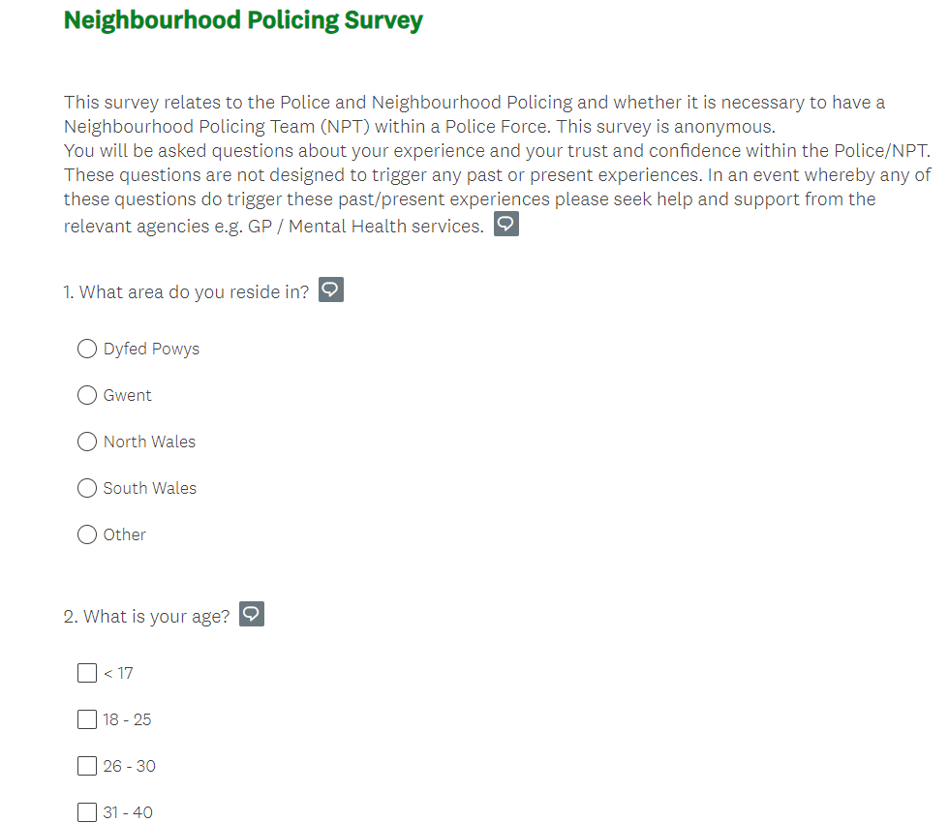
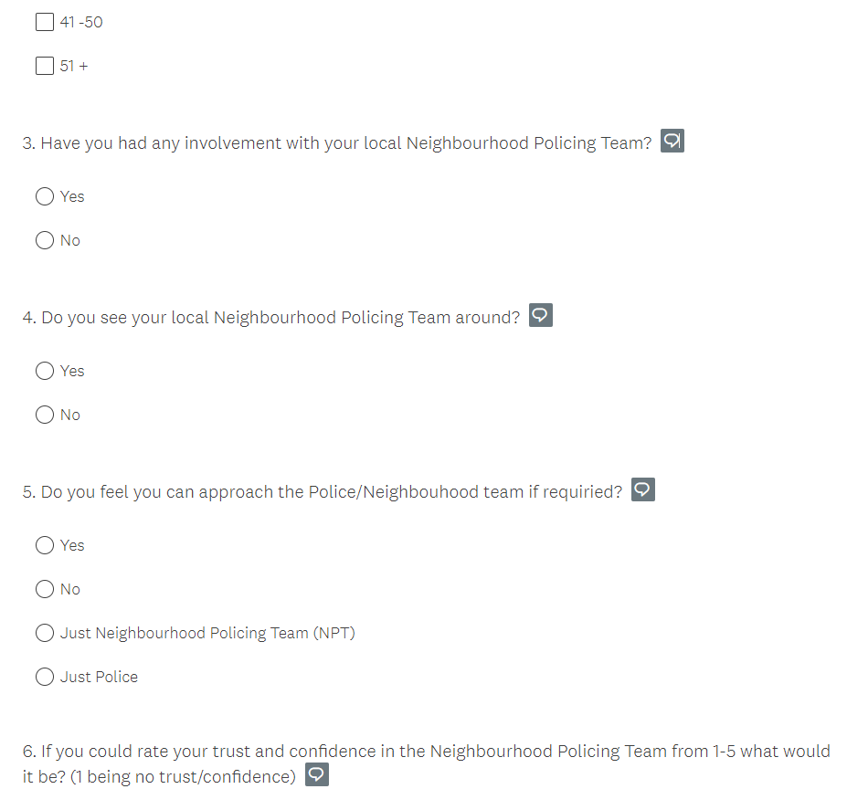
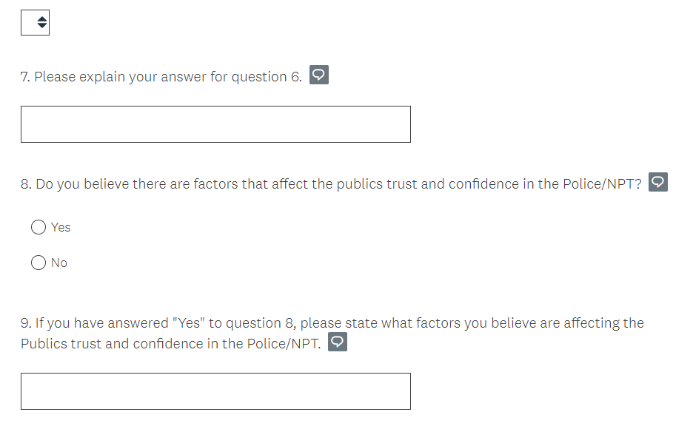

7.3B – Survey (Police)
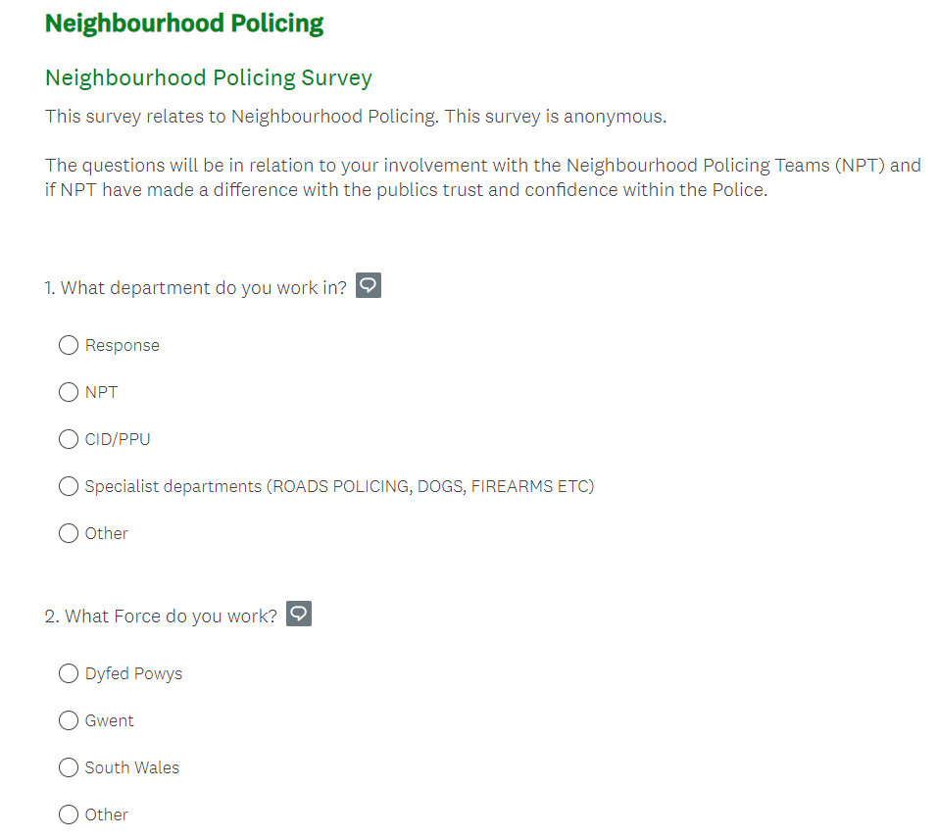
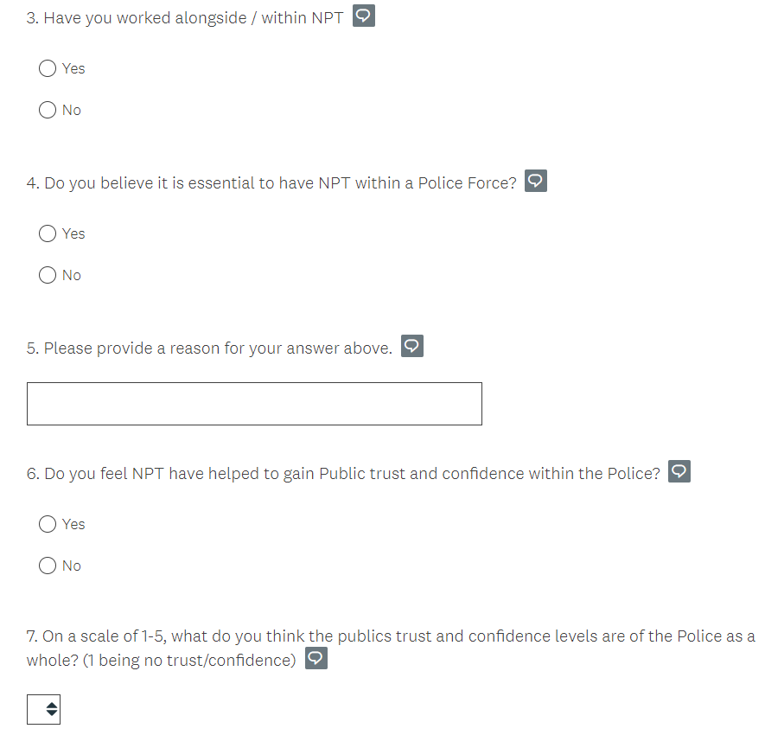
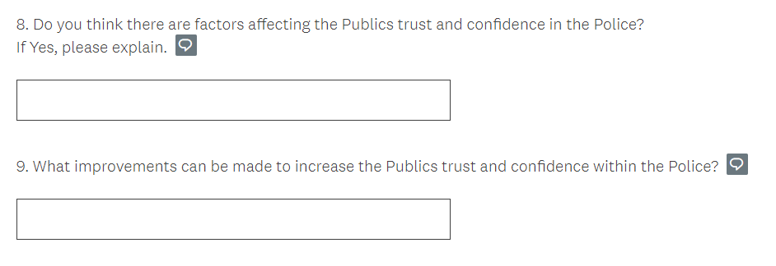

7.4A – Survey Results (Public)
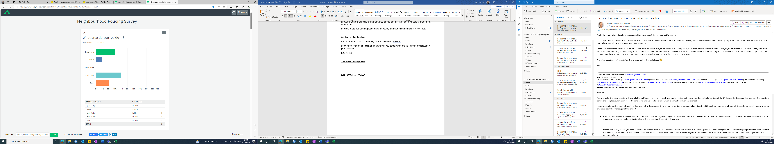
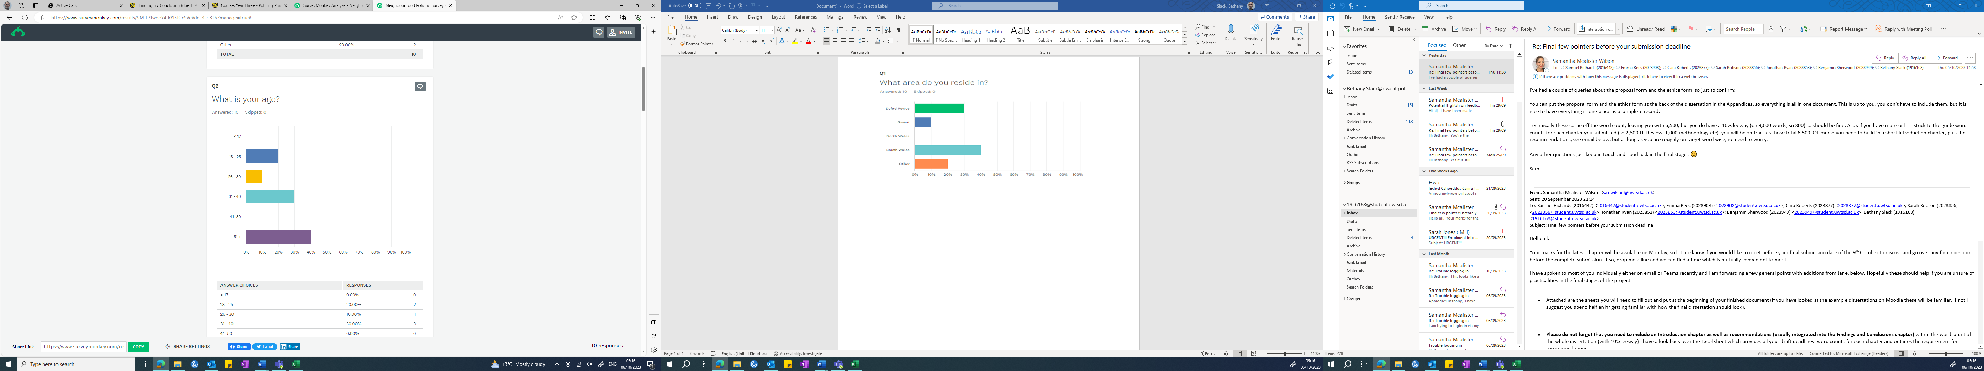
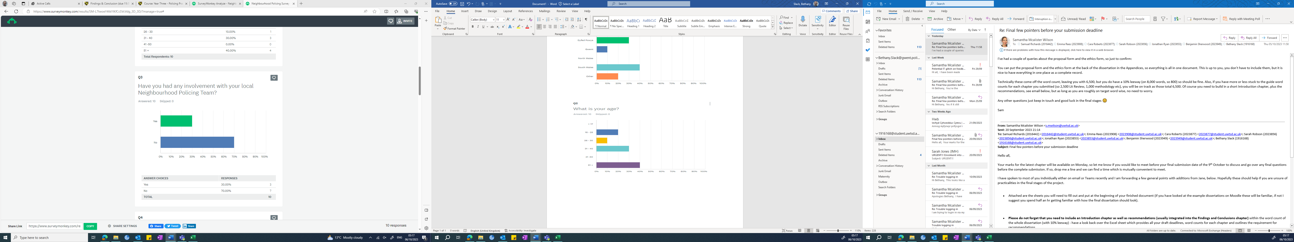
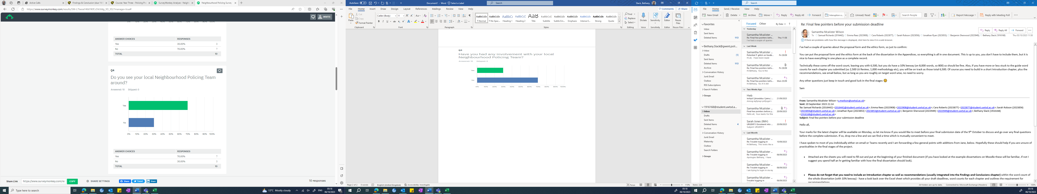
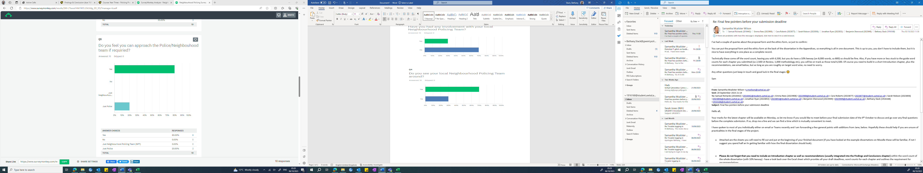
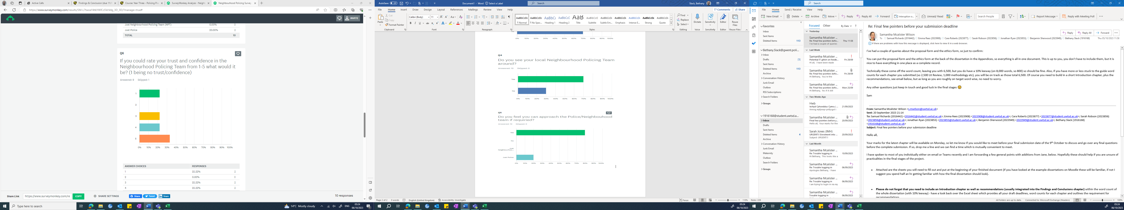
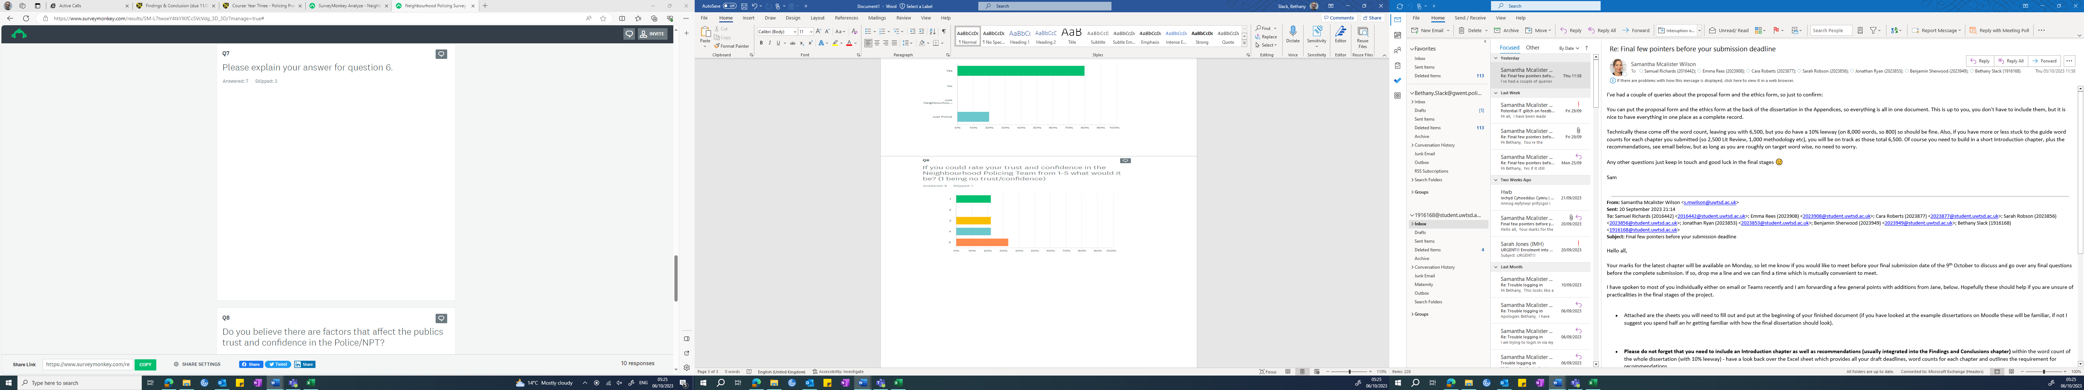
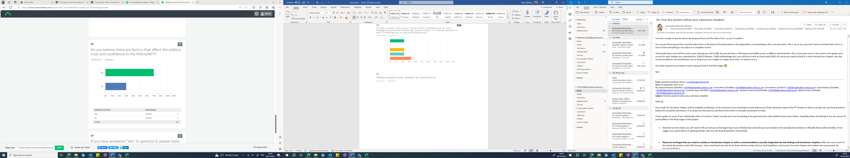
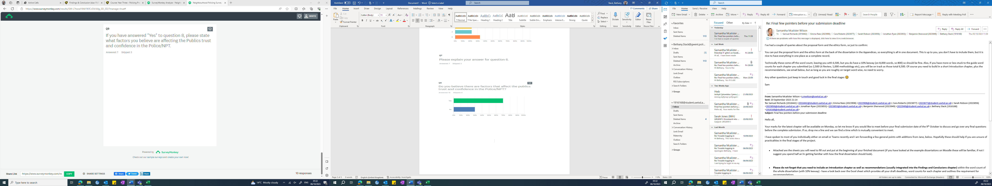

7.4B – Survey Results (Police)



