Module Name: Digital skills for Personal Development and Business Growth
Module code: BMSW4008
Assignment Name: Diamond beauty salon
Student Name: Ewa Szkudlarek
Student number: 2423444
Lecturer: Muhammad Cassimo

AI Acknowledgement
I confirm that I have not presented any Ai generated materials as my own work. I confirm that I have copies of my drafts, notes and other resources I used, which I may be asked to be provide in evidence.

Contents

Task1: Market Research and Website Development for Diamond Beauty Salon 2
Questionnaire Creation and Data Collection 2
Website and Marketing Materials 5
Marketing Materials (Canva) 5
Conclusion 8
Task 2: The Importance of Excel in the Digital Era 8

Task1: Market Research and Website Development for Diamond Beauty Salon

Questionnaire Creation and Data Collection
Diamond Beauty is a beauty salon that offers a one-stop-shop service, providing treatments for nails, facials, lash lifts, non-aesthetic treatments, and pedicures.
To identify customer preferences, an online survey was conducted using Microsoft Forms. The aim was to gather opinions, understand people’s habits, and use these results to create marketing materials for Diamond Beauty. Market research helps small businesses plan more effectively by giving them real information to base their decisions on, rather than relying on guesswork (Munoz, 2023; Naminova et al., 2023).
The survey consisted of ten questions and was shared among peers and friends via email, WhatsApp, and Facebook Messenger. They also shared it with their own contacts, particularly those who fit the typical beauty-salon customer profile, such as individuals aged between 18–30. After receiving 57 responses, the survey was closed. According to Bryman (2016) and Malhotra and Birsk (2017), using a survey is a common and reliable method for collecting information from a target audience.
In terms of preferences when it comes to treatment, the survey revealed:
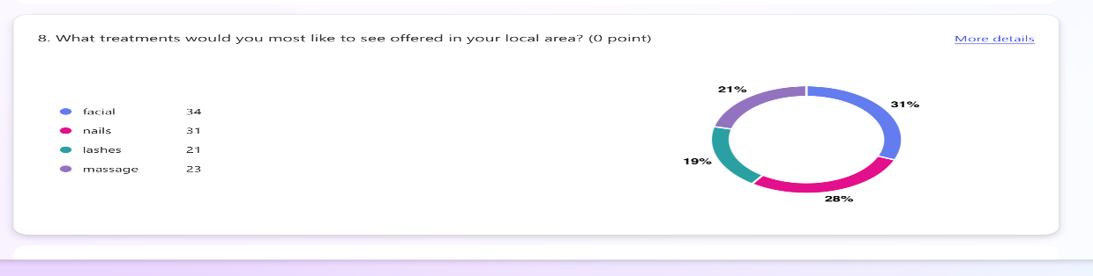
Figure 1: Survey Results - beauty treatment preferences
The highest preference was for facials, which shows strong local interest in skin care. Nails was also very close behind. This indicated that if I want my salon to be successful, nails and facials should be the main services to promote. Because of this, on my website, I highlighted facials and nails first, using images that clearly show these treatments. This also helped shape the marketing materials created on Canva.
A separate question asked what types of beauty treatments respondents currently use. Again, nails and facials were the top two. This matches wider beauty trends that show strong growth in skin care and nail services (Mintel, 2023; Statista, 2023). This suggested that people already use these treatments and will likely return for them regularly. As a result, these services will become the core of my business idea. On the website, they appear at the top of the services page, and I selected photos showing nail and facial treatment results to match what customers expect. This also aligns with customer behaviour research showing that people tend to repeat services they trust and enjoy (Salomon, 2020).
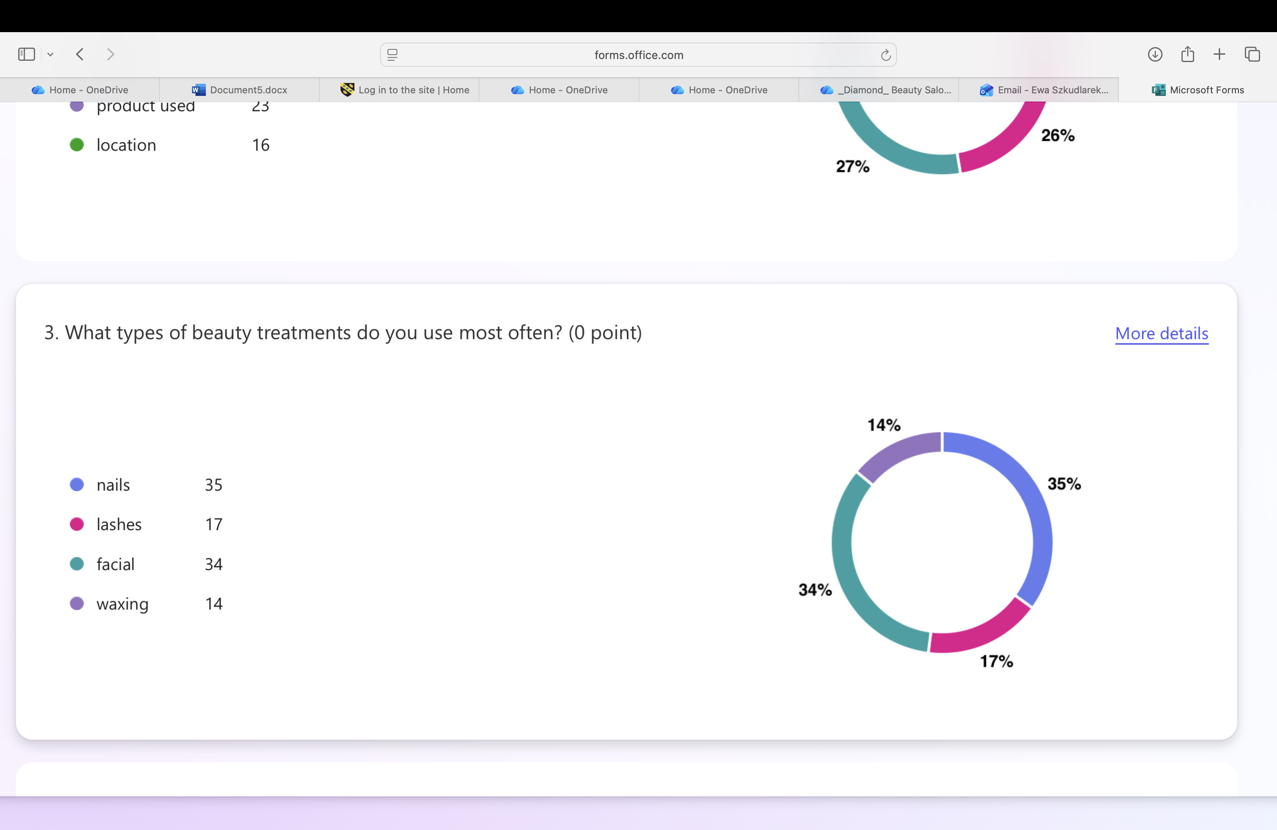
Figure 2: Survey Results - Frequent Beauty Treatments Used
Another question asked: “what makes them choose a salon”? The results showed that quality and hygiene were the two biggest priorities. This is very important for my business because it means people are willing to pay more or travel further if they trust the salon. So, on my website I made sure to use professional, clean, safe, and high-quality visuals. I also added a bright and tidy photo of the salon interior to reinforce this message. These two factors mattered more than price or location. This supports industry research showing that trust and safety are the biggest influences for beauty customers (Statista, 2023).
This question also helped me understand that price is not the main factor. People prefer to feel safe and reassured, so the website includes sentences such as “we are committed to quality” and “you are in safe hands.” I also used clean, bright images of the salon, because visuals play a big role in building trust (Smith and Zook, 2016).

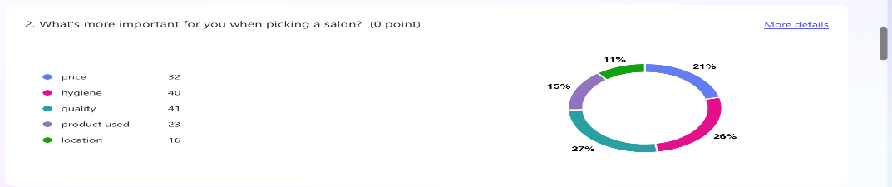

Figure 3: Survey Results – Service categories that incline a customer to visit a salon
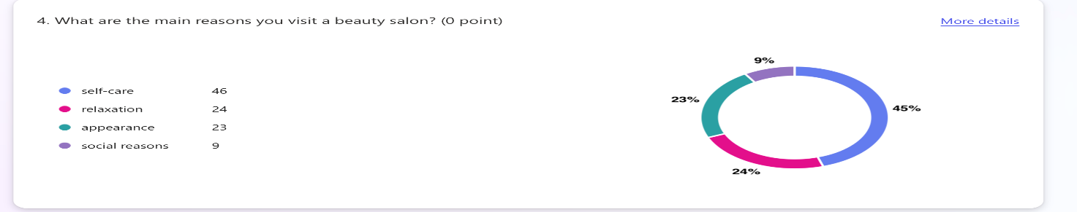
A final question asked for the reasons why people visit a beauty salon.
Figure 4: Survey Results – Reasons why customers visit a beauty salon.
The results showed that people go to a salon because they want to relax and take care of themselves. This shaped the tone of my whole website. Instead of making the site look too commercial, I used warm, welcoming wording like:
- “Beyond the ordinary”
- “This is where our journey begins”
- “We are glad you are here”
I also used softer colours, friendly photos and simple descriptions to create a calm feeling.

Website and Marketing Materials

Marketing Materials (Canva)
To advertise the business, I created a flyer using Canva. Since nails and facials were the most popular service. I made sure that these treatments were the focus of the posters. I used calm colours because people come to a salon to relax. I also included phrases like “treat yourself” and “professional beauty care” to connect with the self-care trend.
SEO Strategy
SEO is important for helping new clients find a business online (Google,2023). Therefore, I created a website for Diamond Beaty using Webador.
The website included:
- Clear heading on each page so google can understand the content (Chaffey and Ellis-Chadwick, 2019).
- Alt text to images to improve accessibility
- A simple website structure
- I used clear keywords so that it would appear in local searches (2020, Sandhu)
- Keywords such as ‘facial”, “beauty salon”, “nails”, “lashes” and “professional treatment” were used.
- For bookings, clients prefer phone call appointments. So, on my website, there is a link to my number for booking.

These steps help improve visibility and make the website more user-friendly. Most people visit salons for self-care, which agrees with recent research showing beauty services are strongly linked to wellbeing and mental relaxation (Mintel, 2023). This result strongly influenced the “feel” of my website. I used warm and welcoming text to make clients feel comfortable, such as “Beyond the ordinary” and “This is where journey begins”. I also kept the design soft and clean to match the idea of relaxation.
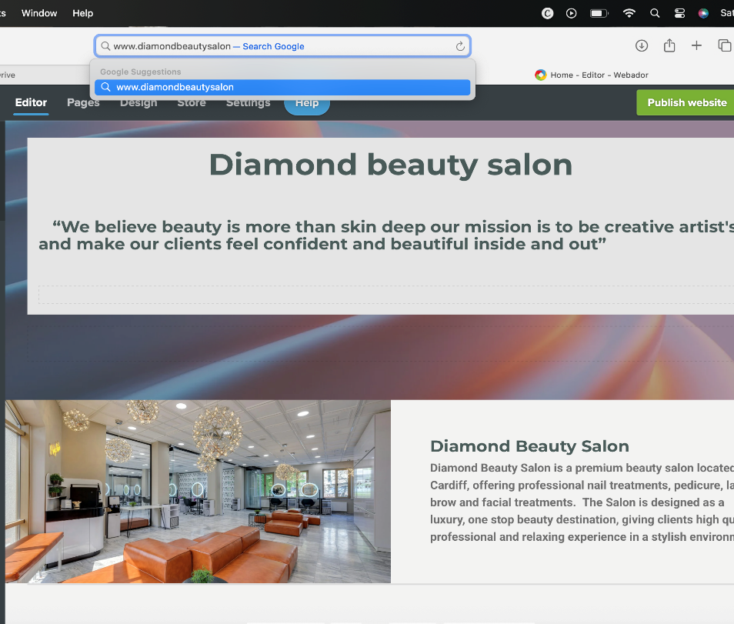

Figure 5: Homepage of Diamond Beauty Website
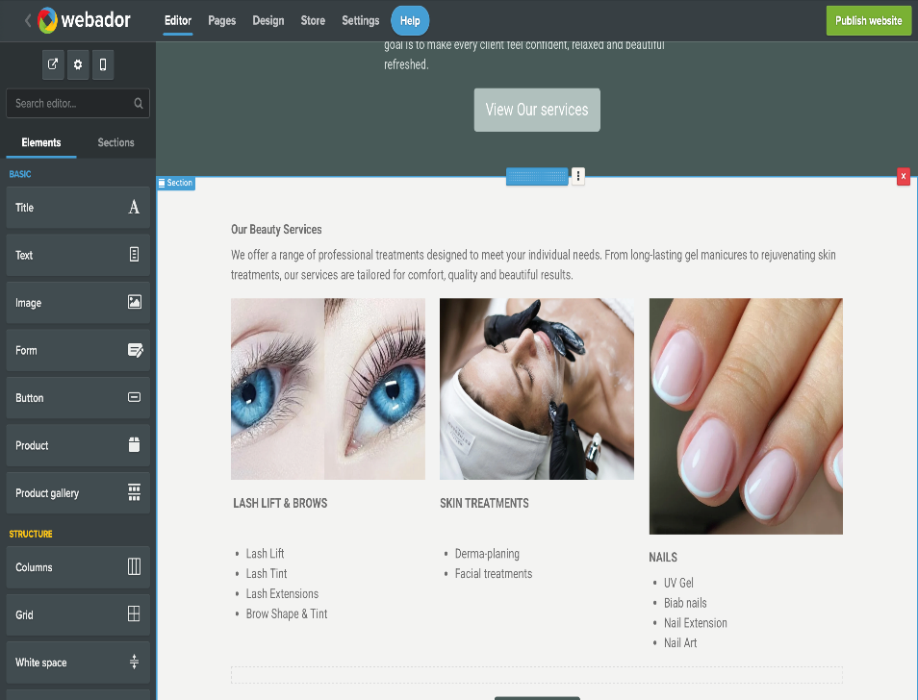

Figure 6: Beauty Service Treatments on the Website
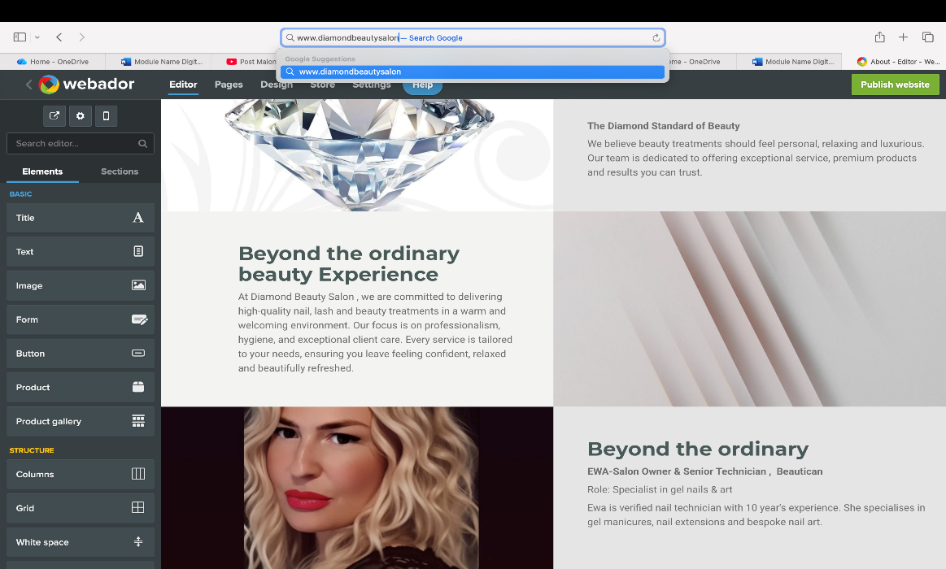

Figure 7: Details of Diamond Beauty on the Website

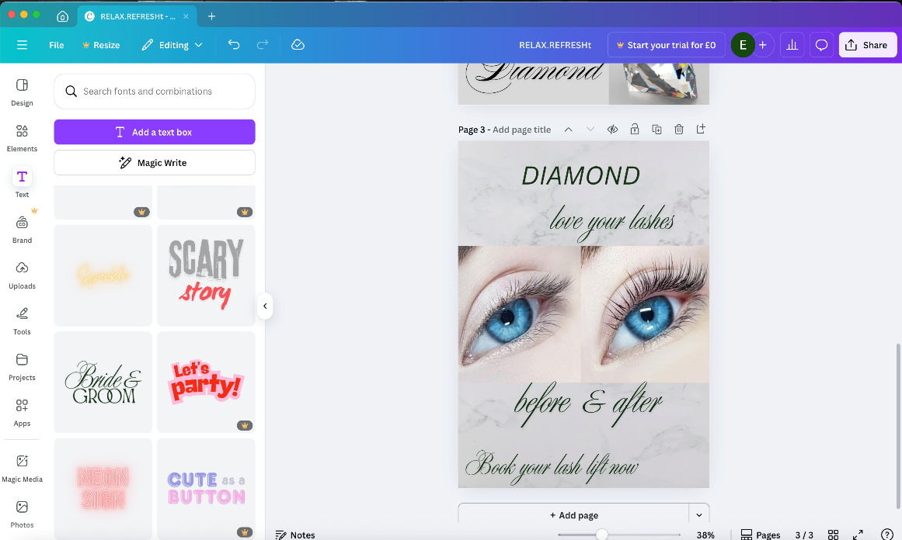
Figure 8: Diamond Beauty Flyer on Canva

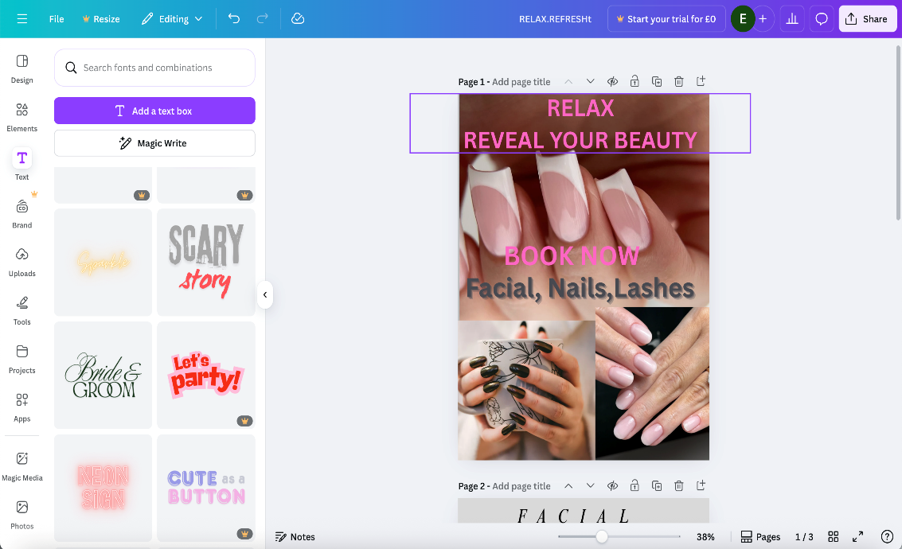
Figure 9: Flyer Continued

Conclusion

Overall, the questionnaire helped me understand what customers expect from a beauty salon and what services are in demand. The strongest findings showed that future clients prefer facial and nail services, they care most about quality and hygiene, and they visit a salon mainly for relaxation and self-care. All these findings guided the way I designed the Diamond Beauty Salon website: the layout, the photos, the colours and the wording. The Canva marketing materials also reflect the trends I discovered. With the help of segmentation, marketing insight and simple SEO techniques, I created a website and business idea based on real customer needs.

Task 2: The Importance of Excel in the Digital Era
Digital literacy is now essential for businesses of all sizes. It involves using technology to manage information, make decisions, and work more efficiently. Even simple tools like spreadsheets are part of digital literacy because they help small businesses stay organised and understand their data (Reedy and Parker, 2017).
In today’s digital world, it does not matter if a business is big or small, everything is based on data, numbers, and organisation. Excel has become one of the most useful tools because it helps keep information clear, safe, and easy to understand. Small businesses like mine can benefit from using Excel to stay organised, understand customer behaviour, and manage day-to-day tasks more easily. Excel is not just a spreadsheet, it is a way of keeping track of information in a clear and simple way, especially when running a salon where many things change daily (Web4Business,2024).
The digital era is all about finding data, understanding it, and using it to make better decisions. Excel makes this possible even for people who are not experts. It allows businesses to analyse trends, compare results, check progress, and plan for the future. In many industries, Excel is considered a “basic skill,” and many companies expect employees to know how to use it. It is also widely used for training, finance, stock-taking, staff management, and performance tracking. Excel works well offline and online, so it is flexible and reliable. Excel makes it easy to organize data, run calculations and create charts, analysing key information and better decision making (Inside Microsoft Excel, 1994; McFredries, 2022)
For my beauty business, Excel would be useful for tracking clients and bookings, as well as managing stock, finances, and marketing. One of the biggest reasons Excel is important today is because businesses deal with a lot of data. Excel can show patterns, totals, and trends. This helps business owners make better decisions based on real information rather than assumptions. Excel helps me manage key information and learning it now boots my confidence and digital skills for future work and study (Anderson, 2019; Byrd, 2021).
Even though there are many modern apps, Excel is still important because it gives full control. The user can create their own tables, formulas, and charts and track their business exactly the way they want. For my beauty salon, Excel can support me in many different areas (Dordevic, Milanovic Zbiljic and Radosavljievic 2025; Sandhu,2020)

Appointment Tracking
Even if I use a booking app, Excel gives me a simple backup system where I can see which days are busy, which treatments are more popular, and what times clients prefer. This can help me plan my schedule more effectively.
Stock and Product Management
In a beauty salon, stock management is important. I will be using many products, including nail colours, creams, lash lift solutions, files, oils, and more. With Excel, I can create a simple sheet listing products, the quantity I have, expiry dates, and suppliers. This makes it easier to see when something is running low and helps avoid wasting money or having too much unused stock.
Financial Tracking
Another important part of running a business is financial management. Excel can record income from treatments, expenses, product purchases, rent, marketing costs, and more. This helps assess business performance and make informed decisions (Bella,2023).
Marketing and Social Media
Excel can help track what clients interact with, including website traffic and social media engagement. This helps plan campaigns and improve marketing effectiveness. Knowing your social media data lets you increase engagement, Measure ROI, and refine your content (Excel,2023)
How Excel Supports My Beauty Business
In my beauty salon, Excel can help me stay organised and save time. My business offers treatments such as nails, facials, lash lifts, massages, and more. For services like these, I need to be organised with numbers, and Excel helps a lot.
Example uses of Excel in my beauty salon include:
Client Tracking: I can keep a list of clients, what treatments they have had, how often they visit, and what products they prefer. This can help me plan offers, loyalty cards, and personalised services.
Stock & Product Management: I can use Excel to track gels and nail products, skincare serums, lash lift solutions, and disposable items.
Financial Planning: Excel helps calculate weekly and monthly income, expenses, profit, growth, and treatment popularity. This makes it easier to see which services bring the most revenue and which need improvement.
Appointments: By tracking busy and quiet days, I can decide when to run promotions and when to add more availability. It also helps plan staff schedules.
Why Excel Matters for Future Growth
As my beauty business grows, data will become even more important. Excel gives me a strong base because it is simple, flexible, and powerful. It can help me understand my business clearly instead of guessing.
Conclusion
Excel remains one of the most important tools for any business in the digital era. For my beauty salon, it helps me understand clients, control stock, manage finances, and plan marketing. It keeps everything organised in one place and supports better decisions every day. Even with many new apps available, Excel is still a key part of my business growth and success.
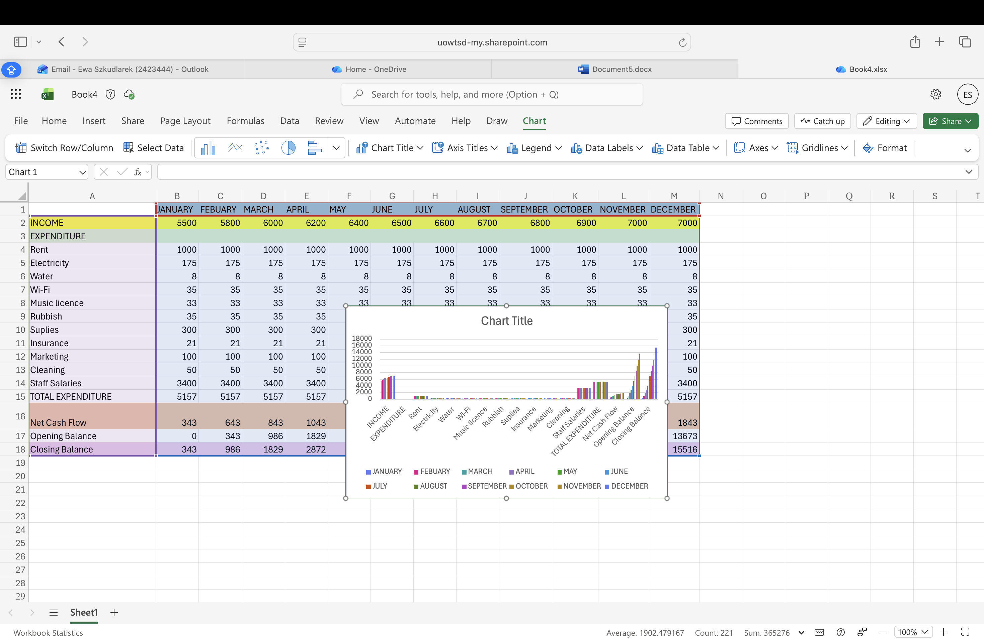
Document4.docx

References:
Anderson, M. (2019) Digital Literacy Unpacked. Katharine Ready and Jo Parker, eds. London: Faced Publishing, 2018. 240p. (ISBN:978-1-78330-197-3)’, College and Research Libraries.
Bencsik, A. (ed.) (2017) Knowledge management initiatives and strategies in small and medium enterprises. Hershey, PA: Business Science Reference. Available at: https://www.igi-global.com/gateway/book/159580 (Accessed: 10 December 2025).
Bryman, A. and Cramer, D. (2011) Quantitative data analysis with IBM SPSS 17, 18 and 19: a guide for social scientists. London: Routledge. Available at: https://librarysearch.uwtsd.ac.uk/permalink/44WHELF_UWTSD/a9ute4/alma99100147659002421 (Accessed: 10 December 2025).
Byrd, L.S. (ed.) (2020) Cultivating entrepreneurial changemakers through digital media education. Hersey, Pennsylvania: IGI Global.
Canva (2013) Diamond Beauty Salon. Available at: https://www.canva.com/design/DAG5vneUXZw/6CPefaQBpod-fV48reDo6g/edit?utm_content=DAG5vneUXZw&utm_campaign=designshare&utm_medium=link2&utm_source=sharebutton (Accessed: 10 December 2025).
Chaffey, D. and Ellis-Chadwick, F. (2019) Digital marketing strategies: insights. Available at: https://www.studocu.vn/vn/document/dai-hoc-kinh-te-quoc-dan/marketing-can-ban/preview-9781292241586-a36188176/114470050 (Accessed: 10 December 2025).
Christy Bella (2025), Why Proper Financial Tracking is Essential for Any Business Available: https://www.londonbusinessnews.com/why-proper-financial-tracking-is-essential-for-any-business/
Dadwal, S.S. (ed.) (2020) Handbook of research on innovations in technology and marketing for the connected consumer. Available at: https://www.igi-global.com/book/handbook-research-innovations-technology-marketing/226306 (Accessed: 10 December 2025).
Global (2022) Beauty and Personal Care Trends Article: mintel-announces-beauty-and-personal-care-trends-for-2023
Social Media Performance Dashboard in Excel Excel, (2023) Available :social-media-performance-dashboard-in-excel
Mandal, P.C. (2021) ‘Marketing of private labels: strategies and initiatives. International Journal of Business Strategy and Applications. DOI: 10.4018/IJBSA.20210101.oa5.
Munoz, J.M. (ed.) (2023) Digital entrepreneurships at the global economy. New York: Routledge.
Nominova, K., et al. (2023) Small businesses investment processes financing package. Available at: e3sconf_pdsed2023_04006.html (Accessed: 10 December 2025).
Reedy, K. and Parker, J. (eds.) (2017) Digital literacy unpacked. London: Facet Publishing. Available at: https://ebookcentral.proquest.com/lib/trinity/detail.action?docID=5490897 (Accessed: 10 December 2025).
Sandhu, K. (2020) Digital transformation and innovative services for business and learning. 1st edn. Hershey, PA: IGI Global, Business Science Reference. Available at: https://librarysearch.uwtsd.ac.uk/permalink/44WHELF_UWTSD/igoone/cdi_econis_primary_1690982152 (Accessed: 10 December 2025).
Web4Business (2024) Website for small businesses, Excell for small businesses Available at: https://www.web4business.com.au/excel-for-small-businesses/
McFedries, P (2022) Teach yourself visually Excell 365. Indianapolis: Visual.
Inside Microsoft Excel (1994) Rochester, N.Y.: Element K Journals.

