Student name: Florin Stefan Solomon
Student ID: 2126932
Module code: LCHS4002_BIRM
Lecturrer: Muhammad Hossain

Digital Skills and Research Methods

Table of Contents
Introduction 3
Research Design 4
Research Methods 5
Ethical Considerations 6
Discussion 17
Conclusion 19
References 20
Appendix-1 22

Introduction
Digital tools are widely used by learners to enhance collaboration. It boosts engagement among students and improvises their academic performance. The use of tools like Creative Cloud helps a student to develop infographics, videos, e-portfolios and presentations related to their assignments. This enhances argument, discoveries and ideas collaboration among them. Through digital literacy, a student can highlight the job market among the competitors. It also simplifies the concept of thinking and helps the learners to simplify their issues. The following research will focus on comprehending the digital tool that is mostly preferred by students for enhancing collaboration. Thus, research, aims, objectives and questions will be formulated to commence the same. Various research methods will be integrated that will help the researcher to identify the methods of evaluating the outcomes. The concept of ethical consideration and its significance in research will also be discussed. The context will further focus on conducting a survey with the help of a questionnaire. A section of discussion will be provided, where the survey results will be interpreted to gather results related to the role of digital skills in enhancing collaboration among learners.

Research Design
Research Aim: To understand the digital tool that is mostly preferred by students for enhancing collaboration
Research Objectives
1. To identify the digital tools that the learners are mostly using for enhancing collaboration
2. To analyse the issues faced by the learners in incorporating digital tools to enhance collaboration
3. To evaluate the overcoming methods implied by the learners for improving their digital collaboration
Research Question
1. What are the digital tools that the learners are mostly using for enhancing collaboration?
2. What are the issues faced by the learners in incorporating digital tools to enhance collaboration?
3. What are the overcoming methods implied by the learners for improving their digital collaboration?

Research Methods
Research Onion
The research onion describes the proper stages which must be covered for developing a research strategy. This strategy provides an effective progression and it also helps to examine and describe the concepts of the research methodology. This research onion was developed by Saunders in 2007. There are several layers for developing researchers which are research philosophy, research approaches and research strategy, etc (Phair, 2021).
Research Philosophy
The very first layer of the onion is the research philosophy which helps to describe the set of beliefs. There are three main research philosophies which are positivism, interpretivism and pragmatism (Mason, Augustyn and Seakhoa-King, 2022). Positive research provides knowledge which can be true, false and meaningless. While doing the research the researcher has chosen Positivism research philosophy as it depends on quantitative data. Due to this, the data researcher gets those are more reliable. Additionally, it is very highly structured and large samples can be handled by the researcher (research-methodology, 2022).
Research Method
There are three options in the research method which are mono, mixed and multi-method. While conducting the research the researchers adopted a mono method. The Mono method deals with only one research approach for a given study due to which the researcher can save time (Ojebode et al., 2018). It is a more flexible approach and choosing a single method either qualitative or quantitative makes the work of the researcher easier. The research has been conducted through a survey with the help of a questionnaire. This will help the researcher to gather real-time data and gather authentic data related to the study.
Research Approach
The research approach refers to a plan and process used to commence research in an effective way. The following research will be using a deductive approach which will help in deriving proper conclusions (Research-methodology, 2022). Moreover, the data collected may be utilised to analyse propositions as well as a hypothesis, in regard to a present theory.
Data collection tools and methods
Data is often collected through various methods. The most identified among them are the books and journals, surveys, interviews, content and thematic analysis. The following research has opted for a survey with the help of a questionnaire (Littlejohns et al., 2020). This will help the researcher to gather real-time data and ensure efficient outcomes.
Sampling method
While collecting data, it is not possible to involve an entire population in research. Thus, the researchers select a part of the population, as a sample to conduct the research. The following research has been initiated through random sampling (Martino, Luengo and Míguez, 2018). Thus, learners from various institutions have collaborated to commence the following research.

Ethical Considerations
Ethical considerations in research refer to a list of principles that a researcher needs to follow in the designs and practices. They enlighten protecting research participants' rights and increase the validity of the research. With the help of ethical considerations, research is able to maintain proper scientific integrity. To ensure the same, the following research will integrate the Data Protection Act of 2018 (Gov, 2018). This helps to protect data laws by securing the personal details of the respondents.

Results
Figure 1
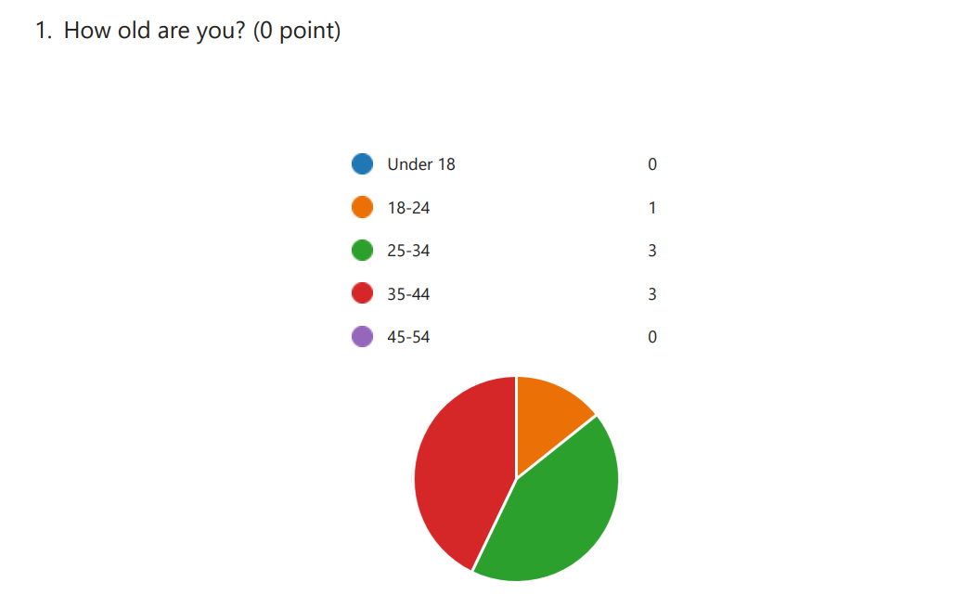

Analysis
Firstly, for the primary analysis the researcher questioned the age of the respondents to categorize the survey accordingly, the maximum number of people was between 25-44.
Figure 2
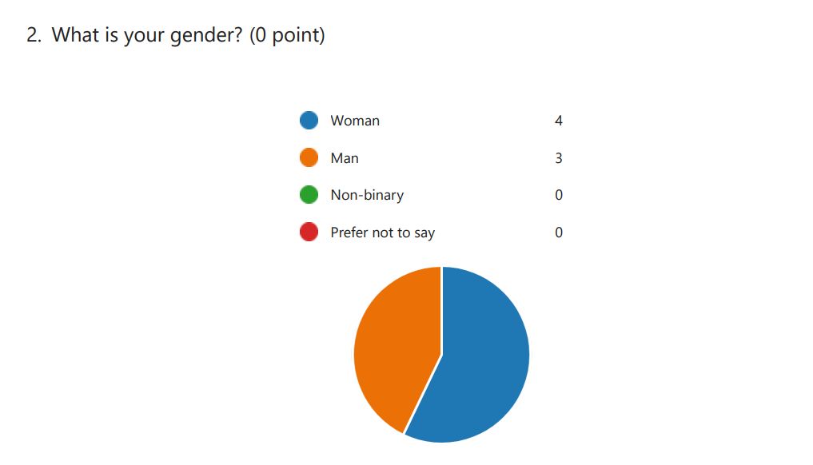
Analysis
For the next question, the researcher inquired about the gender of the respondent. The results of the survey show that 4 of the total respondents are men and the other 3 of them are women.

Figure 3
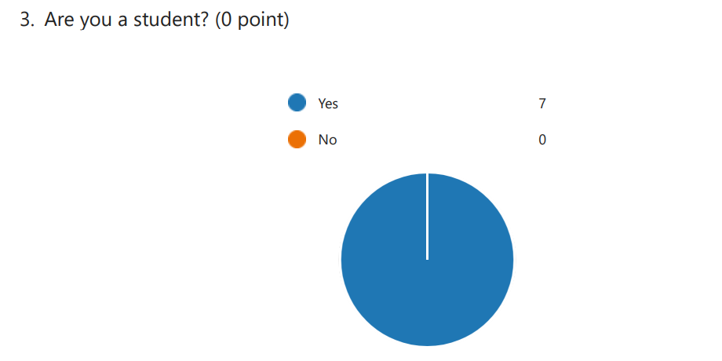
Analysis
Now, since the main focus of the research is on the students, the researcher also made sure to know if the respondent were a student or not so that the answers of the survey conducted for the primary analysis will help to fulfil the objectives, all of the seven respondents are students.
Figure 4
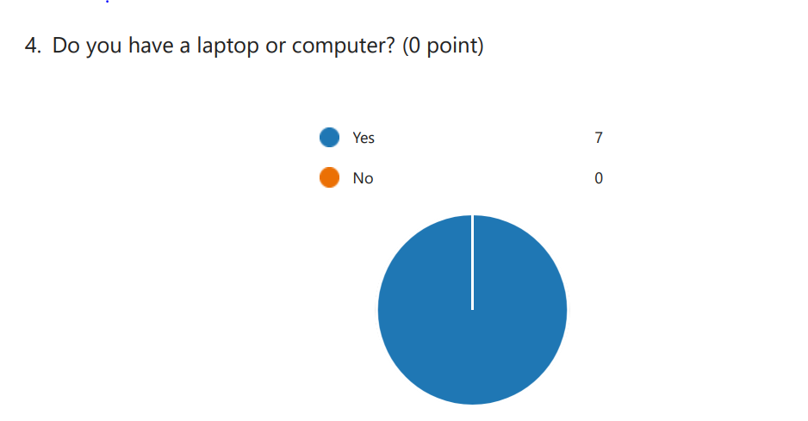
Analysis
After that, the next thing focused on the research is the digital tool that is mostly used by a student for collaboration, to use a digital tool it is important to understand whether the students have a laptop or computer, with the help of which the use of digital tools becomes easy, again the results show that all respondents do have their either one of those devices.
Figure 5
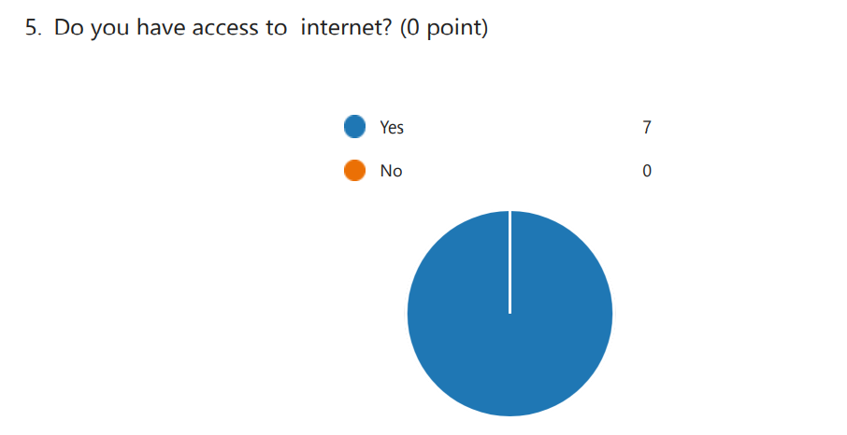
Analysis
The researcher further asks the respondents about their internet connection. This is essential since to use a digital tool it is necessary to have an active internet connection. The above chart shows that all seven respondents have access to the internet.
Figure 6
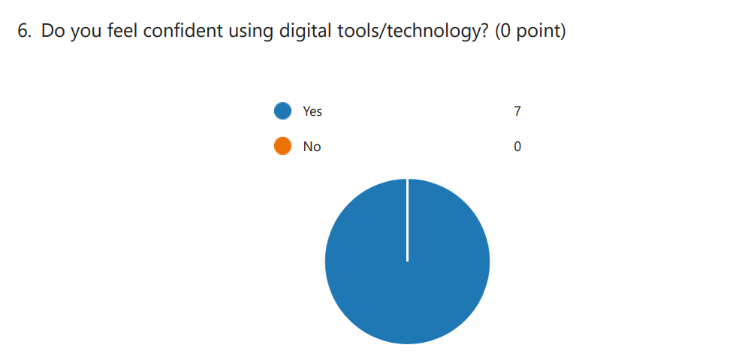
Analysis
The next question asked by the researcher focuses on how students feel about using digital tools and technologies. The results show that all the respondents were confident about using a digital tool or technology.
Figure 7
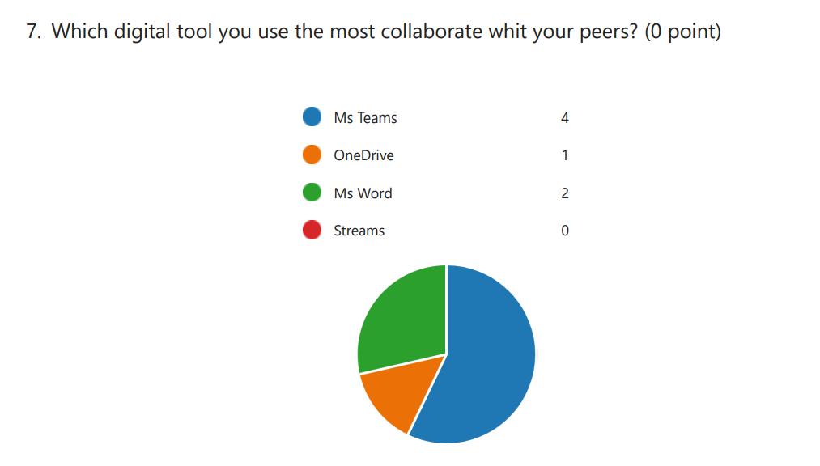
Analysis
The researcher then asks the respondents which digital tool is used by them for collaborating with their peers. According to the respondents, the most collaborative tool they use to connect with their peers is MS Teams, which is used by 4 respondents, followed by MS Word used by 2, and One Drive used by 1.
Figure 8
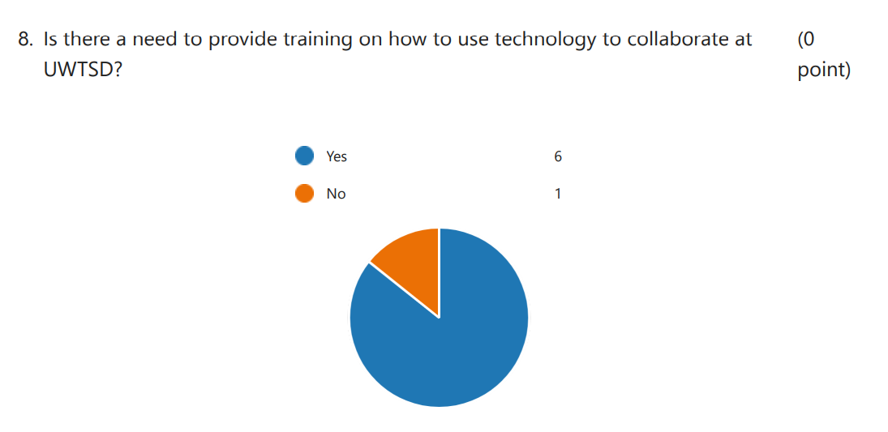
Analysis
The researcher also inquired if there is an essential need to provide training on how to take the help of technology to collaborate. Six respondents with the exception of one thought that there is a need for providing basic and essential training on how to adequately use a digital tool at UWTSD.
Figure 9
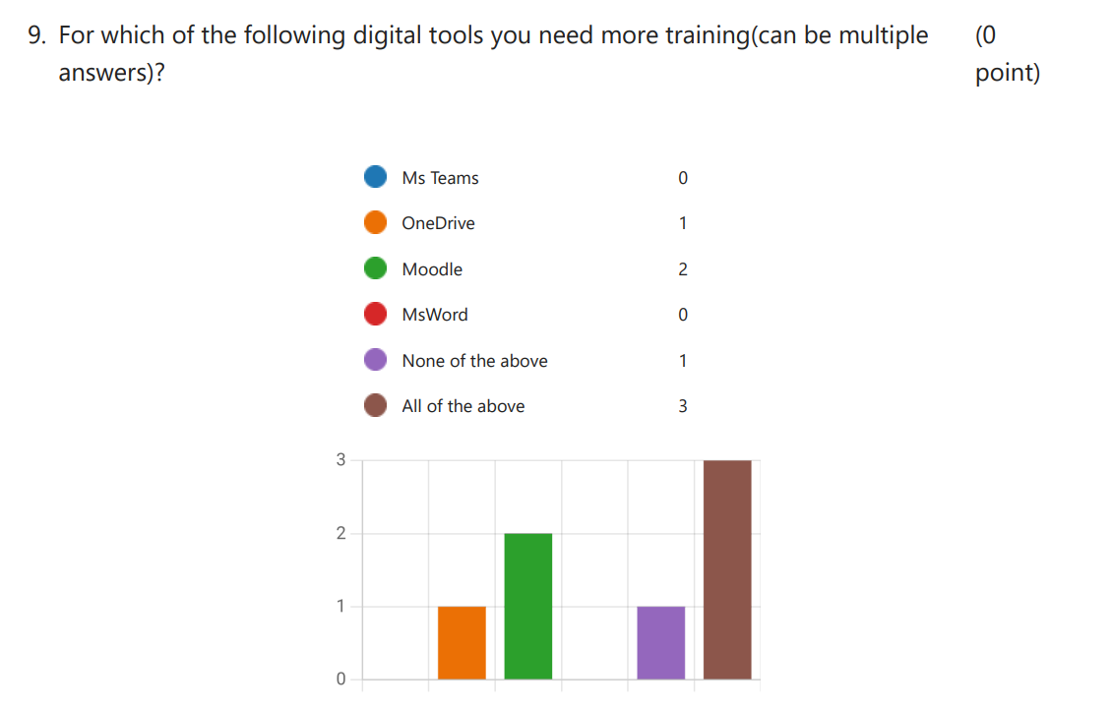
Analysis
Finally, when the researcher inquired about which tool the students needed to be trained for, many of them responded with all collaborative tools, whereas 2 and 1 of them thought some help with Moodle and One Drive respectively, would be adequate. One of the respondents answered that none of the above tools needs to be trained, the students should be able to use these by themselves.

Discussion
The research was conducted to find out which digital tool is used by most of the students to collaborate and study together. The complete research was conducted with the help of both primary and secondary analysis, which aided the researcher to accomplish the aims of the research and fulfilling the objectives. The primary analysis of this research was done by asking different questions with the help of a survey to bring out an outcome that helped the researcher in fulfilling the objectives. Secondary analysis is the means through which a researcher can take out related and essential data from journals and books and analyse it thoroughly to reach an outcome. During the primary analysis, the researcher found which digital tool is mostly used by students to collaborate together. The research analysis conducted has a clear mode of results, which made it easy for the respondents to answer the question. The options were relatable, which helped the respondents to select the ones they think appropriate. A total of 7 participants took part in the survey and helped conduct the primary analysis. The respondents analysed to questioned and answered how they saw fit, due to which the researcher was able to conduct the research and reach an outcome. The outcome of the research varies on the way a researcher has conducted the overall research. In this primary analysis, the main focus was given on a few topics. Firstly, the age of the respondents helps to understand how comfortable and adaptive they are to technological advancements. Secondly, the gender is asked to clarify whether the majority of students were men or women. The very next question was focused on whether the person responding to the survey was a student or not, which allowed the researcher to directly target the student base and inquire them about the digital tool they use the most for collaborating, working, and learning together. The next essential thing to focus on is whether the student responding to the survey has access to materials and things required for using a digital tool. This includes a laptop and access to an internet connection, which allows the students to download and use the tool adequately. It is also essential that every student is confident to use technology and digital tools. In a world like today, where every task is conducted online on various tools or software, it has become necessary for students of every age group to adapt to this and find a way to learn from the enormous information provided online. Thus, it is essential for them to stay active on online platforms and be confident while using to make the most out of them. According to the results reflected in the research analysis part, it can be said that the most used digital tool by the respondents of this survey were MS Teams, which is a platform that allows its user to conduct meetings, which can be online classes. It is essentially used to collaborate with their peers, seniors, and professors to find a way of learning that helps them in every possible manner. MS Teams has been a digital tool that is used by students and professional workers to collaborate as a team and work together effectively. Another purpose that this survey and research project serve is to find out that many students think that is essential for the university to train their students on how to adequately use various digital tools that can be helpful to the students in different ways. Every software or tool that is designed serves a different purpose, which can be utilised by the students to learn and work together efficiently.

Conclusion
The following report has focused o elaborating on the importance of digital skilling in enhancing collaboration among learners. Aims and objectives have been derived and focused on the same. This has also helped in generating the research questions, to evaluate the outcomes. The context has further highlighted the research methods used. Thus, a deductive research approach with positivism philosophy has been highlighted. From the above evaluation, it can also be stated that the researcher has used a mono method of conducting a survey with the help of a questionnaire to determine the outcomes of the following research. Finally, a survey has been conducted among the learners to gather efficient results. After providing such efforts, the research yet lacked various information. No secondary research has been conducted or data gathered from books and journals. Thus, the research lacked information from past-reviewed journals which could have played a significant role in data analysation.

References
Martino, L., Luengo, D. and Míguez, J., (2018). Independent random sampling methods (pp. 65-113). Martino: Springer International Publishing.
Littlejohns, T.J., Holliday, J., Gibson, L.M., Garratt, S., Oesingmann, N., Alfaro-Almagro, F., Bell, J.D., Boultwood, C., Collins, R., Conroy, M.C. and Crabtree, N., (2020). The UK Biobank imaging enhancement of 100,000 participants: rationale, data collection, management and future directions. Nature communications, 11(1), pp.1-12.
Ojebode, A., Ojebuyi, B.R., Oladapo, O.A. and Oyedele, O.J., (2018). Mono-method research approach and scholar–policy disengagement in Nigerian communication research. In The Palgrave Handbook of Media and Communication Research in Africa (pp. 369-383). Palgrave Macmillan, Cham.
Mason, P., Augustyn, M.M. and Seakhoa-King, A., (2022). Research Philosophy. In Encyclopedia of Tourism Management and Marketing. Edward Elgar Publishing.
Gov, (2018). Data protection. [Online] Available at: https://www.gov.uk/data-protection#:~:text=The%20Data%20Protection%20Act%202018,Data%20Protection%20Regulation%20(GDPR).
Phair, D., (2021). Saunders’ Research Onion: Explained Simply. [Online] Available at: https://gradcoach.com/saunders-research-onion/
Research-methodology, (2022). Research Approach. [Online] Available at: https://research-methodology.net/research-methodology/research-approach/
research-methodology, (2022). Research Philosophy. [Online] Available at: https://research-methodology.net/research-philosophy/

Appendix-1
Are students confident in using tecnology to collaborate?
1. How old are you?
a. Under 18
b. 18-24
c. 25-34
d. 35-44
e. 45-54
2. What is your gender?
a. Woman
b. Man
c. Non-binary
d. Prefer not to say
3.Are you a student?
a. Yes
b. No
4. Do you have a laptop or computer?
a. Yes
b. No
5. Do you have access to internet?
a. Yes
b. No
6. Do you feel confident using digital tools/technology?
a. Yes
b. No
7. Which digital tool you use the most collaborate with yours peers?
a. Ms Teams
b. OneDrive
c. Ms Word
d. Streams
8. Is there a need to provide training on how to use technology to collaborate at
UWTSD?
a. Yes
b. No
9. For which of the following digital tools you need more training (can be multiple
answers)?
a. MS Teams
b. OneDrive
c. Moodle
d. MS Word
e. None of the above
f. All of the above

