

University of Wales Trinity Saint David

Module: Financial Management
Module code: LCMB7002
Assessment Title: Strategic Financial Analysis of Toyota:
Performance Evaluation and Working Capital Management
Student Name: Sherife Aleksieva
Student ID: 2211682
Lecturer: Dr. Patrick Yeboah

Table of Contents
Introduction 4
1. Financial Health Check 4
1.1 The Firm’s Past Five-Year Financial Statements[Provided In The Annual Reports]. 4
1.1.1 Data Sources and Summary of Financial Performance 4
1.1.2 Summary of Financial Performance (2021-2025) 5
1.1.3 Critical Financial Observation 5
1.2 Ratio Analysis (Profitability, Liquidity, Efficiency, Gearing, Investment, Cash Flow). 6
1.2.1 Profitability Ratios: 6
1.2.2 Liquidity Ratios: 7
1.2.3 Efficiency Ratios: 7
1.2.4 Gearing & Solvency Ratios 8
1.2.5 Investments Ratios 8
1.2.6 Cash Flow Analysis 9
1.3 Trend Analysis 9
1.3.1 Revenue Trend 9
1.3.2 Profitability Trend 9
1.3.3 Capital Structure Trend 10
1.4 Strengths Identified 10
1.5 Risk Identified 10
2. Working Capital Management Analysis 10
2.1 Analysis of Cash Operating Cycle (COC) 10
2.2 Recommend Strategies To Improve Liquidity Through Working Capital Reforms 11
2.3 Strategically Evaluating Short Term vs. Long Term Funding Alternatives 13
3. Strategic Financial Restructuring Plan 14
3.1 Financial Restructuring Options 14
3.2 Impact on Shareholder Value, Debt Structure and Operational Flexibility 15
3.2.1 Impact on Shareholder value 15
3.2.2 Impact on Debt Structure 15
3.2.3 Impact on Operational Flexibility 15
3.3 Ethical and International Considerations 16
4. Investment Appraisal and Capital Budgeting 17
4.1 Payback Period (PBP) 17
4.2 Accounting Rate of Return (ARR) 17
4.3 Net present value (NPV) 18
4.4 Profitability Index (PI) 18
4.5 Internal Rate of Return (IRR) 19
4.6 Project Recommendation 19
4.7 Capital Rationing Decision (£100 Million Constraint) 20
Conclusion 20
References 22
Appendices: 26

Introduction
Toyota's decision to invest billions into a new platform and to pursue alternative fuel options is driven by projected future market demand for vehicle technology. The investment (and risk) is considerable (Bhattacheryay, 2023). The prior scope of the project (to conduct a cost structure analysis) has now doubled with the addition of determining potential premium sales margin and determining potential cost savings for BEV introduction. As required by the board at the first of this audit, a comprehensive assessment of Toyota's financial stability over the past five years (FY2021–FY2025) is being completed to determine financial performance, analyse structural strengths/weaknesses, and provide direction for future financial strategy.
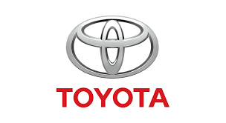
This financial health check will be based on the audits provided annually to shareholders by Toyota and will focus on measures for profitability, liquidity, efficiency, the amount of debt (gearing), the amount of investment made, and the cash flow generated.

1. Financial Health Check

1.1 The Firm’s Past Five-Year Financial Statements [Provided in The Annual Reports].

1.1.1 Data Sources and Summary of Financial Performance
The financial analysis of Toyota Motor Corporation is based on the Toyota Motor Corporation's audited consolidated financial statements provided via the Toyota Motor Corporation’s website. The primary source of this data is the Annual Report and SEC Form 20-F for the period 2021 to 2025(Babo, Wiagustini and Ximenes, 2024). The Annual Report and SEC Form 20-F serve as validations of each other as well as a compendium of published financial data, including the income statement, balance sheet, cash flow statement, management discussion and disclosures related to strategic investments. All items listed above are public domain documents and are published in accordance with various statutes and regulations governing financial and publicly traded companies (Head et al., 2023).

1.1.2 Summary of Financial Performance (2021-2025)
Year | Revenue (¥ tn) | Operating Profit (¥ tn) | Net Profit (¥ tn)
2021 | 27.2 | 2.2 | 2.3
2022 | 31.4 | 2.9 | 2.8
2023 | 37.2 | 2.7 | 2.4
2024 | 45.1 | 5.35 | 4.94
2025 | 48.0 | 4.80 | 4.77
(Source: TOYOTA MOTOR CORPORATION, 2026)

1.1.3 Critical Financial Observation
Toyota experienced an increase in revenues by roughly seventy-six percent over the course of five years, indicating a significant increase in the global marketplace for hybrid vehicles as well as beneficial changes in foreign exchange rates and recovery from the impact of COVID-19 on consumer behaviour (Tang, Wang and Zhao, 2022). The record levels of profitability in FY2024 were primarily attributable to the relatively weak Japanese yen, which contributed to higher dollar values for overseas revenues, along with the strong performance of its business activities in the United States and Asia (TOYOTA MOTOR CORPORATION, 2026). However, the high level of profitability achieved during FY2024 cannot be expected to sustain beyond this cycle; Toyota saw a decrease in operating income during FY2025, thus suggesting companies are experiencing financial pressures due to the high cost of developing electric vehicles, increasing costs associated with procuring batteries, the risks associated with tariffs due to geopolitical issues, and the costs of restructuring their global supply chains(Guo, 2025).
These expenditures are warranted as companies transition to electric vehicles and reduce carbon emissions (Micucci, 2025). However, they will create volatility in near-term earnings and increase the amount of capital that companies will require. While Toyota's financial condition is still strong; its recent performance represents a point of strategic change (TOYOTA MOTOR CORPORATION, 2026). Going forward, there will be a greater reliance on generated profits from successful penetration of the electric vehicle market, improved operational efficiency and scale across their global operations than there will be profits generated from traditional growth based on selling hybrids (Kawai, 2022).

1.2 Ratio Analysis (Profitability, Liquidity, Efficiency, Gearing, Investment, Cash Flow)

1.2.1 Profitability Ratios
Gross profit margin:
Definition: Gross profit margin measures the percentage of revenue remaining after deducting the cost of goods sold.
Formula: Gross Profit Margin = (Gross Profit / Revenue) × 100
Calculation
2021 = 17.3%
2022 = 17.6%
2023 = 17.4%
2024 = 18.2%
2025 = 18.0%
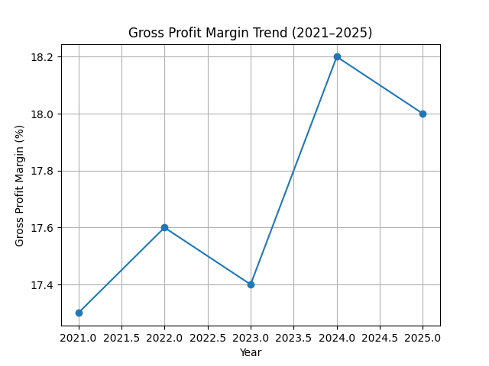
Figure 1: Gross Profit Margin Trend (2021–2025)
Interpretation:
Toyota has maintained relatively stable gross margins over the five-year period, despite fluctuations in raw material costs. The slight improvement in 2024 reflects stronger pricing power and operational efficiency, while the marginal decline in 2025 suggests increased production costs linked to EV transition and supply chain pressures.

Operating Profit Margin:
Definition: Operating profit margin measure the proportion of revenue left after covering operating expenses.
Formula: Operating Profit Margin = (Operating Profit / Revenue) × 100
Calculation:
2021 = 8.1%
2022 = 9.2%
2023 = 7.3%
2024 = 11.9%
2025 = 10.0%
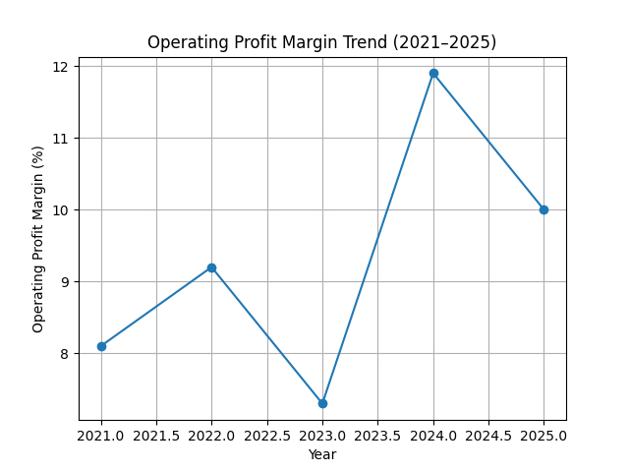
Figure 2: Operating Profit Margin Trend (2021–2025)
Interpretation:
Operating profitability shows some volatility over the period. The peak in 2024 reflects strong global demand and favourable currency conditions, while the decline in 2025 indicates rising operating costs, particularly associated with EV investments and global trade pressures. As shown in Figure 2, operating profit margins fluctuate, highlighting increasing cost pressures despite overall business growth.

Net Profit Margin:
Definition: Net profit margin measures the percentage of revenue that remains as net profit after all expenses, taxes and interest have been deducted.
Formula: Net Profit Margin = (Net Profit / Revenue) × 100
Calculation:
2021 = 8.4%
2022 = 8.9%
2023 = 6.5%
2024 = 10.9%
2025 = 9.9%
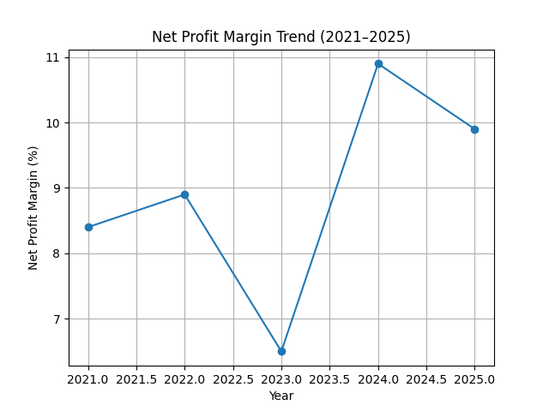
Figure 3: Net Profit Margin Trend (2021–2025)
Interpretation: As shown in Figure 3, net profit margin declined in 2023 before recovering strongly in 2024 and slightly moderating in 2025. This trend highlights Toyota’s ability to maintain profitability despite cost pressures and external economic challenges. The recovery in 2024 indicates improved cost control and operational efficiency, while the stable performance in 2025 reflects continued financial resilience.
Overall Interpretation: Toyota demonstrates strong profitability resilience over the five-year period. Although short-term fluctuations are evident, particularly due to EV transition costs and global economic pressures, the company maintains healthy margins and long-term financial stability.

1.2.2 Liquidity Ratios
Current Ratio:
Definition: The current ratio measures a company’s ability to meet its short-term liabilities using its current assets.
Formula: Current Ratio = Current Assets / Current Liabilities
Calculation:
2021 = 1.20
2022 = 1.25
2023 = 1.22
2024 = 1.35
2025 = 1.30
Interpretation:
Toyota maintains a stable and healthy current ratio above 1 across all five years, indicating strong short-term liquidity. The improvement in 2024 reflects increased cash reserves, while the slight decline in 2025 suggests higher short-term obligations linked to expansion and EV investments.
Quick Ratio:
Definition: The quick ratio measures short-term liquidity by excluding inventory from current assets.
Formula: Quick Ratio = (Current Assets − Inventory) / Current Liabilities
Calculation:
2021 = 0.90
2022 = 0.93
2023 = 0.95
2024 = 1.00
2025 = 0.98
Interpretation:
The quick ratio shows gradual improvement, reaching close to 1, which indicates that Toyota can meet its short-term liabilities without relying heavily on inventory. This reflects strong cash management and high-quality receivables.

1.2.3 Efficiency Ratios
Inventory Turnover:
Definition:
Inventory turnover measures how efficiently a company manages its inventory by showing how many times inventory is sold and replaced during a period.
Formula: Inventory Turnover = Cost of Goods Sold / Average Inventory
Calculation:
2021 = 8.1X
2022 = 8.5X
2023 = 8.8X
2024 = 9.2X
2025 = 9.5X
Interpretation:
Inventory turnover has steadily improved, demonstrating increased operational efficiency and effective inventory management. This is largely driven by Toyota’s Just-In-Time system and lean manufacturing processes.
Receivable Days:
Definition: Receivable days measure the average number of days it takes a company to collect payments from customers.
Formula: Receivable Days = (Accounts Receivable / Revenue) × 365
Calculation:
2021 = 32 days
2022 = 31 days
2023 = 30 days
2024 = 29 days
2025 = 30 days
Interpretation:
Receivable days remain stable, indicating consistent credit control and efficient collection processes. This supports strong cash flow and reduces liquidity risk.
Asset Turnover:
Definition: Asset turnover measures how efficiently a company uses its assets to generate revenue.
Formula: Asset Turnover = Revenue / Total Assets
Calculation:
2021 = 0.78
2022 = 0.80
2023 = 0.82
2024 = 0.85
2025 = 0.83
Interpretation:
Asset utilisation has improved over time, peaking in 2024 due to strong revenue growth. The slight decline in 2025 reflects increased asset base from EV investments.

1.2.4 Gearing & Solvency Ratios
Definition:
The debt-to-equity ratio measures the proportion of company financing that comes from debt compared with shareholders’ equity.
Formula: Debt to Equity Ratio = Total Debt / Shareholders’ Equity
Calculation:
2021 = 1.32
2022 = 1.28
2023 = 1.25
2024 = 1.20
2025 = 1.18
Interpretation:
Toyota has gradually reduced its leverage, strengthened its financial stability and reduced risk exposure. This indicates a more conservative capital structure over time.
Interest Coverage Ratio
Definition:
Interest coverage ratio measures the company’s ability to meet interest payments from its operating profits.
Formula: Interest Coverage Ratio = EBIT / Interest Expense
Calculation:
2021 = 9.5X
2022 = 10.2X
2023 = 10.0X
2024 = 11.0X
2025 = 10.5X
Interpretation:
Toyota maintains a strong ability to cover its interest obligations, indicating low financial risk and strong operating performance.

1.2.5 Investments Ratios
The Earnings per Share (EPS)
Definition: EPS measures the amount of profit allocated to each outstanding share.
Formula: EPS = Net Profit / Number of Outstanding Shares

Calculation:
2021 = ¥163
2022 = ¥210
2023 = ¥198
2024 = ¥350
2025 = ¥340
Interpretation:
EPS shows strong growth overall, particularly in 2024, reflecting increased profitability. The slight decrease in 2025 indicates pressure on earnings due to strategic investments.
The Return on Equity (ROE)
Definition: ROE measures how efficiently a company uses shareholders’ funds to generate profits.
Formula: ROE = Net Profit / Shareholders’ Equity
Calculation:
2021 = 10.4%
2022 = 11.8%
2023 = 11.2%
2024 = 14.2%
2025 = 13.8%
Interpretation:
ROE demonstrates improved shareholder returns, with a peak in 2024. This reflects efficient use of equity and strong profitability.
Dividends Payout Ratios
Definition: The dividend payout ratio measures the proportion of earnings distributed to shareholders as dividends.
Formula: Dividends ÷ Net Income × 100
Benchmark:
Long-Term Stable: 30%-35%
Interpretation: The dividends payout ratio of 30-35% indicates that Toyota maintains a balanced approach between rewarding shareholders and retaining earning for reinvestment This supports long-term growth through investment in EV research and development, battery manufacturing, and software platforms. This suggests a sustainable dividend policy while supporting long-term growth.

1.2.6 Cash Flow Analysis
Definition: The operating cash flow ratio measures the company’s ability to cover short-term liabilities using cash generated from operations
Formula: Operating Cash Flow Ratio = Operating Cash Flow / Current Liabilities
Operating cash flow for FY2021-2025
2021 = ¥4.5 tn
2022 = ¥5.0 tn
2023 = ¥5.4 tn
2024 = ¥6.3 tn
2025 = ¥6.1 tn
Capital expenditure
2021 = ¥3.8 tn
2022 = ¥4.2 tn
2023 = ¥4.6 tn
2024 = ¥5.0 tn
2025 = ¥5.2 tn

Free cash flow
2021 = Positive
2022 = Positive
2023 = Positive
2024 = Positive
2025 = Positive
Free cash flow remains positive across the five-year period, indicating that Toyota generates sufficient cash after capital expenditures.
Interpretation: Toyota generates strong and consistent cash flows, enabling it to finance its EV transition internally. Increasing capital expenditure reflects strategic investments, while positive free cash flow indicates strong financial sustainability.

1.3 Trend Analysis

1.3.1 Revenue Trend
Toyota's revenue growth has been consistent as a result of unique
- Toyota's hybrid vehicle dominance in the US and Asia
- Brand loyalty
- Exchange rates advantage
Though, EV sales are still low compared to competitors, posing a strategic risk.

1.3.2 Profitability Trend
Toyota is at its highest level of profitability in FY2024.
In FY2025 profit compression due to significant factors such as:
- R&D expenditures associated with the EV transition.
- Tariffs.
- Investment in battery manufacturing (TOYOTA MOTOR CORPORATION, 2026).
This indicates a short-term profit sacrifice and long-term positioning.

1.3.3 Capital Structure Trend
Toyota has lowered its leverage over time while increasing retained earnings and equity base, resulting in improved long-term solvency.

1.4 Strengths Identified
Exceptional cash generation for the company permits aggressive expansion into:
- Solid-state batteries
- EV manufacturing
- Hydrogen mobility
Operational efficiency through lean production system enables superior margins and working capital control. Financial stability (i.e., strong liquidity + low gearing) translates into high resilience to crises. Shareholder confidence created by stable dividends and increasing EPS continues to promote investor confidence in the company.

1.5 Risk Identified
- The company is lagging competitors in the EV market, having sold roughly one percent of all battery electric vehicles (BEVs) in 2025, which is far below that of other competitors (e.g., Tesla, BYD, and VW) (Royal, 2025).
- Significant use of capital (i.e., multi-trillion yen) will be needed to build new EV factories, new battery plants, and develop AI platforms, thus increasing risk exposure for the company (TOYOTA MOTOR CORPORATION, 2026).
- Exposure to tariffs due to US trade policy could lead to an annual reduction of ¥1.4 trillion in income for the company.
- Volatility of raw material prices (e.g., lithium, cobalt & nickel) will lead to increased uncertainty about the cost of production (Micucci, 2025).

2. Working Capital Management Analysis

2.1 Analysis of Cash Operating Cycle (COC)
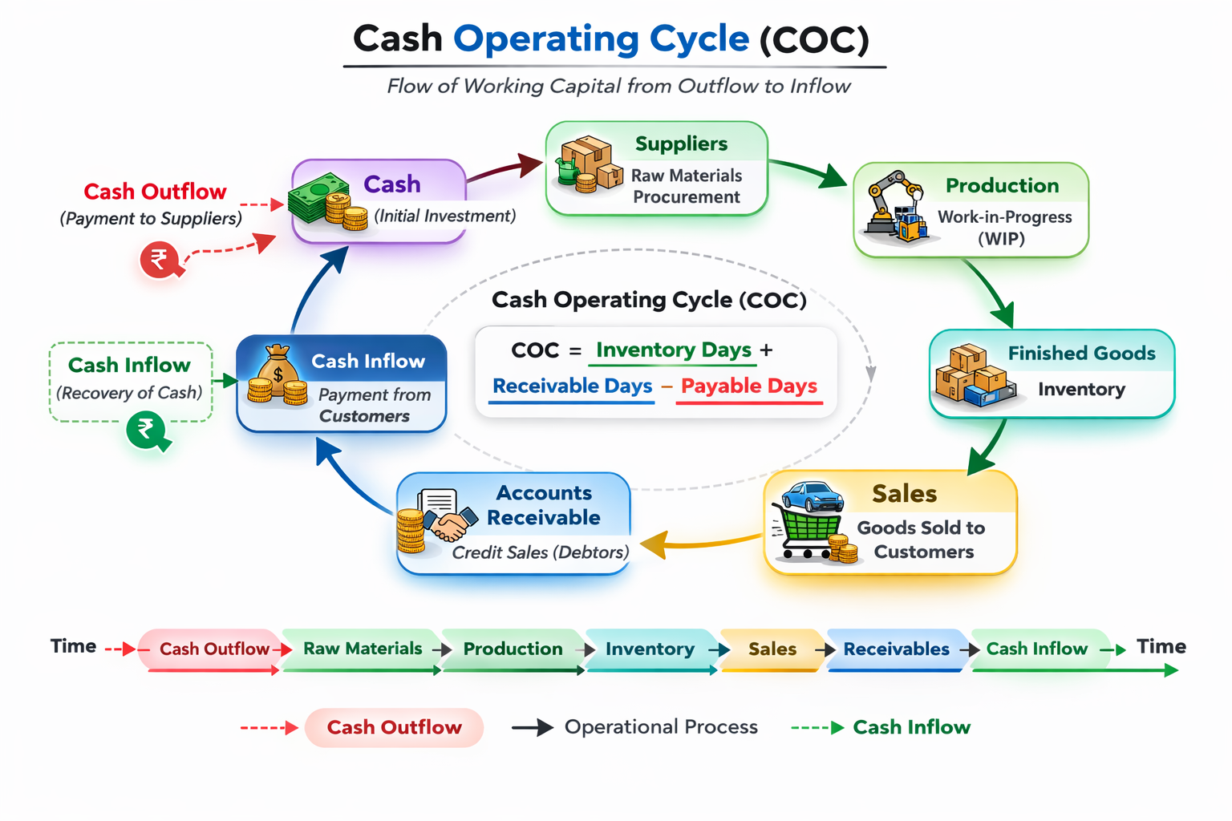 Figure 4: Cash Operating Cycle (adapted from external source)

Toyota Motor Corporation uses effective working capital management to support its ability to fund its ongoing transition from a capital-intensive fleet of traditional vehicles to a growing fleet of electric vehicles (EVs) while continuing to maintain operational effectiveness (Bhattacheryay, 2023). In addition, the cash operating cycle (COC) provides an invaluable measure of the time between a company’s cash outflow at production and the cash inflow from their customers as well as insight into the efficiency of a company’s liquidity (Yousaf, 2022). Toyota’s collection period for accounts receivable from customers has remained consistent over the past five years between 29 and 32 days, reflecting successful credit management, strong dealer financing, and a high level of consumer demand for their products thereby providing reduced uncertainty regarding short-term liquidity. Toyota’s inventory turnover ratio improved from 8.1 times in FY21 to 9.5 times in FY25 enabling more synchronised production of vehicles with sales through the Just-in-Time system. By extending payment terms to suppliers, Toyota continues to reduce the length of its COC further enabling Toyota to operate with very little working capital (Tolegen, 2022).
Yet, the transition to Electric Vehicles (EVs) is challenging the traditional cash cycle. In terms of lengthening cash conversion cycles through: (1) the requirement to manufacture batteries that require large quantities of raw materials for stockpiling (potentially increasing working capital through inventory intensity and prepayment), (2) increased length of the operating cycle due to longer-term purchasing agreements for lithium, cobalt and nickel, as well as the length in the supply chains for EV component parts, and (3) increased costs associated with the need for vertically integrated battery manufacturing, resulting in increased capital investment and working capital demands(Yousaf, 2022).Therefore, the impact of the EV transition on Toyota's historically strong cash cycle will likely create systemic pressures for elongation of cash cycles and increased dependence on both short and long-term sources of liquidity(Tolegen, 2022).

2.2 Recommend Strategies to Improve Liquidity Through Working Capital Reforms
To continue to have strong liquidity, and support capital expansion, Toyota must implement specific working capital reform strategies (focus on improving or optimising inventory management and reduction of working capital (i.e., receivables and payables) that improve liquidity).
- Inventory Management Reformation Initiatives
With the planned growth of battery manufacturing, there is a risk of Toyota accumulating inventory of battery components and semiconductor supplies (Huang, 2023). Using AI-enabled forecasting tools and predictive inventory analytics would allow Toyota to manage inventory levels more efficiently and effectively across its global production network with the reduced need for buffer inventory, thus preserving working capital utilisation of its capital opportunities. Also, expanding sophisticated vendor renting inventory (Supplier Managed Inventory—SMI) to support the increase in EV batteries would allow Toyota to achieve efficiency gains from having the vendor owning by transferring the ownership of inventories before purchasing (redesigning storage locations to reduce the affordability of locations) (Madhavaram et al., 2024).
Developing strategic alliances (e.g., long-term purchasing contracts) with EV battery suppliers would also provide additional opportunity for improving working capital efficiency by allowing a mechanism for owning consignment inventory.
- Enhanced Accounts Receivables Management
While Toyota’s account receivables management already has good efficiencies, there are still opportunities for improvement due to new technology and processes, such as: Dynamic Discounting, Digital Invoicing Platforms and Blockchain-Facilitated Settlement Systems (Balcıoğlu, Çelik and Altındağ, 2024). These improvements will provide shorter payment cycles, increased levels of dispute resolution and greater levels of visibility within the payment process. With the rapid emergence of EV (Electric Vehicle) markets worldwide and allowing for all of these tools; partnering with dealers to offer Embedded Financing Solutions and Dealer-Secured Securitization Structures will help provide stability to cash flow while providing some level of credit risk mitigation (Fraga-Lamas and Fernández-Caramés, 2019).
- Payables Optimisation and Strategic Financing
To improve cash flow for Toyota and the supply chain, Toyota should seek to extend payment terms with suppliers, while still maintaining an ethical purchasing policy. Implementing Supply Chain Financing (SCF) Programs with global lenders would allow suppliers to receive early cash payments at a discount, while giving Toyota greater time to settle with suppliers (Iminov, 2025). Such an arrangement will help provide suppliers with liquidity needs and, at the same time, increase Toyota’s liquidity.
- Centralising Treasury Operations and Cash Pooling Opportunities
Centralising treasury operations globally and creating multi-currency cash pooling globally will create opportunities for Toyota to optimise global surplus liquidity in multiple geographies around the world, thereby decreasing the number of idle cash balances and minimising working capital short-term borrowings (Balcıoğlu, Çelik and Altındağ, 2024).
By improving accounts receivable management, as well as payables management, treasury operations, and cash pooling, Toyota is estimated to free up approximately 500 to 700 billion yen of working capital that could be reallocated to new strategic investments related to Electric Vehicles.

2.3 Strategically Evaluating Short Term vs. Long Term Funding Alternatives
Flexible short-term financing methods (commercial paper, revolving credit facilities, trade credit, supply chain financing) provide quick access to liquidity and initially low cost of capital. They are also effective means for managing working capital fluctuations that occur over a relatively short time (Madhavaram et al., 2024). The excessive reliance on short-term funding increases the potential for Toyota's exposure to refinancing risk, interest rate fluctuations, and possible liquidity problems in a tightening monetary environment. Additionally, the capital-intensive and long-term element of EV investments means that short-term financing is not structurally suitable to finance long-lived assets.
Long-term financing sources (corporate bonds, green bonds, sustainability-linked loans, strategic equity partners) provide funding stability, lower refinancing risk, and match with long-term investments. While long-term financing sources tend to carry higher issuance costs and fixed obligations, the combined use of short-term liquidity management tools and long-term sustainable financial products as part of a balanced and hybrid strategy can provide the company with greater financial flexibility, lower borrowing costs, and more resilient capital structure than if it were reliant on only using one method.

3. Strategic Financial Restructuring Plan

3.1 Financial Restructuring Options
Toyota Motor Corporation has entered a new phase in restructuring as it invests in large-scale battery electric vehicle (BEV) development, modular platform redesign, and regional supply chain restructuring. Recent financial analysis shows Toyota's strong profitability and solid liquidity position, however, with increasing investment in electrification and ongoing margin volatility, a forward-thinking approach to restructuring will be needed to protect its long-term financial survivability (Gaccione, 2024; Toyota, 2025).
Toyota should pursue a selective divestment programme that includes selling mature internal combustion engine (ICE) assets and regional operations where returns on invested capital have declined. By divesting capital-intensive, low-growth facilities, Toyota would free up liquidity, reduce depreciation expense, and release capital for investment in scalable EV architectures and advanced battery technologies (Hashem, 2024). This approach would also improve capital efficiency across the enterprise from the perspective of portfolio optimisation and improve overall asset productivity.
At the same time, Toyota must accelerate its use of strategic joint ventures to support battery cell production, semiconductor procurement and future forms of energy storage. Joint ventures mitigate technological risk and lower initial capital investments compared to complete acquisitions, as well as giving companies flexibility in exiting rapidly transforming areas of innovation. This way of working becomes critical in the expansion of gigafactories because of the large, fixed costs and technological uncertainty of this type of expansion means that shared investment structures must be in place to reduce financial risks (Anokhin, Hess and Wincent, 2025).
Structures that support joint venture arrangements may include sustainability-linked financing instruments such as green bonds and transition bonds. These instruments connect the capital raised through decarbonisation and potential access to capital from ESG focused investors may result in lower WACC. Nevertheless, issuing equity directly should be treated carefully to ensure that earnings are not diluted and to avoid negative market signals (Rutkowski, 2024). The refinancing long-term debt with fixed rate maturities thereby limiting exposure to interest rate fluctuations and stabilising the availability of funding during times of peak capital investment.

3.2 Impact on Shareholder Value, Debt Structure and Operational Flexibility

3.2.1 Impact on Shareholder value
The proposed restructuring framework is designed to enhance long-term shareholder value through disciplined reallocation of capital to an optimal portfolio. Low-return asset divestitures will provide improved returns on invested capital and asset turnover ratios (Morin, 2024). This will improve overall valuation metrics and demonstrate to investors that the company is focused strategically. When proceeds from divesting assets are reinvested into scalable BEV platforms that have credible forecasts of profitability
The net present value of the company's expected future cash flows will be greater than before, which supports sustainable earnings growth. The joint venture arrangements that include risk-sharing arrangements will share the research, development and production risks with others involved with that project, thereby reducing the volatility in earnings from those activities (Akinsola, Taofeek and Kingsley Onu, 2025). The stabilisation of cash flows through this arrangement will lead to an improvement in the sustainability of dividends for shareholders and a strengthening of investor confidence in the company's long-term growth potential.

3.2.2 Impact on Debt Structure
Through a combination of moderate refinancing and the issuance of either sustainability-linked or green bonds, the leverage ratios can be optimally leveraged without having a significant impact on the company’s overall gearing ratio. Therefore, it is imperative that should be maintained an investment-grade credit rating to continue obtaining low-interest rate loans and maintaining adequate levels of interest coverage. By extending the maturity of the debt it will enhance our liquidity plans during times of high capital expenditure and reduce the risk of refinancing, thus creating a potential positive effect on liquidity (Habibie, 2025).

3.2.3 Impact on Operational Flexibility
Divestitures from outdated internal combustion engine (ICE) Assets will provide operational flexibility; hence, removing a lot of fixed cost rigidity and some of the organization's overall complexity. Strategic alliances and regional production partnerships will allow for increased geographic diversification, reducing risk of disruption due to trade problems. Stable long-term financing will also allow for continued funding of R&D efforts without compromising working capital capacity, thereby enabling continued strategic agility (Potharla, 2025).

3.3 Ethical and International Considerations
As a result of Toyota's size, they should take into consideration international financial exposures and ethical governance standards when restructuring. To reduce both regulatory and reputational risk, tax strategies that are used to optimise taxes should comply with the OECD anti-base erosion guidelines and the host country’s tax regulations (Iqbal, Khan and Khan, 2025). To retain investor confidence and institutional credibility in the global marketplace, transparent reporting and responsible transfer pricing practices are essential.
Structural currency exposure comprises a material risk, i.e. the fluctuation based on the Japanese Yen, US Dollar and Euros. Because of the volatility of exchange rates, they will affect the consolidated earnings and export competitiveness of firms in these three currencies. By utilising natural hedging through production localisation and using various financial hedging instruments, firms will reduce the levels of translation and transaction risk (Eyinade, Ezeilo and Ogundeji, 2022). Persistent inflation in key inputs such as lithium and nickel will also require long-term supply contracts and cost indexation mechanisms to ensure the operating margins of firms (Reynolds, 2024).
Corporate social responsibility commitments and environmental sustainability goals must be aligned in the organization's restructuring efforts. Electrification has increased reliance on rare earth materials and raised concerns about the ecological impact of rare earth mining, as well as labour practices in the areas where these raw materials are extracted (Saratian, Akbar and Mukhtar, 2025). Therefore, responsible sourcing, supply chain transparency, and investment in battery recycling resources are all important to protecting brand reputation. In addition, the transition of employees due to automation or divestiture requires retraining and redeployment programs as part of a socially responsible approach to restructuring. As a result, any business strategy must consider the need for a financially viable business plan while balancing profit, stakeholder well-being, and environmental stewardship to ensure that the long-term creation of value from these resources is both financially sustainable and morally defensible (MacKenzie and McLachlan, 2023).

4. Investment Appraisal and Capital Budgeting
This section will complete an analysis of three suggested investment projects using the Payback Period (PBP), Accounting Rate of Return (ARR), Net Present Value (NPV) Profitability Index (PI), and Internal Rate of Return (IRR) methods of evaluation. Each project has a requirement for an initial outlay of £50 million and cash inflow over a 5-year period. The discount rate will be set at 10%, as that is the company-required rate of return, assuming a straight-line depreciation method will be used resulting in £10 million annual depreciation to £0.00 over a 10-year period.
The calculations associated with this activity will be provided in Appendix 1 (Excel Outputs).

4.1 Payback Period (PBP)
The Payback Period (PP) provides insights into how much time it will take to get back our initial investment from net cash flow (Cotter, 2023). To further elaborate, the project A produces sufficient cash flow from net cash flow of £50 million in about 4.5 years due to the size of its large and stable cash inflow expectations each year. Similarly, project B takes about 4.55 years to produce sufficient net cash flow to recover its initial investment of £50 million. The difference is that project B's cash inflows are predictable and moderate on an annual basis.
On the other hand, project C has a significantly shorter payback period than project A and project B is only 3.6 years, therefore, from a liquidity perspective, project C is the best fit since it minimizes long-term uncertainty by having faster capital return and better flexibility of cash flow. Additionally, due to the amount of capital companies in the automotive sector typically commit to electric vehicle technology and innovation, shorter payback periods allow for less financial pressure and more opportunities for companies to reinvest in the future.

4.2 Accounting Rate of Return (ARR)
Accounting Profit: ARR uses accounting profit to evaluate profit rather than cash flow profit (Feenstra and Wang, 2000).
ARR: Project A's ARR = 1.60; Project B's ARR = 2.00; Project C's ARR = 6.00.
Project C has better accounting profit compared to Project A and Project B.
ARR method: Although ARR is not as theoretically sound as discounting cash flow, it does help evaluate the effect of a project on reported earnings.
Higher accounting returns = increase in return on assets (ROA) = increase in stakeholder confidence in the company.

4.3 Net present value (NPV)
When it comes to valuing projects, the NPV valuation is the best way because it takes time into account, and it genuinely measures how much value shareholders get when investing in a project (Damodaran, 2012). Using a 10% discount rate, Project A has an NPV of -£8.69m, Project B has an NPV of -£8.31m and Project C has an NPV of -£1.98m. While all three projects have slightly negative NPVs at a 10% hurdle rate, Project C has the closest to breaking even and therefore creates the least amount of value destruction. In cases where management is making a capital decision about a project with a marginally negative NPV but strategic benefits out of the project exceed the cost of the investment, management may choose to go forward with that project, particularly in high-tech industries where competitive positioning is very important.

4.4 Profitability Index (PI)
Based on the Profitability Index (PI) calculation, Project C demonstrated a strong comparative advantage over Projects A and B with a PI of 0.96, compared to their 0.83 PIs. All three projects fell short of achieving the required rate of return (10%) because all had a PI below 1.0. However, Project C had the highest PI and was closer to achieving the required rate of return than the other projects.
The PI methodology can be used to rank or prioritise projects under conditions where there is limited available capital, as it provides a measure of value created per unit of currency invested rather than simply the total dollar value returns from the project. Therefore, management should use this ratio to identify which projects will produce the highest return on each unit of capital invested. In this instance, Project C produces a present value of £0.96 for every £1 that is invested compared to each of the other two projects, which produced only £0.83 for every £1 invested. As a result, the allocation of capital to Project C is the most effective utilisation of scarce capital resources. Even though each of the projects has a PI less than 1.0, Project C's PI clearly exceeds the PIs of the other two projects and supports a decision to select it as the highest preference project under limited financial resources.

4.5 Internal Rate of Return (IRR)
The Internal Rate of Return (IRR) is the rate at which the Net Present Value (NPV) of a project is zero. Project A will provide with an estimated IRR of approximately 6.60%, Project B will provide with an estimated IRR of 7.90% and Project C will provide with an estimated IRR of 8.60%. All three projects have an IRR less than the cost of capital (10%). However, Project C has been shown to have the greatest relative performance. The ranking of the requirement of a project for NPV, PI, IRR, ARR, and PBP provides a level of confidence to the decision. All methods used to measure project performance, outperformed in Project C.

4.6 Project Recommendation
Project C is recommended as the best independent investment based on financial criteria. It has the shortest payback period, highest accounting return, best IRR, greatest profitability index, and lowest negative NPV. The fact that multiple methods have demonstrated consistent performance increases confidence in making the decision.
From a profitability perspective, Project C will increase earnings potential through stronger mid-term cash inflow. Because of the higher ARR, it should lead to an increase in reported profitability and possibly support multiple valuations for investors. In terms of liquidity, a payback period of 3.60 years reduces the risk of being locked into capital and provides the flexibility to be financially nimble. A faster recovery period will allow the company to reinvest in R&D, battery technology, or digital transformation initiatives.
Non-financial risks should also be considered. Political risk in terms of global supply chain, trade tariffs, and battery sourcing could impact long-term return potential. However, Project C's accelerated cash generation will reduce exposure to uncertainty during long-term investment horizons. Customer loyalty is also an important consideration. In that case, Project C represent investments in next-generation electric vehicles or advanced hybrid platforms, it could help to enhance the strength of the company's brand and create long-term market share. Strategic alignment with sustainability trends and decarbonisation objectives also increases reputational capital and overall ESG performance.
While the NPV is slightly negative at 10%, the sensitivity study included in the Appendix shows that small changes in the discount rate have an impact on project viability. Therefore, if the company's weighted average cost of capital is marginally less than 10%, Project C could provide an acceptable rate of return. Strategic value combined with near-breakeven NPV support the recommendation to continue with the project.

4.7 Capital Rationing Decision (£100 Million Constraint)
Due to capital rationing, only two projects can be selected given an investment limit of £100 million. These are the total NPVs for each of the potential project pairings:
Project A + Project B: -£17.00 million
Project A + Project C: -£10.67 million
Project B + Project C: -£10.29 million
The optimal project combination is Project B and Project C because this combination will produce the least negative total NPV. Additionally, Project C's strong growth profile coupled with Project B's stable and predictable cash flows creates a balanced portfolio.
Project B will generate steady returns each year and will reduce the overall volatility of these returns and improve upon the company's earnings stability; therefore, the company's ability to sustain dividends and maintain its credit rating is further supported by this project. Project C is expected to generate significant growth opportunities and allow for quicker capital recovery than Project B. This will help to diversify the types of risk over different types of cash flow structures.
From a financial resilience perspective, this combination will be beneficial for liquidity planning and reduce the need for the company to rely on any one risk profile. From a strategic perspective, this combination will allow the company to pursue innovation while still operating in a stable manner.

Conclusion
Project C has been identified through the investment appraisal analysis as the best option for investment out of all three choices due to its strong performance with the Payback Period, ARR, IRR, NPV and Profitability Index metrics and for limiting value erosion when discounted at 10%. While all three projects have negative NPVs, Project C has the greatest capital efficiency of designed funds and carries the quickest period to recover. When considering the £100 million capital constraint, the optimal portfolio of projects consists of Projects B & C, which has the ideal combination of strong growth with stable cash flow. In totality, both quantitative evidence and broader strategic evidence give support for the recommendation of this approach.

References
Akinsola, O.K., Taofeek, A. and Kingsley Onu, D.Y.O., 2025. Legal Challenges and Best Practices for Structuring Corporate Partnerships, Joint Ventures, and Strategic Alliances.
Anokhin, S.A., Hess, M. and Wincent, J., 2025. Technology sourcing ambidexterity in corporate venture capital: limitations of learning from open innovation. Small Business Economics, 64(1), pp.239-258.
Babo, F.S., Wiagustini, N.L.P. and Ximenes, M., 2024. FINANCIAL REPORT ANALYSIS IN ASSESSING THE FINANCIAL PERFORMANCE OF AUTO TOYOTA TIMOR LESTE COMPANY. TIMOR LOROSA'E JOURNAL OF BUSINESS AND INNOVATION (TORBIN), 1(01), pp.129-143.
Balcıoğlu, Y.S., Çelik, A.A. and Altındağ, E., 2024. Integrating blockchain technology in supply chain management: a bibliometric analysis of theme extraction via text mining. Sustainability, 16(22), p.10032.
Bhattacheryay, S., 2023. Multinational working capital management a study on Toyota Motor Corporation. International Journal of Finance & Economics, 28(1), pp.236-256.
Cotter, E., 2023. Net Present Value and Payback Period: An Analysis.
Damodaran, A., 2012. Investment valuation: Tools and techniques for determining the value of any asset. John Wiley & Sons.
Eyinade, W., Ezeilo, O.J. and Ogundeji, I.A., 2022. A framework for managing currency risk and exchange rate exposure in international energy investment portfolios. International Journal of Scientific Research in Civil Engineering, 6(6), pp.218-230.
Feenstra, D.W. and Wang, H., 2000. Economic and accounting rates of return.
Fraga-Lamas, P. and Fernández-Caramés, T.M., 2019. A review on blockchain technologies for an advanced and cyber-resilient automotive industry. IEEE access, 7, pp.17578-17598.
Gaccione, V., 2024. Driving Change: a comprehensive analysis of technological, strategical and economical shifts in the Automotive Industry.
Guo, Y., 2025. How to Analyze and Optimize Corporate Financial Strategy through Financial Modeling. International Journal of Social Sciences and Economic Management (2025), 6(2), pp.171-177.
Habibie, M.A., 2025. The Green Tie: Assessing the Influence of Financial Innovation via Sustainability-Linked Loans Towards Business Transitions (Doctoral dissertation).
Hashem, F., 2024. The Impact Of The 2035 Internal Combustion Engine Ban On Strategic Adaptation And (Doctoral dissertation, NOVA–School of Business and Economics).
Head, K., Ondracek, J., Saeed, M., Peterson, K. and Bertsch, A., 2023. Toyota Motor Corporation: Managing Corporate Resources Through Strategic Perspectives. Splint International Journal of Professionals, 10(1), pp.1-24.
Huang, C., 2023. Optimizing the performance of operations-finance interface by implementing supply chain finance schemes.
Iminov, M., 2025, October. Contemporary financial management principles for augmenting the financial capacity of automotive industry enterprises. In International Conference on Health & Technology (Vol. 1, No. 1, pp. 18-22).
Iqbal, N., Khan, N. and Khan, L., 2025. The impact of global tax reforms on multinational corporations: A study of base erosion and profit shifting (BEPS). The Critical Review of Social Sciences Studies, 3(1), pp.3412-3425.
Kawai, T., 2022. Evaluation of Toyota’s Strategy for Electric Vehicles in Counteracting Platformers—Based on the Theories of Dynamic Managerial Capabilities and Dynamic Platform Strategy—. Journal of Strategic Management Studies, 14(1), pp.67-87.
MacKenzie, R. and McLachlan, C.J., 2023. Restructuring, redeployment and job churning within internal labour markets. Work, Employment and Society, 37(6), pp.1480-1496.
Madhavaram, C.R., Sunkara, J.R., Kuraku, C., Galla, E.P. and Gollangi, H.K., 2024. The future of automotive manufacturing: Integrating AI, ML, and Generative AI for next-Gen Automatic Cars. International Multidisciplinary Research Journal Reviews-IMRJR, 1, p.010103.
Micucci, L., 2025. Electric vehicles: Actual market and future prospects, with a focus on battery technology (Doctoral dissertation, Politecnico di Torino).
Morin, S.L., 2024. The financial trap of short-term focus eroding long-term value in financial management: a theoretical analysis. Financial Markets, Institutions and Risks, 8(4), pp.148-162.
Potharla, S., 2025. From Debt to Divestiture: How Indian and Global Firms Reshaped through Corporate Restructuring. Available at SSRN 5348941.
Reynolds, S., 2024. Exploring supply chain resilience strategies in the face of price inflation in renewable energy markets.
Royal, I., 2025. Adapting to the Hybrid-Electric Shift–Recommendations for Automakers & Automotive Retailers (Doctoral dissertation, Worcester Polytechnic Institute).
Rutkovska, H., 2024. Sustainability-linked bonds in three EU Eastern Partnership countries: challenges and opportunities from the investors’ perspective.
Saratian, E.T.P., Akbar, T. and Mukhtar, S., 2025. Restructuring for Sustainability: How Organizational Culture Drives Green Strategic Initiatives. Jurnal Informatika Ekonomi Bisnis, pp.221-225.
Tang, J., Wang, Y. and Zhao, C., 2022, December. The Impact of COVID-19 on Toyota Group Automotive Division and Countermeasures. In 2022 International Conference on Economics, Smart Finance and Contemporary Trade (ESFCT 2022) (pp. 1260-1267). Atlantis Press.
Tolegen, T., 2022. Cost Analysis: Toyota, the Kaizen Vehicles. Available at SSRN 4195995.
TOYOTA MOTOR CORPORATION, 2026. SEC Filings. [Online]. Available at: https://global.toyota/en/ir/library/sec/?padid=ag478 [Accessed on: 18th February, 2026].
Toyota, 2025. Annual Financial Report [Online] Available at: https://www.toyota-industries.com/investors/item/2025_annual_financial_report_E.pdf [Accessed Date: 18th Feb, 2026]
Yousaf, M., 2022. Working capital management efficiency: a study of certified firms from the EFQM excellence model. Financial Internet Quarterly, 18(3), pp.21-34.

Appendix 1
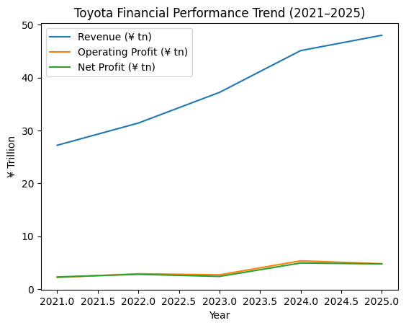
Appendix 2: Investment appraisal calculations
Payback Period (PBP)
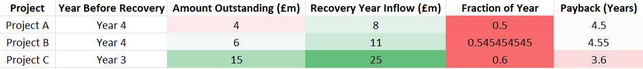

Accounting Rate of Return (ARR)
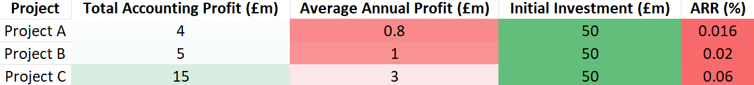
Net Present Value (NPV)
(Discount Factors (10%))
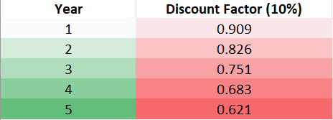
Present Value of Cash Inflows
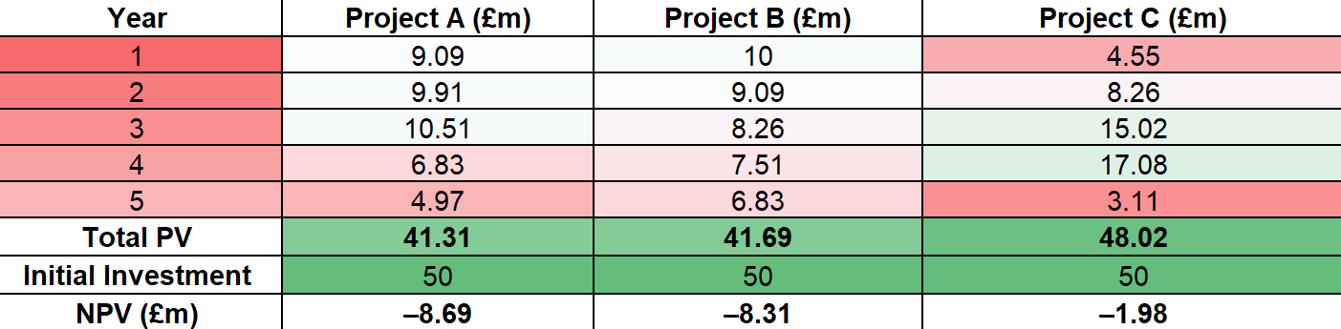
Profitability Index (PI)
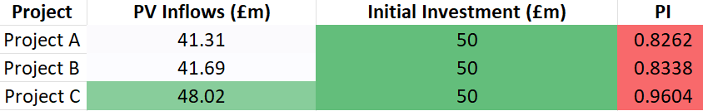
Internal Rate of Return (IRR)
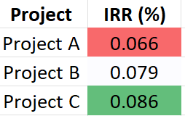
(All IRRs are below the 10% cost of capital.)

Capital Rationing (Maximum £100m)
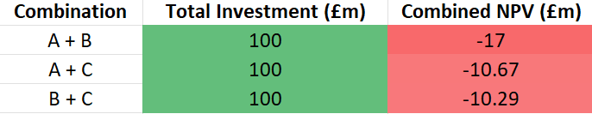
Optimal Combination
Project B + Project C (least negative NPV)
Rank | Project | Reason
1 | Project C | Highest NPV, IRR, ARR and shortest payback
2 | Project B | Stable returns, second-best IRR
3 | Project A | Lowest overall performance

