BUSINESS SKILLS FOR INTERNATIONAL INDUSTRY

MODLE CODE: M4X01917
STUDENT NAME: ELENA BOGDAN
STUDENT NUMBER: 1814439
LECTURER NAME: DALE CLARKE

Introduction:

SWOT:
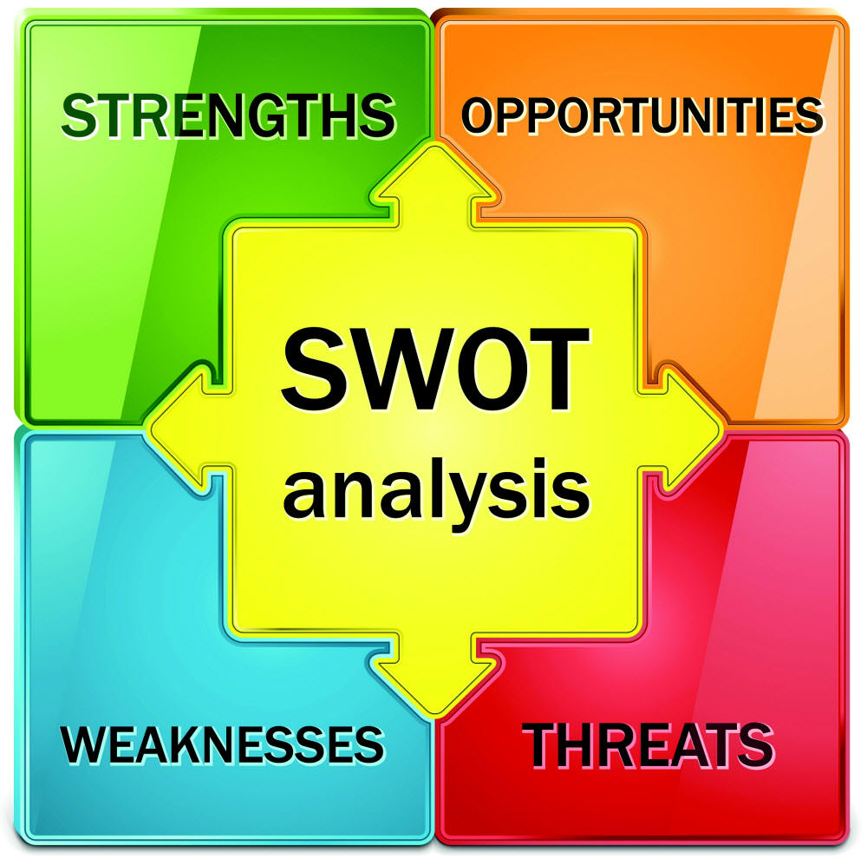
SWOT Analysis is a useful technique for understanding your Strengths and Weaknesses, and for identifying both the Opportunities open to you and the Threats you face.
In this report, SWOT and PDP frameworks will be used to analyze my current academic and employability skills. Having conducted the analysis, I will then provide some suggestions for my about the skills that I need to develop in the future. SWOT – stands for strengths, weaknesses, Opportunities and threats while PDP is defined as Personal Development Planning which can enable students like me to think about career development, plan for the future, as well as focusing on my academic and career development.
My background:
I am a mature student, wife and a mother who was born and raised in Romania. Therefore, English is not my first language. I have decided to study to improve my language skills and career prospect in the future. My learning is slow, but I can understand and apply different skills based on my experience. I am now pursuing my studies developing Business Skills for the International Hotel industry. This is a career path for me.
Strengths: 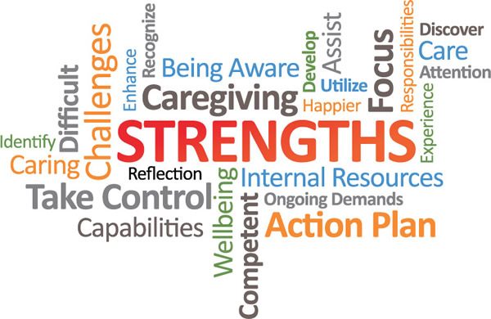
My main strengths we it comes to academic is that, I am good at listening and always I keep the focus on important matters. I am analytical and a good thinker. I have more experience than most students in my class because I have lived and worked in different countries including Romania and Italy. This experience is very important. Also, I enjoy reading and following instructions, therefore, I don’t like making mistakes.

Weaknesses: 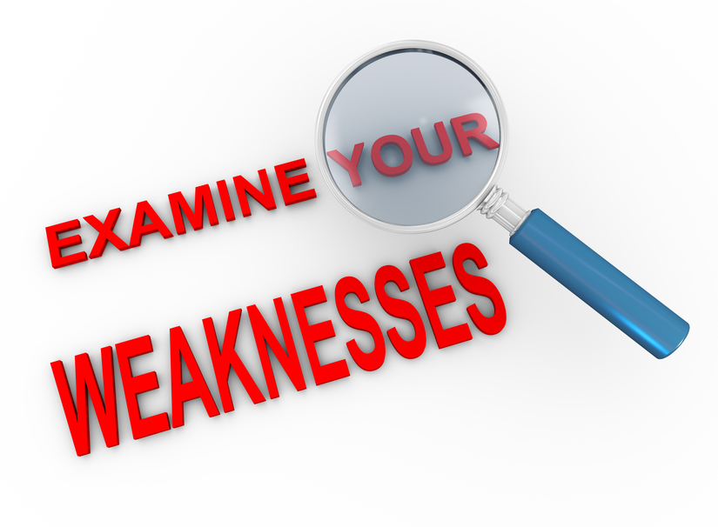
I believe that every person in the world has got weaknesses. I have weaknesses in not understanding some of the English words. Most of the time I waste a lot of time looking at the dictionary. Writing one assignment can take too long, because I have to use the dictionary to check for grammar and anything that does not translate well or has no good meaning. Because of my age, I did not learn much and I can struggle with the teaching style in the United Kingdom.

Opportunities: 
Through our University there are so many opportunities for me to learn and get away from the weaknesses that I mention above. I want to use the extra English support that we have been given for free. Also, I am very shy but now I will be confident to go to the teacher and ask question. In Romania, we do not ask questions because we think the teacher will know everything. In the UK, the teacher invites you to talk to them and encourage you to ask them questions if you want. Now I will use the opportunity to ask questions. Also the library has a number of books for me to improve my skills.
Threats: 
These are issues that are affecting my good development. First, I am scared of Brexit and my future in England. I come to University but I don’t know if it will close one day and we have to go back home. The fear of failing any examination or assignment at this age is real. Sometimes when I go back home, I look at my children and there is that fear that if I fail I will be setting a bad example to them. But, I am keen on working on developing myself to a good level. I am optimistic that this fear will go away as I keep advancing and developing through my degree.

My Personal Development Planning (PDP)
MY SMART Goals Analysis:

Specific
- I would like to attend English extra English classes
- I would like to attend assignment writing workshops

Measurable:
- Increase my academic performance
- Increasing the number of hours, I spend on reading and personal development. May be set time aside for independent reading.
Achievable
- Improve my reading and writing skills
- Grades
Realistic
- Personal development and securing a good job in Hotel Industry

Timed
- Obtained a good job in the Hotel Industry by the end of 2019.
- Be able to speak fluent English with 6 months.

Personal Development Plan

I want to acquire/ develop the following skills/ personal attributes: | To do so , I am going to: | Target dates (when I intend to do this by):
- Assignment writing skills  - Improve my English | - I am going to approach the Academic writing people at the University  - I will approach the English and Academic support people | Within 2 weeks by 28th February 2019  - This week 12th February 2019

Obstacles:
Obstacles that I anticipate to carrying out my plan: | How might I overcome these obstacles: | What help/advice might I need in carrying out my plan
- Shyness and Fear or Lack of confidence  - Lack of time | I will express myself to the teachers and learn to be open to them and tell them how I feel about my own confidence  I need to learn more about time management and how to save time.  Learn how to combine family, work and studies | I need to speak to other students to find out about their experience of dealing with fear and lack of confidence.  I will follow their example.  I need to attend more CPD or skills development sessions at the University. I will find out from my tutors.

Time of Review:
When will I review my progress? | Progress made in carrying out my plan: | Obstacles that have arisen
On monthly basis

In general my development plan will include; improving my English skills so that in future I will be able to find a better job in the hotel industry. Also a good English will help with my assignment at the University. I want to improve my assignment writing skills in English. From this SWOT and the plan, I can see that I have some weaknesses.

In future, I need more CPD sessions in the following:
- Interview skills and Job application
- Time Management skills
- Customer services in the Hotel Industry
- How to think with CRITICAL THINKING
These courses and support I believe they are available through our University and therefore I will not have any problems to improve myself. Personally, I want continue to learn how to work with others and learn from them. I continue to listen to my teachers.

References
- Mindtools.com. (2019). Analysis SWOT – Discover and learn New Opportunities, Manage and Eliminate Threats. [online] Available at: https://www.mindtools.com/pages/article/newTMC_05.htm [Accessed 21 Feb. 2019].
- Cottrell (2010).Skills for success and for achievement the goals Basingstoke,uk.Palagrave Macmillan
- R, N. and G, R. (2011). Develop your marketing skills. London,United Kingdom: Kogan Page 16.
- Thomas, M. (2003). High-performance consulting skills. London: Thorogood, pp.20-78.

