

University of Wales Trinity Saint David
School of Engineering
BEng Mechanical Manufacturing
Daran Griffiths
1909143
Project M5X02064

Abstract

This assignment is a brief research into the origins of FEA and FEM and the basic principles of FEA and FEM techniques, the use of motion study and their applications, also showing a typical example of FEA used with in the medical device sector. This assignment also shows the steps of generation of a gear box assembly and motion analysis on the gearbox , plotting the movement changing from 1st gear to 2nd gear.

Table of Contents
Abstract 2
Table of Figures 4
Introduction 5
What is FEA? 5
Finite Element Method, FEM 7
Example of FEA in a medical device implant. 8
Method. 8
Results 10
Assembly Method 13
Motion Analysis and Summary 14
Bibliography 16

Table of Figures
Figure 1-Example of FEA output- Stresses on piston Rod 6
Figure 2-ZimmerBiomet- Risk Matrix 8
Figure 3-Diagram of loading condition applied to Sirius Femoral stem. 9
Figure 4- Diagram of loading conditions applied to a Taper-loc Femoral Stem 10
Figure 5-Simulation of Sirius stem 11
Figure 6- Simulation of Taper-loc stem 12
Figure 7- Gear box centres 13
Figure 8- Bench Top Frame Assembly 13
Figure 9-Gearbox and bench top frame 14

Introduction

What is FEA?

Depending on one’s perspective, FEA can be said to have its origin in the work of Euler, as early as the 16th century. However, the earliest mathematical papers on Finite Element Analysis can be found in the works of Schell Bach [1851] and Courant [1943].
FEA was independently developed by engineers in different companies and industries to address structural mechanics problems related to aerospace and civil engineering. The development for real life applications started around the mid-1950s as papers by Turner, Clough, Martin and Topp [1956], Argyris [1957] and Babuska and Aziz [1972] show. The books by Zienkiewicz [1971] and Strang and Fix [1973] also laid the foundations for future developments in FEA. (Logan, 1986)
The Finite Element Analysis (FEA) is the simulation of any given physical phenomenon using the numerical technique called Finite Element Method (FEM). Engineers use it to reduce the number of physical prototypes and experiments and enhance components in their design phase to develop better products, faster.
It is necessary to use mathematics to comprehensively understand and quantify any physical phenomena such as structural or fluid behaviour, thermal transport, wave propagation, the growth of biological cells, etc. Most of these processes are described using Partial Differential Equations (PDEs). However, for a computer to solve these PDEs, numerical techniques have been developed over the last few decades and one of the prominent ones, today, is the Finite Element Analysis. (Belytschko, 2007)

It is important to note that finite element analysis only gives an estimated solution of the problem and is a numerical approach to get the real result of these partial differential equations. Simplified, FEA is a numerical method used for the prediction of how a part or assembly behaves under given conditions. It is used as the basis for modern simulation software and helps engineers to find weak spots, areas of tension, etc. in their designs. (Belytschko, 2007)

The results of a simulation based on the FEA method are usually depicted via a colour scale that shows for example the pressure distribution over the object.

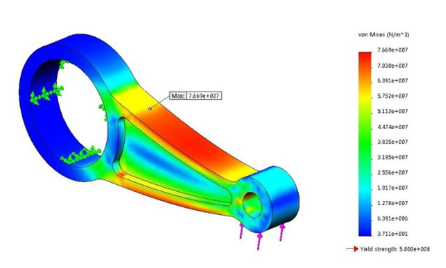

Figure 1-Example of FEA output- Stresses on piston Rod

There are many mechanics and field problems in the domain of engineering technology, such as the analyses of stress-strain field, displacement field, temperature field in the heat conduction, flow field in the hydrodynamics, electromagnetic field in the electromagnetism, etc., which can be considered as the problems to solve the basic differential equations with a certain boundary conditions. Although the basic equations and boundary conditions have been established, very few simple questions can be solved to obtain the analytical solution. (White, 2019)

At present, numerical solution methods in engineering practical applications commonly include the limited element method, finite difference method, the boundary element method, weighted residual method, etc. With the rapid improvement and widespread application of the computer, the finite element method, a relatively new and very effective numerical method, has gradually been used to solve the complex engineering problems. (Xianfang YUE, 2010)

Finite Element Method, FEM

Finite Element Method (FEM) is a combined product of many disciplines, including mechanics, mathematical physics, computational methods, computer technology, and so on. The three research methods, theoretical analysis, scientific experiments and scientific computing, have been applied to study the nature problems. Because of the limitations of scientific theory and experiments, the scientific computing becomes one of the most important research tools. As one of ways to carry out the scientific computing, the finite-element method can almost analyze any complex engineering structure so as to obtain various mechanical properties in most engineering fields. (Xianfang YUE, 2010)
The finite element method found its real stimulus in the 1960s and 1970s by the developments of J. H. Argyris with co-workers at the University of Stuttgart, R. W. Clough with co-workers at UC Berkeley, O. C. Zienkiewicz with co-workers Ernest Hinton, Bruce Irons and others at Swansea University, Philippe G. Ciarlet at the University of Paris 6 and Richard Gallagher with co-workers at Cornell University. Further impetus was provided in these years by available open source finite element software programs. NASA sponsored the original version of NASTRAN, and UC Berkeley made the finite element program SAP widely available. In Norway the ship classification society Det Norske Veritas (now DNV GL) developed Sesam in 1969 for use in analysis of ships. A rigorous mathematical basis to the finite element method was provided in 1973 with the publication by Strang and Fix. (Strang, 1973)The method has since been generalized for the numerical modelling of physical systems in a wide variety of engineering disciplines, e.g., electromagnetism, heat transfer, and fluid dynamics. (Olek C Zienkiewicz, 2013)

Example of FEA in a medical device implant.

Example below show the FEA on an Orthopedic stem implant (Taper-loc Femoral Stem), results are then compared against another model stem (Sirius Femoral Stem) to verify maximum stresses on the stem. (ZimmerBiomet , 2019)
In order to determine the stresses that result when the stems are subjected to the maximum loads required as per ISO 7206-6:2013.
Table 2 shows a matrix for determining the model risk level, based in decision consequence and model influence. The model risk the possibility that a computational model and associated results may lead to an incorrect decision on a product that might result in an adverse patient outcome.
Figure 2-ZimmerBiomet- Risk Matrix

Due to the fact that implant failure could lead to medical/surgical intervention outside of planned procedures, the decision consequence was given an assigned level of 4.
There is a physical testing of the predictive device and therefore the model influence was assigned level 3. Combination from table 2 has resulted in the model risk being ‘Medium’

Method.
The stem assemblies were orientated in Siemens NX 12.02.09, in accordance with ISO 7206:6:2013, and the position of the femoral head was recreated using a reference point.
A vertical load of 5,340 N in the negative direction was applied to the reference point, the proximal face of the stem was tied to the reference point by rigid body function.

The stems were constrained 10mm below resection level, i.e. 10mm below the usual level normally cemented.

Figure 3-Diagram of loading condition applied to Sirius Femoral stem.

Figure 4 below shows exact loading condition on a Taperloc femoral stem.
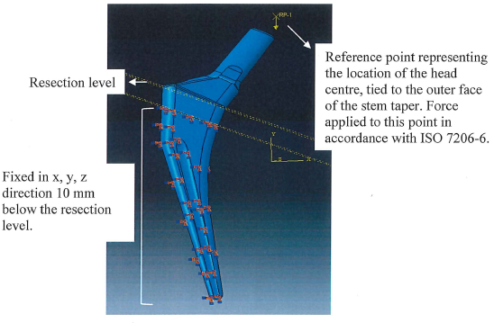
Figure 4- Diagram of loading conditions applied to a Taper-loc Femoral Stem
Results summarized below in table 1 and 2 for the Sirius and Taper-loc stems respectively, including results of the mesh sensitivity study. Mesh condition, an initial tetrahedral mesh of 2mm was selected for the analysis, the element length in the unconstrained region the reduced by half in each step, until the maximum principal stress varied by less than 5% between increments, at which point the model was considered to have converged.

Results

Mesh Size (mm) | Maximum Principal stress (MPA) | Variation (%)
2 | 7055 | n/a
1 | 972 | -86.2
0.5 | 1005 | +3.4
Table 1- Summary of results for Sirius Stem

Mesh Size (mm) | Maximum Principal stress (MPa) | Variation (%)
2 | 603 | n/a
1 | 613 | +1.7
0.5 | 616 | +0.5
Table 2- Summary of results of Taper-loc Stem.
Figure 5 shows the Sirius stem (mesh 0.5mm) where the maximum principal stress (1203 MPa) was found close to the constrained level, however the node considered with the maximum principal stress was on the neck region (1005MPa).

Figure 5-Simulation of Sirius stem
Figure 6 shows the Taper-loc stem (mesh size 0.5mm), where the maximum principal stress (961Mpa) was found close to the constraint level, however the Node considered in the analysis was the node with the maximum principal stress on the neck region (616Mpa), at the base of the neck taper. (red dot)
Figure 6- Simulation of Taper-loc stem
Conclusion
This study indicates that the cemented Taper-loc stem in scope exhibits lower stresses that the Sirius Stem, when loaded under the same conditions.
This small example shows the power of the FEA and FEM method and how useful it is in modern day engineering; without this technology this analysis would never be possible and destructive testing would have to be used.

Assembly Method

For the modelling part of this assignment I went for a cassette style gearbox casing, although I kept the main body as one piece, but conventional cassette gearboxes would be in 2 pieces.
I started by assembling all the gears and input/output shafts, doing this first allowed me to work out the best centers between the shaft, after some trial and error I resulted on centers of 61mm between the shafts, assembling the shifter fork and shifter rod to the assembly would then give me the overall shape of the required B/box housing.
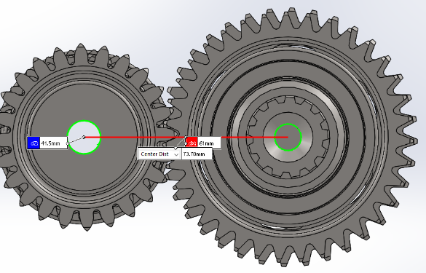

Figure 7- Gear box centres
For the generation of my gearbox housing generated a drawing of the basic shape, I then extruded and shelled the housing to a wall thickness off 6mm, I then generated bearing housings in at the bottom of the G/box housing to hold the bearings. I then added 3 off mounting brackets to allow this to be mounted to the bench top frame I had designed.
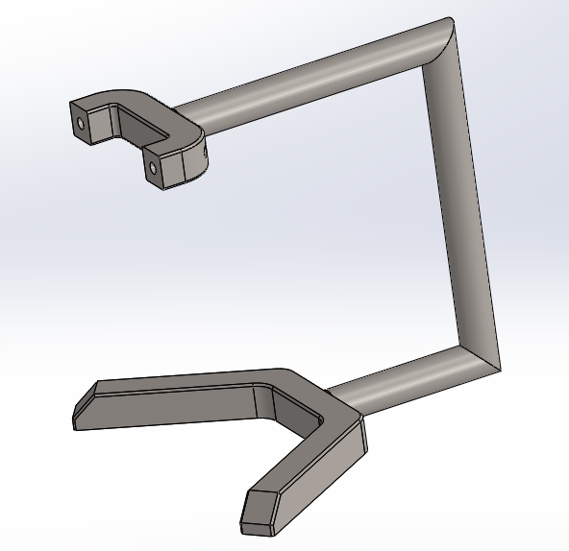

Figure 8- Bench Top Frame Assembly

For the generation of this frame I made up a separate assembly of three separate components, for the main arm I used the sweep feature to produce the form and height requirement to allow the gearbox housing to accurately and with clearance.
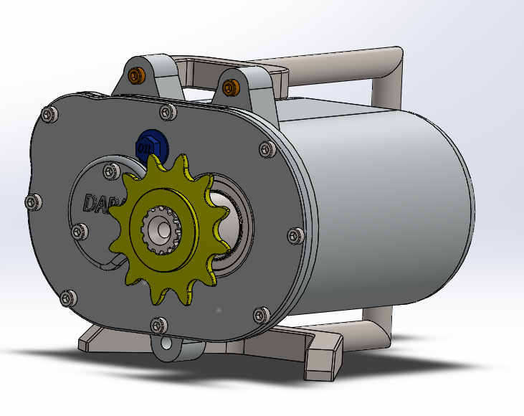
Figure 9 illustration also showing gearbox front plate, sprocket, bearing cover and oil fill plug.

Figure 9-Gearbox and bench top frame
I then preceded to build my assembly using several different standard and mechanical mates , generating and adding all mechanical fixings as required to establish a true representation of a gearbox.

Motion Analysis and Summary

For my motion analysis on the gear box I started off by making several “solid body contacts” between the drive gears and the gear pinions, I then added and a rotary motor driving the primary shaft and a number linear motors driving the shifter from right to left and back to center to simulate the change of 1st to 2nd gear then back to neutral.
I had to make several adjustments to the frame/second to find the correct number to allow the calculation to initialize, I had to remain with the default setting of 25 , for the motion solver I changed over to WSTIFF and reduced the Jacob re-evaluation to the minimum, this did reduce simulation accuracy but due to my PC restrictions it was necessary to allow the calculation to complete.
When I was content with the motion simulation, I reviewed the redundant mates and set about to reduce these to the minimum, I generated rigid groups and the removed the redundant mates.

I then tried to plot on the output shaft velocity during the gear changes form 1st to 2nd, I plotted a velocity over time graph , this plot show the point of contact of primary combined 1st 2nd gear with 1st gear pinion at approx. 2secs (1), this then drives the 1st gear , velocity increasing from 2 secs to 4 secs , you then see linear motor moving the primary combined 1st 2nd from right to left to engage with 2nd gear(slight deceleration (2) pinion to drive the 2nd gear at approx. 5secs (3) , then between 5 and 6secs 2nd gear is driven, you then see the deceleration at approx. 6sec, this is where the linear motor 3 moves the primary combined 1st 2nd gear into neutral position(4) .

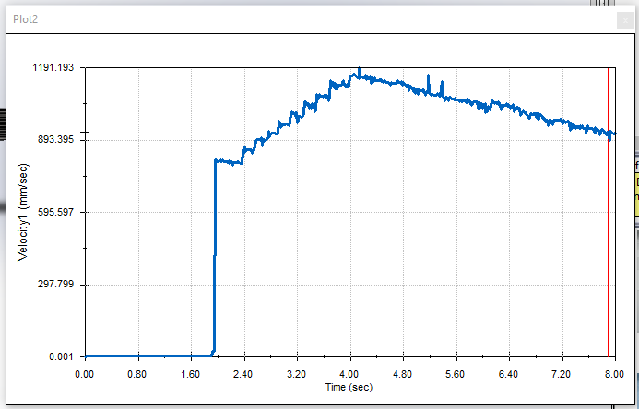
(1)
(4)
(3)
(2)

Bibliography
7206:6, I., 2013. IMPLANTS FOR SURGERY - PARTIAL AND TOTAL HIP JOINT PROSTHESES - PART 6: ENDURANCE PROPERTIES TESTING AND PERFORMANCE REQUIREMENTS OF NECK REGION OF STEMMED FEMORAL COMPONENTS. Brazil: Brazilian Standards.
Baier, M. a., 2014. Computer Aided Analysis of Composites Structural Elements.. Computer Aided Analysis of Composites Structural Elements., Issue 1, p. 7.
Belytschko, J. F. a. T., 2007. www.simscale.com. [Online]
Available at: https://www.simscale.com/docs/content/simwiki/fea/whatisfea.html
[Accessed Sunday May 2020].
Logan, D. L., 1986. A first course in the finite element Methos. Boston: PWS Kent .
Olek C Zienkiewicz, R. L. T. J. Z., 2013. In: 7th, ed. The Finite Element Method: Its Basis and Fundamentals. OXFORD: ELSEIVER.
Strang, G. G., 1973. An Analysis of the Finite Element Method. In: An Analysis of the Finite Element Method. s.l.:Englewood Cliffs, N.J.: Prentice-Hall.
White, D., 2019. DC White Ltd. [Online]
Available at: https://www.dcwhite.co.uk/fea-stress/?gclid=CjwKCAjwh472BRAGEiwAvHVfGutwYQ9SRsWl6YV-r752N-3FjYYcmms01Gwrj-i9tpQvVfDnDoqpOxoC1V8QAvD_BwE
[Accessed SUNDAY MAY 2020].
Xianfang YUE, L. W. R. W. a. F. Z., 2010. Finite element analysis on strains of viscoelastic human skull and duramater. In: D. Moratal, ed. Finite Element Analysis. China: Mechanical Engineering School, University of Science and Technology Beijing, Beijing 100083, pp. 1-44.
ZimmerBiomet , 2019. Comparison of Taperloc Lateralised stem to Sirius for Proximal Fatigue test., Swindon: ZimmerBiomet Healthcare Ltd.

https://uowtsd-my.sharepoint.com/:f:/g/personal/1909143_student_uwtsd_ac_uk/EjOcl11ecd1Jv6G3Qh81S-QBRjGb7iF8nDA3w0NaFbijog?e=rY4zIU

