Tank Cover Redesign Project
Module: Engineering Design Materials
Code: ACHA4001
Name: Tasha Freeman
Student number: 2419263

Table of Contents
1.Introduction 3
2.Key legislation considerations 4
2.1.Health and Safety at Work etc Act 1974 4
2.2.Manual Handling Operations Regulations 1992 4
2.3.Control of Substances Hazardous to Health Regulations (COSHH) 4
3.Specification 5
3.1.Purpose 5
3.2.Functional Requirements 5
3.3.Performance Requirements 5
3.4.Maintenance 5
4.Time plan 6
6.Research 7
7.Design concepts 8
8.Final Design 10
9.Manufacturing Processes 11
10.Justification 12
10.1.Safety Improvements 12
10.2.Design Integrity 12
10.3.Cost-Effectivness 12
11.Conclusion and Further Work 13
References 14

1.Introduction
The client has asked for an alternative design idea for the current tank cover design. The tanks are used for anodisation of aluminium parts for aesthetic and protective purposes. The stainless-steel tanks are filled with a 30% sulphuric acid solution which is heated to 25 °C. The aluminium parts are lifted in and out of the tank using a wire rope mechanism.
When not in use, the tank has a cover made of 5mm stainless steel that is placed over the tank. Due to health and safety concerns, such as the lid being too heavy and requiring two people to lift it, the client is pursuing a redesign. The request for the redesign is for it to be safe to be operated by only one operator, the tank dimensions must remain the same, however modifications may be made. There must also be clearance above the tank in order for the parts to have space to be lowered into it.

2.Key legislation considerations
Legislation is incredibly important within engineering and the workplace. For this particular design change, the key legislation includes;

2.1.Health and Safety at Work etc Act 1974
This is the foundational law that governs workplace safety within the UK. It covers the general duties that employers have regarding both employees and members of public, as well as towards themselves and each other. (GOV.UK, 1974)

2.2.Manual Handling Operations Regulations 1992
This covers the employer’s duty to avoid dangerous manual handling whenever possible, assess and reduce risks of injury when manual handling in unavoidable and provide mechanical aids or redesign tasks to reduce extensive lifting. (GOV.UK, 1992) This is important as the design requires manual handling of the cover.

2.3.Control of Substances Hazardous to Health Regulations (COSHH)
This requires the employer to assess risks that occur due to the use of hazardous substances, prevent and/or control exposure to hazardous substances and educate staff through information, instruction and training about the risks, steps and precautions taken to manage the risks. (GOV.UK, 2002) This is important as the tank contains 30% sulphuric acid.

3.Specification

3.1.Purpose
The design should be operable by one person, eliminate the current risks posed by the heavy design, ensure UK legislation is abided by and maintain protection from hazardous contents when the tank is not being used.

3.2.Functional Requirements
The redesigned lid for the anodising treatment tank must fully cover the tank opening, which measures 1770 mm in length and 1020 mm in width. The tank’s external dimensions and material are fixed and cannot be changed, however modifications to the lid structure and operating mechanism are allowed. The design should make sure no components or mechanisms block the area above the tank. The cover should be secure once placed and not increase the risk of spills or other potential dangers.

3.3.Performance Requirements
In terms of performance, the lid must not involve the lifting of heavy components exceeding safe manual handling limits for a single person. Each individual component should not exceed 15kg in weight. The design should be resistant to the conditions within the tank, this includes exposure to sulphuric acid vapour and an operating temperature of 25°C. It should also be able to withstand day to day use for a prolonged period of time without significant degradation.

3.4.Maintenance
Maintenance requirements must be kept to a minimum. The design should be easy to clean, especially in areas where acid or fumes may accumulate.

4.Time plan
The following time plan outlines the process for producing the redesigned tank lid for the anodising system. The production process is expected to take approximately six weeks and covers all phases from final design stages to full deployment.
The focus for the first week will be completing the final design. This includes improving and finalising technical drawings and CAD models based on the chosen concept, ensuring every aspect complies with the project’s specification, legislation as well as a risk assessment.
The second week would look at obtaining the selected material, as well as additional components like handles. The delivery schedule will be confirmed, and incoming materials will be inspected for quality.
During the third week, the production will start. This involves any necessary alterations to dimensions of the material and the fabrication of any modular parts.
The fourth week will continue with the fabrication and start on the assembly. Any components will be assembled, such as handles being welded on. The cover will also be tested to ensure it fits on the tank.
During the fifth week, there will be a trial operation under supervision, which will check for smooth movement, stability and safety. Any minor modifications shall also occur during this time.
The final sixth week will involve any final touches such as sanding and polishing if necessary. A maintenance guide and safe operating instructions shall be created, as well as training staff how to use the cover.

6.Research

7.Design concepts
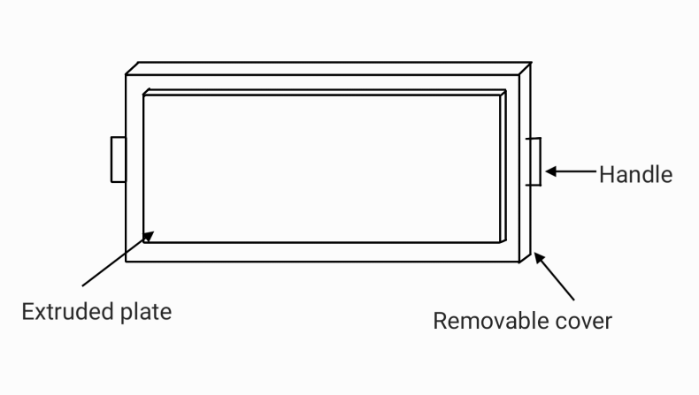
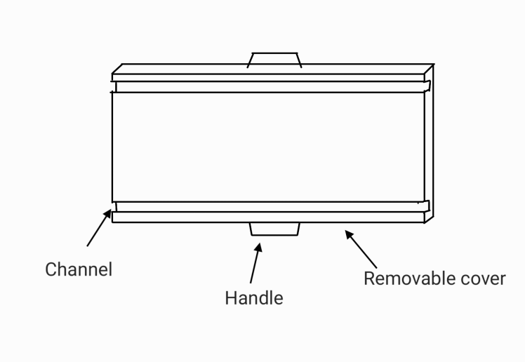
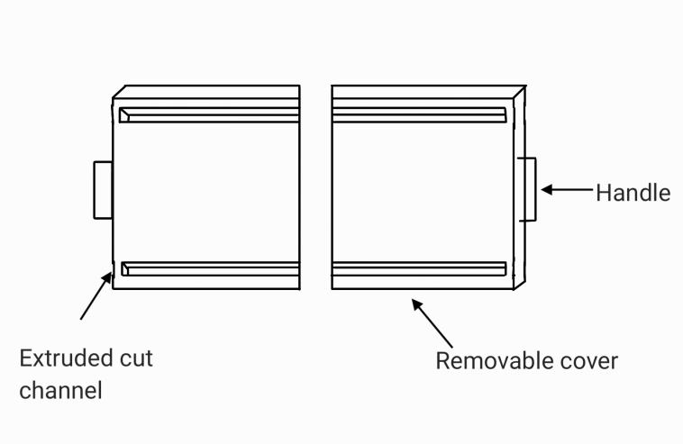

8.Final Design
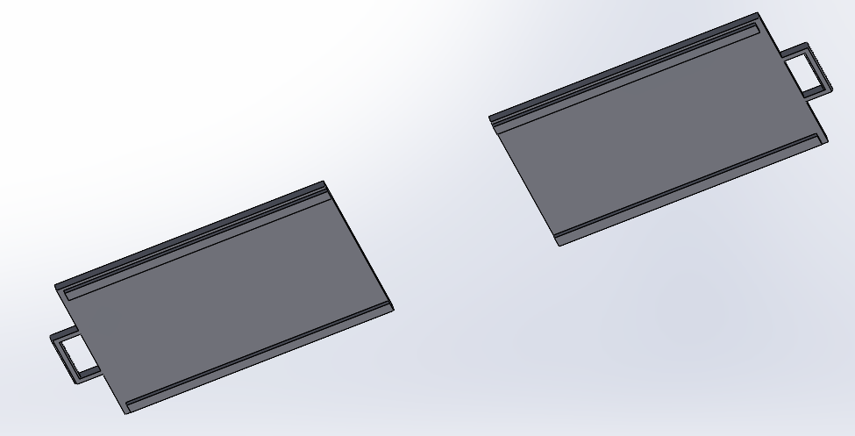

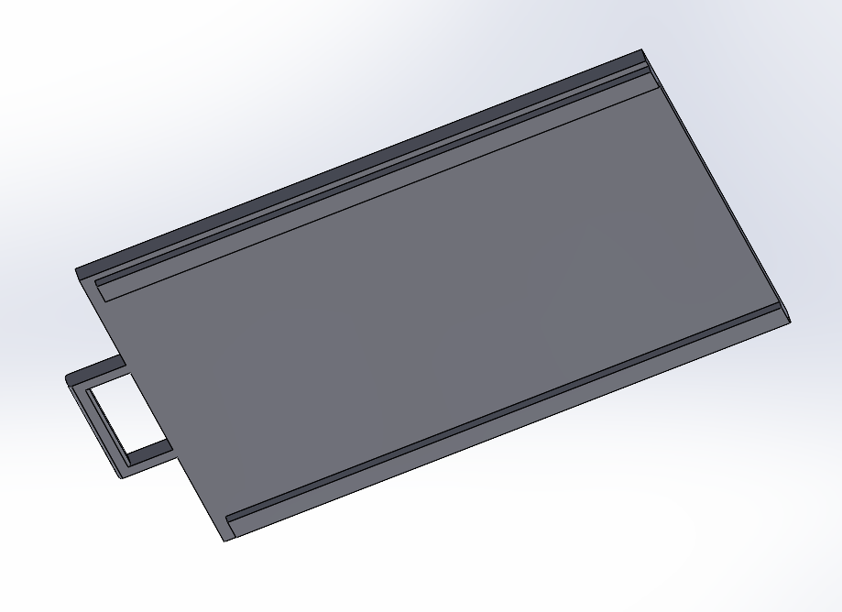

9.Manufacturing Processes
The process begins with the preparation of raw material, which involves sourcing 5 mm thick 316 stainless steel sheets. These sheets are chosen for their superior resistance to sulphuric acid vapour, as well as their durability in industrial environments. (United performance metals, n.d.)
The cutting of the lid panels and guide rails will be carried out using laser cutting due to its high precision and ability to produce clean edges. This ensures components fit accurately and reduces the need for extensive post-processing. (MetalSupermarkets, 2023)
For the joining of parts such as the lifting handles, welding will be used. This is because it is ideal for stainless steel due to its clean and precise welds, as well as its strength. (Besley, n.d.)

10.Justification

10.1.Safety Improvements
The redesigned cover for the tank greatly improves the safety of the design. By introducing two separate panels rather than the original singular one, the weight of each individual component is significantly reduced. This reduces the risk of injuries due to heavy manual lifting. Additionally, the new design allows just one person to safely manage the task, eliminating the requirement for a two-person lift and reducing the potential for coordination errors or accidents.

10.2.Design Integrity
Since the covers continue to be manufactured from 5 mm thick stainless steel, the cover maintains resistance to the corrosive 30% sulphuric acid solution contained within the tank and as well as sustaining the mechanical strength needed for operational durability. The split design also preserves the necessary clearance above the tank, allowing aluminium parts to be hoisted in and out without obstruction.

10.3.Cost-Effectivness
From a cost perspective, the solution remains highly efficient. The redesign uses the same material and requires only minor fabrication adjustments such as additional cutting and welding, meaning there are minimal additional production costs involved.

11.Conclusion and Further Work
The proposed cover design effectively addresses the operational and safety issues related to the existing single-piece stainless steel cover for the anodisation tank. By splitting the original heavy cover into two manageable sections, the new design ensures that the cover can be operated safely and easily by just one person. This modification considerably reduces the risk of manual handling injuries and improves compliance with health and safety regulations.
Additionally, the design remains cost-effective by using existing manufacturing methods and materials, ensuring ease of implementation across multiple tanks at the facility and other company sites. Overall, the modular cover represents a balanced solution that improves safety, usability, and cost-efficiency while maintaining the functional requirements of the anodisation process.
A potential improvement could be research into insulation panels that can be attached to the undersides of the covers. This would be to improve thermal retention of the tank whilst it is not in operation, this could potentially reduce energy consumption.

References
Besley, T. (n.d.). Advantages and disadvantages of welding as a joining method. Retrieved from https://www.forgeway.com/learning/blog/advantages-and-disadvantages-of-welding
GOV.UK. (1974). Health and Safety at Work etc. Act 1974. Retrieved from https://www.legislation.gov.uk/ukpga/1974/37/contents
GOV.UK. (1992). The Manual Handling Operations Regulations 1992. Retrieved from https://www.legislation.gov.uk/uksi/1992/2793
GOV.UK. (2002). Control of substances hazardous to health (COSHH). Retrieved from https://www.hse.gov.uk/cleaning/topics/coshh.htm
MetalSupermarkets. (2023). Laser Cutting Metals: Things to Know. Retrieved from https://www.metalsupermarkets.co.uk/laser-cutting-metals/
United performance metals. (n.d.). 316 stainless steel. Retrieved from https://www.upmet.com/sites/default/files/datasheets/316-316l.pdf

