cameron borkett
1702706

data handling
Sarn Helen data analysis

Contents
Executive summary 2
Excel analysis 3
If function 3
Lookup Function 3
Pivot tables 4
Charts and graphs 5
Strengths of excel 6
Weka data mining 7
Classify 8
Cluster 9
Associate 10
References 12

Executive summary

This report covers a variety of functions and analysis of the company’s data set which make it easier to analys such as the if function the lookup function and pivot tables which are ideal for looking into data in the analysis it was found where the most sales were and what was sold this was done to find where there was profitability and where there was profitability and the reasons that excel Is ideal for this process
The second part of the report is about how weka can be used in analysis and how it can do it quickly and effectively going through the 3 major methods of data mining cluster, association and classification. These are all great tools as classification allows for the predication and analysis, cluster to show the pattern of the data and where trends persist then association to see what items sell well together as a rule of thumb

Excel analysis

In excel there are many ways in which data can be analysed through a plethora of functions so this report will go through the functions that can be used to determine patterns and trends to which there is profitability or loss in the companies’ sales.

If function
The if function is an effective tool as it allows for the user to apply a condition to a data set and if it meets the criteria and whether it does or doesn’t meet will give the analyst a binary answer of yes or no that can give you a quick result so they can have insight in to easy questions for example in the sarn helen data set this function can be useful to find out whether there has been loss. This can be achieved easily by sorting the data by profit and adding an if statement that says if it is over 0 there is profit if not it would be loss below is an example of the function and how it looks in the spreadsheet.
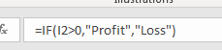
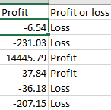
By using this it can be easier to decipher between what is profiting and what is not as on a quick scan it is easier to read.

Lookup Function
A look up can be a helpful tool to use when you need to find a specific part of data within a large data base such as the sarn helen data set so in this example the lookup was used just to find out what the profit or loss was of an individual order and what chatagory it came from by using two look ups
=LOOKUP(U6,A:A,I:I) =LOOKUP(U6,A:A,P:P)
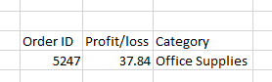

By doing this the function has been able to show how much they order gave and what category it was sold from.

Pivot tables
Pivot tables are a helpful tool to that allows for the user to be able to create more specific tables depending on what data you would like to look in to more specified sets of data an example would be as shown below as it has been put in to a format that makes it more possible to find trends as you can compare in the tables in price and category in a more visually appealing way that will make looking through heaps of data a lot more manageable.
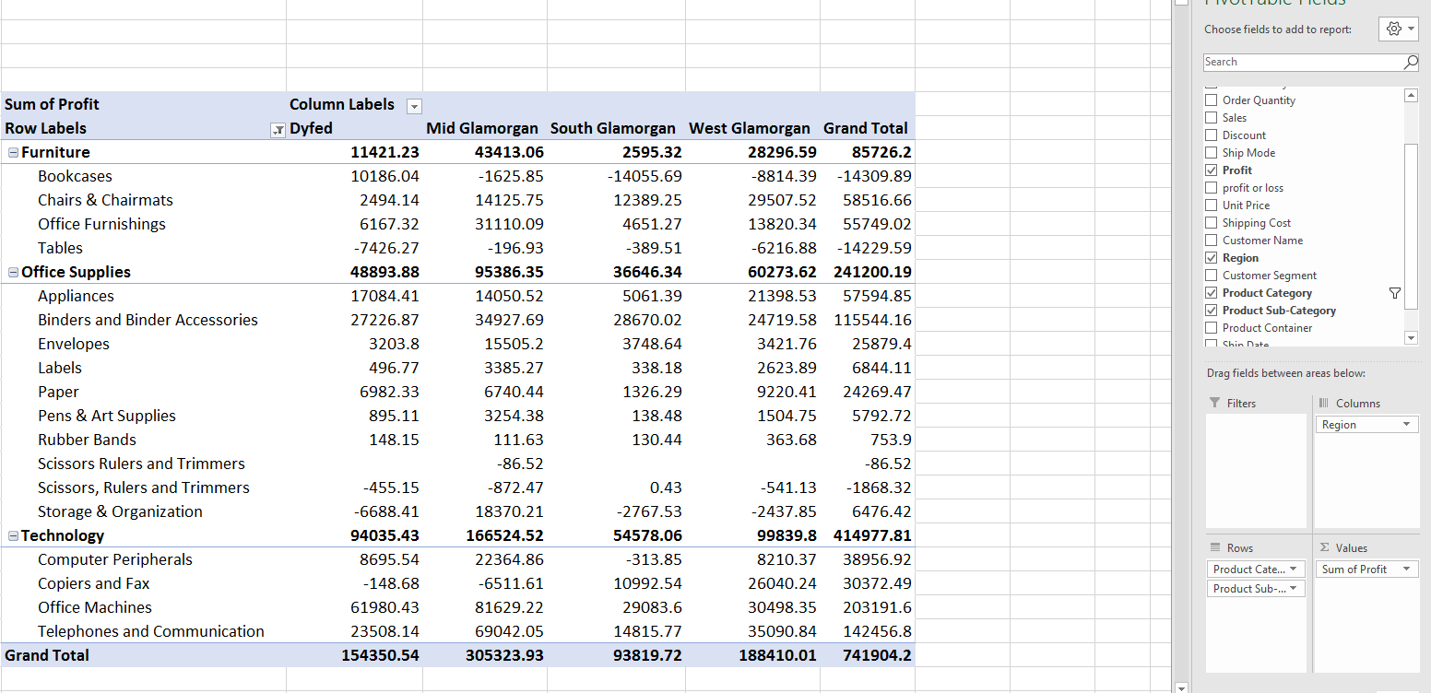
As seen above you can see a pivot table at work you can specify which of the different parts from the table that you want included within this makes it easier to sort through data and pre process before moving on to other software such as weka and maybe to find the relevant information to be turned in to charts to better show off the gathered and sorted information.

Charts and graphs
Once you have the data you want in the pivot table a good way to display this data is through charts and graphs which are easily made with excel and will allow the user to present data in an ideal easy to read format which are great for performance presentations. Below are examples of charts that can be made through the use of excel this a quick and effective way to display data in a more readable format with an array of options to choose from and a lot of customizable options such as being able to switch between the data in the table while using a pie chart doing this allows you to look at the data without having to create a completely new chart every single time you wish to look in to a certain aspect.
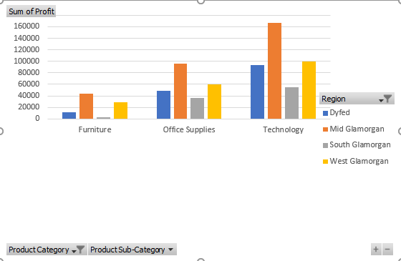
This graph that was made from the pivot table is a good representation of how useful a tool excel is as you can even change some of the features such as getting rid of the subcategories and showing the over all statistics of the categories.
There is also the availability to create pie charts as well in this same way as shown below this can show data in many different ways by doing this there is the availability to switch between the regions and compare with ease making it and ideal software to use in this scenario.
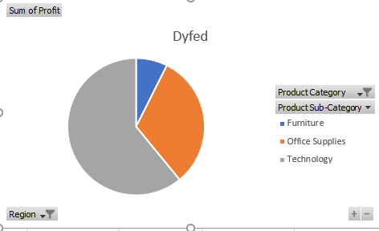
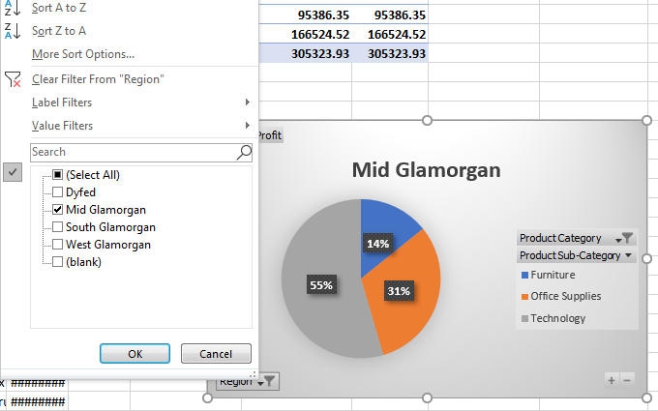

Strengths of excel
Excel is a great tool all round as it is an intuitive piece of software with many capabilities so much so that is is also considered useful with genetic analysis showing its versatility
“Packaging genetic analysis within a familiar and flexible environment resulted in quick understanding and effective performance of population genetic analyses.”(peakall , et al , 2006)
that allow for easy access to data, data manipulation and is a great tool for pre-processing, analysing and visualising data its good at this because it is so accessible with a large quantity of helpful tools that are customizable depending on the tasks needs. It also contains a high level of functionality with the features such as sums, if functions and lookup functions and many more that come included this makes for an ideal piece of software for people who wish to delve in to analysis and organise data in a way that is more advantageous and easier accessed by users that need the information. Its versatility helps in many situations it can be used to keep records of even used to keep market research held that allows for even more applications in to analysis of the customers at hand and giving you a step up in the competition if the companies are able to capitalise on these opportunities created by this software
for the next part of this report and that is data mining where it is possible to interrogate the data and find more of the trends and patterns that are within the data allowing to predict and analyse.

Weka data mining
Data mining is a process within the knowledge of data discovery or KDD but most consider it to be the same thing rather than a step in the process however the process;

“involves repeated iterative application
of particular data-mining methods.” (Fayyad, et al 1996)
And over the years has become a very important part in every business. Data mining is also helpful in
“discovering novel and potentially useful information from large amounts of data.”(baker ,2010)
Weka is a helpful tool in to really looking at large data sets as it is a good software at spotting trends and patterns in data very well with the different functions it has on it such as process, classify, cluster and associate these are all helpful functions however in order for it to be able to work you must ensure that the data is in the correct format of csv and that the data has been sorted as you can see below is a screen shot of what needed to be done as a requirement for it to work as it does not run if there are any “special characters” included in the csv file. So I used the find and replace tool featured in excel.

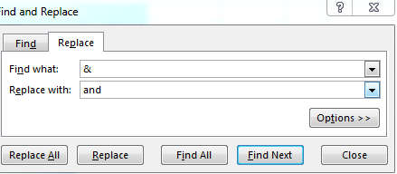

Once the large data set is in weka it looks as such;
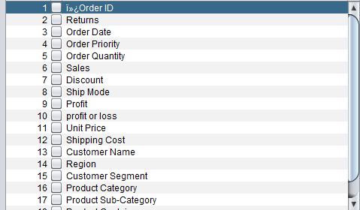

This however is a lot of data to be looking through and some data is not that which is necessary to the task at hand so in this screen it can be used to get rid of the data sets that are not required when going further with the software this screen is a great place to do such as you can get rid of any unnecessary fields that you do not need when beginning to mine in to the data.

Classify
classifying is a feature within weka that
“predicts categorical class labels (discrete or nominal) classifies data (constructs a model)” (han et al 2011)
in this case it has been used to identify and split up what is making profit and where it Is making profit as shown in the tree below
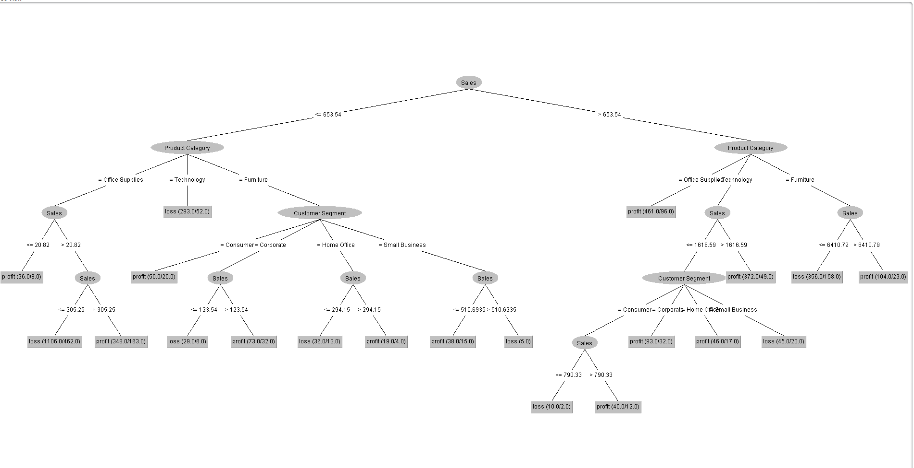
This tree splits in to two in to sales less than 653 and more than and then on each one of its branches it shows the segment that it sold too and what profited and what did not profit this is handy in many situations such as in the sample materials in weka where it can be used to determine what category something falls under in the iris data set. And can be used to make decisions and predictions which is ideal for any business that wants to get that competitive edge over the competitors.

Cluster
A definition of clustering is
“a division of data into groups of similar objects. Representing the data by fewer clusters necessarily loses certain fine details, but achieves simplification.”(berkhin 2006)
the cluster allows you to create a visualised graph of the patterns in which occur in the data by changing around the variables an example is in the screenshot below where the x axis is set to region, the y is set to sales and the colour for the plots are set to profit or loss this was to find out where there has been profit or loss and how much is getting sold in each of the respected regions.
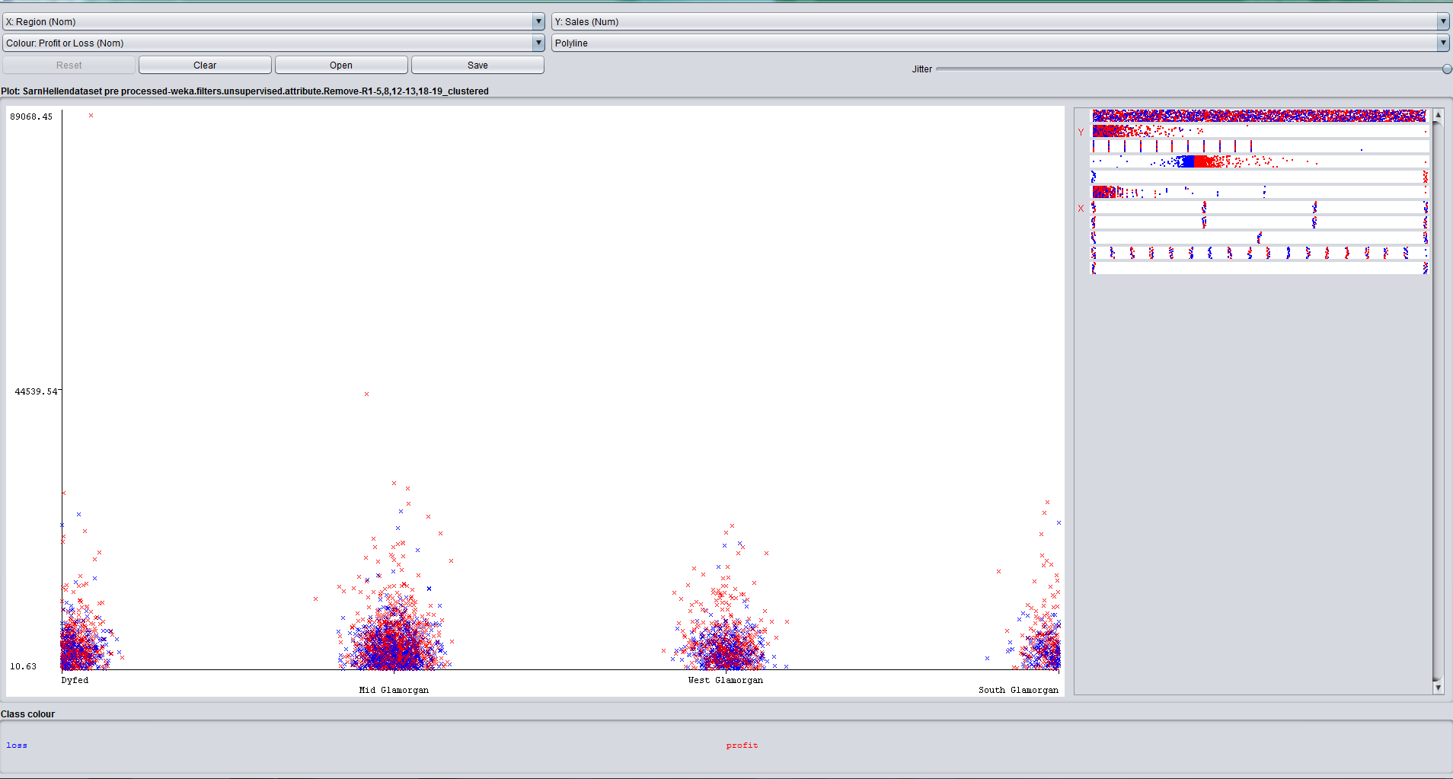
So as you can see from this cluster we can see what region seems to have the most sales and how many of them sales are profitable and which ones are not based on the keys on the graph. This is helpful for businesses as they can see where they need to target with their products and where this is very helpful for sarn helen as they sell such a wide range of products they can see what and where products are selling this means a business knows where to focus their efforts and where it is no longer worth focusing on any longer this allows for sarn helen to make sure they are getting the best out of the sold products.

Associate
The associate rule is there to find links between the data to be able to create groups that show the types of things that sell together doing this however is only between non numerical data and is based on a binary like system of true and false so it was a little bit trickier to pre process however it is a effective as it does create a readable set of rules from the large set of data
“Association rule mining is an important model in data mining. Its mining algorithms discover all item associations (or rules) in the data that satisfy the user-specified minimum support (minsup)” (Liu,1999)
using this allows the business to see what groups are made and the groups that are purchased together which allows a business to see the trends
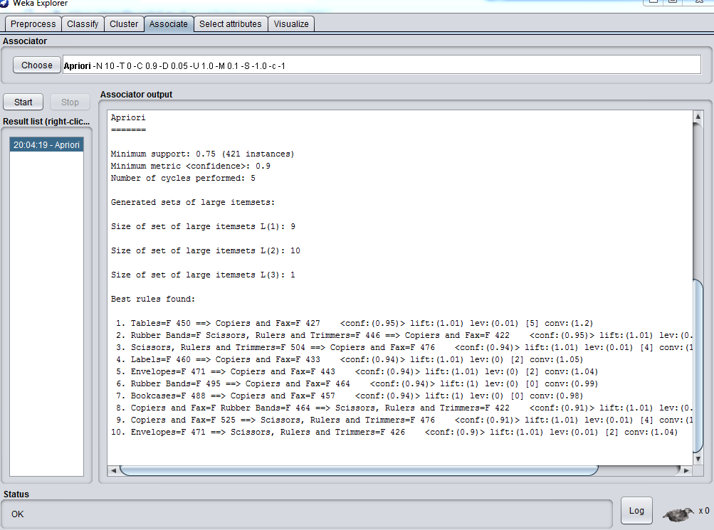
In the weka screenshot above you can see the association rules that were created showing links between each category this helps as products can be grouped accordingly. This could help with up selling in companies so that you know what items to recommend along with what else you sell.

References
Fayyad, U., Piatetsky-Shapiro, G. and Smyth, P., 1996. From data mining to knowledge discovery in databases. AI magazine, 17(3), pp.37-37.
Han, J., Pei, J. and Kamber, M., 2011. Data mining: concepts and techniques. Elsevier.
Peakall, R.O.D. and Smouse, P.E., 2006. GENALEX 6: genetic analysis in Excel. Population genetic software for teaching and research. Molecular ecology notes, 6(1), pp.288-295.
Baker, R.S.J.D., 2010. Data mining for education. International encyclopedia of education, 7(3), pp.112-118.
Berkhin, P., 2006. A survey of clustering data mining techniques. In Grouping multidimensional data (pp. 25-71). Springer, Berlin, Heidelberg.
Liu, B., Hsu, W. and Ma, Y., 1999, August. Mining association rules with multiple minimum supports. In Proceedings of the fifth ACM SIGKDD international conference on Knowledge discovery and data mining (pp. 337-341). ACM.

