

Student Name: JAYASURYA SHAJI
Student ID:2132225
Module Name: Human Resource Management -Assessment 2
Module Code: LCMB7000
Lecturer Name: Dr Gladius Kulothungan

Contents
Introduction 3
Company Overview 3
HRM and IHRM of Amazon 4
Principles of HRM 4
Change Management 5
HR Effectiveness Measurement 7
Compensation 9
Vroom's Expectancy Theory of Motivation 10
Expectancy: 10
Instrumentality: 11
Valence: 11
Application of Expectancy Theory of Motivation in Amazon 11
Recommendation 11
Conclusion 12
Reference 13

Introduction
The assignment portrays an organisation's Human Resource Management (HRM) and IHRM (International Human Resource Management) strategies. The assignment will primarily focus on three areas of HRM or IHRM, which are change management, staffing- recruitment and availability of skilled local labour, and leadership development. Amazon is the chosen company to analyse the three selected areas of human resource management. The assignment will also depict the HRM strategies developed and used in the three regions. The assignment will describe how the chosen strategies will provide the employees with a sense of value and appreciation. Models, principles, and concepts of HRM and IHRM will also be portrayed through the assignment.

Company Overview

Figure 1: Amazon
Source: TC (2022)
Founded in 1994, Amazon is a US-based multinational company with technology and e-commerce as the company's core focus. The headquarters of Amazon is situated in Seattle, Washington, United States. Amazon currently employs around 1,608,000 all around the world (Google Finance, 2022). With a hold on 94,797 shares, Andrew Jassy is the current CEO of Amazon (Google Finance, 2022). Advisor Group Inc., Vanguard Group Inc., and BlackRock Inc. are some of the institutional shareholders of Amazon (CNN Business, 2022). The net worth of Amazon is estimated to be around 438.118 billion dollars. The profit alone of the company in 2021 was 33.364 billion dollars (Google Finance, 2022).

HRM and IHRM of Amazon
As per the observation of Fan et al. (2021), Human Resource Management refers a procedure of employing, assigning, positioning and handling workers in organisation in an effectual and success approach. Human Resource Management deals with problems connected to compensation, presentation organisation, organisation development, protection, health, advantages, employee motivation, training and others. HRM plays an important part in handling people and the work values and atmosphere. According to Cooke et l. (2021), International Human Resource Management (IHRM) refers as the perception and techniques of human resource management that employers used to manage the HR challenges of their international operations such as training, obtaining, rewarding employees and describing and appearing to health a d safety, fairness concerns and the labor relations.
Amazon is one of the most innovative and customer-centric organisations in the world. Human resource strategy is the big part of success in Amazon. Amazon continue to invest heavily in its HR section in 2022. A large number of creativities are designed to support the employees and enhance the retention rate. The introduction of remote working options or the employees are the one of the most notable changes. This flexibility permits the Amazon employees to better balance of the work and personal lives that leads to increase the productivity and satisfaction.

Principles of HRM
According to Dundon and Rafferty (2018), there are seven principles for human resource management (HRM) which are recruitment, performance management, L&D (Learning and Development), planning of succession, benefits and compensation, HRIS (Human Resource Information System), and human resource data and analysis. Recruitment is the process of seeking and hiring talented employees for the company. Performance management is all about bringing out the best skills inside personnel so that it would ultimately benefit the company. Stadler et al. (2022) states that learning and development (L&D) help in employee retention and skill development. Succession planning is a stage where the HR department finds a suitable alternative for parted key employees. For the purpose of motivating and retaining vital employees, fair compensation policies have to be in place for the organisation. Data analysis and HRIS are tools that aid in the betterment of human resources.

Change Management
As per the findings of Akbar et al. (2021), Change management is the process of planning, monitoring and applying changes in an organisation. The main advantage of the change management is benefits improvement of communication, enhancing productivity, reduced strain and tension and enhanced decision making also. Change management can also help to enhance morale and create a more positive environment work. Communication is the most important in a change management and it is a cornerstone of any effective successful management process. As a human resource manager in the Amazon, the applicable change management performs tend to be accepted in this context. So, the high-performance work environment can be attained in an appropriate way. The organisational benefits through the applicable change management are considered as rise in efficiency and a better business development A significant advantage to smearing change management is improving the probability of accomplishment, and the data is rather pure about the association (Dzwigol et al., 2019). At the age of globalisation, the requirements of organisational changes enhanced quickly. For instance, the change management need to be practised in the organisation context of the Amazon. For the context of Amazon, the various kind of changes such as the employee work hour, marketing concepts, decision making process and technological changes are effective for the Amazon. The success change management concepts and models are mentioned in this report.
ADKAR change management model
The ADKAR change management model was introduced by Prosci jeff hiatt in 2003. As per the observation of ADKAR is one of the most helpful models in an organisation and its stands for awareness, desire, knowledge, ability and reinforcement. One of the most upsides of the organisation are leaders and change management team focus on driving the individual. It provides a simple framework for everyone involved in the change.
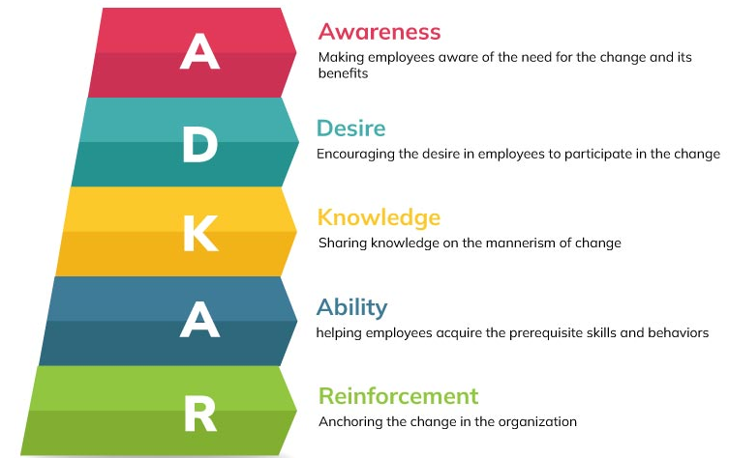
figure 2: ADKAR change management model
source: Yasid and Laela (2022)
Awareness: It is the understanding of why the change is necessary. The HR management need to undertake the needs of change. According to Rosenbaum et al. (2018), it sharing both the nature of change. Moreover, the nature of the change including external or internal changes. The awareness in change management which permits the organisation to formulate proper plan about changes in organisation and add values. It making the employees aware of the need for the change and its benefits.
Desire: As per the findings of Galli (2018), In this step, how to implement the change in an organisation is mainly conducted. Some component needed to assorted by the HR management of Amazon. Employee engagement and employee participation are highly desired to the change management. it is also the encouraging the desire in employees to participate in the change.
Knowledge: sharing a knowledge is the mannerism of the change. In this model, the knowledge is considered mainly education and training. The employees need to understand that how their responsibilities, tools and skills and the process will be impacted in order to begin the change. The knowledge of the change management is discussed with others and the employees are connected with the change management.
Ability: Change management ability are the ability that used to help company through the process of creating organisational changes. A good change management can be critical to the success of Amazon. A clear management specification provided by the HR managers in the change management in an organisation. By helping the employees acquire the prerequisite and behaviour.
Reinforcement: for continued the better performance in long-term in an organisation, the change should sustain (Malo et al., 2021). Constructing a culture and capability around the change need also be confirmed by the management to reinforce the change so it can provide the larger morals to the organisation.

HR Effectiveness Measurement
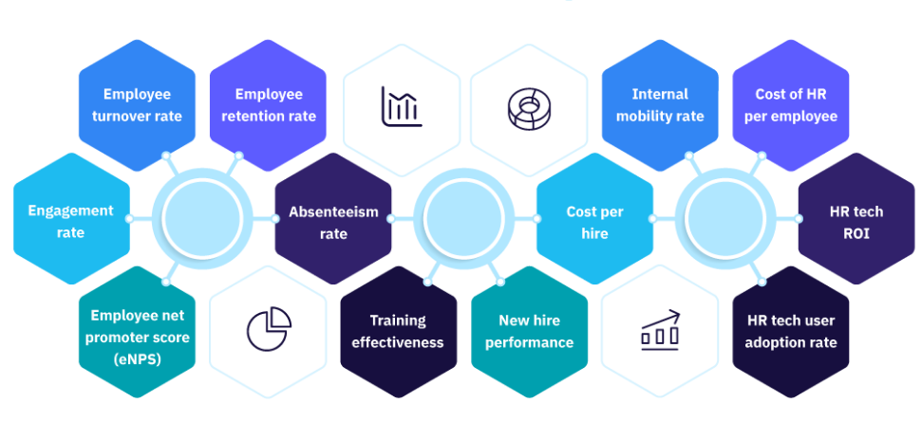
Figure 3: HR effectiveness measures
Source: Kabze, (2022)
Amazon tends to find out the effectiveness of the human resource and the effective human resource strategies are essential within the Amazon. As per the observation of Saharan (2021), recruitment cost report, labor productivity report, discipline, employee morale etc are some of the criteria to measure the efficiency of the HR department. HR effectiveness signifies to measuring how the success action of HR department and actions are to a business. A really effective HR team plays an important role in serving a occupational succeed, particularly since HR leaders are participated in determining complete business adoptions. A successfully designed and implemented employment and onboarding strategy help to bring highest talent on board, leading to improved efficiency and, therefore, income. Likewise, an active presentation management system permits executives and workers to keep track of progress and performance, expand, and meet organisational goals. By measuring HR efficiency, it will get a symbol of how Amazon successfully using the resources. Determining inefficiencies permits to expand these or eliminate them. Measuring the workers training effectiveness help to measure how helpful the present donations. Amazon invest a high deal of resources into training programs. The HR effectiveness can be enhanced by improve ethe organisational communication, providing regular feedback, consult with business leaders, analyse data etc. An HR professional in the Amazon must be able to successfully convey the information to others, from emails to workers to training sessions with managers. In addition, they must be able to articulate ideas and undoubtedly clarify complex information. To comprehend how effective HR in the Amazon, the employees can examine numerous metrics. These metrics will beneficial to the strategy what the workers will look like in the future and take steps to plan the policy and budget accordingly. According to Clardy (2021), HR effectiveness will also benefit to Amazon to imagine and reveal the whole influence of the Human Resources department has on the organisation.
The metrics are successfully used by the Amazon to evaluate the efficiency of the HR tactics. The suitable usage of metrics allows the organisation to reveal how the initiatives of the organisation are effective to get the desired outcomes. Hence, the pure and significant goals need to be set at the starting point.

Compensation

Figure 4: Compensation Strategy
Source: Resource for Employers (2022)
According to Richards et al. (2018), every employee that has worked in a company for a fixed amount of time they have the right to demand financial benefits from the company. A company that adopts the best employee practices will always provide the best compensation plans for the complex work of an employee. The compensation strategy adopted by an organisation can help them achieve three things which are easy job recruitment, employee performance increment, and satisfaction in the job that they do. As per the observation of Zigrang (2022), the compensation policies can be depicted in the job package of an employee, proving to them that the company will appreciate their labour.

Vroom's Expectancy Theory of Motivation
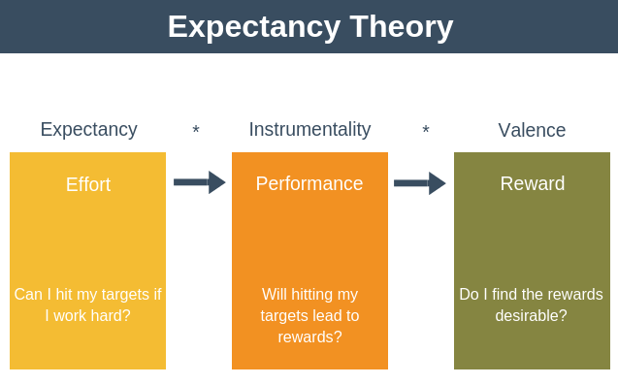
Figure 5: Expectancy Theory
Source: Expert Program Management (2018)
As per the observation of Lloyd and Mertens (2018), first introduced in 1964 by Victor Vroom, the expectancy theory states that the best practice an organisation could adopt is to reward an employee for their actions. In return, there is a high chance that the employee will keep doing that specific task over and over again and will become good at it. Yoes and Silverman (2021) states that by developing a system like this, an organisation can create efficient employees that are good at doing specific tasks even if their difficulty level is high.
Expectancy: Swain et al. (2020) observed that expectancy is the phenomenon which states that if an employee in the context of an organisation works hard, then success is inevitable. Organisational goals and targets can be achieved quickly and with utmost perfection, if employees try to do so. Expectancy will be made by an employee mainly based on three factors which are experience, self-confidence, and difficulty of the objective.
Instrumentality: According to Nhung and Do (2020), instrumentality is a self-assessment conducted by the person on whether or not the company will reward the person if they have completed all the objectives given. Instrumentality depends on three factors which are clarity in the relationship between reward and performance, which is also depicted as an outcome. Trust in the rewarding person is the second factor. Decision-making transparency is the third factor which depicts whether or not the person will be rewarded or won’t be rewarded.
Valence: Aa per the observation of Kim and Kim (2018), valence is the understanding that if the organisational goals are achieved efficiently, there will surely be a reward. Valence can depend upon the reward itself and whether or not employees are motivated by it.

Application of Expectancy Theory of Motivation in Amazon
According to Lahoti (2019), technology has been increasing almost constantly in recent years. Since technology has been growing, the performance of an organisation also has to keep up with the same pace. For Amazon, a company already flourishing in the market, the company can adopt Vroom's Expectancy Theory of Motivation to further increase the performance of the employees. By offering compensation or a reward even to the employee starting at the primary level, the company can ensure a drastic increase in performance.
By introducing such a reward system, the Human Resource (HR) department of Amazon can create a better relationship between the employees. Through the increased level of engagement achieved by implying a compensation strategy, the management of Amazon can ensure that the organisation values all the employees and their efforts. Yang and Kim (2019) observed that the compensation strategy not only helps in performance but also helps in increasing employee loyalty and employee retention.

Recommendation
- Training and development can be given to employees.
- Amazon can implement a strategy of hiring selectively
- The management of Amazon should practise transparency with their employees.
- Information regarding the compensation policies of the company and other details has to be made available for the employees so that the employees can easily access it
- Amazon must consider Internal and external factors before planning a strategy.
- The employees in Amazon must identify the change that needed in an organisation
- Amazon must conduct the reinforcement programs
- Job security can be promised for the employees
- Compensation can be given totally on the basis of performance in the organisation.
- The employees must aware about the company and the required change.

Conclusion
The assignment focuses on human resources strategies that would be developed and deployed in three significant areas, which are the change management, compensation, and HR effectiveness measures in Amazon company. Through the assignment, it has also been analysed how the strategies will make the employees of Amazon feel appreciated for their work. Concepts, models, and principles of HRM and IHRM theories have also been analysed through this assignment.

References

CNN Business (2022) Stakeholders of Amazon. Available at: https://money.cnn.com/quote/shareholders/shareholders.html?symb=AMZN&subView=institutional (Accessed: 26th of August 2022).
Dundon, T. and Rafferty, A. (2018) The (potential) demise of HRM?. Human Resource Management Journal, 28(3), pp.377-391.
Google Finance (2022) Amazon. Available at: https://www.google.com/finance/quote/AMZN:NASDAQ?sa=X&ved=2ahUKEwio36j6oeT5AhXRm1YBHRyJAdQQ3ecFegQIHhAg (Accessed: 26th of August 2022).
Kim, M.R. and Kim, S. (2018) Explaining the Role of Motivation in Opposition to Nuclear Power Energy-Focusing on EIV (Expectancy, Instrumentality, and Valence) in Expectancy Theory. 14(11), pp.73-89.
Lahoti, A. (2019) Applying the expectancy theory to explain the motivation of users of personal care products with special reference to hair oil. Advance and Innovative Research, p.129.
Lloyd, R. and Mertens, D. (2018) Expecting more out of expectancy theory: History urges inclusion of the social context. International Management Review, 14(1), pp.28-43.
Nhung, T.T.K. and Do, N.T. (2020) An extension of Vroom’s expectancy theory (1964) in examining lecturers’ motivation in Vietnam. Science & Technology Development Journal-Economics-Law and Management, 4(1), pp.490-499.
Resources for Employers (2022) How to structure employee compensation. Available at: https://resources.workable.com/tutorial/employee-compensation-structure# (Accessed: 26th of August 2022).
Richards, D.P., Jordan, I., Strain, K. and Press, Z. (2018) Patient partner compensation in research and health care: the patient perspective on why and how. Patient Experience Journal, 5(3), pp.6-12.
Stadler, R., Walters, T. and Jepson, A. (2022) SUSTAINABLE HUMANS: A FRAMEWORK FOR APPLYING SUSTAINABLE HRM PRINCIPLES TO THE EVENTS INDUSTRY. Event Management, pp.19-20.
Swain, J., Kumlien, K. and Bond, A. (2020) An experiential exercise for teaching theories of work motivation: using a game to teach equity and expectancy theories. Organization Management Journal, pp.17-19.
TC (2022) Amazon is primed for online domination. Available at: https://techcrunch.com/wp-content/uploads/2020/11/GettyImages-1211125072.jpg?w=730&crop=1 (Accessed: 26th of August 2022).
Yang, J.G. and Kim, J.G. (2019) A Study on Participation of Korean a university graduate at Youth TLO Applying the Expectancy Theory. Journal of the Korea Academia-Industrial cooperation Society, 20(5), pp.200-212.
Yoes, M. and Silverman, M.J. (2021) Expectancy Theory of Motivation and Substance Use Treatment: Implications for Music Therapy. Music Therapy Perspectives, 39(1), pp.61-68.
Zigrang, T.A. (2022) Healthcare Compensation Plans: Current Challenges and Novel Approaches. Frontiers of Health Services Management, 38(4), pp.26-32.
Kabze, M. (2022) ANALYZING LEADERSHIP PRACTICES IN AN INTERNATIONALLY RENOWNED HR COMPANY: WHY DOES PEOPLE-ORIENTED LEADERSHIP MATTER?. European Journal of Management and Marketing Studies, 7(2).
Bencsik, A. (2022) Background on the Sustainability of Knowledge. Sustainability, 14(15), p.9698.
Yasid, M. and Laela, S.F. (2022) The Success Factors of Conversion Process Using ADKAR Model: A Case Study of Islamic Savings Loan and Financing Cooperative. Afkaruna: Indonesian Interdisciplinary Journal of Islamic Studies, 18(1).
Fan, D., Zhu, C.J., Huang, X. and Kumar, V. (2021) Mapping the terrain of international human resource management research over the past fifty years: A bibliographic analysis. Journal of World Business, 56(2), p.101185.
Cooke, F.L., Wood, G., Wang, M. and Veen, A. (2019) How far has international HRM travelled? A systematic review of literature on multinational corporations (2000–2014). Human Resource Management Review, 29(1), pp.59-75.
Akbar, M.A., Sang, J., Khan, A.A., Mahmood, S., Qadri, S.F., Hu, H. and Xiang, H. (2019) Success factors influencing requirements change management process in global software development. Journal of Computer Languages, 51, pp.112-130.
Dzwigol, H., Shcherbak, S., Semikina, M., Vinichenko, O. and Vasiuta, V. (2019) Formation of strategic change management system at an enterprise. Academy of Strategic Management Journal, 18, pp.1-8.
Rosenbaum, D., More, E. and Steane, P. (2018) Planned organisational change management: Forward to the past? An exploratory literature review. Journal of Organizational Change Management.
Galli, B.J. (2018) Change management models: A comparative analysis and concerns. IEEE Engineering Management Review, 46(3), pp.124-132.
.
Malo, P., Tahvonen, O., Suominen, A., Back, P. and Viitasaari, L. (2021) Reinforcement learning in optimizing forest management. Canadian Journal of Forest Research, 51(10), pp.1393-1409.
Saharan, T. (2021) HR Practices for Financial Acumen. In Financial Intelligence in Human Resources Management (pp. 21-51). Apple Academic Press.
Nilsson, K. and Nilsson, E. (2021) Organisational Measures and Strategies for a Healthy and Sustainable Extended Working Life and Employability—A Deductive Content Analysis with Data Including Employees, First Line Managers, Trade Union Representatives and HR-Practitioners. International Journal of Environmental Research and Public Health, 18(11), p.5626.
Clardy, A., (2021) What Does HR Manage? Workforce Measurement and Control. Merits, 1(1), pp.16-33.

