DS 1 Assignment
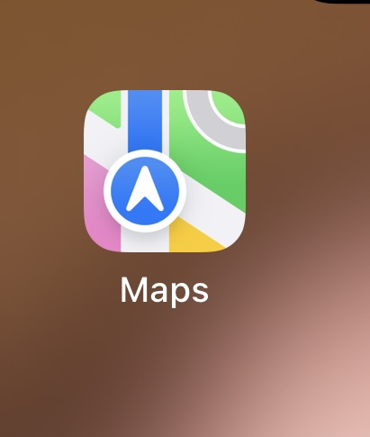
Maps play an important role in our digital live. They help us to find places, discover new destination, and choose the best routes to reach our destination. They also help us to save time and travel more safely.


Yahoo mail it helps us sent and receive emails quickly and easily. We can use it to communicate with family, friends, colleagues, and businesses around the world.i can send documents, photos, and other important information.

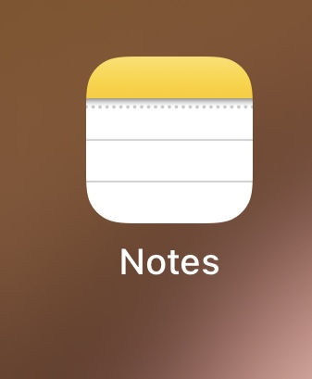 Notes help me to organize my thoughts, write down important information, and remember daily tasks. I can use digital notes to make shopping lists, save ideas, plan my activities, and keep track of appointment.

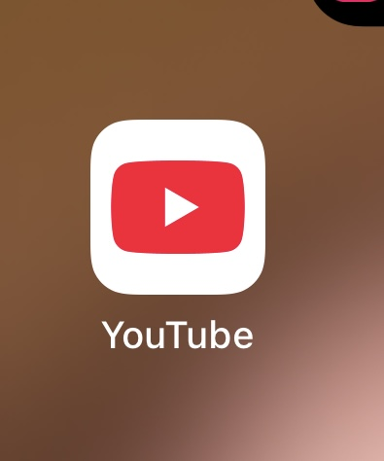
I can use YOUTUBE to watch videos, listen music, learn new skills, and discover useful information. We can find educational video, tutorials, recipes, and entertainment for all ages. YOUTUBE helps us improve our knowledge, learn new languages, and explore different interests.

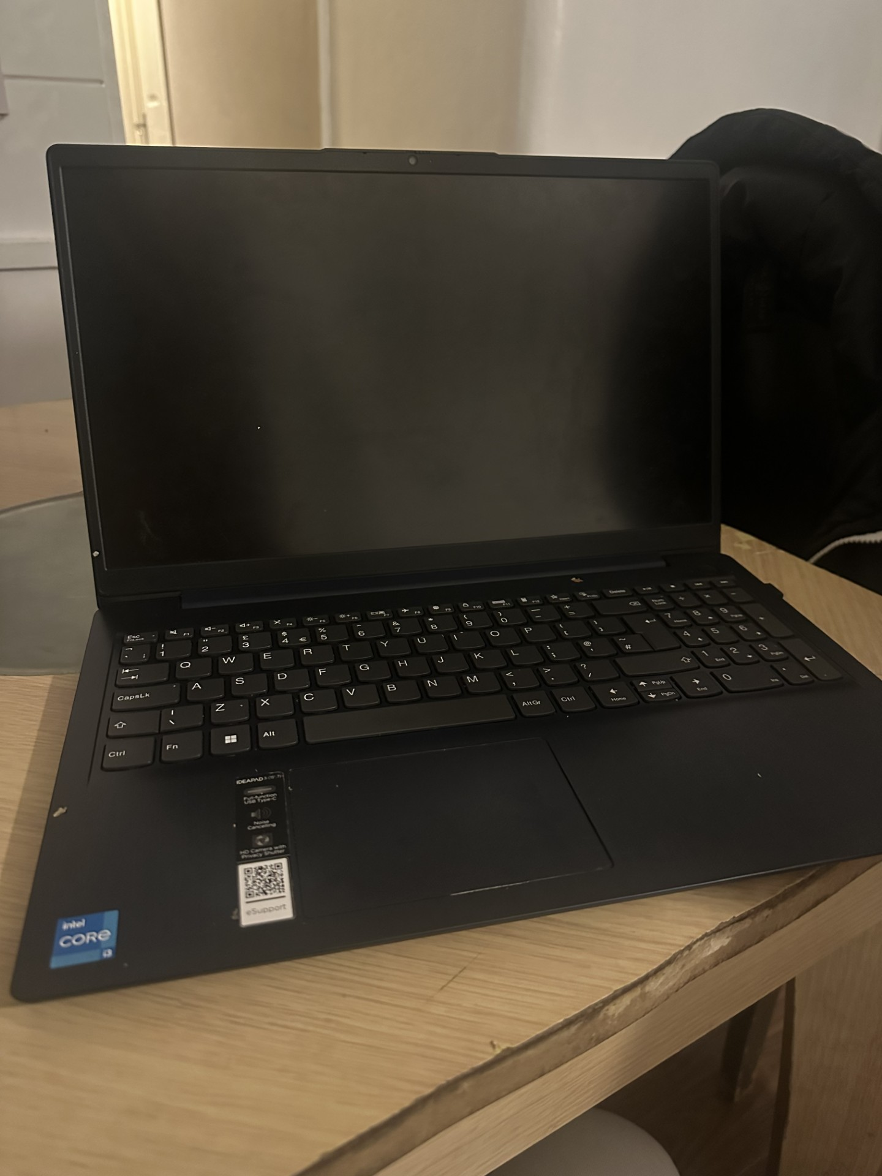 My leptop helps me to study, communication, and find information quickly. A laptop it’s helps us do our homework, write assignment, and create presentation, attend online classes. Also helps to communicate with teachers and classmates, sent emails, and organize our schoolwork.

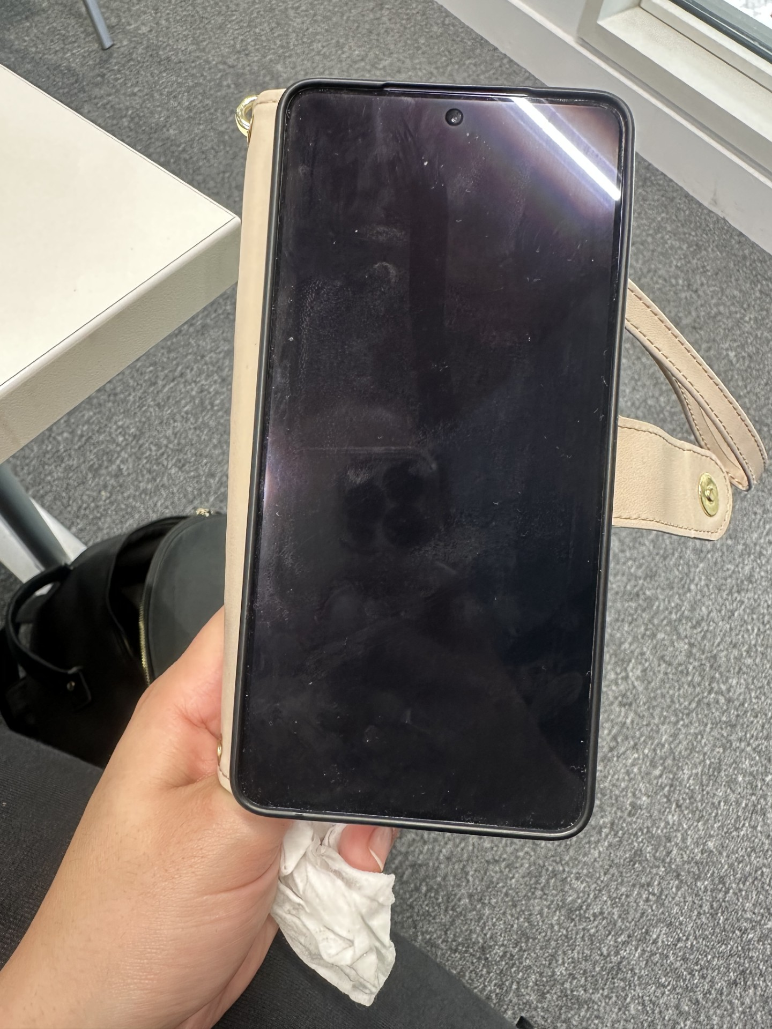
I use my mobile phone to access the apps mentioned above, communicate with my friends, watch videos, listen to music, and search for information on the internet.

My Short Reflection
- Write 5–8 simple sentences about your digital life.
- You can use the sentence starters below if helpful.
I use digital tools to save time, learn new things , and stay connected with others. It’s helps us stay in touch with our family and friends. Digital live is an important part of my daily routine. I believe that our live are much easier thanks technology. I would like to improve my digital life and learn more about technology and its advantages.

Sentence starters
- I use digital tools to …
- I feel confident when I …
- I want to improve …
- I often use these tools: …
- I sometimes feel nervous about …
- I hope this module will help me …
- Digital skills are important for me because …
You can write more if you want.

Submission Checklist
Before you submit, please check:
​​​ ☐ I added 4–6 screenshots
☐ I wrote short sentences for each screenshot
☐ I wrote my short reflection
☐ My work is my own
☐ My file opens correctly
​​☐ My file opens correctly

