Electronic Circuit Analysis
Electrical Control Systems (ACH4010)

Harry Walters
2317556

University Of Wales Trinity St David
School of Engineering
Automotive Engineering HND

28/1/2024

Contents Page

Circuit diagram referenced in question
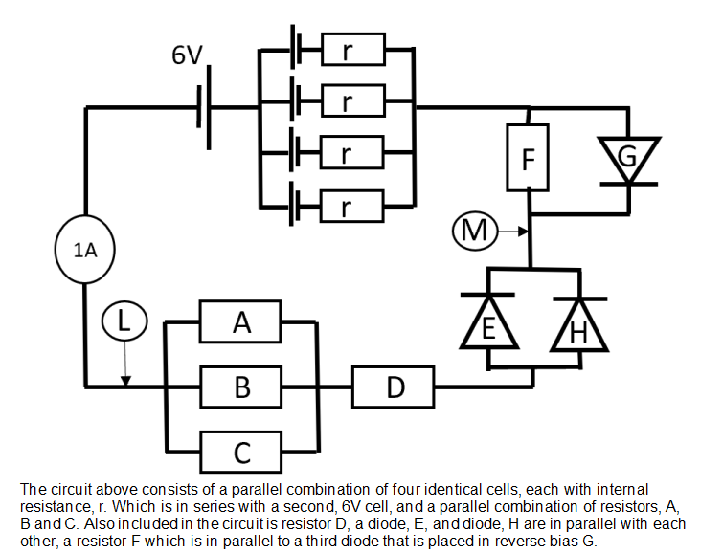

Questions

A) Calculate the resistance of E and H for the circuit’s configuration
H= 5.3Ω E= 5.4Ω
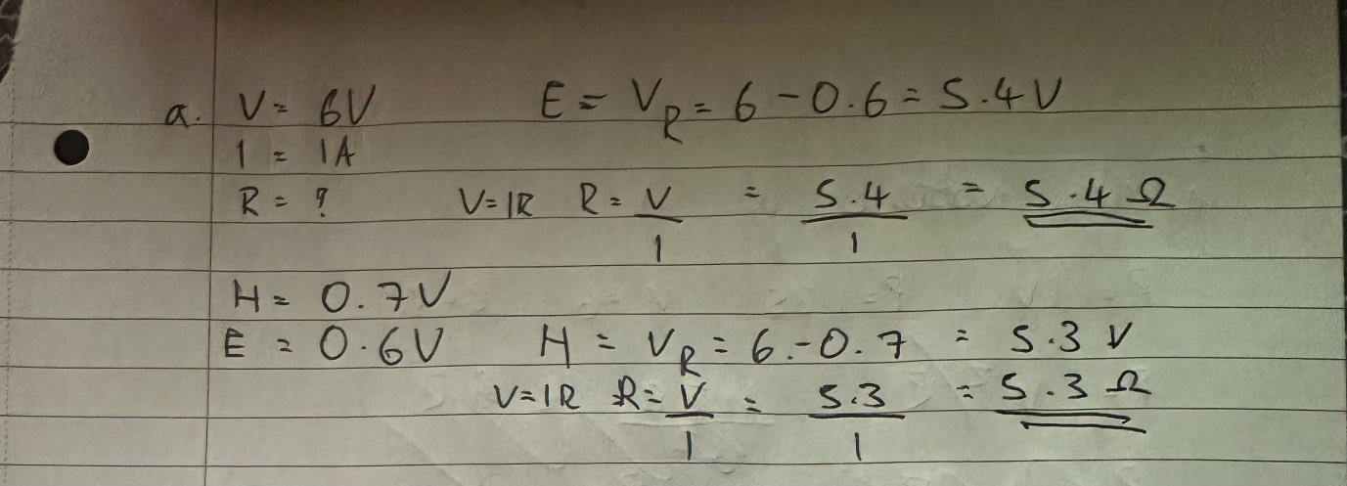

B) Given that B and C are identical and the current passing through A is 0.5A, calculate the current passing through B and C
B = .25A C =.25A
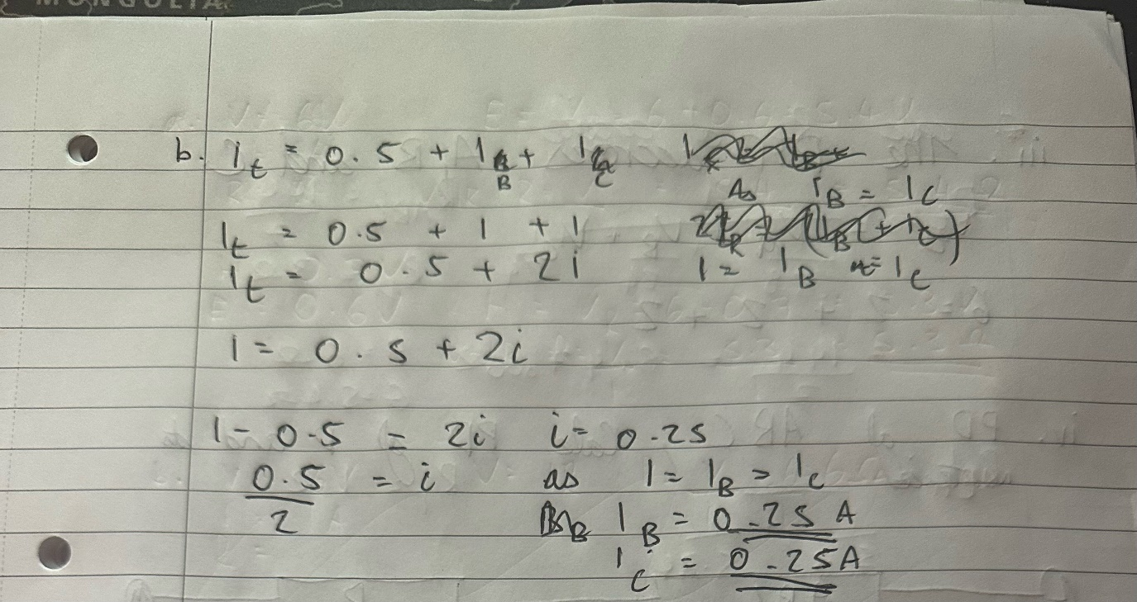

2.3 C) Resistor A dissipates 1.25J of energy every second. Using this fact calculate:
i. 28.8Ω ii. B=24Ω C= 24Ω iii. 2V iv. 6V 3Ω
i. The Resistance of A.
ii. The Resistance of B and C
iii. The potential difference across A, B and C
iv. Since the total potential difference across L to M is 6V, calculate the potential difference across D and find its Resistance.
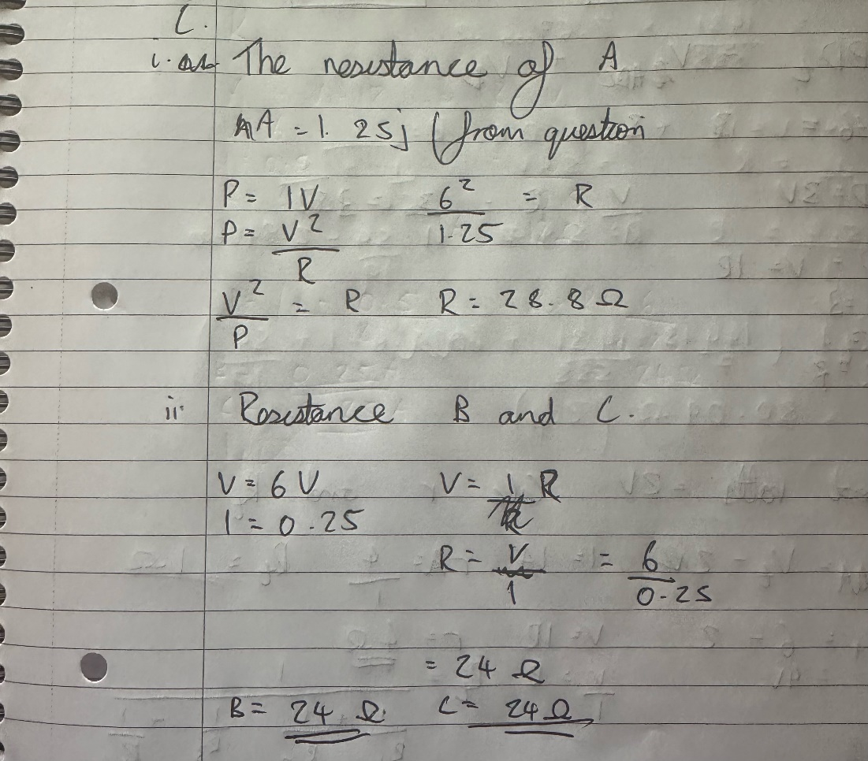
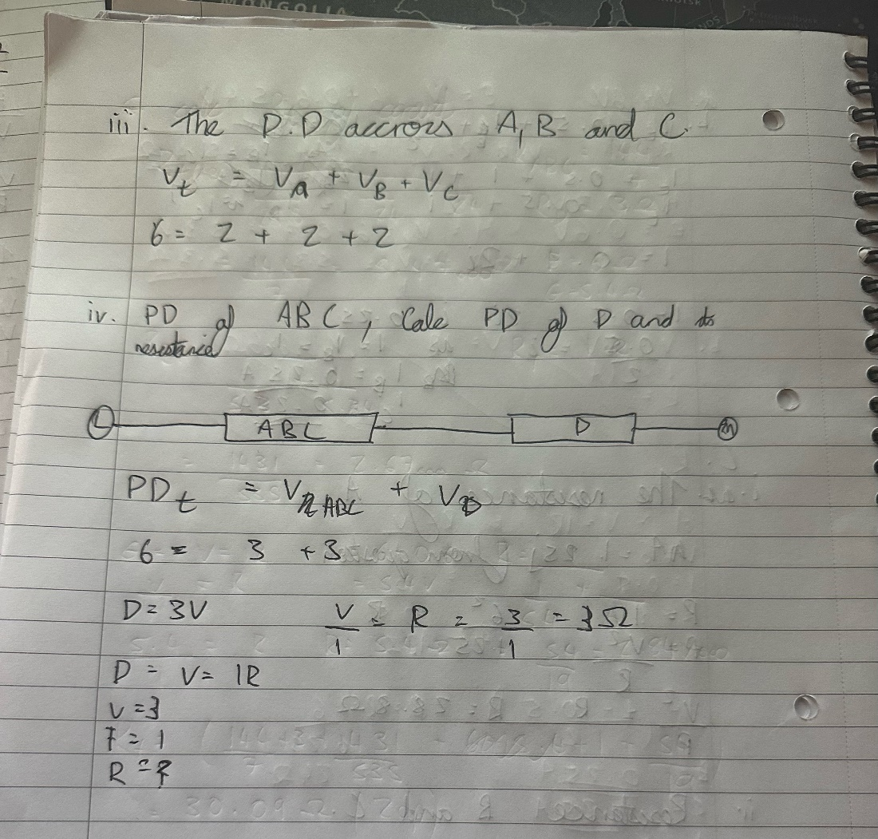

D) The ‘lost volts across one of the cells in the parallel arrangement is 2 V. Calculate r and hence the total resistance of the parallel combination of cells.
R= 4Ω Rt=1Ω
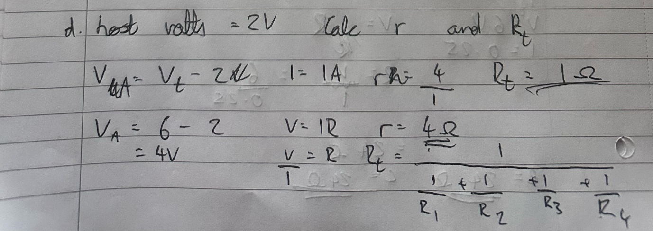

E) Given that the resistance F is 6Ω, calculate the voltage drop across it.
0.6V
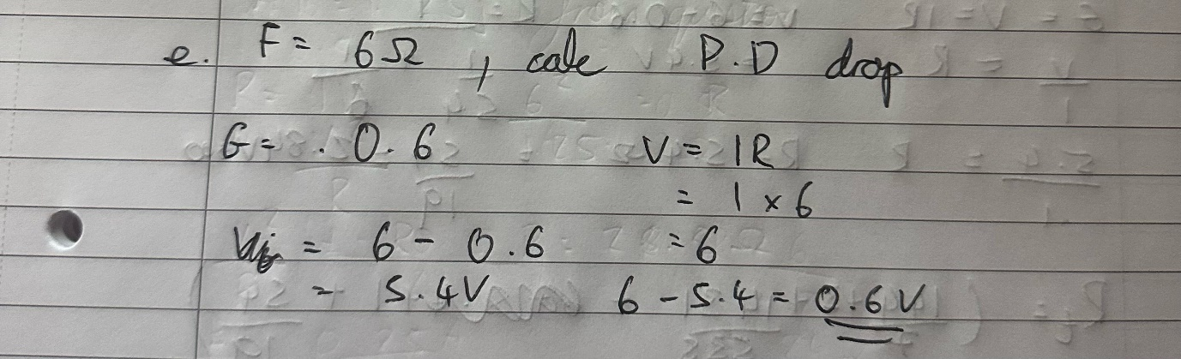

F) Calculate the total resistance of the circuit, this includes total internal and the resistance cause by the reverse polarity battery and the open diodes in given scenario (ignore any “non-open diodes”

Rt = 30.09Ω(2dp)\
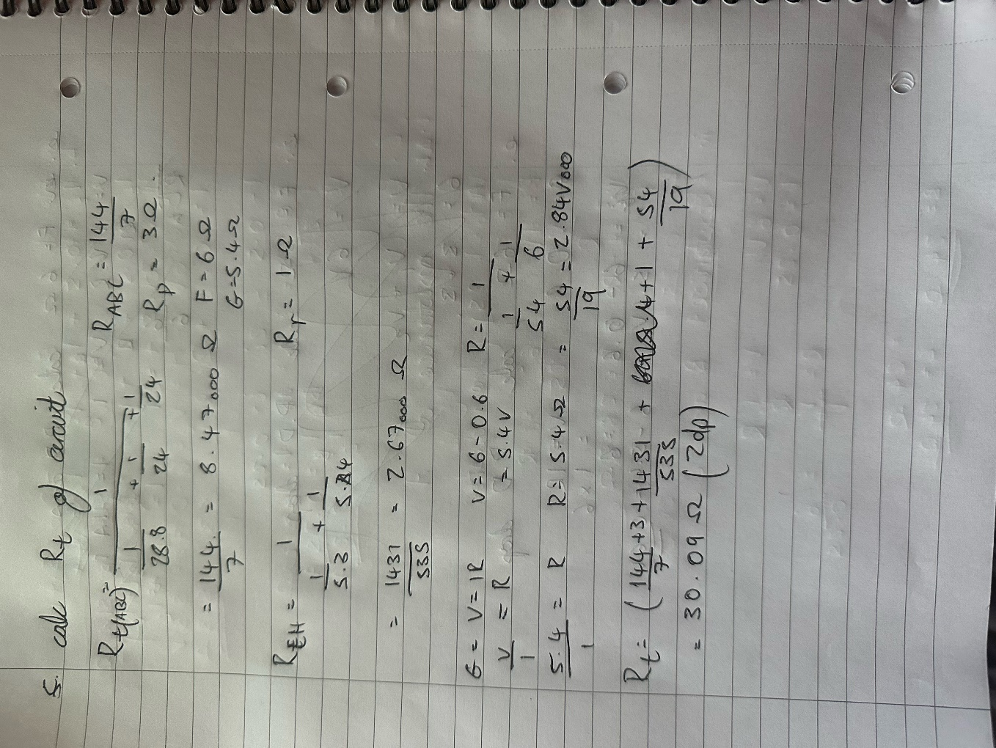

G) Calculate the emf of each of the cells in the parallel combination.

EMF= 7V



