
Module Code ACNA5001
Title Coastal, Marine and Wildlife Conservation
Date 05/05/2021 Level 5 Credits 20
Pre-Requisites None

AIM(S)
• To introduce coastal and marine ecosystems, and their conservation. From a scientific
consideration of these pressures, students will evaluate strategies for the protection
of the maritime environment and wider conservation of species, ecosystems and
natural resources.

LEARNING OUTCOMES
Upon the successful completion of this module, the student should be able to:
• Comprehend the functioning of coastal and marine systems
• Discuss current conservation issues affecting the coastline/inshore waters and
evaluate coastal defence strategies
• Contextualise and demonstrate awareness of the science and practicalities of wildlife
conservation, sustainability and wildlife exploitation.

INDICATIVE CONTENT
• Introduction to the functioning of the marine environment
• Pollution and impacts – microplastics and hydrocarbons
• Oceanic over-harvesting and future implications of key policies.
• Role of oceans in climate regulation
• Impacts of climate change on marine systems.
• Sustainable management of marine wildlife
• Coastal geomorphology and the impact of anthropogenic forces
• Ecosystem services in coastal environments
• Climate change and coastal adaption
• Coastal priorities and management in a changing demography
• Coastal Zone Management, vulnerability and resilience in a changing world
• Wildlife Handing, Ethics and Conservation
• ID Skills and Population Assessment
• Rewilding, Species and Landscape Approach
• Making Space for Wildlife in an Urban Setting
• Green prescribing and the role of Ecological Engagement in the Community

Week No | Date |  | Theme | Tutor
1 | 07/10/22 |  | Introduction to module – coastal & marine principles | CH
2 | 14/10/22 |  | Physical, Chemical & Abiotic Factors | RJ
3 | 21/10/22 |  | Coastal processes and how they influence ecological distribution | CH
4 | 27/10/22 |  | Fieldtrip – Loughor Estuary | CH/RJ
5 | 04/11/22 |  | Marine Pollution: Oil and Litter | RJ
6 | 11/11/22 |  | Hard coastal engineering and wildlife conservation | CH
7 | 18/11/22 |  | Soft engineering and working with nature | CH
8 | 25/11/22 |  | Global Fisheries and Cetacean Science | RJ
9 | 02/12/22 |  | Climate Change Impacts: Biotic | RJ
10 | 09/12/22 |  | Multifunctional coastal defence. A place for wildlife? | CH
11 | 16/12/22 |  | Coastal Management: Essential for conservation? | CH
Christmas Break
12 | 13/01/23 | Exam Period |  | RJ
13 | 20/01/23 | Assignment Feedback |  | ALL

Schedule is subject to minor changes and is flexible in its order.

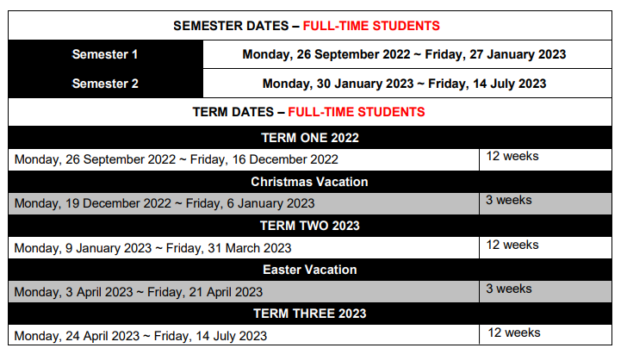
Study Time Allocation
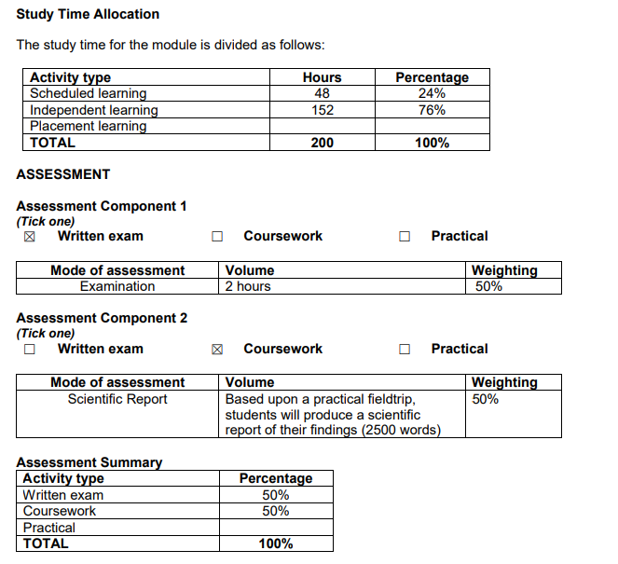

INDICATIVE READING LIST
Module Code ACNA5001
Module Title Coastal, Marine and Wildlife Conservation
Classification Reading List entry Electronic
*
Essential Probert, P.K. (2017) Marine Conservation. Cambridge
University Press

Essential Earll, B. (2018) Marine Conservation: People, Ideas
and Action (Perspectives in Conservation Biology),
Pelagic Publishing.

Essential Haslett, S.K. (2016) Coastal Systems (3rd Edition).
University of Wales Press, Cardiff

52
Essential Esteves, L. S. (Ed.) (2014) Managed realignment: A
viable long-term coastal management strategy.
Dodrecht Springer

