TASK TWO OF PSYCHOLOGY

NAME OLAJUMOKE OLAIDE OWOLAWASE

STUDENT ID; 2026205

MODULE; BMHP4003

LECTURER NAME: REBECCA KAVANAGH

Contents
INTRODUCTION 2
SOCIAL IDENTIFICATION THEORY 3
Social categorisation 5
Social categories for meson 5
THE PLANNING OF THEORTY BEHAVIOUR. 6
Perceive control 7
Theory of aggression 9

INTRODUCTION

According to statistics in England and Wales, there were around 210,000 drugs offences recorded by police in England and Wales, this is 19%highter than 2019/2022in the national total excluding great Manchester from the year ending March 20019 through March 2021and not directly comparable with the other years. [drugs and crime, statistics for England and Wales published,23 December 2021].
This report will be divided into three distinct parts.
The theory of social identity,
Theory of planned behaviour.
Frustration Aggression Hypothesis
What are social identities individual knowledge that they belong to a certain group? They are into three components of social identity {social categorisation, social identification, and
social comprising}.
the second paragraph discusses the theory of planned behaviours and how it applies to the case study. They are three components of behaviours {attitude, subject norm, and perceived behaviour control}
sections: In three-paragraph, I will be discussing the frustration-aggression hypothesis applied to the case study.

SOCIAL IDENTIFICATION THEORY
According to Tafel [1972, p31] defined social identity theory is individuals’ knowledge that the person belongs to certain social groups together with emotions and values important to the group membership and the self-concept as membership of the group. That is social identity this is a person’s sense of who they are based on their group memberships.
Examples of the groups people can belong to are family, football team, and social class. Which people belonged to be an important basis of pride and self-esteem.
The groups give them social identity and a sense of belonging to the social world. (McLeod, 2019, october24. social identity )

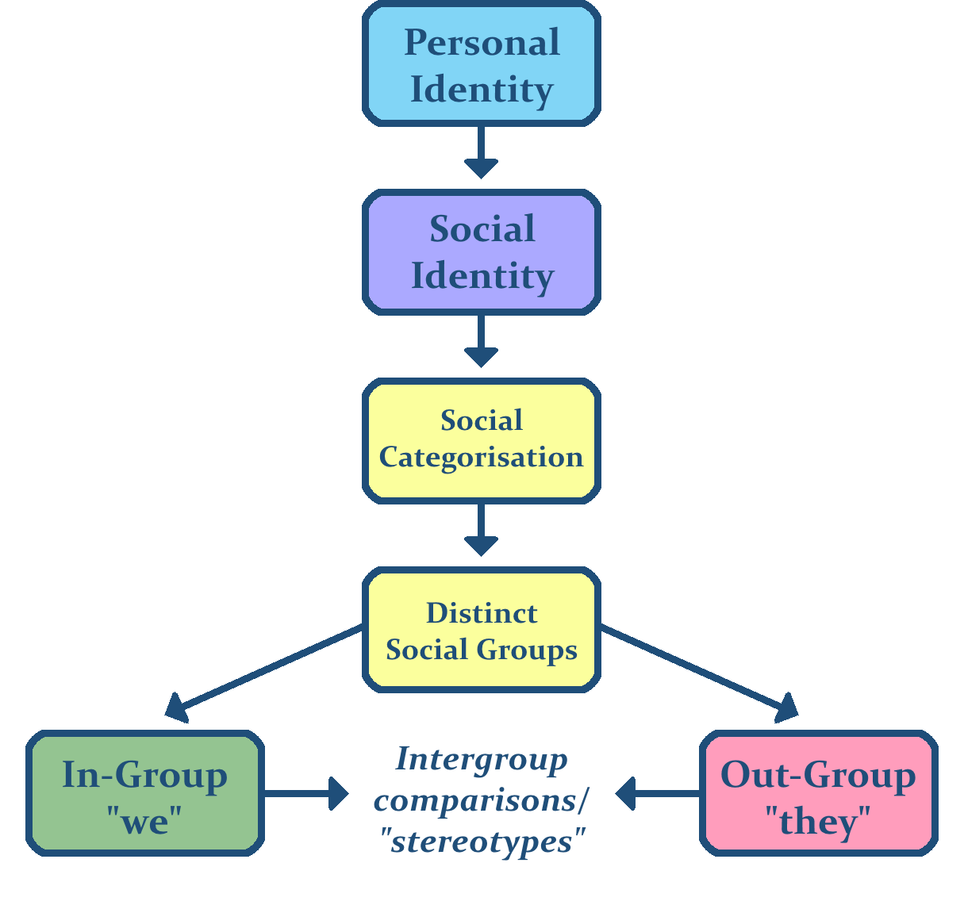fig1 shows the social identity is group,
There are three types of social identity theory
Social categorization:
social categorising as choosing people into categories that give us information about them that help us deals with the difficult social situation also helps us to disregard the individuals interprets them by their characterise.

Social categories for meson
In the Werrington prison meson keep to the rules that the young offending teams give them and he has more responsibility to go to the college and do what the youth offending team asked him to do.
in the Werrington prison where meson is, there may be diverse types of children of his age, the rules beaker and, another rules keeper that is not ready to be listening to what the youth offering team telling them to do, therefore meson joins the group of college children and he was supported by the youth offending teams by helps him when they see his attitude toward going to college, such as drop him to college with his college groups, get some resource for him to use in the colleges such as laptop, pen, books, show him the library, because he attended his apprenticeship on time.
Social identification can be described as accepting the identity of the group we have categorised ourselves as belonging to and our self-esteem becomes dependent on the group membership, it can be emotional importance of the group membership for an individual. [
Social identification for Meson Kabee in the Werrington prison meson identify himself in college groups who keeper to the rule and give his best behaviour and thinking positive to show his serious toward going to college and even do the apprenticeship, by doing this helps Meson to rules keeper at ready to do anything they asked him to do, such as wake up early dress up and ready for college every day.
Social comprising this is the comparisons trend between two groups [in group and out group].
Social comparison for meson kabee: for meson in the Werrington prison the ingroup are the college group while the out-group is those of age group that they are in the Werrington person who they do not want to do anything the rule breaker. while outside Werrington prison the ingroup is the old friend in the area they have something in common sure as drugs dealers that, while in the out-group is the youth’s offending teams, because when they notice that he did not attend college anymore and call for a meeting he displays his attitude towards them.

THE PLANNING OF THEORY BEHAVIOUR.

[Ajzen, 1991] the planning behaviour suggests that the satisfactorily indicate behaviour, we need to consider further variable over the above attitudes [ subjective norms [ our beliefs about the impression of important other, perceived behavioural control our belief that we have control over our behaviours. [Ajzen. [1919]. Theory of planned behaviour, organization Behaviour and Human Decision,50[2],179-211.
There are three components of planning behaviours.
Attitude
Subjective norm

Perceive control
The attitude that people toward the behaviour and it is significant to note that it is the attitudes toward behaviour that are is important
The attitude toward meson kebab's behaviour in going to college was incredibly positive because when he joins the group of the children who go to college, he knows that if he got a cheerful outlook and has his responsibility to do it will help him to go out of the Werrington prison on time when the youth offending teams see his attitude, they try to help him.
Manson also had a negative attitude towards the youth offending teams when he was called meson for a meeting and ask him why he not going to college after living in prison Werrington and he was seeing old friends that are drugs dealer
Mason may also be threatening his old friends that if he does not join the group, he may face pressure from them, this may cause his attitude to change.
Subjective norm: this is very essential to the belief of people who matter to us our family and friends whether they have a favourable attitude towards the behaviours.
Meson's subjective norm when Manson lived in the Werrington prison was he was not going to college, maybe people around him is not going to college so he may see that going to college is nothing but if he around him attend college mason will keep on going to college and thing if he finished from college he can get a good job for himself in future,

Perceived control and whether the person believes they got bits of help and opportunity to engage in the behaviour.
All these three are fed into the intention
Planning behaviour for meson
MENSON ATTITUDE TOWORDS GOING TO COLLEGE
MENSON BEHAVIOUR
MESON INTENTIONS

MANSON SUBJECTIVE NORMS
People around attended college

MENSON BEHAVIOURAL CONTROL,. Does mason got help that make him going to college
Fig 3 shows mason's plan behaviour
Mason perceived control for meson toward going to college is that did meson got help on how to go to college and did get everything he needs to do his college work or got resources and support on how to get to college on and have if this support is there for mason, he may change his attitude or have positive behaviour towards college and it like to have strong intention either good or bad toward college.

Theory of aggression
What is aggression; According to Bandura [1973] say that the behaviour that causes personal injury or destruction of property. [Bandura, A, [1973NJ]. Aggression: social learning theory analysis. Englewood Cliffs, NJ: prentic-Hall.].
There are two aggression theories biological theory aggression and social theories aggression.
Dollard et;al;s. [1939] says the Frustrating -aggression hypothesis is one of the first attempts to model and explain aggression in humans.
Dollard’s also suggested that if an individual is discouraged from accomplishing his purposes by some external factors, this will lead to frustration which will lead to aggression,
FRUSTRATING AGGRESSION.
Mostly hypothesis proposed that aggression happens expected to frustration being experienced. they suggested that individuals are frustrated by an encounter or object then they reactions with aggressive behaviour -if it is the reason to do so.
If an individual is unable to express their frustration with aggressive behaviour, then the individual may redirect this aggressive strength towards different situations or objects – this is called displaced aggression.
Frustration and hypothesis for mason
Meson kabee was verbally aggressive and frustrated when the youth offending teams visit him for a meeting and ask him questions about why is not attending college and he see with the group of his old friend that has known with police, he was very frustrated, maybe the ways they approach him and the tone of voice, body language, eye contact such as rolling eyeballs. this is direct aggressive toward meson in the building.
Maybe mason was frustrated because he did not have a way to get to college and there is resources or money to take the bus to college. [financial]
Manson may be indirectly frustrated in his personal life, because he may be threatened by his old friends to join back the drugs dealer groups, this may cause him to frustrate because he is afraid of going back to prison. He is also frustrated about himself seems like there is no point in going to college because when he finished, he may not be able to job and also, he may be frustrated about being lonely in life.

Conclusion.
In conclusion with help of the theory of social identity and the planned behaviour and frustration-aggression hypothesis have identified the solution to help meson explain ways which will assist him to become a better person in life .social identity explain the group of people with which meson can associate himself with to have positive attitude within the community, while they planned behaviour help meson with his attitude and subjective norms and perceived control will guide his attitude better ways, while frustration-aggression hypothesis analyses what could be a reason for Manson aggression attitude. I believed with these theories will help meson help to shape his life positively if it been considered and articulate.

Reference

1. Tajfel, H., 1972. Some developments in European social psychology. European Journal of Social Psychology.
2. Billing, M. and Tajfel, H., 1973. Social categorization and similarity in intergroup behaviour. European journal of social psychology, 3(1), pp.27-52.
3. Abrams, D. and Hogg, M.A., 2010. Social identity and self-categorization (pp. 179-93). The SAGE handbook of prejudice, stereotyping and discrimination. [Bandura, A, [1973NJ]. 4. Aggression: social learning theory analysis. Englewood Cliffs, NJ: prentic-Hall.].
5. Ajzen, I., 1991. The theory of planned behaviour. Organizational behaviour and human decision processes, 50(2), pp.179-211.
7.https://en.wikiversity.org/wiki/File:Social_identity_theory.png.
(McLeod, 2019, october24. social identity )

