Sarah Marsh
28002939

ECED 7002 Resit Assignment

Critically explore the changing nature of globalisation and inequality in a Post-Covid World. (APPENDIX B)

One year on from lockdown one in March 2020 United Kingdom has experienced three variants of Coronavirus and at the time of writing is once more in the midst of tightened restrictions and vast number of people who have tested positive for the virus on 29th December there were 222,250 new cases reported (JHU CSSE COVID-19 Data 2020). During the past year the public has accepted the wearing of masks, remote working or hybrid working has become the norm. During the peak of the first wave of Coronavirus (COVID-19) countries mandates including acceptable social distances and orders to stay at home unless journeys were absolutely necessary more recently Drakeford, First Minister of Wales has recently introduced legislation which will see people who are able to work from home but do not; face individual fines as well with their employers being fined both are imposed on an increasing should any breaches of legislation continue (gov. Wales 2021).
It must be noted that certain adjustments regarding travel and import/export changes to global trading and free trade coincided with Article 50 of Brexit being enforced in January 2020, Bhattacharjee 2020 noted:

“With Brexit and Covid-19 the UK is facing two large economic disruptions that are clearly affecting some places more negatively than others. Hence – in the absence of adequate policy intervention – they will likely worsen spatial disparities in the UK even further. First, due to Covid-19, large groups of workers are required to work from home. However, evidence shows that this transition has been easier for workers with higher incomes and jobs in service sectors such as finance, insurance, and professional services (Costa Dias et al., 2020), both of which are likely to be found in richer regions”

Thus, the global world of businesses and society as a whole has been forced to adjust in all facets of daily life ; - how people shop, access healthcare and education, additionally how we communicate, whilst in not only in lockdown but also learning to live alongside Coronavirus. The phrases Remote working, Staycation and Social Distance alongside the anacronyms LFT (Lateral flow test) and PCR (Polymerase) Chain Reaction are now part of daily conversation, with the shortening to ‘remote’ being used in job advertisements for example.
“Regional Safeguarding Officer- job post
Clearsprings Group
Cardiff•Remote
£23,000 - £25,000 a year - Full-time, Permanent”

Indeed 2021.

By May 2020 both the UK and many European countries had been placed in total lockdown in an attempt to reduce the deaths of those people who had contracted the deadly virus COVI – 19 with subsequent damage to their economies resulting in loss of businesses and jobs (Parker et al 2020), “not since WW11 has the world experienced such severe restrictions on the freedom of individuals” (Pananto, et al 2020). Ample evidence exists to support the view that technology enabled education to continue within the first few weeks post lockdown (Daniel 2020). The retail sector was forced to change it’s working processes to meet the government mandates, the customer needs during the pandemic. However, many retail organisations began to offer online shopping services and certain healthcare sectors offering their services such as e-consultations with a GP at local level this requires the patient to first of all set up an online account which will be registered with their GP if they offer the service (NHS Wales 2020). Technology has played a huge part in as never before in in the day to day lives of ordinary people. Using a functionalist lens, concentrating in this instance on wellbeing during a global pandemic is important to visualise individual needs and lives on a day-to-day level, through community to national/global in a covid world.

The use of robotics and technology can be seen from the diagram below.

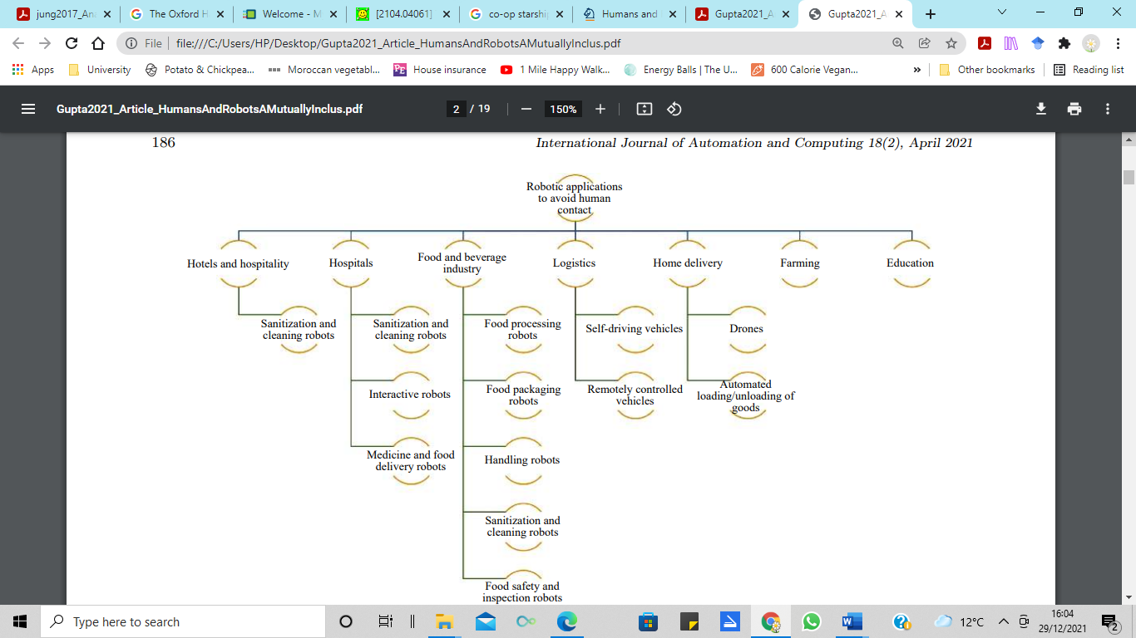

Journal of Automation and Computing (2021)

The image illustrates the extent to which robots, drones, automated systems, and AI have not only taken over hazardous tasks but also been used to assist in more mundane daily living skills.

Recent studies have explored the impact of Coronavirus on the use of technology for online shopping, one such study carried out by The Organisation for Economic Co-operation and Development (OECD) reported several key messages.
These being
- There has been a shift from bricks and mortar retail to e-commerce
- Not all online sellers and product categories benefitted from the rise in e-commerce
Certain shifts brought on by Covid-19 likely involve long term changes in e-commerce
OECD (2020)

Perhaps most importantly when discussing policy changes OECD noted “ policy makers need to ensure that e-commerce delivers for everyone more than ever”……. “ closing digital divides and fostering participation of the vulnerable.” … “ fostering the enabling environment for e- commerce.

Many customers/consumers also have additional needs, are vulnerable, having health needs and retails should remind themselves of the importance of retail experiences to their customers and the need to communicate how much they (the retailer) values the customer. This can be done by a discrete but transparent exercise of information gathering in order to provide a tailored purchase/delivery. Particularly during the pandemic (Pantano 2020).

When considering the global response and availability of online trading the OECD noted that by the end of May 2020 online order s in North America had almost doubled and in Europe were up by 50%.. The UK online edition of The Guardian report in October 2020 at that time the giant corporations Amazon had reported a revenue of $96.5 BN including net sales of £20.63 BN in U K. Supply chain Dive on online supply chain management journalistic magazine reports in 2020 that Amazon’s 2020 planned growth exceeds the last three years growth combined (Leonard 2020). The following chart with what the writer argues to be the most appallingly patronising title ‘Bezos Little Helpers’ even in the spirit of the holiday season demonstrates the employment statistics for the holiday season.

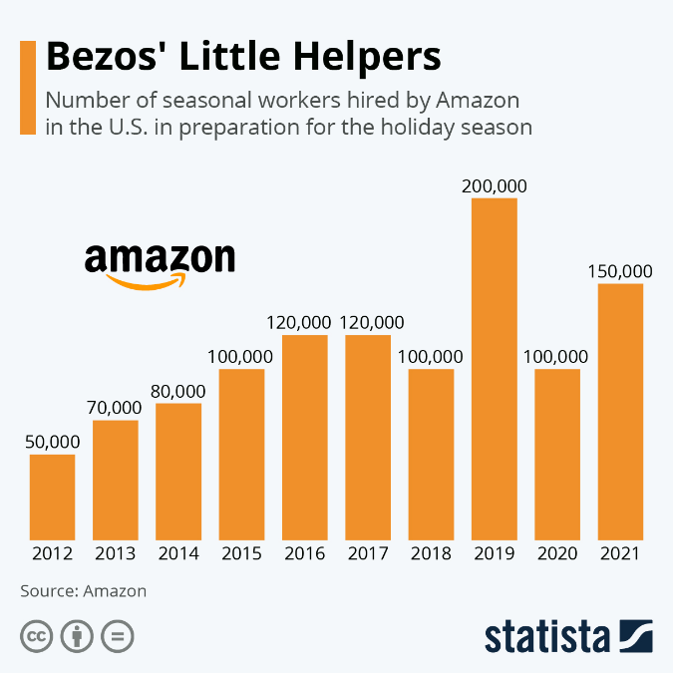

Statistica (2020)

Sungham and Hyunsu (2017) Analysis of Amazon Prime Air UAV Delivery Service as far back as 2017 stated the extent to which the global giants were utilising technology to replace humans. The role of humans in retail, logistics and ‘warehouse work’ is becoming overshadowed by technology and AI with the introduction of the use of the phenomenon of ‘last mile’ logistics which again has been increasingly used during the pandemic.

Last mile or last leg describes literally the last leg of a journey of a package from the warehouse/store to the consumer. Forbes business journal presented the view that because of the horrific disruption to consumer logistics during the pandemic has caused an increase and rethink of increasing last mile use of robotics and autonomous carriers this is also accompanied by customer use of package tracking and usefulness to the consumer. In addition to autonomous delivery vehicles/‘robots’ Singh et al 2021 (2021) note a delivery model that utilises a synchronised delivery last mile system of truck/drone for the provision of essentials and medicines where there are high rise buildings.
Each of the aforementioned examples of the impact of Covid -19, has referred to the global retail habits and transportation of goods. It is gratifying to note that some online web suppliers had in 2020 switched to local suppliers only, particularly in Belgium and the Netherlands (Panatano 2020).

However , the pandemic and subsequent shift to all things technology in daily life also highlighted a digital inequality within the UK. Recent studies undertaken by Cambridge Centre for Housing and Planning Research in Partnership with Cambridge University have explored the subject of digital exclusion this yielded the important facts that whilst lockdown illustrated the importance of digital communication 22% of the UK population lacked basic digital skills, furthermore only 51% of families with an income of between £6,000 - £10,000 as opposed to 99% of people earning over £40000 (Holmes and Burgess 2021). Researchers also reported feedback that in cases where children were being taught online , even more issues prevailed where they needed to have work produced in paper packs which could not be delivered because of lockdown rules. The research also highlights the problems digital inequality , lack of digital skills that affect important areas of life in a non-digital world barriers to employment due to most job applications having to be produced online, inability to write a CV, interviews being conducted via a social platform such as ZOOM or Microsoft Teams both of which necessitate a different set of digital literacy skills (ibd).

Both during the lockdown and not in many banks are closing or have closed permanently which makes accessing finances and budgeting difficult if not impossible as well as public bodies such as Department for Work and Pensions accepting online applications only at its most basic level a person will need to use the following link. https://www.gov.uk/universal-credit/how-to-claim . The information details the requirements which include to set up an account and have an email address. If a person does not have these they can call to a Jobcentre or telephone a helpline. The writer argues that both of these options are not viable at the present time due to lock down or the huge increase in benefit claims, The number of people on Universal Credit doubled to 6.0 million on 11 March 2021 from 3.0 million on 12 March 2020, the last count date before the coronavirus (COVID-19) pandemic (gov.uk 2021). Holmes and Burgess (2020) conclude their work with a profound statement as follows “Unless digital exclusion is taken seriously and addressed, millions of the poorest people in the UK will yet again suffer the consequences”
Within the UK digital inequality lies even more issues in the Principality of Wales and that is that of connectivity, unfortunately due to its spectacular scenery and picturesque villages broadband connection is poor which has been reported in Gann’s 2019 work “Wales has particular challenges in digital inclusion, including social deprivation, an ageing population and poor broadband connectivity in remote rural areas”. The Institute of Wales is an independent think tank and charity having no affiliation to government or political parties. Carrying the strapline “we aim to make Wales better” the writer suggests that this organisations values fit entirely into a functionalist stance by interconnecting values that if accomplished will indeed make Wales better.

The organisation makes the bold statement that access to Internet is a Human right, commenting again on the lack of digital literacy in Wales; highlighting that 19% of disabled people and 17% of people in social housing in Wales are digitally excluded furthermore stating “The proportion of people who do not use the internet rises to 48% for those aged 75 and older, and 18% for those 50 and older”. It may be assumed from these figures that those who are older may in fact need digital skills to access health care online.

In conclusion the writer reiterates that the world remains within the restrictions of the coronavirus Covid 19 Global Pandemic currently Wales lies at alert level 2. The movement of people is governed by their vaccination status, and the production of Covid “passports “ either paper or digital, negative lateral flow tests or negative PCR tests. These requirements vary from country to country. The nation as a whole is now beginning to experience travel disruption indirectly connected to the virus as public transport operators are having to cancel buses and trains immediate evidence of this and the need for connectivity can be seen in appendix A whereby a few moments ago a family member received a cancellation notice of their Eurostar train on Sunday. The message was received both by email and text, without digital literacy skills they would not have known this and would have travelled to London on Sunday expecting to travel to Belgium . The writer has themselves had to overcome limited literacy skills which have in the past affected their ability to produce work to a sufficient standard and although the university has provided superb support the online learning has been affected by connectivity issues.
Functionality and post positivism have each played a party in the worlds outlook on technology as the world has undoubtedly changed for ever.

Whilst some of the changes are for the better and will improve retail experiences the writer during the course of researching the assignment has unearthed information that casts a shadow over the ethics and transparency of Co-operative stores renowned for being at the forefront of environmental issues. The Cooperative group is addressing the Last Mile logistics. In September of this year the group issued a press release announcing the expansion of its Starship Technologies autonomous vehicle deliveri ies which it describes as being UK wide. However nowhere in the information is Wales mentioned. The extra vehicles will be used in Milton Keynes .

“Co-op and Starship Technologies have today confirmed plans to extend their partnership, adding new robots to take the total fleet to 500 autonomous vehicles across the UK, while launching robotic delivery services in five new towns and cities.”
Co-operative Media (2021).

The use of the vehicles is ostensibly to help cut carbon emission - a great part of the Co-op’s selling point, however it would appear that the scheme also involves a strategic partnership with the global giant Amazon who can hardly be described as moral or ethical. The writer would like to include the following statement to conclude the critique of globalisation Post Covid an, illustration of one of the original co-operative movements, utilising modern technology in a postmodern situation but possibly destroying its ethical stance by partnering with one of the largest corporations in the world.

“ C o-op announces major acceleration of ecommerce strategu – new partnership with Amazon and extension of Starship robot deliveries to fuel online sales in communities
Co-operative Media Release (2021)
APPENDIX A

importante concernant la réservation 4TC27Z - Belangrijke informatie over je boeking 4TC27Z
Fwd: Important information about booking 4TC27Z - Mise à jour

SM
Fri 31/12/2021 17:36
- Sarah Marsh (28002939)
RHYBUDD: Deilliodd yr e-bost hwn o du allan i system E-bost Prifysgol Cymru Y Drindod Dewi Sant. Peidiwch ag ateb, na chlicio ar ddolenni nac agor atodiadau oni bai eich bod yn adnabod cyfeiriad e-bost yr anfonwr ac yn gwybod bod y cynnwys yn ddiogel.
WARNING: This email originated from outside University of Wales Trinity Saint David’s Email System. Do not reply, click links or open attachments unless you recognise the sender's email address and know the content is safe.

---------- Forwarded message ---------
From: Ashley Marsh <
Date: Fri, 31 Dec 2021, 17:34
Subject: Fwd: Important information about booking 4TC27Z - Mise à jour importante concernant la réservation 4TC27Z - Belangrijke informatie over je boeking 4TC27Z
To: Sarah Marsh <smarsh9341@gmail.com>

Sent from my iPhone
Begin forwarded message:
From: Eurostar <no-reply@e.eurostar.com>
Date: 31 December 2021 at 16:29:44 GMT
To:
Subject: Important information about booking 4TC27Z - Mise à jour importante concernant la réservation 4TC27Z - Belangrijke informatie over je boeking 4TC27Z
Reply-To: Eurostar <reply-fe8a11737d6d017e71-469_HTML-430402649-7269956-1@e.eurostar.com>
﻿
Email looking a bit odd? View Online

Hello Ashley.
We’re sorry to let you know that your train 9148 on Sunday 02 January from London St Pancras Int'l to Brussels Midi has been cancelled. This is because of operational reasons.
You can either:
  •
  Exchange your booking to travel at a different time or date for free.
  •
  Or cancel your booking and get a full refund. If you have not booked directly with Eurostar, please contact your point of sale.

Please exchange your ticket or ask for a refund as soon as possible.
We’re sorry for the inconvenience caused.
The Eurostar team

Bonjour Ashley,
Votre train Eurostar 9148 prévu le dimanche 02 janvier au départ de London St Pancras Int'l et à destination de Brussels Midi a malheureusement été annulé pour des raisons opérationnelles.
Vous pouvez à votre convenance :
  •
  Échanger gratuitement votre billet en choisissant une autre heure ou date de départ.
  •
  Annuler votre réservation et demander un remboursement intégral. Si vous n’avez pas réserver directement chez Eurostar, veuillez contacter votre point de vente d’origine.

Nous vous recommandons d’échanger votre billet ou de demander un remboursement le plus rapidement possible.
Veuillez nous excuser pour la gêne occasionnée.
L’équipe Eurostar

Hello Ashley,
Helaas moeten we je laten weten dat de Eurostar-trein 9148 op zondag 02 januari van London St Pancras Int'l naar Brussels Midi is geannuleerd. Dit komt operationele redenen.
Eurostar biedt de volgende mogelijkheden:
  •
  Boek kosteloos je ticket om voor een andere dag of tijdstip.
  •
  Annuleer je boeking voor een volledige terugbetaling. Als je niet rechtstreeks bij Eurostar hebt geboekt, neem dan contact op met je oorspronkelijke verkooppunt.

We raden aan om zo snel mogelijk het ticket om te boeken of te annuleren.
We verontschuldigen ons voor het ongemak.
Met vriendelijke groet,
Het Eurostar-team

Contact us

You've been sent this email by Eurostar International Limited, Part 6th Floor, Kings Place, 90 York Way, London N1 9AG. Registration number 02462001.
Copyright © 2021 Eurostar International Ltd. All Rights Reserved.

APPENDIX B

Assignment Title  Ass 2: | Critically explore the changing nature of globalisation and inequality in a Post-Covid World. | Word count (or equivalent): | 2250 words
Submission deadline: | 5 March 2021 | Return date of provisional marks & written feedback: | 23 April 2021

References

Bhattarcharjeem A., Nguyen, D. and Venables, A, T (2020) “ The Prospects for Regional Disparities in the UK in Times of Brexit and Covid-19, “National Institute Economic Review Cambridge University Press, 252, ppR1-R 3.doi:10.1017/nie.2020.25. Available at : https://www.cambridge.org/core/journals/national-institute-economic-review/article/abs/prospects-for-regional-disparities-in-the-uk-in-times-of-brexit-and-covid19/E4A49BA0B3AAF5825E31639B0FCD971B (Accessed 30.12.2021).

Co-operative Media (2021) Co-op and Starship Technologies to expand partnership to 500 robots across five new towns and cities to cut carbon on last mile deliveries Available at https://www.co-operative.coop/media/news-releases/co-op-and-starship-technologies-to-expand-partnership-to-500-robots-across (Accessed 28th December 2021
Daniel, J, Sir, “Education and the Covid -19 Pandemic” , Prospects 49, pp 91-96 Available at: https://link.springer.com/article/10.1007/s11125-020-09464-3. (Accessed 19.12.2021).

Gann, B., “Digital Inclusion and Health in Wales “ Available at Bob Gann (2019) Digital Inclusion and Health in Wales, Available https://www.tandfonline.com/doi/abs/10.1080/15398285.2019.1608499 (Accessed 27th December 2021).

Gordon, C., Forbes (2021),” Covid-19 causes global supply chain havoc intensifying last mile logistics innovations” Available at: https://www.forbes.com/sites/cindygordon/2021/12/27/covid-19-causes-global-supply-chain-havoc-intensifying-last-mile-logistics-ai-innovations/?sh=71a272346a2c (Accessed 30th December (2021).

Gupta, A. Singh, A., D. Bharadwaj, A. K. Mondal. (2021), Humans and robots: a mutually inclusive relationship in a contagious world. International Journal of Automation and Computing, vol.18, no.2, pp.185–
203, 2021. Available at : http://doi.org/10.1007/s11633-020-1266-8. (Accessed 29
December 2021).

Burgess., G., Holmes, H., Cambridge University “Pay the Wi-Fi or feed the children, Coronavirus has intensified the UK digital Divide”. Available at https://www.cam.ac.uk/stories/digitaldivide (Accessed 25th December 2021).

Gov.Uk (2021) Universal Credit Statistics, 29 April 2013 t0 14 October 2021. Available at:

https://www.gov.uk/government/statistics/universal-credit-statistics-29-april-2013-to-14-october-2021/universal-credit-statistics-29-april-2013-to-14-october-2021#:~:text=The%20number%20of%20people%20on%20Universal%20Credit%20doubled%20to%206.0,due%20to%20the%20coronavirus%20pandemic. (Accessed 29 December 2021).

Helmore, E., (2020), The Guardian, “ Amazon third-quarter earnings soar as pandemic sales triple-profits” Available at: https://www.theguardian.com/technology/2020/oct/29/amazon-profits-latest-earnings-report-third-quarter-pandemic Accessed 31st December, (2020)

Indeed (2020) Available at: https://uk.indeed.com/jobs?q&l=Cardiff%2C%20Cardiff&advn=3010801513083604&vjk=336cbcef40880b0e (Accessed 31.12.2021).

International Journal of Automatic Computer Automation (2021) “Robotic applications to avoid human contact” Springer .com ( Accessed 29 December (2021)

JHU CSSE COVID-19 Data (2020). Coronavirus United Kingdom, Available at https://github.com/CSSEGISandData/COVID-19 (Accessed 30 December 2021).

Leonard, M., (2020) Supply Chain Dive ‘ Amazon Logistics' planned 2020 growth exceeds previous 3 years combined’ Available at https://www.supplychaindive.com/news/rbc-amazon-logistics-delivery-stations-growth/585565/ (Accessed 31 Dec. 2021).

Organisation for Economic Co-operation and Development (OECD (2020) policy Responses to Coronavirus Covid-19 “ E-0commerces in the time of Covid – 19 “ Available at: https://www.oecd.org/coronavirus/policy-responses/e-commerce-in-the-time-of-covid-19-3a2b78e8/ (Accessed 31.12.2021).

Pantano, E., Pizzi. G., Scarpi, D., and Dennis., Journal of Business Research, “ Competing during a Pandemic’ Retailers ups and downs during covid-19 outbreak”.

Sing, S., Kumar, R., Panchal R., and Tiwari, M. K., (2021) International Journal of Production Research “ Impact of Covid-19 on logistics systems and disruption in food supply chain” (Accessed 18 December 2021).

Statistica (2021), “Bezos’ Little Helpers”, Available at https://www.statista.com/chart/11909/seasonal-workers-hired-by-amazon/ (Accessed 29th December 2021).

Walker, D., (2020) Institute of Wales, Politics and Policy, “Access to the Internet is a Human Right” Available at: https://www.iwa.wales/agenda/2021/02/access-to-the-internet-is-a-human-right/ (Accessed 19th December 2021).

World Health Organization . (2020). Coronavirus disease (COVID-19) advice for the public. https://www.who.int/emergencies/diseases/novel-coronavirus-2019/advice-for-public #

