Abstract

Daniel Garton (2219350)

2219350@student.uwtsd.ac.uk
Daniel.garton@baesystmes.com
CAE Assignment
ABCD5007 – Computer aided engineering
Contents
1. Introduction 2
2. What is CAE 2
4. What is Ansys 3
5. Types of simulation 3
6. Validation to real world 4
7. Materials validation 4
8. Assumptions 6
9. Modelling 7
10. Meshing 7
11. Solver ability 8
12. Types of tests 8
13. Results 9
13.1 Failed set 11
13.2 2nd working set 12
14. Abaqus compare 14
15. Potential limitations to my data 15
16. Difficulties 15
17. Simulation improvements 16
18. Advantages of CAE and real-world use 16
Bibliography 17

Figure 1 JC values 1 5
Figure 2 Damage constants 5
Figure 3 JC values 2 5
Figure 4 - Steel 4340 dog bone test 6

Introduction
This report investigates the usefulness of CAE in the engineering design process for a munition. CAE is used across many industries now and becoming a standard for business. This report outlines how using CAE can be used to benefit engineering problems and addresses the downfalls of simulations.

What is CAE
Computer aided engineering involves using software to complete engineering analyse [1]and simulate the performance/ characteristics of components in scenarios. For example, a beam under tension on a bridge CAE software can be used to simulate how the beam will react to force applied to the bridge.

CAE does differ to CAD and CAM in specific ways, CAD (Computer aided design) is using software tools to design components. CAM (Computer aided manufacturing) is using software tools to automate the manufacturing process E.g. 3d printing.

What is Ansys
Ansys is an engineering simulation software package used across many industries to simulate products in real life situations to optimize the product. It is a comprehensive engineering tool which can be used to simulate various real-world applications. Ansys was founded in 1970 and is based in Pennsylvania USA and serves a wide range of industries such as aerospace, automotive, manufacturing and electronics. Ansys offer a wide range of engineering tools to simulate different aspects. Ansys features Multiphysics simulations, HPC (High performance computing), User friendly interface, Integration with CAD and allows for personalized scripting. There are other alternatives on the market such as Abaqus, SolidWorks and fusion.

Types of simulation
There are different types of simulations [2] that can be used to solve different engineering problems, each type often has different abilities to solve specific type of engineering problems like heat transfer or stress. Ansys uses FEA (Finite element analysis) is numerical method used to solve complex engineering challenges. It is effective for analysing the behaviour of structures, components and materials under various physical conditions. The key principle of FEA is breaking the physical structure into smaller simpler components called finite elements. These finite elements are interconnect at points called nodes. The solving the calculations it can accurately simulate how the whole system will respond to various external factors.
Key steps in FEA
- Geometry definition
- Meshing
- Material properties
- Boundary conditions
Solution
- Solving equations
- Assembling the results
Postprocessing
- Results visualisation

BEM is an alternative to FEA, BEM (Boundary element method) is a technique used to solve linear partial differential equations (PDEs) which has been formulated as integral equations. It is useful for problems involving boundaries and interfaces such as flow, structural, elasticity, acoustics and electromagnetics. In BEM the boundary needs to be selected making more efficient than FEA in specific problems.
Other types of Testing methods,
Computational fluid dynamics
Multibody dynamics
Electromagnetic simulation
Thermal simulation
Structural simulation
Vibration analysis
Acoustic simulation
Molecular dynamics

Validation to real world
To ensure that the simulation is accurate to real world the material properties need to be correct and the solver needs to be accurate. Every simulating software uses different solvers which is why different software tend to be more accurate to specific properties.
It was decided to complete a material validation test and compare the test data compared to a real-life simulation to test the solvers accuracy.
I found this paper on [3] on high-speed ballistic impact, using the data collect form this investigation it shows how accurate a simulated bullet impact can be to a real-world bullet impact if correctly set up with the necessary data required.

Materials validation
I collect material properties form websites such as Azo materials [4] and Simulia [5], these are industry standard however to check the values function correctly in the solver of Ansys. A dog bone test was done to test the accuracy of the materials. Dog bone testing evaluates Ultimate tensile strength, Yield strength, young’s modulus, elongation at break and stress strain curve. Other options to test the properties are three-point bend test, compression test, shear test, fatigue test, indentation test, creep test. The dog bone test was chosen as it is standardised and consistent making online results most readily available, it has comprehensive results for stress strain relationship and ductility. Dog bone test is relatively easy to simulate due to the simple geometry and simulation parameters. It is commonly used in industries to test material properties of materials.
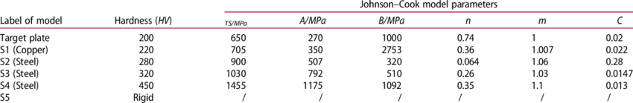
Figure 1 JC values 1
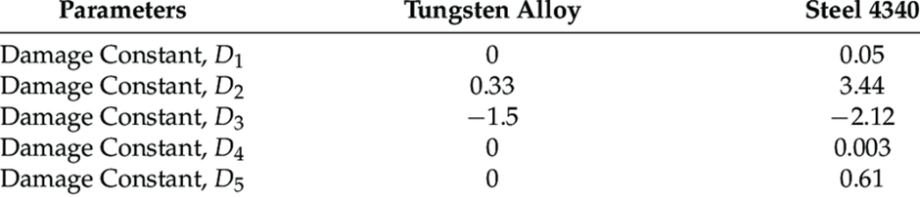
Figure 2 Damage constants
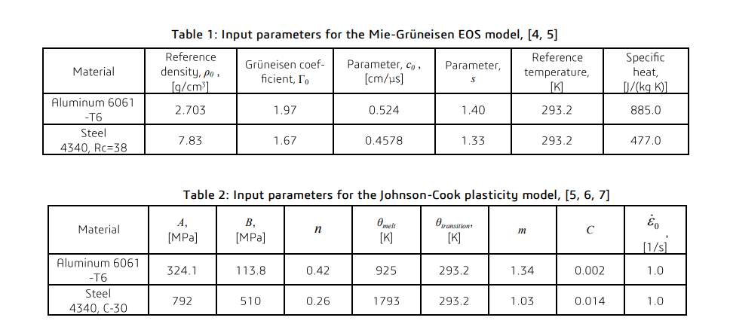
Figure 3 JC values 2
This data was collected online for Steel 4340 in a dog bone test shown below [6]
Strain (%) | Stress (MPa) | Remarks
0.0 | 0 | Start
0.1 | 200 | Elastic Region
0.2 | 400 | Elastic Region
0.3 | 600 | Elastic Region
0.4 | 800 | Elastic Region
0.5 | 860 | Yield Point
1.0 | 900 | Plastic Region
2.0 | 950 | Strain Hardening
5.0 | 1020 | Strain Hardening
10.0 | 1050 | Ultimate Tensile Strength
12.0 | 1030 | Necking
15.0 | 950 | Fracture
Figure 4 - Steel 4340 dog bone test
The first set of steel data collected online created false results in the simulation, it sheared at a stress force of 2.29E-03 this is significantly short of the expected shear point shown in figure 4. A different set of data for steel 4340 reacted better with the solver and gave more realistic results it necked at 6.01E-03 and sheared at 1.68E-03. This is within the margin of error. It did have a visual error where the solver couldn’t properly comprehend how materials sheared apart and created visual anomalies. On the material properties you can see the Johnson Cook values in a graph for each steel data pack and they are significantly different so a significant difference in the simulation results was to be expected.

The aluminium 6061-T6 followed a similar pattern to the steel with the first set of data not working correctly. The Johnson Cook values for both aluminium data set were similar but had significant differences in yield strength. The second data set is about 9% lower then the first data set. The first data set sheard in 2 places which in the real world is a rare but possible occurrence however this occurrence is usually due to reasons the simulation isn’t comprehending. The reasons normally are due to material defects where the material isn’t homogenous or there are internal defects such as voids and cracks. The second reason is that the preparation and poor geometry, multiple fractures can occur when the dog bone is machined it can create stress concentration spots such as notches. When the Dog bone is loaded if the bone is bent the torsion forces can cause multiple fracture points. A material with a high strain rate is most likely to double shear. Therefore, the material that double sheared is likely to have incorrect properties or a solver issue. The final data I got to validate my materials were

The material validation was important to ensure that the materials will react correctly in the solver, this means that the anomalies we get form the bullet simulation we can assume are from the solver.

Assumptions
When running simulations [2] there are some variables which are assumed or not accounted for. The material is assumed to be homogenous meaning there are no weaknesses within the material. It was assumed that the material [7]is isotropic meaning the material is equally strong in all directions, layer materials such as carbon fibre are not isotropic. We assume the values used for the materials properties are correct to real life with no variation unlike a real steel 3430 which has variation in real life due to the manufacturing process. The Bullet hits the plate at the perfect angle of inception unlike real life firings due to yaw. The simulation also takes no account for the thermal effect of the materials and how that will affect the properties of the materials. Finally, no external factors act upon the simulation such as air resistance, gravity and sound waves.
These factors can be accounted for in more robust simulation programs such as temperature and can be set up in Ansys, but these variables were not accounted for in the simulations used in this report.

Modelling
It started with individually creating the plate and bullet on SolidWorks as parts, The bullets diameter is 30 mm and its length 60 mm. The plate is 300x300x50 mm. The dog bones are 120 mm in length and 15 mm in width. Then create an assembly with the bullet facing the plate at 80 mm away model to import into Ansys later. TO begin with you must open a explicit dynamics simulation and import the geometry from SolidWorks. Once the geometry is imported you can create the material profiles with the data you have collected. Once the profiles data is populated you must assign each geometry a material. In the connections folder a body interaction must be selected and create a interaction between the 2 geometry. For the bullet simulation the plate needs to be confined at each edge. This confines the plates movement meaning that when it is struck by the bullet it should react to a rea life trial. The bullet needs to have velocity set in the correct direction to strike the plate. In this case the bullet needs the velocity to be set in the negative X axis direction. The velocity was set to 1200m/s, this speed was selected to be able to compare to previous simulation work. Finally, before the simulation can run you needs to set the time it is calculating and what Properties it must solve, Total deformation, maximum principal elastic strain, maximum principal stress, total velocity.

Meshing
Meshing is critical to Finite element analysis, it is where the elements are divided into small geometry that can be individually analysed and brought together to show how the whole system will simulate the quality of the mesh can significantly affect the accuracy, convergence and computation efficiency of a simulation [8].
The mesh also effects the solver and how the forces are distributed across the plate. Increasing the resolution of the meshing doesn’t just mean more accuracy and linear result. The more nodes can cause faults in the simulation and prevent it running t completion. The meshing shape also makes a difference to the simulation the two main shapes are tetrahedron and hexahedral.
Tetrahedral shapes are four sided with triangular faces, this makes them more flexible to complex components making automatic generation simpler. Tetrahedral is well suited to adaptive meshing allowing for refinement in localized areas. Tetrahedral is usually less accurate than hexahedral nodes. And have higher distortion sensitivity. They have poor performance in linear elastic analysis and less computationally effective for the same effect as hexahedral.
Hexahedral nodes are six sided and have quadrilateral faces. Hexahedral nodes are more accurate specifically in structural analysis as they capture stress concentrations and gradients better. Hexahedral have faster convergence and require fewer nodes compared to tetrahedral mesh. Usually more stable in larger or complex deformation simulations.
Aspect | Tetrahedral Elements | Hexahedral Elements
Shape | Tetrahedron (4 sides) | Hexahedron (6 sides)
Flexibility | High, adaptable to complex geometries | Lower, suited for simpler geometries
Mesh Generation | Easier, faster for complex shapes | More difficult, time-consuming
Accuracy | Lower per element, more elements needed | Higher per element, fewer elements needed
Convergence | Slower, more elements for convergence | Faster, fewer elements for convergence
Computational Cost | Higher, due to more elements | Lower, fewer elements
Applications | Complex geometries, adaptive meshing | Linear analysis, structured meshes, high-stress regions

Both types of mesh were used in the simulations for each geometry. The plate used hexahedral elements as the plate is a basic shape being a cuboid. The hexahedral elements make the plate easier to simulate and accurate due to all the elements being identical. The bullet uses tetrahedral elements due to the bullet being a more complex shape, the tetrahedral elements allow for the meshing to accurate to the geometry. The combination of these two types of meshing allows for the simulation to get the benefits of both types of mesh as they can interact with each type of mesh.

Solver ability
The Ansys solver is a Multiphysics simulation tool meaning it can solve a wide range of engineering problems. For the purposes of this report, there is explicit dynamics which is specific to impact simulations catering for high speed and nonlinear events these points work well for bullet impacts. The Ansys solver excels in nonlinear equations which is vital for bullet impact simulations. The simulation results are high fidelity allowing for the view of stress waves and material failure such as fragmentation. Ansys built in material library has explicit data which is vital for bullet simulation and allows for the user’s data to be added. The mesh can be refined in specific areas allowing for the impact zone to have more detail and lower the resolution of the mesh to the rest of the plate which can improve efficiency of the simulation’s calculation times.

Types of tests
Ansys has multiple different analysis systems available to the user to solve multiple engineering problems. To name a couple:
  - Electric
  - Fluid flow
  - Harmonic acoustics
  - Harmonic response
  - Magnetostatic
  - Modal
  - Motion
  - Static structural
  - Steady state thermal
  - Structural optimization
  - Steady state thermal
  - Structural optimization
  - Transient structural
  - Transient thermal
  - Turbomachinery fluid flow
This makes Ansys a powerful tool due to the number of simulations that are possible to complete within the 1 simulation, these analysis systems can also be used together to create a more coherent simulation using more data to increase its accuracy. For example, to increase the accuracy of a bullet hitting a plate Static structural, steady thermal state and explicit dynamics would increase its accuracy over just using explicit dynamics.

Results
During explicit analysis there are many different mechanical properties that can be measured to determine what the plate is experiencing. The ones focused on in this investigation was Deformation, Max principal stress, Max principal strain and velocity.
Deformation analysis simulates how the plate displaces as the bullet impacts. The simulation measures how each node moves in all directions.
Strain is a measure of the deformation [9] a material will experience under external forces. Simulating the strain distribution across the plate focusing on the maximum tensile strain, this is called max principal strain. Normal strain is measured length per unit length along principal axis’s which is the axis where the strain is maximum and minimum. This data can be used to create failure predictions and predict where the material is most likely to deform.
Stress is defined as the force per unit area that acts upon a material [10]. The max principal stress measures the stress distribution across the plate. Normal stress is measured along principal axis’s which is the axis where the strain is maximum and minimum. Stress is giving a good indication of structural strength and indicates points of failure. Max principal stress can also aid in improving designs.
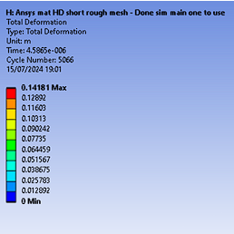
The simulation has an overlay which occurs over the top left, it includes the simulation name, what is being measured and what time part is currently being showed. Below is the scale. The scales on Ansys are automatically applied and can be adapted by the user by adding more colour points. The minimum and maximum are fixed. Each scale is automatically set for each individual data you are evaluating.
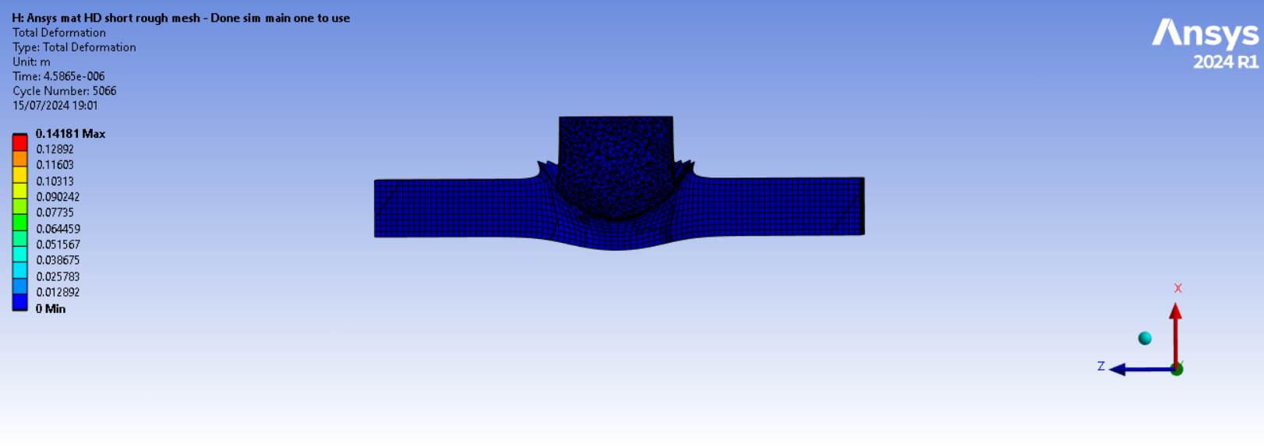

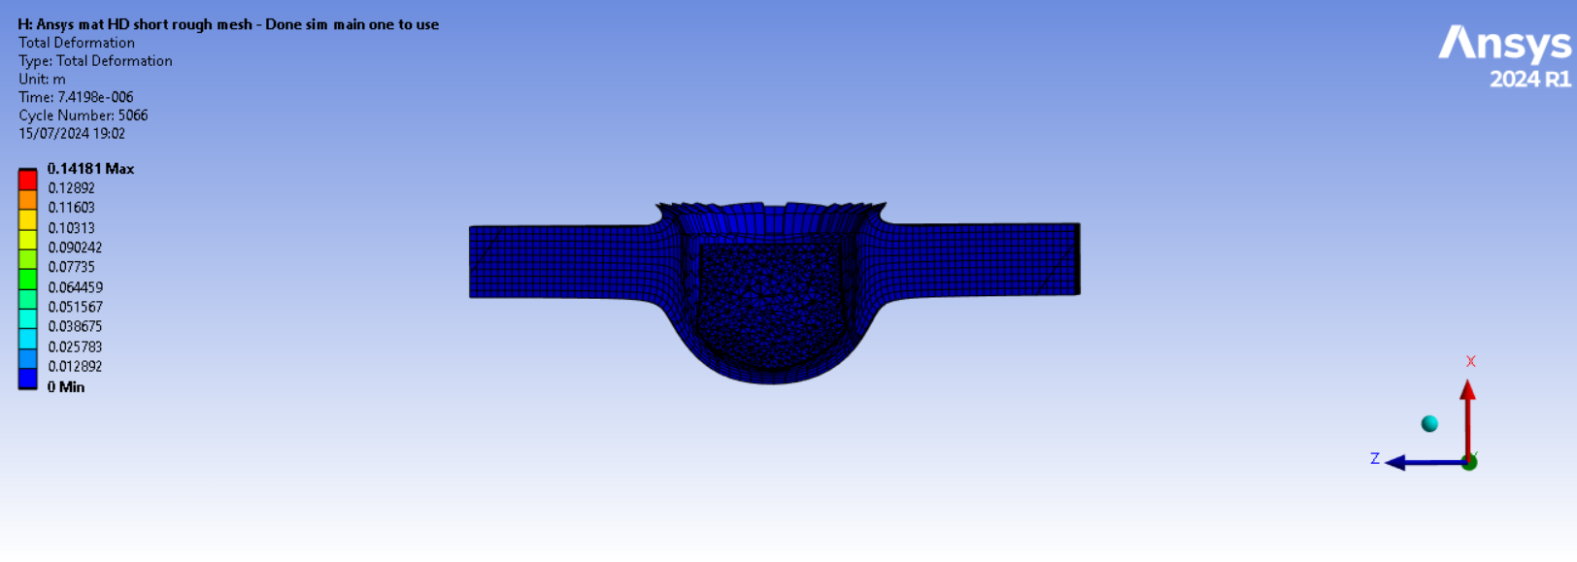

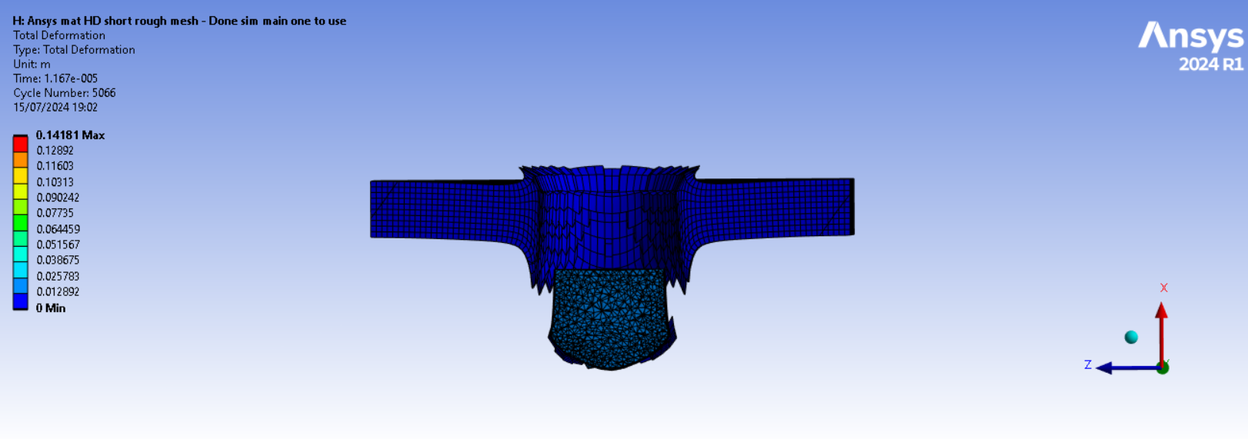

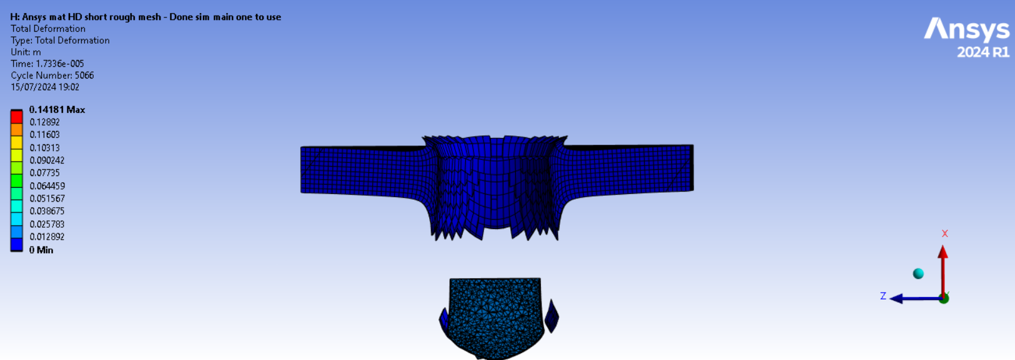

Failed set
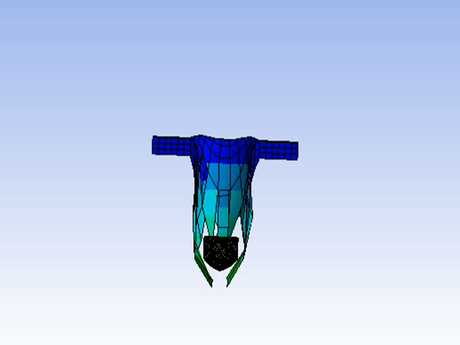
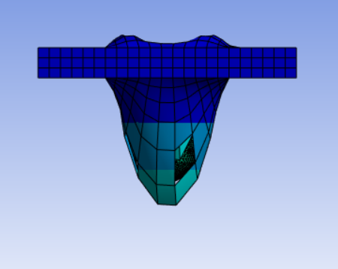
As mentioned above the in the dog bone testing the first material failed to react correctly. It was also used in a bullet simulation. This simulation was at 300m/s due it being the first simulation, the lower speed means the simulation is more likely to complete. Specifically, the steel of the bullet performed relatively realistically. It kept its shape as it perforated the aluminium plate only dulling partially throughout the simulation. The Aluminium however has a drastic difference to how the simulation would’ve been expected to function. 1 The elasticity of the aluminium plate was incorrect this caused the plate to stretch far past the point where it should’ve fractured shown in the dog bone tests. The aluminium should have perforated sooner through the deformation of the plate. The plate on impact creating a large ridge on the entry hole with a smooth gradient unlike the sharp edges normally created on entry.

2nd working set
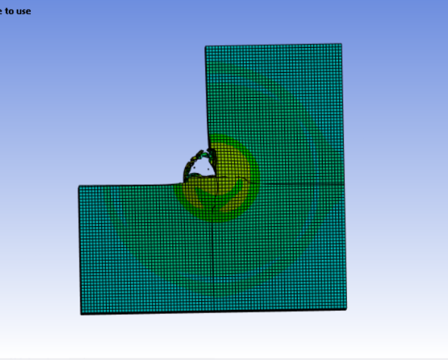
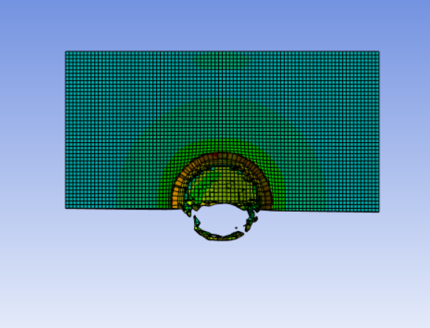
In this simulation the bullet speed is set to 1200m/s and is the correct set of materials properties shown in the dog bone test previously. The bullet in the first has created a recess and the material is being ejected around the edges of the bullet. The first propagation wave is affecting the plate. Looking from the view it can be seen by the green circle impact point. This is a band of strain shows where the material is experiencing the highest strain. This wave travels through the plate to the edges before traveling back to the centre of the plate. The plate strain rate in this band is 0.0034 whilst the rest of the plate is -0.00111 strain rate. The plate is penetrated in this stage and the back end of the plate has bowed out and is experiencing the highest strain rate of 0.10332 and above peaking at 0.149 at the very centre of the plate and the ridge on entry.
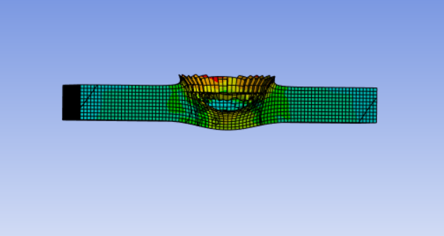

Step 2
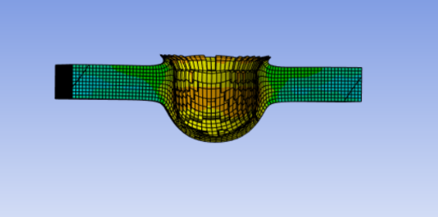
The projectile has not perforated the plate at tis point of the simulation, the propagation wave of stress has reached the edges of the plate and is traveling back into the centre of the plate. The plate edges in contact with the bullet are experiencing high strain rate at 0.0080422. At this point you can clearly see when looking at the simulation from below the strain is concentrated at the centre of the plate and disperses outwards.
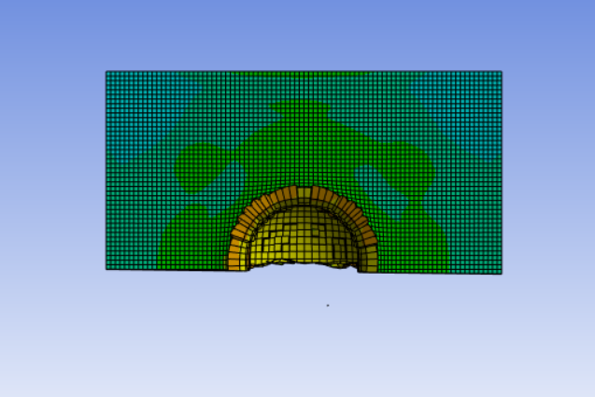

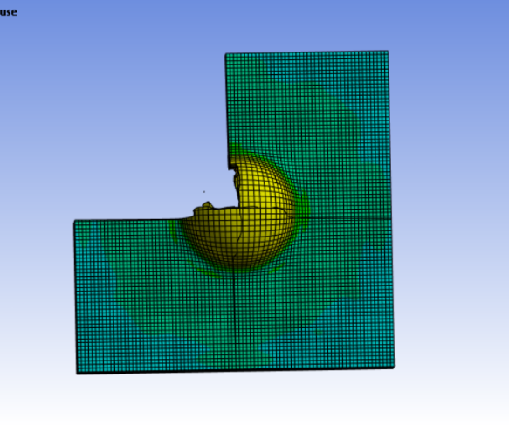

Step 3
At this point the projectile has perforated the plate creating fragmentation as the plate deformed. The exit side of the Projectile hole and fragments are experiencing significant strain still. The propagation wave is traveling to the edges of the plate created from when the plate gave way. The tips of the exit hole are experiencing the highest strain at 0.0149

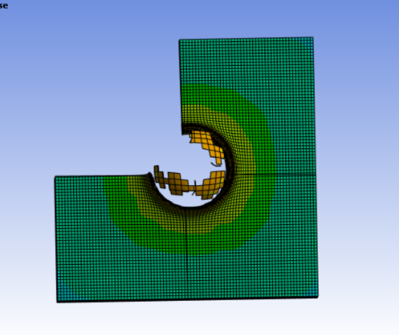
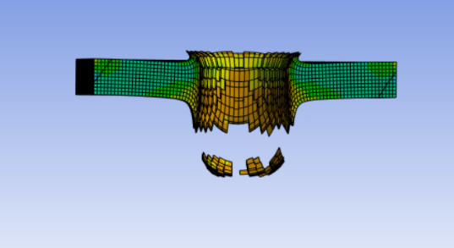
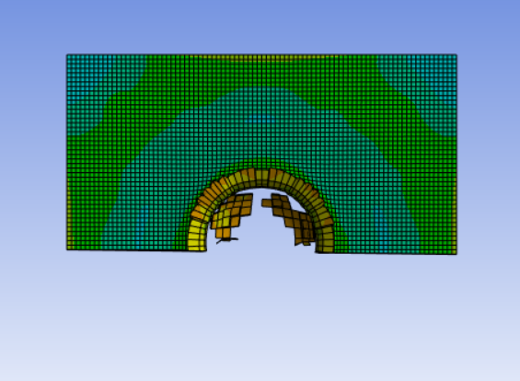

Step 4
The fragmentation has moved away from the plate but has remained in 2 large fragments. The propagation wave is traveling from the edge from the plate back to the centre of the plate. Through the bullet hole of the plate the strain increases as it goes to the exit side
Here is the data from the simulation in a table. It shows the time point in the simulation, The minimum, maximum and average strain. As shown through the table the average strain through the
Time | Min M/m | Max m/m | Average m/m
1.18E-38 | 0 | 0 | 0
0 01.00E-05 | 0 | 1.65E-02 | 8.42E-04
2.00E-05 | 0 | 3.89E-02 | 1.69E-03
3.00E-05 | 0 | 6.12E-02 | 2.35E-03
4.00E-05 | 0 | 8.36E-02 | 3.09E-03
5.00E-05 | 0 | 0.10596 | 3.89E-03
6.00E-05 | 0 | 0.12832 | 4.59E-03
7.00E-05 | 0 | 0.15069 | 5.34E-03
8.00E-05 | 0 | 0.17306 | 6.13E-03
9.00E-05 | 0 | 0.19542 | 6.84E-03
1.00E-04 | 0 | 0.21779 | 7.58E-03
1.10E-04 | 0 | 0.24015 | 8.37E-03
1.20E-04 | 0 | 0.26252 | 9.08E-03
1.30E-04 | 0 | 0.28489 | 9.82E-03
1.40E-04 | 0 | 0.30725 | 1.06E-02
1.50E-04 | 0 | 0.32962 | 1.13E-02
1.60E-04 | 0 | 0.35199 | 1.21E-02
1.70E-04 | 0 | 0.37435 | 1.29E-02
1.80E-04 | 0 | 0.39672 | 1.36E-02
1.90E-04 | 0 | 0.41909 | 1.43E-02
2.00E-04 | 0 | 0.44145 | 1.51E-02
Plate increases throughout the simulation. The average strain is significantly lower than the maximum throughout the entire simulation.

The velocity of the projectile is measure through the simulation, the graph for this is shown below. The bullet begins at 1200m/s, The bullet makes first contact the plate and looses 157m/s of speed. After the initial impact and plate is perforated by the projectiles, speed oscillate marginally between 1037.5 and 1038.5. The bullets oscillation is dues to the aerodynamics effect and elastic deformation of the bullet and plate. These effects combine to increase and reduce the velocity of the projectile

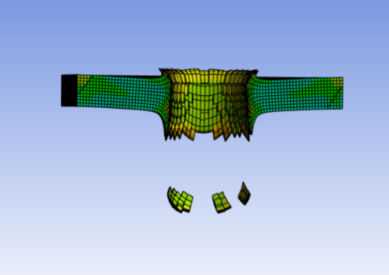
Abaqus compare

To compare these two-simulation software the geometry, material properties velocity are all set the same. This means this test difference is from the meshing difference as it wasn’t possible for Abaqus to get a finer mesh and the solver differences.
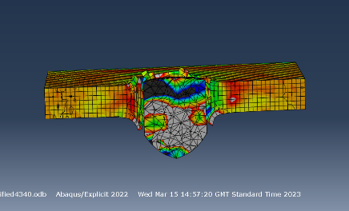
The results from Abaqus and Ansys are extremely similar when looking at the finished plate. The bullet perforates in both simulations, in the Ansys simulation it simulates a larger ridge then Abaqus and the entire plate has bent inwards. They both show the same propagation waves throughout the plate as the simulations runs.
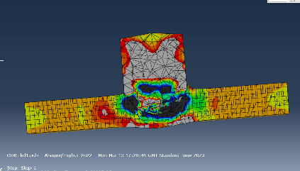
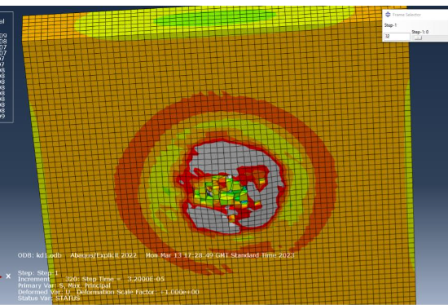
Abaqus does a better job of showing the compressions from the impact of the projectile. It has clear pockets of compression unlike Ansys. This may be to Ansys difficult to use automatic scales. This makes fine tuning the scale to reveal as much data as possible difficult. The Abaqus simulation does not show fragmentation due to the need to disable this functionality to achieve a successful simulation.
Ansys is simpler to use software package making new users able to get up to speed far quicker than using Abaqus. To use Abaqus effectively there is a large amount of learning on how to perform lots of tasks.
Overall Ansys was far easier and intuitive simulation package but lacks the detail and power of Abaqus.

Potential limitations to my data
When running the simulator, the plate oscillated back and forth after the bullet left the plate. There are multiple reasons why this might occur one is the elastic recovery as the stress waves travel through plate. Another reason could be the sudden release of load as the bullet leaves the plate can cause the plate to oscillate as the energy disperses [11]. Finally, the it could be due to the material properties not being quite correct, specifically the dampening characteristics and elastics properties are not correct causing the plate to react incorrectly as it the energy dissipates.

Difficulties
Throughout the simulation process there was some difficulties getting the optimum results. The first difficulty was finding material properties that reacted correctly in the solver. Finding explicit data for steel 4340 and aluminium 6061 from a reputable source was difficult. The first set of data failed so another source had to be found and inputted into the Ansys. The Mesh created some issues with running the simulations, The student version can only run a specific quantity of nodes. Furthering this when trying to increase the mesh on the University computers with full access to Ansys the simulation failed. This meant the simulation possibly wasn’t as accurate as it could be from a meshing perspective. The results are shown graphically using colours to indicate focuses of forces and the distribution. This means the results effectiveness are heavily dependent on the scale used to show the data in the correct perspective. The scale on Ansys is automatic and has very little which can be done to change it meaning the automatic scale is what you end up with and it is not always accurate. To solve this, I changed the forces to only show for the plate as the bullet experiences drastically different forces and skews the scales, once this was done the scale was far more effective but still had room for improvement.

Simulation improvements
In a Simulation there are many factors that create a functioning and accurate simulation, this means that there are many reasons for a simulation to go wrong. One for example is like previously stated the errors in the material, this is a fundamental aspect of the calculations and is a key part of the results. If the simulation had more accurate material properties [12] it would improve the accuracy of the simulation. The set up of the simulation is another factor for the results of the simulations. The simulation needs to be set with many parameters, the simulation can always have more data such as temperature as this will affect the materials properties and therefore the simulation results. Ansys has a temperature section built into the solvers. Another way to improve the simulation is that there were relatively large time intervals between each step, If this could shortened there would be more data to analyse and would show the trends better as the forces travel through the plate.

Advantages of CAE and real-world use
CAE is vital to solving engineering problems throughout all engineering sectors, specifically in the defence industry CAE could dramatically reduce costs and risks in weapons trials. With accurate CAE available to these businesses [13], an accurate simulation can be set up and made for each new weapon system. This would be quicker, safer, cheaper and better for R&D. Simulations are quicker then real-world trials dues to being restrained by manufacturing time, transport and paperwork time. Simulations can also be used for rapid prototyping as the munition model can relatively simply can be adapted. The Simulations are also safer than real-world trials, despite all the health and safety applied to the defence industry when work with energetic materials there is always a risk of an incident. The simulations means that energetic material can be used later in the product development process with more knowledge of how it will react to specific stimulus allowing for more informed decisions and a safer process. The simulations have a large upfront cost of software licenses and machines capable of running the complex simulations. Employees require training to effectively use the software and get accurate results. However once initially set up it comes relatively inexpensive as it costs employee salaries. For a munitions weapons test there are many costs, Licensing, transportation, packaging, manufacturing, disposal, R&D, measuring equipment and range hire. These costs add up significantly. A 155mm round costs roughly $3300Euros just to manufacture and buy, these haven’t changed in 2 decades. A trial will fire 5 plus shells so at a range you are at a minimum cost $16,500euros. Simulations software is very bespoke and cost each company differently as they are often adapted for large corporations, but it isn’t uncommon for the license to cost around £10-50k which can be used for all kinds of simulations for the life cycle of a product. Simulation software is very versatile. If a new type of weapon is created or a new energetic material it is impossible to predict whether the simulation will be correct to real-world so real world test would still have a fundamental in the engineering process to ensure safety and product performance.

Simulations can be vital part of a products development cycle when accurate. In the defence industry simulations and range firings are used in conjunction, they are used to support each other to build up. Simulations are not yet totally accurate to real-world events however they can be used in conjunction with trials. The simulations will get more accurate over time as the solvers are improved and iterated.

Bibliography

[1] | “Siemens - Computer-aided engineering (CAE),” Siemens, [Online]. Available: https://www.sw.siemens.com/en-US/technology/computer-aided-engineering-cae/. [Accessed 12 07 2024].
[2] | “TWI - WHAT IS SIMULATION? WHAT DOES IT MEAN? (DEFINITION AND EXAMPLES),” TWI, [Online]. Available: https://www.twi-global.com/technical-knowledge/faqs/faq-what-is-simulation#:~:text=Simulation%20systems%20include%20discrete%20event,different%20levels%20of%20the%20organisation.. [Accessed 11 27 2024].
[3] | “Dassault systems - Modeling of High-Rate Ballistic Impact of Brittle,” simulia, [Online]. Available: https://www.3ds.com/products-services/simulia/products/abaqus/. [Accessed 8/5/2023 May 2023].
[4] | “Azo Materials - AISI 4340 Alloy Steel (UNS G43400),” Azo materials, 2012 september 2012. [Online]. Available: https://www.azom.com/article.aspx?ArticleID=6772. [Accessed 08 May 2023].
[5] | “AISI 4340 Steel | 36CrNiMo4 | 1.6511 | EN24 | 817M40 | SNCM439,” ASTM Steel, [Online]. Available: https://www.astmsteel.com/product/4340-steel-aisi/. [Accessed 08 May 2023].
[6] | “ADS - Mechanical Properties Analysis of 4340 Steel Specimen Heat Treated in Oven and Quenching in Three Different Fluids,” 2018.
[7] | “ESA - The importance of simulation assumptions when evaluating detectability in population models,” 2019.
[8] | “What is the Importance of Meshing in CFD and FEA,” Spatial, [Online]. Available: https://www.spatial.com/resources/glossary/what-is-meshing#:~:text=Meshing%20is%20one%20of%20the,and%20solve%20times%20become%20longer.. [Accessed 08 07 2024].
[9] | “Cambridge unversity dictionary,” Cambridge Universisty , [Online]. Available: https://dictionary.cambridge.org/dictionary/english/strain. [Accessed 05 07 2024].
[10] | “Xometry - What is stress,” Xometry, [Online]. Available: https://www.xometry.com/resources/materials/stress-vs-strain/. [Accessed 13 07 2024].
[11] | “advantages and disadvantages of simulation,” Computer science wiki, [Online]. Available: https://computersciencewiki.org/index.php/Advantages_and_disadvantages_of_simulation#:~:text=Disadvantages%20of%20Simulation%5Bedit%5D,can%20be%20difficult%20to%20obtain.. [Accessed 16 07 2024].
[12] | “Math works - Check and improve simulation accuracy,” Math works, [Online]. Available: https://www.mathworks.com/help/simulink/ug/improving-simulation-accuracy.html. [Accessed 28 06 2024].
[13] | “Anylogic - Why use simulaton modelling?,” Any logic, [Online]. Available: https://www.anylogic.com/use-of-simulation/#:~:text=Simulation%20modeling%20solves%20real-world,clear%20insights%20into%20complex%20systems.. [Accessed 03 07 2024].
[14] | N. Nordendale, “Modeling of High-Rate Ballistic Impact of Brittle,” Depertment of civil engineering, vanderbilt university, Nashville.
[15] | “Simulation of the ballistic perforation of,” Simulia, 2012.
[16] | “Mechanics of Materials: Stress,” Boston university, [Online]. Available: https://www.bu.edu/moss/mechanics-of-materials-stress/#:~:text=Stress%20is%20the%20a%20measure,sectional%20area%20of%20the%20material.. [Accessed 08 May 2023].

