Cogent Power – Orb Site
Reduction of burr feature on Electrical steel coil
Alex Harrison - 2115879
Harrison, Alex
3-31-2023

Contents
Introduction 2
Orb electrical steels product overview. 2
Grain orientated electrical steel 2
Customer complaint 3
Initial project proposition 3
Problem definition and Project scope 3
Problem definition 4
Project scope 5
Determining data collection 5
Determination of relevant variables 5
Analysis of current position 8
Improvement planning 9
Improvement ideas generation 9
Improvement selection 9
Further steps 9
Bibliography 10

Introduction

Orb electrical steels product overview.

Orb electrical steels was initially founded in 1898 as a large scale steelwork producing corrugated steel for construction applications. During World war two, the site had seen large re-purposing to assist in the wider strategic needs of the nation. After this period the Orb steelworks had seen a major strategic shift; from the production of rolled aluminium to grain orientated electrical steel. This product represented a niche marked with a difficult to manufacture product and commanded a price tag accordingly.

Grain orientated electrical steel
From the later half of the 20th century through to the start of the of 21st century, Orb manufactured grain oriented electrical steels. This product would become the only product offered by the plant as the company focussed on high profit products.
Grain orientated steels are manufactured for use principally in power transformers. Where sheets of the material are used to construct the ferrous core. 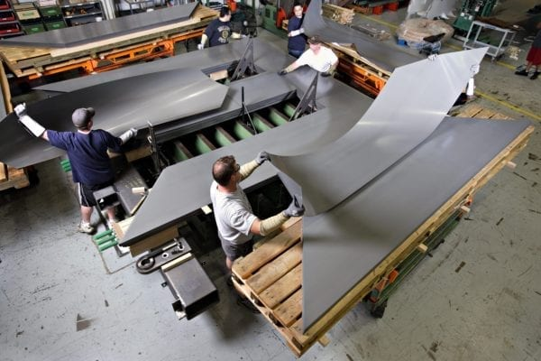Figure 1: laminations being assembled into a transformer core. (Waukesha transformers, 2023)
Grain orientated electrical steels are manufactured to accentuate magnetic performance (properties such as flux density and magnetic permeability) in a given direction. The other aim is to reduce electrical conductivity.
Reduction of electrical conductivity in a transformer core is critical to the core’s performance overall. The usual operation of a transformer will induce electrical losses in the form of eddy currents. Whilst an in depth explanation of eddy currents is excessive for this report it is important to note that these eddy currents act as a form of inefficiency.
The goal of modern transformer core production is to produce the core using laminations which are electrically insulated from each other.

Customer complaint
In March 2018 Orb electrical steelworks had received a number of complaints from a customer, GE grid solutions, for burr on slit coil supplied to them. According to customer internal investigations this burr would end up being pressed through the softer insulation layers between the laminations during construction.
This created two problems for the customer. The first was these electrically connected laminations exacerbated eddy currents in the transformers, costing performance. The second was that the contact points would begin to spark due to currents passing through, damaging the insulative coating further.

Initial project proposition

Problem definition and Project scope
To begin with the overall project was planned using A3 project planning. This is largely as it is the standard practice for projects within the business. A3 Project planning is well-used and well understood tool within industry since its development at Toyota.
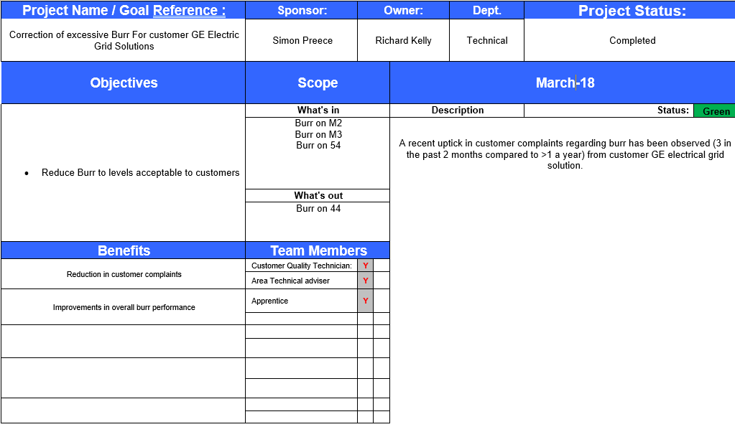
It allows for an assessment the scope of the project, what resources are available, who is expected to participate in the project, as well as a predicted timeline for its completion. Additionally, whilst the layout of the project itself was utilising an A3 project plan to discuss Resources and expectations, the project itself would seek to principally use the DMAIC as the basis for its problem solving method.
The Kaizen approach was considered for the project, itself utilising PDCA (Plan Do Check Act) over, this was considered insufficient for the following reasons:
- This defect was already reaching customers, this demanded investigation and correction as opposed to iterative improvements.
- The cause of the defect was currently unknown, with little in the way of available data for analysis.
It was acknowledged that PDCA may see use later on in the process when it came to implementation of controls. (Womack, Jones, & Roos, 1991)
Finally the projects progress was monitored through the use of a Simple Gantt chart, as the scope of the project aimed to be focussed and precise – reduction of a single variable the project was given the time frame of a month. This was seemed enough to produce a preliminary report and identify key changes for implementation in larger improvement projects.
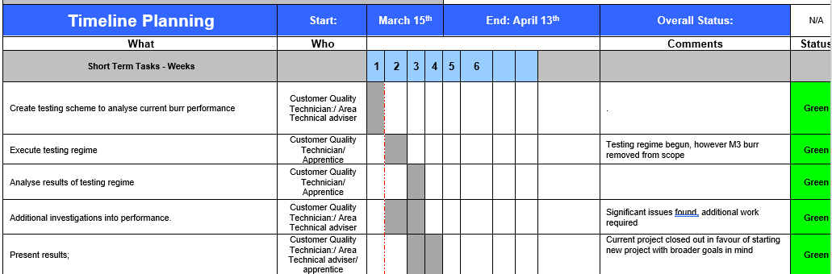

Problem definition
The definition of the problem came easily as it was communicated to us by the customer (which this report acknowledges is suboptimal in regard to customer satisfaction).
Ordinarily at this point in the process the team would aim to discover the quality needs of the customer. This would typically utilise Quality function deployment to capture the Voice of the customer and consider the customers priorities in a matrix to rank and prioritise them. An example of this is the Toyota house of quality. (Gavin, 1987)
This project comes as a response to changes in customer needs. Discussions between our own customer service technicians and the customers internal quality control over this issue had decided on a maximum acceptable limit on the burr for the customer to remain satisfied with the product. This came from their own internal investigation on the matter.
This maximum was decided at 20 microns of burr, the reasoning behind the decision being that the minimum coating thickness of the insulation layers was 25 microns thick.
It is important to clarify for the sake of the project that this project was not intended to determine the cause of the loss of performance on their power transformers, but instead to adjust what our business provided to meet customer needs.

Project scope
The expectations of this project were:
- To determine the current Burr on products delivered to our customers.
- To determine the root causes behind the Burr.
- To reduce or eliminate Burr from our products.
- To implement a means of controlling and monitoring performance in this new customer requirement.

Determining data collection
The First hurdle was to define how burr would be measured. This was also the product of discussions with our customer, as this would ensure closest alignment with customer expectations.
It was decided that burr would be measured as “the increase in gauge at the edges of material over real gauge thickness” or to demonstrate visually:
Cross section of the edge of steel sheet
A
B
C
A = Gauge of the material supplied. Typically 0.2mm to 0.3mm thick
B = Gauge of the material as measured on the very edge of the material
C = Product of A subtracted from B. or how proud the burr stands from the surface of the material.

The second consideration was the method of measurement used. While industrial grade continues monitoring for the line itself was attractive it was also beyond the budget of the team at the time. Further conversation with the customer determined that they were measuring their own burr using a depth gauge, with five measurements taken over two separate 1 meter samples as a representative of the entire coil. This system was replicated for our trials to align our project results with those the customer had produced.
This measurement system is far from perfect, providing very little information for a coil that may be anywhere from 100m to 1000m. In addition, it is destructive, removing the material for analysis. Finally the production line itself must be halted in order to cut the sample.

Determination of relevant variables
In order to determine what variable would be relevant to solving the issue it was important to map the process. This is relatively simple as this process is applied as a finishing process of the final product.

Initial edge cutting on M2 finishing line
Slitting on the 54 slitting line
Initial edge cutting on M3 finishing line
Slitting on the 44 slitting line
Shipping and distribution of final product
Based on this it becomes apparent that there are 4 different lines from which burr could arrive:
- The edge trimmers of M2 finishing line.
- The edge trimmers of M3 finishing line.
- Any of the slits in the 54 slitter.
- Any of the cuts on the 44 slitter.
Some of these can be eliminated as products supplied to GE Grid solutions were only supplied through the 54 slitter. This is the slitting line that provides slit coil at the widths they require.
The variables from each line are as follows:
- Which line has cut which edge
- Burr produced by the cut (in microns)
- Line setting on M2
  - Line speed (m/s)
  - Edge trimmer gap setting (microns)
  - Team on M2
- Line setting on M3
  - Line speed (m/s)
  - Edge trimmer gap setting (microns)
  - Team on M3
- Line settings on 54 slitter
  - Line speed (m/s)
  - Trimmer gap setting (microns)
  - Team on 54
There was a complication however, as some edge cuts will have been from the finishing line and others from the slitting line. This is because the slitting line cuts coils which have been through the finishing line, a process with its own slitting facilities. As a result of this the outermost cuts on a production run are not related to the performance of the slitting line itself, as slitting of already slit edges is redundant.

As an example, the right edge of our feed coil is “inherited” by child 4.
Therefore, if our analysis concludes that it is the right hand edge that underperforms, our efforts must be focussed on improvements on the finishing line.
Child
1
1
Child
2
1
Child
3
1
Child
4
1
1 x 940mm coil being cut into 4 x 235mm coils for the customer.
Our analysis needed to include whether or not the edge measured was from one of these outside cuts. In order to achieve this the edges were tracked and assigned a value from 1 to 8 where 1 was the leftmost edge (referred to as the drive edge) and 8 was the rightmost edge (referred to as the desk edge) the numbers were assigned as below.
Feed coil
Child coil 1
Cut
1
Drive edge
Desk edge
Child coil 2
Child coil 3
Child coil 4
Cut
2
Cut
3
Cut
4
Cut
5
Cut
6
Cut
7
Cut
8
The standard sampling method that was agreed with the customer (5 checks per edge, over the course of a meter) was followed for a week’s production.

Analysis of current position

The following analysis represents the initial analysis of the data acquired after a week of analysis. Over the course of the week the plant had processed 68 coils intended for delivery to GE Grid solutions, resulting in 340 individual data points per cut.
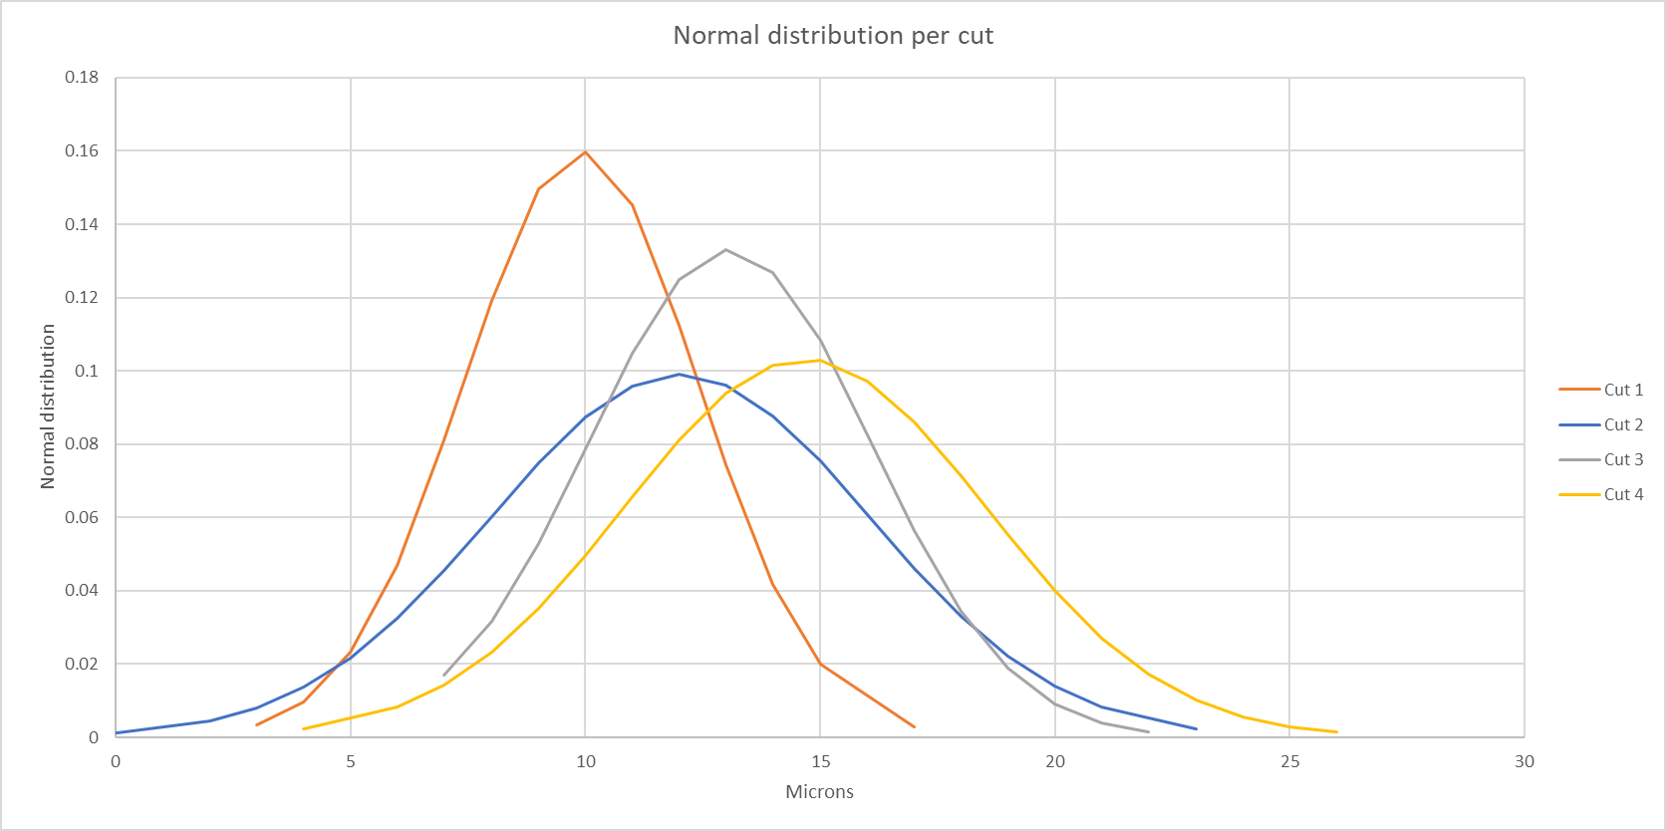
Normal distribution of cuts 1 to 4
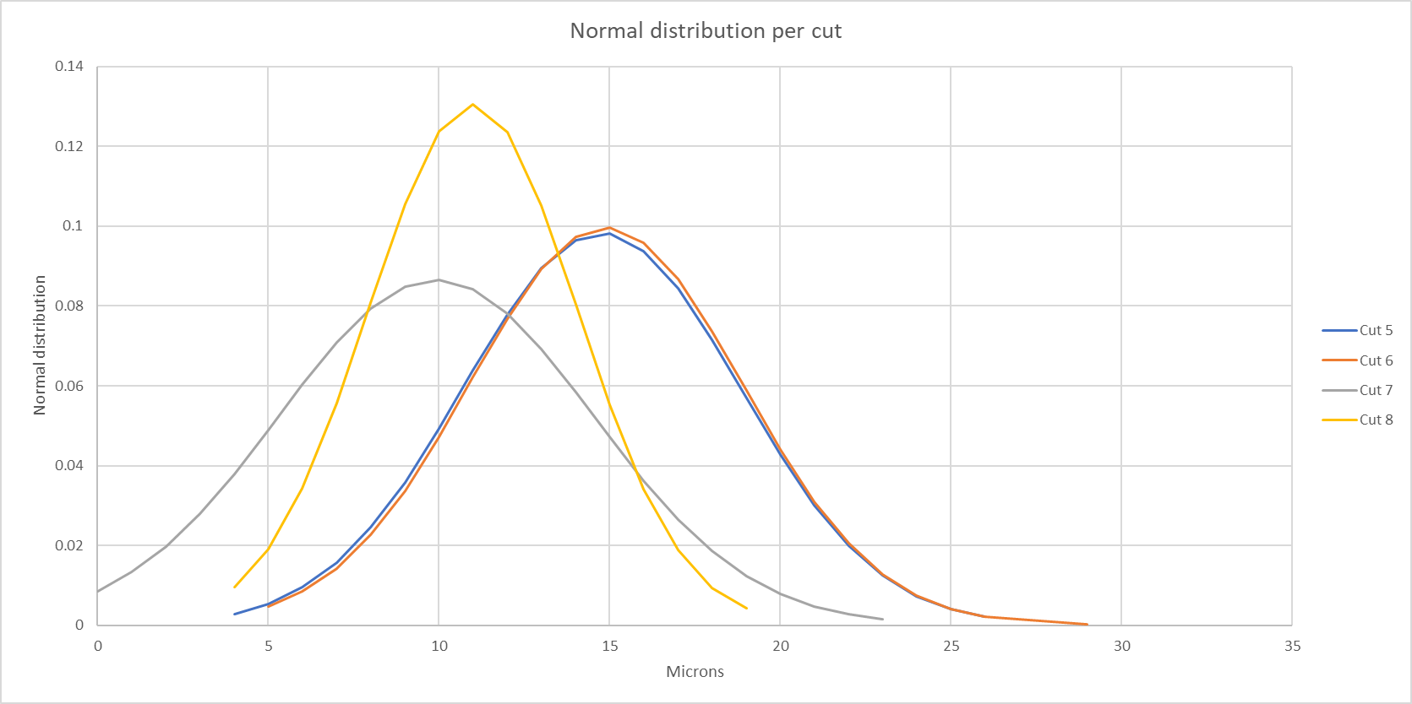
Normal Distribution of cuts 5 to 8

From the data presented a number of conclusions can be drawn:
The most notable of these conclusions is that cut 1 and 8, the edge cuts both produced results acceptable to the customer. However, the internal cuts performed on the 54 saw a number of samples fail inspection.
In addition, it was noted that the performance would degrade over a scheduled run, the production schedule saw the 68 coils produced in 3 runs (a run being defined as a distinct change in slitter head assembly and all subsequent production until the line is run down in preparation for the next production order).
However, from the data collected it could not be determined whether or not production from M3 saw an increase in burr variation or magnitude. This was due to the fact that that not a single coil in the trial sample group was produced by M3.

Improvement planning

Improvement ideas generation
It was decided that an interrogative method was better suited to generating improvements. For this the 5 whys technique was applied. This was quite late in the process but yielded a number of interesting results.
Results included the relative inexperience of some crews, who struggled with craftsmanship required to assemble a slitting head, combined with a poor understanding amongst both operational, engineering, and technical staff as to the degradation of slitter performance.

Improvement selection
With an understanding of the technical challenges facing the line the focus of the project saw a change. A large body of documentation and standardisation needed to be developed in order to support continuous improvement. This ran the risk of ballooning the current project and seeing it bogged down and failing to deliver an acceptable result to the customer within an acceptable timeframe.
As such the focus was adjusted to achieving some “quick wins” to show process improvement to soothe customer dissatisfaction. As such it was decided that the process adjustments would be made to shorten the runs of coil destined for GE Grid solutions. This would require little in the way of investment and could be deployed rapidly.

Further steps
It is the primary recommendation that the line develop a standard method of monitoring burr on the line, this could be implementation of the current methodology across the operational team, with samples collected every coil. This method still carries costs in both time and material. Requiring approximately 30 minutes to run the line down, take and measure a sample then run it back up as well as 20m of coil in order to ensure that the line is up to speed for the sample to be representative.
Another option is installation of on-line profile monitoring equipment, this would allow for the creation of accurate live control charts for use. It carries the benefit of immediate results with little chance of inaccuracies due to mechanical deformation during testing. This carries upfront costs and would require the initiation of a new project as this lies beyond the scope of this particular project.
Regardless of the method used to collate the data the priority should be the creation of a control chart, this would afford operational crews the information needed in order to initiate corrective measures proactively. A mock-up example can be seen below. (Tague, 2005)
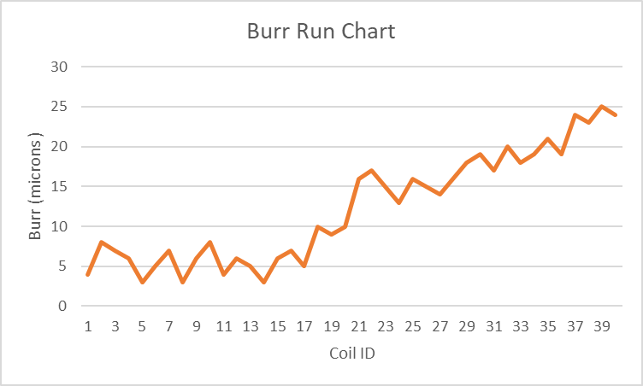
A run chart would allow for an upper limit to trigger when the slit head no longer provides the desired quality.
The implementation of some form of Statistical process control is absolutely necessary for the development of further quality progression too; the data it provides will be invaluable for continues improvement projects.
The other recommendation is the establishment of a monthly review by technical and operational management staff, to be included in the currently existing operational reviews already held. This offers opportunities to plan and discuss further improvement activities, with potential for PDCA projects further down the line. According to
In addition, the project team was unable to find an FMEA study for the line, perhaps it was lost or never existed. Regardless of the cause this should be rectified as soon as possible to ensure a logical operation capable of proactive activities. The creation of FMEA documentation is beyond the scope of this individual report but demands correction nonetheless.

Bibliography
Gavin, D. A. (1987). Competing on the Eight Dimensions of Quality. Harvard Buisness Review, 101.
Tague, N. (2005). The quality toolbox. Milwaukee: American society for quality.
Waukesha transformers. (2023, March 31). Waukesha transformers. Retrieved from Waukesha transformers: https://www.waukeshatransformers.com/power-transformers/manufacturing/core-and-coil/
Womack, J. P., Jones, D. T., & Roos, D. (1991). The Machine That Changed The World: The Story of Lean Production. New York: Harper Perennial.

