Module: Effective Team-working and Communication
Module Code: BMSK4002
Assignment Title: A report on communication within the work place
Student ID: 1805518

Effective communication method and team development in workplace

Executive summary

I have been appointed as a business consultant in toy store of Michelle Sullivan. His toy store is rapidly expanding and to operate his business smoothly asked me to develop a team structure and a communication channel. Here I have analyzed the current communication system of Michelle’s toy store. I have presented here verbal and non-verbal communication importance according to the scenery. As a mounting business, I have suggested a team development structure for managing the toy store. I have analyzed the case and have suggested an effective communication method for this store. this report has been made reading article, books, magazine, example from others small store and based on my experience and job knowledge.

Contents
Executive summary 0
Introduction 3
Importance of effective communication in Toy store of Michelle Sullivan 3
The importance of two-way communication 4
Effective method of communication in this case 5
Team work theories and its application in this case 6
Findings 7
Conclusion 7
Recommendation 7
Action plan 8
References 9

Introduction

From this report I have known that 27 people are working here in different sector but not regular employees. Three managers regulate the employees informally. There is no formal team working but help each other in stockroom, sales and clean. This toy store is increasing currently and has to make a team development where an effective communication should remain to operate the business smoothly. I have suggested the most used Tuckman and Belbin Team development theory for the case. Here I will present why verbal and non-verbal communication is important in this organization. (Knight, 2013)

Importance of effective communication in Toy store of Michelle Sullivan

Business communication is the process of sharing information, knowledge, experience and making report of sales and expenditure for the authority. So communication should be effective for the recording, knowing and coordinating the business. Basically, in small organization like this toy store, they use verbal and non-verbal communication. Verbal communication is used when the size of organization is small but non-verbal communication is used when it becomes large. So in this current situation, this toy store is going to non-verbal communication (Krizan, 2011). The importance of verbal and non-verbal communication is given below-
Verbal communication
Verbal communication may be spoken, signed or written. We talk with our colleagues in organization with our language or organizational language. But technology is used for verbal communication like text message, chat etc. For the case of Toy Store, when it was small sized employees, they usually used verbal communication within few members (Norander, 2018). Verbal communication clarifies a concept in this organization. There is low probability in verbal communication. The face to face communication fosters employees to work purely. Verbal communication is used as tool of persuasion and may be a debate place, creativity practicing and make a strong relationship. But verbal communication is used in all organization.
Non-verbal communication
Non-verbal communication involves gestures, facial expression, body language and eye contract. The sound of voice can lead the employees towards work. Non-verbal communication hurts an employee than verbal communication (S.ST., 2016). When his manager looks at him crucially, it hurts his mind and work well. Love, emotion, arrogant, pressure is shown by our facial and eye expression. In this case, Toy store has no formal communication system like report writing, phone calling, emailing etc. So manager use his body language to evaluate employee’s performance (Eliot, 2016).

The importance of two-way communication

In two-way communication the receiver sends message and receiver gives the feedback. This model uses some steps for sending and responding to message. These steps are receiver sends message via media. Then the receiver decodes it and gives feedback to the receiver.
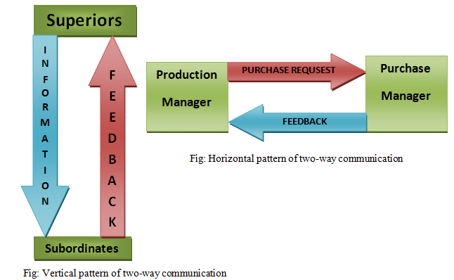
Source: Wiiliam B, Communicating Effectively p32
Here I have presented a figure in the perspective of this toy store. The importance of two-way communication is many. It ensures smooth flow of information between manager and staff. But we can see, there is no formal communication is this toy store as most of the employees are working here as part time. Using this model, the managers get the acknowledgment from the staffs. Manager gives direction to employees using this mode and employees works according to the message. But here we don’t see such this process. two-way communication gives the feedback to the receiver which may be suggestion for the manager in this case. But here the manager don’t get any cooperation from the employees. Two-way communication creates democratic environment and overcome ambiguity. It also develops informal relationships which increase employee’s performance. For this reason, Michelle’s toy store needs two-way communication (Communication, 2019).

Effective method of communication in this case

From the above mentioned scenery we can see that his employees are increasing. During small size, it doesn’t matter what types of communication method has been used by the managers to control the staffs. But when it is growing day by day, it has to take effective communication system. We can see that three managers have to keep information of all employees but there is no maintained formal communication to lead the staffs. Now in this perspective the effective communication method is given below-
We can see that this toy store is recruiting employees and training on the job. As this organization is expanding day to day so it should use written communication system. As a shop the sales assistance will make report about sales, products needs to purchase, demands of customers to the manager. The manager will keep records of all kinds information given by the employees. Though email is used but it has only one branch so letters, memos, proposals etc. can be used in written communication. Here verbal communication like face to face, phone calling can be used to meet the current situation. So formal communication will create here through written communication. Here employees will be more accountable and give better performance. Written communication is comprehensive and detailed and applicable for large organization (Belloc, 1967).

Team work theories and its application in this case

We can see that there is no formal team within the workforce. As ever growing store, it needs to make team for sales assistance, cleaners, storeroom keepers and guards. Team works increase employee’s performance through sharing information and experience. It makes an informal relationship which fosters to work together. The process is given below-
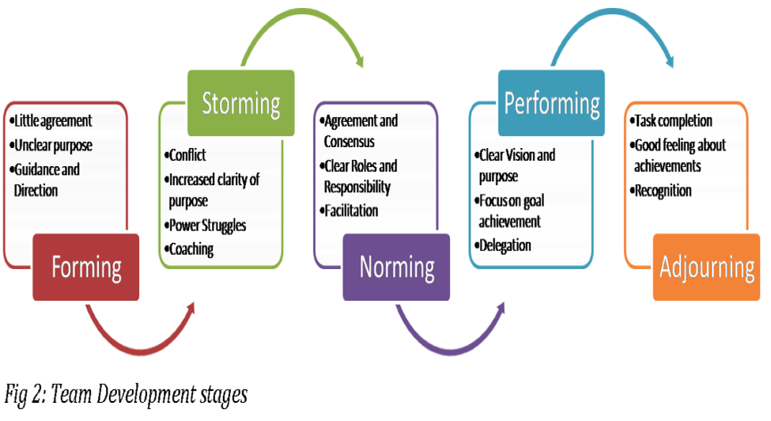
Source: (Cockburn, 2019)
- Forming: Employees of this toy store will disagree to work together as they don’t know what will they do and their benefits.
- Storming: The staffs will create chaos due to uncertainty. Manager and staff will bargain for their duty time, partner choices etc. Manager will teach them what is the benefits of team working.
- Norming: Then the employees will make an agreement to work within team. Now they can know the roles and responsibilities in every section. The sales employees will cooperate with each other to increase sales.
- Performing: Every employee will know his clear vision. Here guards will know what is duty and how they will help during situation. Again, store keepers will share among themselves which products need to collect. The manager will delegate power to team where a leader will direct others members (Khedhaouria and Ribiere, 2013).
- Adjourning: The toy store owner will give them rewards for team development as a recognition.
Thus this Toy shop can develop its formal team using this model.

Findings

From the case study we can see that Michelle’s shop is increasing. So he has to maintain his employees using an effective communication method. Team development requires to give better performance for him. We can see that; the employees have been appointed as par time. But permanent job can do well for his organization. We have showed that Verbal and non-verbal communication is used here as a compulsory communication within shop. But two-way communication was not there, and three managers perform like ad-hoc. Even, during night shift there is no manger. For this situation, Michelle has to create two ways communication and using written communication for data recording. Trough team development he has to make a floor to sharing knowledge and information among the employees that has been explained above (Batenburg, van Walbeek and in der Maur, 2013).

Conclusion

Communication is the process of information sharing. Michelle has to develop his own communication style for the growing store. Now written communication is better for him. Using Tuckman team development theory, we can develop effective team that is required in every organization. Using two-way communication method, the managers and staff can share their information, thinking, creativity and data records in this toy store. Thus Michelle Sullivan can manage his store (Khedhaouria and Ribiere, 2013).

Recommendation
The below mentioned recommendations has been suggested for the case-
- Written communication may be fruitful for his growing store.
- Using two-way communication, the owner can from a democratic style which may bring creativity and strong relationship.
- Though both verbal and non-verbal communication is practiced there but the system should change and make a procedure in taking opinion form managers and staffs.
- During team development, the manager has to inform what is he going to do and what is the benefits. Then team work will work indeed.

Action plan

For implementing the communication process and team development, the below mentioned action plan must be implemented-
Firstly, for introducing written communication, the owner has to arrange all types of components like report writing paper, memos, computer and printer. They have to train on the job training under manager.
Secondly, to make team development, for fourteen sales assistance will be divided into three team. The manager will specify every team roles and responsibilities for each toy’s shelf. The manager will take responsibility according to the slaughter or dividing their group in different time. Employee is free to choose their slot (Anon, n.d.).
Thirdly, manager will inform staffs what he is going to do, what is the responsibilities and benefits form this team making.
Fourthly, to ensure two ways communication, the transmitting process should be clear. The manager will train them how to send message, interpretation and feedback.

References

Anon, (n.d.). 6 steps to creating an effective communication plan. [online] Available at: https://www.axiapr.com/blog/6-steps-to-creating-an-effective-communication-plan [Accessed 2019].
Anon, (n.d.). What Is Two-Way Communication? - Definition, Systems .... [online] Available at: https://study.com/academy/lesson/what-is-two-way-communication-definition-systems-examples.html [Accessed 2019].
Batenburg, R., van Walbeek, W. and in der Maur, W. (2013). Belbin role diversity and team performance: is there a relationship?. Journal of Management Development, 32(8), pp.901-913.
Belloc, H. (1967). On. Freeport, N.Y.: Books for Libraries Press.
Cockburn, T. (2019). Team Leadership Case Study and Role Play Exercise – Friday 13th, Appendix #1: R. M. Belbin´s Nine Team Roles. SSRN Electronic Journal.
Communication, T. (2019). What is two-way communication? Definition & Importance. [online] The Business Communication. Available at: https://thebusinesscommunication.com/two-way-communication-and-importance/ [Accessed 18 Feb. 2019].
Eliot, G. (2016). The mill on the Floss. New York: Open Road Integrated Media.
Khedhaouria, A. and Ribiere, V. (2013). The influence of team knowledge sourcing on team creativity. The Learning Organization, 20(4/5), pp.308-321.
Knight, M. (2013). Usability and Business Communication. Business Communication Quarterly, 76(4), pp.395-396.
Kohler, R. (2016). Optimization of Leadership Style. Wiesbaden: Springer Gabler.

Krizan, A. (2011). Business communication. Australia: South-Western Cengage Learning.
Norander, S. (2018). Best Practices for Facilitating Communication-Centered Professional Development for Non-Communication Faculty. Journal of Communication Pedagogy, 1(1), pp.124-131.
Williams B (nd) Communicating Effectively, A managers guide to getting through to people.

