
Changemakers: Creativity & Value Creation
Assignment 2: Practical & Professional Development (ACCA5033)
Sophie Foyle (2506393) | 7/31/26 | ACCA5033

Fraud Triage Dashboard
Contents
Introduction 2
Task 1: Practical Development/Implementation 2
Question 1: Initial Feedback 2
Question 2: Implementation 3
Troubleshooting: 9
Task 2: Enterprise & Innovation 9
T2 – Innovation 9
Question 1 9
Question 2 14
Task 3: Project Reflection 15
Question 1: Practical Feedback 15
Question 2: Project Progress Diary 15
Question 3: Skills 16
Question 4: Positive Social Impact (PSI) 16
Conclusion 17
Appendices 18
Considering Business Types 18
Feedback Form 20
20
Case Study – LAS IT Failure 22
Project Progress Diary 23
Further Feedback Form 26
Engagement with online course 27
REFERENCES: 29

Introduction
This report outlines the development of a Fraud Triage Dashboard, detailing the project-management approach, initial design, development stages and feedback-based improvements. It explains how user feedback, usability principles and industry requirements contributed to the final design, and how ethical considerations such as fairness, transparency and responsible data handling were considered throughout. The report also assesses technical and practical decisions made during development and reflects on the skills gained, effectiveness of the project planning and the wider impact of creating a tool that supports consistent and fair decision-making within the fraud environment.

Task 1: Practical Development/Implementation

Question 1: Initial Feedback
Microsoft Forms [1] was used to obtain feedback regarding the project idea, design and initial implementation, including suggestions for improvements and recommendations for changes. Figma allowed for easy implementation of these recommendations [2].
Overall, feedback from users was positive, highlighting the clear layout, professional appearance and logical tabs. Users noted key information such as claim details, risk scores and routing outcomes, and tabs were relevant, self-explanatory and provided good navigation. Feedback around additional tabs for incoming claims to filter through unreviewed, escalated and closed claims was positive. This aligns with established usability principles, including Nielsen’s Heuristics, which emphasise clear navigation, minimalism and presenting only essential information [3].
Constructive suggestions were also provided, as users felt the ‘priority scoring’ tab didn’t clearly relate to the risk flags and would be more useful with a breakdown of how the risk score is calculated. Feedback also suggested the ‘escalated’ claims tab should clearly show the escalation reason, such as high-cost, high-risk or delays in being reviewed. Some users felt the home screen could be simplified, noting metrics like ‘average response’ and ‘auto resolved’ could be removed.
Based on the feedback, the priority scoring tab will be redesigned to include a clear explanation of how scores are generated, including keywords and indicators. The ‘escalated’ claims tab will be enhanced to display clear escalation reasons, and the home screen will be refined by removing unnecessary data, creating a cleaner and more user-friendly layout. A help section will be added to support non-technical users by explaining key terms and dashboard functions. These changes will improve usability and ensure the dashboard is more accessible for all users.

Question 2: Implementation
Multiple refinements were made, improving the dashboard’s clarity, usability and functionality. Most updates were driven by user feedback, including a redesign of the ‘priority scoring’ tab with a clear breakdown of how risk scores are calculated, reordered claims from highest to lowest risk, explicit risk-type indicators and a dropdown for detailed scoring factors. The escalated claims tab was enhanced with a visible escalation-reason, the home screen was simplified by removing unnecessary metrics, and a help section was added to explain risk tags, team responsibilities, fraud types and key terminology. Improving the clarity of risk scores and escalation reasons aligns with research showing decision making systems work best when they are transparent and easy for users to understand [4]. Further opportunities for improvement were identified during implementation, such as displaying the allocated handler and team within the incoming claims tab, renaming and expanding the handlers tab to ‘teams and handlers’ with workload, escalation and team-filtering features, and removing non-functional toggles from the routing rules tab. These changes strengthen navigation, improve transparency and support effective monitoring across teams.

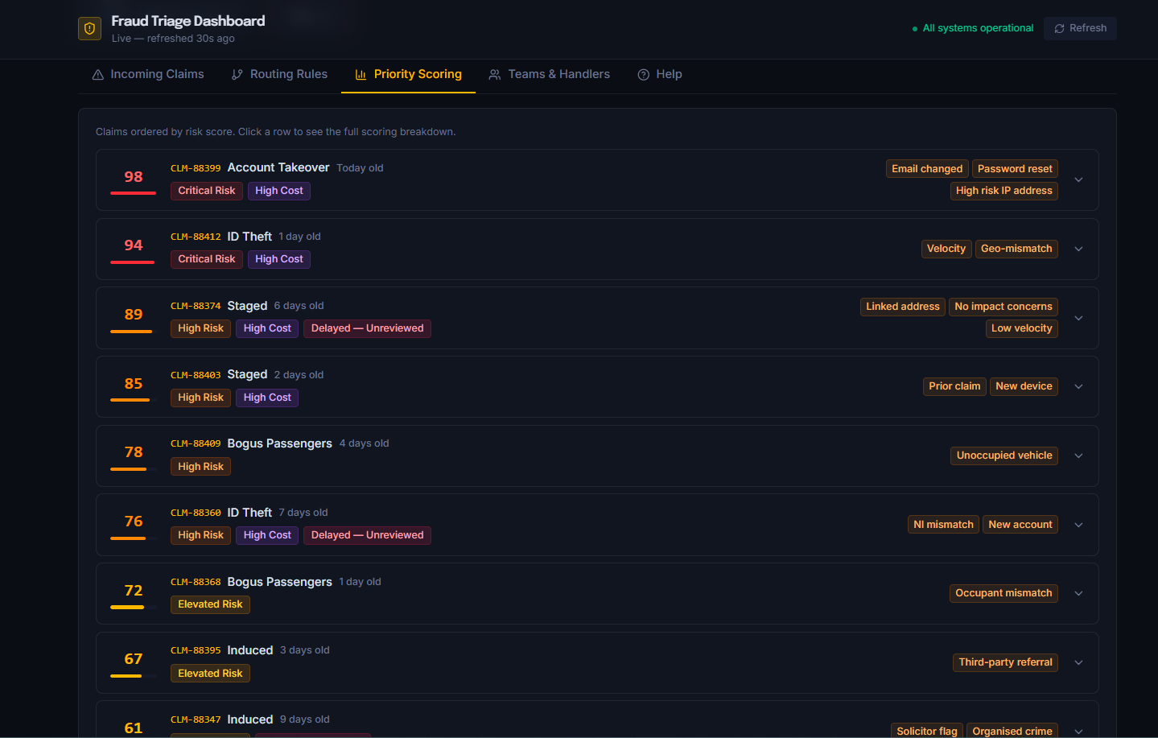
Figure 1: Redesigned Priority Scoring tab, showing claims in risk order and displaying risk type.

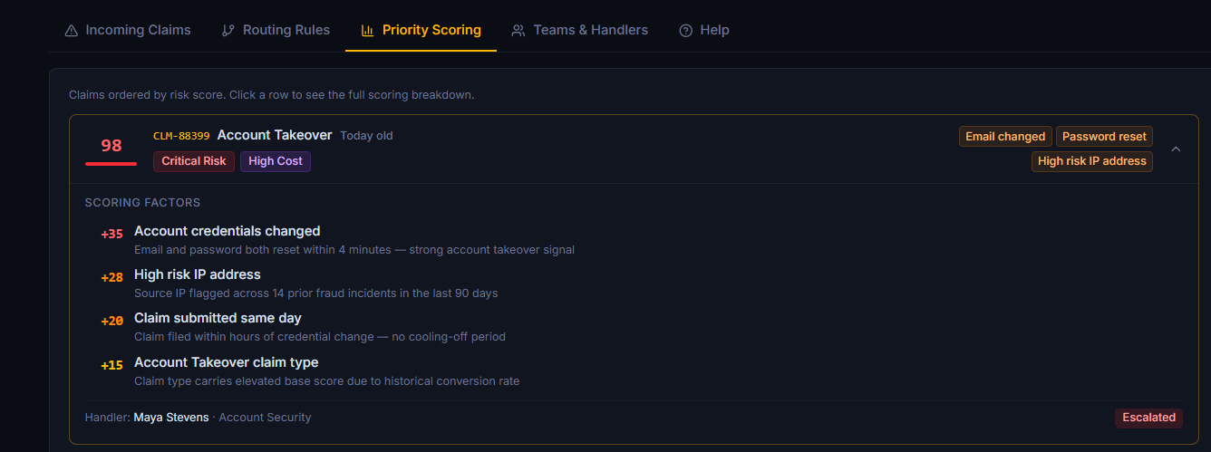
Figure 2: Expanded view of scoring factors considered to establish the final risk score.

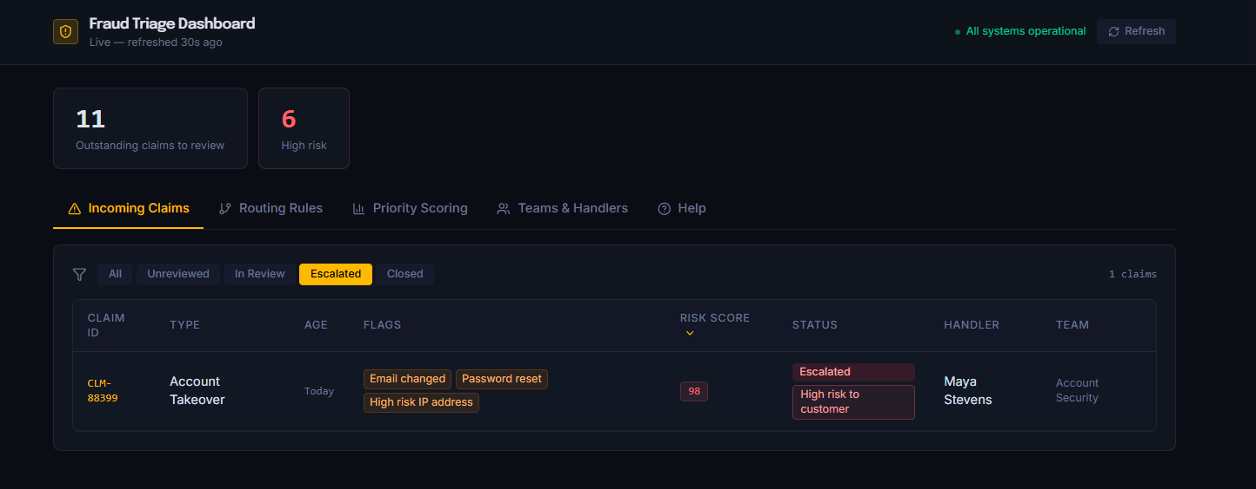
Figure 3: Escalated Claims tab with escalation reason tag applied (high-risk to customer).

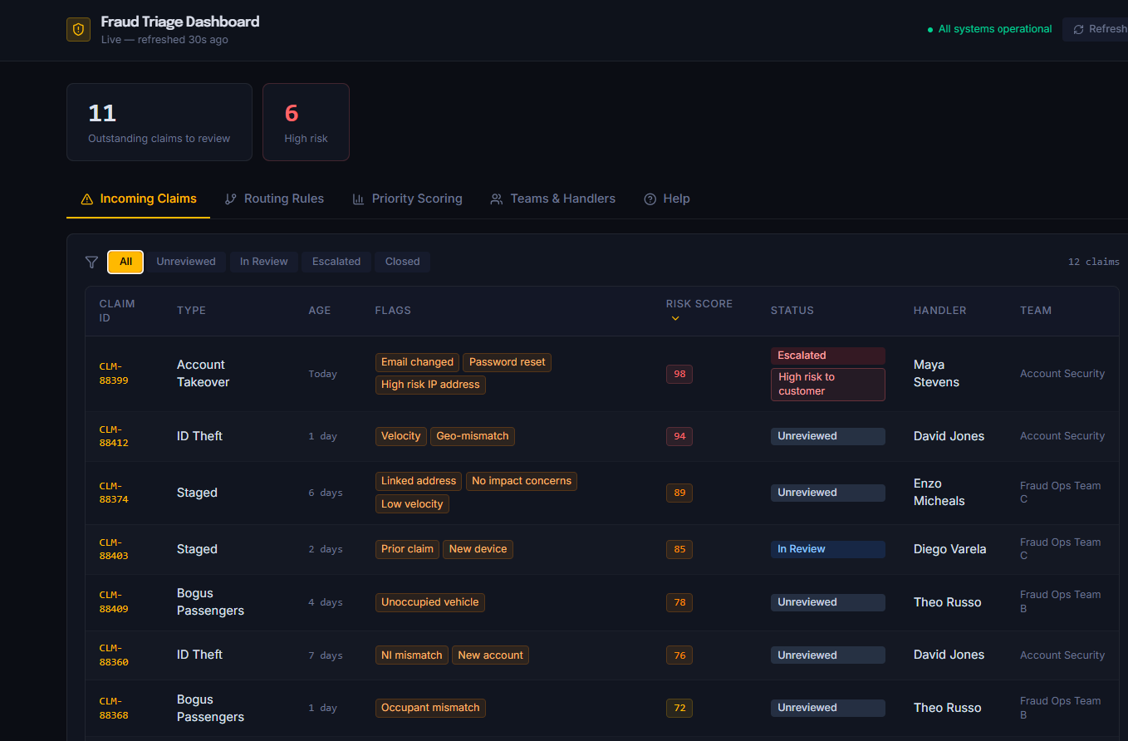
Figure 4: Simplified home screen showing key metrics only and displaying the allocated handler and team for each claim.

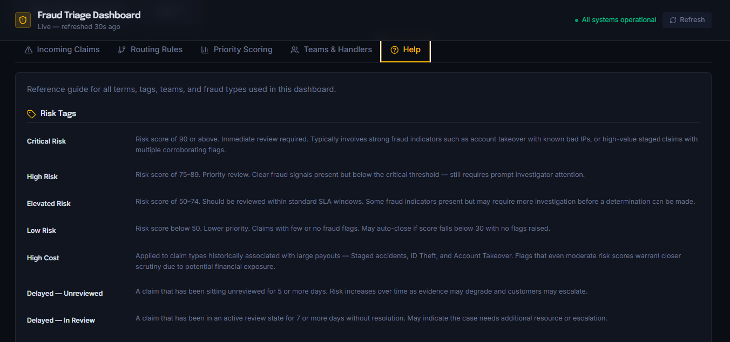 Figure 5: Help tab providing definitions and explanations of all risk tags.

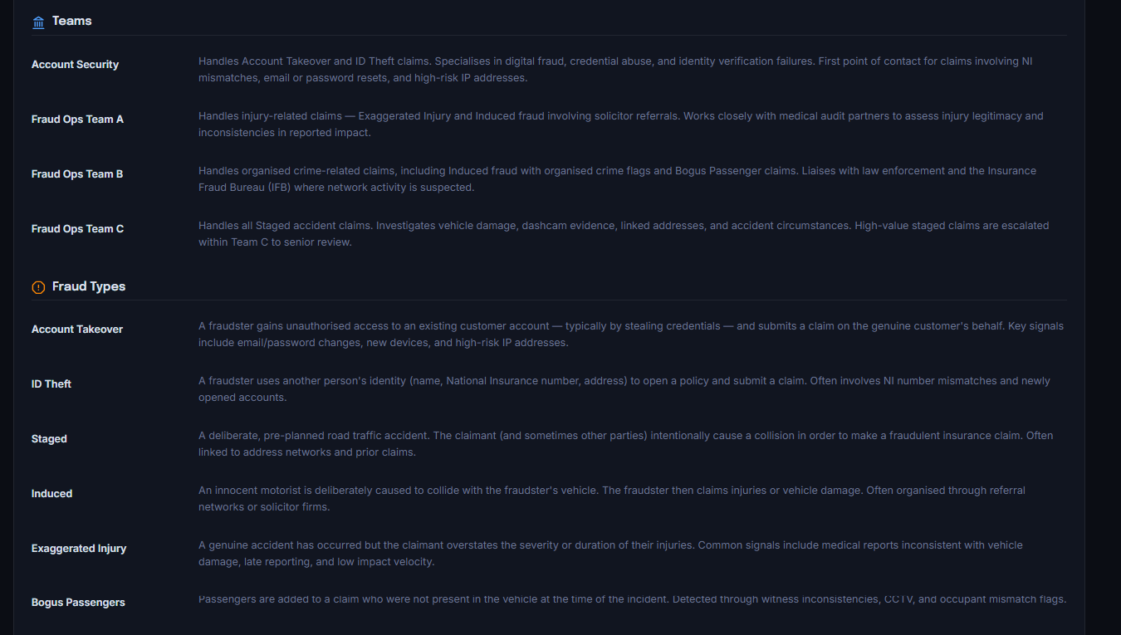
Figure 6: Help tab section outlining team responsibilities and defining all fraud types.

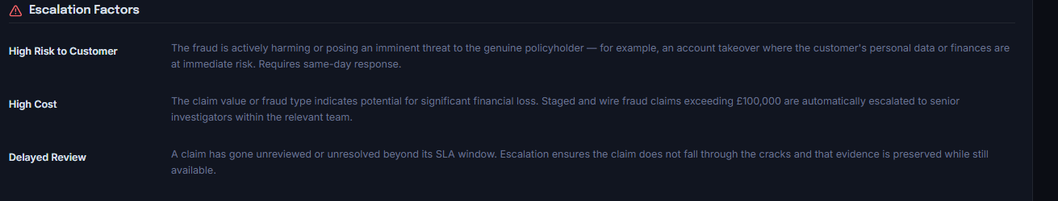
Figure 7: Help tab section detailing escalation factors such as high cost, high risk and review delays.

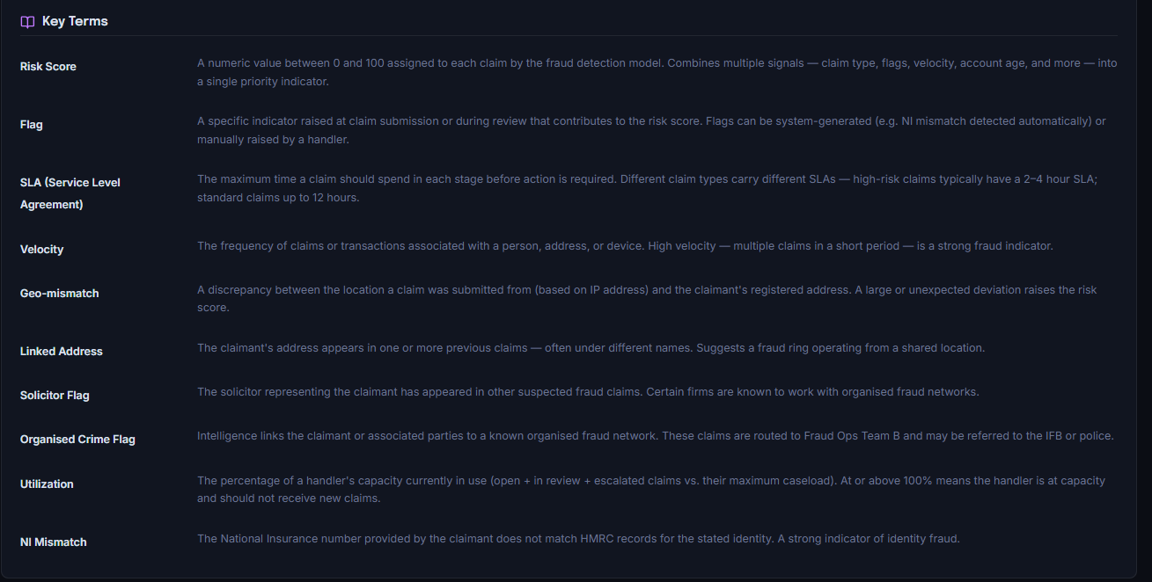
Figure 8: Help tab glossary providing definitions of key terms used throughout the dashboard.

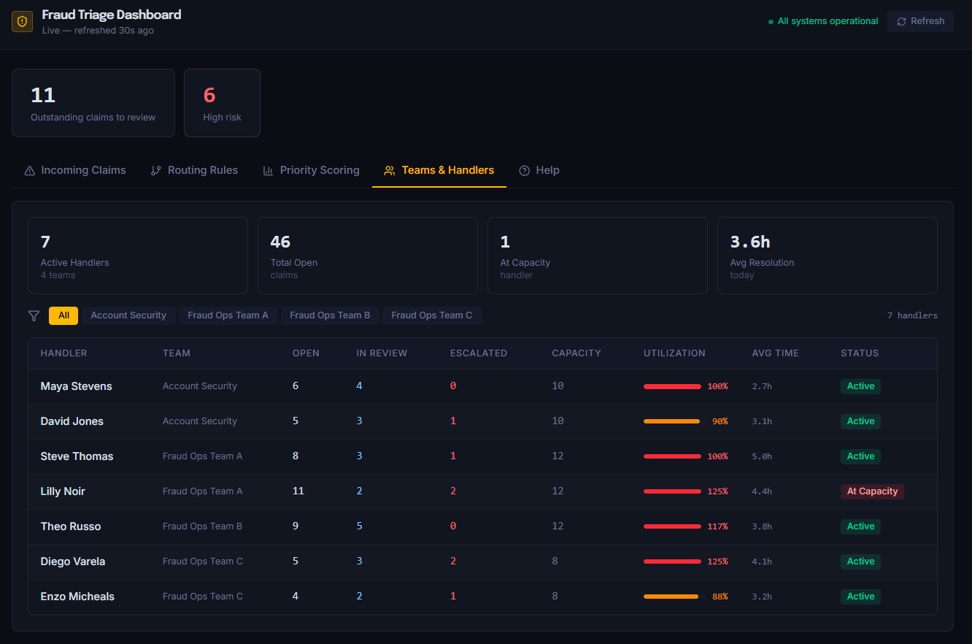
Figure 9: Teams & Handlers tab showing workload distribution, escalation counts, capacity status and team filtering options.

In line with SMART objectives, the home screen needed to function as a simplified, quick-view page, giving immediate access to key metrics, while remaining clean and visually appealing. To achieve this, it was restructured to display only high-level metrics, such as outstanding claims and high-risk claims, supported by clear visuals including a claim status chart, a fraud category distribution chart and a seven-day high-risk trend chart. This creates a clear starting point, giving users a quick understanding of key information, while separate tabs provide more detailed insights when needed. This approach improves clarity, supports efficient decision-making and ensures users can access both summary and detailed information in a user-friendly structure. This follows the ideas of Cole Nussbaumer Knaflic, who explains that dashboards work best when they show only the most important information clearly and use simple visuals to support quick understanding of data. [5]

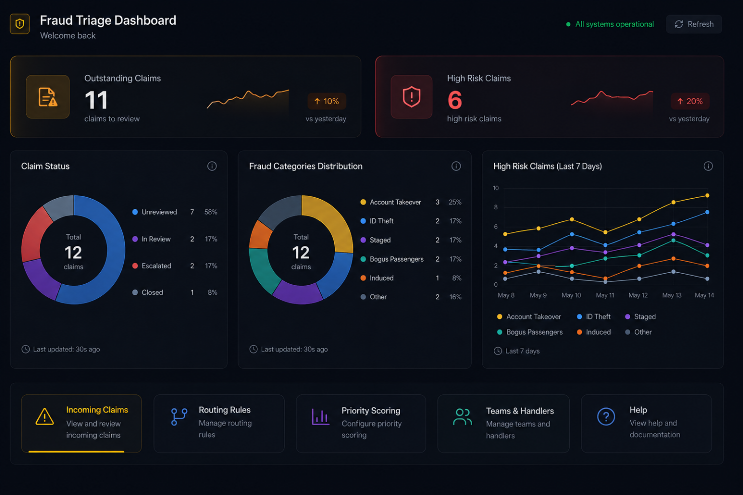
Figure 10: Streamlined home screen providing quick access to key statistics, visual summaries of claim status and fraud category distribution, seven-day high-risk trends and navigation tabs for accessing in-depth dashboard views.

Troubleshooting:
During testing, no functional issues were identified. All components, including navigation tabs, charts and data displays, operated as expected. Troubleshooting therefore focused on usability based on user feedback, including checking navigation, verifying chart readability and ensuring each tab displayed relevant information. These checks supported the refinement decisions made during the redesign.

Task 2: Enterprise & Innovation

T2 – Innovation

Question 1
If the fraud-analysis dashboard was implemented within a large insurance company, several established concepts, methods and tools would be needed to support development, deployment, maintenance and long-term improvement.

Development
Insurance providers implementing the dashboard for fraudulent claims would rely heavily on accurate data and clear, readable reports, supporting efficient decision making [5]. The dashboard would need to be built using approaches that support reliability, transparency and continuous refinement as fraud trends change [4].
The development process would follow a hybrid method, using the Systems Development Life Cycle (SDLC) and Kanban workflow [6], [7]. This provides structured planning and clear development stages from detailing requirements, design, development, testing and reviewing [6]. The strong emphasis on testing supports the accuracy and reliability required and ensures the dashboard is developed in an organised manner. Despite the structured stages, this method still allows ongoing adjustments based on feedback or emerging fraud trends. Kanban complements SDLC by breaking work into smaller tasks, visualising progress, helping prioritise work and quickly identifying delays [7].
Within a large insurance company, the dashboard would need to be developed using industry-standard tools reliably and securely handle personal data. Power BI would be used to design the dashboard and its structure, as it is specifically designed for creating interactive dashboards, reports and visualisations from business data [8]. An SQL database store claim data, routing rules and scoring outputs, as it is designed to enforce business logic [9]. Together, these tools implement logic, provide clear reports and offer quick access to relevant data for efficient triage.
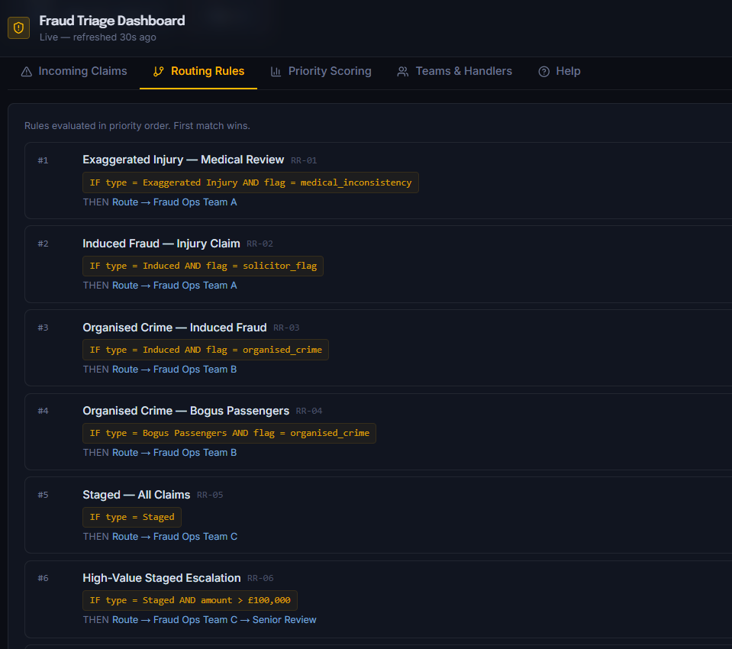
Figure 11: ‘Routing Rules’ tab showing implementation of routing rules which would be stored and updated within SQL tables.

Deployment
Deploying the dashboard within a large insurance company requires controlled, well-structured processes to ensure it is accurate, scalable, able to perform under high-user demand and compliant with regulations. Before going live, User Acceptance Testing would be carried out by fraud analysts and claims handlers to ensure the dashboard behaves correctly, supports real-world data and processes claims in accordance with GDPR. Splunk explains that “User Acceptance Testing (UAT) is the final phase of software testing, where real users validate that a system meets business requirements and works as intended in real-world scenarios before deployment [10].”
After testing, the organisation would stagger the rollout and gradually expand access to the wider business. This reduces the risk of unexpected issues affecting live performance and allows for early rectification, before they affect the wider department.
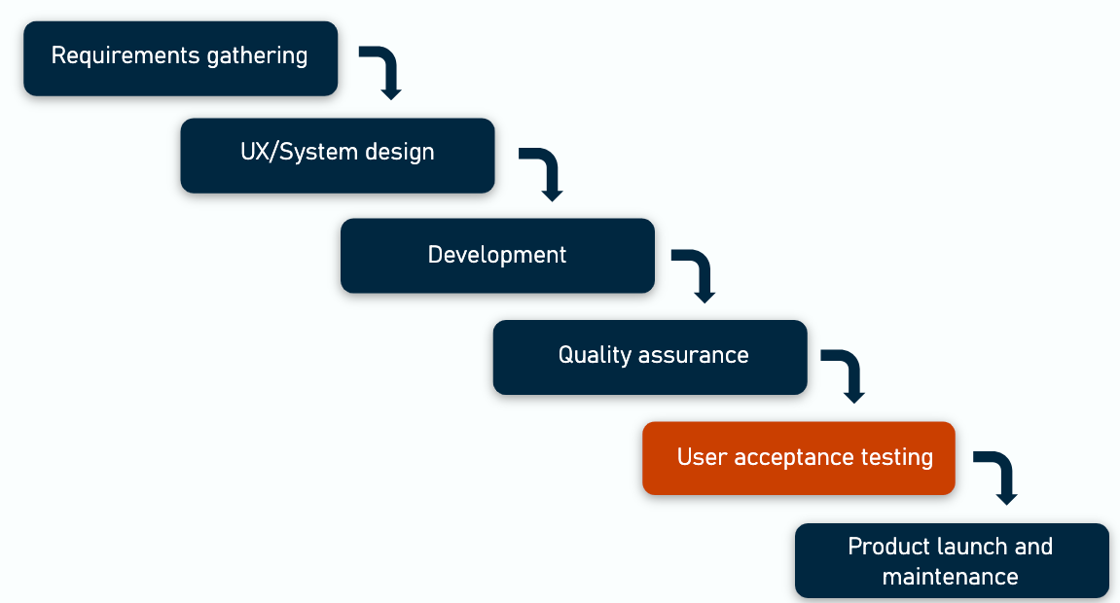
Figure 12: Flow chart highlighting User Acceptance Testing as the final stage before deployment, within a structure development model [11].

Maintenance
Once deployed, the dashboard requires ongoing maintenance to ensure accuracy and reliability. This could be via manual reviews or automated alerts identifying issues such as missing claims data, incorrect scoring activity or gaps in rules preventing correct routing.
In the initial phase, regular feedback from fraud handlers and intelligence teams would help highlight areas for improvement or gaps in the database, such as new fraud types that need adding, updating missing risk indicators, identifying incorrectly routed claims or refining visual elements to make key information more accessible.
Fraud patterns change regularly and quickly, and handlers may move between teams, therefore scoring logic and routing rules would need frequent reviews to ensure it remains accurate and effective [12].
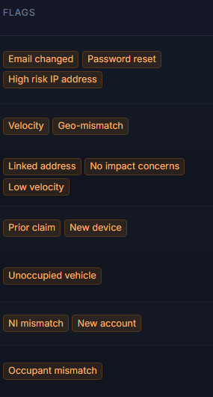
Figure 13: Current risk flags within the dashboard. This is an area that can be updated based on user feedback and emerging trends.

Evolve
As the dashboard becomes fully implemented, it would need ongoing amendments to keep up with changing fraud trends, process requirements and regulatory standards. This requires structed change-management to ensure improvements are introduced gradually and do not disrupt current functionality.
Performance data, user feedback and operational needs would be reviewed regularly and prioritised, so the most essential updates are completed first.
New features could include more in-depth team performance data, further breakdowns of fraud types, or introducing a machine-learning model to identify emerging trends, suspicious claimants and companies or addresses of concern. Deloitte highlights that modern fraud-prevention systems must continuously adapt to new behaviours and risks to remain effective [13]. Any changes would again require testing with small groups before being deployed into the wider department, ensuring updates are accurate and do not negatively impact current processes or dashboard features.

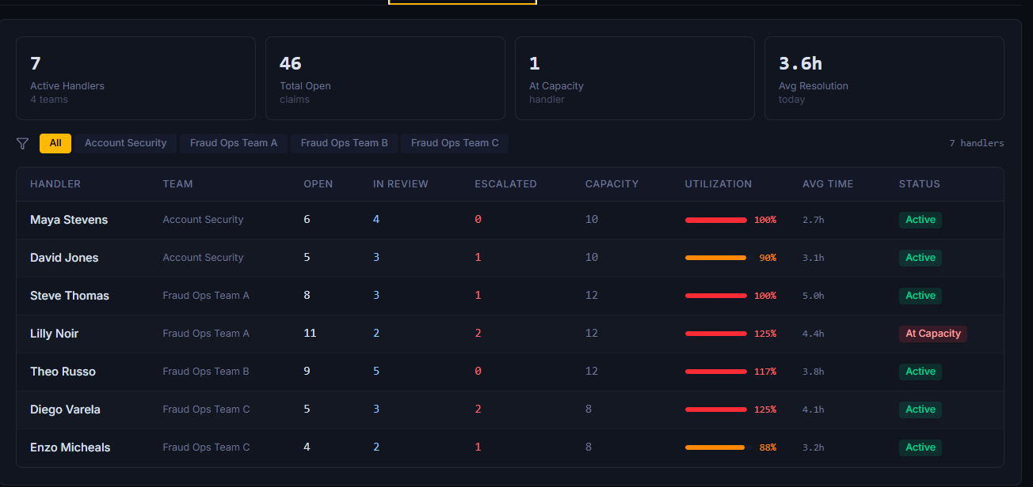
Figure 14: The current Teams & Handlers tab. This could evolve into including data such as number of retained claims, number of claims settled vs number of claims where fraud savings were made.

Question 2
A PEST analysis is used to consider the Political, Economic, Social and Technological factors that impact an organisation or project [14]. Below details the PEST factors to be considered including legal and ethical considerations
PEST Factor | Analysis
Political | - GDPR and data protection laws impact how customer data is stored. The database would need to be secure and adhere to these laws.  - FCA and other regulatory bodies require correct and transparent claims handling, therefore the data needs to be accurate and prioritise correctly.  - Various rules to the fraud industry influence how data can be shared, therefore it must be compliant with these rules.  - There are legal obligations around accessibility, equality and correct/fair decision making – the database would need to ensure it has fair, non-discriminatory scoring [15]
Economical | - Inflation, rising repair costs and general increased business running costs can affect budgets and long-term maintenance or updates.  - Increased inflation and cost of living can drive fraudulent activity, increasing incoming claims and therefore the workload, adding pressure to teams and the ability to review the claims thoroughly.  - Implementation of new systems and subsequent training of handlers/users requires investment, increasing business costs and therefore, insurance prices for consumers.  - A lot of companies are moving to automated systems, there is high competition meaning high pressure for continuous improvement [16].
Social | - Customers expect fast, fair and transparent claims decisions. The dashboard must support this by providing clear and accurate data.  - With increased use of online claims and digital communication, the dashboard must integrate with these systems and support digital workflow.  - Data protection and privacy concerns mean the dashboard must only display data that handlers genuinely need.  - Considering accessibility and inclusion, the dashboard must be easy to use and display information clearly [17].
Technological | - The dashboard must integrate and be compatible with any claims systems used therefore would need to reliable link to policy and payment systems and any other databases.  - Cybersecurity is essential, therefore the dashboard must safely store customer and handler data and defend against cyber-fraud.  - The system must be scalable, therefore must handle busy periods without slowing down [18].

Task 3: Project Reflection

Question 1: Practical Feedback
Feedback on the updated dashboard was collected using Microsoft Forms [1]. Overall, users felt the dashboard was clear, professional and easy to navigate. Several commented the home screen displayed key information effectively, and the tabs for routing rules, priority scoring and handlers were accessible and logically placed.
Changes to the ‘priority scoring’ tab were well received, with users noting improved quality and relevance of information and clearer escalation reasons. The new ‘help’ tab received positive feedback, though some users felt simpler explanations would benefit new handlers unfamiliar with fraud terminology.
Added filters within the ‘handler & teams’ tab were described as useful, and one user suggested expanding this to include additional performance data such as retained claims and handler fraud savings to support performance monitoring.
Based on the feedback, further changes would include simplifying the ‘help’ tab with clearer terminology, and updating the ‘handler & teams’ tab to include metrics such as fraud savings, retained claims and claims passed back with no concerns to strengthen performance reviewing

Question 2: Project Progress Diary
Weekly progress was made using progress sheets to track development, identify issues and set the next weeks objectives.
Project management was structured through weekly objectives, reviews and task planning, supporting steady progress and ensuring changes were implemented in an organised, time-managed way.
The progress sheets effectively tracked completed work, identified delays early and clearly outlined future objectives. Completing short-term tasks contributed to overall progress, providing a structured approach that ensured each stage aligned with the project’s aims.
Future projects would benefit from earlier initial feedback, as this highlighted areas requiring improvement and generated new ideas. Earlier feedback allows more time for implementing changes, troubleshooting and refinement, followed by additional feedback. This provides time for further improvements, ensuring the final version is thoroughly tested and more closely aligned with user needs and the initial objectives.

Question 3: Skills
This project developed several new skills and strengthened existing abilities. Technical knowledge was gained around dashboard functionality, including the importance of clear, structured data, rule-based scoring, usability and navigation.
Practical skills were also developed, such as using Figma, and effectively requesting, obtaining and reviewing user feedback to implement user-interface changes. Weekly progress reviews developed project-management skills including planning, prioritising and time-management.
Understanding of industry concepts improved, particularly SDLC, Kanban workflow, PEST analysis and their importance to system development. Knowledge of legal and ethical elements of decision-making systems also developed, alongside awareness of widely recognised usability principles.
Overall, the project improved technical capability, strengthened organisational skills and encouraged attention to detail throughout development.

Question 4: Positive Social Impact (PSI)
The project and the skills it developed have multiple ways to create a positive social impact. Dashboards are widely used across many industries, and improving accuracy and usability is particularly important within the fraud industry. Accurate triaging and identification ensures fair scoring and consistent decision-making, helping insurers identify fraud earlier. Reducing fraud protects insurers from financial loss, which helps prevent premium increases for customers and builds trust.
The skills developed through project management, dashboard design and refinement are transferable to industries that rely on accurate data for informed decision-making. Understanding legal and ethical principles such as fairness, transparency, data protection and responsible data handling strengthens awareness of ethical considerations.
Improved usability and navigation contribute to better customer experiences, ensuring data is accessible, understandable, and supports fair outcomes.
Although the dashboard was designed to benefit a business, it is ultimately customer-driven, aiming to ensure accuracy, fairness and consistency with ethical awareness in mind. This was achieved while developing transferable skills that can support other areas and contribute to a positive impact elsewhere.

Conclusion
Development of the Fraud Triage Dashboard demonstrated how structured project management, user-focused design and implementing feedback can produce a clear, functional and accessible tool, supporting accurate decision-making with minimal human input.
Feedback led to meaningful changes improving usability, navigation and clarity of data, whilst remaining aligned with industry principles and practical fraud-handling requirements.
The process developed valuable technical, managerial and ethical skills from understanding rule-based scoring and usability principles, to considering legal and ethical elements such as fairness, transparency and responsible data handling.
Overall, the project highlighted the importance of structured development plans, progress tracking, implementing feedback and considering objectives and social impact to provide a tool which benefits both businesses and customers. It strengthened critical thinking, problem-solving, attention to detail and transferable skills that will benefit future work across data-focused areas.

Appendices

Considering Business Types
For a tech/data-related product like a fraud dashboard, would likely choose incorporated business

1. Liability protection
An incorporated business is legally separate - personal assets are protected if something goes wrong
As a fraud dashboard deals with sensitive data, risk scoring, and regulated environments — personal liability would be risky.

2. Appears more professional
Unincorporated can look too informal for the fraud industry.

3. Scalability
Incorporated businesses can hire staff, take investments, sign commercial contracts and license software

4. Tax benefits
- Pay corporation tax instead of income tax
- Pay yourself via salary + dividends
- Deduct business expenses easier

Unincorporate is largely used where there is:
- No sensitive data
- No risk
- No clients
- No contracts
- No employees
- No wants or ability to scale products
This does not align with a fraud dashboard project.

Conclusion for choosing incorporated:
It avoids personal liability whilst appearing more professional.
It provides the ability to sign contracts, and the product can be scaled, which would be required of a fraud-related dashboard.

Feedback Form

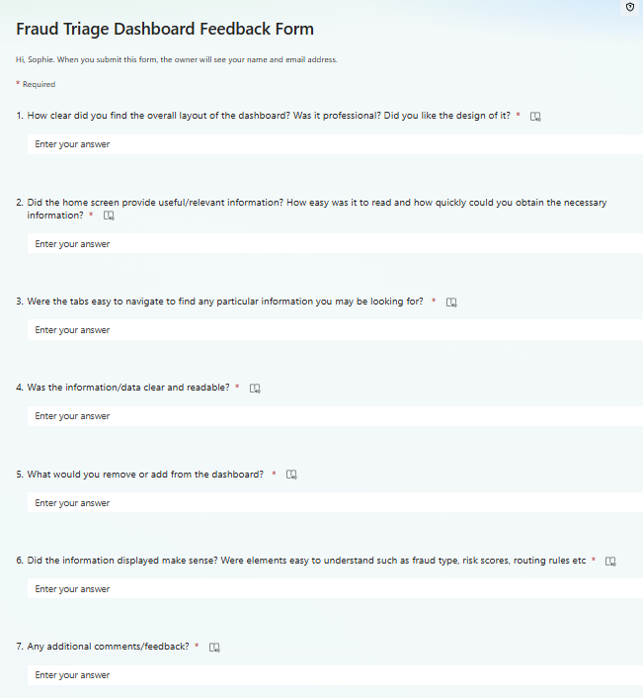
Figure 15: Screenshot of the feedback form generated on Microsoft Forms, to receive user feedback.

Changes to be made on review of feedback
- Remove the assigned handler tab – Instead, include which handler and team is assigned each claim on the incoming claims tab.
- Replace the ‘submitted’ column with how many days old the claim is.
- Change priority scoring tab – totally remove current content and replace with a breakdown of how risk score was calculated. Display claims in order of risk, highlighting what the risk is (high cost, high risk, or delayed being reviewed). Include the flags also used to calculate this risk score. A dropdown to give more information on scoring factors.
- In escalated claims tab within the incoming claims tab –add a tag with a reason why claim has been escalated
- Home screen - Remove average response and auto resolved boxes – instead, show only key data such as number of outstanding claims to be reviewed, how many of these are high risk.
- Add a HELP section – explain what each risk tag means, what each team deals with, what fraud types there are, what factors go into escalated claims (high risk, high cost, delays in reviewing), explain key terms used
- Add the ability to filter by team in the ‘handler workload tab’.

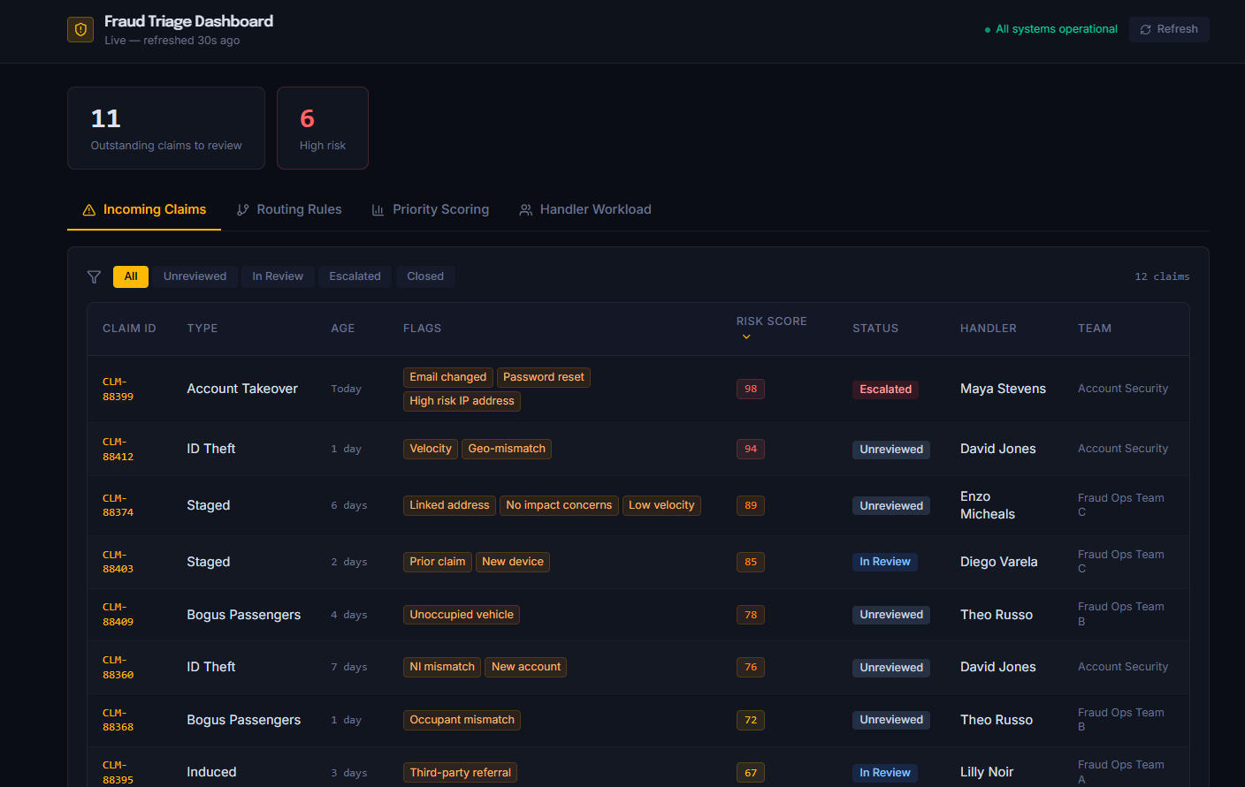
Figure 16: The main page of the dashboard once some amendments were made, leading to the decision to create a separate home page.

Further review:
The home screen does not display enough key data and takes users straight into the main information hub.
Further changes to make:
Make a separate home screen with the tabs accessible from the home screen.
Requirements/goal:
Home screen needs to display basic information at a glance, with more in-depth information available from there.
Data to include on home screen:
- Outstanding claims
- High risk claims
- Claim status overview
- Distribution of claims within each fraud category
- Specify the number of high-risk claims for each fraud category, via a line chart
- Initial tabs to be clearly visible and easily accessible from this page.

Case Study – LAS IT Failure
What caused the bugs and problems in the London Ambulance Service (LAS) IT Failure (1992)?

Technical issues with the system
It couldn’t distinguish if multiple people were calling about the same incident.
Software was unable to keep track of logged calls. Someone called multiple times, with no record of her earlier calls

Main Issues [19]:
- Lack of time
- Lack of testing
- System and users were not prepared for the deployment – lack of training.
- Only had a one-phase deployment, so was issued to all users at the same time, with lack of testing and no back up plan.
- The company contracted to create software was ‘out of its depth’ with no prior experience with such complex systems.
- They settled for the lowest costing system rather than ensuring the company was able to provide a reliable product.
- Ultimately were errors in design, development and deployment.

What Development tools, methods and best practices could be used to prevent the flaws in the ‘London Ambulance Service IT Failure’ before it was released?
- Full requirements gathering – developers did not understand how the dispatch actually worked
- Early user testing with an offline system
- Multi-phase deployment – release the system to small groups, rather than deploying to the full service without any back up plans.
- Training – practice sessions, user manuals and guides, prepare staff for the new system.
- Full testing of all areas – individual components, simulate real life emergencies/calls, User Acceptance Testing (with real dispatchers)
- Chose a more experienced vender without being focused on cost. Given the sector, the developer should not have neem chosen based on being lowest cos [20].

Project Progress Diary
Project Overview
Name: Sophie Foyle
Student number: 2506393
Project Name: Fraud Triage Dashboard

Project Aim: To create a dashboard to remove/minimise manual input involved in claims triaging and allocation.

Project Objectives: The project followed SMART objectives, detailed in the project proposal.
- Reduce manual input via rule-based processes
- Improve routing accuracy with predefined rules and indicators
- Prioritise urgent claims using rule-based scoring
- Increase consistency via rule-based criteria and accuracy of risk scores.

Progress Diary:
Week commencing 06/07/2026
Objectives:
- Gather feedback.
- Implement all changes.
- Re-review the dashboard layout and identify any other changes that would benefit the look and functionality.

Progress:
- User feedback obtained – all changes were implemented
- Full re-review of dashboard complete. Further areas for improvement were identified, including the need for a separate home screen for quick view summary, adding team workload visibility, implementing team filtering and displaying allocated handlers and teams within incoming claims.
- The additional home screen was implemented on identification.

Week commencing 13/07/2026
Objectives:
- Implement the remaining required changes that were identified but not complete in the previous week.
- Troubleshoot any issues.

Progress:
- All additional improvements were implemented – all changes have now been fully completed.
- Troubleshoot complete. The dashboard functioned as expected, therefore focus was on testing navigation and usability.

Week commencing 20/07/2026
Objectives:
- Consider PEST factors
- Obtain further feedback since amendments made

Progress:
- PEST factors considered and noted.
- Feedback has been obtained.

Week commencing 27/07/2026
Objectives:
- Complete further troubleshooting now changes have been made.
- Note further areas of improvement for the next stage, now further feedback has been obtained

Progress:
- Troubleshooting complete – as before, the dashboard functions correctly therefore troubleshooting focused on usability and accessibility.
- The additional changes required have been noted, in preparation for further amendments to be made.

Further Feedback Form
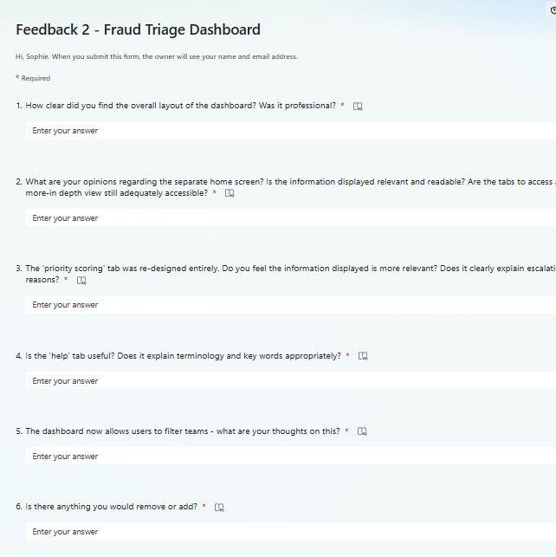
Figure 17: Feedback form on Microsoft Forms to obtain further feedback once all changes had been completed.

Engagement with online course
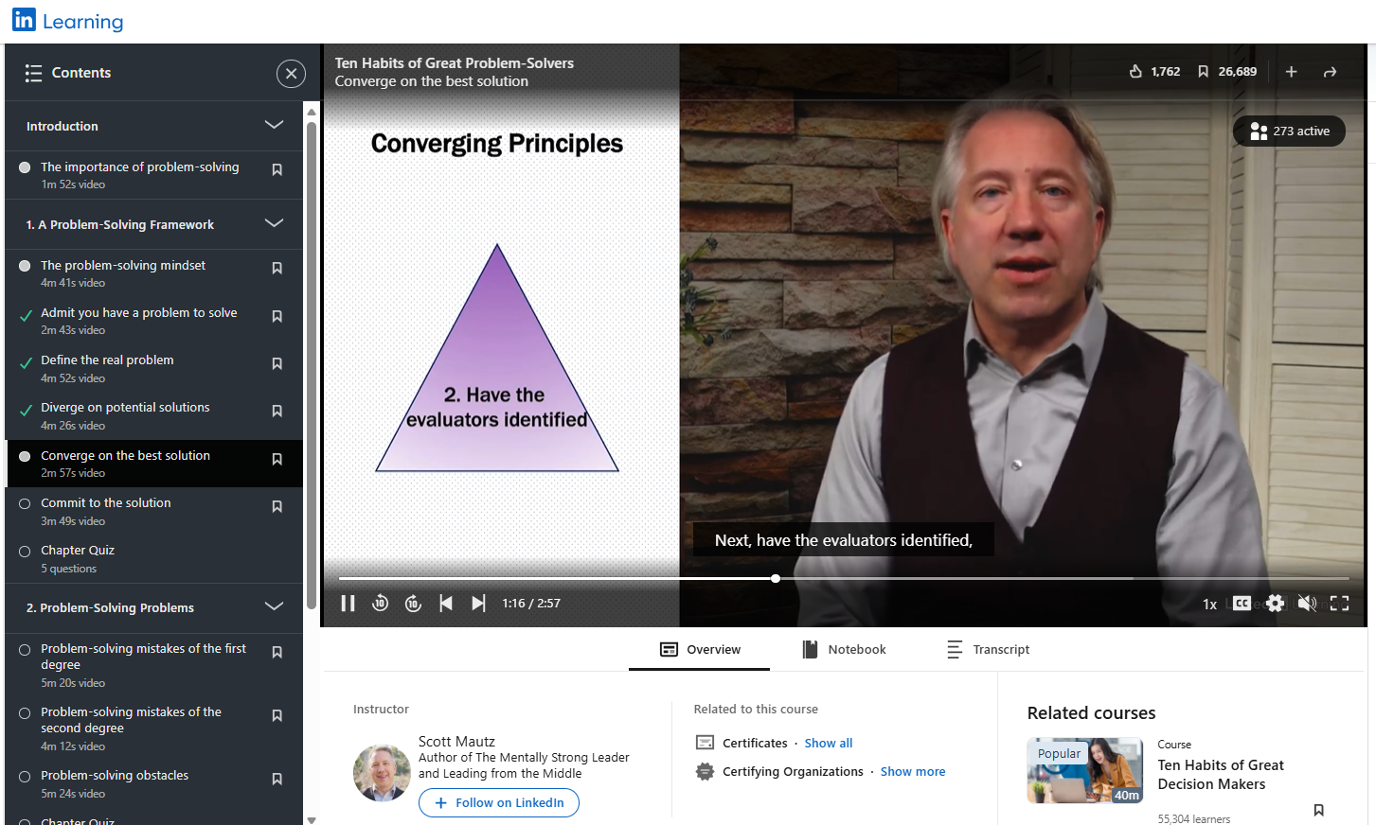
Figure 18: Participation in an online problem-solving course

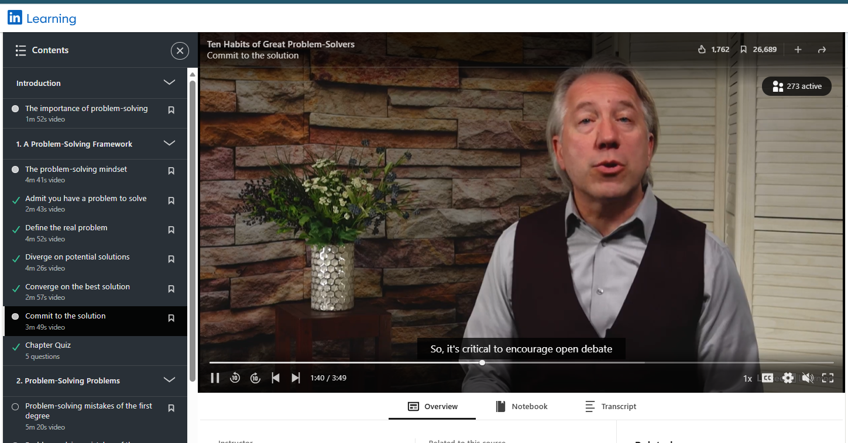
Figure 19: Further evidence of participation in an online problem-solving course

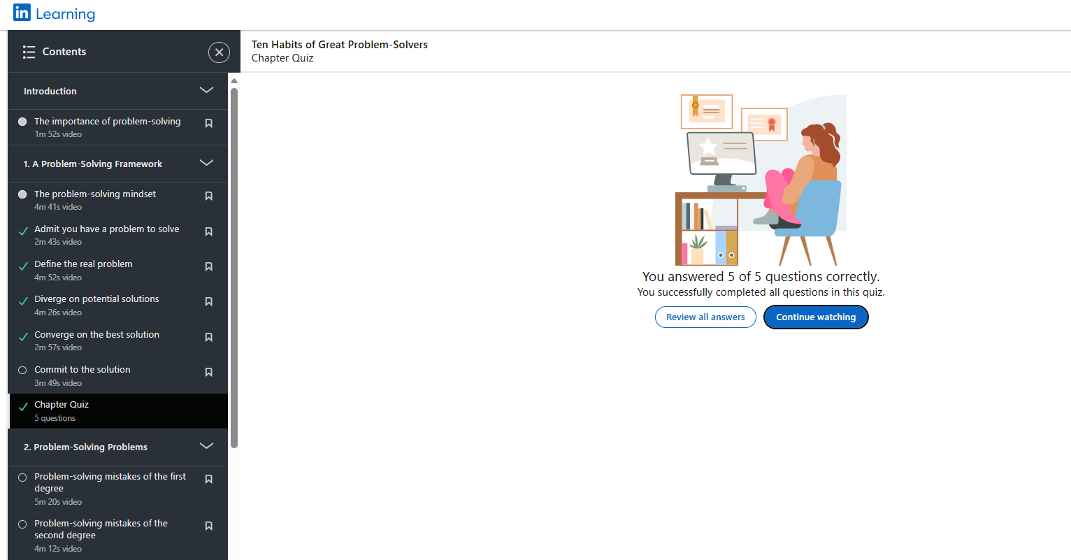
Figure 20: Quiz results after participating in the online course [21].

REFERENCES:
[1] Microsoft Corporation, “Microsoft Forms.” Accessed: Jul. 14, 2026. [Online]. Available: https://forms.microsoft.com/
[2] Figma, Inc., “Figma.” Accessed: Jul. 14, 2026. [Online]. Available: https://www.figma.com/
[3] J. Nielsen, “10 Usability Heuristics for User Interface Design,” Nielsen Norman Group, Apr. 24, 2020. Accessed: Jul. 21, 2026. [Online]. Available: https://www.nngroup.com/articles/ten-usability-heuristics/
[4] F. Doshi-Velez and B. Kim, “Towards a Rigorous Science of Interpretable Machine Learning,” arXiv, Feb. 2017. Accessed: Jul. 21, 2026. [Online]. Available: https://arxiv.org/abs/1702.08608
[5] C. N. Knaflic, Storytelling with Data: A Data Visualization Guide for Business Professionals. Hoboken, NJ, USA: John Wiley & Sons, 2015.
[6] I. Sommerville, Software Engineering, 10th ed. Pearson, 2015.
[7] D. J. Anderson, Kanban: Successful Evolutionary Change for Your Technology Business. Blue Hole Press, 2010.
[8] Microsoft Corporation, “Share and Collaborate on Power BI Reports and Dashboards – Power BI.” Accessed: Jul. 2026. [Online]. Available: https://learn.microsoft.com/en-us/power-bi/collaborate-share/service-share-dashboards
[9] Microsoft Corporation, “Use SQL Database as an Operational Data Store – Microsoft Fabric.” Accessed: Jul. 2026. [Online]. Available: https://learn.microsoft.com/en-us/fabric/database/sql/use-case-operational-data-store
[10] Splunk, “User Acceptance Testing (UAT): Definition, Types & Best Practices,” Splunk Learn, Oct. 21, 2024. Accessed: Jul. 28, 2026. [Online]. Available: https://www.splunk.com/en_us/blog/learn/user-acceptance-testing-uat.html
[11] AltexSoft, “User Acceptance Testing: A Comprehensive Guide.” Accessed: Jul. 2026. [Online]. Available: https://www.altexsoft.com/blog/user-acceptance-testing/
[12] Financial Conduct Authority (FCA), Financial Crime: Fraud Trends and Emerging Risks. FCA Report, 2024.
[13] Deloitte, “3 Insights Into the Future of Fraud Prevention.” Accessed: Jul. 2026. [Online]. Available: https://deloitte.wsj.com/riskandcompliance/3-insights-into-the-future-of-fraud-prevention-f4eb8e55
[14] G. Johnson, K. Scholes, and R. Whittington, Exploring Corporate Strategy, 10th ed. Pearson, 2020.
[15] Information Commissioner’s Office (ICO), Guide to the UK GDPR, 2024.
[16] Association of British Insurers (ABI), UK Insurance: Key Facts 2024, 2024.
[17] Financial Conduct Authority (FCA), Consumer Duty: Finalised Guidance FG22/5, 2024.
[18] National Cyber Security Centre (NCSC), Cyber Security for Organisations, 2024.
[19] Stanford University, “Critical Systems in Commercial Environments.” Accessed: Jul. 2026. [Online]. Available: https://cs.stanford.edu/people/eroberts/courses/cs181/projects/1999-00/critical-systems/commercial.htm
[20] Microsoft Copilot, “AI Assistance and Productivity Features.” Accessed: Jul. 2026. [Online]. Available: https://copilot.microsoft.com/
[21] LinkedIn Learning, “Ten Habits of Great Problem Solvers – Assessment.” Accessed: Jul. 2026. [Online]. Available: https://www.linkedin.com/learning/ten-habits-of-great-problem-solvers/quiz/urn:li:learningApiAssessment:69491861

