Name – Julian Milligan
Student number – 1904804
Course – Bachelor of Science (Part-time): Computing (Software Engineering)
Module - L4 - Introduction to Web and Database Concepts
Date – 11/04/2021

Table of Contents
Introduction 3
Requirements 4
Implementation 6
Site screen shots 6
Validation 11
HTML 11
CSS 14
Evaluation 15
The site 15
Website usability 15
Accessibility 15
Search Engine Optimisation 15
Usefulness (usability and utility) 15
Search Engine Optimisation (SEO) 16
Accessibility 16
References 16
Appendices 17

Introduction

This report will focus on the design and build of a five-page website using Hyper Text Markup Language HTML and Cascading Style Sheet CSS. The report author has decided to use CSS grids to help layout out the site as he has never used this layout method before. The author / designer admits to not being a very artistic person, so the site is very minimal, but the designer feels the site works well with the content that has been included in it.

Requirements

The site is based on the Amazon Tv show The Expanse. The site focuses on several pages which give the users a brief introduction in the show. The crew of the Rocinante which the ship the main protagonist crew and use during their adventures. There is also a page which displays some information about the Roci (Rocinante) and the Tycho station which also plays a big with in the later seasons of the show. Another page gives a brief description of the 3 main factions within the show. The final page mentions some of the extended cast.
The show it`s self is based on the books by James S.A Corey who are two collaborators Daniel Abraham and Ty Franck. Ty Franck is also a producer on the series.
The reason the site was designed around this TV series is because of the authors liking for the series because of the true to life visual affects and the science used with in the series.
The target audiences is users who may have not seen the show or users that may have started watching it and want to more about the characters, ships or factions. Moving forward more cast members could be added and all the ships listed.
The author / designer has knowledge of bootstrap which could have been used to layout the site but while researching other ways of laying out webpages he came across CSS Grids. As he had never used this technology before it was decided that this method would be used as it would be a new learning experience. There are some other benefits of using CSS Grids these are :-
- All the code is controlled in the main CSS file even though a second one could be created for just the grids. If the site became much larger.
- No JavaScript is needed which is needed for Bootstrap. Even though most browsers now support Javascript as a norm. Some mobile phone browsers do have issues running Javascript. [1]
- Extra files are required on the sites for the use of Bootstrap.

The site is laid out in a very basic pattern, there is a header with a image the height and width of this image is controlled within the HTML code and is measured in pixels.
<img src="images/header.png" alt="The Expanse logo" height="250" width="1200" />
Below the header is the Navigation Bar which listed all the pages of the site, the styling is controlled via CSS. The design consists of an unordered listed with is horizontal and it has had the bullet points removed. The standard a href colour and line below the text has also been altered via CSS. Now the colour matches the rest of the site and there is an hoover affect where the text becomes bold. There is no selected attribute being used.
Next there is the content of the page, this has a very slight background colour to make it stand out a little from the main background colour. In the content there are some links to external sites and anchors within the main site but on other pages. These links are different from the Nav links and use CSS to make them bolder than the other text. Padding is used so the text position looks nicer and so it`s not touching the borders.
On some of the page’s tables are used to help layout the text, images, and specifications about the ships.

Below the content there are two further areas one on the left which displays several social media accounts to follow. Moving forward this could be changed to show live and dynamic accounts from Twitter or Facebook. This would be like some of the features on WordPress which is a prebuild Content Management System. CMS are used for some small business; the designer can build the site and allow members of the team access to a backend or admin system to update content on the site. An example of a WordPress site is Go Sport & Leisure . The site is designed using a grid layout but because of the vast amount of prebuild features Facebook and TripAdvisor features are built in. The staff also can update the pages with out needing any HTML skills. This site was created by the author and permission was granted by the business manager Kirsty Charlene Ball to link to the site. Next to the Social media links is an iFrame which displays a Youtube video. Currently this is a static video but moving forward this could be coded to display the latest video in channel on YouTube.

Finally, we have the footer with copyright information and a disclaimer about external sites. On a side note if this site was published on-line then a General Data Protection Regulation cookie notice would be needed, even though no personal data is being collected cookies could still be used for analytics. Analytics is cover in more depth in the Evaluation section of this report.
The content for the site came from a few sources. [2]

Implementation

Site screen shots

Index
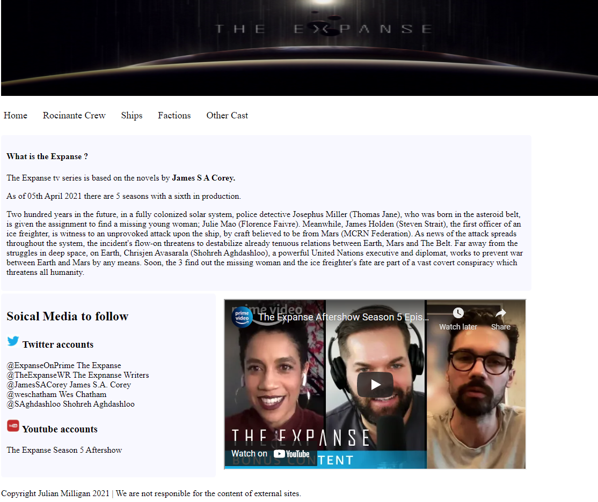

Rocinante Crew
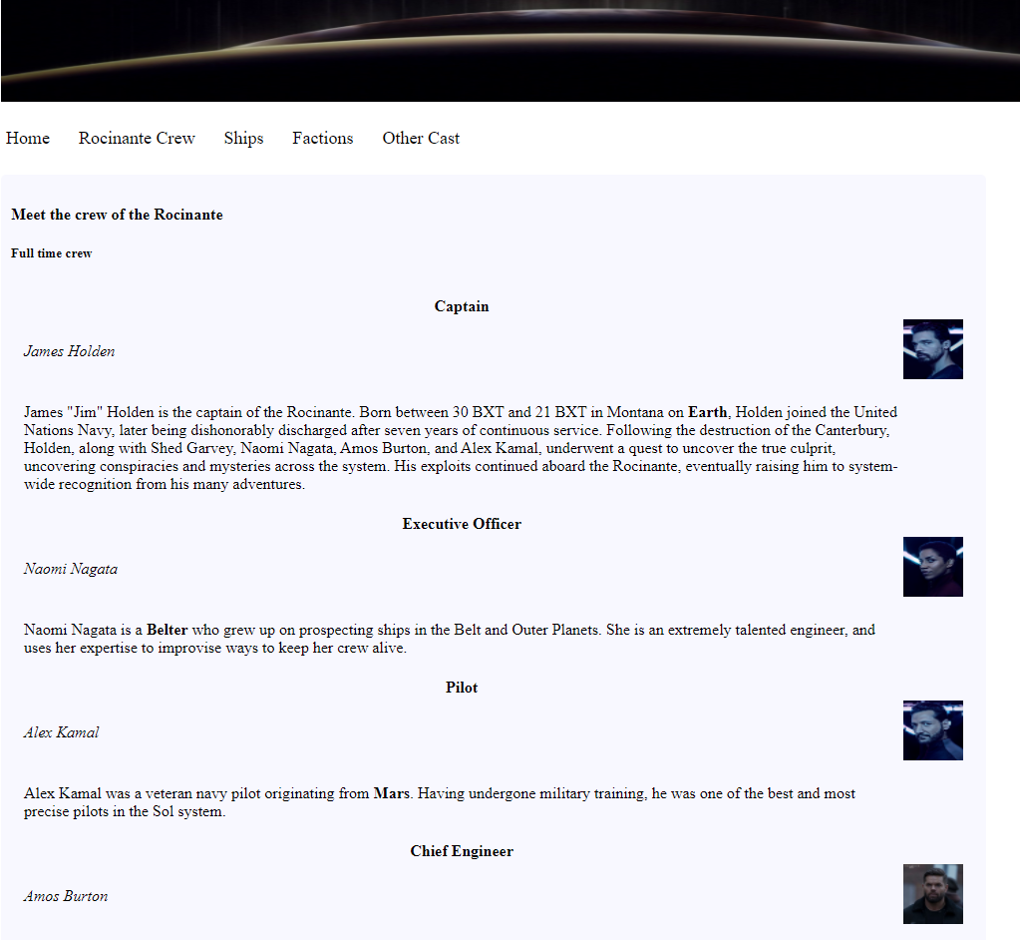

Ships
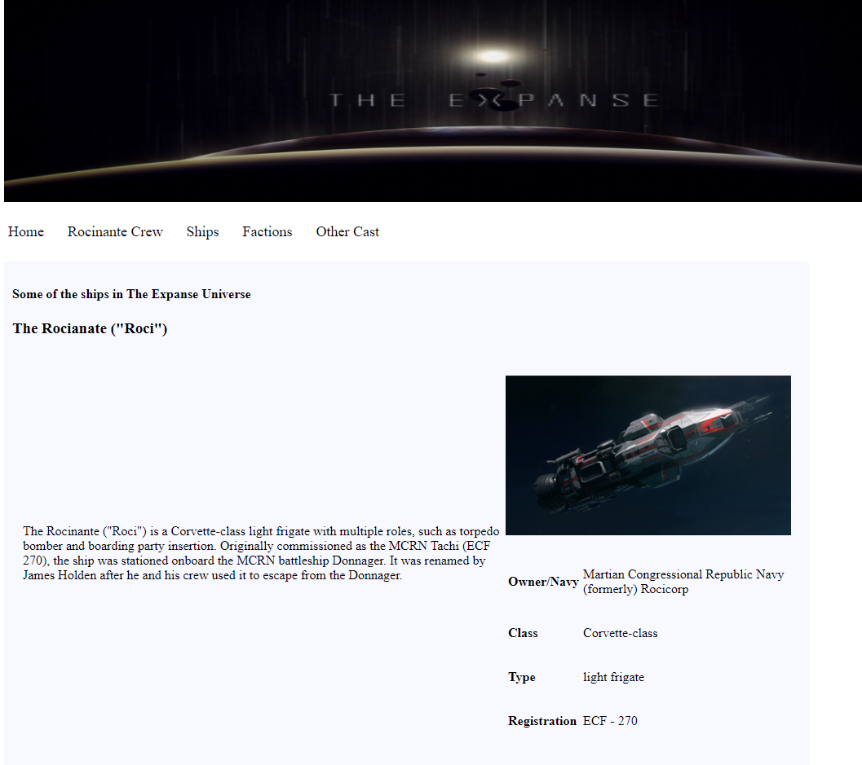

Factions
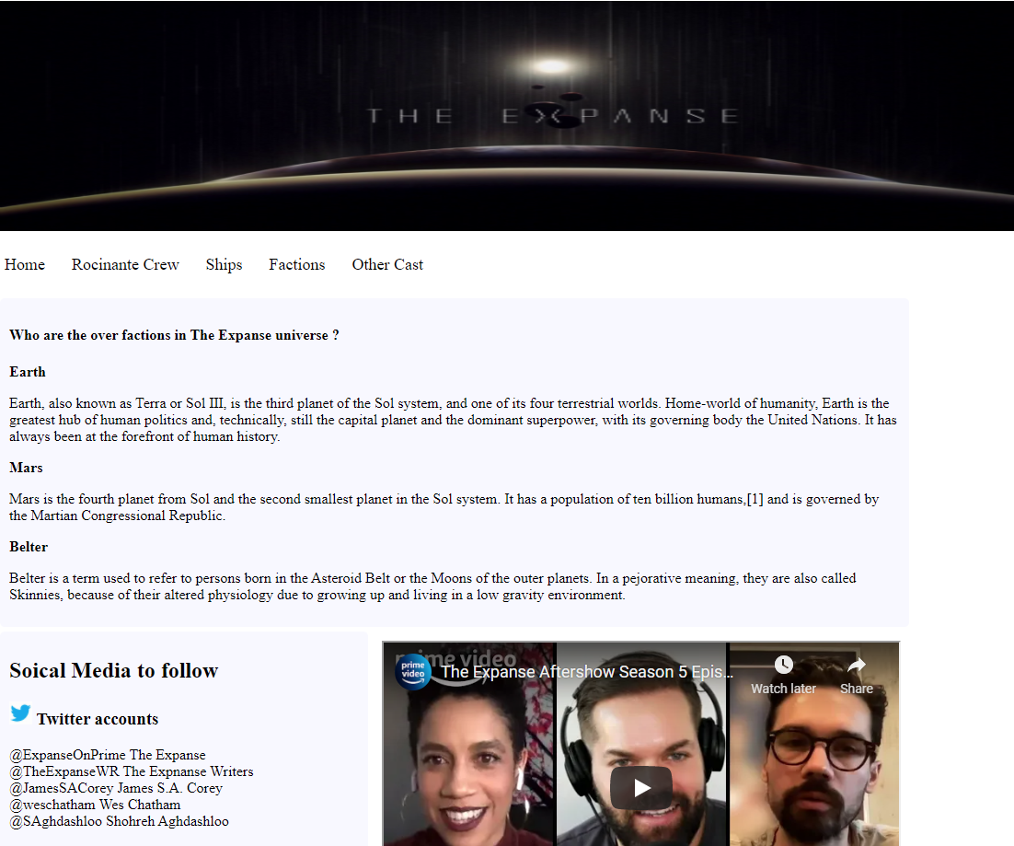

Other Cast
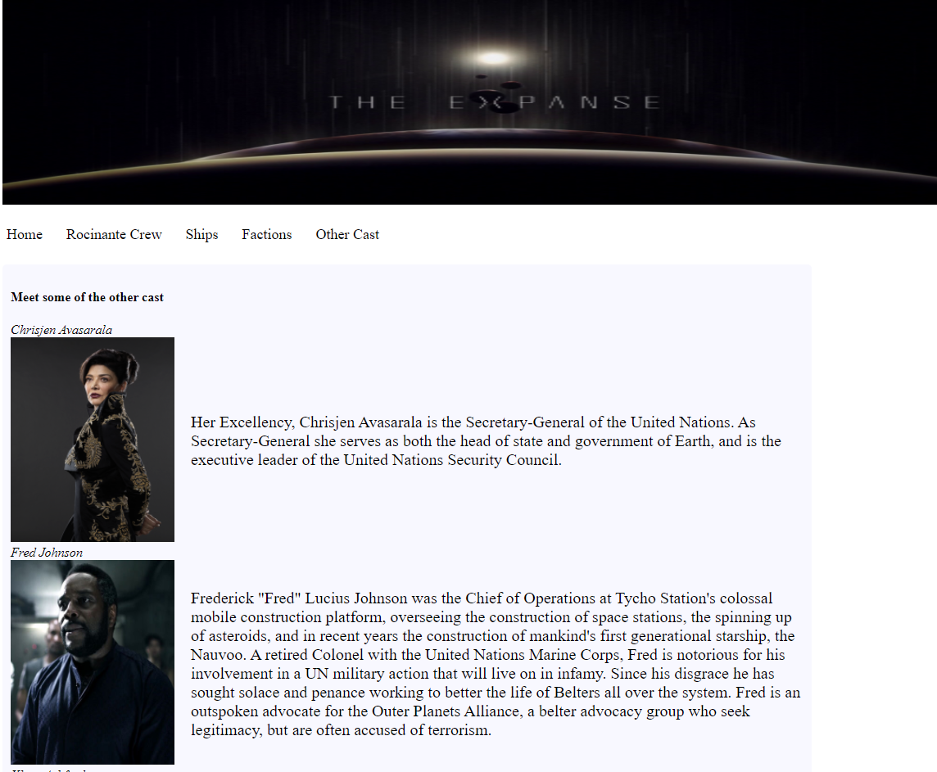

Validation

HTML

The HTML was validated via W3C Markup Service at The W3C Markup Validation Service. There were initially some errors with the way tables were laid out. The author only had one table heading, in another column there were 2 two rows and the last had only one row. Changes were made so all rows matched. The author / designer was not aware of the on-line validation tools for HTML and CSS. Also following on from this course the designer will look at taking several courses to improve his confidence and knowledge.
The will include :-
Introduction to Web Accessibility | edX
Front-End Web Developer Professional Certificate | edX

Index
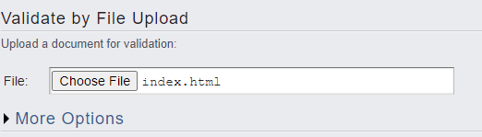
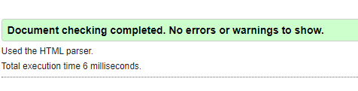
Rocinante Crew
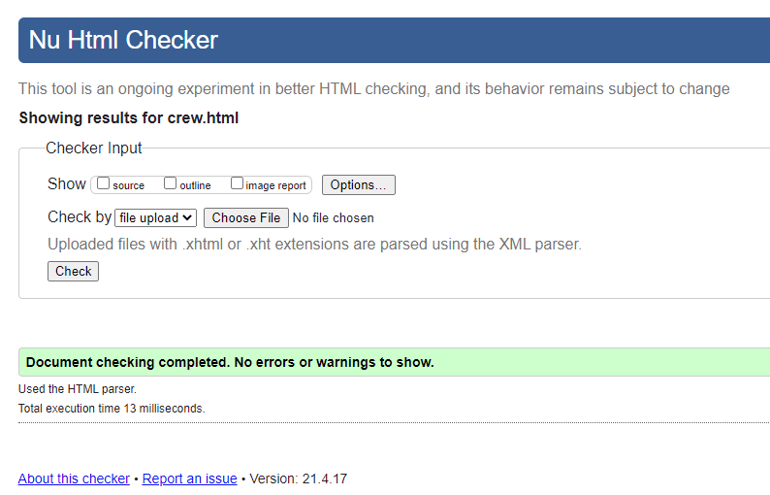

Ships
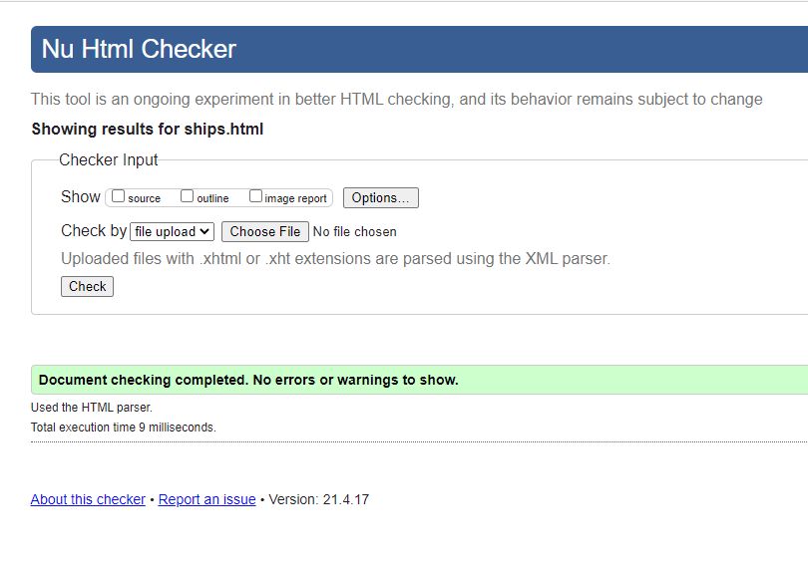
Factions
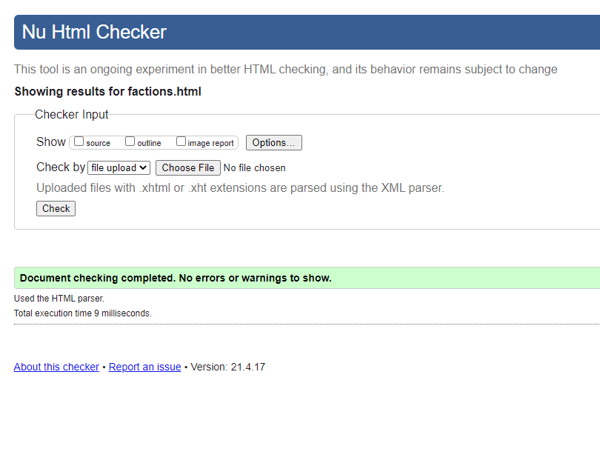

Other Cast
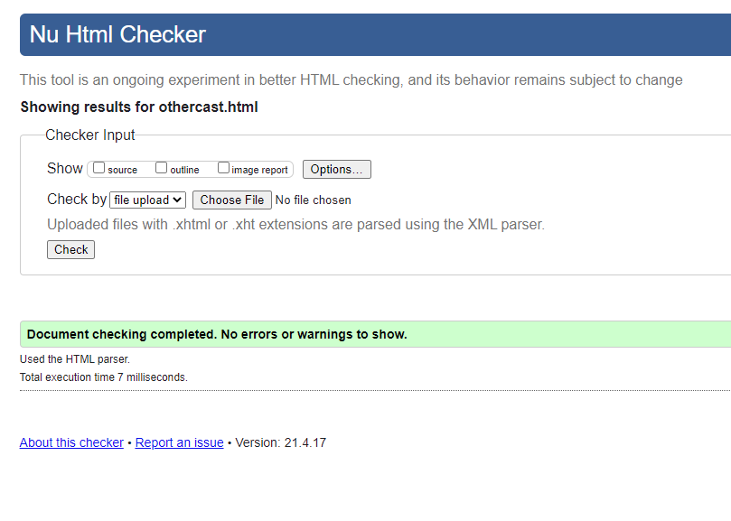

CSS

The site that was used to validate the CSS was The W3C CSS Validation Service. There were no errors in the CSS so the validation was added to the site`s footer. The author / designer does use CSS on a daily basses in his work environment but most is generated, completing this assignment has given him the confidence to look and modify the CSS to improve the look, feel and functionality of the projects.
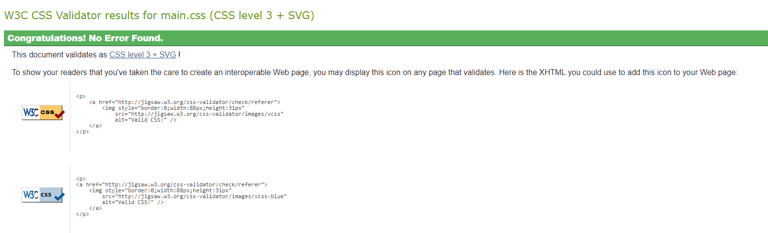

Evaluation

This was an interesting assignment to work even though the author has been in the position as a developer for a number of years and designed a number of sites using ASP.NET MVC and WordPress he has not build a site from scratch using the latest version of HTML and CSS. He used a number of books in his personal library to help refer to tags and best practices. [3] [4]. Even though the publishing dates are a couple of years old I feel they still have relevance in today’s development world.

The site

The site is very minimal however the designer feels it does give the user the necessary information about The Expanse universe. There are several sites out there that are much larger and are powered by SQL database and a large number of users that submit and edit sections of the sites. The site that was build could in future have more pages added and the content improved to match the sites already out there.

Website usability
As Alexiei Dingli and Sarah Cassar mention in their paper An Intelligent Framework for Website Usability [5] there is some confusion between Website usability and Website Accessibility. The International Standards Organization ISO09241 [6] which states ““Usability is the” extent to which a product can be used by specified users to achieve specified goals with effectiveness, efficiency, and satisfaction in a specified context of use” whereas World Wide Web Consortium [7] states “ “people with disabilities can perceive, understand, navigate, and interact with the web, and they can contribute to the web.”. The Accessibility part of the site will be discussed further on in this report.
Even though the paper is written for more advance websites and IUE Tool and talks about AJAX requests, so the page need not refresh and the data is always up to date. Some of the concepts discussed in the paper can be used for the site in this assignment. These include having the main part of the content below the heading so the user only need focus on part of the site to get the important content and less relevant parts are further away from the header. More can be seen in Experiment 3 on the paper [5]

Accessibility
As mentioned above usability and accessibility are in the authors thoughts two different aspects to a website. Usability can relate to all users where accessibility will mainly focus on users where aspects of the website would affect their overall experience of the site such as not being able to read the text due the colour of the background and the text not being a good match or a visually impaired person not being able to listen to the site using a screen reader.
A tool was installed into the author browser called WAVE Evaluation Tool [8]to test the Accessibility of the site. See Appendix 1 for the results. The site had warnings for Page Regions and using the guidance on Page Regions • Page Structure • WAI Web Accessibility Tutorials (w3.org) changes would be made to the site before it was published to the internet.

Search Engine Optimisation
Quoted from Moz.com under the question What is SEO? They quote.
“SEO stands for “search engine optimization.” It’s the practice of increasing both the quality and quantity of website traffic, as well as exposure to your brand, through non-paid (also known as "organic") search engine results.”
In layman terms the art SEO is getting your webpage on page 1 of the results page on a search engine. Madeline Jacobson mentions “The average web user won`t go past the first five listings on a search engine results page (SERP)” [9]
To improve the chances of a site being seen on these magic 5 pages there are some changes that can be made to a website. According to the journal by Shuman, Lou; McNickle, Ian [10]
- Maximize your tile tags
- Create a customized meta description
- Create a site map
- Create fresh and rich content
- Encourage website backlinks
- Be socially active
Please see appendix 2 for a listing of the Tile tags and meta description used on this assignment.
For item number 2 The site map. The following is a visual example of the site for the site:-
Home
Crew
Factions
Other cast
Ships

See appendix 3 for the coded version of the sitemap in XML format.

Usefulness (usability and utility)

Moving forward if the site was to become live on the internet, then most of the content would be added to a SQL Database and allow authorized users to Create, Read, Update and Delete data. Because the site will then be capturing personal information and using cookies then a GDPR cookie accept message will need to be used on the site.

References

[1] | T. C. W. a. B. Shreya Bose, “How to resolve JavaScript Cross Browser Compatibility Issues,” BrowserStack , 18 02 2021. [Online]. Available: https://www.browserstack.com/guide/resolve-javascript-cross-browser-compatibility-issues. [Accessed 11 04 2021].
[2] | Fandom, “The Expanse Wiki,” [Online]. Available: https://expanse.fandom.com/wiki/Rocinante_(TV). [Accessed 2021 04 11].
[3] | C. M. &. B. Kennedy, HTML & XHTML, O`Reily, 2006.
[4] | J. Niederst, Web Design in a nutshell, 2001.
[5] | A. D. a. S. Cassar, “An Intelligent Framework for Website Usability,” 14 04 2014. [Online]. Available: https://www.hindawi.com/journals/ahci/2014/479286/. [Accessed 18 04 2021].
[6] | I. 1. 4. E. o. h.-s. interaction, “ISO 9241-11:2018,” 03 2018. [Online]. Available: https://www.iso.org/standard/63500.html. [Accessed 18 04 2021].
[7] | W. W. W. C. (W3C), “Introduction to Web Accessibility,” 2005. [Online]. Available: https://www.w3.org/WAI/fundamentals/accessibility-intro/. [Accessed 18 04 2021].
[8] | “WAVE Browser Extensions,” [Online]. Available: https://wave.webaim.org/extension/. [Accessed 18 04 2021].
[9] | M. Jacobson, “How Far Down the Search Engine Results Page Will Most People Go?,” Leverage Marketing, [Online]. Available: https://www.theleverageway.com/blog/how-far-down-the-search-engine-results-page-will-most-people-go/. [Accessed 18 04 2021].
[10] | L. Shuman and I. McNickle, “6 simple steps to great SEO,” Dental Products Report, vol. 50, no. 5, p. 7880, 2016.
[11] | “Grid by Example,” [Online]. Available: http://gridbyexample.com/.
[12] | “How to Add an Anchor Link to Jump to a Specific Part of a Page,” W3Docs, [Online]. Available: https://www.w3docs.com/snippets/html/how-to-create-an-anchor-link-to-jump-to-a-specific-part-of-a-page.html. [Accessed 11 04 2021].
[13] | L. &. M. I. Shuman, “ 6 Simple steps to great SEO,” 6 Simple steps to great SEO, vol. 50, no. 5, p. 78, 2016.

Appendices

Appendix 1
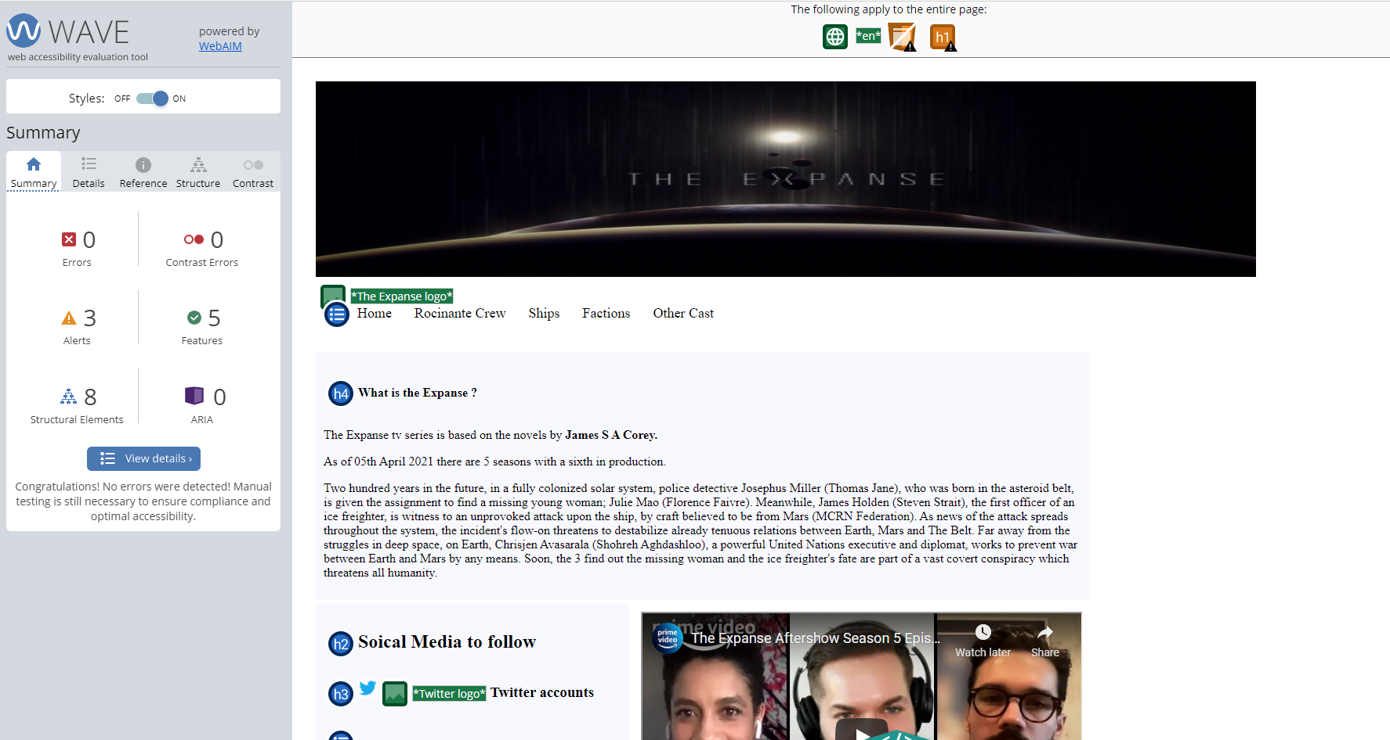
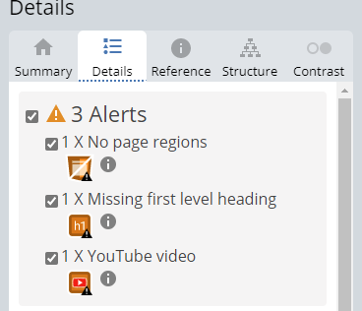
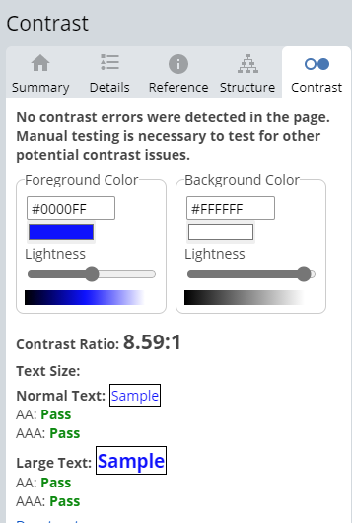

Appendix 2
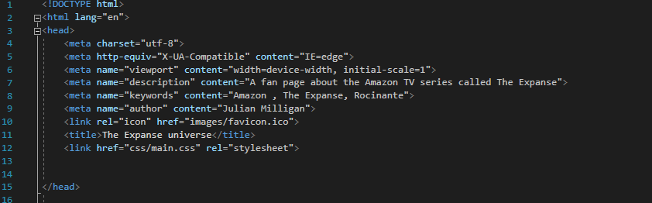

Appendix 3

<?xml version="1.0" encoding="utf-8"?>

<urlset xmlns="http://www.sitemaps.org/schemas/sitemap/0.9">

<url>

<loc>http://192.168.1.193/UniYear2/ACCA4023/assignment2/index.html</loc>

<lastmod>2021-04-18</lastmod>

<changefreq>monthly</changefreq>

<priority>1.0</priority>

</url>
<url>

<loc>
http://192.168.1.193/UniYear2/ACCA4023/assignment2/crew.html/ </loc>

<lastmod>2021-04-18</lastmod>

<changefreq>monthly</changefreq>

<priority>0.8</priority>

</url>

<url>

<loc>http://192.168.1.193/UniYear2/ACCA4023/assignment2/ships.html </loc>

<lastmod>2021-04-18</lastmod>

<changefreq>monthly</changefreq>

<priority>0.8</priority>

</url>

<url>

<loc>http://192.168.1.193/UniYear2/ACCA4023/assignment2/factions.html </loc>

<lastmod>2021-04-18</lastmod>

<changefreq>monthly</changefreq>

<priority>0.8</priority>

</url>

<url>

<loc>http://192.168.1.193/UniYear2/ACCA4023/assignment2/otherCast.html </loc>

<lastmod>2021-04-18</lastmod>

<changefreq>monthly</changefreq>

<priority>0.8</priority>

</url>

</urlset>

