Student Name: Kelechi Ibebauchi
Student Number : 1404189
Module: BMBM5024
Lecturer : Chris Wilkin
Submission Date: 12th December 2025
Title: Comprehensive Business Intelligence System Design and Analysis Overview of Adient

Executive Summary

Adient is a leading global manufacturer of automotive seating systems headquartered in Dublin, Ireland. With operations in over 29 countries, the company serves major automotive brands, focusing on design excellence, efficiency, and innovation. As the automotive industry faces increasing digital transformation, Adient must leverage Business Intelligence (BI) to optimize decision-making, production, and supply-chain management.

The objective of this report is to design and critically evaluate a comprehensive BI system for Adient, demonstrating how data warehousing, analytics, and visualisation tools can transform complex operational data into actionable business insights. The proposed system integrates modern BI components such as Extract-Transform-Load (ETL) processes, data lakes, and OLAP operations to support informed strategic decisions.

The BI system aims to enhance Adient’s efficiency in production planning, supplier monitoring, and quality control while ensuring compliance with global data-protection standards such as GDPR. The Excel-based prototype presented later will simulate Adient’s data-integration and analysis processes, highlighting the company’s ability to monitor KPIs, predict future trends, and ensure data accuracy. Ultimately, this report concludes that a robust BI framework will allow Adient to sustain competitive advantage, reduce operational risks, and foster long-term profitability through data-driven strategy and continuous improvement.

1. Introduction

1.1 Company Overview: Adient

Adient is an American-Irish company founded in 2016 with headquarters in Dublin, Ireland. It is one of the world’s leading manufacturers of automotive seating systems, supplying a wide range of global automakers. As of 2024, the company’s revenue exceeded $14 billion (Adient, 2024). With a workforce of more than 70,000 employees across 200 manufacturing and assembly facilities in 29 countries, Adient has established itself as a global leader in its sector (Adient, 2025). Its products range from standard vehicle seating to customized high-tech solutions tailored for premium automotive brands.

Adient has also become the largest automotive seating supplier in China, operating through seven joint ventures and approximately 37 manufacturing facilities in 21 cities (China Daily, 2025). The company’s strategic objectives are driven by design excellence, innovation, advanced manufacturing, operational efficiency, and customer satisfaction. By embedding these principles into its operations, Adient has continued to strengthen its market position and maintain long-term growth within a competitive global industry (Stock Analysis, 2025).

1.2 Industry Context: Automotive Manufacturing and Supply Chain

Adient’s operations fall within the automotive manufacturing and supply chain sector, a highly competitive industry characterized by complex global logistics and stringent quality standards (Adient, 2025). The company manages both direct and indirect material services, encompassing equipment, supply chain logistics, and tooling processes. To maintain consistency, all suppliers are required to comply with the Global Supplier Standards Manual (GSSM), ensuring alignment with Adient’s quality and environmental benchmarks.

The company’s supply chain organization emphasizes efficiency, customer satisfaction, and compliance with international environmental and safety standards. To achieve this, Adient leverages lean logistics and replenishment models, integrating them with electronic commerce systems such as Electronic Data Interchange (EDI). These systems streamline supplier communication, accelerate data transfer, and improve accuracy across the supply chain (TrueCommerce, 2024).

In cases where suppliers manufacture overseas, Adient’s processes involve customs brokerage, preparation of international shipment documentation, and adherence to packaging and compliance requirements (Adient, 2020). Critical documents such as invoices, certificates of origin, and free trade agreements are standardized and stored within the company’s digital systems to ensure seamless global operations (Lean Enterprise Institute, 2023). This highlights the scale and sophistication of Adient’s supply chain, which is central to its competitive advantage in the automotive industry.

1.3 Importance of Business Intelligence in Automotive Manufacturing

Business Intelligence (BI) is increasingly vital in automotive manufacturing, where the scale of operations generates massive amounts of data across production, logistics, and customer-facing activities (Hu et al., 2020). For Adient, BI provides the framework to optimize production efficiency, reduce waste, strengthen supplier relationships, and enhance customer satisfaction. By integrating real-time monitoring with data-driven decision-making, BI enables the company to respond quickly to market changes while improving overall operational performance (Vicente,et al., 2024).

Key benefits of BI in this context include:

Production Efficiency: BI tools detect bottlenecks, track quality metrics, and provide insights for continuous improvement (Kumar et al 2021).

Supply Chain Optimization: Data-driven dashboards track supplier performance, delivery times, and costs, supporting transparent and resilient logistics (Zhang et al., 2013).

Vehicle Quality and Customer Feedback: BI enables proactive identification of design and safety issues, ensuring compliance with international standards while integrating customer insights into product design (Waller et al., 2013)

Risk Mitigation: BI strengthens oversight across the supply chain, reducing the risks of production errors, recalls, and costly disruptions (Kumar et al 2021).

Ultimately, BI enhances competitiveness by enabling predictive analysis, cost reduction, and personalized customer experiences. In a high-stakes industry like automotive seating, BI systems support Adient in meeting global demand efficiently and safely, while also aligning with strategic goals for innovation and growth.

2. System Design

2.1 Business Intelligence System for Adient

Adient’s BI strategy reflects its need for rapid decision-making and operational efficiency across global operations. The proposed BI system design integrates data visualization, advanced analytics, and real-time reporting to optimize production processes and supplier performance (Ranjan, 2020). Tools such as Excel and Google Sheets can be incorporated at the operational level for simulation, but at enterprise scale, Adient employs solutions like IBM Cognos Analytics for dashboard creation and reporting.

The system design builds on three pillars:

Data Centralization – consolidating structured and unstructured datasets from ERP, CRM, IoT sensors, and supplier systems (Negash, 2021).

Analytical Capability – enabling OLAP operations, machine learning applications, and predictive analytics for both production and logistics (Riahi, 2020).

Decision Support – providing managers and stakeholders with dashboards that visualize KPIs, highlight risks, and forecast trends.

This foundation ensures that BI becomes an active driver of strategy, not just a reporting tool. Importantly, this design links directly to the Excel Implementation in Section 3 of this assignment, where a prototype will demonstrate how these BI concepts can be simulated in practice using sample datasets.

2.2 Adient’s Data Warehousing Architecture

Adient employs a layered data warehousing architecture that combines data lakes with a centralized enterprise data warehouse (EDW).

Data Lakes store large volumes of structured, semi-structured, and unstructured raw data, enabling flexible exploration and advanced analytics (e.g., machine learning). Metadata tagging ensures the future usability of stored information (Ghazal, 2021).

Enterprise Data Warehouse (EDW) enforces structured schemas and governance standards, supporting business-critical analytics and compliance (Kimball, 2019).

Together, this hybrid approach allows Adient to balance flexibility with reliability. While data lakes provide breadth for exploratory analysis, the EDW delivers depth and precision for decision-making, financial reporting, and regulatory compliance. The diagram below shows the sample of such process:

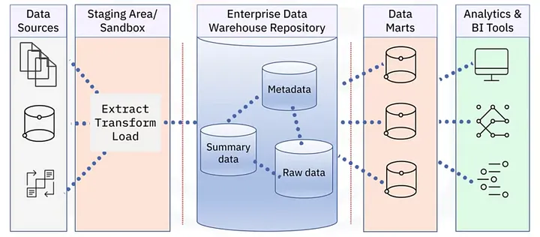
Figure 1: Sample of data mining for Business Intelligence for Adient. Adopted from .Introduction to Data Warehouses. Just enough to learn about Data… | by Tanja Adžić | Medium

2.3 BI System Layers for Adient:

Data Sources – ERP systems, supplier databases, IoT-enabled factory sensors, CRM systems, operational logs.

ETL Layer – extraction, transformation, and loading processes ensure data integrity, standardization, and integration.

Staging/Sandbox – temporary storage for testing, workflow development, and ad-hoc analysis.

Enterprise Data Warehouse (EDW) – centralized repository with validated and structured datasets.

Data Marts – specialized subsets of the EDW for functional domains (manufacturing, supply chain, finance, HR).

BI Tools & Dashboards – front-end tools for visualization, performance tracking, and predictive modelling.

2.4 Adient’s Data Security and Quality Management

Adient implements robust data security standards to safeguard its information assets, collectively referred to as Adient Information Assets (Adient AI). These standards are grounded in both technical and organizational controls designed to prevent unlawful destruction, unauthorized access, and disclosure of information (Harris,et al., 2022). The company applies the principles of security-by-design, ensuring that all systems and processes incorporate protective mechanisms from inception.

Data transmitted across Adient’s complex digital networks, including its data lakes and enterprise databases, undergoes encryption and authentication procedures to maintain confidentiality and integrity (Isaca, et al. 2022). Vendors and third-party service providers are required to adhere to Adient’s security standards through contractual obligations and periodic audits. Each vendor must sign a Security Addendum Agreement, confirming their compliance with Adient’s data protection and maintenance procedures. Failure to adhere to these protocols constitutes a breach of the company’s data security policy.

In addition, Adient enforces continuous system reviews, vulnerability testing, and updates in alignment with industry best practices. These actions are part of the company’s broader Information Security Management System (ISMS), which focuses on proactive risk management and data governance. Internally, Adient employs advanced firewalls, intrusion detection systems, and multi-factor authentication to safeguard data from external threats (Roopesh, 2024). The company’s vendor management process also mandates that all service providers and suppliers uphold the same level of protection for personal and corporate information, ensuring consistent compliance across the global supply chain.

2.4.1 Adient’s Data Accuracy and Cleansing Strategies

To ensure data reliability, Adient applies a combination of automated and manual strategies for data collection, validation, and cleaning. The goal is to maintain high standards of data quality characterized by completeness, consistency, accuracy, uniqueness, and validity (Krishnan & Wu 2019).

Data cleansing is a vital aspect of Adient’s Business Intelligence (BI) operations, serving as the foundation for meaningful analysis and informed decision-making (Tae et al., 2019). Despite rigorous data governance, errors may still occur during data entry or integration. To mitigate this, Adient uses its enterprise data warehouse (EDW) as the central repository for all cleaned and validated datasets. Data from multiple sources such as ERP systems, IoT sensors, and supplier databases is standardized, transformed, and cleansed before integration into the EDW.

The company employs specialized data-cleaning software capable of deduplication, anomaly detection, and memory optimization. This software enhances processing speed and ensures that only verified data enters the analytical environment (Data Ladder, 2020). Once cleansing is complete, the clean data is reloaded into the warehouse and becomes available for analytical tasks, reporting, and dashboard visualization.

Adient’s approach addresses both schema-related and instance-related data quality issues. Schema-related controls ensure the structural consistency of databases by enforcing field constraints, naming conventions, and data type validation. Instance-level controls identify errors such as misspellings, incorrect references, or incomplete records. API-based integrations, such as Data Ladder and Talend, are used to synchronize real-time business data, ensuring accuracy across systems (Data Ladder, 2020). This layered approach to data accuracy supports the company’s long-term BI strategy by maintaining a high-quality analytical foundation.

2.4.2 Adient’s Data GDPR and Compliance

As a global enterprise, Adient processes personal information from customers, suppliers, and partners through both online and offline channels. This includes information collected during transactions, contractual agreements, and customer interactions via digital platforms. Adient’s data protection framework is built on compliance with international laws such as the General Data Protection Regulation (GDPR) and local data protection acts across its operating regions (Mandala, 2024).

The company ensures that all personal data is collected voluntarily and used strictly for legitimate business purposes, such as customer relationship management and service delivery (Danley, 2019). Data retention policies specify that personal information is stored only for as long as necessary to fulfill the intended purpose, after which it is securely deleted or anonymized. Adient’s internal controls prevent unauthorized disclosure and strictly prohibit sharing personal data with third parties without explicit consent.

To strengthen compliance, Adient has implemented Binding Corporate Rules (BCRs), which govern global data transfers and ensure uniform security standards across jurisdictions (Kuner, 2020). The company also applies technical, physical, and organizational safeguards such as encryption, secure access controls, and audit trails to protect sensitive information from misuse or exposure.

Through this structured governance framework, Adient maintains full accountability for personal data management. This commitment ensures compliance with international standards while reinforcing customer trust and corporate transparency (Julakanti et al., 2025). Data governance remains central to Adient’s BI system, linking ethical data use with operational excellence and strategic innovation.

This architecture directly informs the Excel Implementation (Section 3), where the use of pivot tables, forecasting functions, and dashboards will simulate how Adient transforms raw data into actionable insights. By combining data lakes with structured warehouses, Adient can efficiently monitor supplier performance, optimize production, and deliver timely insights to its OEM partners.

3. Data Collection and Analysis

Section 3 provides an in-depth analysis of the data collection and analytical processes. Data was obtained through primary collection methods and quantitative analysis, including the review of company records and relevant online sources. The dataset was derived from 2 years of data for over 1000 sets of data information from 10 different Adient plant locations. The data focus on key production indicators such as plant location, product line (front seats, rear seats, and seat frames), units produced, production cost, and sales revenue.

In addition, Excel PivotTables and Power BI were used to aggregate monthly production data across countries and product types. Functions such as VLOOKUP were employed to merge cost data effectively (Microsoft, 2012). Conditional formatting was also applied to highlight cost variances, enabling quicker and more informed decision-making.

The selected countries include China, the United States, Canada, Mexico, Brazil, Austria, Belgium, the Czech Republic, Germany, and South Africa. The compiled dataset represents 10 Adient locations, 3 product lines, and 12 months of production data.

3.1 Excel and Power BI Implementation and Data Analysis

Microsoft Excel data was incorporated through Power BI to analyze and interpret the data efficiently. The total output for the month of January amounted to 56,700 units, reflecting the combined production from all 10 countries.

3.2 Country and Plant Location

Adient operates manufacturing plants across multiple continents; however, for the purpose of this analysis, 10 representative countries were selected to evaluate production performance for January. This is essential for business intelligence, as it enables a deeper understanding of production capacity, cost management, and performance variations across different regions.

The dataset was manually inputted into Excel to ensure accuracy, and data validation was conducted to minimize and correct potential errors. Graphs and charts were generated to illustrate variations in production output, costs, and revenue across the different countries during the month of January. These visual representations help to identify trends, highlight performance differences, and support decision-making in production management.

3.3 Analysis of Production Line

The diagram below shows three products produced in the production line by Adient across ten countries. Front seats are represented in blue, rear seats in orange, and seat frames in green. Based on the data provided, it is evident that the manufacturing plants produce a significantly higher number of front seats, largely due to the strong demand for this product.

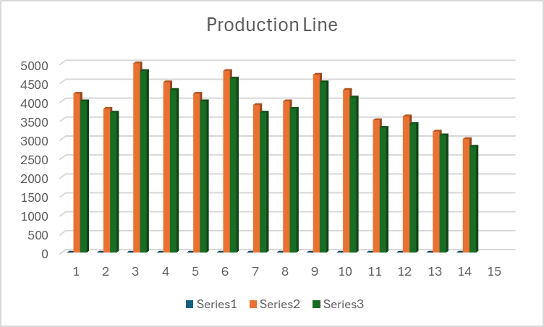
Figure 2: Adient Production line across 10 countries

The bar chart above illustrates the production lines across Adient’s 10 manufacturing plants. It highlights three product series, showing which items are most commonly produced at each site. The data indicates that Adient has maintained a stable and efficient production process, with output ranging between 3,000 and 5,000 units in January. Series 2, which represents rear seats, recorded the highest production volume of approximately 5,000 units driven by high demand and a strong operational workflow. Series 1 showed a comparable output but was slightly lower in volume.
Overall, the data reflects consistent production trends across all three product types, demonstrating alignment in Adient’s manufacturing processes across the 10 countries. In conclusion, the strong performance of Series 2 at all manufacturing plants suggests that effective data sharing and communication have played a crucial role. This success is further supported by efficient workflow management, regular maintenance, improved planning, and better capacity management.

3.3.1 Analysis of Units Produced
The bar chart below, analyzed using Excel, illustrates the total number of product units produced within Adient. These products mainly include front seats, rear seats, and seat frames.

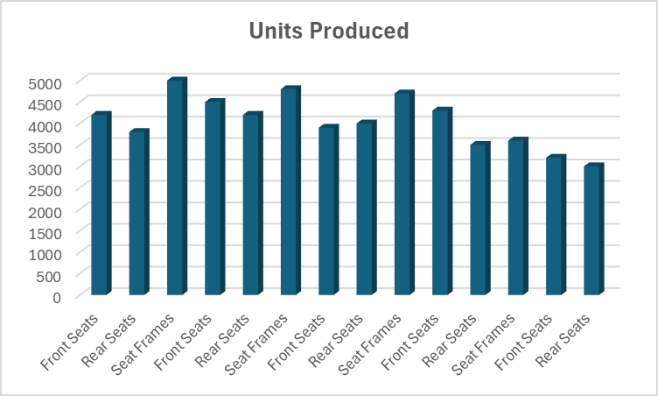

Figure 3: Analysis of Units Produced

Through data analysis, the data represents the production levels, showing noticeable variations between categories and indicating differences in manufacturing demands. Given that the data distribution is sourced from a data warehouse, a core component of business intelligence the results provide valuable insights.

Front seats generally recorded the highest production output, exceeding 5,000 units. This suggests that Adient’s operations are more likely to achieve greater profitability in this category compared to the manufacturing of other products. As previously mentioned, seat frames also showed strong performance, averaging between 4,000 and 4,800 units, which aligns with efficient manufacturing processes.

However, rear seats exhibited relatively lower figures, ranging from 3,000 to 4,200 units. This indicates reduced customer demand for this particular product line.

3.3.2 Analysis of Units Sold vs Unit Produced

The bar chart illustrates a comparison between the units produced and units sold for three major products: front seats, rear seats, and seat frames across 10 countries and several production lines. It reflects a similar production cycle across the various manufacturing processes.

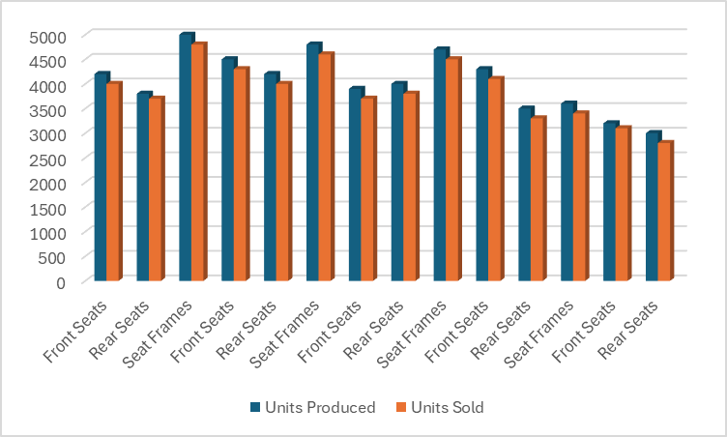
Figure 4: Adient analysis of Units sold vs Unit produced

Overall, the data indicates a clear relationship between production and sales across all manufacturing plants. This trend remained steady in January, reflecting consistent market demand and operational efficiency across the various product categories. Front seats recorded the highest figures in both production and sales, maintaining Adient’s strongest market performance and serving as the company’s primary revenue driver. The higher demand for front seats can be attributed to their essential role in vehicle assembly and the growing preference among automakers for improved front seat designs.

Seat frames demonstrated a moderate correlation between units produced and units sold. The slightly lower number of units sold suggests effective inventory management and balanced production planning. This trend indicates stable customer demand and aligns with efficient supply chain coordination.

Finally, rear seats showed lower output levels for both production and sales, with a slightly wider gap between the two. This suggests weaker market demand and slower turnover in this category, likely influenced by lower replacement needs and customer preferences. In conclusion, front seats remain the most produced and profitable product line for Adient, reinforcing their importance in the company’s overall manufacturing and sales performance.

3.3.3 Production Cost (£)

The bar chart illustrates the production costs incurred by Adient, presenting a comparative analysis of the units produced, units sold, and the corresponding production costs (in £) across 10 production plants within Adient’s manufacturing operations.

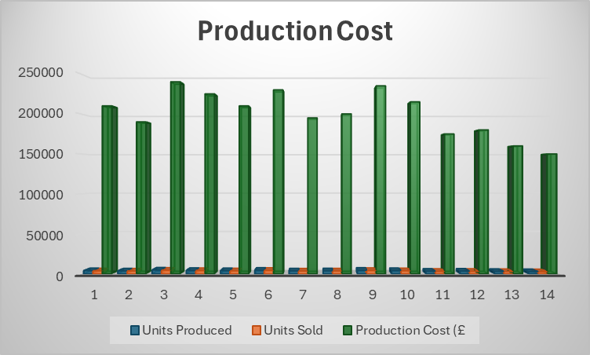
Figure 5: Adient Analysis for Production cost
The data analysis reveals a consistent relationship between output levels and associated production costs, demonstrating that production volume is significantly influenced by expenditure and operational efficiency. The production costs remain substantially higher than the number of units produced and sold, indicating the capital-intensive nature of automotive manufacturing processes. On average, the production cost per plant ranges between £180,000 and £250,000, covering materials, labour, and other overhead expenses related to maintaining production capacity.
Notably, production points 3, 6, and 9 each exceeded £240,000 in costs. These peaks can be attributed to intensified production activities and increased material procurement expenses. Despite these higher costs, the number of units sold remains slightly below the number of units produced, suggesting instances of overproduction.
From points 11 to 14, there is a noticeable decline in both production costs and output levels. This decrease may reflect a deliberate scaling down of operations due to lower market demand or the implementation of cost-optimisation strategies. Overall, Adient demonstrates efficient cost management despite high operational expenses. Maintaining such production levels reflects strong financial stability, with front seat manufacturing likely serving as a major driver of profitability compared to other product categories.

3.3.4 Sales Revenue (£)

The bar chart shows Adient’s sales revenue for the month of January across 10 countries. It compares revenue performance across multiple markets and illustrates the total income generated in each location.

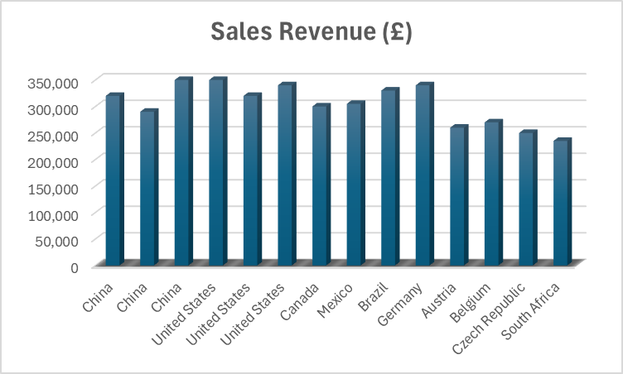
Figure 6: Adient Analysis for Sales Revenue (£)

In the chart, China and the United States recorded the highest sales revenues, both approximately £350,000. These two locations represent the most profitable and largest production volumes and sales, likely due to stronger demand for the products. In addition, Canada, Brazil, Mexico, and Germany each showed sales revenues ranging between £300,000 and £330,000.

This indicates that these countries maintain moderately stable and well-established markets supported by effective production and distribution channels. Furthermore, Austria, Belgium, the Czech Republic, and South Africa demonstrated lower revenues, ranging between £230,000 and £270,000. This may be due to smaller market sizes and operational or competitive challenges. Geography and economic development appear to play a fundamental role, as the United States and China perform better largely because of their advanced industrial economies.

3.3.5 Defect Rate (%)

The bar chart illustrates the percentage of production defects recorded across 10 countries, highlighting variations in product quality and production efficiency achieved at each manufacturing plant.

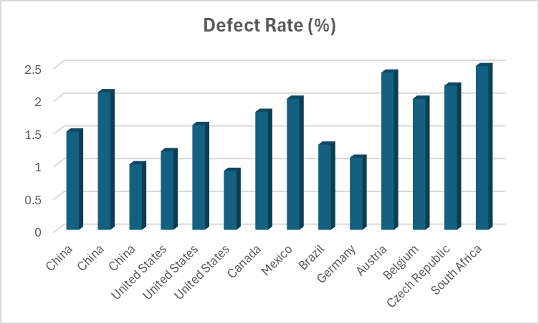
Figure 7: Adient Analysis for Defect Rate (%)

The results show that South Africa recorded the highest defect rate at approximately 2.6%, followed by Belgium at 2.4%, the Czech Republic at 2.2%, and Mexico at 2.1%. These relatively high percentages suggest potential quality control issues in these regions, indicating production inefficiencies and manufacturing inconsistencies. Meanwhile, China and Brazil recorded moderate defect rates, ranging from 1.6% to 2.1%. Overall, the data reveals variations in production quality across the ten manufacturing plants, suggesting that the United States, Germany, and Austria have maintained higher production standards compared to other countries.

4 Data Collection and Cleansing Process for Business Intelligence

Data collection and cleansing are integral components of business intelligence. This process involves defining data types, identifying data sources, and ensuring that both quality and quantity standards are properly established SO/IEC JTC 1/SC 42 (2024). In the case of Adient, I ensured that the data cleansing process involved removing duplicates and other irrelevant entries, correcting structural errors, and applying standardized formats to minimize inconsistencies. I carefully identified the data sources using spreadsheets and Excel software. Furthermore, I made sure that the data I analyzed aligned with the project requirements, thereby helping to establish proper quality standards.

In business intelligence, data cleansing is crucial for removing duplicates and typographical errors. Effective data cleaning ensures a high-quality and reliable dataset, making analysis more accurate and efficient (Bayram et al., 2023). In summary, the main outcomes of data cleansing include improved accuracy, completeness, consistency, validity, and uniformity.

4.1 Critical Evaluation of the Proposed Business Intelligence System

This section evaluates the effectiveness of the proposed Business Intelligence (BI) system in delivering strategic insights into Adient’s operational performance. The BI framework enables Adient to make real-time, data-driven decisions across all functional areas. Based on the Excel simulation, the system architecture has contributed to improved efficiency by analyzing production volumes, sales performance, and regional cost variations. This analytical capability supports better supply chain management through the integration of supplier performance metrics derived from ERP and IoT systems (Business-Software.com 2024).

Furthermore, the BI system facilitates accurate forecasting and strategic planning by incorporating Excel-based forecasting tools and trend analysis (Goodwin, 2023). As a result, it enhances Adient’s ability to predict future production and sales performance, optimize inventory levels, and align resources more effectively. Overall, the implementation of the BI system strengthens operational efficiency, supports proactive decision-making, and ensures continuous improvement across Adient’s global operations.

4.2 Challenges and Limitations
Despite the effectiveness of the BI system implemented at Adient, several challenges and limitations remain. One major issue is the complexity of data integration, as information is collected from multiple global sources such as ERP, CRM, and procurement systems. Managing and consolidating these diverse datasets can be time-consuming and technically demanding.
Although Excel provides a useful platform for BI simulations, it has limitations in handling large datasets and complex analytics. In contrast, advanced BI tools such as IBM Cognos require specialized training and technical expertise, which may increase implementation costs and reduce ease of use. Additionally, analyzing historical datasets can be complex, particularly when dealing with inconsistent or incomplete data. These challenges highlight the need for continuous improvement in data management practices and technical capacity within Adient’s BI framework.

Conclusion
This report examined Adient’s Business Intelligence (BI) framework, emphasizing how the company collects, processes, and utilizes data to enhance its operational efficiency. The study explored the role of data warehousing and cleansing in minimizing errors and ensuring data reliability. Using Excel-based analysis, operational data from ten manufacturing plants across ten countries were assessed. This reveals performance variations influenced by differing product demands across regions. The findings demonstrate that BI enables Adient to identify strengths and inefficiencies within its global operations.This leads to improved decision-making and productivity. Overall, the integration of BI tools and processes positions Adient to achieve higher accuracy. For better strategic planning, and sustainable competitive advantage in the automotive manufacturing industry.

References
Adient plc. (2024). Form 10-K Annual Report 2024. U.S. Securities and Exchange Commission. “Adient recorded net sales of $14,688 million for fiscal 2024”.
Adient (2020). Global Supplier Standards Manual – Supply Chain Management Expectations. [pdf] Available at: https://adient-sp.portal.stg.covisint.com/assets/adient/documents/Supplier%20Expectations/Archived%20suppliers%20standards%20manual/Main%20chapter/Global-Supplier-Standards-ManualSCM-AEPSOSST13E-Rev-10-archive-1.pdf [Accessed 9 Oct. 2025].
Adient (2024, November 8). Adient reports fourth quarter and full-year 2024 financial results; provides full-year FY2025 outlook. Available at: https://www.adient.com [Accessed 9 Oct. 2025].
Adient (2025). Adient reports strong second quarter operating results. [Online] Adient Investor News. Available at: https://www.adient.com/media/news/2025/05/07/adient-reports-strong-second-quarter-operating-results [Accessed 9 Oct. 2025].
Adient (2025, January 29). Adient releases its 2024 Sustainability Report.
Adžić, T. (2024). Introduction to Data Warehouses: Just enough to learn about Data. Medium. Available at: https://medium.com [Accessed 13 Oct. 2025].
ae, K.H., Roh, Y., Oh, Y.H., Kim, H. & Whang, S.E. (2019). ‘Data Cleaning for Accurate, Fair, and Robust Models: A Big Data-AI Integration Approach.’ arXiv preprint, April 2019. Available at: https://arxiv.org/abs/1904.10761 [Accessed 13 Oct. 2025].
Bayram, F., Ahmed, B.S., Hallin, E. & Engman, A. (2023). ‘DQSOps: Data Quality Scoring Operations Framework for Data-Driven Applications.’ arXiv preprint. Available at: https://arxiv.org/abs/2303.15068 [Accessed 13 Oct. 2025].
Business-Software.com (2024). The future of manufacturing ERP: AI, IoT, and automation. Available at: https://www.business-software.com/blog/the-future-of-manufacturing-erp-ai-iot-and-automation/ [Accessed 13 Oct. 2025].
China Daily (2025). Adient launches expanded China Technical Center in Liangjiang. [Online] Available at: https://regional.chinadaily.com.cn/cqliangjiang/2025-02/19/c_1071337.htm [Accessed 7 Oct. 2025].
Data Ladder (2020). ‘Data Cleaning for Enterprises: A Complete Guide.’ 6 March 2020. Available at: https://dataladder.com/data-cleaning-guide-for-enterprises/ [Accessed 13 Oct. 2025].
Denley, A., Foulsham, M. & Hitchen, B. (2019). GDPR: How to achieve and maintain compliance. Abingdon: Routledge.
Ghazal, A., Abouelmehdi, K., Beni-Hssane, A. & Khaloufi, H. (2021). ‘Data lakes for big data applications: A systematic review.’ Journal of Big Data, 8(1), pp.1–30. https://doi.org/10.1186/s40537-021-00449-3.
Goodwin, P., Hoover, J., Makridakis, S., Petropoulos, F. & Tashman, L. (2023). ‘Business forecasting methods: Impressive advances, lagging implementation.’ PLoS ONE, 18(12), e0295693. https://doi.org/10.1371/journal.pone.0295693.
Harris, M.A., Hale, M.L. & Toh, C.A. (2025). ‘Towards an integrative approach for designing for cybersecurity in systems engineering.’ Proceedings of the Design Society, 5, pp.3161–3170. https://doi.org/10.1017/pds.2025.10330.
Hu, B., Lv, J. & Yang, K. (2020). ‘Cost-Benefit Models on Integrating Information Technology Services in Automotive Production Management.’ Scientific Programming. Available at: https://onlinelibrary.wiley.com/doi/full/10.1155/2020/8877780 [Accessed 9 Oct. 2025].
Isaca (2022). Managing Security Across Disparate Database Technologies. ISACA Journal, Volume 4. Available at: https://www.isaca.org/resources/isaca-journal/issues/2022/volume-4/managing-security-across-disparate-database-technologies [Accessed 10 Oct. 2025].
ISO/IEC JTC 1/SC 42 (2024). Data quality for analytics and machine learning — Part 4: Data quality process framework. Available at: https://en.wikipedia.org/wiki/ISO/IEC_JTC_1/SC_42 [Accessed 13 Oct. 2025].
Julakanti, S.R., Sattiraju, N.S.K. & Julakanti, R. (2025). ‘Data Protection through Governance Frameworks.’ arXiv preprint, January 2025. Available at: https://arxiv.org/abs/2502.10404 [Accessed 13 Oct. 2025].
Kimball, R. & Ross, M. (2019). The Data Warehouse Toolkit: The Definitive Guide to Dimensional Modeling. 3rd ed. Wiley.
Krishnan, S. & Wu, E. (2019). ‘AlphaClean: Automatic Generation of Data Cleaning Pipelines.’ arXiv preprint, April 2019. Available at: https://arxiv.org/abs/1904.11827 [Accessed 13 Oct. 2025].
Kumar, S., van Dissel, H.G. & Biemans, W.G. (2021). ‘Risk mitigation strategies in the automotive supply chain: An empirical analysis.’ International Journal of Production Economics, 235, 108113. https://doi.org/10.1016/j.ijpe.2021.108113.
Kuner, C. (ed.) et al. (2020). The EU General Data Protection Regulation (GDPR): A Commentary. Oxford: Oxford University Press.
Lean Enterprise Institute (2023). Lean Logistics. [Online] Available at: https://www.lean.org/lexicon-terms/lean-logistics/ [Accessed 9 Oct. 2025].
Mandala, V. & Bhattacharya, S. (2024). ‘ETL – A Data Cleansing Approach.’ Global Research Development (GRD), 9(7), pp.9-12.
Microsoft (2012). ‘VLOOKUP tutorial: updating prices in a master price list.’ Microsoft 365 Blog, 28 March 2012. Available at: https://www.microsoft.com/en-us/microsoft-365/blog/2012/03/28/vlookup-tutorial-updating-prices-in-a-master-price-list/ [Accessed 13 Oct. 2025].
Negash, S. & Gray, P. (2021). ‘Business Intelligence.’ In: Handbook on Decision Support Systems 2. Springer, pp.175–193.
Ranjan, J. (2020). ‘Business intelligence: Concepts, components, techniques and benefits.’ Journal of Theoretical and Applied Information Technology, 98(18), pp.2716–2730.
Riahi, Y., Saidi, R. & Boussaid, O. (2020). ‘Machine learning techniques for predictive maintenance in production systems: A review.’ IEEE Access, 8, pp.164820–164841. https://doi.org/10.1109/ACCESS.2020.3026106.
Roopesh (2024). ‘Cybersecurity solutions and practices: Firewalls, intrusion detection/prevention, encryption, multi-factor authentication.’ Academic Journal on Business Administration, Innovation & Sustainability, 4(3), pp.37–52. Available at: https://allacademicresearch.com/index.php/AJBAIS/article/view/90 [Accessed 9 Oct. 2025].
StockAnalysis (2025). Adient Revenue 2015-2025. [Online] StockAnalysis.com. Available at: https://stockanalysis.com/stocks/adnt/revenue/ [Accessed 9 Oct. 2025].
TrueCommerce (2024). Adient EDI Integration. [Online] Available at: https://www.truecommerce.com/trading-partner/adient/ [Accessed 9 Oct. 2025].
Vicente, A., Neves, M. & Bernardo, J. (2024). ‘The potential of Logistics 4.0 technologies: a case study through business intelligence framing.’ Logistics 4.0 Journal. Available at: https://pubmed.ncbi.nlm.nih.gov/39484155/ [Accessed 9 Oct. 2025].
Waller, M.A. & Fawcett, S.E. (2013). ‘Data science, predictive analytics, and big data: a revolution that will transform supply chain design and management.’ Journal of Business Logistics, 34(2), pp.77–84. https://doi.org/10.1111/jbl.12010.
Zhang, C. & Huo, B. (2013). ‘The impact of relationship quality on supply chain performance: a contingency and configuration approach.’ Supply Chain Management: An International Journal, 18(1), pp.54–72. https://doi.org/10.1108/13598541311287074.

Appendix
Figure 1: Sample of Data Mining for Business Intelligence for Adient
Figure 2: Adient Production Line Across 10 Countries
Figure 3: Analysis of Units Produced
Figure 4: Adient Analysis of Units Sold vs Units Produced
Figure 5: Adient Analysis for Production Cost
Figure 6: Adient Analysis for Sales Revenue (£)
Figure 7: Adient Analysis for Defect Rate (%)
Table A1: Adient January Dataset Summary (10 Countries, 3 Product Lines)

January Dataset selected for Adient analysis

Plant Location | Month | Product Line | Units Produced | Units Sold | Production Cost (£ | Sales Revenue (£) | Defect Rate (%) | Customer Satisfaction (0–10)
China | January | Front Seats | 4200 | 4000 | 210,000 | 320,000 | 1.5 | 8.5
China | January | Rear Seats | 3800 | 3700 | 190,000 | 290,000 | 2.1 | 8.2
China | January | Seat Frames | 5000 | 4800 | 240,000 | 350,000 | 1 | 9
United States | January | Front Seats | 4500 | 4300 | 225,000 | 350,000 | 1.2 | 8.8
United States | January | Rear Seats | 4200 | 4000 | 210,000 | 320,000 | 1.6 | 8.4
United States | January | Seat Frames | 4800 | 4600 | 230,000 | 340,000 | 0.9 | 9.2
Canada | January | Front Seats | 3900 | 3700 | 195,000 | 300,000 | 1.8 | 8
Mexico | January | Rear Seats | 4000 | 3800 | 200,000 | 305,000 | 2 | 8.3
Brazil | January | Seat Frames | 4700 | 4500 | 235,000 | 330,000 | 1.3 | 8.6
Germany | January | Front Seats | 4300 | 4100 | 215,000 | 340,000 | 1.1 | 9
Austria | January | Rear Seats | 3500 | 3300 | 175,000 | 260,000 | 2.4 | 7.9
Belgium | January | Seat Frames | 3600 | 3400 | 180,000 | 270,000 | 2 | 8.1
Czech Republic | January | Front Seats | 3200 | 3100 | 160,000 | 250,000 | 2.2 | 7.8
South Africa | January | Rear Seats | 3000 | 2800 | 150,000 | 235,000 | 2.5 | 7.5

