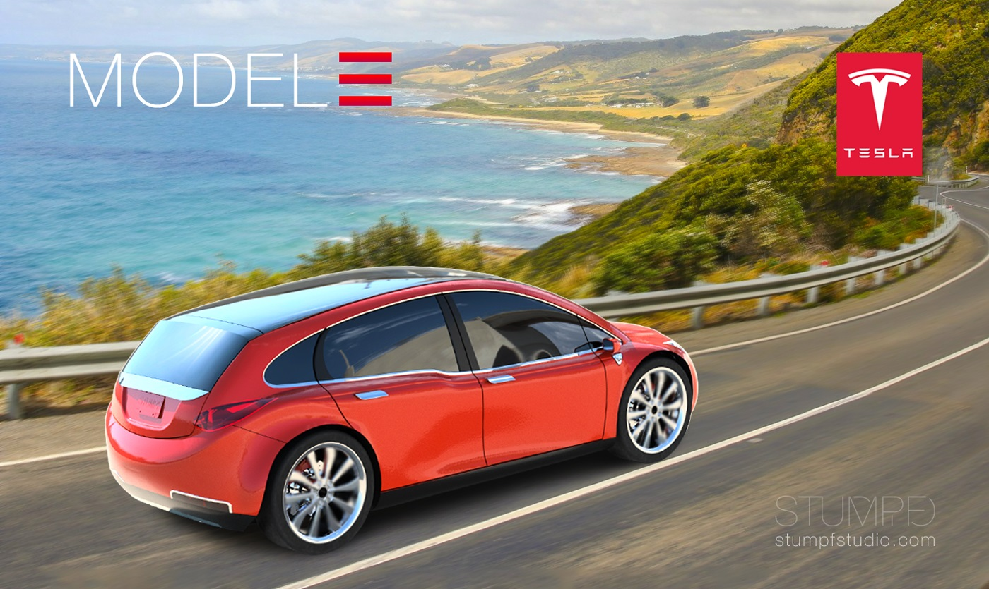

MBA Marketing Management
Curtis Mckenzie Student Number:1808750 Assessment 2 Lecturer: Tushara Balendran Marketing Management (LCMB7001)
20/04/2022

Table of Contents
Introduction 2
PESTLE analysis 2
SWOT Analysis 2
Segmentation, targeting and positioning (STP model) 2
Conclusion 2
Recommendation 2
References 2

Introduction
The process wherein a company’s marketing agenda is discussed to achieve the objectives that have been set by the company. The goals of the company are being discussed and the future planning for the company and its marketing strategies are all included in the marketing management project. Marketing management is important for the companies as it involves the further propaganda for the company in upcoming times. This paper will discuss the various factors of Tesla with an in-depth analysis.
Tesla is a private company established in 2003, manufactured cars and energy generation storage based in California, Netherlands, Nevada and New York etc. Majority of Tesla patents consisted in energy generation making seamless integrated battery storage. One of the main goals of the company is to transit the world into sustainable energy. Tesla offered four car models- Model S, Model X, Model 3 and Model Y. Tesla’s net started to accelerate since 2014 and turned into a full profit company for the first time in 2020 (Carlier, 2021).

PESTLE analysis
A company like TESLA has various departments, which are interrelated. These departments work cooperatively to run the company. TESLA is susceptible to political, economic, social, technological, legal and environmental situations. All these departments will be discussed in the following part with PESTLE analysis. PESTLE tool will be used to analyze the performance of the company.
As far as the political factor is concerned, it is important for the company to understand the political situation in the country that the company is operating in. Thus, the company should be aware of the tax rates, government’s corporate policies and trade restrictions that directly influence upon the company’s policy and targets. The economic factors of the company affect upon the company’s supply and demand of the products or services that the company is offering. To understand the customer buying behaviour, the company must understand the social factors of the environment that the company operates in. Legal factors will eventually make the company aware of the fact that the company must follow some regulations and restrictions, like the environmental factors which make the company aware of the ecological consequences of their production (Trott, 2008).

Political factors
TESLA provides both electricity and gas. However, these cars do not need as much gas as any other traditional cars. The government has deployed an instance to improve the expansion of electric and hybrid engines. Customers who buy TESLA could opt for a specific tax credit for buying an electric car. Tesla can use the governmental regulations towards the drift of using EVs (Gafarov, 2019). However, imposing a higher tax rate and the issue of stability can impact the international market for Tesla. The political instabilities created in the international market due to the US – China trade war have affected Tesla as well; it has raised prices of its products especially in China since 2019 due to the escalation of the trade war between US and China. Due to raised Tariffs on US – made cars in China, the raised prices of the products are justified (cnbc, 2021). Nonetheless, since the company targets premium customers with a higher spending ability, the raised prices did not affect its sales (Refer to Figure 1).
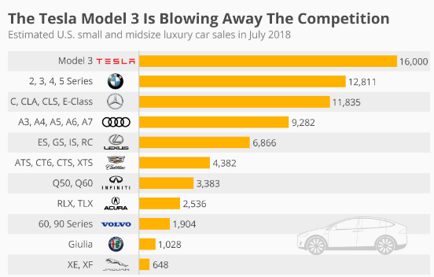
Figure 1: Sales record of Tesla’s competitors after launching Model 3
Source: (Statista, 2018)
Economic factors
Sales for electric vehicles are on the rise in the global economy. In 2020, TESLA became a full profit company. The cost of materials is on the decline for TESLA, which allows the company to produce cost-effective cars for the customers. The economic availability depends on the country’s economy. In a developing country, TESLA can expand their business because they have little competition and people like to opt for smart buy. So, the environmentally conscious customers could opt for it. The expensive raw materials and the labour can cause a menace for Tesla (Kim, 2020). The premium price range of its products may not attract a huge number of customers in the emerging economies. However, the high GDP of the US and other developed countries where Tesla operates, help it to gain more financial advantages. The customer segment that is targeted by the company is also of high spending capacity making it financially advantageous for Tesla. However, the tariffs imposed upon the products due to the US – China trade war have been economically disadvantageous for the company.
Social factors
TESLA targets eco-friendly consumers as TESLA waives the use of fuel in their vehicles as opposed to traditional cars. The social factor imposes a direct impact on the business development of an organisation, the social affordability and trend change influences brands to integrate changes at a strategic level (Musonera and Cagle, 2019). The recent occurrence of the pandemic due to the Covid – 19 outbreak has changed the consumers’ preferences in terms of investing towards costly products. They are tending to buy ‘essentials’ more than buying automobiles or any other expensive product. Thus, such a social trend could have impacted the expensive brands including Tesla; however, the steady sales of Tesla states otherwise. The high quality of its products against the products of its competitors in the similar price range (refer to Figure 2) can be stated to be the reason behind such steady sales of Tesla since automotive is also necessary for people in the modern time (BBC, 2021).
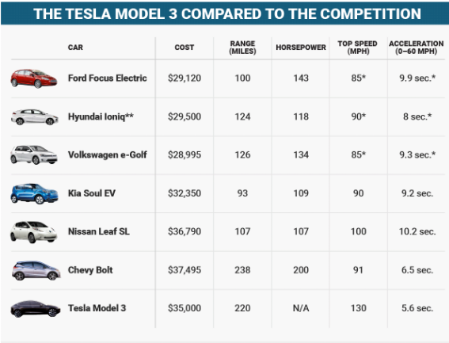
Figure 2: Comparison of Tesla model 3 with their competitors
(Source: money usnews, 2021)
Technological factors
Technology is a prime consideration of TESLA to maintain the imposition of possible opportunities in business operations. The company produces automotive and energy solutions cars, and the company is increasing its popularity in online mobile systems. Technological innovation and engineering are the fundamental basis of the concerned company i.e., Tesla. One of the new technological features in the new models of the company includes camera that would make auto-piloting possible; these would provide a view up to 250 meters away. Besides that, the models also include 6 pairs of long-range ultrasonic sensors and digitally controlled electric assist system. The hardware of the Tesla models is also technologically advanced making the cars stand out in the automotive industry at the international level (Refer to Figure 3). Thus, the impact of technology is highly positive in terms of the business and growth of Tesla (Ingle and Phute, 2016).
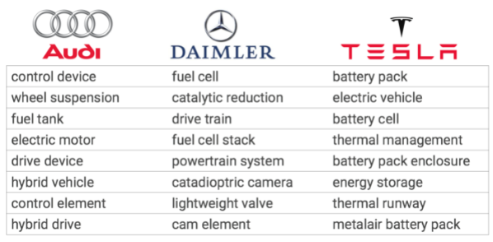Figure 3: Logo and Feature Tesla’s Competitors
(Source: CB Insights Research, 2021)
Legal factors
Tesla expands its company overseas with international patent protection. The company also follows the employment laws for their employees. The company has various paths to expand their business through sales, in some states of the USA. The company manufactures the vehicles based on the energy consumption regulations. There have been various legal controversies against Tesla; it has been involved in illegal workers’ suit, security litigations including the acquisition of Solar City, CEO performance award litigation of 2018, misrepresented loan and allegations in terms of retaliation of whistleblowers. Thus, the company needs to work in compliance with the legal provisions to face legal issues because otherwise the legal allegations and lawsuits will not only impact its reputation but also sales and overall growth (Rice, 2019).
Ecological/Environmental Factors
The environmental factors provide opportunity as the pollution and negative impact of Tesla is comparatively lower than any other organization (Ahmad and Khan, 2019). The improvement of specific effectiveness and changes in environmental policy is a matter of consideration for the organisation. The company’s mission and vision focus on sustainability through continuous improvement of lifecycle of the products through transition of the same based on sustainable energy. Its lithium – ion batteries are 100% recyclable. Thus, the company is sustainable in terms of its products (Aybaly et al., 2017).
After the PESTLE analysis of the company, it can be understood that the company has a mixed business environment in the region. To some extent, the company is having favorable situations, and in some cases it is unfavorable.
The application of the PESTLE framework can be critically analysed; whereas it has been helpful in providing a critical analysis of the external business environment factors that have impacts on the business of the concerned company, it has failed to provide the assessment of the steps taken by the company in terms of mitigating the issues or grabbing the emerging opportunities (Perera, 2017); that could have been done through the application of the SWOT framework which would have failed to provide a detailed analysis of the external factors. In addition to this, the PESTLE framework also did not provide a detailed analysis of the competitive factors against the company; the application of the Porter’s five forces model could have been helpful although the information would still be limited in terms of the company’s capabilities or weaknesses in terms of gaining or losing the competitive edge in the market. Thus, the organizational operations of a business can fully be analysed through the application of various analytical tools and not only one. Nonetheless, the PESTLE framework has been helpful in terms of providing a detailed critical analysis of various external issues including politics, technology, social trends, etc. (Rastogi et al., 2016).

SWOT Analysis
SWOT analysis addresses the strength, weaknesses, opportunity and threats of the company to improve the condition of the company. The SWOT analysis of Tesla is as follows:
Strength
The major strength of Tesla is its innovation of electric sports cars for the first time in the world. This creative innovation serves as the greatest strength for the company. The next strength of the company is considered as the power the company holds as a brand. Tesla has established its name in the market with the business goal of CEO Elon Musk (Vance, 2017). The company manufactured various components of the vehicle blocking the involvement of third parties which works as a strength for the company (Thomas and Maine, 2019).
Weakness
The company has its base market in the USA and in some parts of China only; therefore, a limited expansion of the company is a major weakness of Tesla. Relating to the business expansion, the company also has a limited supply chain all over the world making the expansion harder for the company. Lastly, the price of the Tesla cars is higher in comparison with other sports cars available in the market. So, the company is only limited to elite class consumers.
Opportunity
According to the weaknesses, Tesla did not expand their brand globally. So, the global expansion of the company is one factor Tesla should look after. According to Maoheng (2018), along with the global expansion of the sale, the expansion of the supply chain is also required for the company to enlarge the brand. The company can go for diversification by innovating new products in the automobile sector.
Threats
Figure 3: Logo and Feature Tesla’s Competitors
(Source: CB Insights Research, 2021)

The constant competitions among the automotive companies compel the threatening factor for Tesla. The fluctuating price of the raw materials in the market is another threat for the company, like the cost of lithium which is used as the storage product for the company. The company directly sells its product to the customers. There are some places where direct dealership is prohibited; therefore, this regulation hinders the expansion of Tesla (Musoner and Cagle, 2019).

Segmentation, targeting and positioning (STP model)
According to Almenhali et al., (2021), segmentation means dividing the population in accordance with some features of some products and then targeting that group of people for the selling of the product. Lastly, positioning of the product is done by proper marketing mix (Kotler et al, 2020)
In terms of Tesla, their market set up focused on the established markets of the suburban area where the car is needed for the transportation. The company is environmentally conscious, so it attracts the people who are environmentally friendly who belong from the upper middle class. The target group of Tesla is especially gender specific because it produces sports cars that are the males aged between 40-55 years and white-collar workers. People who have high income and have disposable money are the target customers for Tesla. Tesla adopts a distinct positioning in the market since it produces automobile vehicles (Ladonlahti et al., 2020). The environmentally conscious people will go for the electric car. The growing awareness among people regarding global warming also encourages the customers to go for electric cars. So, Tesla positioned their car accordingly in the market. The segmentation in Tesla involves mono-segment positioning in the market. The company involves anticipatory type of positioning also, in which the company predicts the future in the field of product development. Tesla uses differentiation method in the market positioning (Dudovskiy, 2021).
Product
Tesla produces fully electric automated cars, which are ecofriendly. The company produces energy savings built with electric technology. The cars are innovative and stylish and filled with different features. Tesla is using eco-accommodating product branding strategy in their market (iide, 2021).
Price
There are various models of Tesla available with different prices, which are affordable to the target customers that are upper middle and elite class people. Since the company does not have any franchise, Tesla undertook premium-pricing strategy to develop eco-accommodating vehicles (iide, 2021).
Promotion
Tesla promotes their cars on social media platforms with celebrity endorsement and social media influencers. Once an influencer buys a Tesla then they upload a video on the YouTube and grow the customers for the company. Existing promotion method adopted by company is referral and word of mouth. No significant is played by social media in promoting this product. However minor advertisement or promotion conducted by company in form of billboard and social media.
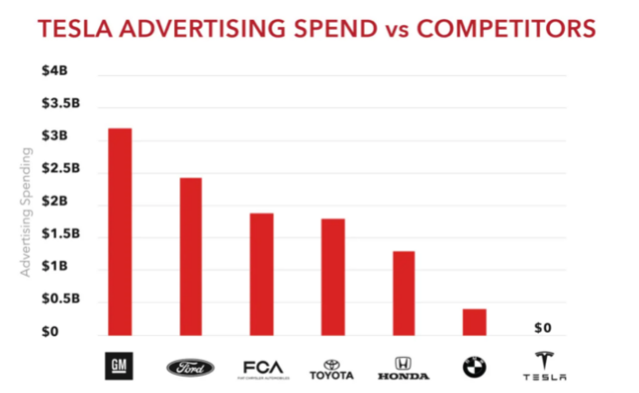
Figure 3: Comparison of advertisement spend of Tesla with their competitors
(Source: Thomas and Maine, 2019)
Place
The only place where these cars are available is its official company websites and galleries that are company owned. Tesla does not have any franchise. They distribute form their direct outlets.
People
The company assures the customers get services once they get attached with the brand. The online services are also available to resolve the issues regarding their purchase. From the perspective of Employee Company prefer to motivate employee through rewards and promotion. The firm uses regulated motivational session to keep the employees motivated across the operations.
Process
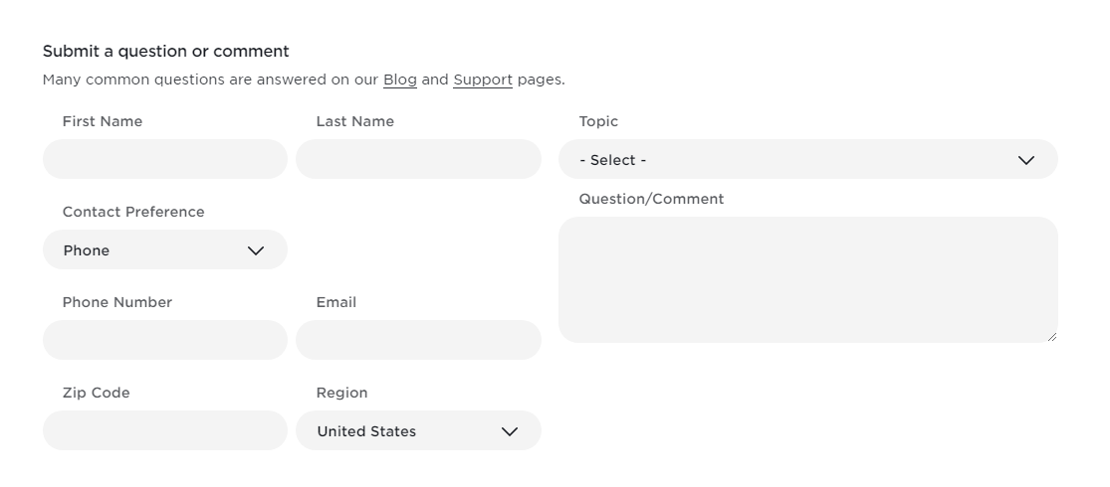
Figure 4: Tesla customer compliant form
(Source: Tesla, 2021)
Tesla produces their own batteries as buying from third parties would cost more. Company assures that customer get best of best in services and delivery. For completion of this process, it company give 24*7 online technical support and conduct customer loyalty program. For registering compliant customer do not have to wait or do not have face any problem they can easily register their complaint through website and can get within 8-10 hours.
Physical evidence
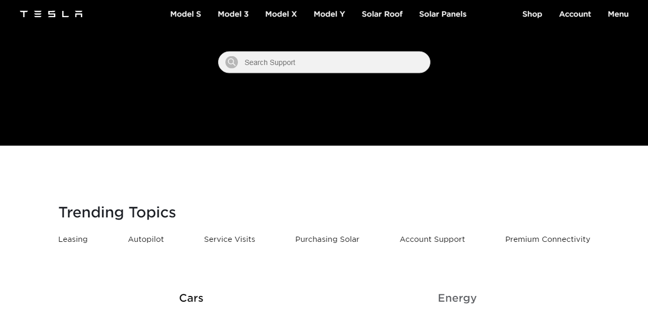
Figure 5: Tesla technical support page
(Source: Tesla, 2021)
The company offers technical support and roadside superchargers to serve the customers. The chargers are found to charge the batteries of the car. There are over twelve thousand chargers around the world.

Conclusion
Tesla has established the company and being the first electric sports car company, it has become a brand. It has been observed that Tesla’s automation is the biggest contribution in its revenue system. So specialized staff selection works as an advantage in its organizational relationship. Though there are some loops in the company which should be looked after. Considering the loopholes and developing the above-mentioned analysis will help the company to strategize further planning to enhance the market for Tesla. The marketing management report will assist the company to modify their regulations by adopting some new strategies to expand their business.

Recommendation
Tesla holds a brand power in its own significant way. However, to expand the company here is some recommendations, which could be followed by the company. As discussed in the SWOT analysis, the company needs to expand the sale as well as the supply chain all over the world to grow and expand the company globally. The price of the cars could be another factor which needs to be revised, so that it can reach more customers. The company should continue investing in the innovation sector. The diversification in the supply chain will help the company to reduce the risk in the supply related portions (Bruijl, 2018). Last but not the least, the customer related services should be developed which will ensure positive feedback for the company. Tesla should be able to penetrate market with the penetration strategy of selling Model S, Model 3 and Model X. The firm should develop their product by acquisition of more product feedback by both experts and customers. The market development of the company will eventually make more strategically appropriate decision for the company. As far as the diversification of the firm is concerned, the firm should be able to diversify the entire product proposition to offer diversified customer options (Kelly, 2021).

References
Afonso, N.A. (2018). Project of the implementation of driverless technology in vehicles of Tesla company (Doctoral dissertation, InstytutOrganizacjiSystemówProdukcyjnych).
Ahmad, S. and Khan, M. (2019). Tesla: Disruptor or Sustaining Innovator. Journal of Case Research, 10(1).
Almenhali, A. Alhajeri, H. Almansoori, H. Aljneibi, N. Almansoori, N. Alsulaity, N. Mohammed, Y. and Nobanee, H. (2021). Financial Analysis of Tesla. Available at SSRN 3896901.
Aybaly, R. Guerquin-Kern, L. Manière, I.C. Madacova, D. and van Holt, J. (2017). Sustainability practices in the luxury industry: How can one be sustainable in an over-consumptive environment? Sustainability in the automotive world: The case of Tesla. Procedia computer science, 122, pp.541-547.
BBC News. (2021). Tesla reports record deliveries but shares slide. [online] Available at: <https://www.bbc.com/news/business-55835503> (Accessed 20:December 2021].
Bruijl, G.H.T. (2018). The relevance of Porter's five forces in today's innovative and changing business environment. Available at SSRN 3192207.
Carlier, M. (2021). Tesla's net income 2014-2020 | Statista. [online] Statista. Available at: <https://www.statista.com/statistics/272130/net-loss-of-tesla/#:~:text=Tesla%20turned%20a%20full%2Dyear,million%20U.S.%20dollars%20in%202020.> (Accessed:10 January 2022).
CB Insights Research. (2021). Tesla Patents Highlight Their Energy and Energy Storage Focus vs Their Competitive Peers. [online] Available at: <https://www.cbinsights.com/research/tesla-motors-patents/> (Accessed:1 November 2021).
cnbc.com. (2021). Tesla to raise prices in China on August 30 as trade war escalates. [online] Available at: <https://www.cnbc.com/2019/08/26/tesla-to-raise-prices-in-china-on-august-30-as-trade-war-escalates.html> (Accessed:20 December 2021).
Dudovskiy, J., (2021). Tesla Ansoff Matrix - Research-Methodology. [online] Research-Methodology. Available at: <https://research-methodology.net/tesla-ansoff-matrix-2/#:~:text=Tesla%20Ansoff%20Matrix%20is%20a,development%2C%20market%20development%20and%20diversification.> (Accessed:17 December 2021).
Gafarov, R., (2019). Evaluation of the financial position and the performance of Tesla, Inc (Doctoral dissertation, Masarykovauniverzita, Ekonomicko-správnífakulta).
iide, (2021). Power-up Analysis on Tesla Marketing Strategy | IIDE. [online] IIDE. Available at: <https://iide.co/case-studies/tesla-marketing-strategy/> (Accessed:17 December 2021).
Ingle, S. and Phute, M., (2016). Tesla autopilot: semi-autonomous driving, an uptick for future autonomy. International Research Journal of Engineering and Technology, 3(9), pp.369-372.
Kelly, J., (2021). Tesla’s Leaked Employee Handbook Is as Unconventional as Founder Elon Musk.[online] Forbes. Available at: <https://www.forbes.com/sites/jackkelly/2020/02/14/teslas-leaked-employee-handbook-is-as-unconventional-as-its-founder-elon-musk/?sh=ab069f67ec27> (Accessed:17 December 2021).
Kim, H., (2020). Analysis of How Tesla Creates Core Innovation Capability. International Journal of Business and Management, 15(6), pp.42-61.
Kotler, P. et al. (2020) Principles of marketing. 8th ed. Harlow: Pearson.
Ladonlahti, T., Laamanen, M. and Uotinen, S., (2020). Ensuring diverse user experiences and accessibility while developing the Tesla e-assessment system. In Engineering data-driven adaptive trust-based e-assessment systems (pp. 213-238). Springer, Cham.
Lee, J. Lee, S.J. and Jung, K. (2020). Balanced SWOT: Revisiting SWOT Analysis through Failure Management and Success Management. Available at SSRN 3612519.
Lugtu Jr, R.C., (2019). Tesla: Testing a Business Model at its (R) Evolutionary Best (Doctoral dissertation, DE LA SALLE UNIVERSITY-MANILA).
Maoheng, W. (2018). Research On the Brand Marketing of Tesla Electric Vehicle (Doctoral dissertation, SIAM UNIVERSITY).
Matthews, T. Hirve, M. Pan, Y. Dang, D. Rawar, E. and Daim, T.U. (2020). Tesla Energy. In Innovation Management in the Intelligent World (pp. 233-249). Springer, Cham.
money.usnews.com, (2021). Tesla Competitors: 6 Rival Electric Vehicle Stocks [online] Available at: <https://money.usnews.com/investing/stock-market-news/slideshows/upstart-tesla-competitors-to-watch> (Accessed:1 November 2021).
Musonera, E. and Cagle, C. (2019). Electric Car Brand Positioning in the Automotive Industry: Recommendations for Sustainable and Innovative Marketing Strategies. Journal of Strategic Innovation & Sustainability, 14(1).
Musonera, E. and Cagle, C. (2019). Electric Car Brand Positioning in the Automotive Industry: Recommendations for Sustainable and Innovative Marketing Strategies. Journal of Strategic Innovation & Sustainability, 14(1).
Perera, R., (2017). The PESTLE analysis. Nerdynaut.
Rastogi, N.I.T.A.N.K. and Trivedi, M.K., (2016). PESTLE technique–a tool to identify external risks in construction projects. International Research Journal of Engineering and Technology (IRJET), 3(1), pp.384-388.
Rice, D. (2019). The driverless car and the legal system: Hope and fears as the courts, regulatory agencies, Waymo, Tesla, and Uber deal with this exciting and terrifying new technology. Journal of Strategic Innovation and Sustainability, 14(1), pp.134-146.
Statista, (2018). Infographic: The Tesla Model 3 Is Blowing Away the Competition. [online] Statista Infographics. Available at: <https://www.statista.com/chart/14921/the-tesla-model-3-is-blowing-away-the-competition/> (Accessed:10 January 2022).
Tesla, (2021). Customer Support. [online] Tesla.com. Available at: <https://www.tesla.com/support/customer-support> (Accessed:10 January 2022).
Thomas, V.J. and Maine, E., (2019). Market entry strategies for electric vehicle start-ups in the automotive industry–Lessons from Tesla Motors. Journal of Cleaner Production, 235, pp.653-663.
Trott, P. (2008), Innovation Management and New Product Development, 4th ed, Harlow: FT Prentice Hall.
Vance, A. (2017) Tesla, SpaceX, and the Quest for a Fantastic Future. New York: Harper Collins Publishers.

