MODULE CODE: LCLM5006
MODULE: DEVELOPING EMOTIONAL INTELLIGENCE SKILLS

ASSIGNMENT TITLE: COMPONENT 2 – INDIVIDUAL WRITTEN REPORT

STUDENT NAME: DANIEL BOB
STUDENT ID:2409052
Table of Contents
Introduction 3
Task 1: Emotional Intelligence in the Workplace 3
Concept of Emotional Intelligence 3
Emotional Intelligence Models 4
Goleman's Emotional Intelligence Framework 4
Mayer and Salovey Ability Model 5
Bar-On Emotional-Social Intelligence Model 6
Application of Emotional Intelligence in the Workplace 6
Effective Communication 6
Conflict Management 7
Leadership Effectiveness 7
Decision-Making 8
Task 2: Managing a Multigenerational Workforce 9
Overview of Multigenerational Workforce 9
Characteristics of Different Generations 9
Generation X 9
Millennials (Generation Y) 10
Generation Z 10
Impact of Generational Differences on Organisational Effectiveness 10
Using Emotional Intelligence and Mindfulness to Manage Generational Diversity 11
Recommendations 12
Conclusion 13
References 14

Introduction
Emotional intelligence (EI) and mindfulness have emerged as critical skills in modern organisations because of their beneficial effect to the behaviour of employees, leadership performance, and organisational effectiveness. Emotional intelligence is the skill to identify, comprehend, regulate and control personal feelings and emotions and in response react to the feelings of other people in a proper manner and mindfulness is the skill to be present in the present without being judgemental or closed-minded. A combination of these capabilities has facilitated communication, resilience, and decision-making and collaboration in various workplace settings. Highly emotionally intelligent employees are in a better position to solve organisational conflicts, cope with organisational change and establish positive working relationships, which would enhance personal performance and make the organisation successful in general.
Therefore, emotional intelligence has become a prevalent aspect of leadership growth, recruitment, and engagement tactics by many organisations to create psychologically safe and inclusive work environments. The report is a critical analysis of how emotional intelligence and mindfulness can be used to enhance performance at work and how they are used to deal with multigenerational workforce. It further appraises applicable emotional intelligence models and their implications to the modern-day organisations.

Task 1: Emotional Intelligence in the Workplace

Concept of Emotional Intelligence
Emotional intelligence (EI) is the capacity to recognise, understand, control and effectively manage ones own emotions, and the capacity to properly perceive and respond to the emotions of others. It provides people the ability to make informed choices, establish meaningful relationships and adjust to the variable work situations. Mindfulness is the complement to emotional intelligence because it promotes living in the moment, emotional acceptance and non-judgemental focus on thoughts and feelings (English, and Kenny, 2025). Mindfulness allows employees to be more conscious about their emotional reactions and enhances self-control and minimises impulsive behaviour in difficult circumstances. Emotional intelligence and mindfulness are becoming considered indispensable skills in the contemporary organisation as they contribute to collaboration, employee welfare and effectiveness of leadership (Ullah, Khan, and Riaz, 2024). Emotionally intelligent workers are more effective communicators who are capable of effectively addressing conflict at the workplace and have a better chance to uphold resiliency when a problem occurs.

Emotional Intelligence Models

Goleman's Emotional Intelligence Framework
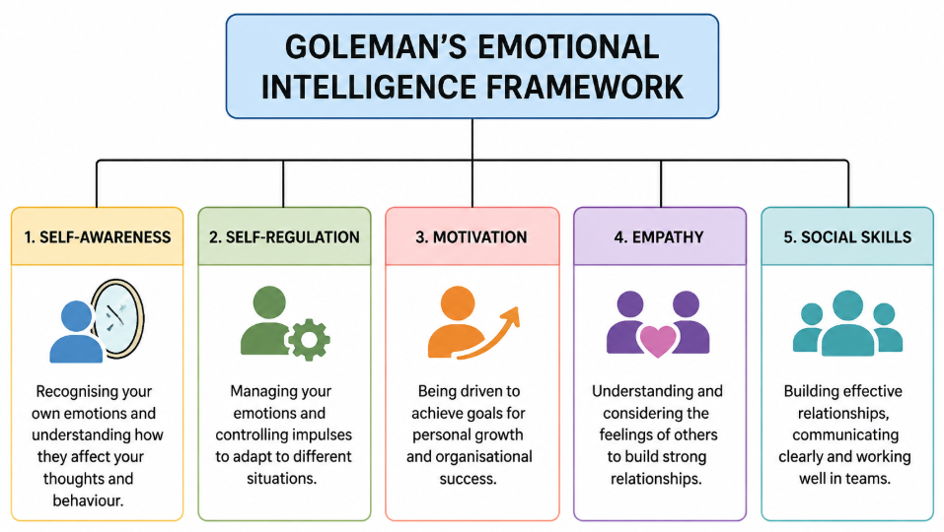
Figure 1: Goleman's Emotional Intelligence Framework
(Source: Learner)
Emotional Intelligence Framework by Goleman determines that there exist five competencies that contributes to success in the workplace, which are self-awareness, self-regulation, motivation, empathy and social skills (Woime, and Shato, 2025). Through self-awareness, the employees are in a position to identify their feelings and their impact on behaviour and decisions. Self-regulation encourages the ability to control emotions such as impulsive responses in work problems. Motivation fosters dedication towards organisational objectives by internal drive and not external incentives. Because of its ability to help employees and leaders put themselves in the mindset of colleagues, empathy builds stronger interpersonal relationships, whereas social skills enable them to communicate effectively, teamwork and resolve conflicts (Cao et al., 2022). The key strength of the framework is its practical use in the fields of leadership development and managing employees.

Mayer and Salovey Ability Model
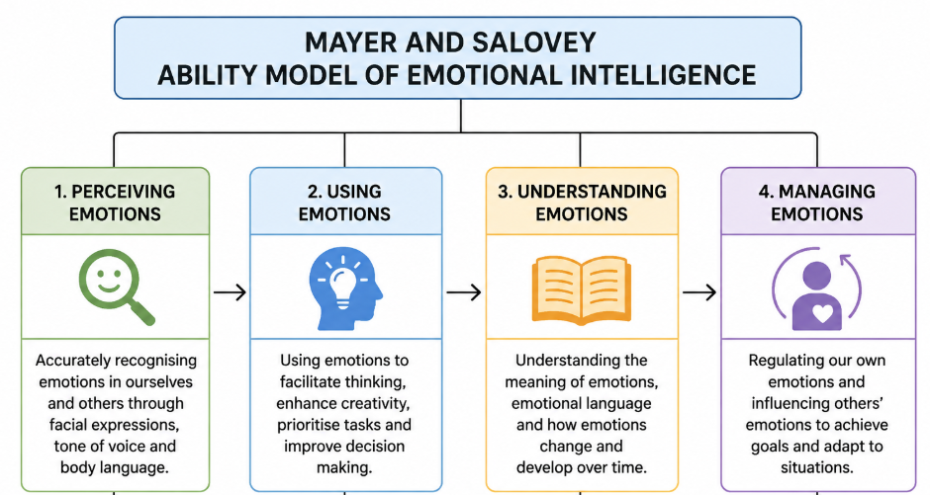
Figure 2: Mayer and Salovey Ability Model
(Source: Learner)
The Mayer and Salovey Ability Model is used to conceptualise emotional intelligence as a thinking skill which is made up of four subordinated skills namely perceiving emotions, using emotions, understanding emotions and managing emotions (Shukla, and Agnihotri, 2022). Experiencing emotions entails the correct perception of emotional expression both in other people and oneself. By employing emotions, people can incorporate emotions when thinking or in solving problems. Being able to understand emotions involves being able to identify emotional changes and know subtle emotional relationships whereas managing emotions is about being able to regulate emotions in order to attain positive results (Singh, and Keshari, 2026). The major advantage of the model is its scientific basis that allows considering emotional intelligence as a measurable mental capacity, and not a personality trait. However, its assessment procedures are said by many to be complex and not as practical to access.

Bar-On Emotional-Social Intelligence Model
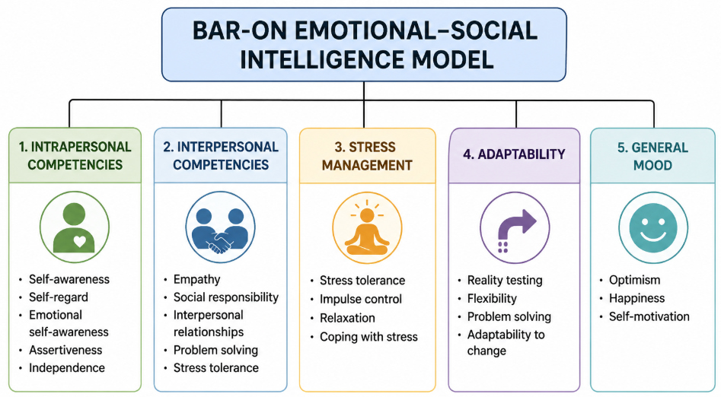
Figure 3: Bar-On Emotional-Social Intelligence Model
(Source: Learner)
The Emotional-Social Intelligence Model developed by Bar-On focuses on both emotional and social skills that help individuals to live well and contribute to organisational success. The model consists of intrapersonal competencies, interpersonal competencies, stress management, adaptability and general mood. Intrapersonal competencies enhance self-awareness, confidence and interpersonal competencies enhance empathy and strengthening relationships (Nawaz et al., 2024). Stress management helps employees to stay calm when under pressure, flexibility allows the employees to respond to organisational change in a flexible manner and general mood is helpful to keep the employees optimistic and resilient (Dubey, Priya, and Pandey, 2025). One of the main strengths of the model is that it is a very holistic approach, as it combines emotional with workplace wellbeing. However, critics believe that its general size intersects with personality and psychological wellbeing constructs.

Application of Emotional Intelligence in the Workplace

Effective Communication
Emotional intelligence plays a huge role in improving workplace communication level because it has the capacity to increase activities in active listening, emotional awareness, trust and collaborations. Highly emotionally intelligent employees are effective listeners, who pay full attention to others, accurately decide and respond to verbal and non-verbal communication and contact with great empathy (Pradhan et al., 2023). In his model, Goleman suggests that empathy and interpersonal abilities are the forces that enhance the relationships between people by enabling the members of the team to express themselves in a respectful way and understand one another. Moreover, emotional awareness helps employees to control emotional responses to tricky discussions, avoiding misunderstandings and encouraging positive communication (Kundi et al., 2023).
These skills enhance trust, facilitate sharing of knowledge and facilitate effective cooperation within diverse organisational environment. On the contrary, emotionally intelligent communication enhances employee satisfaction, minimises tension at the workplace and promotes an inclusive atmosphere, in which employees feel appreciated, respected and motivated to make contributions towards the organisational goals (Dahleez et al., 2026).

Conflict Management
Emotional intelligence is key in resolving conflict in the workplace, because it promotes emotional regulation, empathy, negotiation and collaborations in solving problems. Those employees that control their emotions may stay calm in disagreements and this way the discussions may be more concerned with the issues but not with differences (Saka et al., 2023). The self-regulation competency of Goleman is useful in the sense that it helps people to restrain their impulsive responses, whereas empathy enhances knowledge of the conflicting opinions. Furthermore, the Bar-On model brings into focus stress management and inter-personal skills which facilitate positive conflict management (Ufomba, Monyei, and Ukpere, 2025). Instead of being authoritative, emotionally intelligent managers stimulate open communication, recognize issues that are troubling the employees and find ways of achieving a compromise instead of causing them to agree (Manoharan, Durai, and Rajesh, 2022). These proactive practices of cooperation reduce the tension at work, build trust among the workers and make the team more cohesive.

Leadership Effectiveness
EI is commonly held as a core competence of successful leadership since it enhances employee engagement and motivation, team performance and team psychological safety. The framework used by Goleman indicates that self-awareness helps a leader to realise the impact of their feelings on leadership behaviour whilst empathy also helps them to be sensitive to the feelings of their employees to offer them the necessary help (Kalra, Dugan, and Agnihotri, 2022). Self-regulation focus on normal and ethical leadership in times of organisational uncertainty and social skills facilitates teamwork and building relationships (Rizvi, 2023). Emotionally intelligent leaders are also inspiring in terms of intrinsic motivation, they acknowledge the efforts of employees and encourage open communication by providing psychologically safe conditions in which employees are not scared of voicing their ideas and concerns.

Decision-Making
Emotional intelligence helps to create efficient organisational decision making by balancing emotions with rational thinking. The Ability Model of Mayer and Salovey states that a person initially experiences relevant emotions, incorporates emotional information into thoughts, comprehends emotional implications and regulates emotional reactions on the way to making a decision (Mayer et al., 2024). This step-by-step procedure decreases the emotional bias, but it helps in making ethical judgements and objective solutions to problems. When under pressure, employees who have strong emotional regulation do not impulses and consider other options before making a decision. In addition, emotional awareness can also help the managers to think about the emotional consequences of the decision on the employees and organisational stakeholders leading to a more responsible and fair decision (Awais, Ishaq, and Gillani, 2025).
Critical Evaluation of Emotional Intelligence
Emotional intelligence has many positive effects to individuals and organisations in enhancing communication, leadership effectiveness, teamwork, the wellbeing of the employees and the performance of the organisations. Employees exhibiting high levels of emotional intelligence tend to display better interpersonal relationships, resilience in the face of an organisational change and better conflict management (Sharma, Dhanta, and Sharma, 2024). Moreover, combining mindfulness exercises with emotional intelligence development will improve emotional regulation and decrease stress at workplace in addition to fostering emotional awareness (Martínez et al., 2023). In spite of these benefits, emotional intelligence has been heavily criticized. Scholars suggest that its conceptual boundaries are not clear since a number of emotional intelligence competencies are overlapped with personality traits, social skills as well as characteristics of behaviour.
Furthermore, emotional intelligence is quite difficult to measure, with self-report methods being subject to social desirability, and the ability-based methods often difficult to read (Brown, Heck, and Chabris, 2023). Another controversy is with regard to the comparative significance of emotional intelligence to intelligence quotient (IQ). Despite the role of emotional intelligence in making one a successful leader and managing relationships, cognitive intelligence is needed to play its crucial role in providing technical expertise, analytical thinking and solving complex problems (Singh, Prabhakar, and Kiran, 2022). Organisational success relies on a harmonious mix of emotional intelligence and cognitive ability as opposed to solely competing with either of the competencies. Additionally, emotional intelligence is a desirable organisational tool as long as it accompanies an element of mindfulness, proper leadership growth and evidence-based evaluation practices (Ravikumar, and Muralidharan, 2025). By investing in emotional intelligence training, organisations can establish psychologically safe work environments, enhance employee engagement and long-term organisational performance.

Task 2: Managing a Multigenerational Workforce

Overview of Multigenerational Workforce
Contemporary organisations are becoming more flexible by hiring many generations of workers to form diverse work environments with diverse experiences, expectations and working styles. Appreciating the differences between generations is now crucial in the efforts by managers to make collaboration, employee engagement and organisational performance better (George, Baskar, and Srikaanth, 2024). Digital transformation, flexible working arrangements and inclusive leadership are current trends in the workplace. This demand organisations to exist and treat employees of Generation X, Millennials and Generation Z appropriately whilst collaborating to develop mutual respect, knowledge sharing and inclusion in the workplace.

Characteristics of Different Generations

Generation X
Generation X workers, who were born around the years 1965-1980, tend to appreciate job security, control and professionalism. They do not prefer indirectness and ambiguity and value solitude in discharging work duties. Their incentives are usually provided with the basis of career security, popularity and chances to use their vast professional experience. GenX is not a digital native generation, however the generation has been able to adapt to changes in technology successfully because of life-long learning and on-the-job training (Dalessandro, and Lovell, 2025). They reconcile old fashioned management expectations as well as technical ability are useful to mentor younger employees. Their experiences at work, capacity of solving problems and a high level of organisational commitment adds a benefit to knowledge transfer, stability of operations and decision making to the modern organisations (Saraiva, and Nogueiro, 2025).

Millennials (Generation Y)
Millennials appreciate teamwork, collaboration and lifelong learning. They want meaningful careers and frequent learning, positive feedback and supportive leadership. Tremendously qualified in digital technologies, they respond swiftly to changes in technology and prefer work-life balance and flexibility in their working positions (Dixit, 2023). Their team spirit promotes creativity, employee involvement and enhanced cross functionalism.

Generation Z
Generation Z workers are digital natives who are not afraid to use the new technologies and innovations through emerging digital platforms. They appreciate workplace flexibility, diversification and inclusion with anticipations of constant feedback and a tailored career build (Visser, and Terblanche, 2025). Mindfulness and adaptability as well as their creativity brings new ideas and innovation. At work, they favour teamwork-learning spaces which promote open dialogue and organisational learning.

Impact of Generational Differences on Organisational Effectiveness
The influence of generational differences on organisational effectiveness is large because they affect communication styles, motivating employees, learning preferences, technology acceptance, knowledge sharing, innovation, and cooperation. Structured communication methods, as well as face-to-face interaction prescribes to generation X, but digital communication tools are popular among Millennials and the generation Z and introduce possible misunderstandings in case communication strategies are not modified accordingly (Andriani et al., 2022). Furthermore, there is a difference in employee motivation, as Generation X prefers stability and appreciation, Millennials prefer career development and meaningful work, and the Generation Z is focused on flexibility and constant learning and feedback (Alimbudiono, and Tandianto, 2025). Moreover, the younger generations tend to embrace technologies faster, whereas the experienced employees can offer organisations with lots of knowledge and experience.
Such cross-functional capabilities promote innovation by offering a variety of ideas and promoting a solid transfer of knowledge among senior and those who are still developing their career. However, the variations in work values, communication preferences and expectations can potentially cause interpersonal conflicts, resistance to change and less collaboration unless addressed (Hackney et al., 2022). The organisations on the other hand that appreciate and acknowledge the difference between the different generations possess the advantage of creativity, problem-solving skills and better organisational flexibility. By fostering an inclusive leadership approach, promoting cross-generational mentoring and open lines of communication, managers can turn generational diversity into a strategic asset increasing engagement of employees, organisational learning, innovation and long-term organisational performance and reducing misunderstandings and conflict in the workplace.

Using Emotional Intelligence and Mindfulness to Manage Generational Diversity
The application of emotional intelligence and mindfulness in the recruitment processes, employee management and retention practices can help managers manage effectively multigenerational workforces. In the recruitment process, the emotional intelligence model offered by Goleman can be used to implement an inclusive hiring strategy by stimulating self-awareness and empathy (Ihensekien, and Joel, 2023). This allows managers to be more aware of their unconscious behavioural biases and to select candidates based on their abilities rather than on their generation-specific stereotypes. Mindfulness also improves recruiting by advancing the objective decision-making process and alleviating the biases that can be experienced in the process of hiring candidates, making the employment of all the generations equal (Xueyun et al., 2023).
Emotional intelligence in employee management helps in enhancing communication, coaching and conflict management among the different ages. Empathic and social leaders hear their employees and listen to them, value diverse communication goals and offer person-centred coaching in accordance with personal career desires (McCartney, and Fu, 2022). Self-regulation helps managers act evenly when it comes to resolving conflicts at the workplace, whereas mindfulness promotes listening and responding carefully instead of out of emotions. To illustrate, a manager can arrange mentoring programmes during which Generation X staff members provide hands-on insights into the workings of the industry. Millennials and Generation Z members can exercise digital innovations that will bring about mutual respect and an opportunity to learn together.
Furthermore, Emotional intelligent leadership helps to retain employees. By understanding the emotional needs of the employees, managers are able to make the work environment psychologically safe where employees feel respected, valued and supported, irrespective of their age (Aggarwal et al., 2022). Leaders enhance employee engagement, wellbeing and organisational commitment by being empathetic, acknowledging success, and promoting a free flow of information. In addition, emotional wellbeing and resilience helping activities in organisational change are mindfulness activities in the form of stress management sessions, reflective team sessions (Demir et al., 2023). As an example, the varying expectations of Generation Y, Millennials and Generation Z can be brought into focus when organisations adopt flexible working processes in addition to frequent wellbeing conversations.

Recommendations
Companies need to implement rigorous emotional intelligence (EI) employee and manager training programs to foster their self-awareness, self-regulation, empathy and motivation coupled with social skills. Communication, conflict management, and decision-making can be involved in regular workshops, coaching, and practical simulation to make employees use emotional intelligence (Somwethee, Aujirapongpan, and Ru-Zhue, 2023). Incorporating EI development in leadership programmes will enhance interpersonal relationship, enhance collaboration and heighten employee involvement at all levels of the organisation. Moreover, organisations are encouraged to organize mindfulness programs to enhance the wellbeing and resilience of the employees (Waworuntu, Kainde, and Mandagi, 2022). Mindful training or workshops on stress management, meditation groups and acts of reflection could assist the employees to cope with the pressure at the work place, control their emotions and remain involved. Motivating employees to integrate mindfulness into their day to day activities will lower stress levels, reduce the cases of burnout and promote healthier workplace, thus enhancing productivity and job satisfaction (Abaker et al., 2025).
Emotional intelligent leadership must be developed within organisations by making sure that managers are always empathetic, emotionally aware and are also morally upright in their decision making (Khemraj et al., 2023). Leaders must be great listeners, individually identify employee needs, offer constructive feedback and build positive relationships that are based upon trust. Emotionally intelligent leaders have the ability of better motivating the employees, change management and positive organisational culture that is conducive to innovation, accountability and high performance (Dissanayake, and Rajapaksha, 2025). Furthermore, organisations ought to enhance inclusive hiring measures through adopting effective selection methods like structured and competence-based selection sensitive to unconscious bias. The skills, capabilities and potential of candidates should be considered in the hiring decision and not their ages (Ghaith, Alshirbini, and Huimin, 2025). Various interviewing panel and objective evaluation criterion can aid in fair hiring and appealing to as well as acquiring skilled representatives of various generations and resources that will enhance diversification in the labour force and organisational strengths.
In order to create long-term organisational competitiveness, employers must promote long-term learning and professional growth via mentoring programmes, on-line learning platforms, leadership development programmes and cross-functional training opportunities (Chung, Cichocki, and Chung, 2023). The staff of various age groups must also be motivated to share knowledge and skills and leave aging workers to transfer industry knowledge with younger staff members add technological knowledge and new horizons. In addition, organisations can build psychological safety and enhance cross-generational working by providing inclusive working environments where employees are able to feel respected, valued and confident enough to share ideas without being to blame of criticising one another (Tamás et al., 2024). Managers must promote a dialogue, cross-generational mentoring, cross-generational mentoring and team work as a way of enhancing cross-generational understanding between Generation X, Millennials and Generation z. These efforts will build trust and knowledge sharing, employee retention and improvement of organisational adaptability, so organisations can attain sustainable performance, and hold a competitive edge in an ever-changing and diverse business environment.

Conclusion
Mindfulness and emotional intelligence are critical in enhancing performance and employee wellbeing at the organisational level, as well as, leadership effectiveness. Their use improves communication, conflict management, ethical decision-making and conflict resolution as well as promotes psychologically safe workplaces. Moreover, effective leadership based on emotional intelligence allows organisations to effectively handle multigenerational workforces through facilitating inclusiveness, active involvement and resilience thus enhancing organisational performance, creativity and sustainable success over an extended period.

References
Abaker, M., Noureldin, A., Aboueldahab, M., Fakhfakh, A. and Al-Hariry, B., (2025). Mindfulness and work engagement: How emotional intelligence bridges the gap. Journal of Management World, (2025)(2), pp.320-332.
Aggarwal, A., Sadhna, P., Gupta, S., Mittal, A. and Rastogi, S., (2022). Gen Z entering the workforce: Restructuring HR policies and practices for fostering the task performance and organizational commitment. Journal of public affairs, 22(3), p.e2535.
Alimbudiono, R.S. and Tandianto, H.S., (2025). The Relationship between Cultural Control, Generational Differences, and Organizational Efficiency. Jurnal Ilmiah Manajemen Kesatuan (JIMKES), 13(6), pp.4463-4474.
Andriani, M., Christiandy, A., Wiratmadja, I. and Sunaryo, I., (2022). Knowledge management effectiveness model in facilitating generation differences. Knowledge Management Research & Practice, 20(6), pp.947-959.
Awais, M., Ishaq, H.M. and Gillani, S.I.A., (2025). The Impact of Emotional Intelligence on Rational and Ethical Decision-Making. Scholar Insight Journal, 3(2), pp.105-121.
Brown, M.I., Heck, P. and Chabris, C.F., (2023). Exploring the disconnect between self-report and performance measures of emotional intelligence. Available at SSRN 4590206.
Cao, Y., Gao, L., Fan, L., Jiao, M., Li, Y. and Ma, Y., (2022). The influence of emotional intelligence on job burnout of healthcare workers and mediating role of workplace violence: a cross sectional study. Frontiers in public health, 10, p.892421.
Chung, S.R., Cichocki, M.N. and Chung, K.C., (2023). Building emotional intelligence. Plastic and Reconstructive Surgery, 151(1), pp.1-5.
Dahleez, K.A., Al-Brwani, R., Salah, M. and Al-Sinawi, S., (2026). Sustaining workplace through emotional intelligence: the role of empowering leadership in fostering engagement and risk-taking in healthcare. Journal of Health Organization and Management, 40(2), pp.197-217.
Dalessandro, C. and Lovell, A., (2025). Sustaining Workers: The Influence of Environmental Sustainability on Employee Commitment and Recruitment. Global Business and Organizational Excellence, 45(1), pp.31-41.
Demir, A., Budur, T., Omer, H.M. and Heshmati, A., (2023). Links between knowledge management and organisational sustainability: does the ISO 9001 certification have an effect?. Knowledge management research & practice, 21(1), pp.183-196.
Dissanayake, D.F. and Rajapaksha, S., (2025). The Minful Organization: Intersections of Emotional Intelligence and Workplace Presence. Journal of Desk Research Review and Analysis, 3(2).
Dixit, A., (2023). A review of personality characteristics of millennials. SMS Journal of Entrepreneurship & Innovation, 9(Issue-2), pp.60-69.
Dubey, N., Priya, M.S. and Pandey, A., (2025). Integration of Emotional Intelligence in Effective Workplace Performance: Reflecting on Future Research Agenda through Bibliometric Analysis. European Economics Letters, 15(3).
English, V. and Kenny, B., (2025). Artificial intelligence and emotional intelligence in the workplace and the consequences for leadership and organizational culture. Journal of Contemporary Research in Business, Economics and Finance, 7(2), pp.172-190.
George, A.S., Baskar, T. and Srikaanth, P.B., (2024). Bridging the generational divide: Fostering intergenerational collaboration and innovation in the modern workplace. Partners Universal International Innovation Journal, 2(3), pp.198-217.
Ghaith, A., Alshirbini, M. and Huimin, M., (2025). The impact of emotion regulation and emotional intelligence on the relationship of dispositional mindfulness and collective mindfulness. EuroMed Journal of Business, pp.1-22.
Hackney, A., Yung, M., Somasundram, K.G., Nowrouzi-Kia, B., Oakman, J. and Yazdani, A., (2022). Working in the digital economy: A systematic review of the impact of work from home arrangements on personal and organizational performance and productivity. Plos one, 17(10), p.e0274728.
Ihensekien, O.A. and Joel, A.C., (2023). Abraham Maslow’s hierarchy of needs and Frederick Herzberg’s two-factor motivation theories: Implications for organizational performance. The Romanian Economic Journal, 85(1), pp.133-146.
Kalra, A., Dugan, R. and Agnihotri, R., (2022). “A little competition goes a long way”: Substitutive effects of emotional intelligence and workplace competition on salesperson creative selling. Marketing Letters, 33(3), pp.399-413.
Khemraj, S., Pettongma, P.W.C., Thepa, P.C.A., Patnaik, S., Wu, W.Y. and Chi, H., (2023). Implementing mindfulness in the workplace: A new strategy for enhancing both individual and organizational effectiveness. Journal for ReAttach Therapy and Developmental Diversities, 6(2s), pp.408-416.
Kundi, Y.M., Badar, K., Sarfraz, M. and Ashraf, N., (2023). Interpersonal conflict as a barrier to task performance: the mediating role of workplace deviance and the moderating role of emotional intelligence. International Journal of Conflict Management, 34(1), pp.104-124.
Manoharan, G., Durai, S. and Rajesh, G.A., (2022), May. Emotional intelligence: A comparison of male and female doctors in the workplace. In AIP Conference Proceedings (Vol. 2418, No. 1, p. 020006). AIP Publishing LLC.
Martínez-Pérez, I., García-Rodríguez, A., Morales-Rodríguez, F.M. and Pérez-Mármol, J.M., (2023). Mindfulness abilities are associated with anxiety levels, emotional intelligence, and perceived self-efficacy. Sustainability, 15(6), p.4729.
Mayer, J.D., Caruso, D.R., Sitarenios, G. and Escobar, M.R., (2024). How many emotional intelligence abilities are there? An examination of four measures of emotional intelligence. Personality and Individual Differences, 219, p.112468.
McCartney, S. and Fu, N., (2022). Bridging the gap: why, how and when HR analytics can impact organizational performance. Management Decision, 60(13), pp.25-47.
Nawaz, N., Gajenderan, V., Gopinath, U.M. and Tharanya, V., (2024). Nexus between emotional intelligence and occupational stress: Role of workplace spirituality among teaching fraternity. Asia Pacific Management Review, 29(1), pp.141-150.
Pradhan, R.K., Jandu, K., Samal, J. and Patnaik, J.B., (2023). Does practicing spirituality at workplace make teachers more engaged? Examining the role of emotional intelligence. International Journal of Ethics and Systems, 39(4), pp.859-874.
Ravikumar, M. and Muralidharan, S., (2025). Enhancing Leadership Through Mindfulness and Emotional Intelligence: A Path to Inclusive and Effective Organizational Culture. In Strategic Approaches to Mindful Leadership and Change Management (pp. 35-78). IGI Global Scientific Publishing.
Rizvi, Y.S., (2023). Drivers of exemplary leadership behaviour: the role of regulation competence amid disruptions. International Journal of Management Practice, 16(6), pp.744-764.
Saka, K.A.O., Olaleye, B.R., Sarpong, E., Ibrahim, A. and Adedokun, J.O., (2023). The influence of workplace bullying on the performance of hotel employees: the mediating role of emotional intelligence and psychological resilience. Tourism & Management Studies, 19(3), pp.59-71.
Saraiva, M. and Nogueiro, T., (2025). Perspectives and realities of disengagement among younger generation Y and Z workers in contemporary work dynamics. Administrative Sciences, 15(4), p.133.
Sharma, P., Dhanta, R. and Sharma, A., (2024). Emotional intelligence and conflict resolution in the workplace. In Leveraging AI and emotional intelligence in contemporary business organizations (pp. 102-121). IGI Global Scientific Publishing.
Shukla, A. and Agnihotri, A., (2022). Emotional intelligence is now more necessary than ever due to the use of artificial intelligence in the workplace. Int J All Res Educ Sci Methods (IJARESM), 10, pp.601-604.
Singh, A., Prabhakar, R. and Kiran, J.S., (2022). Emotional intelligence: A literature review of its concept, models, and measures. Journal of Positive School Psychology, 6(10).
Singh, V.K. and Keshari, A., (2026). Workplace well-being through organisational aesthetics: how emotional intelligence, leadership, and organisational support shape employee experience?. Current Psychology, 45(5), p.484.
Somwethee, P., Aujirapongpan, S. and Ru-Zhue, J., (2023). The influence of entrepreneurial capability and innovation capability on sustainable organization performance: Evidence of community enterprise in Thailand. Journal of Open Innovation: Technology, Market, and Complexity, 9(2), p.100082.
Tamás, M., Jenei, S., Elena, M., Vasantha, P.L., Malatyinszki, S. and Dávid, L.D., (2024). The role of lifelong learning in labour market competitiveness. Journal of Ecohumanism, 3(8), pp.7743-7761.
Ufomba, R.E., Monyei, F.E. and Ukpere, W.I., (2025). Leveraging emotional intelligence competencies in managing interpersonal conflicts: evidence from higher learning institutions. Organization Development Journal, 43(1), pp.151-168.
Ullah, R., Khan, A. and Riaz, T., (2024). Emotional Intelligence in the Workplace: Strategies For Enhancing Employee Performance And Satisfaction. Social Science Review Archives, 2(2), pp.259-271.
Visser, C. and Terblanche, N., (2025). The soft-skills characteristics of Generation Z employees: A scoping review and research agenda. SA Journal of Human Resource Management, 23, p.2975.
Waworuntu, E.C., Kainde, S.J. and Mandagi, D.W., (2022). Work-life balance, job satisfaction and performance among millennial and Gen Z employees: a systematic review. Society, 10(2), pp.384-398.
Woime, A.W. and Shato, G.A., (2025). The role of emotional intelligence and conflict management in job satisfaction and teamwork: A systematic review. Public Health Challenges, 4(2), p.e70054.
Xueyun, Z., Al Mamun, A., Masukujjaman, M., Rahman, M.K., Gao, J. and Yang, Q., (2023). Modelling the significance of organizational conditions on quiet quitting intention among Gen Z workforce in an emerging economy. Scientific reports, 13(1), p.15438.

