WORKSHEET 4a – QUESTION (Lists)

- Write a program that allows the user to enter the names of five products into a list and the prices of the products into a second list. When all the products and prices have been entered, print them on the screen, then calculate the total price of all the products.

The shop has also decided to have a flash sale, with 20% off everything today.

Calculate the sale price and print this on the screen too.

Your output might look something like this:

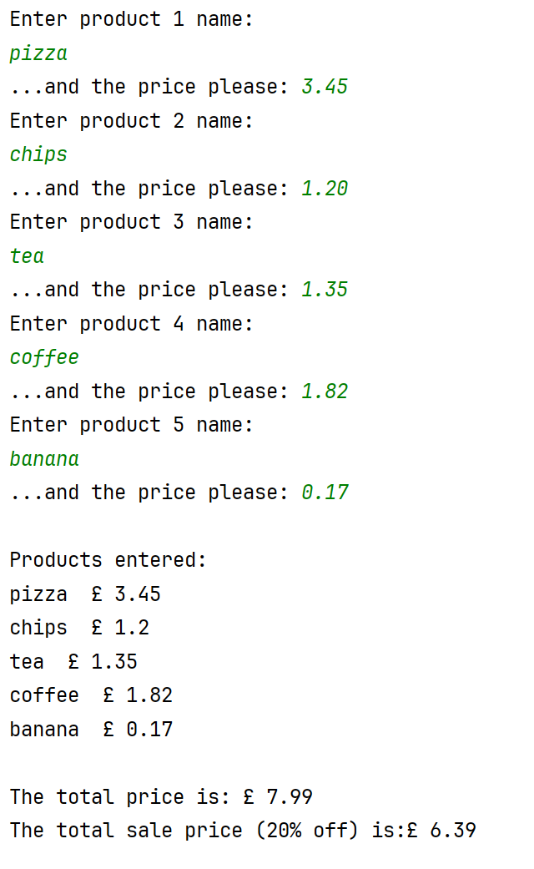

Use validation in your code where appropriate to prevent the user from entering inappropriate values.

- Extend your program to allow the user to search the list. Write code to determine if the product has been entered, and if it has, print out the price.

Your output might look something like this:



