Intercultural Competence Report

Student: Dominik Csaba David
Module: Cultural Awareness (BMIH5003)
Lecturer: Heidi Prosser

Introduction
Diversity Hotel & Spa, a distinguished 5-star UK-based hotel company, is poised for international expansion with the inauguration of a new hotel in Hungary. To ensure a seamless transition and maintain the chain's operational excellence and brand standards, the General Manager is scheduled to visit the Hungarian location for training and orientation of the local hotel personnel. This report aims to provide a comprehensive understanding of Hungarian culture and customs, conduct a detailed country analysis based on the GLOBE Project's culture and leadership study, and highlight the critical importance of cultural intelligence and sensitivity within the context of the hospitality industry.

Main Body
Hungary is a small country situated in Central Europe, very rich in national and cultural diversity, deeply influenced by its complex history (Barany et al., 2023).
Culture and customs in Hungary:
- Hungarian (Magyar) serves as the official language. Although English is frequently spoken in the hospitality industry, making an effort to learn and use basic Hungarian phrases reflects respect for the local culture and can facilitate better communication with staff and guests (Osoblivaia, 2023).

- Hungarian cuisine is renowned for its distinct flavours and traditional dishes, including goulash, paprika chicken, and dobos torte (dobos cake). Incorporating these local delicacies into the hotel's menu can provide an authentic and delightful culinary experience for guests (Tas, 2023).
Family, Traditions and Etiquette:
- Family holds a central and cherished role in Hungarian culture, with traditions like folk music and dance playing a significant part in the national identity (Scroope, 2017).

- Hungarian society places a premium on punctuality and proper etiquette. This includes offering a firm handshake and addressing individuals with their appropriate titles, such as Mr. or Mrs., which is customary and appreciated in social and business interactions (Anderson, 2017).
GLOBE Project’s cultural and leadership study:
- In group collectivism: Hungarian culture emphasises strong relationships and a sense of belonging, and values close-knit social organisations. This necessitates that hotel staff prioritise the development of strong relationships with both visitors and coworkers, thereby fostering an environment characterised by inclusivity and connection (Cherry, 2022).

- Uncertainty avoidance: Uncertainty avoidance is moderate in Hungary, suggesting that the population is generally at ease with complexity and change. This implies that hotel staff ought to possess qualities such as flexibility, receptiveness to new ideas, and the ability to manoeuvre through circumstances in which the result may not be instantaneously apparent (Smit, 2016).

- Performance orientation: Hungary is highly performance-oriented, with an unwavering pursuit of excellence and flawlessness. In order to reflect these cultural values, hotel personnel ought to uphold stringent criteria, perpetually striving for excellence and delivering the highest possible standard of service to guests (Lowrie, 2021).

- Gender egalitarianism: Hungary exhibits a range of levels of gender egalitarianism ranging from moderate to high, which suggests that the hotel ought to proactively foster diversity and inclusiveness within its personnel. This assures a balanced and equal gender representation at all organisational levels, in accordance with local values.
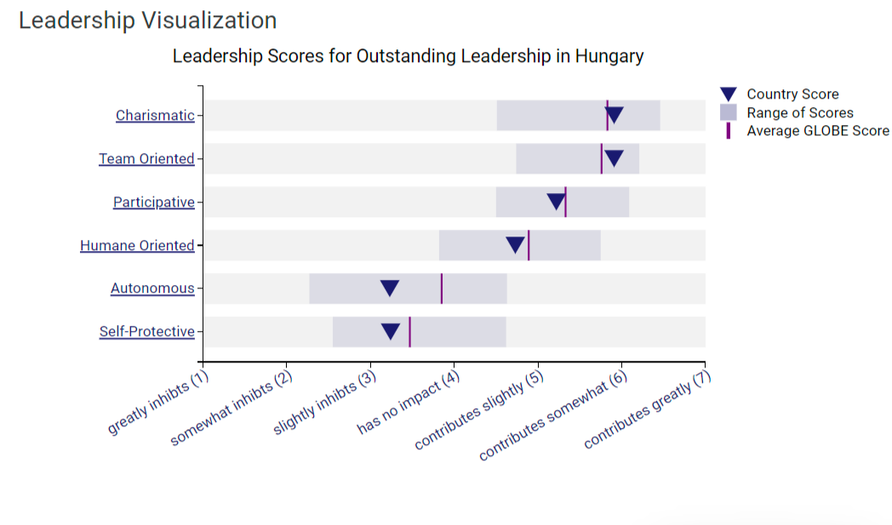
The significance of cultural intelligence and sensitivity:
Cultural intelligence and sensitivity are indispensable qualities for hotel personnel as they navigate the dynamic business landscape, particularly within the hospitality industry. Diverse is the significance of these elements:
- Effective communication: Communication effectiveness is vital to the success of any enterprise in the hospitality sector. Hotel personnel who possess cultural intelligence are better able to communicate with guests and coworkers, thereby decreasing the likelihood of miscommunications, misunderstandings, and conflicts that may negatively impact the guest experience.

- Reputation and brand image: The exhibition of cultural competence serves to bolster the reputation and brand image of the hotel. Adopting a culturally sensitive approach has the ability to appeal to a wide range of clients and cultivate brand loyalty. Guests remember and value an experience that demonstrates a genuine regard for their culture.

- Enhanced customer service: Acknowledging and valuing the cultural customs and inclinations of guests are fundamental in order to guarantee guest contentment and deliver outstanding customer service. This phenomenon not only fosters customer loyalty but also produces highly regarded online evaluations and positive word-of-mouth, both of which are indispensable within the hospitality sector (Hayes, 2022).

- Conflict resolution: Cultural sensitivity is an essential factor in preventing miscommunications and disputes with both visitors and coworkers. When working with a diverse clientele and in a culturally diverse workplace, the capacity to navigate cultural differences promotes harmony and mitigates conflicts that may have adverse effects on operations (Waugh, 2021).

- Market adaptation: In light of the hotel industry's ongoing global expansion, the ability to effectively navigate and operate in various markets is imperative for achieving success. Cultural intelligence enables hotel staff to proficiently acclimatise to the specific circumstances, demands, and inclinations of the local market. The ability to adapt is a critical factor in both attracting and retaining visitors of diverse cultural heritage.
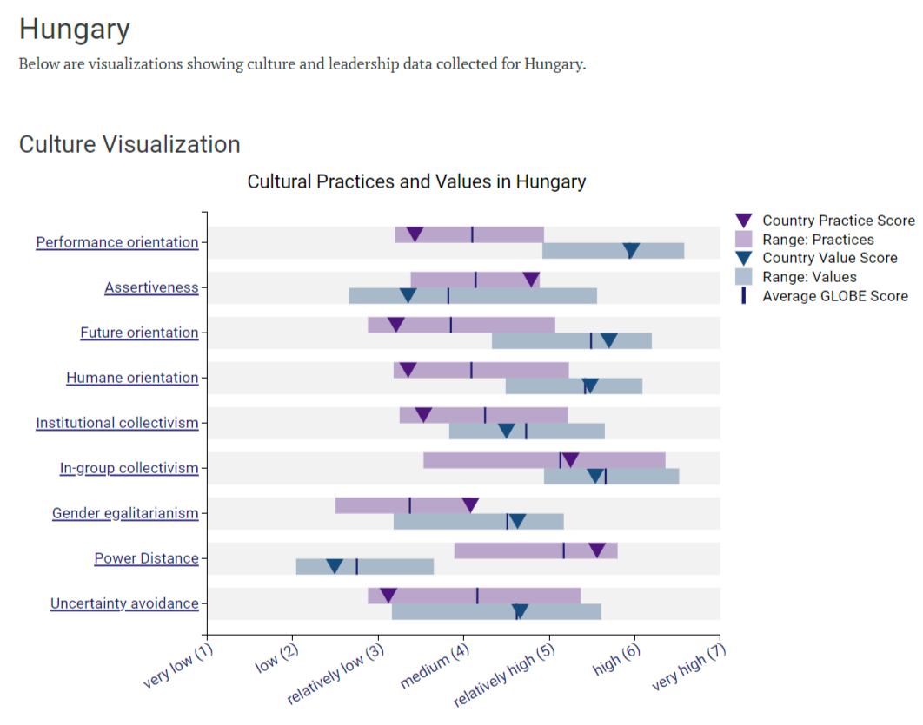

Importance of Cultural Intelligence and Sensitivity for hotel personnel within the business context.
- Effective communication: Miscommunication and service failures can result. Cultural intelligence helps hotel workers communicate with visitors from different cultures, making their stay more pleasant.

- Enchanted Guest experience: In hospitality, guest experience is everything. Hotel staff may personalise and enhance client experiences by understanding and respecting cultural differences. This boosts guest pleasure, reviews, and repeat business.

- Cross-Cultural problem solving: Hotel problems and conflicts are inevitable. Culturally intelligent teams can handle these circumstances better, lowering bad incidences and improving the hotel's reputation (Kopp, 2023).

- Diversity and inclusion: The hospitality sector welcomes diversity. Staff and guests feel included and at home with culturally aware approaches. It promotes harmony and respect by ensuring no one feels excluded.

- Brand reputation and loyalty: Cultural sensitivity boosts the hotel's brand, attracting a wider range of customers. Hotels that respect guests' traditions and principles are more likely to retain them (Blair, 2023).
Potentional challenges for the general manager
- It may be difficult for the general manager, who is based in the United Kingdom, to modify management practises for Hungary. Misunderstandings could potentially result from the Hungarian staff's varying work culture and expectations. To ensure a smooth transition of the hotel in Hungary and ensure potential challenges are surmounted, the general manager must employ strategies such as facilitating open communication, encouraging cross-cultural training, and cultivating an inclusive work environment.

Summary
Diversity Hotel & Spa's Hungarian expansion depends on understanding and accepting Hungarian culture and customs and promoting cultural intelligence and sensitivity. These improvements will improve customer service, communication, brand image, and work environment, helping the hotel succeed in Hungary. The General Manager of Diversity Hotel & Spa can use this report to manage hotel staff in Hungary, recognise cultural differences, and improve visitor satisfaction while avoiding traps and problems. Cultural knowledge is essential for success in a globalised hospitality industry.
(Wordcount for the pure text is: 1094 word, not included the 3 headings)

References
Anderson, M. (2017) Quick guide to hungarian etiquette, Budapest Bound. Available at: https://www.budapest-bound.com/quick-guide-to-hungarian-etiquette/ (Accessed: 06 November 2023).
Barany, G., Berend, I.T. and Macartney, C.A. (2023) Hungary, Encyclopædia Britannica. Available at: https://www.britannica.com/place/Hungary (Accessed: 08 November 2023).
Blair, A. (2023) Brand reputation: What does it mean for customer loyalty?, GetApp. Available at: https://www.getapp.com.au/blog/3377/brand-reputation-customer-loyalty (Accessed: 09 November 2023).
Cherry, K. (2022) Understanding collectivist cultures, Verywell Mind. Available at: https://www.verywellmind.com/what-are-collectivistic-cultures-2794962 (Accessed: 09 November 2023).
Hayes, A. (2022) Word-of-mouth marketing: Meaning and uses in business, Investopedia. Available at: https://www.investopedia.com/terms/w/word-of-mouth-marketing.asp (Accessed: 09 November 2023).
Kopp, C.M. (2023) Cross culture: Definition, examples, and differences across countries, Investopedia. Available at: https://www.investopedia.com/terms/c/cross-culture.asp (Accessed: 09 November 2023).
Lowrie, L. (2021) What is the difference between performance orientation and communication orientation?, Bizfluent. Available at: https://bizfluent.com/what-is-the-difference-between-performance-orientation-and-communication-orientation.html (Accessed: 09 November 2023).
Osoblivaia, T. (2023) Origins of the Hungarian language and its linguistic similarities, PoliLingua. Available at: https://www.polilingua.com/blog/post/origin-of-hungarian-language-Its-similarity-other-languages.htm (Accessed: 09 November 2023).
Scroope, C. (2017) Hungarian culture - core concepts, Cultural Atlas. Available at: https://culturalatlas.sbs.com.au/hungarian-culture/hungarian-culture-core-concepts (Accessed: 08 November 2023).
Smit, C. (2016) What is uncertainty avoidance, Culture Matters. Available at: https://culturematters.com/what-is-uncertainty-avoidance/ (Accessed: 09 November 2023).
Tas, T. (2023) Hungarian food & the 85 dishes you should know, Offbeat Budapest. Available at: https://www.offbeatbudapest.com/budapest-city-guide/best-traditional-hungarian-dishes/ (Accessed: 07 November 2023).
Waugh, J. (2021) Conscious Travel: Tips for respecting local cultures and Communities, Solo Traveler. Available at: https://solotravelerworld.com/solo-travel-safety-cultural-respect/ (Accessed: 09 November 2023).

