
A Report on the
International Financial Management in British American Tobacco (BAT)
Module name: International Financial Management
Module code: LCBB6002
Assessment 1
Lecturer: Dr Konstantina Mari Dr Rexon Nting Zainab Atta
Student name: Lucian Mirica
Student Id: 2013041

Table of Contents

Introduction 3
Dividend Distribution Policy 3
Efficient Market Hypothesis Theory 4
Marketplace Sentimentality and Behavioral Prejudices 5
Information Asymmetry 5
Limited Market Participation 6
Project Appraisal Methods 6
Net Present Value (NPV) 6
Internal Rate of Return (IRR) 7
Payback Period 7
Profitability Index (PI) 8
Conclusion 8
References 9

Introduction
British American Tobacco (BAT) is a global cigarette company that operates out of London, United Kingdom. BAT produces, distributes, and sells tobacco products in a little over 180 countries worldwide (Cox, 2015). The value of International Financial Management (IFM) to a multinational corporation's bottom line and ability to compete on a global scale is difficult to emphasize. By analyzing BAT's dividend distribution regulations, the efficient market hypothesis, and its ways of evaluating projects, this paper will critically assess and evaluate IFM's significance to the company.

Dividend Distribution Policy
A multinational corporation's dividend distribution strategy is a crucial part of its overall financial management since it decides how much of the company's profits are returned to shareholders in the form of dividends and how much is kept being reinvested (Desai et al., 2017). A dividend policy that is well-structured may help attract and keep investors, offer a stable income stream to the stockholders, and communicate the business's financial health and outlook for the future. These benefits can all originate from the same source: the firm. British American Tobacco (BAT) has been instrumental in creating long-term wealth for its shareholders by adhering to a progressive dividend policy.
BAT has a progressive dividend policy whereby the payout per share is increased on an annual basis in accordance with the development of long-term profitability (Hooi et al., 2015). By maintaining a portion of its earnings for investment and expansion, the corporation is able to reward its shareholders on a regular basis. BAT's dividend per share is expected to increase at a CAGR of about 6% between 2023 and 2028, demonstrating the company's dedication to repaying value to shareholders while still maintaining its long-term development. In 2020, BAT paid out £5.0 billion towards dividends, or 77% of net income to shareholders, while keeping the remaining 23% for use in expanding the business (Mcnamara, 2019). By maintaining such a low payout ratio, BAT has shown that it values both current returns to shareholders and the ability to invest in future development amidst the advent of pandemic.
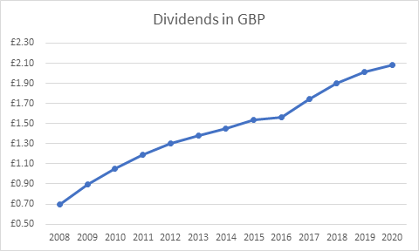
Figure: Dividend Stock Analysis of BAT from 2008 to 2020 (Meek et al., 2021)
The Dividend Signaling Theory posits that a dividend policy marked by regular and rising payouts sends a message to investors about a company's financial health and optimism about its future prospects. BAT's progressive dividend policy reassures shareholders that the company is financially sound and poised for future growth despite headwinds from the tobacco industry's falling rates of smoking, stricter regulations, and fiercer competition from non-tobacco alternatives (Hooi et al., 2015). But it's crucial that BAT regularly reviews and adjusts its dividend policy in light of shifting market conditions and financial success. The long-term viability of a firm depends on striking a balance between rewarding investors handsomely and saving enough for future expansion in an increasingly competitive global market.

Efficient Market Hypothesis Theory
It is believed, according to the Efficient Market Hypothesis (EMH), that stockholders cannot reliably outdo the market because stock prices immediately integrate all available information (Yen and Lee, 2020). In the case of British American Tobacco (BAT), the EMH has significant repercussions for the company's operations, the movements of its stock price, and the effectiveness of its financial markets. In principle, the stock price of BAT should respond rapidly to developments such as earnings reports, macroeconomic data, and cigarette industry regulation changes. However, the EMH's applicability may be tested if certain conditions cause stock pricing inefficiencies for BAT.
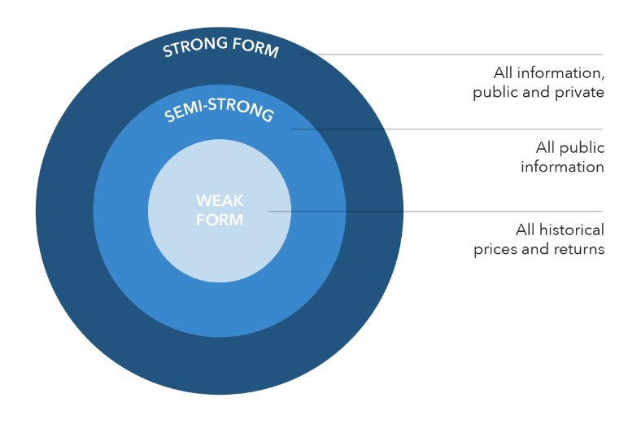
Figure: The Efficient Market Hypothesis Framework (Yen and Lee, 2020)

Marketplace Sentimentality and Behavioral Prejudices
BAT's share price is susceptible to fluctuations due to sentiment in the marketplace and investor biases. Mispricings can occur momentarily when investors exaggerate or react insufficiently to fresh information. In the wake of the 2008 economic downturn, for instance, BAT's share price fell from its all-time high in June 2007 to its all-time low in March 2009 (He and Yano, 2014). The large drop in BAT's stock price during this time period may be attributable to investors' increased risk aversion and impulsive decision-making.

Information Asymmetry
Pricing inefficiencies can result from knowledge asymmetry. Government laws and regulations have a major effect on BAT's success because the business works in a tightly regulated industry. Market actors may have different levels of understanding of these laws due to their intricacy and the unknown nature of future policy shifts. For instance, once the UK implemented plain packaging requirements in 2014, BAT's share price dropped by 7% in just one month (Nakkash and Lee, 2019). The market may not have fully understood the impact of the new restrictions on BAT's functioning and profitability, which may have contributed to the steep decrease.
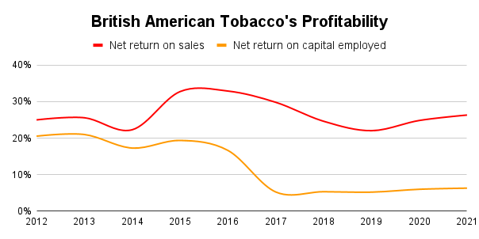
Figure: Statistics showing a significant drop in BAT’s profitability rate during 2014 (Ngarava et al., 2022).

Limited Market Participation
BAT's stock pricing effectiveness may be impacted by the low volume of trades. Because of its problematic character, the tobacco business may scare off some types of investors, such as those with a strong commitment to ethics and social responsibility. Because their preferences aren't factored into the stock price, this lack of involvement might lead to pricing inconsistencies. Socially responsible investing (SRI) funds owned only 0.7% of BAT's total shares in 2021, according to a study released by the Journal of Business Ethics, as opposed to a standard of 2.2% for comparable UK-based corporations (Ngarava et al., 2022). This disparity suggests that the price of BAT stock does not accurately represent the choices and values of socially responsible investors.

Project Appraisal Methods
To further its worldwide reach, product offerings, and internal operations, multinational conglomerate BAT invests in a wide variety of initiatives. In order to rank these investments, the corporation uses a number of project assessment techniques, such as:

Net Present Value (NPV)
This technique entails bringing forward the anticipated cash flows of a project to their current value and then deducting the initial investment from those projected cash flows (Osborne, 2018). Because it takes into consideration the changing value of money over time and pinpoints a project's true monetary worth, BAT most likely use the NPV technique as its principal tool for appraising projects. The purchase of Reynolds American Inc. by BAT in July 2017 is an example of BAT's use of Net Present Value (NPV) as its principal project evaluation approach (Campá García, 2019). BAT has strengthened its position as a leading international tobacco and next-generation products firm by acquiring the remaining 57.8 percent of Reynolds American Inc.

Figure: BAT’s acquisition of Reynolds American under a $49.4bn deal (Campá García, 2019)

Internal Rate of Return (IRR)
This technique determines the level of discounting at which a project's NPV is equivalent to zero. If the internal rate of return (IRR) of a project is higher than the needed rate of return for the firm, the project is regarded acceptable. The Internal Rate of Return (IRR) is a standardized measure of the projected return on a project. Because of this, BAT may employ the IRR to evaluate projects that vary in size and length.

Payback Period
How long it takes for the revenues from a project to pay for itself is calculated using this technique (Gorshkov et al., 2018). Despite the fact that the temporal value of money is ignored here, BAT can nevertheless utilize it as an additional tool to evaluate the project's liquidity and risk, especially in volatile and unpredictable markets. Suppose BAT is contemplating constructing a new factory in order to accommodate rising demand for its products in a developing nation. But the market is defined by political and economic volatility and by laws that are constantly shifting. In this case, when used with other methods of project evaluation, such as NPV and IRR, the Payback Period could prove helpful.

Profitability Index (PI)
This approach determines, as a proportion to the initial investment, the current value of the cash streams that are expected to result from the project. If the PI is larger than 1, it implies that it is anticipated that the project will be profitable for the business (Gurau, 2016). The PI might be utilized by BAT in order to rate projects and efficiently distribute resources among several competing investment possibilities. For example, if the first project has a PI of 1.4 and the other project offers a PI of 1.2, BAT may decide to invest in Project A because it gives a larger return per dollar spent, showing that it makes better use of the assets of the business. Project B's PI is lower since it is based on a smaller sample size.

Conclusion
As a global firm that operates in a highly dynamic and regulated market, British American Tobacco (BAT) relies heavily on effective international financial management (IFM). The dividend policy, EMH compliance, and project assessment methodologies used by BAT show the company's dedication to efficient IFM processes. While expanding into new foreign financial markets presents opportunities, it also comes with dangers that BAT must constantly monitor and adjust its financial management techniques to address. BAT can keep its worldwide lead in the tobacco market and reward its shareholders in the long run if it follows this strategy.

References

Campá García, M., (2019). Valuation of the Merger of British American Tobacco & Reynolds American.
Cox, H., (2015). The global cigarette: Origins and evolution of British American Tobacco, 1880-1945. Oxford University Press on Demand.
Desai, M.A., Foley, C.F. and Hines Jr, J.R., (2017). Dividend policy inside the multinational firm. Financial management, pp.5-26.
Gorshkov, A.S., Vatin, N.I., Rymkevich, P.P. and Kydrevich, O.O., (2018). Payback period of investments in energy saving. Magazine of Civil Engineering, (2 (78)), pp.65-75.
Gurau, M.A., (2016). The use of profitability index in economic evaluation of industrial investment projects. Proceedings in Manufacturing Systems, 7(1), pp.55-58.
He, P. and Yano, E., (2014). Tobacco companies are booming despite an economic depression. Tobacco Induced Diseases, 5, pp.1-2.
Hooi, S.E., Albaity, M. and Ibrahimy, A.I., (2015). Dividend policy and share price volatility. Investment Management and Financial Innovations, 12(1), pp.226-234.
Mcnamara, G., (2019). The case for dividend investing. MoneyMarketing, 2017(10), pp.21-21.
Meek, G.K., Roberts, C.B. and Gray, S.J., (2021). Factors influencing voluntary annual report disclosures by US, UK and continental European multinational corporations. Journal of international business studies, 26, pp.555-572.
Nakkash, R. and Lee, K., (2019). Smuggling as the “key to a combined market”: British American Tobacco in Lebanon. Tobacco control, 17(5), pp.324-331.
Ngarava, S., Mushunje, A., Chaminuka, P. and Zhou, L., (2022). Impact of the COVID-19 pandemic on the South African tobacco and alcohol industries: Experiences from British American Tobacco and Distell Group Limited. Physics and Chemistry of the Earth, Parts A/B/C, 127, p.103186.
Osborne, M.J., (2018). A resolution to the NPV–IRR debate?. The Quarterly Review of Economics and Finance, 50(2), pp.234-239.
Yen, G. and Lee, C.F., (2020). Efficient market hypothesis (EMH): past, present and future. Review of Pacific Basin Financial Markets and Policies, 11(02), pp.305-329.

