Job Advert

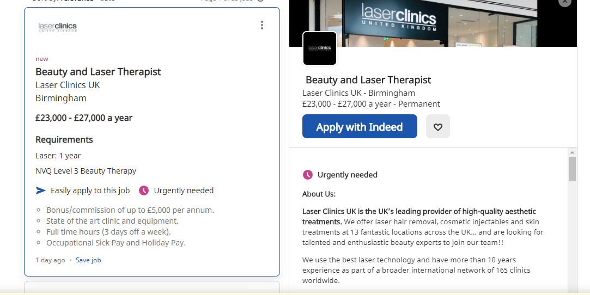

Cover letter

Laser clinic uk
Laser Clinics UK Unit 22,
Grand Central,
Birmingham
B2 4XJ

15th October 2020

Dear sir/madam,

I am writing to apply for the Beauty Therapist position currently advertised on indeed.com. Please find a copy of my CV attached.
I'm a certified beauty therapist with valuable previous experience with a wide variety of clients. I was responsible for welcoming clients into the therapy room in my previous position and maintaining their satisfaction and determining consumer needs.
With excellent communication skills, both written and verbal, I am a positive and hard-working person. I have a strong understanding of the needs and desires of consumers, and I am able to give recommendations on health & beauty.
In addition, I am a certified therapist at NVQ Level 3. I am a fast learner, so I can adapt to a fast-paced environment. I 'm great with customers and can provide outstanding customer service.
With my experience and knowledge, I sincerely believe that at laser clinic Uk, I will be an asset to your team. Many thanks to you for considering my application. I am looking forward to hearing about you,

Yours faithfully,

Eltaf Mockbil
eltafm@outlook.com

Eltaf Mockbil | Birmingham | eltafm@outlook.com | 07847270844

Experience
receptionist – MyCOSmetic group

10/2014 – 9/2016
- Serves visitors by greeting,
- welcoming, and directing them appropriately.
- Notifies company personnel of visitor arrival.
- Maintains security and telecommunications system.
- Informs visitors by answering or referring inquiries.
LASER TECHNICIAN – AL shafa CLinic
09/2016- present
- Assembly, dismantling, installation, calibration, examination, operation and repair of lasers
- Carry out alignment processes, clean optics, combine lasers with parts of opto-mechanics,
- Laser documentation and troubleshooting work.

WAITRESS - ISTANBUL RESTAURANT
06/2012 – 08/2014
- Taking orders
- Serving meals and drinks
- Checking in with consumers
- Payments collection
- Setting up seating areas

Education

- AAT LEVEL 2 in Accounting
- Level 4 NVQ beauty therapy
- LEVEL 2 in Finance Studies
- NVQ level 3 with Electrolysis
- GCSE Maths
- GCSE Science
- GCSE English
- GCSE R.E
- GCSE I.C.T

Skills

- Sales (3 years)
- Customer Service (2 years)
- Business Administration (2years)
- Waitressing (2 years)
- Receptionist (2 years)
- Scheduling (2 years)
- Filing (2 years)
- Billing (2 years)
- Data Entry (2 years)
- Laser skin renewal (4 years)
- Laser hair removal (4 years)
- Cellulite improvement (4 years)

REFERENCES – Available on request

