Marketing plan is written for

______________________________ Marriot Hotel__________________________

Student Name
Bijaya dip Karki
__________________________________________________

Student ID number
__________2207937_________

Marketing Essentials BMIH4005

Lecturer

_______________Luciana Suardi_________________

Marriot Hotel and resorts is an American-based multinational brand that offers full service at hotels and resorts. The hotel is providing services worldwide with more than 590 hotels and resorts in various parts of the world (Orfila-Sintes and Mattsson, 2009). The vision of the company demonstrates its company value,
"To enhance the lives of our customers by creating and enabling unsurpassed vacation and leisure experience (Marriott, 2022)”.
Due to COVID, The London Marriot Hotel which is one of the main hotels of Marriot Hotel Services located in County Hall, London was affected, and its sales were got down badly (Jiang and Wen, 2020). Now the company wants to enhance its sales by employing an innovative marketing plan. The marketing plan would be evaluated through SOSTAC Analysis, which would use different frameworks to identify the measures.

SOSTAC Analysis
SOSTAC Analysis is a marketing model designed by PR Smith which helps managers to analyze the perfect plan and provide a guide to making a perfect digital marketing plan (Reed, 2014). The important findings of this analysis are given:

Situational Analysis
It focuses on defining the current performance of the company. This can be explained through:

SWOT Analysis

Strengths | Weaknesses
- Global Presence  The company operates globally which helps it to increase its revenue (Haugen and Mach, 2010).  - Market Leadership  It is a market leader with the largest hotel chain operating more than 30 brands.  - Loyal Customers  The customers of Marriot are not observed to be switched to other brand services due to its quality service. | - Data Protection  In 2018, the company failed to protect the customer's database and personal information (Tzanou, 2013).  - Too strict  Although, strictness with the employees is the essence of success high strictness brings down productivity. In 2018, the company fired about 200 employees just like a tweet of a political party.
Opportunities | Threats
- Emerging Economics  It must focus on providing hospitality services as demand for hospitality is rapidly increasing.  - Shifting Demographics  Due to more millennials entering the consumer market, the concept of hospitality would be highly recommended. | - Stiff Competition  The company has been facing stiff competition from Hilton to Novotel and many more (Napierała and Birdir, 2020).  - Looming Recession  The pandemic has affected the economy of very developed countries. Operating buisess in such countries may create challenges for the company.  - Risk of Terror Attacks  In many countries, terror groups are targeting five-star hotels and foreigners.

Comparison Against Competitors
Marriot hotel must face intense competition in the hotel service industry. Although Marriot is a 5-star hotel still the competition is very stiff (Napierała and Birdir, 2020). The major competitors of Marriot in London are Hilton Worldwide, Jin Jiang International Co., IHG Hotels & Resorts, Wyndham Hotel & Resorts, and Accor Group. The comparison of Marriot with Hilton and Accor Hotels is given below:
 | Marriot Hotels and Resorts | Hilton Worldwide | Accor Group of Hotels
Properties | 7000 | 6800 | 5100
Expansion | 131 countries | 119 countries | 110 countries
Brands | 30+ | 18+ | 40+
World Rank | 79th | 84th | 6th
Current Market Cap | $44.20 Billions | $32.46 B | $6.74 B

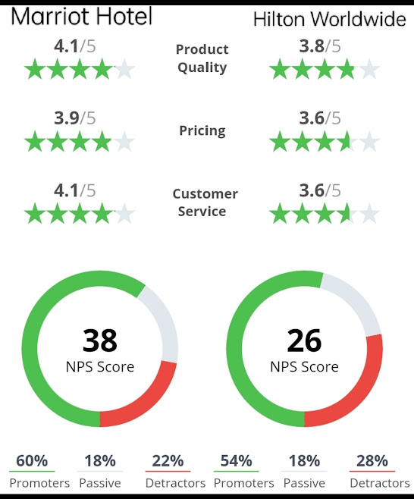
Figure 1: (COMPARABLY, 2022)

Segmentation, Targeting, and Positioning
- Segmentation
Marriot segments its customers through various measures such as income, marital status, and occupation rather than age and gender because Marriot hotels are designed based on these statuses. Moreover, according to geographic segmentation, it focuses on areas with high tourist rates. Psychographic segmentation tends to make segments based on the opinions and interests of the people (Morritt, 2014).
- Targeting
Marriot tends to target people of the upper class, honeymooners, corporate, families, and travelers. Moreover, it also targets millennials as they focus to enjoy luxury hotel services.
- Positioning
Marriot's positioning strategies are based on benefits and affordability. The company has positioned itself as a luxury service that offers low-cost features. So, people are associating the Marriot with luxury services.

Objectives
In the fresh marketing plan, the company must have to analyze the goals it wants to achieve and related strategies such as pricing, distribution, and promotion (Westwood, 2019).

SMART Goals

Specific | The company must need to increase the marketing spending by 40% for the next 5 months.
Measurable | The company must analyze an increase in spending by 40% would be compatible or not. It must focus on evaluating the spending on physical and online advertising space (Cothran and Wysocki, 2019).
Achievable | The company must examine that is the 40% increment target achievable. Moreover, it must analyze that are the micro targets (pricing, promotion, and distribution) are achievable.
Realistic | The company must analyze that does the company possess enough financial resources to increase spending to attract new customers (Cothran and Wysocki, 2019).
Timely | The company would have to analyze whether is the company able to bare the increment in marketing spending for 5 next 5 months.

Strategies

Pricing Strategies
Based on the marketing environment analysis (weaknesses and threats identified in SWOT analysis), the company must provide some advanced features such as full AC service in summer, high-quality meals, a play area for children, etc. (Kotler and Keller, 2016). It must focus on providing packages to foreigners and discounts to local tourists.

Distribution Strategies
The company must ensure its presence on online platforms 24/7 hours to assist the customers. The company can use digital marketing equipment such as social media, websites, blogs, TV ads, etc. for communicating its innovative policies (Kannan and Li, 2017).

Promotion
The company must focus to advertise its services through digital marketing such as social media, as it is the most widely used marketing tool worldwide with a full of audience.

Tactics

Customer Value
The company can offer excellent customer value by providing unsurpassed vacation and leisure experiences full of comfort and enjoyment (Smith and Colgate, 2007). It must go the extra mile through online websites, social media, TV media, and local Franchise to offer the vacation experience to the customers, this helps the company retain customers.

Marketing Mix

Products Strategy | Marriot offers services for hotels and resorts; it can evolve and upgradation its services. It can employ high-quality AC and well-furnished rooms with comfortable pieces of equipment. It must focus on providing refrigerators, internet service, money exchange, medical facilities, and laundry service to attract more customers (Goi, 2009).
Pricing Strategy | It must focus on adopting a premium pricing strategy as it offers superior quality services at value-based prices such as full AC service in summer, high-quality meals, a play area for children, Internet service, etc. It must be confident about its pricing policies because it offers immaculate services.
Placing Strategy | It must focus on locating its hotels in prime locations like highways, airports, and vital parts of the city.
Promotion Strategy | Marriot must launch high-impact ads and campaigns to enhance brand awareness. It must publish its high-quality features in the ads such as free merchandise, vacations, gifts, bonuses, and upgraded rooms (Goi, 2009).

Actions
Following are the key areas where the company must pay attention within the limited time (Ong, Wang and Zainon, 2016).

Gantt Chart
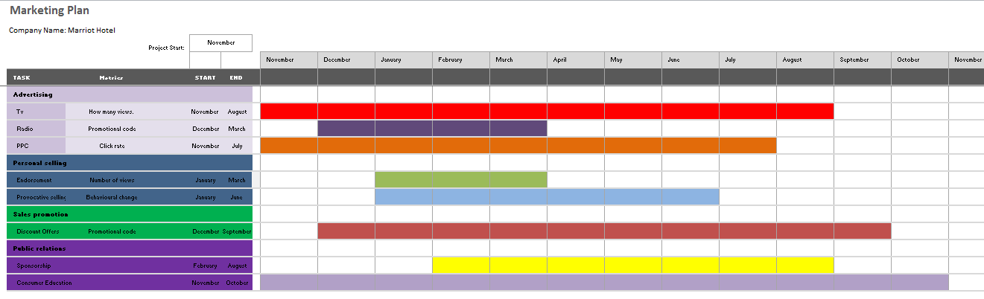

Control
To measure the performance of the above proposal, the company must need to be organized which would help it to analyze the marketing efforts effectively (Cogneau and Hubner, 2009). The company must put equal effort into all the marketing practices and evaluate if one is not working effectively then it should be managed with more focus.

USP, Features, and Benefits
The unique selling proposition of the company would be well-furnished rooms, decorative lodges, high-quality meals, and many more (Kippenberger, 2000). These USPs would propose excellent features as compared to competitors and would attract customers.

Measuring Success
The performance must be analyzed through highly valued staff and innovative technology. It must provide greetings and gifts to new customers to create a positive attitude toward the brand (Cogneau and Hubner, 2009).

Conclusion
To attract new customers after the recession, the company would focus on spending 40% more on marketing practices. Although then it would be difficult, the company must stay positive and work hard to implement and get the best out of the proposed plan (Napierała and Birdir, 2020).

Reference list
Cogneau, P. and Hubner, G. (2009). The 101 Ways to Measure Portfolio Performance. SSRN Electronic Journal. doi:10.2139/ssrn.1326076.
Cothran, H.M. and Wysocki, A.F. (2019). Developing SMART Goals for Your Organization. EDIS, 2005(14). doi:10.32473/edis-fe577-2005.
Goi, C.L. (2009). A Review of Marketing Mix: 4Ps or More? International Journal of Marketing Studies, [online] 1(1). doi:10.5539/ijms.v1n1p2.
Haugen, D.M. and Mach, R. (2010). Globalization. Detroit: Greenhaven Press.
Jiang, Y. and Wen, J. (2020). Effects of COVID-19 on hotel marketing and management: a perspective article. International Journal of Contemporary Hospitality Management, [online] 32(8), pp.2563–2573. doi:10.1108/ijchm-03-2020-0237.
Kannan, P.K. and Li, H.A. (2017). Digital marketing: a framework, Review and Research Agenda. International Journal of Research in Marketing, 34(1), pp.22–45. doi:10.1016/j.ijresmar.2016.11.006.
Kippenberger, T. (2000). Remember the USP? (Unique selling proposition). The Antidote, 5(6), pp.6–8. doi:10.1108/eum0000000006861.
Kotler, P. and Keller, K.L. (2016). A framework for marketing management. 6th ed. Boston: Pearson.
Marriott (2022). About Marriott International | Corporate Information. [online] Marriott.com. Available at: https://www.marriott.com/marriott/aboutmarriott.mi [Accessed 5 Dec. 2022].
Morritt, R.M. (2014). Segmentation strategies for hospitality managers : target marketing for competitive advantage. New York: Routledge.
Napierała, T. and Birdir, K. (2020). Competition in Hotel Industry: Theory, Evidence and Business Practice. European Journal of Tourism, Hospitality and Recreation, 10(3), pp.200–202. doi:10.2478/ejthr-2020-0017.
Ong, H.Y., Wang, C. and Zainon, N. (2016). Integrated Earned Value Gantt Chart (EV-Gantt) Tool for Project Portfolio Planning and Monitoring Optimization. Engineering Management Journal, 28(1), pp.39–53. doi:10.1080/10429247.2015.1135033.
Orfila-Sintes, F. and Mattsson, J. (2009). Innovation behavior in the hotel industry. Omega, [online] 37(2), pp.380–394. doi:10.1016/j.omega.2007.04.002.
Reed, D. (2014). SOSTAC: The guide to the perfect digital marketing plan. Journal of Direct, Data and Digital Marketing Practice, [online] 16(2), pp.146–147. doi:10.1057/dddmp.2014.79.
Smith, J.B. and Colgate, M. (2007). Customer Value Creation: A Practical Framework. Journal of Marketing Theory and Practice, 15(1), pp.7–23. doi:10.2753/mtp1069-6679150101.
Tzanou, M. (2013). Data protection as a fundamental right next to privacy? ‘Reconstructing’ a not so new right. International Data Privacy Law, 3(2), pp.88–99. doi:10.1093/idpl/ipt004.
Westwood, J. (2019). HOW TO WRITE A MARKETING PLAN : define your strategy, plan effectively and reach your ... marketing goals. Kogan Page Limited.
COMPARABLY, C. (2022). Hilton vs Marriott. [online] Comparably. Available at: https://www.comparably.com/competitors/hilton-vs-marriott [Accessed 12 Nov. 2022].



