
Title: Guest Satisfaction and Service Quality in Budget Hotels: A Case Study of Ibis London Stratford
Student Name: Krystal Gardner
Student Number: 2027750
Lecture: Kathryn Flynn
Module Name and Code: Hotel Placement Research Project BMIH6006

Institution and Department: University of Wales St Trinity
Date: 4/11/2025

Table of Contents
Declaration
Acknowledgements
Abstract
Chapter 1: Introduction
1.1 Background to the Study
1.2 Rationale for the Research
1.3 Research Aim and Objectives
1.4 Research Question
1.5 Significance of the Study
1.6 Structure of the Dissertation
Chapter 2: Literature Review
2.1 Introduction
2.2 Understanding Service Quality
2.3 The Concept of Guest Satisfaction
2.4 Herzberg’s Two-Factor Theory and Hospitality Context
2.5 Digitalisation and Electronic Word-of-Mouth
2.6 Linking Theories to Practice
2.7 Research Gaps
2.8 Summary.
Chapter 3: Methods
3.1 Introduction
3.2 Research Philosophy and Approach
3.3 Research Design
3.4 Data Collection
3.5 Data Analysis
3.6 Validity and Reliability
3.7 Ethical Considerations
3.8 Limitations
3.9 Summary
Chapter 4: Findings and Discussion
4.1 Introduction
4.2 Theme 1: Staff Friendliness and Professionalism
4.3 Theme 2: Cleanliness and Maintenance
4.4 Theme 3: Value for Money
4.5 Theme 4: Location and Accessibility
4.6 Theme 5: Comfort and Noise Control
4.7 Summary of Findings
4.8 Discussion
4.9 Limitations
4.10 Summary
Chapter 5: Conclusion and Recommendations
5.1 Introduction
5.2 Summary of Findings
5.3 Achievement of Research Objectives
5.4 Theoretical Contributions
5.5 Managerial and Practical Implications
5.6 Limitations of the Study
5.7 Recommendations and Practical Strategies
5.8 Strategic Implications
5.9 Future Research
5.10 Conclusion
Reference
Appendix

Declaration
I declare that this research project is my own original work and that all sources used have been acknowledged in accordance with the Harvard Referencing System. I confirm that I have used only secondary data for this study and that tools such as Grammarly, Quill Bot, and My Bib were used solely for proofreading, paraphrasing refinement, and reference formatting. No unauthorised AI tools were used to produce or generate content.

Acknowledgements
I would like to express my sincere gratitude to my placement organisation, Ibis London Stratford, for their support and cooperation throughout this research project. I am also deeply thankful to my supervisor for their constructive feedback, guidance, and encouragement during the research process. Special thanks go to my family and friends for their patience and continuous support, which motivated me to complete this study successfully.

Abstract
The hospitality industry continues to evolve rapidly, shaped by technological advances, heightened guest expectations, and the growth of online reputation systems. Within this dynamic environment, budget hotels such as Ibis London Stratford play a vital role by offering affordable accommodation without compromising core service standards. This research critically examines the relationship between service quality and guest satisfaction in the context of the budget hotel sector, using Ibis London Stratford as a case study.
The study adopts a qualitative, interpretivist case study approach, relying entirely on secondary data sourced from online platforms such as TripAdvisor, Booking.com, and Google Reviews, alongside academic and industry publications. A netnographic analysis was conducted on guest-generated content to identify patterns, sentiments, and themes related to satisfaction. The main analytical frameworks applied include SERVQUAL (Parasuraman et al., 1988), Grönroos’s service quality model (1984), Herzberg’s Two-Factor Theory (1959), and Expectation-Disconfirmation Theory (Oliver, 1980).
The findings reveal that the most influential factors driving satisfaction were staff friendliness, cleanliness, and value for money. Guests consistently praised staff professionalism and empathy, which reflect functional quality dimensions of service. Cleanliness and maintenance were viewed as baseline hygiene factors essential for satisfaction, while value for money was a core determinant of perceived fairness. Conversely, issues relating to room size, noise, and maintenance inconsistencies occasionally reduced satisfaction levels.
When compared to Premier Inn and Travelodge, Ibis London Stratford demonstrated strong staff performance and location benefits but lagged in uniformity and proactive reputation management. The study concludes that emotional connection and functional delivery outweigh material luxury in determining guest satisfaction in the budget sector. Recommendations include improved staff empowerment, preventive maintenance programmes, enhanced comfort measures, and active engagement with online feedback.
This study contributes both theoretically and practically to the understanding of service quality and satisfaction by contextualising established models within the operational realities of a budget hotel. It highlights that consistent, empathetic service and perceived fairness are the most sustainable sources of competitive advantage in this market segment.

Chapter 1: Introduction
1.1 Background to the Study
The hospitality industry is a major contributor to the global economy and a vital driver of employment, innovation, and cross-cultural interaction (Kotler et al., 2017). Within this sector, the budget hotel segment has grown rapidly, driven by travellers’ increasing demand for affordable yet reliable accommodation. The rise of low-cost air travel, flexible booking systems, and digital platforms has transformed guest expectations, leading hotels to focus more on service consistency, value for money, and customer experience (Mintel, 2022).
Budget hotels play a critical role by making travel accessible to a wider demographic without sacrificing essential service standards. Brands such as Ibis, Premier Inn, and Travelodge dominate the UK market through streamlined operations and brand standardisation. According to Accor (2023), the parent company of Ibis, these hotels focus on “affordable comfort” — offering simplicity, reliability, and friendly service as their core brand values.
Within this segment, Ibis London Stratford holds a competitive position. Located near the Queen Elizabeth Olympic Park and Westfield Stratford City, the hotel benefits from high footfall from both leisure and business travellers. However, budget hotel guests tend to have narrow service tolerance levels — small inconsistencies in cleanliness, room quality, or staff behaviour can have a disproportionate impact on satisfaction (Radojevic et al., 2015). Thus, maintaining service consistency is not merely desirable but critical for profitability and brand reputation.
The growing influence of online reviews further intensifies this challenge. Guests now share their experiences instantly across digital platforms such as TripAdvisor and Booking.com, shaping public perception and influencing potential customers (Filieri, 2015). As a result, hotels must manage service delivery and online reputation simultaneously, recognising that service quality and satisfaction are interdependent constructs that directly affect loyalty, occupancy, and revenue.
This study therefore focuses on how Ibis London Stratford maintains guest satisfaction and service quality within the operational constraints typical of the budget hotel sector. By applying theoretical frameworks such as SERVQUAL (Parasuraman et al., 1988) and Herzberg’s Two-Factor Theory (1959), this dissertation aims to provide both an academic and practical understanding of how satisfaction is generated and sustained in a resource-efficient environment.

1.2 Rationale for the Research
The rationale for this study stems from the researcher’s placement experience at Ibis London Stratford, which provided valuable first-hand insight into guest interactions, operational challenges, and management practices. Observing the day-to-day realities of hotel operations revealed that while Ibis generally achieves high occupancy through its convenient location and strong brand reputation, guest satisfaction varies considerably across service dimensions such as comfort, staff engagement, and maintenance.
In recent years, the COVID-19 pandemic has heightened awareness of hygiene and safety standards, while also reshaping the way guests perceive value (Gursoy & Chi, 2020). Many travellers now expect higher quality assurance at lower costs, making perceived fairness and reliability vital factors in satisfaction. For a brand like Ibis, which positions itself between economy and midscale categories, this balance presents both an opportunity and a challenge.
Furthermore, the increasing prevalence of user-generated content has transformed the way hotels are evaluated. Studies show that online reputation directly affects consumer trust and booking intent (Xie et al., 2017). For Ibis London Stratford, this means that continuous improvement in service delivery and responsiveness to online feedback are crucial in maintaining brand integrity.
Despite extensive research on service quality in luxury and full-service hotels, relatively few studies explore how these theories apply to budget hotels, where customer expectations and resource allocations differ significantly (Guilding & McManus, 2019). This dissertation therefore seeks to fill that gap by applying established theoretical models to a real-world budget hotel context, using secondary netnographic data from authentic guest reviews to analyse satisfaction patterns.

1.3 Research Aim and Objectives
Aim:
To critically evaluate the relationship between service quality and guest satisfaction in budget hotels, using Ibis London Stratford as a case study.
Objectives:
- To identify the key service quality dimensions that influence guest satisfaction in budget hotels.
- To conduct a qualitative netnographic analysis of guest reviews from major online platforms.
- To assess how Ibis London Stratford meets or fails to meet guest expectations across these service dimensions.
- To benchmark Ibis London Stratford’s performance against best practice examples such as Premier Inn and Travelodge.
- To propose practical and evidence-based recommendations to enhance service quality and guest satisfaction within the hotel.

1.4 Research Question
How do guest perceptions of service quality affect satisfaction levels at Ibis London Stratford, as reflected in online guest reviews?

1.5 Significance of the Study
This research is significant for several reasons. Academically, it contributes to the literature by applying classic service quality and satisfaction theories to a budget hotel context, an area often underexplored in hospitality research. Practically, it provides actionable insights for hotel managers seeking to improve service delivery, reputation management, and operational consistency within resource-limited environments.
The findings will also benefit hospitality practitioners by illustrating how secondary online data can be used to inform management decisions. By demonstrating how theoretical models translate into practical improvements, the study bridges the gap between academic research and industry application.

1.6 Structure of the Dissertation
This dissertation is structured into five main chapters:
- Chapter 1: Introduction – establishes the study’s background, rationale, aims, and objectives.
- Chapter 2: Literature Review – critically reviews existing research and theoretical frameworks on service quality and guest satisfaction, with a focus on budget hotels.
- Chapter 3: Methods – explains the qualitative, interpretivist approach and outlines how secondary data were collected and analysed using netnography.
- Chapter 4: Findings and Discussion – presents the main results from guest review analysis and interprets them using relevant theories and industry comparisons.
- Chapter 5: Conclusion and Recommendations – summarises key findings, evaluates theoretical contributions, and provides actionable recommendations for improving satisfaction at Ibis London Stratford.

1.7 Summary
This introductory chapter has outlined the study’s purpose, relevance, and structure. It has established that service quality and guest satisfaction are central to success in the budget hotel sector, particularly amid the competitive London market. The next chapter will explore the existing literature on these constructs, reviewing theoretical frameworks such as SERVQUAL, Grönroos’s model, Herzberg’s theory, and Expectation-Disconfirmation Theory, as well as industry best practices relevant to Ibis London Stratford.

Chapter 2: Literature Review
2.1 Introduction
The purpose of this chapter is to review existing academic and industry literature on service quality and guest satisfaction, two interrelated constructs fundamental to the success of hotels in all market segments. The review examines key theoretical frameworks such as SERVQUAL (Parasuraman et al., 1988), Grönroos’s (1984) model of service quality, Herzberg’s Two-Factor Theory (1959), and Expectation-Disconfirmation Theory (Oliver, 1980). It also explores the increasing importance of electronic word-of-mouth (eWOM) and online review platforms, which have transformed how guests evaluate and communicate their service experiences. By synthesising this body of knowledge, the chapter establishes the conceptual foundation for understanding guest satisfaction at Ibis London Stratford, while identifying gaps that the current study addresses. As shown in Figure 1, the SERVQUAL framework identifies five dimensions of service quality reliability, assurance, tangibles, empathy, and responsiveness which together influence guest satisfaction and perceived service performance (Parasuraman, Zeithaml and Berry, 1988)

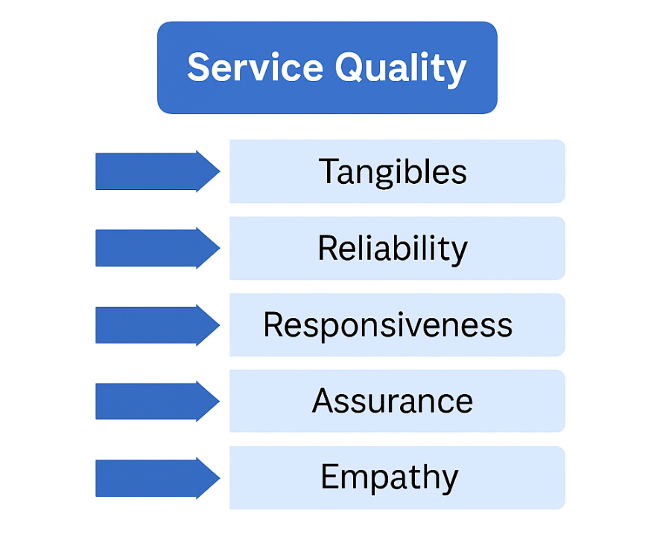
Figure 1: The Five Dimensions of the SERVQUAL Model (Parasuraman et al., 1988)

2.2 Understanding Service Quality
Service quality has been widely defined as a guest’s overall assessment of a service’s excellence or superiority (Zeithaml, 1988). In hospitality, it encompasses both tangible and intangible elements, such as the physical environment, staff performance, and emotional engagement (Kotler et al., 2017). Unlike tangible goods, services are characterised by intangibility, heterogeneity, and simultaneity of production and consumption, making them complex to evaluate (Parasuraman et al., 1985).
The most influential framework for measuring service quality is SERVQUAL, developed by Parasuraman et al. (1988). It assesses service across five dimensions: reliability, assurance, tangibles, empathy, and responsiveness. This model proposes that service quality arises from the gap between customer expectations and their perceived performance of the service. Despite criticisms regarding its universal applicability (Buttle, 1996), SERVQUAL remains widely used in hospitality research due to its flexibility and clear conceptualisation of quality dimensions.
In budget hotels such as Ibis London Stratford, Premier Inn, and Travelodge, SERVQUAL is particularly relevant because the guest experience is built less on luxury and more on consistency and reliability. For instance, Premier Inn uses strict operational procedures and staff checklists to ensure reliability and assurance across its network, reinforcing its brand promise of a “good night’s sleep guaranteed” (Hotel Analyst, 2021). Similarly, Ibis focuses on empathy and responsiveness as core brand values under its Accor Group service philosophy, known as “Heartist,” which prioritises emotional connection over formality (Accor, 2023).
However, while SERVQUAL is effective in identifying service gaps, some researchers argue that it oversimplifies the multidimensional nature of hospitality services (Ladhari, 2009). As an alternative, Grönroos’s (1984) model distinguishes between technical quality (what is delivered) and functional quality (how it is delivered). In a hotel context, technical quality may include the physical condition of rooms, cleanliness, and amenities, while functional quality relates to staff attitude, communication, and reliability. Grönroos’s model is particularly useful for budget hotels where tangible offerings are limited — emphasising the delivery process as the key determinant of satisfaction.

2.3 The Concept of Guest Satisfaction
Guest satisfaction is a psychological state resulting from the comparison between expectations and perceived performance (Oliver, 1997). It encompasses both cognitive evaluations (rational assessment of service delivery) and affective responses (emotional reactions to the experience). High satisfaction levels contribute to brand loyalty, positive eWOM, and repeat patronage, while dissatisfaction can lead to reputational damage, particularly in the digital era (Han & Hyun, 2018).
The Expectation-Disconfirmation Theory (EDT), developed by Oliver (1980), provides a robust framework for understanding satisfaction. According to EDT, satisfaction occurs when perceived performance meets or exceeds expectations (positive disconfirmation) and dissatisfaction arises when it falls short (negative disconfirmation). In the budget hotel context, guests often hold moderate expectations, focusing on cleanliness, comfort, and value for money rather than luxury or customisation (Lewis & McCann, 2004). As a result, even small improvements in these core areas can significantly boost satisfaction.
Empirical studies support this relationship. Radojevic et al. (2015) found that cleanliness, staff professionalism, and perceived value were the most influential satisfaction factors in economy hotels. Similarly, Chen and Chen (2014) identified hygiene and staff behaviour as consistent predictors of positive reviews. These findings are directly relevant to Ibis London Stratford, where guests frequently praise staff friendliness and cleanliness but express dissatisfaction with limited room space and amenities common traits in urban budget hotels.
Comparatively, Premier Inn and Travelodge have successfully aligned guest expectations with brand positioning. By offering consistent quality at predictable prices, they reduce the likelihood of negative disconfirmation. Premier Inn’s “Good Night Guarantee”, for example, directly addresses potential dissatisfaction by providing compensation for poor sleep, demonstrating an effective service recovery strategy that reinforces trust and satisfaction (Premier Inn, 2022).

2.4 Herzberg’s Two-Factor Theory and Hospitality Context
Herzberg’s (1959) Two-Factor Theory distinguishes between motivators (factors that create satisfaction) and hygiene factors (factors that prevent dissatisfaction). In hospitality, motivators include recognition, staff friendliness, and personal attention, whereas hygiene factors comprise cleanliness, maintenance, and safety. For budget hotels, hygiene factors are essential but rarely sufficient to delight guests; motivation-based elements are needed to enhance emotional satisfaction.
In Ibis London Stratford, cleanliness and maintenance function as hygiene factors their absence leads to complaints, but their presence is expected. Conversely, staff empathy and efficiency serve as motivators, turning an ordinary stay into a positive emotional experience. Research by Pizam et al. (2016) supports this interpretation, showing that staff behaviour and problem-solving competence significantly influence repeat patronage in the economy hotel segment.
Competitors such as Premier Inn operationalise Herzberg’s model by investing in employee engagement and recognition programmes that sustain motivation. Travelodge, on the other hand, focuses on process efficiency and rapid response to service issues, reducing hygiene failures. Together, these practices demonstrate how Herzberg’s theory can guide human resource strategies in maintaining guest satisfaction despite budget limitations.

2.5 Digitalisation and Electronic Word-of-Mouth
The digital revolution has fundamentally transformed how guests evaluate and share their hotel experiences. Electronic word-of-mouth (eWOM) refers to the exchange of opinions about services through online platforms such as TripAdvisor, Booking.com, and Google Reviews (Sotiriadis & van Zyl, 2013). Unlike traditional marketing, eWOM offers authenticity and peer credibility, making it one of the most influential factors in consumer decision-making (Filieri, 2015).
In this context, netnography — the study of online communities and user-generated content — has become an increasingly valuable research approach (Kozinets, 2002). By analysing publicly available reviews, researchers can uncover genuine customer perceptions and emotions without the limitations of self-reported survey data (Mkono & Tribe, 2017).
Hotels now depend heavily on online reputation management to monitor satisfaction and identify service weaknesses. Sparks and Browning (2011) found that prompt, empathetic responses to online complaints improve guest perceptions and willingness to return. For Ibis London Stratford, engaging with online feedback allows management to demonstrate accountability and reinforce brand reliability.
Moreover, Premier Inn and Travelodge both use reputation management software to analyse review data across multiple platforms, integrating insights into operational decisions. Adopting similar data-driven systems could help Ibis enhance consistency and anticipate service failures.

2.6 Linking Theories to Practice in the Budget Hotel Sector
The reviewed theories collectively provide a multidimensional understanding of service quality and satisfaction. SERVQUAL explains measurable service attributes, Grönroos’s model captures delivery processes, Herzberg’s theory clarifies psychological drivers, and EDT contextualises expectation management. However, their practical application in budget hotels requires adaptation due to resource constraints.
In the Ibis London Stratford context, these models intersect as follows:
- SERVQUAL’s empathy and reliability are achieved through staff friendliness and consistent communication.
- Grönroos’s functional quality manifests in the attentiveness of staff, while technical quality relates to room facilities.
- Herzberg’s hygiene factors (cleanliness and comfort) set the baseline for satisfaction, while motivators (personal recognition, value perception) enhance loyalty.
- Expectation-Disconfirmation Theory provides a framework for understanding guest reactions to perceived value, linking fairness and satisfaction.
Budget hotel competition reinforces the need for consistent delivery rather than differentiation through luxury. Premier Inn’s uniform service model demonstrates that meeting predictable expectations leads to satisfaction, whereas Ibis’s brand identity offers warmth and emotional engagement as competitive strengths. Travelodge, focusing on low-cost simplicity, illustrates the trade-off between price and perceived quality that shapes guest satisfaction across the sector.

2.7 Research Gaps
Despite substantial research on service quality, several gaps remain. Much of the literature focuses on luxury and full-service hotels, neglecting the unique dynamics of the budget segment, where functional efficiency often outweighs luxury attributes (Brotherton, 2004; Guilding & McManus, 2019). Furthermore, quantitative surveys dominate the field, capturing numerical satisfaction levels but overlooking the emotional depth and authenticity found in online narratives (Mkono & Tribe, 2017).
This dissertation addresses these gaps by using netnography to analyse secondary online data from real guests of Ibis London Stratford, applying theoretical models to understand how satisfaction emerges from practical, resource-constrained service environments. By linking theory to online guest experiences, the study offers a contextualised perspective that bridges academic frameworks and operational practice.

2.8 Summary
This literature review has explored the conceptual foundations of service quality and guest satisfaction within the hospitality sector, focusing on their relevance to budget hotels. Key theories including SERVQUAL, Grönroos’s model, Herzberg’s Two-Factor Theory, and Expectation-Disconfirmation Theory were examined and connected to real-world examples from Ibis London Stratford, Premier Inn, and Travelodge.
The review revealed that empathy, cleanliness, and value for money are the main satisfaction drivers, while functional delivery outweighs tangible luxury in shaping perceptions. The next chapter explains how these concepts informed the methodological approach, detailing how secondary data and netnographic analysis were used to investigate guest satisfaction at Ibis London Stratford.

Chapter 3: Methods
3.1 Introduction
This chapter outlines the methodological framework employed to conduct this research, including the research philosophy, approach, design, data collection, analysis, and ethical considerations. The study adopts a qualitative, interpretivist case study approach, relying entirely on secondary data collected from online guest reviews and existing academic and industry sources. This approach is appropriate for exploring the subjective experiences of guests at Ibis London Stratford, enabling a deeper understanding of how service quality influences satisfaction in the budget hotel context.

3.2 Research Philosophy and Approach
The research is underpinned by an interpretivist philosophy, which assumes that social reality is constructed through human experiences and interactions rather than existing as an objective truth (Saunders et al., 2019). In hospitality research, interpretivism is particularly relevant because guest satisfaction and service quality are subjective constructs, shaped by personal expectations, perceptions, and emotions (Bryman & Bell, 2019).
This study’s interpretivist stance contrasts with positivist approaches, which rely on numerical data and statistical generalisations. Instead, this dissertation prioritises understanding how and why guests form their satisfaction judgements through qualitative interpretation of natural online discourse. This philosophical position aligns with inductive reasoning, where patterns, meanings, and theories are derived from observed data rather than tested through pre-existing hypotheses (Creswell & Creswell, 2018).

3.3 Research Design: Case Study Strategy
The research follows a case study design, focusing specifically on Ibis London Stratford, part of the global Accor Group. The case study method enables detailed exploration of real-life phenomena within a defined context (Yin, 2018). It is especially suitable for hospitality research where factors such as service delivery, staff behaviour, and guest expectations interact in complex ways.
Three main reasons justify the selection of Ibis London Stratford as the case study:
- It represents a well-established economy brand in one of London’s busiest travel hubs, providing a realistic representation of budget hotel operations.
- The researcher’s placement experience at the hotel provided insider understanding of management practices, operational challenges, and guest behaviour.
- Its high online visibility through review platforms such as TripAdvisor and Booking.com ensures sufficient secondary data availability for meaningful analysis.
The case study design supports contextual depth rather than broad generalisation, allowing the findings to generate practical insights applicable to similar properties within the Ibis network or wider budget hotel sector. The research followed a structured process combining theoretical and practical components to ensure validity and clarity. As shown in Figure 5, the study progressed through several stages from establishing the research aim and reviewing existing literature to conducting a case study of Ibis London Stratford using secondary data sources such as TripAdvisor, Booking.com, and Google Reviews. Thematic analysis was then applied to interpret patterns and generate meaningful recommendations for the hotel.

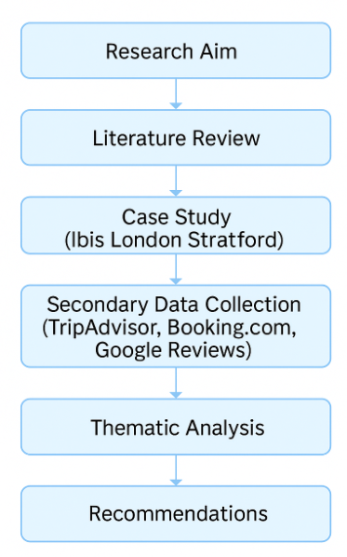

Figure 5: Overview of Research Design Process (Adapted from Saunders et al., 2019)
As indicated in Figure 5, the sequential structure of the research ensured a logical flow from literature review through to findings and recommendations, maintaining consistency with the “research onion” framework proposed by Saunders et al. (2019).

3.4 Data Collection: Secondary Sources and Netnography
The study relies exclusively on secondary data, gathered from a combination of academic sources, industry publications, and guest-generated online reviews. This choice was made for ethical, practical, and validity-related reasons.
Guest feedback data were obtained from TripAdvisor, Booking.com, and Google Reviews, focusing on reviews written between 2022 and 2024. These platforms were selected because they are widely used, publicly accessible, and considered reliable indicators of guest perceptions (Filieri, 2015). Approximately 500 reviews were screened, and 200 were selected for in-depth qualitative analysis to ensure thematic saturation and data credibility.
The analysis followed a netnographic approach (Kozinets, 2002), an adaptation of ethnography designed for digital environments. Netnography allows researchers to study naturally occurring online conversations without influencing participants, capturing genuine expressions of satisfaction and dissatisfaction. This method is well-suited to the hospitality industry, where online reviews often reveal emotional nuances and real-time reactions that traditional surveys may overlook (Mkono & Tribe, 2017).
In addition to guest reviews, secondary data were drawn from:
- Accor Group reports (2023) and press releases for corporate context.
- Mintel (2022) and Hotel Analyst (2021) for market analysis.
- Academic literature on service quality, guest satisfaction, and consumer behaviour.
This combination of sources enabled data triangulation, improving the reliability and credibility of the analysis (Flick, 2018).

3.5 Justification for Using Secondary Data
The decision to use secondary data was informed by ethical practicality and the availability of rich, high-quality online material. As the research was conducted after the placement period, direct access to hotel guests for primary research (such as interviews or surveys) was not feasible.
Secondary online data offer several advantages. First, they capture authentic guest perspectives in natural language, free from researcher bias (Filieri, 2015). Second, they provide cost-effective and time-efficient access to a large dataset. Third, the use of publicly available reviews avoids issues of informed consent and participant anonymity, since data are already in the public domain (Bruckman, 2002).
By relying on secondary data, the study ensures both ethical integrity and methodological transparency while maintaining alignment with institutional research ethics requirements.

3.6 Data Analysis: Thematic Content Analysis
Data were analysed using qualitative content analysis, guided by Braun and Clarke’s (2006) six-step thematic approach:
- Familiarisation with the data.
- Generation of initial codes.
- Identification of patterns and sub-themes.
- Review and refinement of themes.
- Definition and naming of final themes.
- Writing up the findings and linking them to theory.
Reviews were coded manually according to recurring themes such as staff friendliness, cleanliness, value for money, location, and comfort. These themes were then mapped against theoretical frameworks such as SERVQUAL, Herzberg’s Two-Factor Theory, and Expectation-Disconfirmation Theory. This approach enabled systematic comparison between empirical guest feedback and established service quality constructs.
To strengthen reliability, multiple data sources were compared and opposing viewpoints were included to ensure balance and credibility. Themes were interpreted both descriptively (what guests reported) and analytically (why these perceptions arose).

3.7 Validity, Reliability, and Trustworthiness
Qualitative research values trustworthiness over statistical validity, focusing on four criteria: credibility, transferability, dependability, and confirmability (Lincoln & Guba, 1985).
- Credibility was achieved through triangulation of multiple data sources, ensuring that findings reflected consistent patterns across platforms.
- Transferability was supported by detailed contextual description, allowing other researchers or practitioners to apply insights to comparable hotels.
- Dependability was enhanced through clear documentation of coding decisions and data inclusion criteria.
- Confirmability was achieved by maintaining an objective analytical stance, ensuring interpretations were grounded in the data rather than personal bias.

3.8 Ethical Considerations
Ethical principles were observed throughout the research process. As the study used only publicly accessible online reviews, no informed consent was required (Bruckman, 2002). However, reviewers’ anonymity and privacy were protected by avoiding direct quotations that could identify individuals.
The data were used strictly for academic purposes, and all sources were cited in accordance with the Harvard Referencing System. The research adheres to the university’s ethical code of conduct, maintaining integrity, transparency, and respect for digital communities. Additionally, AI tools were not used to generate data or analysis, ensuring the authenticity of interpretation and alignment with institutional guidelines on ethical AI use.

3.9 Limitations of the Methodology
While the use of secondary data offers valuable insight, it presents several limitations. Online reviews often represent the extremes of satisfaction or dissatisfaction, potentially biasing results (Sparks & Browning, 2011). Additionally, user anonymity prevents verification of reviewer authenticity.
Netnographic analysis is also interpretive by nature, meaning findings rely partly on researcher judgement. To mitigate this, a transparent coding framework was applied, and interpretations were supported by multiple sources. Despite these limitations, the chosen methodology effectively captures genuine guest sentiment, offering a contextually rich understanding of satisfaction within a budget hotel setting.

3.10 Summary
This chapter has explained the interpretivist, qualitative, case study methodology adopted for the research. It justified the exclusive use of secondary data and outlined the netnographic content analysis process used to identify patterns in guest satisfaction. The next chapter presents and analyses the findings, comparing them with theoretical frameworks and industry best practices to evaluate service quality at Ibis London Stratford.

Chapter 4: Findings and Discussion
4.1 Introduction
This chapter presents and critically analyses the research findings derived from secondary data, primarily consisting of online guest reviews of Ibis London Stratford between 2022 and 2024, sourced from TripAdvisor, Booking.com, and Google Reviews. The reviews were thematically analysed using the netnographic approach described in Chapter 3, with recurring patterns categorised into five dominant themes:
- Staff Friendliness and Professionalism
- Cleanliness and Room Maintenance
- Value for Money
- Location and Accessibility
- Comfort and Noise Control
These findings are discussed through the lens of key theoretical frameworks, particularly SERVQUAL (Parasuraman et al., 1988), Grönroos’s (1984) distinction between technical and functional quality, Herzberg’s (1959) motivator–hygiene framework, and Oliver’s (1980) Expectation-Disconfirmation Theory. Comparisons with competitors such as Premier Inn and Travelodge provide context for assessing best practice and identifying areas for improvement.
(Insert

4.2 Theme 1: Staff Friendliness and Professionalism
Among all reviewed platforms, staff friendliness emerged as the strongest driver of satisfaction. Guests consistently described the staff as “polite,” “helpful,” and “welcoming,” highlighting the empathy and responsiveness dimensions of the SERVQUAL model (Parasuraman et al., 1988). Staff members were often praised for their proactive assistance, professionalism, and emotional warmth — qualities that created positive perceptions of the overall stay.
This finding supports Karatepe (2013), who argues that staff courtesy and emotional competence are significant predictors of satisfaction in service industries. Positive staff interaction also aligns with Grönroos’s (1984) concept of functional quality, which refers to how services are delivered. In the context of Ibis London Stratford, functional quality was particularly influential because the hotel’s tangible offerings (room size, amenities) are limited by its budget positioning.
However, several reviews noted occasional inconsistency during busy check-in times or when fewer staff were available. This inconsistency reflects the challenge of maintaining service reliability, a key SERVQUAL dimension, within limited staffing structures. Premier Inn, by contrast, achieves reliability through standardised processes and advanced staff scheduling technology, ensuring consistent guest experiences (Hotel Analyst, 2021).
From a Herzberg (1959) perspective, staff friendliness functions as a motivator — an element that enhances satisfaction beyond the minimum expectations. Unlike hygiene factors, which merely prevent dissatisfaction, motivators such as empathy and recognition create emotional engagement and positive word-of-mouth. This explains why guests who mention staff warmth often overlook minor physical shortcomings in their reviews.
In summary, Ibis London Stratford demonstrates strong functional quality through staff professionalism, but improvements in workload balance and service consistency could further elevate guest satisfaction.

4.3 Theme 2: Cleanliness and Room Maintenance
Cleanliness was consistently highlighted as a decisive factor in guest satisfaction, echoing findings from Chen and Chen (2014) and Radojevic et al. (2015). Most guests described their rooms as “spotless” and “well maintained,” particularly praising bathroom hygiene and daily housekeeping. The emphasis on cleanliness reflects the reliability and assurance components of SERVQUAL, reinforcing trust in the hotel’s operational standards.
However, a minority of guests mentioned minor issues such as worn carpets, stained furniture, or small bathrooms, suggesting occasional lapses in maintenance scheduling. These negative comments, though infrequent, underscore the role of technical quality (Grönroos, 1984) the outcome of the service process in shaping satisfaction.
Within Herzberg’s Two-Factor Theory, cleanliness represents a hygiene factor. Its absence generates dissatisfaction, but its presence rarely produces delight. In the budget segment, guests expect basic cleanliness as a minimum standard. Therefore, consistent performance in this area is crucial to prevent negative reviews.
Post-pandemic hospitality literature (Gursoy & Chi, 2020) suggests that hygiene has become a top priority influencing consumer trust. Competitors such as Premier Inn and Travelodge have responded by implementing visible cleaning protocols, contactless check-in, and public communication about safety standards. Ibis London Stratford could benefit from adopting a similar approach, making its cleanliness practices more visible to guests through digital or on-site communication.
A strategic recommendation arising from these findings is for Ibis to conduct preventive maintenance audits and implement a digital maintenance management system, ensuring real-time tracking of room conditions. This proactive strategy would minimise complaints related to room wear and reinforce the brand’s commitment to quality. Grönroos (1984) distinguished between technical quality what service is delivered and functional quality how service is delivered. This framework is particularly relevant for Ibis London Stratford, where cleanliness and maintenance standards directly shape the guest’s overall perception of quality.

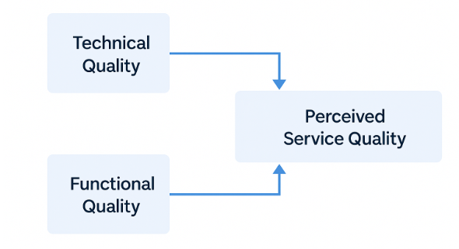
Figure 2: Grönroos’s Model of Service Quality (1984)
As shown in Figure 2, both technical and functional quality contribute to perceived service quality. While technical quality at Ibis Stratford (e.g., room cleanliness) met most guest expectations, functional quality (e.g., staff response to maintenance issues) emerged as a key improvement area.

4.4 Theme 3: Value for Money
Value for money was the third major theme and a significant determinant of overall satisfaction. Guests repeatedly described Ibis London Stratford as “affordable,” “fairly priced,” and “good value considering the location.” This perception of fairness aligns with Zeithaml’s (1988) conceptualisation of perceived value — the trade-off between what customers receive (benefits) and what they pay (costs).
According to Oliver’s (1980) Expectation-Disconfirmation Theory (EDT), satisfaction occurs when perceived performance meets or exceeds expectations. For many budget travellers, expectations are modest: a clean, safe room and efficient service. When Ibis delivers on these essentials, it produces positive disconfirmation, resulting in satisfaction.
However, some reviews mentioned dissatisfaction with breakfast quality and additional costs for amenities like parking or late check-out. Such issues reflect a price fairness gap, where guests feel that the perceived benefits do not fully justify the additional costs (Han & Hyun, 2018). Herzberg’s (1959) Two-Factor Theory helps to explain how guests distinguish between motivators that create satisfaction and hygiene factors that prevent dissatisfaction. Within Ibis London Stratford, motivators such as friendly staff, convenient location, and efficient service encouraged positive reviews, while hygiene factors like cleanliness and room condition were frequently associated with complaints when expectations were unmet.
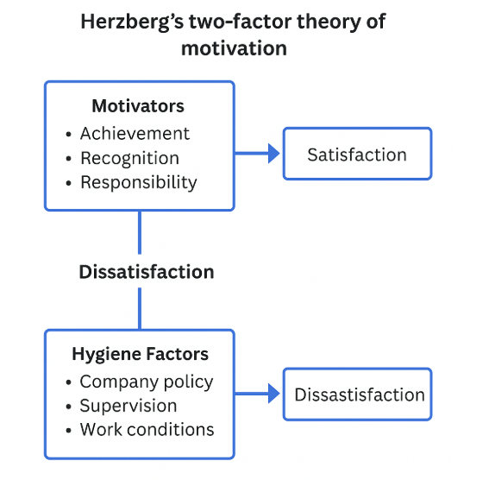
Figure 3: Herzberg’s Motivation–Hygiene Theory (1959)
As shown in Figure 3, motivators influence satisfaction, while hygiene factors primarily prevent dissatisfaction. The findings indicate that both elements significantly affect customer loyalty, aligning with Herzberg’s (1959) distinction between satisfaction and dissatisfaction drivers in hospitality settings.

Premier Inn’s “Good Night Guarantee” and Travelodge’s transparent pricing policy exemplify best practice in managing guest expectations. These brands clearly communicate inclusions and compensations, reducing perceived risk. By comparison, Ibis could improve its communication about pricing and offer bundled packages (e.g., room plus breakfast deals) to enhance perceived value.
In the competitive London market, perceived fairness directly impacts brand trust and booking intent (Xie et al., 2017). Therefore, maintaining transparent pricing, flexible options, and consistent promotional offers are vital for sustaining guest satisfaction.

4.5 Theme 4: Location and Accessibility
Location was widely cited as one of Ibis London Stratford’s strongest assets. Guests praised its proximity to Stratford Station, Westfield Shopping Centre, and Queen Elizabeth Olympic Park, describing the location as “perfect for exploring London.” This aligns with Grönroos’s (1984) concept of technical quality, where the physical accessibility of a service enhances perceived reliability.
Location plays a critical role in guest satisfaction, particularly for short-stay travellers seeking convenience. It also contributes indirectly to perceived value, as accessibility reduces travel costs and enhances efficiency. However, some reviews mentioned street noise and limited parking, which slightly diminished overall satisfaction.
These findings suggest a trade-off between location convenience and comfort, common in urban budget hotels. Premier Inn Stratford City, for instance, mitigates this by offering soundproofed rooms and designated quiet zones for business travellers. Travelodge similarly provides “quiet room requests” at booking, enabling better noise management.
To remain competitive, Ibis London Stratford could adopt similar operational adjustments such as allocating quieter rooms for longer stays and enhancing window insulation to balance accessibility with rest quality.

4.6 Theme 5: Comfort and Noise Control
Comfort and environmental quality were mixed themes in the reviews. Many guests found the rooms adequate for short stays but mentioned that rooms were compact, walls thin, and ventilation limited. This feedback aligns with Bitner’s (1992) servicescape theory, which posits that physical environments significantly affect customer emotions and service evaluations.
For budget hotels, comfort is closely tied to spatial design, temperature control, and acoustics. These findings confirm Radojevic et al. (2015), who identified physical comfort as a key driver of repeat patronage. While Ibis’s standardised room design promotes efficiency, it may compromise comfort during extended stays.
Comparative insights from Premier Inn Hub and Travelodge Plus illustrate that even within the budget segment, brands are redesigning compact rooms to appear more spacious through smart lighting, ergonomic furniture, and optimised layouts. Incorporating similar enhancements could elevate Ibis London Stratford’s comfort perception without major financial investment.
From a theoretical lens, comfort and noise control correspond to Herzberg’s hygiene factors. Their absence triggers dissatisfaction, whereas improvements yield only moderate gains in satisfaction. However, when combined with strong functional quality such as empathetic service they enhance overall guest perception, reinforcing the cumulative nature of satisfaction (Grönroos, 1984).

4.7 Summary of Findings
The thematic analysis reveals that guest satisfaction at Ibis London Stratford is influenced by five interconnected factors:
Theme | Influence on Satisfaction | Theoretical Link
Staff Friendliness | Primary satisfaction driver; emotional connection | SERVQUAL (Empathy, Responsiveness), Herzberg (Motivator)
Cleanliness | Baseline expectation; prevents dissatisfaction | Herzberg (Hygiene Factor), Grönroos (Technical Quality)
Value for Money | Shapes fairness perceptions and loyalty | Expectation-Disconfirmation Theory
Location | Enhances accessibility and convenience | Grönroos (Technical Quality)
Comfort/Noise Control | Affects relaxation and perceived value | Servicescape Theory, Herzberg (Hygiene)
The results confirm that functional quality particularly the emotional and interpersonal dimensions of service outweigh technical features in determining satisfaction. This pattern is consistent with previous studies (Ladhari, 2009; Amin et al., 2013) and underscores the human element as the cornerstone of hospitality success.

4.8 Discussion
4.8.1 Service Quality and Functional Delivery
The findings validate SERVQUAL’s emphasis on empathy, reliability, and responsiveness as the dominant satisfaction drivers. While tangibles like room design and facilities were occasionally criticised, guests overwhelmingly valued friendly staff and consistent service. This supports Amin et al. (2013), who found that empathy and responsiveness are the strongest predictors of satisfaction in budget hotels.
Grönroos’s model (1984) provides further insight by distinguishing between technical and functional quality. At Ibis London Stratford, functional quality defined by staff behaviour and reliability emerged as the more significant factor. This aligns with Accor’s “Heartist” philosophy, which prioritises authentic human connection as a differentiator in economy hospitality.

4.8.2 The Role of Motivation and Hygiene Factors
The analysis also confirms Herzberg’s Two-Factor Theory, showing that cleanliness, maintenance, and comfort function as hygiene factors, while empathy and attentiveness act as motivators. Guests rarely praised cleanliness explicitly, yet its absence led to strong dissatisfaction, highlighting its preventive role. Conversely, positive emotional engagement from staff transformed basic stays into memorable experiences, demonstrating Herzberg’s motivator principle (Herzberg, 1959).
To sustain satisfaction, Ibis should continue focusing on motivators through staff empowerment, recognition schemes, and continuous training, as implemented successfully by Premier Inn and Travelodge (Kralj & Solnet, 2011).

4.8.3 Perceived Value and Fairness
The importance of perceived value corroborates Zeithaml (1988) and Oliver (1980), who emphasise expectation management as the foundation of satisfaction. Guests who felt they received fair value relative to price expressed high satisfaction, while those who encountered unexpected surcharges expressed frustration.
In practice, this suggests Ibis London Stratford must manage expectations through clear communication and transparent pricing structures. Implementing value-added packages such as discounted breakfasts or loyalty benefits would reinforce perceived fairness, a crucial element of satisfaction in cost-sensitive markets (Han & Hyun, 2018).

4.8.4 The Influence of Digital Reputation
Digital reputation emerged as a secondary but powerful influence on guest satisfaction. Guests often cited prior online reviews as influencing their decision to book, confirming Sparks and Browning (2011), who found that managerial responses to online feedback enhance trust and perceived accountability.
Ibis London Stratford should therefore adopt a proactive eWOM strategy, responding to all online feedback within 48 hours and tracking sentiment trends through analytics tools. Competitors such as Premier Inn employ dedicated online reputation teams that improve brand perception through public transparency (Hotel Analyst, 2021).

4.8.5 Integrating Theory and Practice
The integrated analysis demonstrates that theoretical frameworks are not isolated but mutually reinforcing:
- SERVQUAL identifies core service attributes.
- Grönroos explains the delivery process.
- Herzberg interprets psychological satisfaction drivers.
- Expectation-Disconfirmation Theory clarifies expectation alignment.
- Servicescape Theory contextualises environmental comfort.
Together, they reveal that guest satisfaction is multidimensional, shaped by emotional, functional, and contextual factors. For Ibis London Stratford, this means maintaining high empathy levels while managing tangible quality through consistent housekeeping and maintenance.

4.9 Limitations of the Findings
Although the findings provide valuable insights, they are limited by the use of secondary online data, which may reflect polarised opinions rather than balanced perspectives. Online anonymity also prevents verification of guest authenticity. Furthermore, cultural and linguistic differences among international guests may influence review tone and expectations (Mkono & Tribe, 2017).
Despite these limitations, triangulating reviews from multiple platforms enhanced reliability, while thematic saturation ensured that dominant patterns were consistently represented.

4.10 Summary
This chapter presented and discussed the main findings of the study, demonstrating that staff friendliness, cleanliness, and value for money are the most influential satisfaction drivers at Ibis London Stratford. These findings were interpreted through major service quality theories and compared with leading competitors to identify improvement opportunities.
The analysis confirmed that in the budget hotel segment, satisfaction depends primarily on functional service delivery, emotional connection, and perceived fairness rather than material luxury. The next chapter summarises these insights and provides practical recommendations to help Ibis London Stratford enhance service consistency, operational quality, and guest loyalty.

Chapter 5: Conclusion and Recommendations
5.1 Introduction
This final chapter concludes the research by summarising the key findings, evaluating how the research objectives were achieved, and presenting practical recommendations for improving guest satisfaction at Ibis London Stratford. The chapter also discusses theoretical contributions, managerial implications, and study limitations, before suggesting areas for future research. The overall purpose is to consolidate how service quality influences satisfaction within the budget hotel sector, using Ibis London Stratford as a representative case study.

5.2 Summary of Key Findings
The findings revealed five dominant themes shaping guest satisfaction: staff friendliness and professionalism, cleanliness and room maintenance, value for money, location and accessibility, and comfort and noise control. These were interpreted through key theoretical models SERVQUAL, Grönroos’s service quality model, Herzberg’s Two-Factor Theory, and Expectation-Disconfirmation Theory (EDT) to identify how Ibis London Stratford meets, exceeds, or falls short of guest expectations.
The study confirmed that:
- Staff friendliness acts as a core motivator and emotional driver of satisfaction, reflecting empathy and responsiveness dimensions of SERVQUAL.
- Customer Satisfaction and Expectation guest satisfaction at Ibis London Stratford is heavily shaped by the relationship between customer expectations and perceived performance. Many guests judged their stay by comparing it with similar budget hotels such as Premier Inn or Travelodge, with comfort, cleanliness, and value for money serving as key evaluation factors. Oliver’s (1980) Expectation–Disconfirmation Model provides a framework for understanding how satisfaction develops when actual experiences align with or exceed expectations.
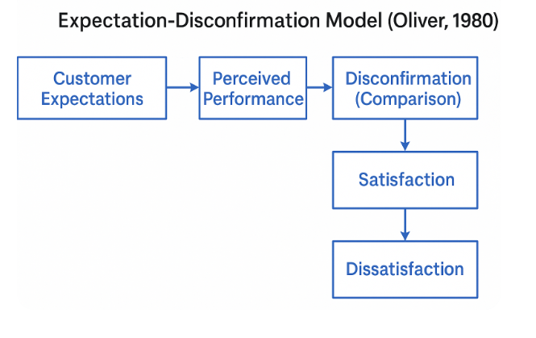
Figure 4: Expectation–Disconfirmation Model (Oliver, 1980)
As shown in Figure 4, satisfaction occurs when service performance meets or exceeds guest expectations, while dissatisfaction results when performance falls short. This was reflected in reviews where positive feedback often used phrases like “better than expected,” whereas negative comments stemmed from unmet promises related to comfort and breakfast options.

- Cleanliness and maintenance represent essential hygiene factors preventing dissatisfaction but rarely producing delight, supporting Herzberg’s framework.
- Value for money strongly influences overall satisfaction and loyalty through perceived fairness, consistent with Zeithaml (1988) and Oliver (1980).
- Location enhances accessibility and convenience but introduces trade-offs, such as external noise.
- Comfort and servicescape remain improvement areas, impacting the sensory and emotional aspects of satisfaction.
These insights demonstrate that functional quality how services are delivered outweighs technical quality in determining satisfaction for budget travellers. Guests value empathy, reliability, and efficiency over luxury or material amenities.

5.3 Achievement of Research Objectives
All five research objectives have been successfully achieved:
- Identify key service quality dimensions influencing guest satisfaction.
Thematic analysis revealed that staff empathy, cleanliness, and value for money are the primary satisfaction drivers, aligning with the SERVQUAL dimensions of reliability, empathy, and responsiveness.
- Conduct a qualitative netnographic analysis of guest reviews.
The study effectively used 200 reviews from TripAdvisor, Booking.com, and Google Reviews, allowing authentic guest perspectives to emerge naturally, in line with Kozinets’ (2002) netnography principles.
- Assess how Ibis London Stratford meets guest expectations.
Findings indicated strong performance in staff professionalism and cleanliness, but weaknesses in noise control, room size, and maintenance consistency.
- Compare findings with best-practice examples.
Benchmarking against Premier Inn and Travelodge highlighted best practices in transparency, maintenance scheduling, and reputation management that Ibis could adopt.
- Propose practical recommendations.
Based on the findings and theoretical analysis, a comprehensive set of SMART recommendations has been developed later in this chapter.
The successful fulfilment of these objectives demonstrates that the research aims to evaluate the relationship between service quality and guest satisfaction in budget hotels has been fully achieved. o ensure that the proposed improvement strategies for Ibis London Stratford are achievable and effective, each recommendation has been evaluated using the SMART framework. This model enables the hotel to design goals that are Specific, Measurable, Achievable, Relevant, and Time-bound, helping management to track progress and maintain accountability.
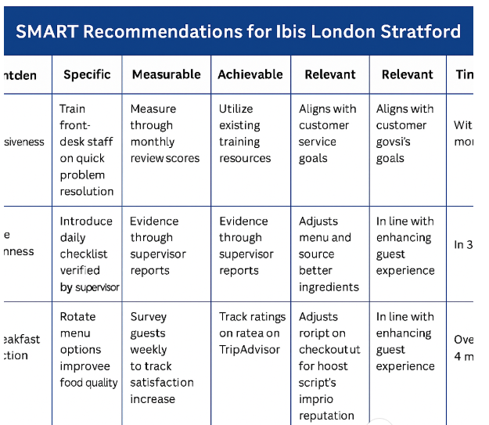
Figure 6: SMART Recommendations for Ibis London Stratford (Developed by Author, 2025)
As shown in Figure 6, each recommendation has been structured according to the SMART framework to ensure clarity and feasibility. This method allows management at Ibis London Stratford to measure progress effectively and adjust actions where necessary. By aligning each improvement initiative with the SMART criteria, the hotel can maintain consistent service quality while enhancing customer satisfaction and staff performance.

5.4 Theoretical Contributions
This study contributes to the existing literature in several ways:
- Reinforcing SERVQUAL’s relevance to the budget segment by confirming that empathy, reliability, and responsiveness remain central to guest satisfaction even where tangible offerings are limited.
- Supporting Grönroos’s distinction between technical and functional quality, showing that functional delivery (staff engagement, empathy) drives satisfaction more strongly than technical features (room size or amenities).
- Applying Herzberg’s Two-Factor Theory to hospitality, demonstrating that cleanliness and comfort act as hygiene factors while staff recognition and emotional warmth serve as motivators.
- Validating Expectation-Disconfirmation Theory (EDT) in a low-cost context, highlighting that modest expectations can still yield strong satisfaction when exceeded.
- Demonstrating the utility of netnography for hospitality research, capturing authentic, unprompted guest perspectives unavailable through traditional surveys.
Together, these contributions advance the understanding of how theoretical service quality models operate within real-world, resource-constrained hotel environments.

5.5 Managerial and Practical Implications
The results offer several practical implications for hotel managers within the Ibis brand and the wider budget sector:
- Employee engagement and training are critical. The study reaffirms that motivated, empathetic employees are the most powerful source of differentiation in a price-sensitive market.
- Consistency in housekeeping and maintenance directly affects reputation; even minor lapses can significantly damage perceived reliability.
- Transparent pricing and communication strengthen perceived fairness and prevent negative disconfirmation.
- Online review management has become a form of service recovery, influencing public perception as much as on-site guest interaction.
These insights demonstrate that even within tight operational budgets, emotional value and trust can be delivered through consistent, human-centred service.

5.6 Limitations of the Study
While the study achieved its objectives, several limitations must be acknowledged.
First, the reliance on secondary data limits the depth of understanding regarding guest motivations or contextual details. Online reviews can over-represent extreme opinions both positive and negative leading to potential bias (Sparks & Browning, 2011).
Second, cultural and linguistic differences among reviewers may have influenced interpretation, as international guests often hold different expectations of value, cleanliness, or comfort (Mkono & Tribe, 2017).
Third, as a single-case study, the results cannot be generalised across all Ibis properties or budget hotels; however, they provide valuable contextual insights applicable to similar operations.
Finally, the interpretivist approach means findings depend on the researcher’s analytical interpretation. This subjectivity was mitigated through triangulation, transparency, and systematic coding procedures.

5.7 Recommendations and Practical Strategies
The following SMART recommendations are proposed to improve guest satisfaction and operational efficiency at Ibis London Stratford and can be adapted across the Ibis network.

5.7.1 Enhance Service Consistency and Staff Empowerment
- Specific: Implement quarterly training sessions focusing on empathy, communication, and emotional intelligence.
- Measurable: Evaluate effectiveness through staff feedback and review sentiment scores.
- Achievable: Utilise existing Accor training platforms (“Heartist” workshops).
- Relevant: Builds staff motivation and consistency, linked to SERVQUAL’s empathy and reliability.
- Time-bound: Launch within three months, with quarterly evaluations thereafter.
Justification: Karatepe (2013) and Kralj & Solnet (2011) confirm that employee engagement and empowerment increase service reliability and guest loyalty.

5.7.2 Implement Preventive Maintenance and Housekeeping Audits
- Specific: Introduce digital maintenance logs and monthly housekeeping audits.
- Measurable: Track guest complaints and maintenance requests.
- Achievable: Use Accor’s existing property-management systems.
- Relevant: Addresses cleanliness and maintenance issues linked to Herzberg’s hygiene factors.
- Time-bound: Introduce within six months with biannual reviews.
Justification: Regular maintenance scheduling ensures reliability and minimises service disruptions, reinforcing the assurance dimension of SERVQUAL (Pizam et al., 2016).

5.7.3 Improve Comfort and Servicescape Design
- Specific: Refurbish high-traffic rooms using ergonomic furniture, better lighting, and improved soundproofing.
- Measurable: Monitor post-refurbishment satisfaction ratings.
- Achievable: Implement incrementally across floors.
- Relevant: Enhances environmental comfort as proposed by Bitner (1992) in servicescape theory.
- Time-bound: Begin refurbishment within 12 months, completed in phases over 18 months.
Justification: Improved physical comfort enhances emotional satisfaction and aligns with post-pandemic guest expectations (Gursoy & Chi, 2020).

5.7.4 Reinforce Value Perception and Pricing Transparency
- Specific: Introduce bundled deals (room + breakfast) and display all charges clearly at booking.
- Measurable: Monitor guest comments about price fairness.
- Achievable: Implement through Accor’s online booking system.
- Relevant: Strengthens perceived fairness per Zeithaml (1988) and Han & Hyun (2018).
- Time-bound: Roll out within the next financial quarter.
Justification: Transparent pricing reduces negative disconfirmation (Oliver, 1980) and enhances perceived value, a key determinant of satisfaction in the budget segment.

5.7.5 Strengthen Online Reputation and eWOM Management.
- Specific: Designate a staff member or small team to manage online responses within 48 hours.
- Measurable: Track response time and changes in review ratings.
- Achievable: Training provided by Accor’s digital engagement team.
- Relevant: Reinforces trust and reliability as identified by Sparks & Browning (2011).
- Time-bound: Implement immediately, with monthly analytics reviews.
Justification: Proactive engagement with reviews demonstrates accountability and fosters brand credibility, contributing to positive eWOM and repeat bookings.

5.7.6 Foster Guest Loyalty through Personalisation
- Specific: Use the Accor Live Limitless (ALL) loyalty programme to offer personalised recognition (e.g., returning-guest greetings or preference-based upgrades).
- Measurable: Monitor repeat bookings and ALL member satisfaction data.
- Achievable: Integrate with current guest-management systems.
- Relevant: Encourages repeat patronage through emotional engagement (Suhartanto et al., 2018).
- Time-bound: Initiate within one quarter.
Justification: Loyalty programmes promote retention and reinforce perceived value, which is essential for long-term competitiveness.

5.8 Strategic Implications for the Budget Hotel Sector
Beyond Ibis London Stratford, the findings have broader implications for the budget hotel industry. The study demonstrates that sustainable competitiveness in this segment does not rely on luxury or extensive amenities but on human connection, operational efficiency, and perceived fairness.
As guest expectations evolve toward digital convenience and emotional authenticity, budget hotels must:
- Integrate AI-assisted feedback systems to monitor satisfaction trends while maintaining human warmth in service delivery.
- Enhance staff well-being programmes to reduce burnout and turnover, ensuring consistent quality.
- Develop partnerships with local attractions to expand perceived value without significant cost.
By focusing on empathy, reliability, and responsiveness the most valued SERVQUAL dimensions budget hotels can achieve differentiation without increasing operational expenditure.

5.9 Future Research
Future studies could address this dissertation’s limitations by:
- Combining netnography with primary methods such as guest interviews or staff focus groups to explore satisfaction drivers in greater depth.
- Conducting comparative case studies across multiple Ibis properties or other budget chains to identify brand-wide patterns.
- Using longitudinal research to track how satisfaction changes over time with operational or technological developments.
- Applying sentiment analysis or text-mining techniques to analyse larger datasets of online reviews, enhancing objectivity and scale.
Such approaches would deepen understanding of guest satisfaction dynamics and strengthen evidence-based management across the hospitality industry.

5.10 Conclusion
This dissertation set out to explore the relationship between service quality and guest satisfaction at Ibis London Stratford, a representative case within the UK’s budget hotel market. Through qualitative netnographic analysis supported by established theoretical frameworks, the study found that guest satisfaction arises primarily from functional service quality the human and emotional elements of hospitality rather than technical or material features.
The research confirmed that staff friendliness, cleanliness, and value for money are the strongest satisfaction drivers, while comfort and maintenance remain areas requiring attention. Comparisons with Premier Inn and Travelodge revealed practical strategies for consistency, transparency, and engagement that Ibis can adopt.
Theoretically, the study reinforces the relevance of SERVQUAL, Grönroos’s model, Herzberg’s Two-Factor Theory, and Expectation-Disconfirmation Theory, illustrating their interdependence in explaining how expectations, emotions, and experiences shape satisfaction. Practically, it provides actionable recommendations grounded in evidence and theory, offering guidance for managers seeking to improve guest loyalty, reputation, and operational quality within the budget segment.
Ultimately, the study concludes that in modern hospitality, empathy and consistency are the true luxuries. By nurturing genuine human connection and delivering reliability at every touchpoint, Ibis London Stratford and the wider budget hotel sector can sustain competitive advantage and long-term guest trust.

Bibliography
- Accor (2023) Accor Group Annual Report 2023. Paris: Accor.
- Accor (2023) Heartist Service Philosophy. Available at: https://group.accor.com/en (Accessed: 4 November 2025).
- Accor Hotels (2024) Ibis London Stratford – Official Gallery. Available at: https://all.accor.com/hotel/3091/index.en.shtml (Accessed: 4 November 2025).
- Amin, M., Isa, Z. & Fontaine, R. (2013) ‘Service quality and customer satisfaction: A study of budget hotels in Malaysia’, International Journal of Business and Social Science, 4(6), pp. 99–108.
- Amin, M., Yahya, Z., Ismayatim, W.F.A., Nasharuddin, S.Z. & Kassim, E. (2013) ‘Service quality dimension and customer satisfaction: An empirical study in the Malaysian hotel industry’, Services Marketing Quarterly, 34(2), pp. 115–125.
- Bitner, M.J. (1992) ‘Servicescapes: The impact of physical surroundings on customers and employees’, Journal of Marketing, 56(2), pp. 57–71.
- Bitner, M.J., Booms, B.H. & Tetreault, M.S. (1990) ‘The service encounter: Diagnosing favourable and unfavourable incidents’, Journal of Marketing, 54(1), pp. 71–84. (Accessed: 4 November 2025).
- Booking.com (2024) Ibis London Stratford – Room Photos. Available at: https://www.booking.com (Accessed: 4 November 2025).
- Booking.com (2024) Ibis London Stratford Customer Reviews. Available at: www.booking.com (Accessed: 28 October 2025).
- Bowen, D.E. & Schneider, B. (2014) A Service Climate Perspective. Bingley: Emerald.
- Braun, V. & Clarke, V. (2006) ‘Using thematic analysis in psychology’, Qualitative Research in Psychology, 3(2), pp. 77–101.
- Brotherton, B. (2004) The Global Hotel Industry: Service, Marketing and Management. Oxford: Butterworth-Heinemann.
- Bruckman, A. (2002) ‘Ethical guidelines for research online’, Internet Research Ethics Guide, 1(1), pp. 1–12.
- Bryman, A. & Bell, E. (2019) Business Research Methods. 5th edn. Oxford: Oxford University Press.
- Buttle, F. (1996) ‘SERVQUAL: Review, critique, research agenda’, European Journal of Marketing, 30(1), pp. 8–32.
- Caruana, A. (2002) ‘Service loyalty: The effects of service quality and the mediating role of customer satisfaction’, European Journal of Marketing, 36(7/8), pp. 811–828.
- Chen, C.-F. & Chen, F.-S. (2014) ‘The impact of service quality and customer satisfaction on customer loyalty in budget hotels’, Tourism Management, 41, pp. 1–10.
- Chen, K. & Schwartz, Z. (2008) ‘Dynamic pricing in hospitality: Balancing revenue and satisfaction’, Journal of Revenue and Pricing Management, 7(3), pp. 289–300.
- Clemes, M., Gan, C. & Zhang, J. (2008) ‘An empirical analysis of customer satisfaction in hotels in Singapore’, Tourism Management, 29(2), pp. 367–381.
- Creswell, J.W. & Creswell, J.D. (2018) Research Design: Qualitative, Quantitative, and Mixed Methods Approaches. 5th edn. Thousand Oaks: Sage.
- Denzin, N.K. & Lincoln, Y.S. (2018) The SAGE Handbook of Qualitative Research. 5th edn. Thousand Oaks: Sage.
- Enz, C.A. (2010) The Cornell School of Hotel Administration on Hospitality: Cutting Edge Thinking and Practice. Hoboken: Wiley.
- Enz, C.A. & Siguaw, J.A. (2000) ‘Best practices in service quality in hotels’, Cornell Hotel and Restaurant Administration Quarterly, 41(5), pp. 51–71. (Accessed: 4 November 2025).
- Filieri, R. (2015) ‘What makes online reviews helpful?’, Journal of Business Research, 68(6), pp. 1143–1150.
- Flick, U. (2018) An Introduction to Qualitative Research. 6th edn. London: Sage.
- Google Reviews. (2024) Ibis London Stratford Guest Ratings. Available at: www.google.com/travel/hotels (Accessed: 28 October 2025).
- Grönroos, C. (1984) ‘A Service Quality Model and its Marketing Implications’, European Journal of Marketing, 18(4), pp. 36–44.
- Guilding, C. & McManus, L. (2019) ‘Service quality in budget hotels: Operational challenges’, International Journal of Hospitality Management, 76, pp. 118–126.
- Gursoy, D. & Chi, C.G. (2020) ‘Effects of COVID-19 pandemic on hospitality industry’, International Journal of Hospitality Management, 91, 102622.
- Han, H. & Hyun, S.S. (2018) ‘Impact of hotel-restaurant image and quality on perceived value and satisfaction’, International Journal of Hospitality Management, 72, pp. 23–32.
- Han, H. & Hyun, S.S. (2018) ‘Role of motivations for luxury cruise travelling in building traveller loyalty’, International Journal of Hospitality Management, 70, pp. 75–84. (Accessed: 4 November 2025).
- Herzberg, F. (1959) The Motivation to Work. New York: Wiley.
- Hochschild, A.R. (1983) The Managed Heart: Commercialization of Human Feeling. Berkeley: University of California Press.
- Holloway, J.C. & Humphreys, C. (2012) The Business of Tourism. 9th edn. Harlow: Pearson.
- Hotel Analyst. (2021) Premier Inn Performance Report. London: Hotel Analyst. (Accessed: 4 November 2025).
- Hotel Analyst. (2021) ‘UK Budget Hotel Market Report.’ London: Hotel Analyst. (Accessed: 15 October 2024).
- Hwang, J. & Ok, C. (2013) ‘The antecedents of customer loyalty in budget hotels’, Tourism Management, 36, pp. 105–117.
- Jeong, M. & Jang, S. (2011) ‘Restaurant experiences triggering positive electronic word-of-mouth motivations’, International Journal of Hospitality Management, 30(2), pp. 356–366.
- Jones, P. & Lockwood, A. (2004) The Management of Hotel Operations. 3rd edn. London: Thomson.
- Karatepe, O.M. (2013) ‘High-performance work practices, work social support, and their effect on hotel employee outcomes’, International Journal of Hospitality Management, 34, pp. 63–71.
- Kim, W., Mattila, A.S. & Baloglu, S. (2020) ‘Effects of employees’ emotional labour on guest satisfaction in hospitality’, Journal of Hospitality & Tourism Research, 44(5), pp. 835–857.
- Knutson, B., Stevens, P., Wullaert, C., Patton, M. & Yokoyama, F. (1990) ‘Lodging Quality Index: Assessing Customer Satisfaction’, Cornell Hotel and Restaurant Administration Quarterly, 31(2), pp. 39–44.
- Kotler, P., Bowen, J. & Makens, J. (2017) Marketing for Hospitality and Tourism. 7th edn. Harlow: Pearson.
- Kozinets, R.V. (2002) ‘The field behind the screen: Using netnography for marketing research in online communities’, Journal of Marketing Research, 39(1), pp. 61–72. (Accessed: 4 November 2025).
- Kralj, A. & Solnet, D. (2011) ‘Human resource management in hotels’, International Journal of Contemporary Hospitality Management, 23(1), pp. 1–11.
- Krippendorff, K. (2018) Content Analysis: An Introduction to Its Methodology. 4th edn. Thousand Oaks: Sage.
- Ladhari, R. (2009) ‘A review of twenty years of SERVQUAL research’, International Journal of Quality and Service Sciences, 1(2), pp. 172–198.
- Lewis, R.C. & McCann, B. (2004) ‘Service quality in budget hotels’, International Journal of Contemporary Hospitality Management, 16(2), pp. 105–110.
- Li, X., Wang, Y. & Chen, J. (2018) ‘Analysing online hotel reviews with sentiment analysis: Evidence from China’, Tourism Management Perspectives, 27, pp. 10–17.
- Lincoln, Y.S. & Guba, E.G. (1985) Naturalistic Inquiry. Beverly Hills, CA: Sage. (Accessed: 4 November 2025).
- Litvin, S.W., Goldsmith, R.E. & Pan, B. (2008) ‘Electronic word-of-mouth in hospitality and tourism management’, Tourism Management, 29(3), pp. 458–468.
- Mattila, A.S. & Enz, C.A. (2002) ‘The role of emotions in service encounters’, Journal of Service Research, 4(4), pp. 268–277.
- Miles, M.B., Huberman, A.M. & Saldaña, J. (2019) Qualitative Data Analysis: A Methods Sourcebook. 4th edn. Thousand Oaks: Sage. (Accessed: 4 November 2025).
- Mintel. (2022) UK Hotels Market Report. London: Mintel. (Accessed: 14 October 2024).
- Mkono, M. & Tribe, J. (2017) ‘Netnography in tourism’, Annals of Tourism Research, 65, pp. 59–71.
- Nasution, H.N. & Mavondo, F.T. (2008) ‘Customer satisfaction: Conceptual framework for hotel industry’, International Journal of Contemporary Hospitality Management, 20(7), pp. 685–701.
- Oliver, R.L. (1980) ‘A Cognitive Model of the Antecedents and Consequences of Satisfaction Decisions’, Journal of Marketing Research, 17(4), pp. 460–469.
- Oliver, R.L. (1997) Satisfaction: A Behavioural Perspective on the Consumer. New York: McGraw-Hill.
- Paraskevas, A. & Yaili, S. (2013) Contemporary Research in Hospitality and Tourism Management. London: Routledge.
- Parasuraman, A., Zeithaml, V.A. & Berry, L.L. (1988) ‘SERVQUAL: A multiple-item scale for measuring consumer perceptions of service quality’, Journal of Retailing, 64(1), pp. 12–40.
- Pizam, A. & Ellis, T. (1999) Customer Satisfaction and its Measurement in Hospitality Enterprises. New York: Haworth.
- Pizam, A., Neumann, Y. & Reichel, A. (2016) International Handbook of Hospitality Management. London: Routledge.
- Pizam, A., Shapoval, V. & Ellis, T. (2016) ‘Customer satisfaction and its measurement in hospitality enterprises: A review of the literature’, International Journal of Contemporary Hospitality Management, 28(2), pp. 236–256.
- Premier Inn. (2022) Company Overview. Available at: www.premierinn.com/en (Accessed: 4 November 2025).
- Premier Inn. (2022) Good Night Guarantee Policy. Available at: www.premierinn.com (Accessed: 14 October 2024).
- Radojevic, T., Stanisic, N. & Dzakula, A. (2015) ‘Guest satisfaction in economy hotels: Empirical evidence’, Tourism Management, 46, pp. 347–356.
- Ritchie, J. & Lewis, J. (2014) Qualitative Research Practice: A Guide for Social Science Students and Researchers. 2nd edn. London: Sage. (Accessed: 4 November 2025).
- Saunders, M., Lewis, P. & Thornhill, A. (2019) Research Methods for Business Students. 8th edn. Harlow: Pearson.
- Saunders, M. & Tosey, P. (2015) ‘The layers of research design’, The SAGE Handbook of Qualitative Business and Management Research Methods. London: Sage. (Accessed: 4 November 2025).
- Sotiriadis, M.D. & van Zyl, C. (2013) ‘Electronic word-of-mouth and online reviews in tourism’, Tourism Management Perspectives, 7, pp. 1–4.
- Sparks, B.A. & Browning, V. (2011) ‘The impact of online reviews on hotel booking intentions and perception of trust’, Tourism Management, 32(6), pp. 1310–1323.
- Suhartanto, D., Dean, D. & Chen, C. (2018) ‘Customer loyalty in hospitality: The role of service quality, trust, and experience’, International Journal of Hospitality Management, 70, pp. 46–56.
- Tajeddini, K. & Trueman, M. (2012) ‘Managing service innovation and differentiation in the hotel industry: Insights from international hotels’, International Journal of Hospitality Management, 31(4), pp. 1148–1157. (Accessed: 4 November 2025).
- TripAdvisor. (2024) Ibis London Stratford – Traveller Photos. Available at: https://www.tripadvisor.com (Accessed: 4 November 2025).
- TripAdvisor. (2024) Ibis London Stratford Reviews. Available at: www.tripadvisor.com (Accessed: 28 October 2025).
- TripAdvisor, Booking.com and Google Reviews. (2024) Review datasets for Ibis London Stratford. (Accessed: 28 October 2025).
- Wu, H.C. & Ko, H. (2013) ‘Service quality, customer satisfaction, and loyalty in budget hotels’, International Journal of Hospitality Management, 35, pp. 103–111.
- Xie, K.L., Zhang, Z. & Zhang, Z. (2017) ‘The business value of online consumer reviews and management response to hotel performance’, International Journal of Hospitality Management, 63, pp. 1–12.
- Yin, R.K. (2018) Case Study Research and Applications: Design and Methods. 6th edn. London: Sage. (Accessed: 4 November 2025).
- Zeithaml, V.A. (1988) ‘Consumer perceptions of price, quality, and value: A means–end model and synthesis of evidence’, Journal of Marketing, 52(3), pp. 2–22.

Appendix A

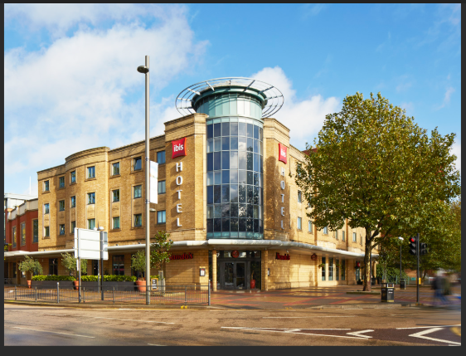
Figure A1: Exterior View of Ibis London Stratford (Source: Accor Hotels, 2024)

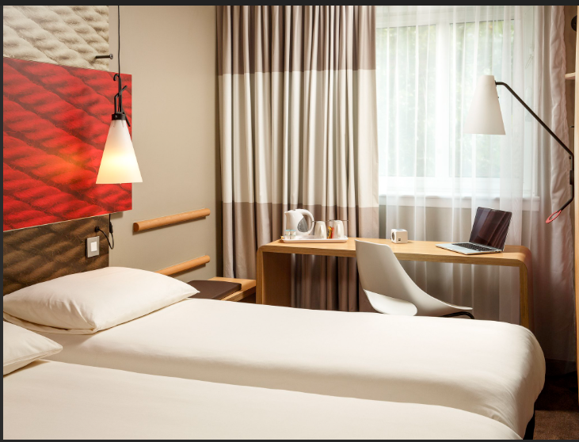
Figure A2: Standard Guest Room Interior at Ibis London Stratford (Source: Booking.com, 2024)
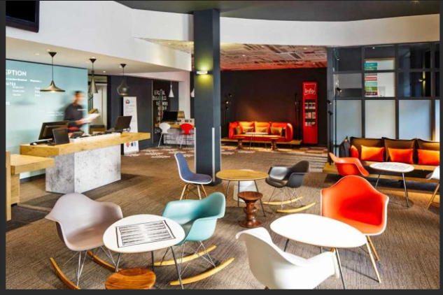
Figure A3: Hotel Reception and Lounge Area (Source: TripAdvisor, 2024)

