An Investigative Comparison of Features between Population Deprivation Indices Using Statistics and GIS Modelling in Swansea, South West Wales.

Daniel Morley | BSc (Hons) Environmental Conservation | May 2018

School of Architecture, Built and Natural Environments
Faculty of Architecture, Computing and Engineering


Contents
Introduction 3
Background 3
GIS in Environmental Management 3
Townsend Index 3
Governmental Index and WIMD 4
Methodology 4
Data Collection/Collation 4
Data synthesis 4
Results 6
Lower Super Output Area 6
Middle Super Output Area 7
Discussion and Conclusion 10
References 10

Table of Figures
Figure 1: A Microsoft Excel Table Showing the Level of Organisation Required for Collating the Multiple Townsend Index Data Points, Demonstrated for the Swansea LSOAs. 5
Figure 2: Excel Table Exhibiting the Percentage, Variances, Zscores and Final Townsend Scores for the Swansea LSOAs Using all Four Indicators. 5
Figure 3: Scatterplot Graph Depicting the Weak Positive Correlation Between Total Housing Population and the Townsend Index Scores for the LSOAs, Created Using Microsoft Excel. 6
Figure 4: Scatterplot Graph Depicting the Weak Positive Correlation Between Total Housing Population and the Government Index Scores for the LSOAs, Created Using Microsoft Excel. 7
Figure 5: Scatterplot Graph Depicting the Weak Positive Correlation Between Total Housing Population and the Townsend Index Scores for the MSOAs, Created Using Microsoft Excel. 8
Figure 6: Scatterplot Graph Depicting the Weak Positive Correlation Between Total Housing Population and the Government Index Scores for the MSOAs, Created Using Microsoft Excel. 8
Figure 7: One of Multiple Data Tables Loaded into a MapInfo Workspace Browser Ready for the creation of a Thematic Map. 9
Figure 8: Thematic Map of the Townsend Index Deprivation Measurements for Swansea’s 31 MSOAs, Created Using the MapInfo GIS Programme. 9

Introduction
Measures of deprivation are powerful tools in understanding the potential causalities at play within a population’s poverty distribution. There exist multiple methods for assessing a populations deprivation, namely this pertains to using differing correlated indicators. Indicators typically used in deprivation measures include employment, education, health, vehicle and home ownership and housing situation. Understanding how the use of differing indicators in different configurations can produced varied results allows for a greater understanding of the dynamics in play within a population, providing useful information for policy makers and researchers. Furthering the understanding of difference in deprivation measure is the rationale for this paper, focussing on the city of Swansea in South West Wales.

Background

GIS in Environmental Management
In recent decades, the use of Geographical Information Systems (GIS) in environmental management has increased exponentially. The capacity for GIS programmes to process and spatially represent population scale data sets efficiently and amenably has affirmed their efficacy as research and information tools. Tsihrintzis et al., (1996) exhibits an example of GIS programmes efficacy in water resource management. Li et al., (2005) provide an example of how a GIS programme can increase the sustainability of a construction build.
Baja, Chapman and Dragovich (2002) demonstrate how GIS can be used in spatial planning and the designation and distribution of Land Management Units. This attests to the efficacy of GIS in its primary and most frequent usage area of spatial planning. Ru et al., (2013) exhibit how GIS can be further deployed regarding spatial planning, demonstrating a municipal project management and decision-making tool based on GIS. This demonstrates how GIS is relevant to numerous aspects of planning, relating directly to environmental management. Aydin, Kentel and Duzgun (2010) demonstrate how GIS can directly reconcile environmental assessment with spatial planning regarding wind energy systems, further attributing to the ability for GIS to increase analytical and therefore protective power regarding environmental management.

Townsend Index
The Townsend Deprivation Index is a direct and absolute measure of a population’s poverty rate, developed by Peter Townsend in 1988 (Townsend, Phillimore and Beattie, 1988). The Townsend index uses the indicators of Unemployment, Non-car ownership, Non-home ownership and Household overcrowding to calculate a measure of deprivation termed the ‘Townsend Score’. In typical deployment, the higher the Townsend score, the more deprived the individual, a demonstration the score calculation is detailed in a following section. The Townsend Index is commonly deployed alongside population scale census data. This typically equates to postcodes and large geographical Output Areas (OA) such as the Middle Super Output Areas (MSOA) and Lower Super Output Areas (LSOA), these being employed in this paper. Synchronising an individual’s Townsend Scores with their postcodes and subsequently their Output Area permits the use of GIS Programmes to visually display trends geographically. This is especially useful at small area scopes, as Saunders (1988) highlights, it allows trends between socio-economic groups to be examined in greater detail.
The usage of different OAs has the potential to produce different results for all types of deprivation measures. For this paper both the MSOAs and LSOAs for Swansea were used to analyse the difference in correlations between deprivation measures. The 31 larger MSOAs encompass the 148 smaller LSOAs for Swansea, the LSOAs being subdivided MSOAs. This means there should be a consistent trend between the two OA groups.

Governmental Index and WIMD
More direct measures of population deprivation exist, the government census provides the most directly amenable alternative to the Townsend Index. Along with the large amounts of additional census data, the government releases a deprivation measure, the most recent being released in 2011. The government deprivation index uses the indicators of housing, health, education and employment to provide a result. The results are provided as the number of houses within an OA that are deprived in a specific number of the indicators. For this paper, the minimum number of deprivation indicators used was four, so a count of how many houses in the OA that are deprived in all four indicators. This measure is a more direct numerically ordinal measurement that doesn’t perform a calculation to provide a score, instead using threshold measurements to determine deprivation in an indicator.
Both the Townsend and Government indices use housing and employment to determine deprivation rates, but the Government index using health and education instead of car ownership and overcrowding means that the indices draw from different data sets to produce a result. Comparing both measures facilitates the determination of which indicators produce a stronger result and therefore what index is the most relevant to research and policy decisions. Other indices in the literature use a wider range of indicators to provide a score. The 2014 Welsh Index of Multiple Deprivation (WIMD) employs the eight indicators of Income, Employment, Health, Education, Access to Services, Community Safety, Physical Environment and Housing to determine a score (Welsh Government, 2014). This number of indicators provides a considerably stronger depth of analysis, however the WIMD and its numerous indicators are intended for usage at smaller scales because of the amount of detail, so not directly amenable.

Methodology

Data Collection/Collation
To compare the correlations for both the Townsend and Government Indices, data was retrieved for the 148 LSOAs and 31 MSOAs for Swansea. Data was extracted from the UK Data Service. Extracting the governmental index data was a simple process, involving denoting the desired OAs then selecting the census deprivation measure and downloading. This process being simple and efficient is a result of the Governmental Index being of a singular precalculated and pre-synthesised measure of deprivation, requiring only one download.
The data for the Townsend Index required multiple separate downloads of different data sources required to ‘build’ the data for synthesis then final analysis. Each indicator had to be downloaded separately for both the MSOAs and LSOAs, consisting of eight separate downloads. Once the data was downloaded, it was compiled in Microsoft Excel, this allowed each column to be colour coded and organised comfortably for the subsequent synthesis process. The Townsend Excel document was saved as an Excel Workbook instead of a CSV, to allow the necessary formulas for synthesis to be performed. an example of the level of organisation necessary for collating the multiple Townsend data sets for Swansea is shown in Figure 1.

Data synthesis
The Governmental Deprivation Index required minimal synthesis to be analysis ready, the only prerequisite was deciding upon the level of data complexity required for suitable analysis. As mentioned, the category of ‘houses deprived in all 4 indicators’ was selected for correlation analysis against the Townsend Index. This was selected so that the most deprived houses were at the fore of analysis. This was also selected because of the otherwise uncomplex nature of the Governmental data, this choice lent more analytical power to each data point.

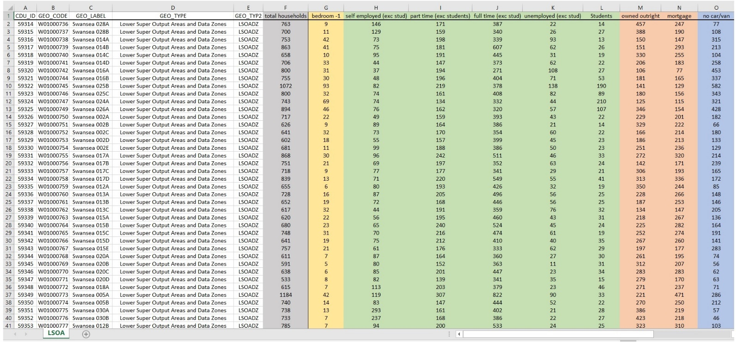
Figure 1: A Microsoft Excel Table Showing the Level of Organisation Required for Collating the Multiple Townsend Index Data Points, Demonstrated for the Swansea LSOAs.
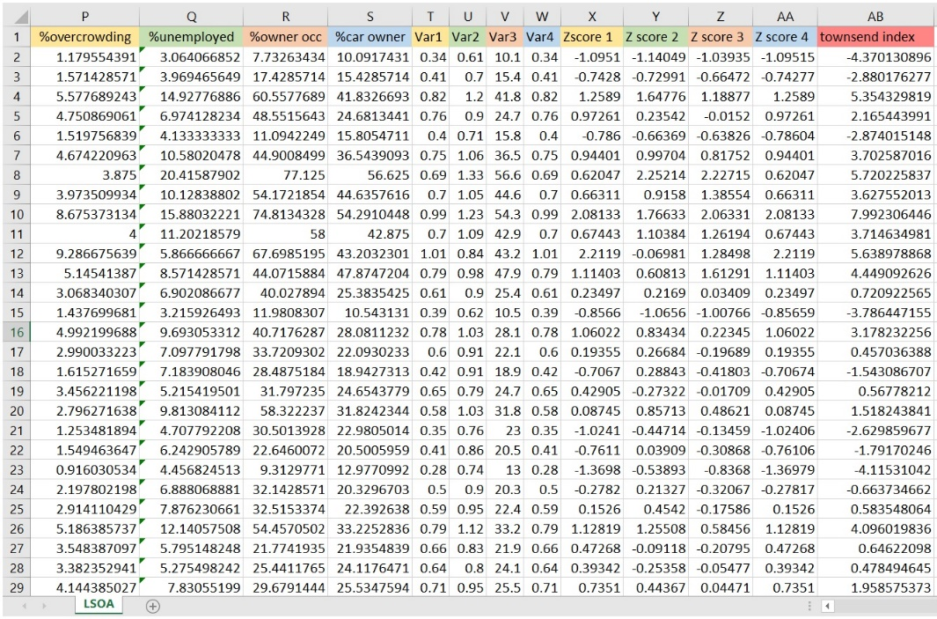
The synthesis for the Townsend Index took considerably longer to perform. Once the Townsend data for both the LSOA and MSOA had been collected and collated as shown in figure 1, the Townsend Scores could be synthesised. The first stage consisted of calculating the percent of each indicator, for the overcrowding, owner occupancy and vehicle ownership, the percentage was out of total households, unemployment is a percentage of total unemployment over all other employment types. From there, the variance of all 4 indicators was calculated, the logarithm for overcrowding and unemployment was employed to normalise the data in comparison to the other two indicators. With the variances calculated, the Zscores were calculated, = variance – mean of variance/ standard deviation. Once each Zscore was calculated for each OA’s indicators, the sum of these four produces the Townsend Score. This process was made amenable and efficient by the use of MS Excel, Figure 2 shows the collated information for Swansea’s Townsend LSOAs.
Figure 2: Excel Table Exhibiting the Percentage, Variances, Zscores and Final Townsend Scores for the Swansea LSOAs Using all Four Indicators.

Results

Lower Super Output Area
To analyse the correlation differences and dynamics between the Townsend Scores and the Government Index Scores statistical testing was required. This required a standardised baseline to be selected to objectively compare both indices and conclude on their correlations. The total housing rate for each OA was chosen, this allowed the objective contrast necessary for proper analysis and conclusion. The separate 148 scores for both indices were individually correlated to total housing, from here a Spearman’s rank correlation coefficient was calculated. Calculating a Spearman’s rank coefficient allows the type and strength of the two correlations to be compared. Spearman’s rank was selected over the more commonly employed Pearson’s rank for its robustness in dealing with non-linear and non-normal variables.
The results of the Spearman’s rank for the Townsend Index scores demonstrates a weak positive relationship between deprivation and the total housing, where n = 148 and R = 0.233809. A probability value could’ve been calculated but wasn’t necessary as the data comes from a census. This meant the data is guaranteed to come from the same uniform place, therefore doesn’t require an assessment of the probability of results being random. Figure 3 demonstrates the Townsend scores weak positive correlation graphically, created using MS Excel.
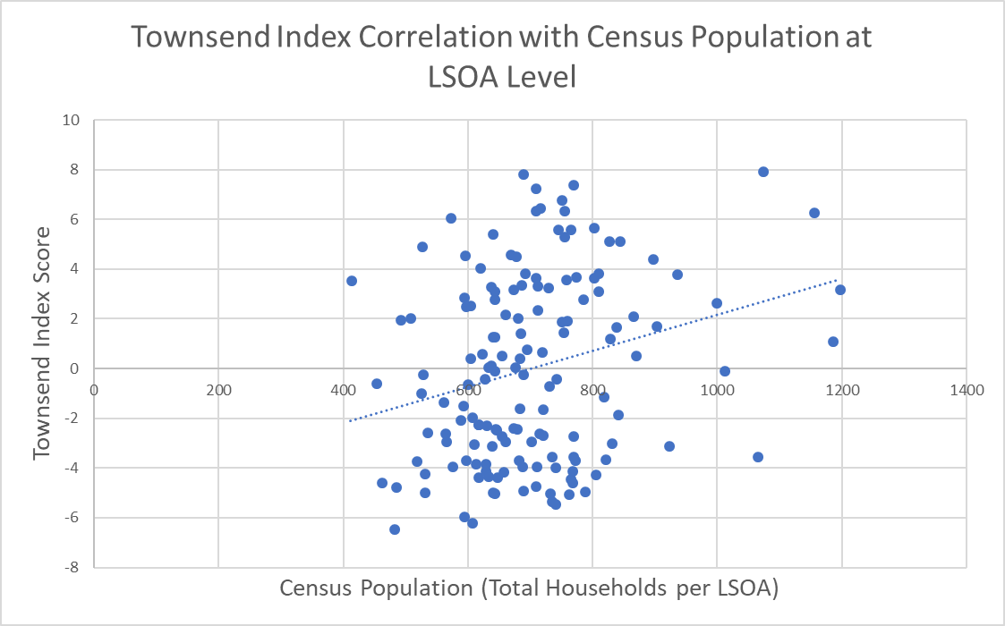
Figure 3: Scatterplot Graph Depicting the Weak Positive Correlation Between Total Housing Population and the Townsend Index Scores for the LSOAs, Created Using Microsoft Excel.
The results for the correlation between total housing and the Government Deprivation Index show a moderately positive correlation between the variables, where n = 148 and R= 0.48081. Figure 4 depicts this correlation graphically in the same manner as Figure 3.

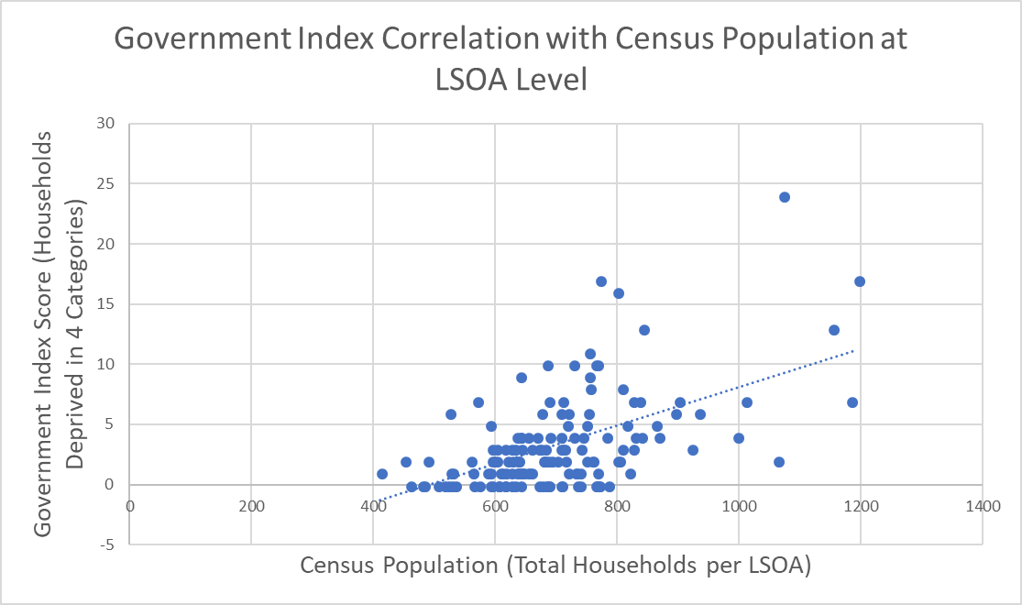
Figure 4: Scatterplot Graph Depicting the Weak Positive Correlation Between Total Housing Population and the Government Index Scores for the LSOAs, Created Using Microsoft Excel.
In comparing the R values for correlations, the Townsend Index’s correlation being lower at R = 0.233809 than the Government scores at R= 0.48081 demonstrates that the Townsends correlation is weaker. This means that changes in population density per OA are less capable of predicting population deprivation derived from the Townsend Index, whilst the same change in population density is more capable of predicting population deprivation derived from the Government Deprivation index. This is suggestive of the Government Index being more simplistic in its assessment of deprivation than the Townsend Index, possibly a result of the complex calculation process of the Townsend compared to the simple measure.

Middle Super Output Area
The same process was performed for the MSOAs as with the LSOAs, total housing was used as the baseline and Spearman’s rank correlation coefficients were calculated to permit analysis of difference in correlations. The results for the Spearman’s Ranks Correlation between the Townsend Index Scores and the Total Housing exhibits a moderate positive correlation, where n = 31 and R=0.671439. Figure 5 depicts this correlation graphically. The results for the Spearman’s Rank correlation between the Government Index Scores and the Total Housing exhibits a similarly moderately positive relationship, where n = 31 and R= 0.735334, depicted by Figure 6.
A similar dynamic to the LSOA correlation comparison is apparent in comparing the correlations of the MSOAs results. The Government Index has a higher correlation than the Townsend Index, indicative of the Government Index being more powerful in predicting deprivation in a population sample. This consistency in correlation comparison was to be expected, as the LSOAs are subdivided MSOAs, being based on the same data. Despite this, the R values for the MSOAs are much closer than with the LSOAs, this is likely a result of the increased scope of the MSOAs. This demonstrates that as granularity decreases, the capacity for detailed analysis also decreases and vice versa, showing that differing scopes can produce varied results, but results that are typically part of a larger trend.
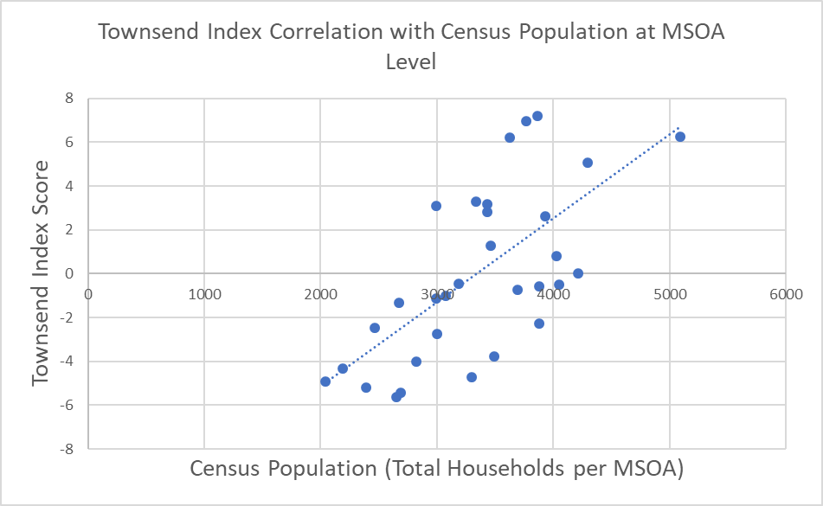
Figure 5: Scatterplot Graph Depicting the Weak Positive Correlation Between Total Housing Population and the Townsend Index Scores for the MSOAs, Created Using Microsoft Excel.
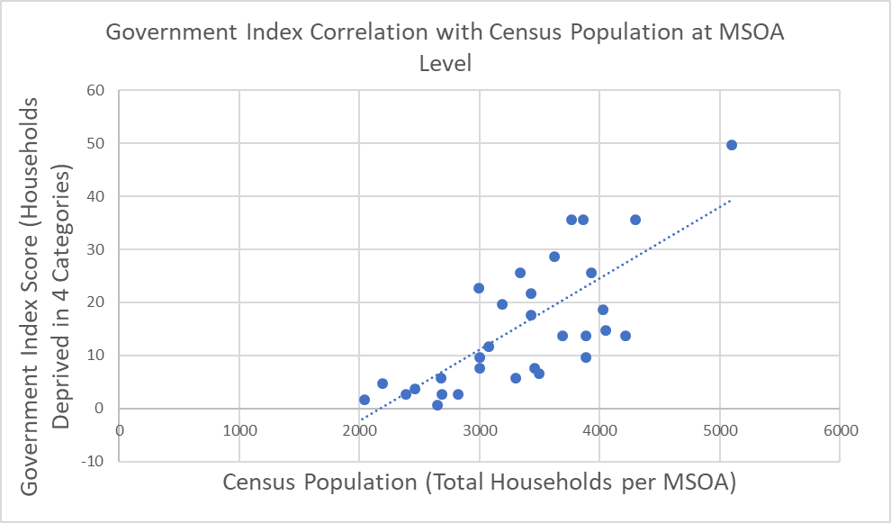
Figure 6: Scatterplot Graph Depicting the Weak Positive Correlation Between Total Housing Population and the Government Index Scores for the MSOAs, Created Using Microsoft Excel.

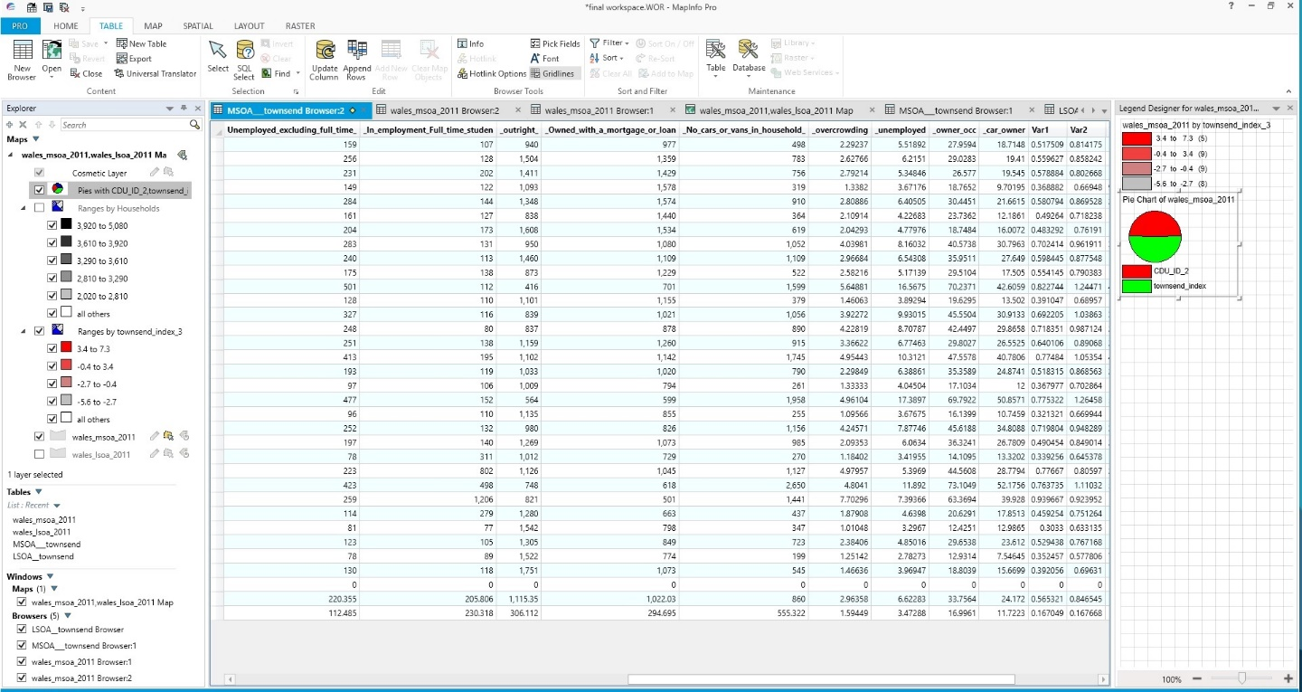
Figure 7 depicts the various tables for the MSOAs and LSOAs loaded in to MapInfo’s workspace browser ready to create a thematic map from the deprivation data. A workspace was created for both the Townsend Index and Government Index data. Figure 8 depicts Townsend Index deprivation measurements for Swansea’s 31 MSOAs as a thematic map using the data tables from figure 7.
Figure 7: One of Multiple Data Tables Loaded into a MapInfo Workspace Browser Ready for the creation of a Thematic Map.
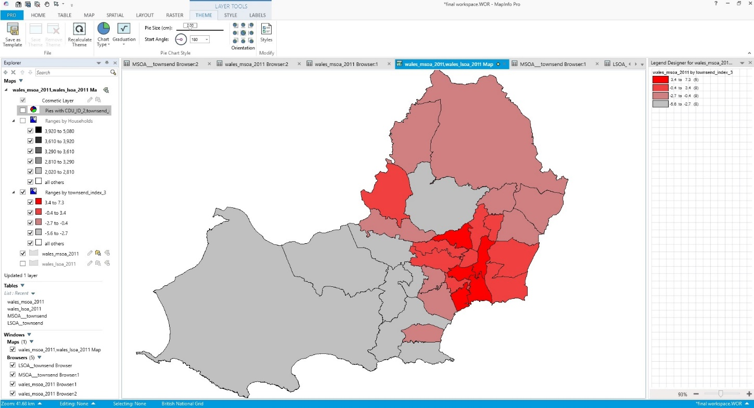
Figure 8: Thematic Map of the Townsend Index Deprivation Measurements for Swansea’s 31 MSOAs, Created Using the MapInfo GIS Programme.

Discussion and Conclusion
The results of the comparison between correlations within the LSOAs and MSOAs exhibits noteworthy results. For the LSOAs, a large difference in correlation power, sided toward the Government Index shows that this index has a higher capacity for predicting deprivation over a larger population, whereas the Townsend Index has a weaker capacity. This is possibly a result of the complexity of the Townsend Scores being less amenable to correlation analysis, especially at a city sized scope. This complexity is exacerbated in comparison to the simpler numerical measure the Government Index employed. The simplicity of the Government Index appears more applicable and amenable to the larger scope of this paper.
These results demonstrate the importance of selecting an appropriate scope in GIS. The correlations being considerably more disparate for the LSOAs compared to the MSOAs shows that an increasing scope reduces the analytical detail of results. This difference in scope is what implicated the difference in correlation between indices, as the Government Index was more powerful at greater scope because of its simplicity and the Townsend Index is more powerful in greater detail. This has further implications for GIS in the preparation of data, the Townsend Index taking considerably longer to synthesise than the Government Index.
In conclusion, this analysis shows that the selection of an appropriate scope is essential to obtaining proper results when using GIS. It shows that differing scopes can have implications for the data and index types. For this paper, the Governmental Index appears to be the more effective tool, being quicker to synthesise, easier to organise and more amenable to analysis. However, this is a result of the city-wide scope. Had the analysis been at a smaller scale, the Townsend Index and the level of intricacies of detail it can provide would make for a more effective tool for analysis.

References
Aydin, N.Y., Kentel, E. & Duzgun, S. (2010) GIS-based environmental assessment of wind energy systems for spatial planning: A case study from Western Turkey Renewable and Sustainable Energy Reviews [Online] 14 (1) pp. 364-373.
Baja, S., Chapman, D.M. & Dragovich, D. (2002) A Conceptual Model for Defining and Assessing Land Management Units Using a Fuzzy Modeling Approach in GIS Environment Environmental Management [Online] 29 (5) pp 647–661.
Li, H., Chen, Z., Yong, L. & Kong, S.C.W. (2005) Application of integrated GPS and GIS technology for reducing construction waste and improving construction efficiency Automation in Construction [Online] 14 (3) Pgs. 323-331.
Ru, X. W., et al., (2013) Municipal Infrastructure Projects Management and Decision-Making Support System Based on GIS Advanced Materials Research [Online] 726-731 pp. 4596-4599.
Saunders, J. (1988) Weighted Census-based deprivation indices: their use in small areas Journal of Public Health Medicine [Online] 20 (3) pp. 253-260.
Townsend, P., Phillimore, P. & Beattie, A. (eds). (1988) Health and deprivation. Inequality and the North Health Policy [Online] 10 (2) pp. 207-206.
Tsihrintzis, V.A., Hamid, R. & Fuentes, H.R. (1996) Use of Geographic Information Systems (GIS) in water resources: A review Water Resources Management [Online] 10 (4) Pgs. 251-227.
Welsh Government (2014) Welsh Index of Multiple Deprivation (WIMD) 2014 [Online] Available from: https://gov.wales/docs/statistics/2015/150812-wimd-2014-revised-en.pdf [Accessed 3rd May 2018].

