The Application of an Engineering Design Methodology for a Dry Sump Pan

James Smith
1801879
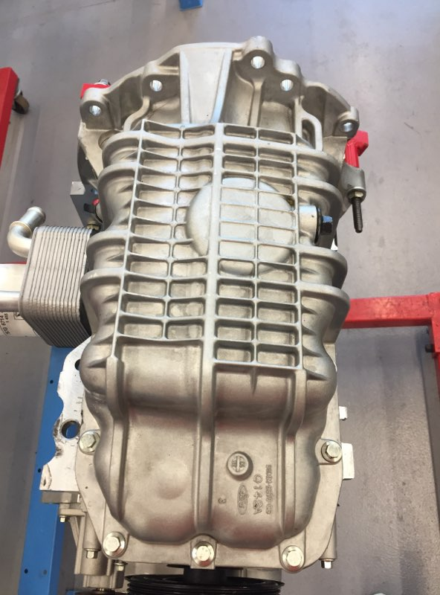

-Figure 1: Wet Sump

Contents

Title Page………………………………………………………………………………………...………………………… Page 1
Contents Page………………………………………………………………………………………………………….... Page 2
List of Figures………………………………………………………………………………………..……………….…… Page 3
Introduction……………………………………………………………………………………..……………..….……… Page 4
Secondary Research………………………….……………………………………………..………..……….……… Page 5
Primary Research…………………………….…………………………………………………………..………………Page 6
Design Specification………………………….……………………………………………………………….…………Page 7
Quality Function Deployment………………………………………..…………………………………………….Page 8
Concept Designs……………………………….……………………………………………….………….……….……Page 9
Design Isolation………………………………………………………………………………………………………...Page 11
Design Development and Final Design………………...……………………..………………….…….……Page 11
Final Design Documentation………………………………………………………………….…….……….……Page 13
References……………………………………………………………………………………….………….……….……Page 14

List of Figures

Figure 1………………………………………………………………………….………………………… Wet Sump, Page 1
Figure 2………………………………………......………………………. Customers Requirement Table, Page 4
Figure 3………………………………………………….………………………………….…. Wet Sump Images, Page 7
Figure 4…………………………….…...….… Market Requirements, Design Specification Table, Page 7
Figure 5………………………………………………………Life in Service, Design Specification Table, Page 7
Figure 6………..…………………………Production Requirements, Design Specification Table, Page 7
Figure 7………………………………………………………………………………………….………… QFD Table, Page 8
Figure 8………………………………………………………………………………….…… FMEA Concept One, Page 9
Figure 9…………………………………………………………………..…..……………. Concept Design One, Page 9
Figure 10……………………………………………………………………….…………. FMEA Concept Two, Page 10
Figure 11…………………………………………………………..……….…………… Concept Design Two, Page 10
Figure 12…………………………………………………………………….………… Design Isolation Table, Page 11
Figure 13…………………………………………………………..……… Design Isolation Results Table, Page 11
Figure 14…………………………………………………………………………………………..…..Final Design, Page 12
Figure 15………………………………………………………….……..…..Final Design Documentation, Page 13
Introduction

This application of an engineering design report, will include the design process taken to create two concept designs and a final design using Solid Works. The designs will be created for a dry sump system that can be easily fitted to the customer’s standard Ford engine and must abide by the parameters and requirements given by the customer. The customer has commissioned a dry sump pan and oil pickup point design for a 1.6 Ford Zetec engine, which they then want to use for motorsport and track competitions. This report is going to outline the design process taken, showing the journey from the concept designs to the fully rendered final design and technical drawings with improvements being made throughout, to make the dry sump system most effective for the customer.

The customers standard 1.6 Ford Zetec engine is already fitted with a wet sump pan, which is used to store and collect the oil. The oil stored in the sump is then pumped through galleries to the lubrication points in the engine and collects back in the sump pan, where it repeatedly cycles around.

Customer requirement | Requirement importance rating (out of 10)
The product should be light weight | 8
The product should be easy to install (initial set-up) | 5
In the event of a roll-over, the engine should not be flooded with lubricant | 9
The product should be low cost | 7
The product should allow easy/fast access for servicing/maintenance | 7
The parameters given by the customer are; an external oil pump needs be added to the improved dry sump system to scavenge the oil from the sump pan, which will be delivered to an external oil tank. The oil pumped into the tank will then be fed back to the oil pick up point, where the standard pump will be used to deliver the oil to the lubrication points in the engine, where it repeatedly cycles around.
-Figure 2: Customer Requirements Table

As shown in figure 2 are the customer requirements with the importance ratings out of 10 shown next to them. These ratings show how important each requirement is to the customer and will help the designing process to make sure the final design successfully satisfies all the customer’s requirements.

Secondary Research

During the design process, two dry sump concepts are going to be presented showing the improvements made each time. The concepts will be designed after a product design specification has been produced, outlining the key features needed in the sump designs. The customer has commissioned the design to eliminate some of the problems present when using a wet sump for a track car in race conditions. One of the problems with a standard wet sump system is that the oil moves from side to side when cornering heavily which leaves parts of the engine to become starved from oil.

‘The engine in your race car goes through some dynamic conditions over the course of a race: acceleration and cornering loads, which force the oil back and to either side, and deceleration loads driving the oil to the forward positions of the engine. These conditions can cause oil starvation at a time when the engine needs the protection of the oil system the most. This starvation is caused by the pump pickup becoming uncovered for brief periods of time as the car goes through these transitions.’

(V, Hill 2006)

As stated by Hill in Hot Rod Network, a wet sump system can cause starvation of oil in the engine for periods of time when there is acceleration, cornering loads and deceleration loads, which is unwanted when using an engine for race conditions. A dry sump eliminates this factor because the pump in the oil pick up creates a vacuum in the sump which instantly scavenges all the oil collected, causing constant lubrication in the engine.

The two concepts designed will be in response to the customer requirements and the fact that the design is for a one of product. The final product is going to be fitted to a race car being used in extreme track conditions, “race cars are designed under the rule of saving space, reducing weight and using a layout for lowering the mass centre of the vehicle by reducing the car to floor height” (Corzo, 2018). As stated by Corzo in International Journal of Automotive and Mechanical Engineering the key to an effective race car is a low centre of mass, so when designing the sump, the depth and shape will be an important factor to leave as much room underneath the sump as possible.
The dry sump system will allow for a lower centre of mass of the car by adding an external oil tank outside the engine.
‘Furthermore, the oil stored in this external tank, called dry-sump system, allows to improve the oil-air separation avoiding the foaming. The race cars are subjected to high acceleration and decelerations forces that commonly can reach values as high as 2 g or 3 g during several seconds. These forces push the oil against the vertical walls compromising the normal lubrication and cooling of the engine. In particular, the dry-sump oil systems could guarantee oil pumping in every situation.’
(International Journal of Automotive and Mechanical Engineering, 2018)
As stated by the International Journal of Automotive and Mechanical Engineering, a dry sump system is perfect for an engine being using in a race car to reduce any possible failure factors present when in a racing environment.

Primary Research
To be able to produce accurate concept designs and a final design, measurements were firstly taken from the 1.6 Zetec engine. The measurements obtained were the bolt hole layout on the bottom of the engine block, the width of the sump pan, the depth of the sump and the gear box mount bolt hole positions.

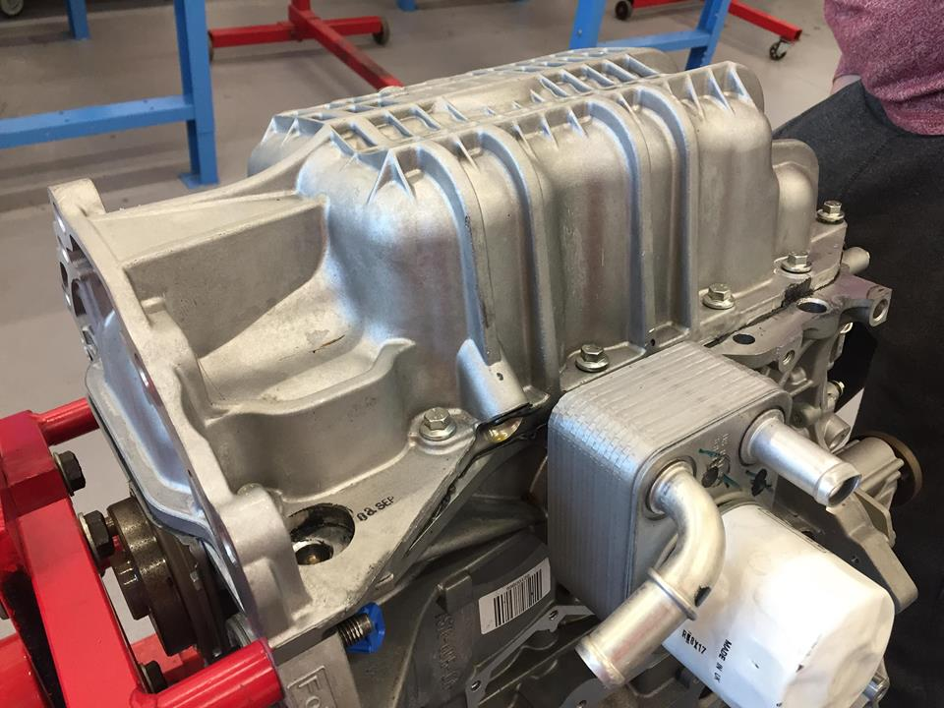
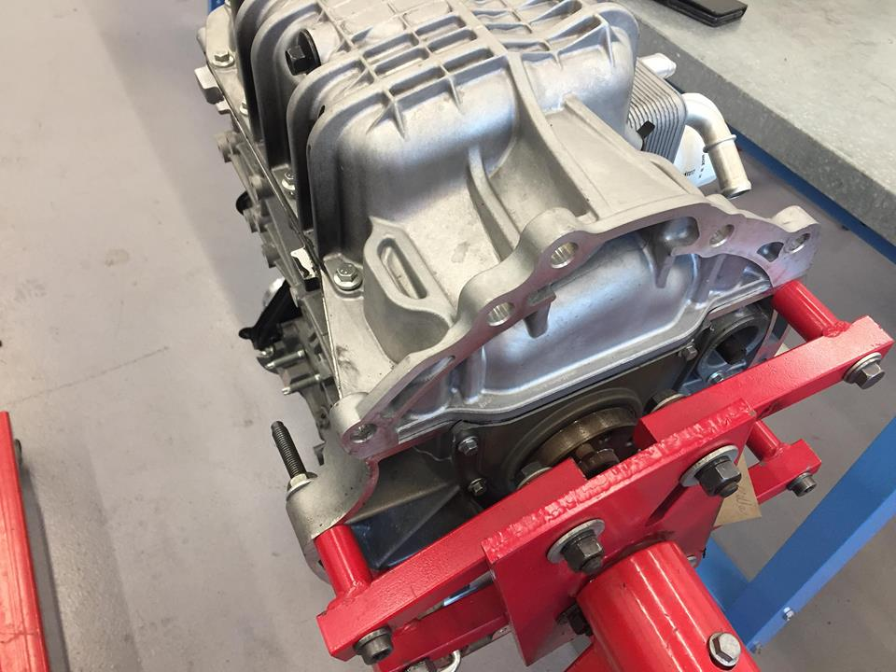
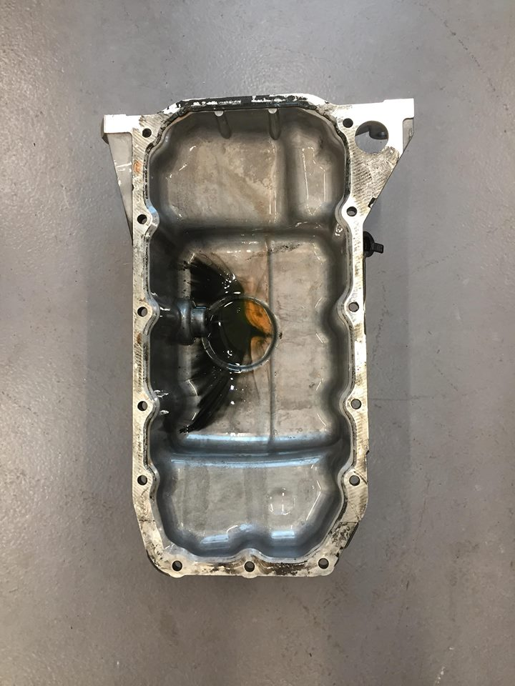
The measurements needed were obtained using a range of measuring equipment including a set of Vernier callipers, squares, a micrometer and a metal ruler. After finding all the needed measurements from the engine and sump pan, the outcome was obtained after looking at the standard sump that a ribbed exterior on the sump would improve strength and reduce any possible common failures.
-Figure 3: Wet Sump Images

Design Specification
Market Requirements | Design Requirement | Design Specification
Must be light weight | Shallow flat shape | <10kg
Must be easy to install (initial set-up) | Easy access to gear box mounts and sump holes | Direct access to all 18 bolt holes
Should be low cost | Material choice | <£100
-Figure 4: Market Requirements, Design Specification Table
Life in Service | Design Requirement | Design Specification
Must allow for easy access for maintenance | Quick and easy access to all holes with standard bolts used | Direct access to bolt holes with standard bolts used and countersink holes
Must be strong and not damage easily | Protective material added to sump | Ribbed material added to outer faces
The engine should not be flooded with lubricant if car rolls over | Add a non-return valve | Add a check valve at oil pick up point
-Figure 5: Life in Service, Design Specification Table
Production Requirements | Design Requirement | Design Specification
Target cost of production | Production should be low cost | <£60
One off production type | Interesting design with key features | Strengthened design with protective outer material
-Figure 6: Production Requirements, Design Specification Table
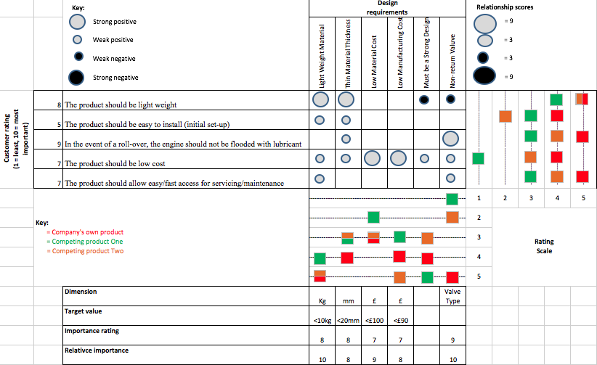
Quality Function Deployment
-Figure 7: QFD Table

After researching two other competing dry sump products, the quality function deployment tool has been created to see how the product being designed is going to compare to other existing products.

The first competing product chosen is the ‘Titan 1.6 Eco-boost Dry Sump Kit’ from Puma Speed Performance Tuning (2019). This sump kit is Titanium and has twin scavenge, which both add a lot extra weight to the sump which is a big factor for the customer, so the material chosen for the sump concepts being designed will be aluminium alloy to please the customer most.

The second competing product chosen is the ‘Duratec Dry Sump Kit’, from Race line (2019). This sump is sand cast aluminium, with an integral dry sump pump and has a height of 75mm, so the concept sump designs must be 75mm or less to be suitable for racing.
Concept Designs


Before starting the design process on Solid works, a Failure Modes and Effects Analysis (FMEA) has been produced using the customers’ requirements as shown in figure 2 on page 4. The purpose of an FMEA table can vary massively but this FMEA table has been produced to outline the factors that may cause future damage to the engine if actions are not taken.
-Figure 8: FMEA Concept One

As shown in figure 8 is an FMEA table created for the first concept design, this illustrates the points needed to consider when creating the initial design. By following figure 8, will increase the chances of the first concept fulfilling all the client’s needs and requirements.

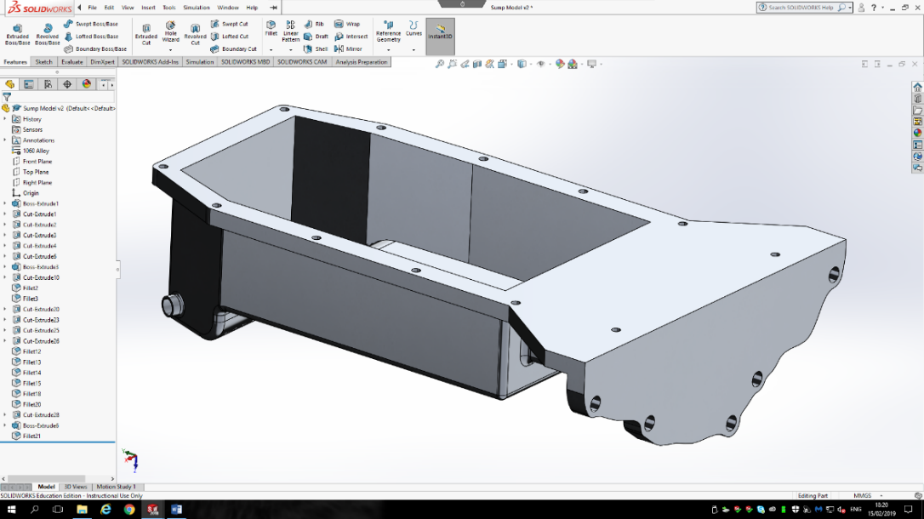
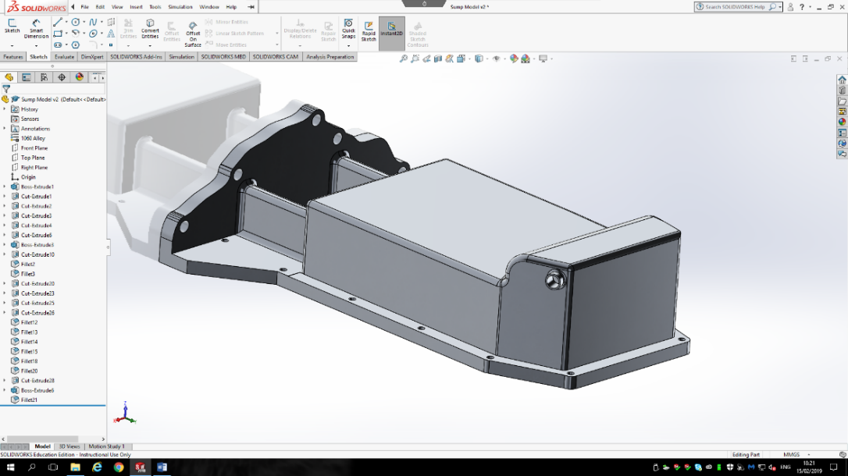
The first concept design for the dry sump system has been designed to reduce the chances of the oil pick up point being ripped off the bottom of the sump when cornering. This has been done by positioning the pick-up point the side of the sump to reduce this factor and make sure the engine is not damaged. The material chosen for first design is 1060 Aluminium Alloy, this material has been chosen because it is lightweight, corrosion resistant and cost effective which are all very important factors for the customer.
-Figure 9: Concept Design One

After analysing concept one, the outcome that the sump pan is too big has been observed, to overcome this factor the sump pan will be re-designed to make the design much smaller, lighter and reduce the chances of the sump being ripped off when on a track if the car rolls or corners sharply. Because this is an initial design, the next design will be designed using the benefits of this sump whilst improving any flawed aspects that have been observed.


Before starting the second design an improved FMEA table has been produced to make sure the same flawed aspects are not repeated on the second concept design.
-Figure 10: FMEA Concept Two

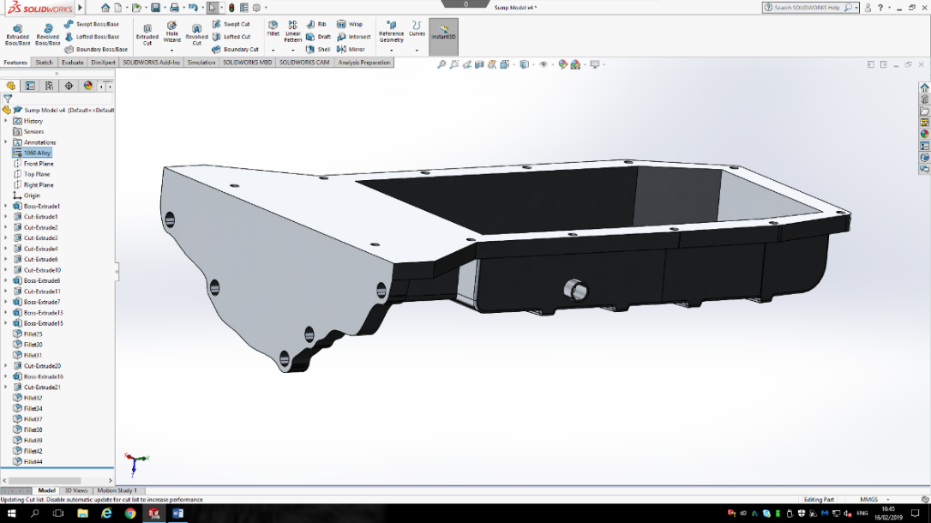
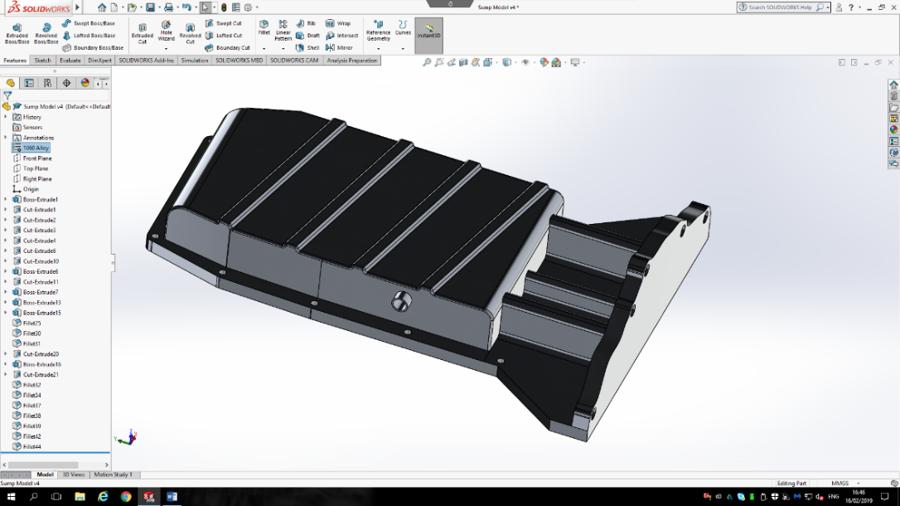
The new FMEA table shown in figure 10 clearly shows that the depth and shape of the sump needs to be re-designed to reduce the risks of the sump being damaged on sharp cornering, making the sump safer once being used in track conditions.
-Figure 11: Concept Design Two

Reducing the sumps depth has cut down on the weight and overall price of the sump, satisfying the customers’ requirements. This second concept has been designed with safety in mind because by decreasing the depth of the sump will reduce the possible failure modes presents when in racing conditions.

Design Isolation

Feature | Concept One | Concept Two
Light Weight | Medium | High
Serviceability | Medium | High
Ease of Maintenance | Medium | High
Ease of Production | High | High
Ease to Install | Medium | Medium
Design detail | Low | Medium
Cost | Moderate | Cheap
-Figure 12: Design Isolation Table
Score | Concept One | Concept Two
Low | 1 | 0
Medium | 4 | 2
High | 1 | 4
Cost | Moderate | Cheap
-Figure 13: Design Isolation Results Table

The design isolation score table in figure 13 suggests that the second concept is a more suitable design to adapt for the final design. This has also been backed up by the FMEA table shown in figure 10, which shows the flaws and various areas which need improvement from the first concept and these improvements are shown in the second concept idea.

Design Development and Final Design

Once the design isolation tables shown in figure 12 and 13 were complete it was decided that concept two is the ideal concept to take further to develop into a final design that satisfies all the customer requirements.

After analysing the design specification, QFD, customer requirements, FMEA tables and the design isolation tables a strong light weight sump with protective ribbed outer material, is needed to make sure the sump is suitable and safe for use in race conditions.

The final design for the sump has been created to overcome and eliminate some of the failure modes present as shown in the FMEA table in figure 10. To make the sump stronger a ribbed material design has been applied to the bottom of the sump to strengthen and reduce the chances of the sump being damaged or damaging the engine when being used in racing conditions.
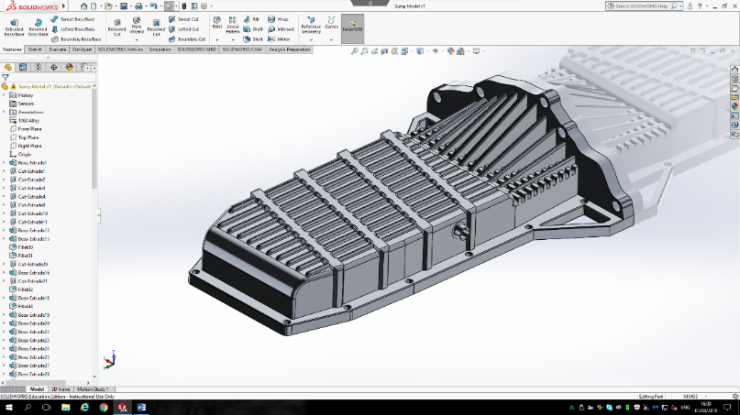
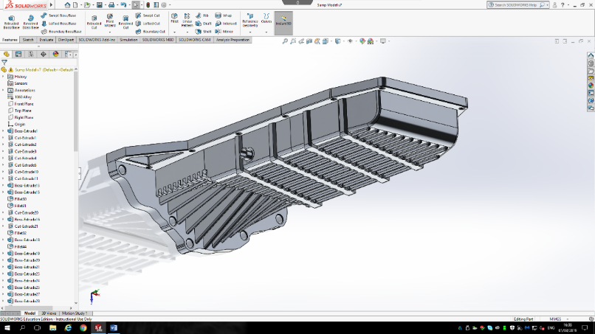
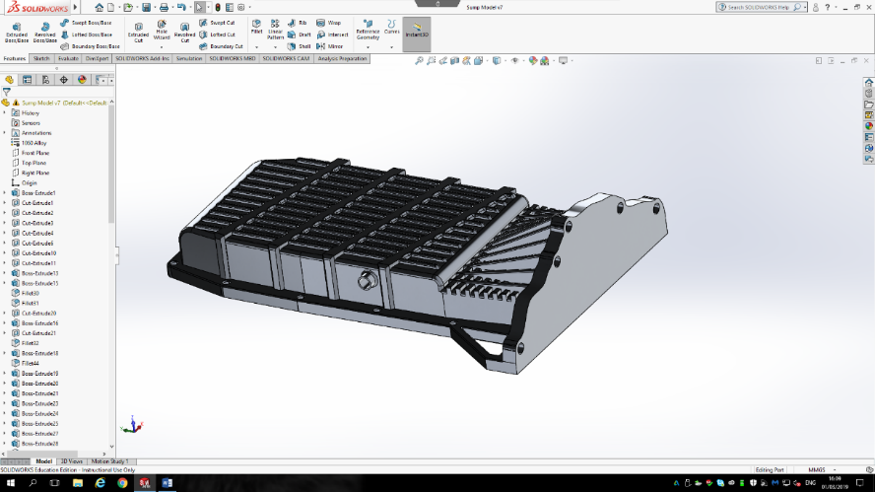
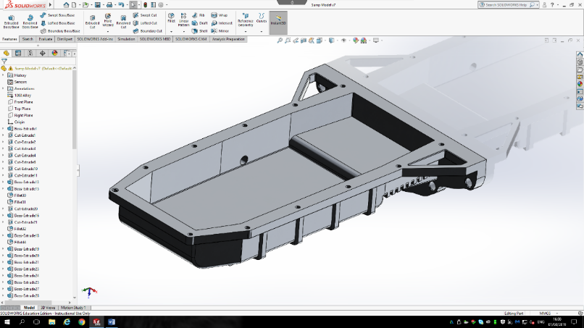

-Figure 14: Final Design

As shown in figure 14, is the final dry sump design solution, which has been massively improved from concept two to increase the suitability against other existing and competing products. The bottom of the sump has been improved by shelling out the whole bottom section, countersunk bolt holes have been added, along with protective ribbed material and strengthen gear box mounts. The design has been fully rendered with chamfered and fileted sections where appropriate in the design.

It is believed that this final design satisfies all the customer requirements, by using the correct and appropriate design tools where needed to show the journey from the initial concept to final design with improvements being made throughout the report.

Final Design Model and Design Documentation: https://uowtsd-my.sharepoint.com/:f:/g/personal/1801879_student_uwtsd_ac_uk/EuyoxZtJuIlNj7MrYTn_OfoBKr9MDeyN1za09Za_XUc93A?e=8cdiAh
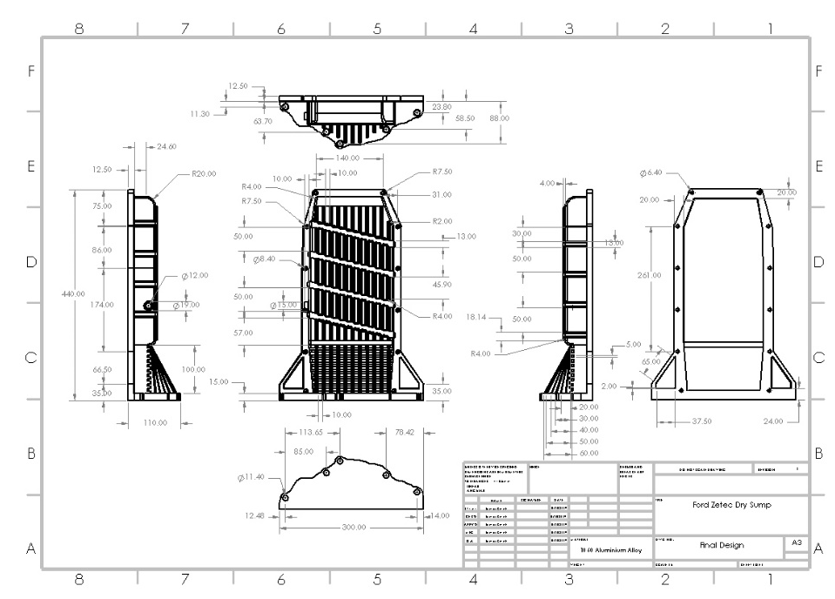
Final Design Documentation
-Figure 15: Final Design Documentation
References

CORZO, S.F., RAMAJO, D.E. and NIGRO, N.M. (2018). Transient Numerical Assessment of Race Car Dry-Sump Oil Under Extreme Maneuvers. International Journal of Automotive and Mechanical Engineering, 15, pp. 5636-5637. [Online] Available: https://search-proquest-com.ezproxy.uwtsd.ac.uk/docview/2153617798/fulltextPDF/7087C7237DD54DF0PQ/1?accountid=130472
[Accessed 24th February 2019]

Hill, V (2019). Hot Rod Network [Online] Available: https://www.hotrod.com/articles/ctrp-0608-power-in-the-pump/
[Accessed 15th February 2019]

Puma Speed Performance Tuning (2019). Titan 1.6 Eco-boost Dry Sump Kit [Online] Available: http://www.pumaspeed.co.uk/product-Titan-16-Ecoboost-Dry-Sump-Kit_16860.jsp
[Accessed: 6th March 2019]

Race line (2019). Duratec Dry Sump Kits [Online] Available: https://www.raceline.co.uk/products/part_section.asp?SectionID=23&CategoryID=1
[Accessed: 6th March 2019]

